# Q2 e)

## Impulse and Step Responses

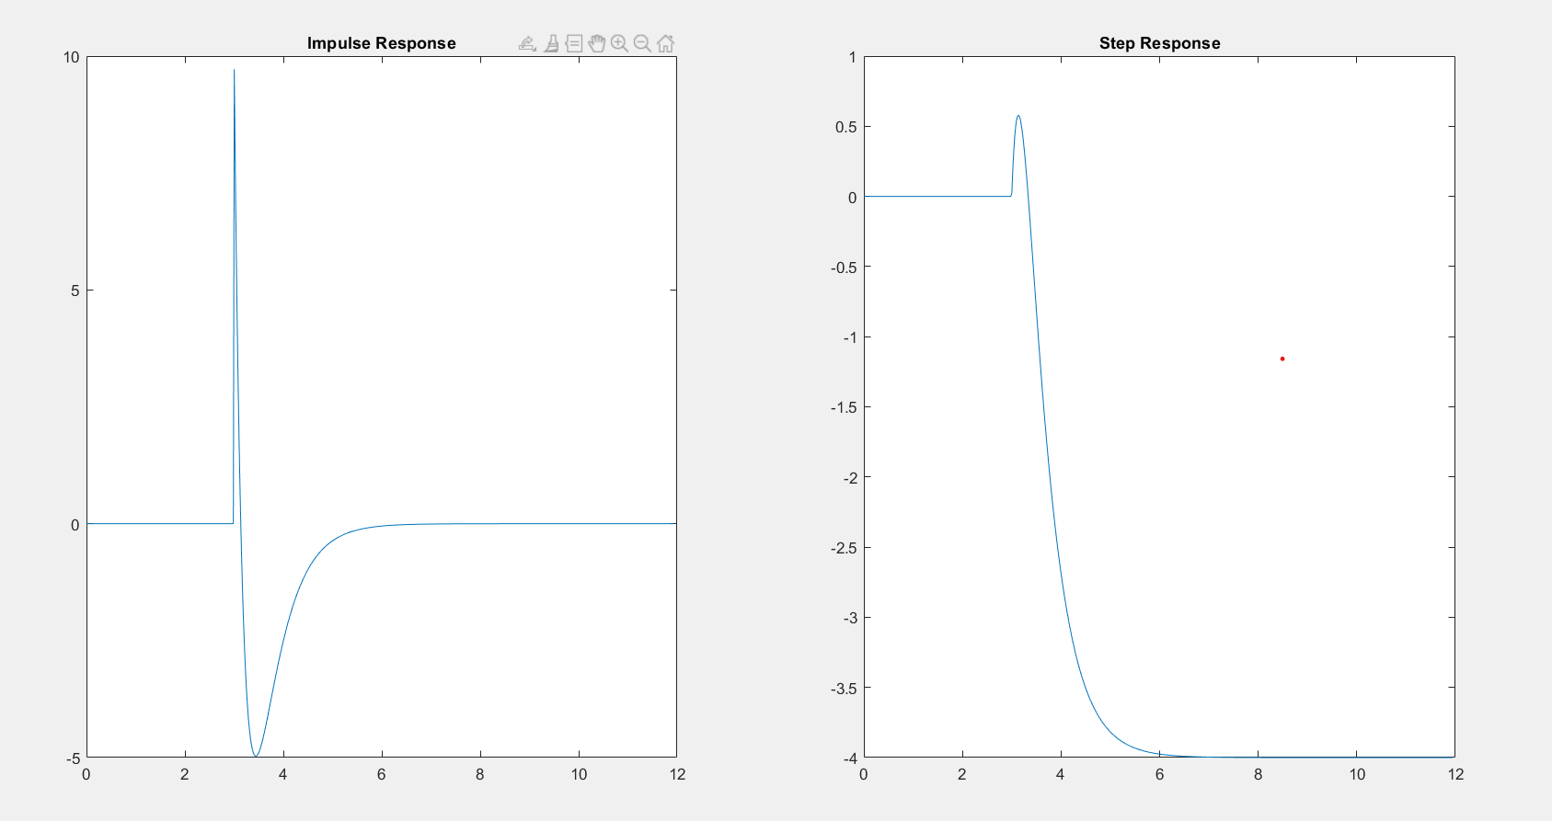

*Figure 1: Impulse and Step responses*

## Large time response

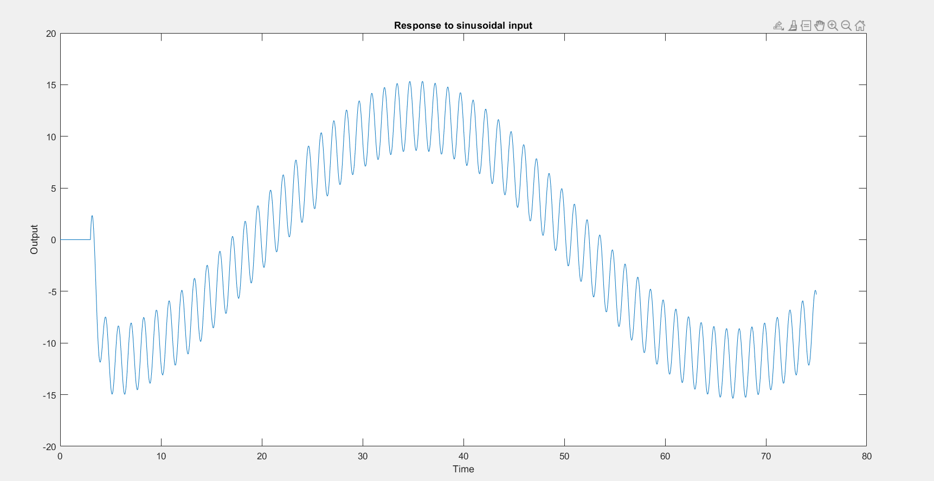

*Figure 2: Large time response from lsim*

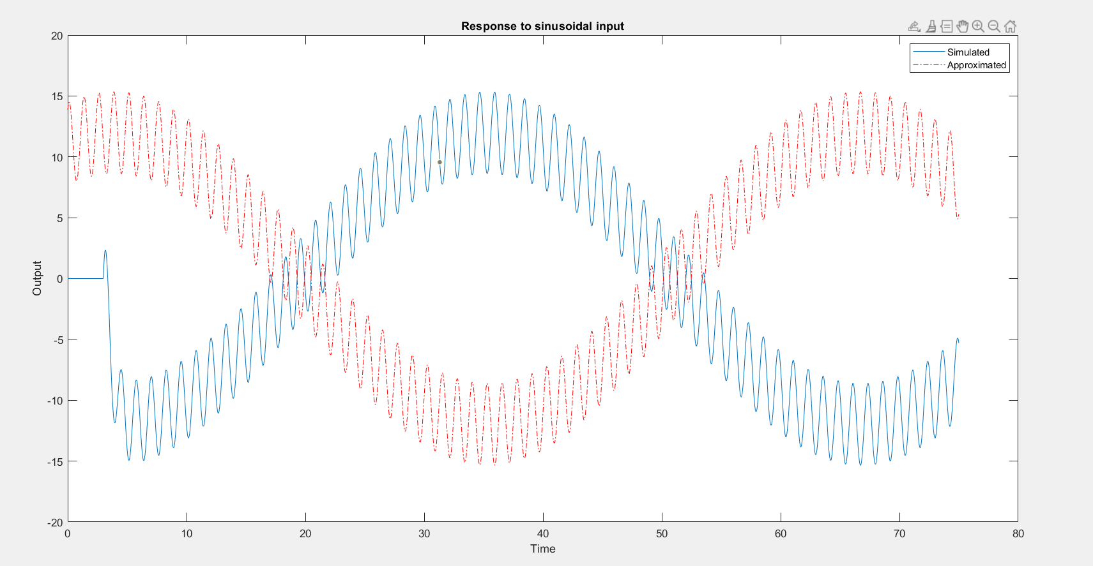

*Figure 3: lsim compared to handwritten approximation*

We see there is almost a 180 degree phase shift of the larger sinusoid. I am not sure whether that is a problem with my code or a problem with my derived expression. (or should they not match at all for small times?)

## Bode Diagram

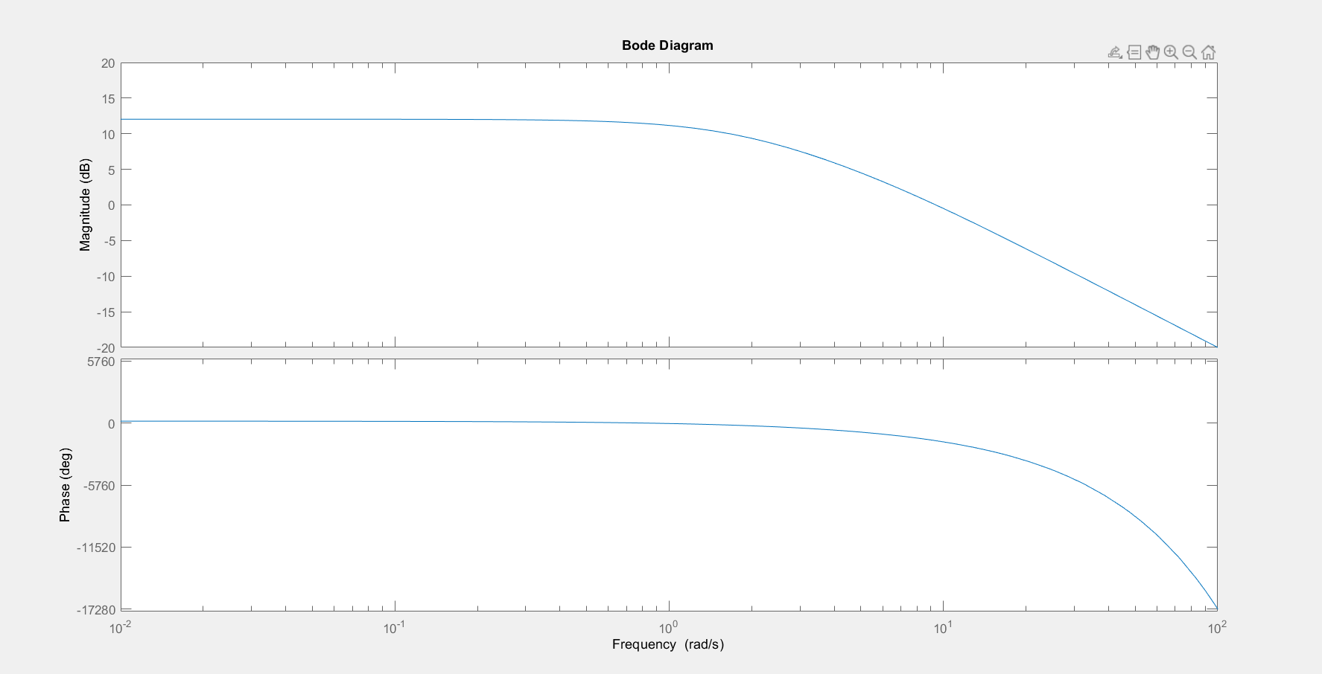

*Figure 4: Bode Diagram of the system*

## Minimal system

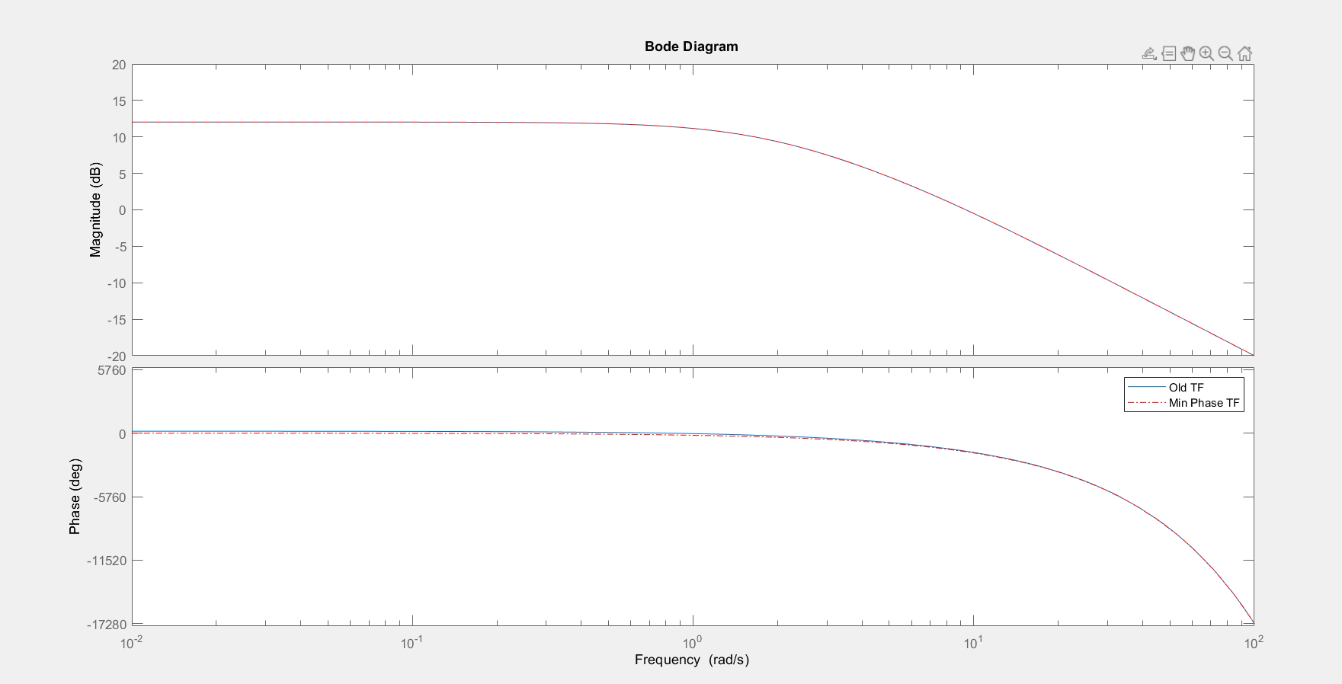

*Figure 5: Comparing the bode diagrams of original system and minimal system*

We can see that their magnitudes are same but the minimal system has lower phase than the original system. In fact, it will have the lowest phase among all systems having the same magnitudes.

## MATLAB code

close all; clear;

G = tf([10 -40],[1 7 10],'InputDelay',3);

%% Part a)- Impulse and Step responses

% Impulse response

[Yimpulse,Timpulse] = impulse(G);

subplot(1,2,1);

plot(Timpulse,Yimpulse);

title('Impulse Response');

% Step response

[Ystep,Tstep] = step(G);

subplot(1,2,2);

plot(Tstep,Ystep);

title('Step Response');

%% Part b)-Response to the given sinusoidal input

Tmax = 75;

t = 0:0.01:Tmax;

U = 2*sin(5*t) + 3*cos(0.1*t);

Y = lsim(G,U,t);

yhand = 3.363*sin(5*t-17.87) + 11.9863*cos(0.1*t-0.3949);

figure();

plot(t,Y); title('Response to sinusoidal input');

xlabel('Time');ylabel('Output');

figure();

plot(t,Y,t,yhand,'r-.');

legend('Simulated','Approximated'); title('Response to sinusoidal input');

xlabel('Time');ylabel('Output');

%% Part c) Bode Plot

figure();

bode(G);

[MAG,PHASE,W] = bode(G);

%% Part d) MinPhase

G2 = tf([10 40],[1 7 10],'InputDelay',3);

[MAG2,PHASE2,W2] = bode(G2);

figure();

bode(G);

hold on;

bode(G2,'r-.');

legend('Old TF','Min Phase TF');