# Q4

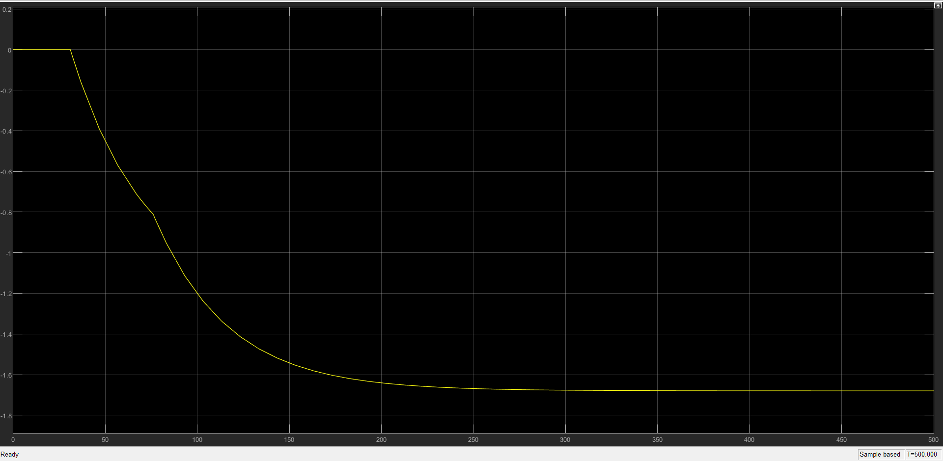

*Figure 4.1: Plot of output vs time for a unit step input*

A combination of two delayed subsystems. Initially we can’t see any response, then we see a response. But after sometime a second subsystem kicks in, it shows a different kind of variation.

It is different than usual for two reasons:

1. Late response
2. The response curve is non-differentiable at one point (that is, the slope becomes discontinuous). As explained above this is because, the overall 2nd order system is composed of two 1st order systems with different delays.

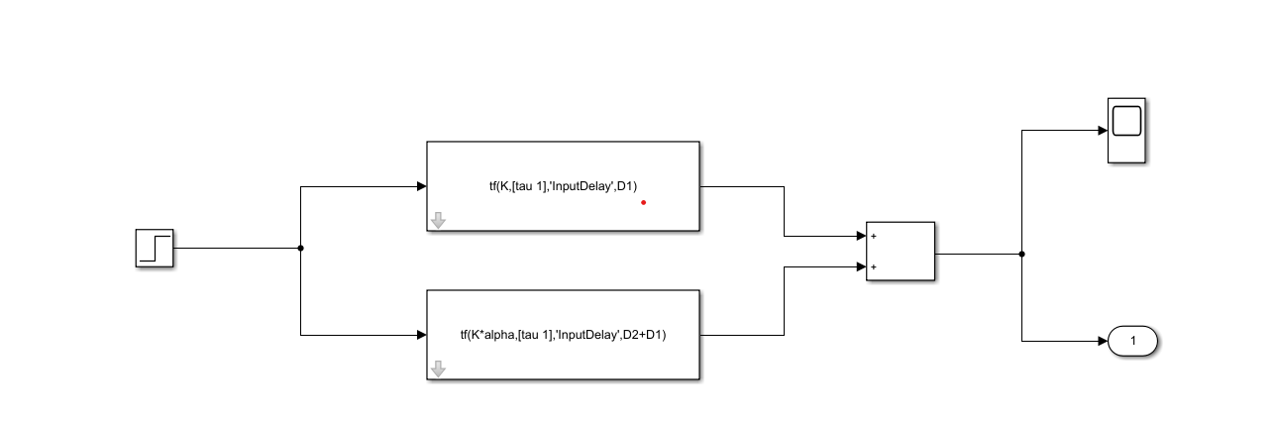

*Figure 4.2: SIMULINK Model. (LTI blocks have been used to simulate the system)*

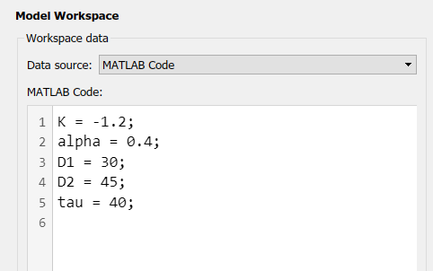

*Figure 4.3: Variables initialisation*