# Question 3)

## Question 3) a)

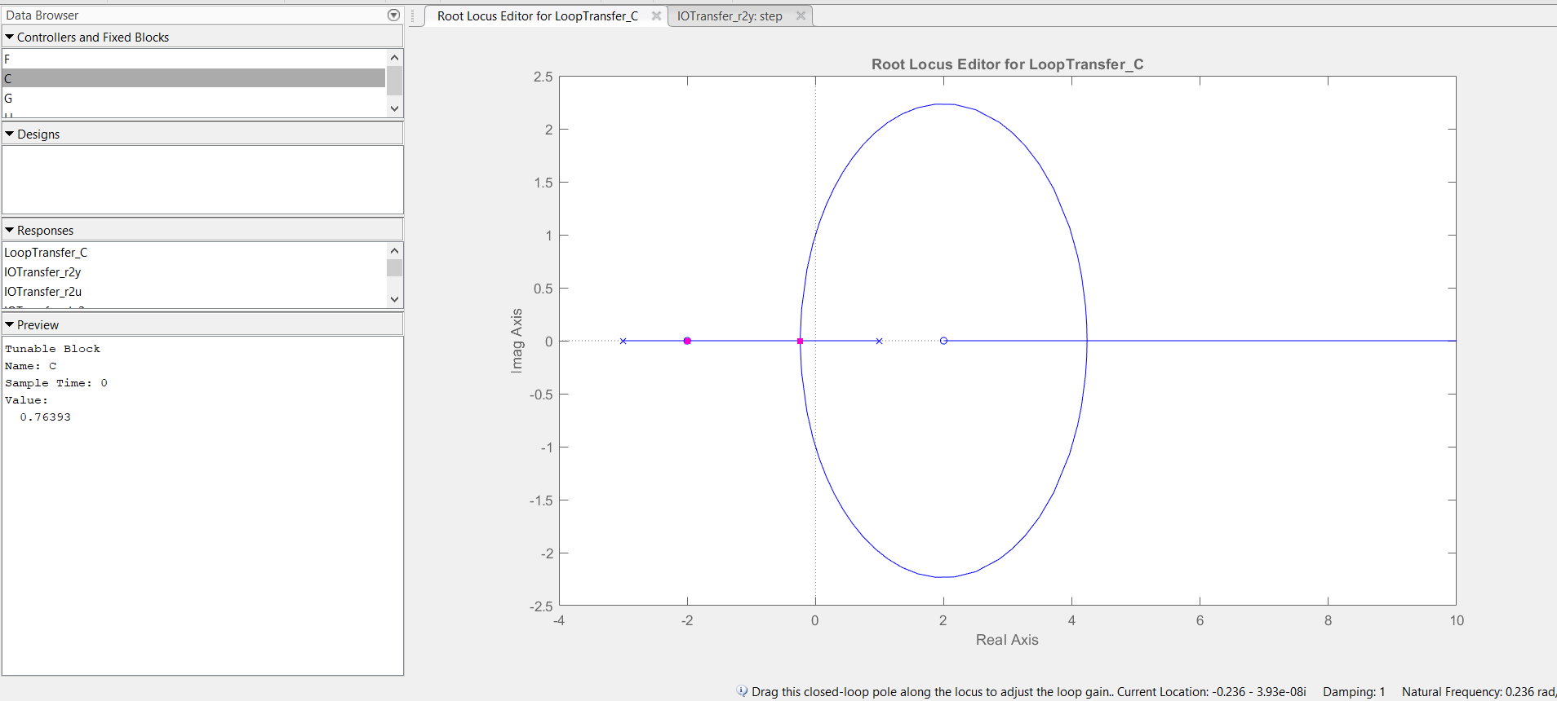

## Question 3) b)

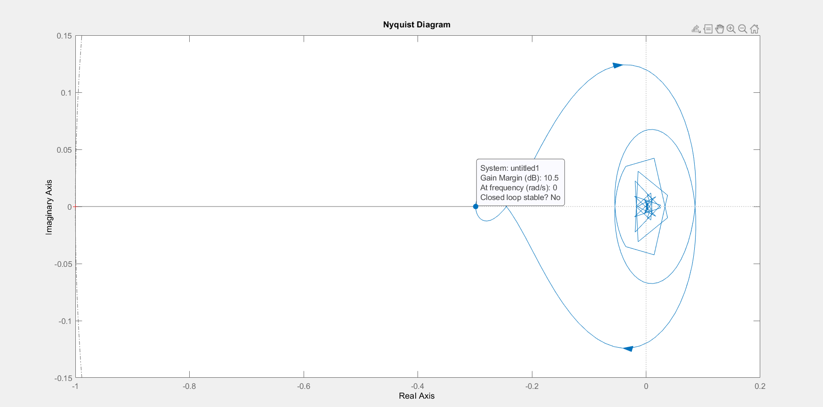

*Figure 3.2: Nyquist Diagram for the system with gain margin 10.5 dB*

Since the system is closed loop unstable, the step response of the system blows up.

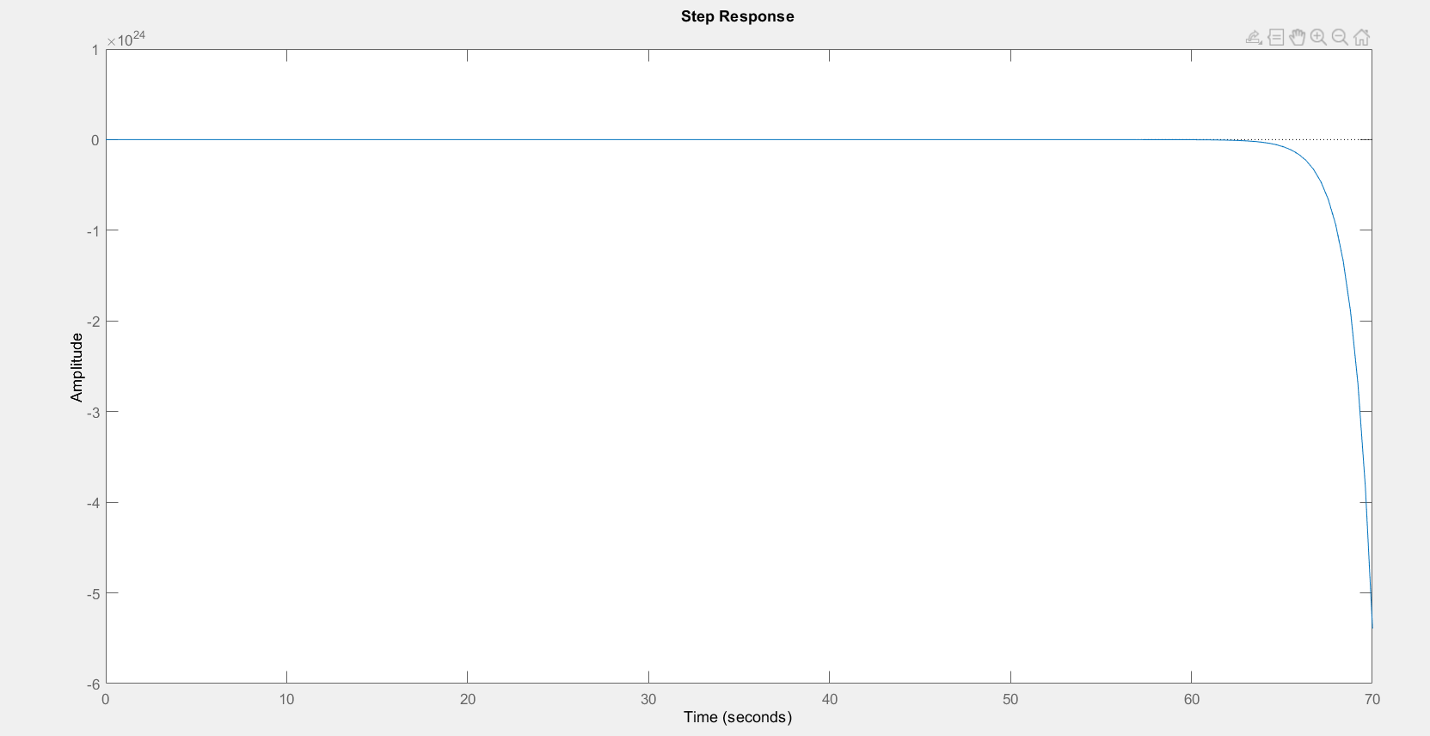

*Figure 3.3: Step response of the system.*