# Question 3 c) updated

For all simulations, the variance of disturbance was set as 0.1

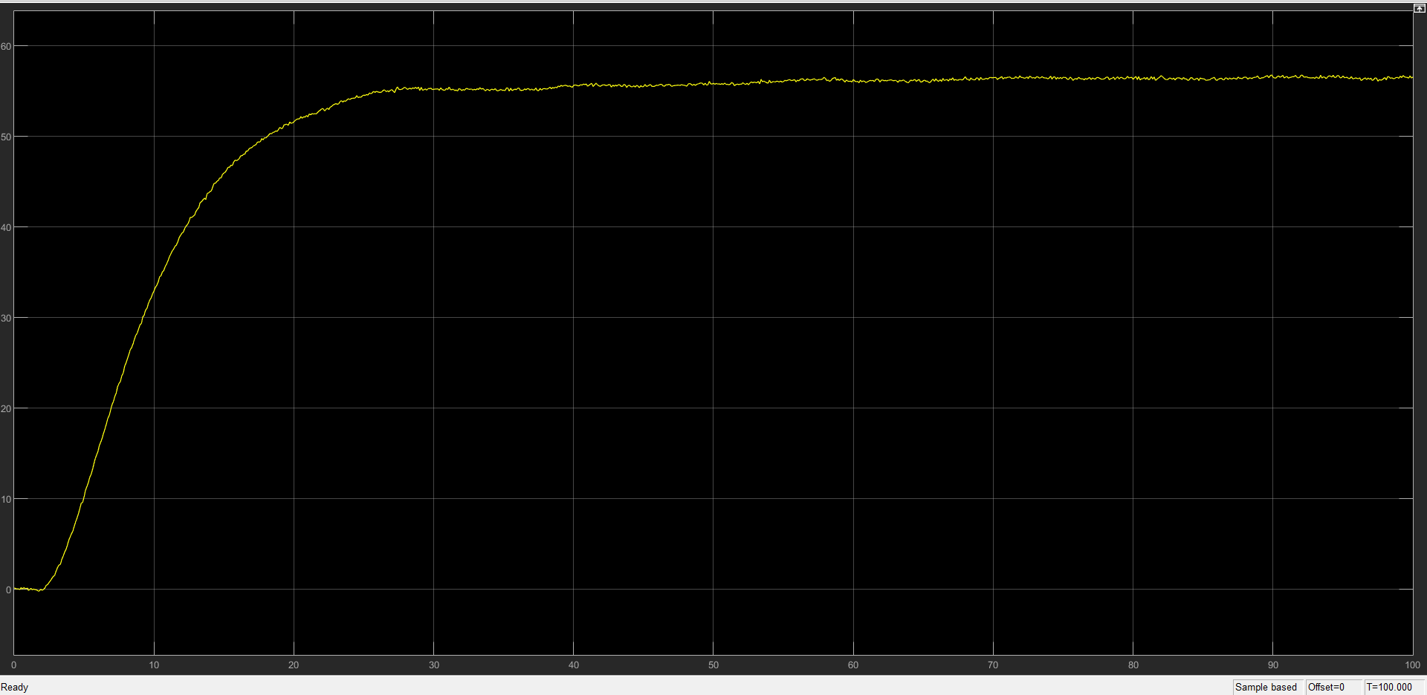

*Figure: Plot of step response of the closed loop system for Kc = 0.7636 (part-a)*

We see that GC1 has an offset of about 55.

For controller design using Pade’s second order approximation, we use the rltool on L to get -0.2 as real part of the dominant pole as shown in the below figure

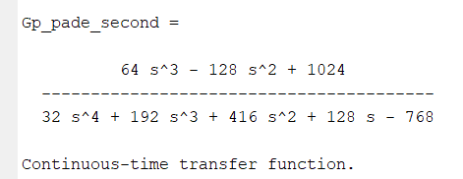

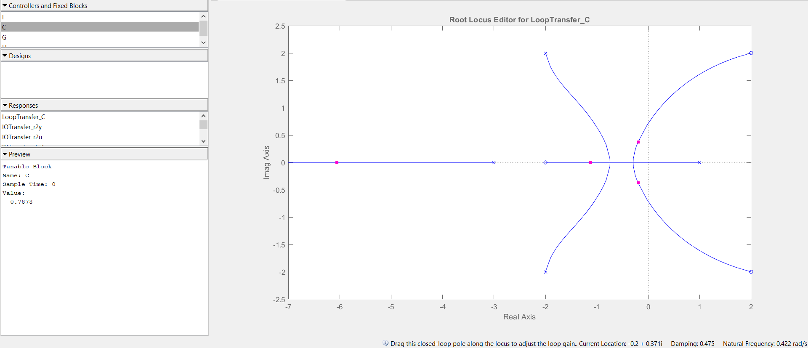

*Figure: RL plot with the required roots marked. (along with the KC value)*

KC = 0.7878

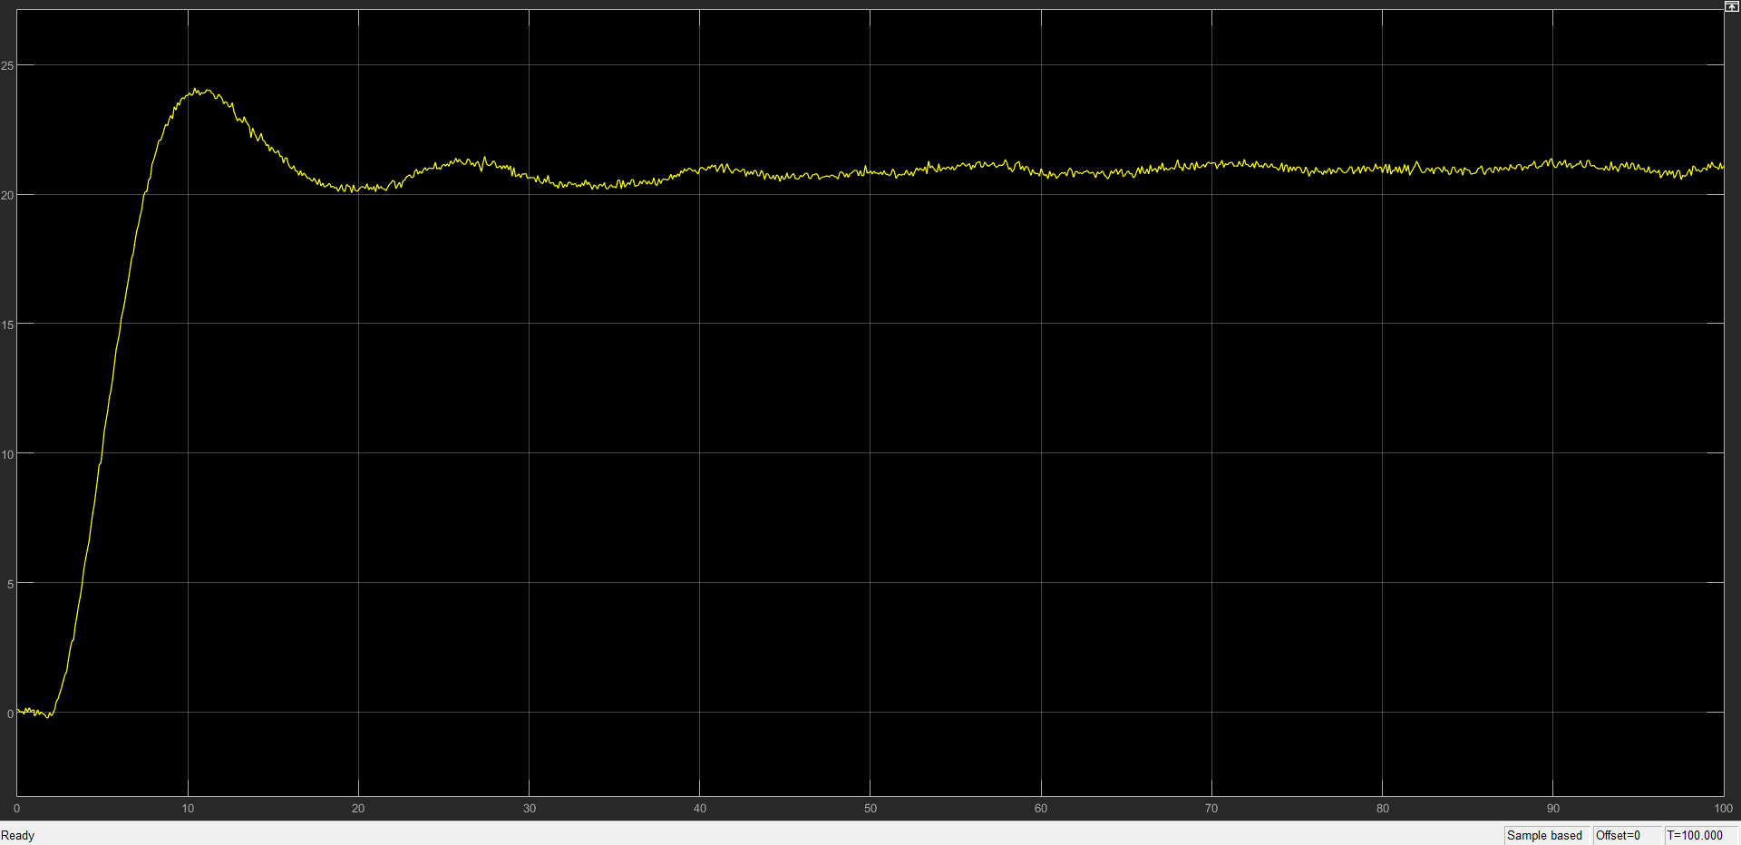

*Figure: step response of the closed loop system with KC = 0.7878*

**Conclusion:** Closed loop system with controller from part b) is unstable as shown earlier. We see that the offset with controller from part a) (~55) is much greater than controller from part c) (~21). So we conclude that controller proposed by utilizing Pade’s second order approximation has proven to be more effective in dealing with the actual system.

Code:

clear; close all;

%% Setup the system

s = tf('s');

Gp = 2*(s+2)/(s^2+2*s-3)*exp(-s);

%% 3a

Gp_pade = 2*(2-s)/(s^2+2*s-3);

f = @(s)(2*(2-s)/(s^2+2*s-3));

Kc_a = -1/(f(-0.2));

poles_parta = pole(1/(1+Kc_a*Gp_pade))

%% 3c

Gp_pade_second = 2*(s+2)*(1-s/2+s^2/8)/((s^2+2*s-3)*((1+s/2+s^2/8)));

rltool(Gp_pade_second)

%0.7878