# Q1 b) plot

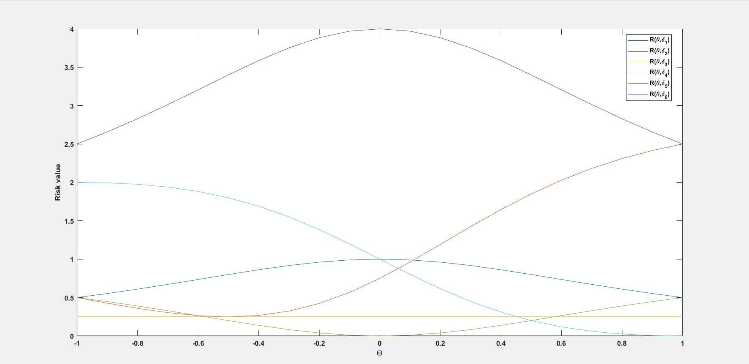

# Q1 e) plot

N set as 10000.

All risk values scaled by n

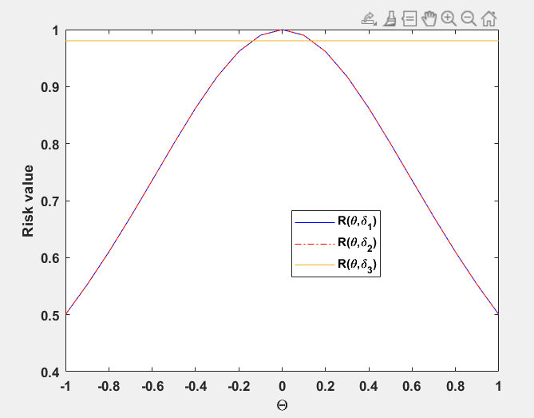

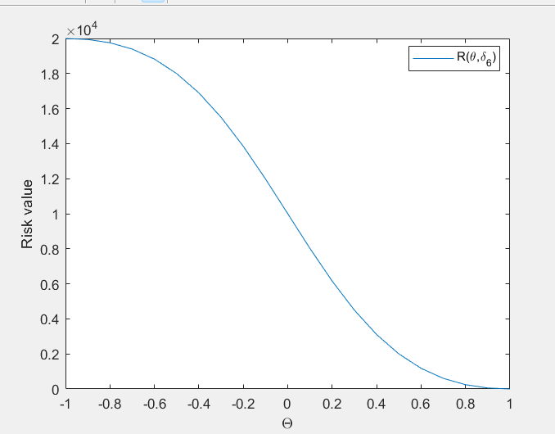

Plotted separately because of high risk value

# Q2 b) plot

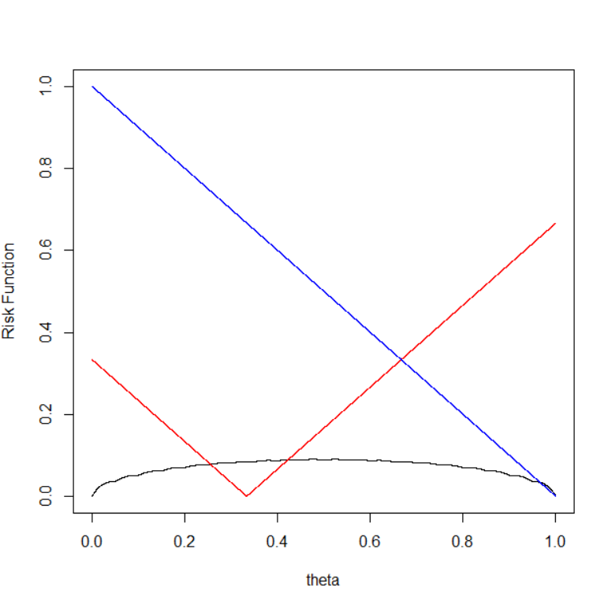

Legend:

* Black – Procedure-1 (d = X/n)
* Red – Procedure-2 (d = 1/3)
* Blue – Procedure-3 (d = 1)

# Q2 d) plot

