PoTSurveyAnalysis

Mark Walter

3/3/2021

# Introduction

This document currently has 2 parts.

* Year of hire by quarter and then by current rank.
* Distribution of Actual, Preferred and Expected Workload by Activity

## Hire Year Data

## Warning: position_stack requires non-overlapping x intervals

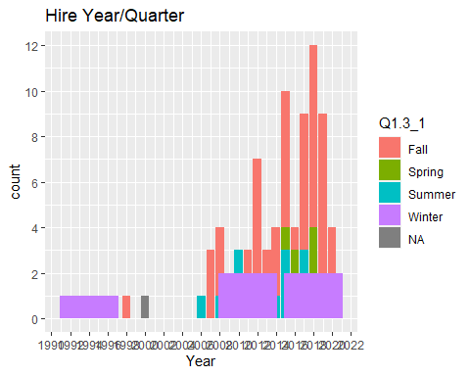

## Warning: Removed 3 rows containing non-finite values (stat_count).

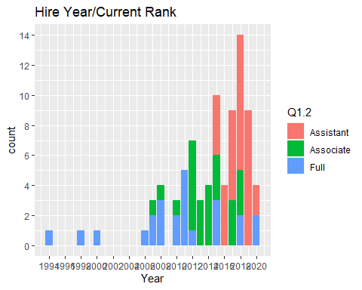

## Workload Distribution Data

… # Plots …

p <- ShowWorkMeans("1==1")  
p + scale_fill_brewer(palette="Greens") +  
 labs(title="All PoT (Count = 83)",  
 subtitle="Workload Distribution: Expected, Desired, Actual")

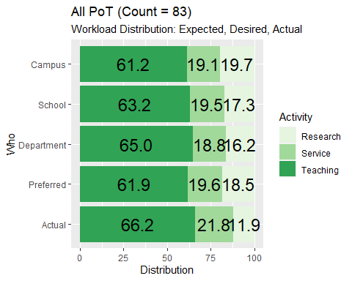

p <- ShowWorkMeans('Q1.3_2>="2015"') # greater than 2015  
p + scale_fill_brewer(palette="Blues") +  
 labs(title="PoT Hired 2015 and Later (Count = 50)",  
 subtitle="Workload Distribution: Expected, Desired, Actual")

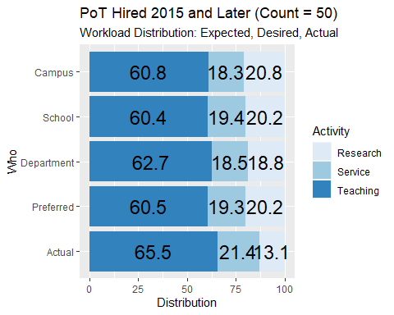

p <- ShowWorkMeans('Q1.3_2<"2015"') # Less than 2015   
p + scale_fill_brewer(palette="Reds") +  
 labs(title="PoT Hired Before 2015 (Count = 33)",  
 subtitle="Workload Distribution: Expected, Desired, Actual")

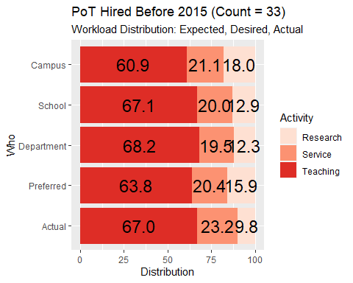

p <- ShowWorkMeans('Q1.2=="Assistant"') # Assistant PoTs  
p + scale_fill_brewer(palette="Oranges") +  
 labs(title="Assistant PoTs (Count = 34)",  
 subtitle="Workload Distribution: Expected, Desired, Actual")

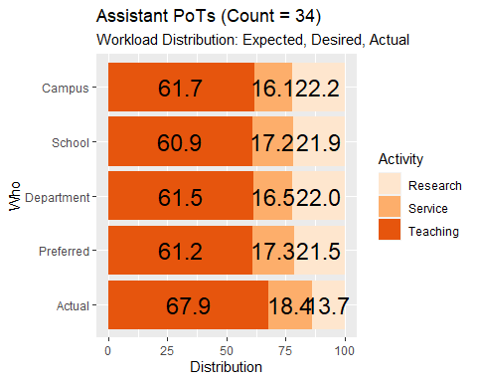

p <- ShowWorkMeans('Q1.2=="Full"|Q1.2=="Associate"') # Full and Associate PoTs  
p + scale_fill_brewer(palette="Purples") +  
 labs(title="Associate and Full PoTs (Count = 52)",  
 subtitle="Workload Distribution: Expected, Desired, Actual")

