**Assignment 02 – Maxpooling** Chandira R.M.

Module maxpool is designed to output the maximum element of every 2×2 window, where data flow is handled by AXI stream.

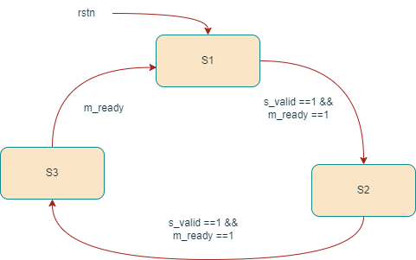

Fig 3. Maxpool state diagram

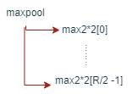

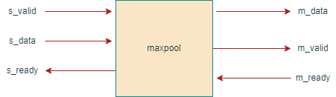

Fig 2. Module maxpool

Fig 1.Module hierarchy

Module hierarchy

The hierarchy depends on the parameter R representing the number of rows in the input matrix. Top module is maxpool while R/2 max2×2s are under it as in figure 1. Maxpool act as the control module and max2×2 modules as computational modules.

Module design

Max2×2 module is designed to compare 4 values which will be provided to it in two instances as a pair in each time, resembling a 2 by 2 matrix. Maxpool module is designed to handle the AXI stream of input and output data and to provide and receive data from the max2×2 modules as in figure 2.

State machine

Maxpool module consist of three states, namely S1, S2 and S3 and state transition happens according to control signals s_valid and m_ready as shown in figure 3. In states S1 and S2 the module accepts two sets of data and feed the adjacent pairs to max2×2 modules. In S3 the module provide output of one fourth the size of total input data containing maximum element of each 2 by 2 window and make m_valid signal high.

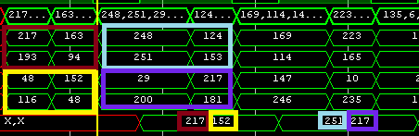

The picture on the left is part of the waveform generated from the testbench. The maximum element in first 2 by 2 window (red box) is 217 which is the first value of output data (row 6). Each window of input and respective output is marked with same colour box.

Max2×2 module is also driven by the S1, S2 and S3 states of maxpool module. In S1 state max2×2 module accepts a pair of data and set the maximum of them to max_1. In S2 state this module accepts another pair of data and set the maximum of them to max_2. In the S3 state the module compare between max_1 and max_2 and assign the largest to comp_out and returns the data to maxpool module. In this example waveform two max2×2 modules are used as input contains 4 rows.