**Assignment 3 - ASIC Flow Report**

Submission – Chandira R.M.

1. The synthesized RTL design schematic visualized in Design Vision of DC

1. Information from reports

Ports and cells

Number of ports: 4

Number of nets: 1068

Number of cells: 923

Number of combinational cells: 612

Number of sequential cells: 310

Number of macros/black boxes: 0

Number of buf/inv: 119

Number of references: 51

Area (Units µm2)

Combinational area: 1728.941639

Buf/Inv area: 394.177350

Noncombinational area: 2163.527918

Macro/Black Box area: 0.000000

Net Interconnect area: 923.917724

Total cell area: 3892.469557

Total area: 4816.387281

Power

Global Operating Voltage = 0.7

Power-specific unit information :

Voltage Units = 1V

Capacitance Units = 1.000000ff

Time Units = 1ns

Dynamic Power Units = 1uW (derived from V,C,T units)

Leakage Power Units = 1pW

Timing

data required time 0.364

data arrival time -4.042

----------------------------------------------------------------------------------------------

slack (VIOLATED) -3.678

1. The completed PnR layout visualized inside ICC2

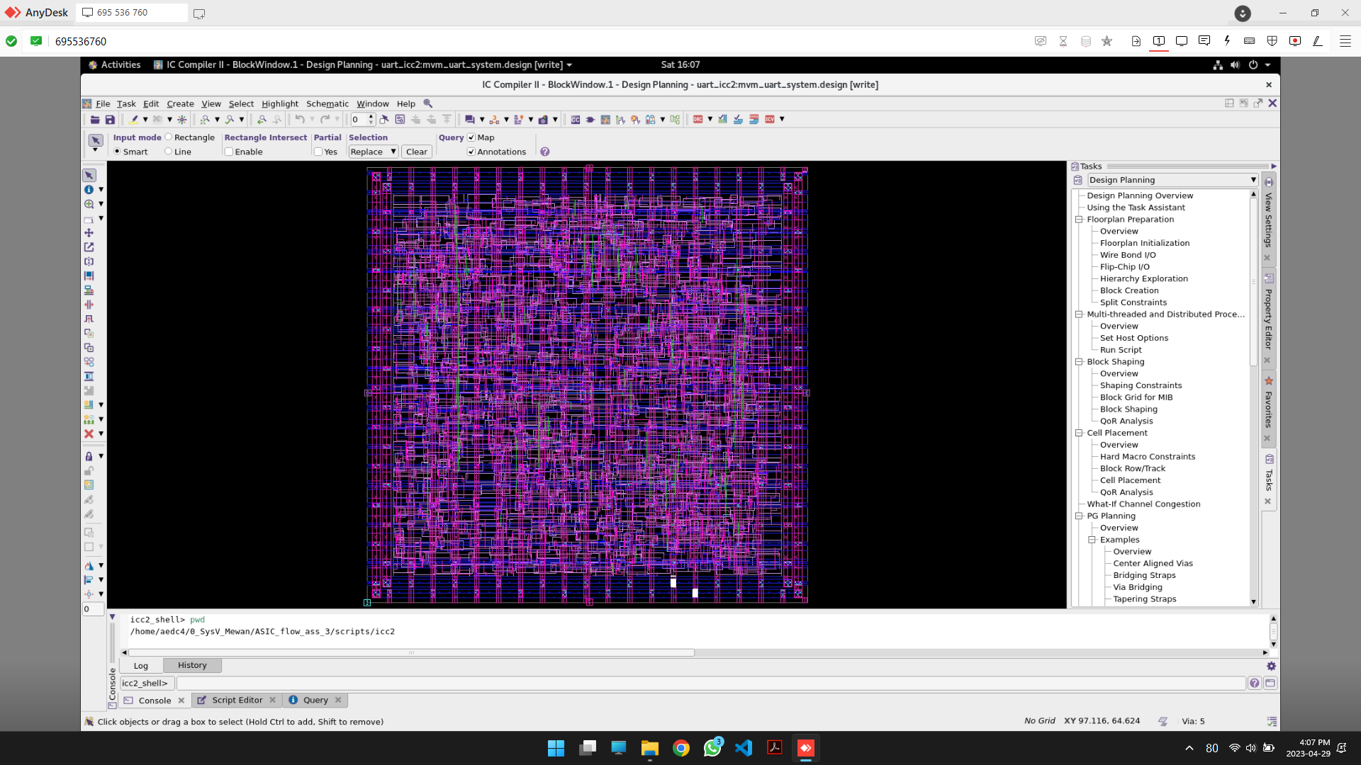

1. The final exported GDSII file visualized using kLayout

