Customer Experience Indicator: Twitter Sentiment Analysis
Capstone Project on Tweets about US Airlines

Background:
In 2021, 192 million daily active users are on Twitter and over 330 million users log onto the site at least once per month. Social Media has become an increasingly popular venue for customers to share their negative (or positive) customer experiences and link this to the company via their corporate social media accounts. The potential for negative publicity if a customer’s tweet goes viral is a real risk for a company’s reputation.
Sentiment Analysis is Natural Language Processing (NLP) technique which derives the attitude of the writer on a particular topic from a written or spoken source. It is becoming a popular tool for companies to better understand the real-time feelings of their customers about a topic, product, or experience from social media posts. Using this mined information allows for service recovery efforts as well as opportunities for improvement and targeted marketing for customers.

Problem Statement
How accurately can you identify the sentiment of airline customers leveraging the use of NLP to dissect their tweets and developing machine learning models?
If there is a high success rate it will allow for airlines to have a real-time view into customer experience and allow them to continually improve their operations.

Data & Problem Approach:
The data for this project was scraped from Twitter in February of 2015. Individual contributors were then asked to review each tweet and classify it as positive, negative, or neutral. If the tweet was identified as negative, they were asked to categorize into a negative reason code. The dataset contains about 14.5K individual tweets referencing 6 major US airlines.

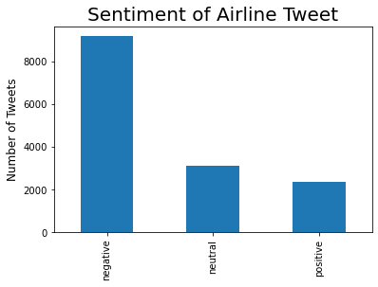 | 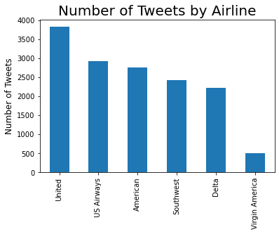

The methodology for this project will be to first start with analyzing the text data of the tweets. For this the python Natural Language Toolkit (NLTK) will be used. This toolkit allows you to quickly analyze text and identify commonalities and patterns in the data. The output will then be combined back to the original dataset to fit various machine learning models and attempt to predict the sentiment for each tweet.

