Yes — here’s a clean package you can use directly.

1) BRD / Project Document Content

Project Title
Smart Customer Segmentation Platform for Patient Prioritization

Business Requirement
Healthcare teams need a simple tool to classify patients into Critical, Moderate, and Stable groups based on health condition and treatment urgency. This will help operations managers allocate beds, ICU support, doctor attention, and follow-up care more effectively.

Problem Statement
Today, patient handling may depend too much on manual review. That can slow down prioritization, resource allocation, and treatment planning. A simple triage-based module is needed so staff can quickly identify high-risk patients and manage care efficiently.

Objective
Develop a basic software module that:
- categorizes patients into Critical, Moderate, and Stable
- uses simple rule-based triage logic
- supports daily patient monitoring
- helps healthcare teams plan resources and treatment actions

Scope
The module will:
- capture patient details
- evaluate triage-related attributes
- assign a patient priority group
- show patient category summaries
- support monitoring over multiple days
- help with discharge and resource planning

Out of Scope
- advanced AI/ML prediction
- direct medical diagnosis
- integration with external hospital systems
- real-time device monitoring

Stakeholders
- Healthcare Operations Manager
- Doctors
- Nurses
- Hospital Admin Team
- Bed / ICU Allocation Team
- IT Support Team

Functional Requirements
- System should allow patient data entry.
- System should store daily patient records.
- System should classify patients into Critical, Moderate, or Stable.
- System should display patient category in the dashboard.
- System should allow filtering by region, branch, and doctor.
- System should show pending lab, bed need, ICU need, and discharge priority.
- System should provide summary reports by patient category.
- System should track daily movement of patient condition.

Non-Functional Requirements
- simple and easy-to-use UI
- fast response for classification
- secure patient data handling
- scalable for more patients and branches
- downloadable reports in CSV/Excel

Business Rules
- Critical: ICU required or very high severity/urgency/risk
- Moderate: medium severity and regular observation needed
- Stable: low-risk routine care cases

Sample Classification Rules
- If ICU_Required = Yes, classify as Critical
- Else if Severity_Score >= 8, classify as Critical
- Else if Treatment_Urgency >= 8 and Vital_Risk_Score >= 7, classify as Critical
- Else if Severity_Score between 5 and 7, classify as Moderate
- Else classify as Stable

Expected Benefits
- faster patient prioritization
- better resource allocation
- better visibility of high-risk patients
- improved discharge planning
- simplified decision-making for operations teams

2) PPT Content

Slide 1 – Title
Smart Customer Segmentation Platform
Patient Prioritization for Better Healthcare Operations

Slide 2 – Business Need
- Manual patient prioritization is slow
- High-risk patients need faster identification
- Resource allocation must be more efficient
- Need a simple triage-based categorization tool

Slide 3 – Objective
- Categorize patients into:
  - Critical
  - Moderate
  - Stable
- Support treatment planning and resource usage
- Monitor patient movement daily

Slide 4 – Patient Categories
Critical
- immediate attention
- ICU / emergency / high risk
Moderate
- regular treatment
- observation required
Stable
- routine care
- minimal oversight

Slide 5 – Segmentation Logic
Critical
- ICU required
- very high severity
- high urgency + high risk
Moderate
- medium severity
- scheduled treatment
- observation needed
Stable
- low severity
- low urgency
- routine check-up cases

Slide 6 – Key Input Fields
- Patient ID
- Age / Gender
- Condition
- Severity Score
- Treatment Urgency
- Vital Risk Score
- Comorbidity Count
- Follow-up Required
- Bed Required
- ICU Required
- Discharge Priority
- Region / Hospital Branch

Slide 7 – Key Features
- patient registration
- triage-based grouping
- dashboard summary
- daily monitoring
- branch-wise tracking
- discharge planning
- report generation

Slide 8 – Sample Workflow
- Enter patient details
- Apply triage logic
- Assign patient category
- Show dashboard summary
- Monitor status daily
- Support treatment and resource planning

Slide 9 – Expected Outputs
- patient priority group
- critical patient alerts
- daily trend monitoring
- branch summary
- ICU / bed requirement summary
- discharge planning view

Slide 10 – Benefits
- improved patient care
- quicker prioritization
- better hospital operations
- easier resource planning
- simple and practical implementation

3) Module Design

Module Name
Patient Prioritization Module

Main Components

A. Patient Data Entry Module
Captures:
- demographic data
- condition details
- urgency and severity inputs
- care-related flags

B. Classification Engine
Applies business rules and assigns:
- Critical
- Moderate
- Stable

C. Monitoring Module
Tracks patient status by day:
- condition changes
- appointment status
- pending lab tests
- bed / ICU needs

D. Dashboard Module
Shows:
- counts by category
- branch-wise patient distribution
- high-risk patient list
- discharge priority list

E. Reporting Module
Generates:
- daily patient summary
- category summary
- ICU requirement summary
- branch-based reports

4) Simple Data Flow
Input
Patient details + health status + treatment urgency
Processing
Rule-based triage classification
Output
Priority group + monitoring dashboard + reports

5) Simple Technical Logic
Input patient record
|
Validate required fields
|
Check ICU_Required
|-- Yes --> Critical
|
Check Severity_Score
|-- >= 8 --> Critical
|
Check Treatment_Urgency and Vital_Risk_Score
|-- high --> Critical
|
Check Severity_Score 5 to 7
|-- Yes --> Moderate
|
Else --> Stable

6) Suggested Database Tables

Table: Patients
- Patient_ID
- Age
- Gender
- Region
- Hospital_Branch
- Primary_Condition
- Doctor_Assigned
- Insurance_Type

Table: Patient_Daily_Status
- Patient_ID
- Record_Date
- Severity_Score
- Treatment_Urgency
- Vital_Risk_Score
- Comorbidity_Count
- Recent_Admissions_Last_6M
- Medication_Adherence
- Last_Visit_Days_Ago
- Follow_Up_Required
- Readmission_Risk
- Appointment_Status
- Lab_Test_Pending
- Bed_Required
- ICU_Required
- Discharge_Priority
- Priority_Group

7) Example User Story
As a healthcare operations manager, I want a simple patient prioritization tool that classifies patients into Critical, Moderate, and Stable groups, so that I can allocate resources effectively and improve patient care.

8) Example Use Cases
- identify patients needing ICU
- monitor moderate patients for worsening condition
- separate routine patients for faster discharge
- allocate beds based on priority
- generate daily management reports

9) One-line Summary for Presentation
A simple triage-based healthcare module that classifies patients by priority level to improve care management and resource allocation.
I can also convert this into a formal Word document format or a 10-slide presentation structure with speaker notes.

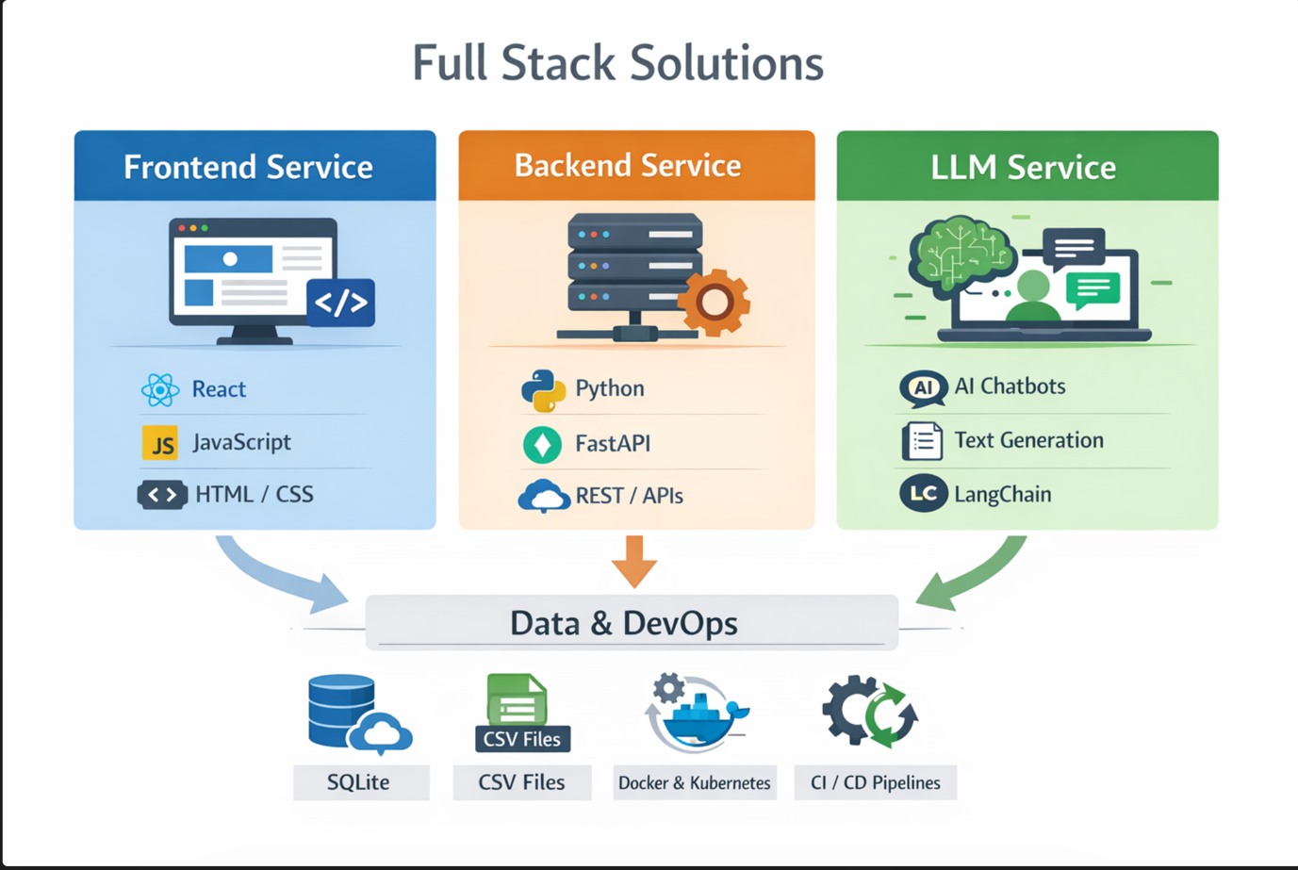

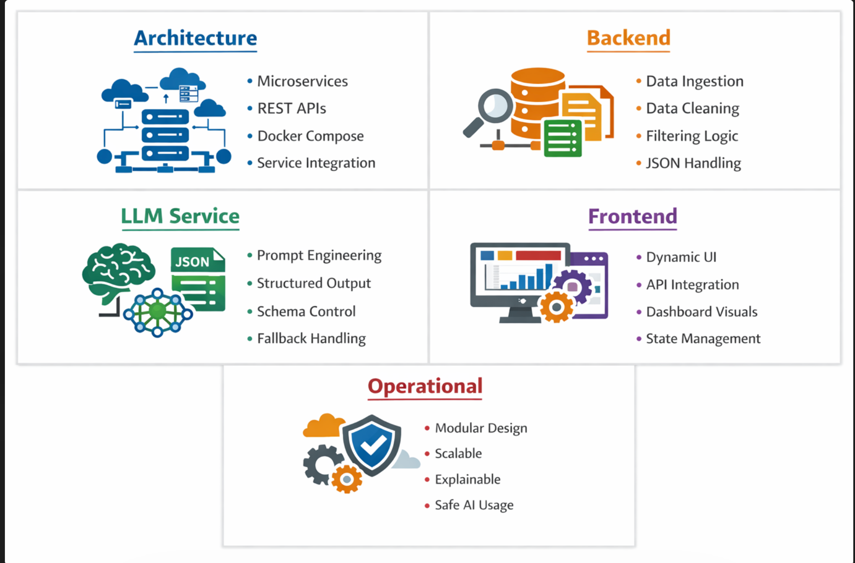

in presentation with minimum point with issue and extend the usecase if we know no restriction or less model
https://jumaai.lovable.app/

