**Ankit Sharma**

Phn no.:- 8439266994

Email id:- [03ankitsharma@gmail.com](mailto:03ankitsharma@gmail.com)

**Career Objective**

Seeking an opportunity to work In challenging environment,learn new skills and enhance the same for companies growth and development.

**Academic Qualification**

* 10th from St.Poul High School ,Agra
* 12th from Vijay Memorial Public School,Agra
* BCA from Bhim Rao Ambedkar University
* MCA from A.P.J.Abdul Kalam Technical University(AKTU)(pursuing)

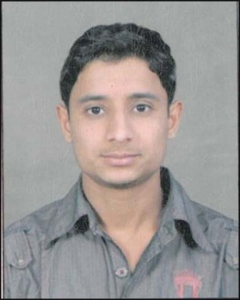

**Summer internship**

1. Project:- youth for nation and website designing

Role:- developer

Institute:- Bhartiya Computer Sansthan & c cet ,agra

2. Project:- Online courier services in asp.net.

Role:- developer

**Experience**

* An year experience as a trainee in computer center
* 5 months experience in "yes me online".
* 6 Month Summer Internship in Hotel Orient Taj in IT Department

**Industrial visit**

Industry name:- NANOTECH (year :-2013)

**Workshops**

* Attended two days workshop on “object oriented programming using java”
* Cyber security
* Attended workshop on “cyber cure & forensic”

**Computer skills**

* Microsoft office
* php
* .net

**Personal details**

Name:- Ankit Sharma

Father's name:- Raj Narayan Sharma

Address:- 18/320 ,maithan ,near gurudwara ,agra

Languages known :- Hindi,English

**Declaration**

I hereby confirm that all my above details are correct to my knowledge.

Date:- 22 March 2017

Place: - The GateWay Hotel , Agra Ankit Sharma