


MASTER THESIS
Thesis Title
Name

for obtaining the academic degree “Master of Science”
in the Course Materials Science and Engineering

Universität Augsburg
Faculty of Mathematics, Natural Sciences and Materials Engineering MNTF
Institute of Materials Resource Management MRM
Chair of Materials Engineering, Complex Structured Materials, Data Driven Product Engineering and Design

First Examiner: ______________________
Second Examiner: ______________________
Supervisor: ______________________

Date of submission: [dd.mm.yyyy]

Declaration
I affirm that the master thesis was compiled entirely by myself and using exclusively the sources and materials cited.

______________________

Acknowledgements
This is an opportunity to thank people supporting your thesis, e.g. technicians, supervisors, friends providing mental support, etc.

Abstract
Short abstract of the research work in German and English
An abstract is a condensation of the content into one paragraph, at most one page. The abstract should stand on its own and present the motivation, methods, goals, and results of the work to someone who does not have time to read the entire work. It must enable a reader to decide whether he should read this work. The abstract is of great importance and should be formulated very consciously, because crucial key points of the work must become clear.
Context: First, the reader should get on board. For this purpose, one or two sentences are used to introduce the subject.
State of research: At this point, the current state of research is summarized very briefly. In particular, shortcomings of previous results should be addressed in order to work towards one’s own research question.
Research gap: Here the own research question is worked out. What is missing so far or which aspects need to be examined more closely?
Own approach: This section describes the methods used - what is one’s approach to solving the research question?
Results: What came out of the work and which conclusions may be drawn?
You may also summarize your work in a graphical abstract and use it as the title image
of this thesis.

Graphical Abstract
You may summarize your work in a graphical abstract. Here is some more info on
graphical abstracts: www.elsevier.com/authors/tools-and-resources/visual-abstract

Table of Contents
List of Abbreviations VI
Symbols VI
1 Introduction 1
2 State of the Art, Literature Review, Background, Research gap, Objectives 1
2.1 … 1
3 Methodology, Modeling, Experimental Methods, Experimental Procedure, Processing 1
3.1 … 1
4 Results and Discussion 1
4.1 … 2
5 Conclusion and Outlook 2
6 References 2
List of Figures 2
List of Tables 2
7 Example Chapter 3

List of Abbreviations
CMC | Ceramic Matrix Composites

Symbols
C | Stiffness tensor / GPa

Introduction
This chapter should start with the motivation outlining the necessity and novelty of the scientific endeavor. The goal of the introduction is the elaboration of the research question from which the objective of the thesis is derived. The specific aspects which are examined are to be illustrated in a brief and concise manner. This chapter, as well as the abstract, can be finalized towards the end of the thesis in order to ensure the coherence with the last chapter (conclusion).

State of the Art, Literature Review, Background, Research gap, Objectives
This chapter is supposed to prepare the reader for the following chapters. It includes the analysis of relevant scientific work on the given topic (state of the art) as well as the elaboration of the fundamental knowledge necessary for the presentation of one’s own work. While writing assume that the reader has a professional background without a deep knowledge within the specific field of research. The gap within current research activities should be contextualized and should lead to the justification of your thesis work.

…

Methodology, Modeling, Experimental Methods, Experimental Procedure, Processing
This chapter should describe the applied methods or the newly developed methods to obtain research results. There is a difference between an experimental thesis and a modeling thesis in this chapter. The first one will have a rather descriptive character, while the second one will include more own developments in this chapter.

…

Results and Discussion
In this chapter you should compile the results of your work into graph sand tables showing the relationships within the investigated parameters.
In the discussion you should critically interpret and crosslink your results taking into account the current state of the art. You also should comment on the reliability of your results.

…

Conclusion and Outlook
This is a short chapter summarizing the key findings of your work. In addition, it should provide an outlook on further steps in the research field.
This chapter should show a link to the issues and gap highlighted in the introduction. Introduction and conclusion form a key part of a good thesis to motivate reading your work.

References
1. Savage G. Oxidation and oxidation protection. In: Carbon-Carbon Composites: Springer, Dordrecht; 1993. p. 193–225. doi:10.1007/978-94-011-1586-5_6.

List of Figures
Fig. 1 Picture of nanoCT machine (left) and Schematic illustration of the set-up (right) 1

List of Tables
Table 1 Description of signals generated in scanning electron microscopy 2

Example Chapter
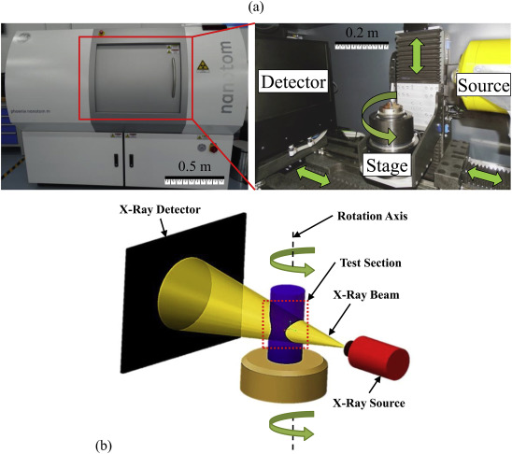
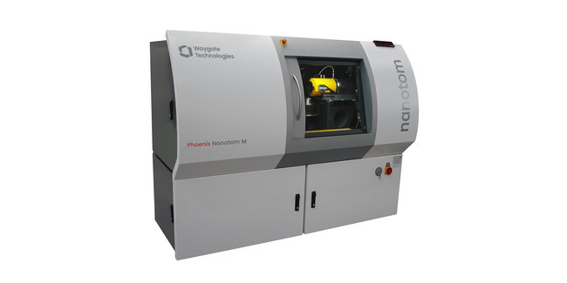
Example of Figure with caption (Cross-reference Fig. 1)
Fig. 1 Picture of nanoCT machine (left) and Schematic illustration of the set-up (right)
(a)
(b)

Table 1 Description of signals generated in scanning electron microscopy
Signal generated | Cause | Generation depth | Information recorded
Secondary Electrons (SE) | Inelastically scattered electrons from the surface | Up to 100 nm | Surface topology. Independent of material composition.
Back scattered electrons (BSE) | Elastically scattered electrons from the surface | Up to 2-3 µm | Contrast depends on Atomic number
Characteristic X-rays | Outer shell electron replacing an inner shell displaced electron | Deeper than BSE | Elemental composition and mapping

Expected length of thesis works:
Lab project: 20 to 30 pages
bachelor thesis : 30 to 50 pages
master thesis: 50 to 80 pages

Further hints will be found in Latex-template in the git-hub:
mateng-m / thesis_template · GitLab (uni-augsburg.de)
README.md
(thesis.pdf)

