a new title

Carrie

11/3/2017

## R Markdown

#install the package  
install.packages("raster",repos = "http://cran.us.r-project.org")

##   
## The downloaded binary packages are in  
## /var/folders/8k/xg4c9h8x0cn3wpk8d1q2q90r0000gn/T//RtmpMdinOu/downloaded_packages

#load the package  
library(raster)

## Loading required package: sp

#get country borders  
germany<-getData("GADM",country="DEU",level=2)  
#plot germany boundaries  
plot(germany)

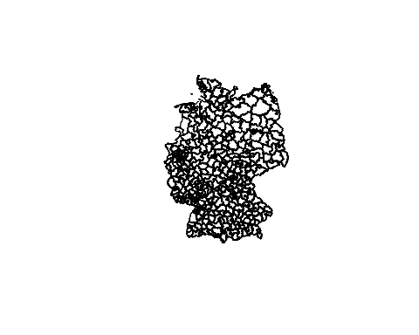

#get precipitation data  
prec<-getData("worldclim",var="prec",res=5,lon=10,lat=51)  
#plot precipitation  
plot(prec)

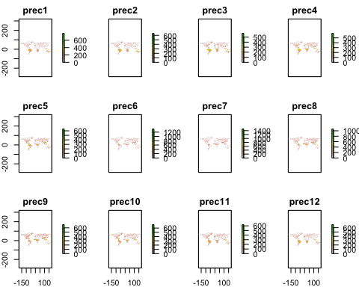

#crop precipitation to extent of germany  
prec.ger1<-crop(prec,germany)  
#plot result  
spplot(prec.ger1)

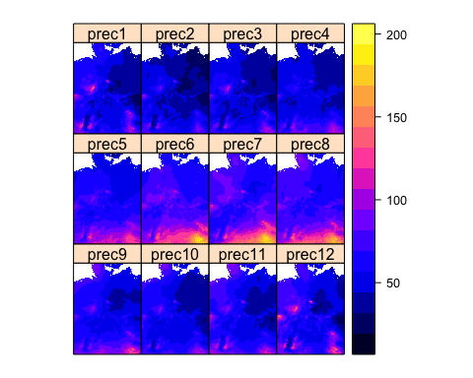

#mask precipitation to shape of germany  
prec.ger2<-mask(prec.ger1,germany)  
#plot result  
spplot(prec.ger2)

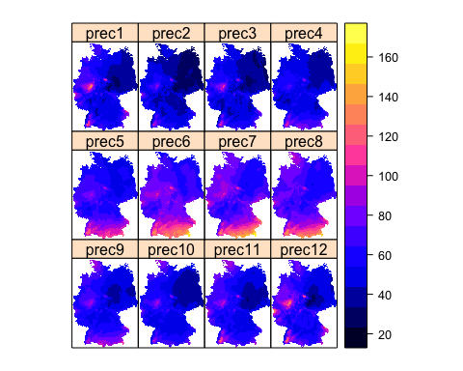

prec.ger2<-mask(prec.ger1,germany,inverse=TRUE)

This is an R Markdown document. Markdown is a simple formatting syntax for authoring HTML, PDF, and MS Word documents. For more details on using R Markdown see <http://rmarkdown.rstudio.com>.

When you click the **Knit** button a document will be generated that includes both content as well as the output of any embedded R code chunks within the document. You can embed an R code chunk like this:

summary(cars)

## speed dist   
## Min. : 4.0 Min. : 2.00   
## 1st Qu.:12.0 1st Qu.: 26.00   
## Median :15.0 Median : 36.00   
## Mean :15.4 Mean : 42.98   
## 3rd Qu.:19.0 3rd Qu.: 56.00   
## Max. :25.0 Max. :120.00

## Including Plots

You can also embed plots, for example:

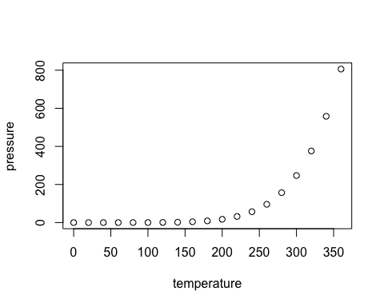

Note that the echo = FALSE parameter was added to the code chunk to prevent printing of the R code that generated the plot.