Estimating the Temperature of Absolute Zero

By Paige Meyer for 20th Century Physics

## Statement of Problem

When molecules are heated, the average speed and kinetic energy for the molecules also increase. This added speed and energy increases the average times a molecule bounces into other things, such as other molecules or sides of the container. These added collisions increase the pressure of the molecules.

This lab solved the temperature (in Celsius) of absolute zero with uncertainty.

Pressure of a fixed volume of gas increases linearly with temperature such that

$$P=aT+b$$

Where P is the pressure, T is the temperature measured in degrees Centigrade, and a and b are the constants. It is known that pressure should be zero when the temperature is -273.15 °C, but this lab will verify that value is not significantly different from the experimental value. The value of a can be easily solved by taking multiple measurements of pressures at various temperatures. The slope should be equivalent to a. Mathematically solving for T when the pressure is zero:

$$P=aT+b$$

$$0=aT+b$$

$$T=\frac{-b}{a}$$

Thus T is equivalent to the constant over the slope.

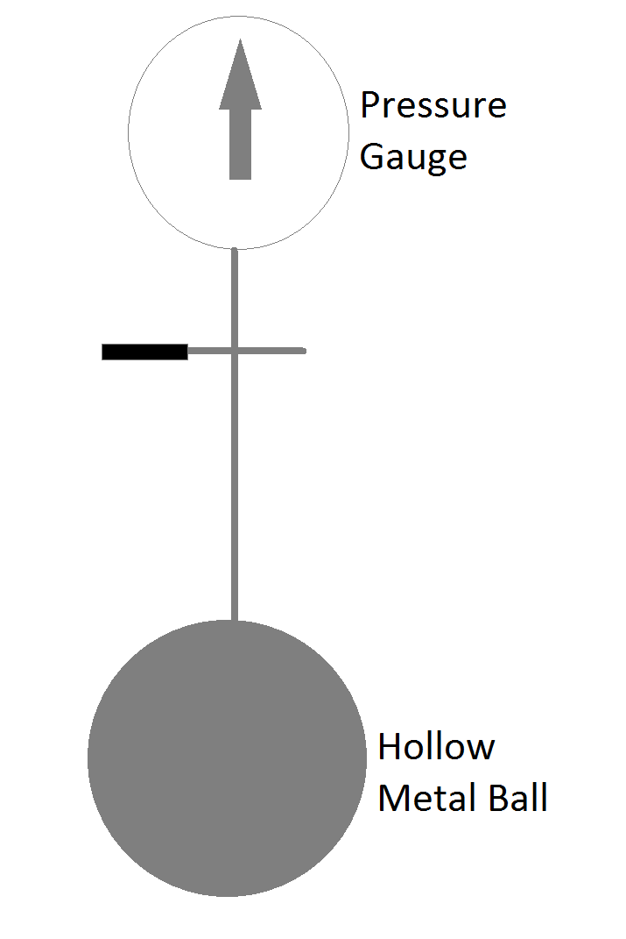

Figure 1 - Constant Volume Gas Cell

## Statement of How to Solve Problem

First solving for the constant is done by using a constant volume gas cell (shown in figure 1) to measure the pressure of liquid nitrogen, dry ice, ice, room temperature water, and boiling water. All of these substances were large quantities, so it is assumed that by inserting the constant volume cell into the reservoirs, the temperature of the substances did not change noticeably.

## Statement of Solution

The results of the temperature including error, and the pressure including error are shown in the table below.

|  |  |  |  |  |
| --- | --- | --- | --- | --- |
| **Substance** | **Temperature (°C)** | **Temperature Error (°C)** | **Pressure (psi)** | **Pressure Error (psi)** |
| **Liquid Nitrogen** | -196 | 5 | 4.5 | 0.5 |
| **Dry Ice** | -78.7 | 0.3 | 10.5 | 0.5 |
| **Ice** | 0 | 1 | 14 | 0.5 |
| **Room Temperature Water** | 27.7 | 0.5 | 15.5 | 0.5 |
| **Boiling Water** | 94 | 0.5 | 18.5 | 0.5 |

The liquid nitrogen measurement may be off because of two things. The temperature may be slightly off because we used the accepted value for the temperature, as we did not have a thermometer which could measure the temperature accurately. One other thing to note is with the constant volume gas cell, it has air as the constant volume. The air is comprised of mainly: nitrogen (78%), oxygen (20.95%), and argon (0.93%) **[1]**. Nitrogen and oxygen at -196°C will liquefy. This phase change is associated with a pressure change. For example, liquids have lower pressure than the gaseous form, as shown in figure 2. This phase change for nitrogen (at -196°C) and oxygen (at -183°C) interfered with an accurate pressure measurement.

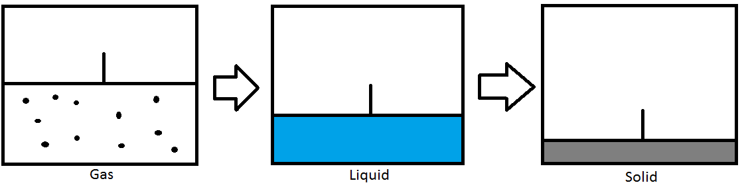

Figure 2 - Pressure Changes in Different Phases Source: goo.gl/8gby22 [2]

Using the four highest data points, LoggerPro fit the slope, a, as being equivalent to 0.04650 [**add in error**]. Then the constant, b = 14.13 [**add in error**]. From the statement of the problem section, we know

$$T=-\frac{b}{a}=-\frac{14.13}{0.0465}≈- 304°C$$

Comparing this to the accepted -273.15°C absolute zero:

$$\left|\frac{-304-(-273.15)}{3}\right|=10$$

In conclusion, the accepted value and the measured value are ______ since they are approximately ___ standard deviations apart.

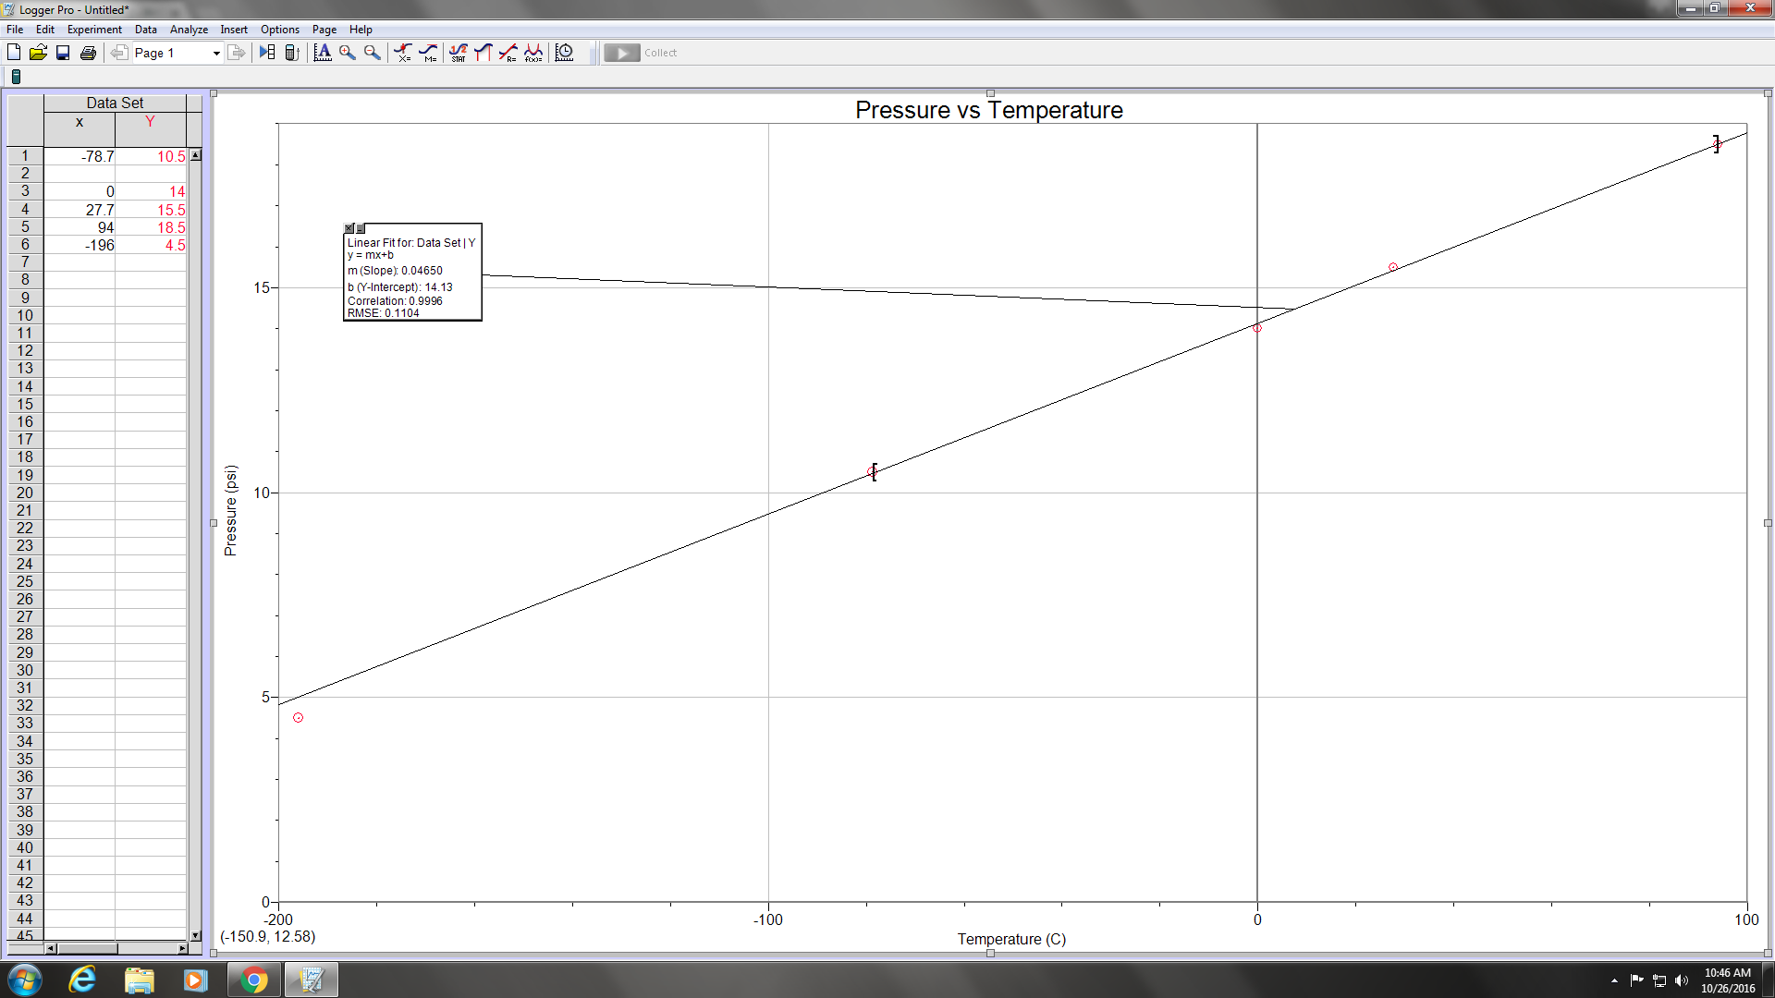

## References

<https://books.google.com/books?hl=en&lr=&id=YNL7NZodOvoC&oi=fnd&pg=PR9&dq=air+composition&ots=5XYRm3Rcac&sig=DexIDCeLkWkgZd9ba0w8D4eRAiM#v=onepage&q=air%20composition&f=false>

<http://chem.libretexts.org/Core/Physical_and_Theoretical_Chemistry/Physical_Properties_of_Matter/States_of_Matter/Phase_Transitions/Fundamentals_of_Phase_Transitions>