**Grading standard**

|  |  |  |
| --- | --- | --- |
| Section | Criteria | Score (of 5) |
| Abstract | * Does the abstract provide a good summary of the experimental question, the method used to solve it, and the results and conclusions of the experiment? |  |
| Introduction | * Provide background for the interesting question you will explore. * Give references (AIP format) to earlier work and places readers may turn to further information. You should have a minimum of 5 references. * Clearly state the interesting question, and use to it to test a claim. |  |
| Experimental methods | * Schematic diagram of the experiment, explicit independent and dependent variables are and how they were measured, etc. * Setup, procedure necessary for replicating experiment |  |
| Results | * This is where you put data tables and graphs. * For graphs, follow all good practices: label axes, put units on axes, etc. * You should usually include x- and y- error bars. * There should be a paragraph to describe the data and what the reader should pay attention to. For example, what combination of variables you used to linearize a graph, or what kind of scales (log-log, etc) you plot the data on. * Present fit parameters and their uncertainties. * Present accepted or theoretical value and its uncertainty. |  |
| Conclusions | * Your goal is to come back to your interesting question and check if the data supports your claim. * Determine the discrepancy between and how many sigma it is. * Interpret the above result. * If there is disagreement, give possible reasons why. If there is agreement, discuss what improvement could give small uncertainty. |  |
| References | * **You need 5 relevant references (website URLs not allowed) in AIP format** |  |
| Quality of writing | * Punctuation correct and appropriate? * Spelling correct? * Paragraphs logically constructed and understandable? * Is writing typically in the 3rd person, passive voice? |  |
| Notebook | * Does project begin with a title page in notebook? * Are dates and times of entries given? * Does notebook show how uncertainty determined? * Does notebook show comparison of measured to accepted values? * Does notebook discuss significance of the discrepancy? |  |

**Intermediate Lab: Electron Diffraction**

**Paige Meyer**

Minnesota State University Moorhead, Department of Physics and Astronomy, Moorhead MN

*An abstract which provides a good summary of the experimental question, the method used to solve it, and the results and conclusions of the experiment.* **Introduction**

In 1925, Louis de Broglie first theorized electrons exhibited wave-like behavior [1]. He came derived the equation $λ=\frac{c}{\left|\vec{p}\right|},$ where $λ$ denotes wavelength, c denotes the speed of light, and $\vec{p}$ denotes momentum from using Einstein’s photoelectric law and Bohr’s theory [2]. The de Broglie equation is only one way to calculate wavelength from the diffraction pattern. Another way is to utilize Bragg’s equation: $2dsinθ=nλ,$ where d is the lattice spacing, $θ$ is the angle of diffraction, and $n$ is an integer. Electron diffraction has experimentally used to measure chemical changes or chemical composition  [3]: the photocycle and associated structural changes in bacteriorhodopsin [4], and the molecular structure of trans-stilbene [5], and the molecular composition of trans-azobenzene  [6].

This experiment experimentally gathers data about the angle of diffraction, diffraction pattern, and from that data extrapolates the value of the wavelength at each voltage. To extrapolate the wavelength, both Bragg’s Equation and the de Broglie equation will be used. This will produce two different wavelengths. Both wavelengths are not dependent on any of the same quantities, so these calculated wavelengths will be compared to see if the wavelengths produced are significantly different.

**Experimental methods**

This experiment utilizes the TelAtomic electron diffraction apparatus, a Pasco Scientific SF-9586 power supply, measuring tape, and the equations described the first paragraph of the introduction. This diffraction apparatus had a graphite polycrystalline (graphite foil)  [7] for the diffraction crystal. When the electrons in the electron beam accelerating towards the graphite foil hit the graphite, the electrons are diffracted at the inner structure of the graphite, shown in figure 1. This diffraction pattern is then displayed on the florescent screen. This entire process happens within a vacuum tube to avoid interference with air molecules.

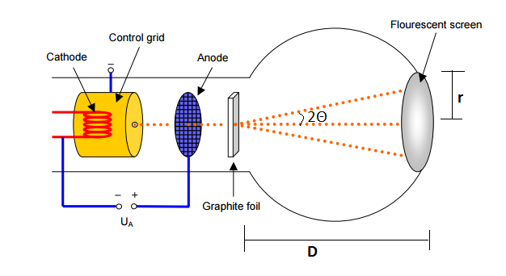

Figure 1 - TelAtomic Electron Diffraction Apparatus [7]

Research into the precision of the lattice parameters measured by double angle diffractrometry concluded for various substances, the index of refraction’s relative error ranges from $3∗{10}^{4}$ to $5∗{10}^{5}$ [8]. Thus, during the experiment, we will approximate the error by the double angle diffractrometry to be zero.

The diffraction is constructive only at integer multiples of the wavelength. At places where n is not an integer multiple, the electrons are destructive.

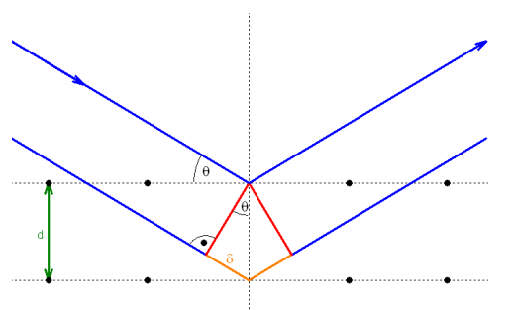

Figure 2 - Graphite Interference [7]

The de Broglie wavelength can be manipulated to get $λ=\frac{h}{p}=\frac{h}{\sqrt{2emU}}$, where h is Planck’s constant, e is the charge of an electron, m is the mass of the electron, and U is the potential energy also referred to a Voltage. Substituting the constants in, the equation is now $λ=\frac{4.14eVs}{\sqrt{2∗1e∗5.1∗{10}^{5}\frac{eV}{c^{2}}∗U}V}=\frac{4.14eVs}{\sqrt{2∗1e∗5.1∗{10}^{5}\frac{eV}{c^{2}}∗U}V}=\frac{0.0040992108}{\sqrt{U}}$

meters.

Your goal is to make clear how the interesting question was explored using enough detail that someone could repeat it to test your claims In general, include:

* Schematic diagram of the experiment, explicit independent and dependent variables are and how they were measured, etc.
* Setup, procedure necessary for replicating experiment

**Results**

The method described in the experimental methods section was implemented, and the following data values were gathered. With both equations, pay attention to the lambda and error calculation. The equations should produce similar wavelengths, but may be slightly different due to errors in measurements.

Using Bragg’s equation

$λ=2dsinθ$

the following lambdas are calculated with error: **[INSERT ERROR FORMULA]**. Although the voltage was not used in calculating the value for lambda in Bragg's equation, it is included in the table for reproducibility. Also note that d in the equation was given by the distance in nanometers from the graphite foil to the fluorescent screen.

|  |  |  |  |  |  |  |
| --- | --- | --- | --- | --- | --- | --- |
| Voltage (kV) | Voltage Error (kV) | Theta (rad) | Error Theta (rad) | Lambda (nm) | Lambda Error | d (nm) |
| 2 | 0.1 | 0.059 | 0.008 | 0.025 | 0.003 | 0.213 |
| 3 | 0.1 | 0.048 | 0.007 | 0.020 | 0.003 |  |
| 4 | 0.1 | 0.041 | 0.007 | 0.017 | 0.003 |  |
| 5 | 0.1 | 0.037 | 0.007 | 0.016 | 0.003 |  |
| 6 | 0.1 | 0.033 | 0.007 | 0.014 | 0.003 |  |

Using the de Broglie equation

$λ=\frac{h}{\sqrt{2emU}}$

the following lambdas are calculated with error: **[INSERT ERROR FORMULA]**. The difference with this table is that the thetas are not included as they are not necessary. **[DELETE EMPTY COLUMNS]**

|  |  |  |  |  |  |
| --- | --- | --- | --- | --- | --- |
| Voltage (kV) | Voltage Error(kV) |  |  | Lambda (m) | Lambda Error |
| 2 | 0.1 |  |  | 0.0275 | 0.0007 |
| 3 | 0.1 |  |  | 0.0224 | 0.0004 |
| 4 | 0.1 |  |  | 0.0194 | 0.0002 |
| 5 | 0.1 |  |  | 0.01736 | 0.00017 |
| 6 | 0.1 |  |  | 0.01585 | 0.00013 |

These calculated wavelengths were plotted with error. This shows the overlap between the de Broglie calcuated wavelength and Bragg calculated wavelength. If you notice the error in the voltage is not included because the data points on both lines corresponding to the same voltage were taken without adjusting the voltage at all. As shown in figure 3, the data points and error overlap the corresponding other line's data point. This shows that these equations produce similar wavelengths for this experimental data.

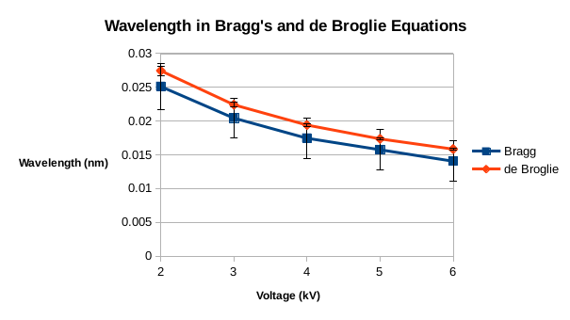

**Conclusions**

The data collected in this experiment does not show significant difference between the Bragg equation calculation and the de Broglie equation calculation. The standard deviations between the two data points is calculated and shown in the table below. Based on this, there is no significant difference between the calculations.

|  |  |  |
| --- | --- | --- |
| **Voltage (kV)** | **Standard Deviations** | **Significant Difference?** |
| **2** | 0.572 | No |
| **3** | 0.590 | No |
| **4** | 0.606 | No |
| **5** | 0.510 | No |
| **6** | 0.577 | No |

This experiment has no reason to refute the claim that the de Broglie equation and Bragg equation calculate different wavelengths. Instead, the data supports the claim that the equations calculate the same wavelengths.

**References**

[1] D. B. Williams and C. B. Carter, in *Transm. Electron Microsc.* (Springer, 1996), pp. 3–17.

[2] L. de Broglie, Philos. Mag. Ser. 6 **47**, 446 (1924).

[3] J. C. Williamson, J. Cao, H. Ihee, H. Frey, and A. H. Zewail, Nature **386**, 159 (1997).

[4] S. Subramaniam, M. Gerstein, D. Oesterhelt, and R. Henderson, EMBO J. **12**, 1 (1993).

[5] M. Traetteberg, E. B. Frantsen, F. C. Mijlhoff, and A. Hoekstra, J. Mol. Struct. **26**, 57 (1975).

[6] M. Traetteberg, I. Hillmo, and K. Hagen, J. Mol. Struct. **39**, 231 (1977).

[7] CERN Teachers Lab, *Electron Diffraction Tube* (n.d.).

[8] M. A. Davidson and S. R. Stock, (1999).