陕西理工大学实验报告
2020 — 2021 学年第一学期
课程名称：ASP.NET程序设计 实验项目名称：C#语言的运用
实验类型:设计
实验学时：2 实验时间：2020年11月9日
实验地点：数计学院网络工程实验室 指导教师：高凯
专业班级：网络1801 学生姓名：李瑞鹏 学号：1818064016

实验中使用的主要仪器设备及软件:
计算机, Microsoft Visual Studio 2012 ，数据库管理系统 SQL server 2012等

实验目的:
构建一个前后端分离的动态网站，前后端通信全部由接口控制，以便完全分离，便于后期团队合作维护与二次开发。

实验原理:
后端利用 Microsoft Visual Studio 2019 软件,使用 C# 语言编程。
前端利用 Hbuilder X 软件，使用W3C规范的前端语言编程。

实验步骤（附设计源代码和截图）：
1.在VS中创建.Net Web项目，勾选API项
2.配置跨域及编写common类
3.连接数据库
4.编写后端接口并调试成功
5.编写前端页面并渲染数据
6.根据需求打包发布
7.数据库的设计以及数据操作

数据库设计与操作部分截图如下：

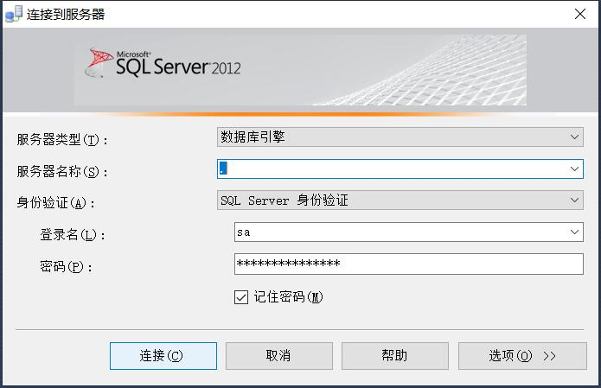
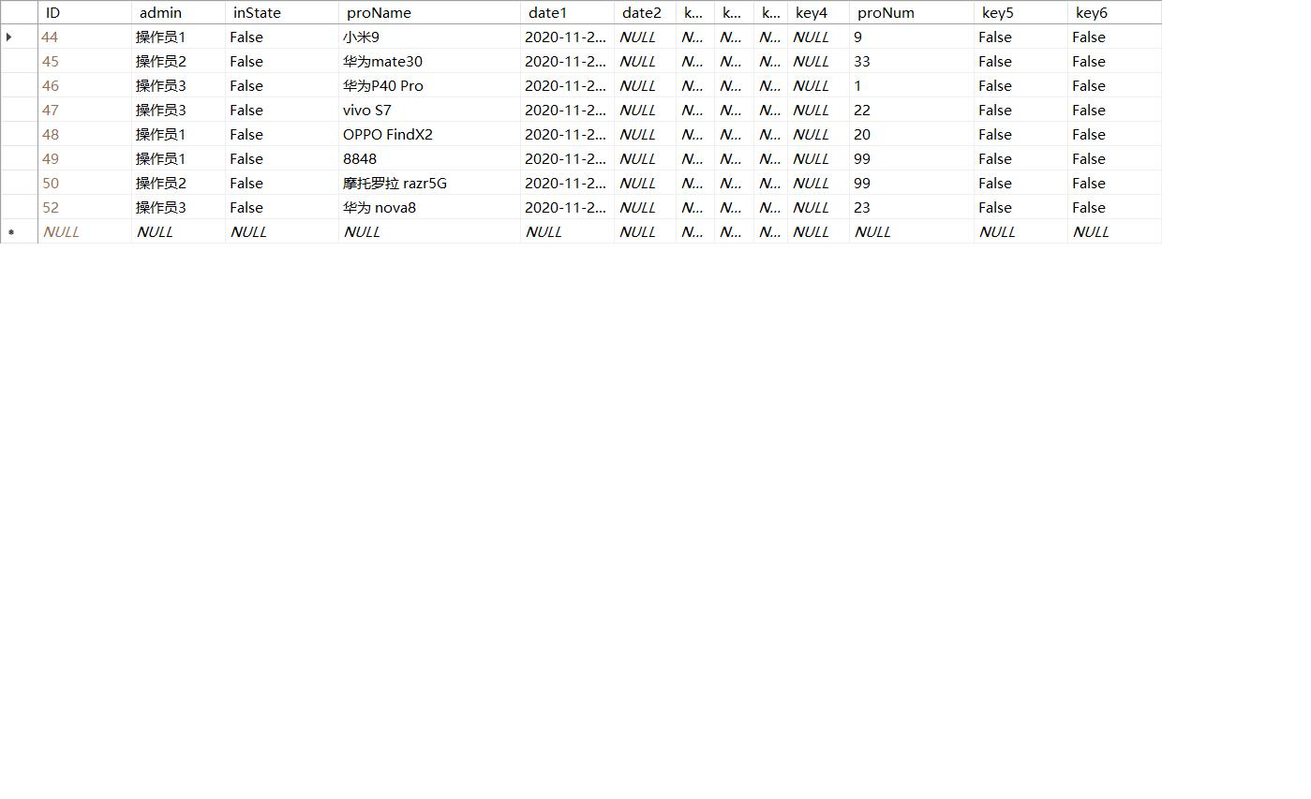

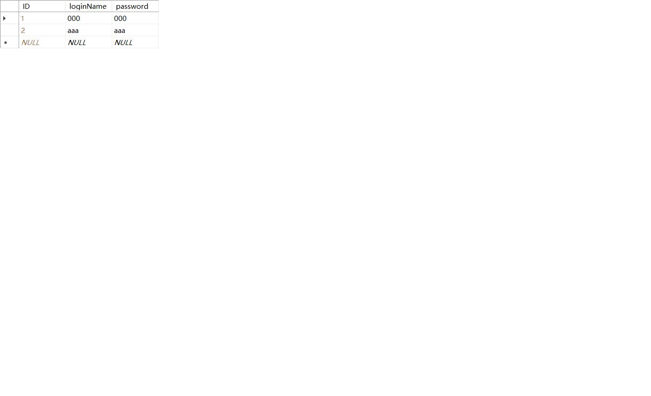
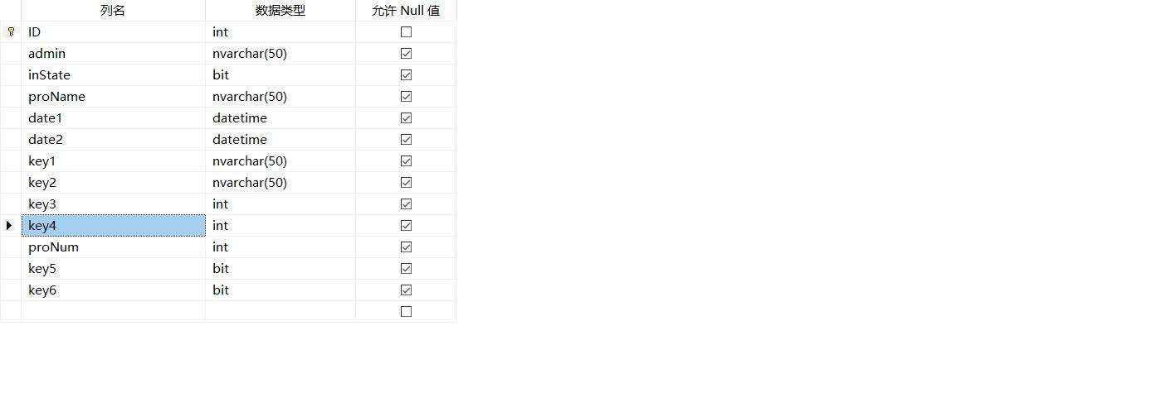页面显示截屏如下：
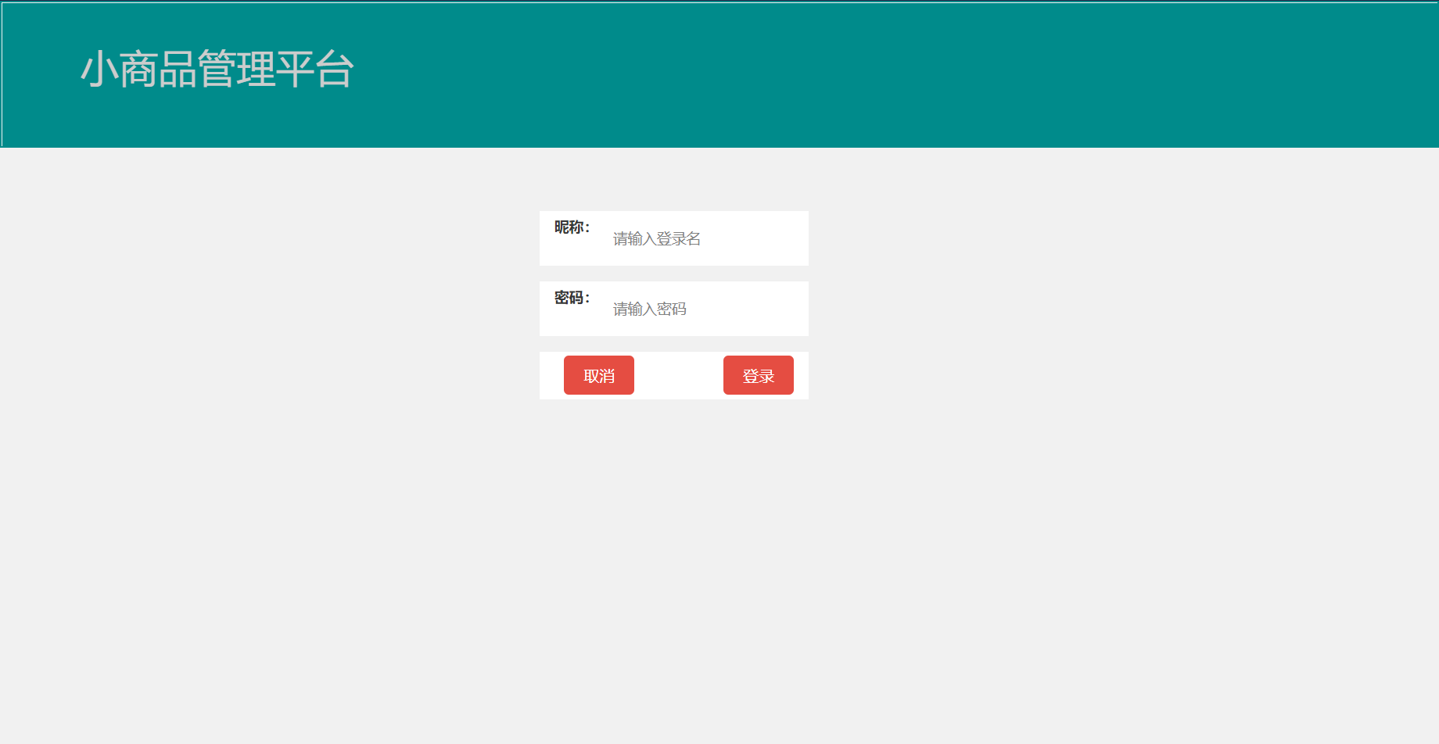

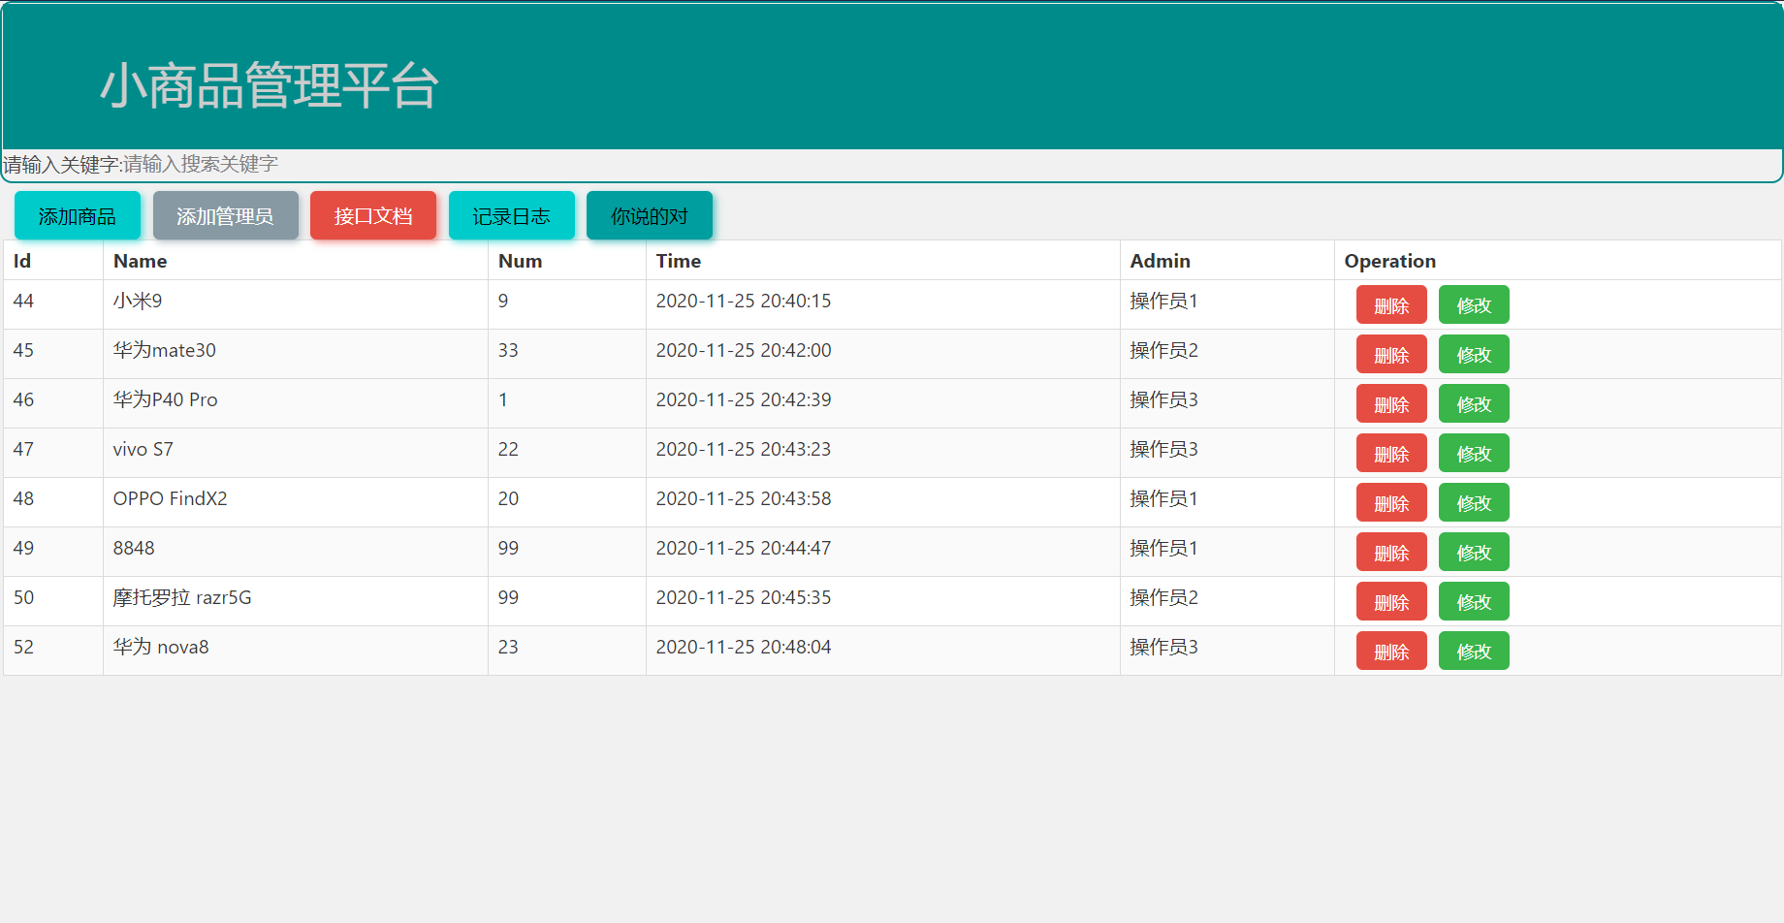

相关代码如下：

USE [master]
GO
/****** Object: Database [shopWeb] Script Date: 2020/11/26 21:24:13 ******/
CREATE DATABASE [shopWeb]
CONTAINMENT = NONE
ON PRIMARY
( NAME = N'shopWeb', FILENAME = N'E:\sql server 2012\MSSQL11.MSSQLSERVER\MSSQL\DATA\shopWeb.mdf' , SIZE = 5120KB , MAXSIZE = UNLIMITED, FILEGROWTH = 1024KB )
LOG ON
( NAME = N'shopWeb_log', FILENAME = N'E:\sql server 2012\MSSQL11.MSSQLSERVER\MSSQL\DATA\shopWeb_log.ldf' , SIZE = 2048KB , MAXSIZE = 2048GB , FILEGROWTH = 10%)
GO
ALTER DATABASE [shopWeb] SET COMPATIBILITY_LEVEL = 110
GO
IF (1 = FULLTEXTSERVICEPROPERTY('IsFullTextInstalled'))
begin
EXEC [shopWeb].[dbo].[sp_fulltext_database] @action = 'enable'
end
GO
ALTER DATABASE [shopWeb] SET ANSI_NULL_DEFAULT OFF
GO
ALTER DATABASE [shopWeb] SET ANSI_NULLS OFF
GO
ALTER DATABASE [shopWeb] SET ANSI_PADDING OFF
GO
ALTER DATABASE [shopWeb] SET ANSI_WARNINGS OFF
GO
ALTER DATABASE [shopWeb] SET ARITHABORT OFF
GO
ALTER DATABASE [shopWeb] SET AUTO_CLOSE OFF
GO
ALTER DATABASE [shopWeb] SET AUTO_CREATE_STATISTICS ON
GO
ALTER DATABASE [shopWeb] SET AUTO_SHRINK OFF
GO
ALTER DATABASE [shopWeb] SET AUTO_UPDATE_STATISTICS ON
GO
ALTER DATABASE [shopWeb] SET CURSOR_CLOSE_ON_COMMIT OFF
GO
ALTER DATABASE [shopWeb] SET CURSOR_DEFAULT GLOBAL
GO
ALTER DATABASE [shopWeb] SET CONCAT_NULL_YIELDS_NULL OFF
GO
ALTER DATABASE [shopWeb] SET NUMERIC_ROUNDABORT OFF
GO
ALTER DATABASE [shopWeb] SET QUOTED_IDENTIFIER OFF
GO
ALTER DATABASE [shopWeb] SET RECURSIVE_TRIGGERS OFF
GO
ALTER DATABASE [shopWeb] SET DISABLE_BROKER
GO
ALTER DATABASE [shopWeb] SET AUTO_UPDATE_STATISTICS_ASYNC OFF
GO
ALTER DATABASE [shopWeb] SET DATE_CORRELATION_OPTIMIZATION OFF
GO
ALTER DATABASE [shopWeb] SET TRUSTWORTHY OFF
GO
ALTER DATABASE [shopWeb] SET ALLOW_SNAPSHOT_ISOLATION OFF
GO
ALTER DATABASE [shopWeb] SET PARAMETERIZATION SIMPLE
GO
ALTER DATABASE [shopWeb] SET READ_COMMITTED_SNAPSHOT OFF
GO
ALTER DATABASE [shopWeb] SET HONOR_BROKER_PRIORITY OFF
GO
ALTER DATABASE [shopWeb] SET RECOVERY FULL
GO
ALTER DATABASE [shopWeb] SET MULTI_USER
GO
ALTER DATABASE [shopWeb] SET PAGE_VERIFY CHECKSUM
GO
ALTER DATABASE [shopWeb] SET DB_CHAINING OFF
GO
ALTER DATABASE [shopWeb] SET FILESTREAM( NON_TRANSACTED_ACCESS = OFF )
GO
ALTER DATABASE [shopWeb] SET TARGET_RECOVERY_TIME = 0 SECONDS
GO
EXEC sys.sp_db_vardecimal_storage_format N'shopWeb', N'ON'
GO
USE [shopWeb]
GO
/****** Object: Table [dbo].[products] Script Date: 2020/11/26 21:24:14 ******/
SET ANSI_NULLS ON
GO
SET QUOTED_IDENTIFIER ON
GO
CREATE TABLE [dbo].[products](
[ID] [int] IDENTITY(1,1) NOT NULL,
[admin] [nvarchar](50) NULL,
[inState] [bit] NULL,
[proName] [nvarchar](50) NULL,
[date1] [datetime] NULL,
[date2] [datetime] NULL,
[key1] [nvarchar](50) NULL,
[key2] [nvarchar](50) NULL,
[key3] [int] NULL,
[key4] [int] NULL,
[proNum] [int] NULL,
[key5] [bit] NULL,
[key6] [bit] NULL,
CONSTRAINT [PK_products] PRIMARY KEY CLUSTERED
(
[ID] ASC
)WITH (PAD_INDEX = OFF, STATISTICS_NORECOMPUTE = OFF, IGNORE_DUP_KEY = OFF, ALLOW_ROW_LOCKS = ON, ALLOW_PAGE_LOCKS = ON) ON [PRIMARY]
) ON [PRIMARY]

GO
/****** Object: Table [dbo].[userInfo] Script Date: 2020/11/26 21:24:14 ******/
SET ANSI_NULLS ON
GO
SET QUOTED_IDENTIFIER ON
GO
CREATE TABLE [dbo].[userInfo](
[ID] [int] IDENTITY(1,1) NOT NULL,
[loginName] [nvarchar](50) NULL,
[password] [nvarchar](50) NULL
) ON [PRIMARY]

GO
ALTER TABLE [dbo].[products] ADD CONSTRAINT [DF_products_date1] DEFAULT (getdate()) FOR [date1]
GO
EXEC sys.sp_addextendedproperty @name=N'MS_Description', @value=N'商品ID' , @level0type=N'SCHEMA',@level0name=N'dbo', @level1type=N'TABLE',@level1name=N'products', @level2type=N'COLUMN',@level2name=N'ID'
GO
EXEC sys.sp_addextendedproperty @name=N'MS_Description', @value=N'管理员' , @level0type=N'SCHEMA',@level0name=N'dbo', @level1type=N'TABLE',@level1name=N'products', @level2type=N'COLUMN',@level2name=N'admin'
GO
EXEC sys.sp_addextendedproperty @name=N'MS_Description', @value=N'在库状态' , @level0type=N'SCHEMA',@level0name=N'dbo', @level1type=N'TABLE',@level1name=N'products', @level2type=N'COLUMN',@level2name=N'inState'
GO
EXEC sys.sp_addextendedproperty @name=N'MS_Description', @value=N'商品名称' , @level0type=N'SCHEMA',@level0name=N'dbo', @level1type=N'TABLE',@level1name=N'products', @level2type=N'COLUMN',@level2name=N'proName'
GO
EXEC sys.sp_addextendedproperty @name=N'MS_Description', @value=N'时间字段1' , @level0type=N'SCHEMA',@level0name=N'dbo', @level1type=N'TABLE',@level1name=N'products', @level2type=N'COLUMN',@level2name=N'date1'
GO
EXEC sys.sp_addextendedproperty @name=N'MS_Description', @value=N'时间字段2' , @level0type=N'SCHEMA',@level0name=N'dbo', @level1type=N'TABLE',@level1name=N'products', @level2type=N'COLUMN',@level2name=N'date2'
GO
EXEC sys.sp_addextendedproperty @name=N'MS_Description', @value=N'保留字段1' , @level0type=N'SCHEMA',@level0name=N'dbo', @level1type=N'TABLE',@level1name=N'products', @level2type=N'COLUMN',@level2name=N'key1'
GO
EXEC sys.sp_addextendedproperty @name=N'MS_Description', @value=N'保留字段2' , @level0type=N'SCHEMA',@level0name=N'dbo', @level1type=N'TABLE',@level1name=N'products', @level2type=N'COLUMN',@level2name=N'key2'
GO
EXEC sys.sp_addextendedproperty @name=N'MS_Description', @value=N'int保留字段1' , @level0type=N'SCHEMA',@level0name=N'dbo', @level1type=N'TABLE',@level1name=N'products', @level2type=N'COLUMN',@level2name=N'key3'
GO
EXEC sys.sp_addextendedproperty @name=N'MS_Description', @value=N'int保留字段2' , @level0type=N'SCHEMA',@level0name=N'dbo', @level1type=N'TABLE',@level1name=N'products', @level2type=N'COLUMN',@level2name=N'key4'
GO
EXEC sys.sp_addextendedproperty @name=N'MS_Description', @value=N'商品数量' , @level0type=N'SCHEMA',@level0name=N'dbo', @level1type=N'TABLE',@level1name=N'products', @level2type=N'COLUMN',@level2name=N'proNum'
GO
EXEC sys.sp_addextendedproperty @name=N'MS_Description', @value=N'bit保留字段1' , @level0type=N'SCHEMA',@level0name=N'dbo', @level1type=N'TABLE',@level1name=N'products', @level2type=N'COLUMN',@level2name=N'key5'
GO
EXEC sys.sp_addextendedproperty @name=N'MS_Description', @value=N'bit保留字段2' , @level0type=N'SCHEMA',@level0name=N'dbo', @level1type=N'TABLE',@level1name=N'products', @level2type=N'COLUMN',@level2name=N'key6'
GO
EXEC sys.sp_addextendedproperty @name=N'MS_Description', @value=N'唯一ID值' , @level0type=N'SCHEMA',@level0name=N'dbo', @level1type=N'TABLE',@level1name=N'userInfo', @level2type=N'COLUMN',@level2name=N'ID'
GO
USE [master]
GO
ALTER DATABASE [shopWeb] SET READ_WRITE
GO

实验结果及分析:
通过本次实验，我学习到了网站简易的动态交互以及数据渲染。也了解到了.Net的强大与无所不能，还有更多的知识和乐趣等待我去探索和发掘。在老师细心的指导和团队成员的不懈努力下，基本掌握了利用VS通过C#语言对数据的增删改查，但掌握的还远远不够牢固。我希望利用接下来的时间和精力将继续完善和改进项目，比如防护一些sql注入和增加审核机制。

