*Matthew Meyn*

*2017/2/1*

*CS556 hw #1*

Video Tracking

**Introduction**

For this project, I used MATLAB’s built-in SURF feature detector and extractor, and its built-in feature matching, to track a changing object over a video of about 125 frames. The initial bounding box was given; the task was to update the corners of the bounding box for each subsequent frame.

**Distance Estimation**

My approach was to determine the bounding box corners according to an estimate of how far the object has moved between two successive frames. For each pair of frames, we first detect some features, then get their descriptors and match them against each other:

[f1, v1] = getFeatures(img1);

[f2, v2] = getFeatures(img2);

pairs = matchFeatures(f1, f2);

points1 = v1(pairs(:, 1), :);

points2 = v2(pairs(:, 2), :);

To get the features in a frame, we use the SURF detector:

function [feat, vis] = getFeatures(img)

sf = detectSURFFeatures(img, 'MetricThreshold', 7500.0);

[feat, vis] = extractFeatures(img, sf);

end

After extracting the locations of points from each collection, we compute and straight-line distance between each pair of matched points.

for i = 1:numPoints

dists(i, 1) = loc2(i, 1) - loc1(i, 1);

dists(i, 2) = loc2(i, 2) - loc1(i, 2);

x = dists(i, 1);

y = dists(i, 2);

dists(i, 3) = sqrt(x*x + y*y);

end

Finally, we take the median of this list of pairs of points, as sorted by straight-line distance. The and of the bounding box are taken from this median pair. The corners of the box are adjusted by that amount in x and y.

**Results**

The procedure I used was able to approximate the ground-truth bounding box corners with a mean error over all frames of 14.8, as measured in “straight-line” pixel distance.

These sequential snapshots, taken at 10 frame intervals (moving forward through the video left to right, top to bottom), show the ground-truth boxes in blue and the computed boxes in yellow.

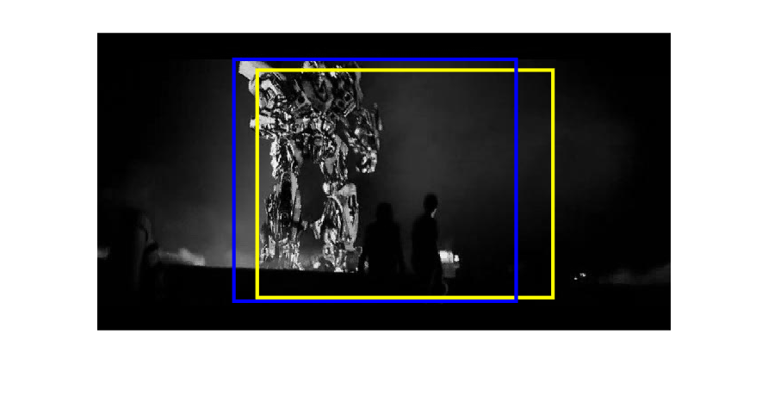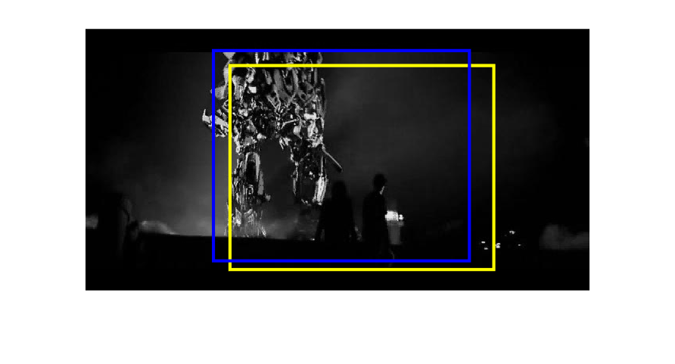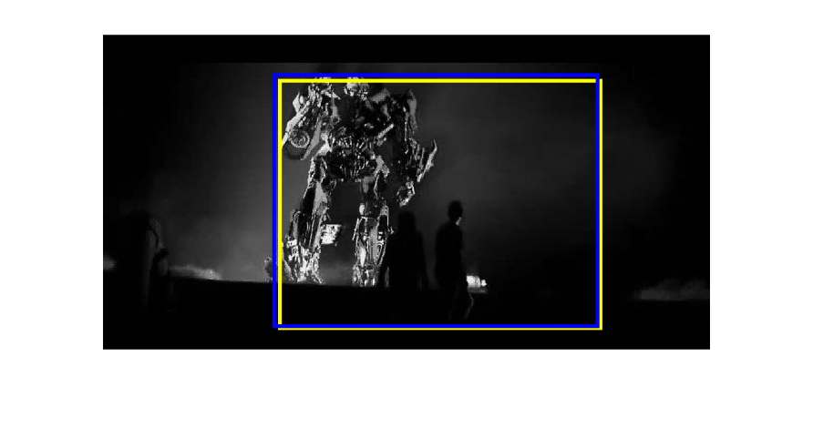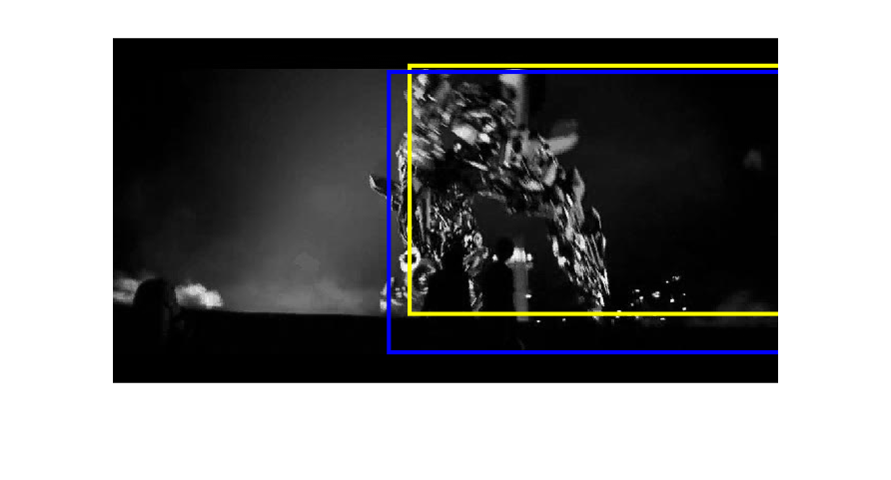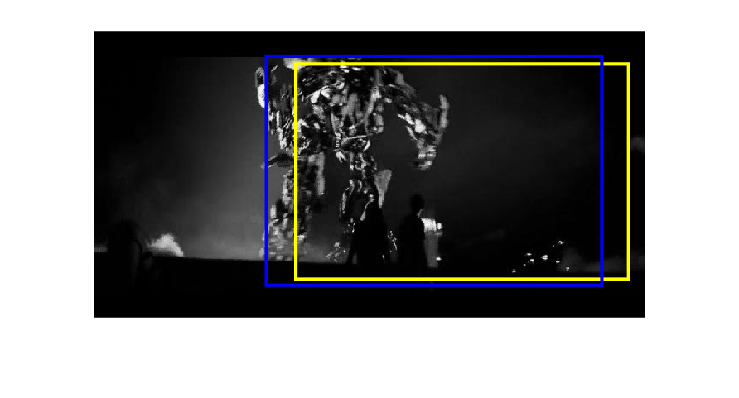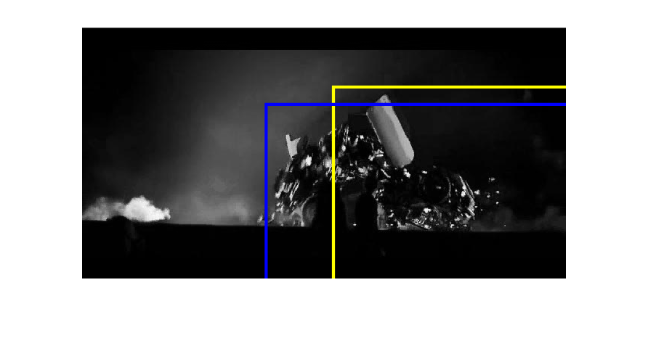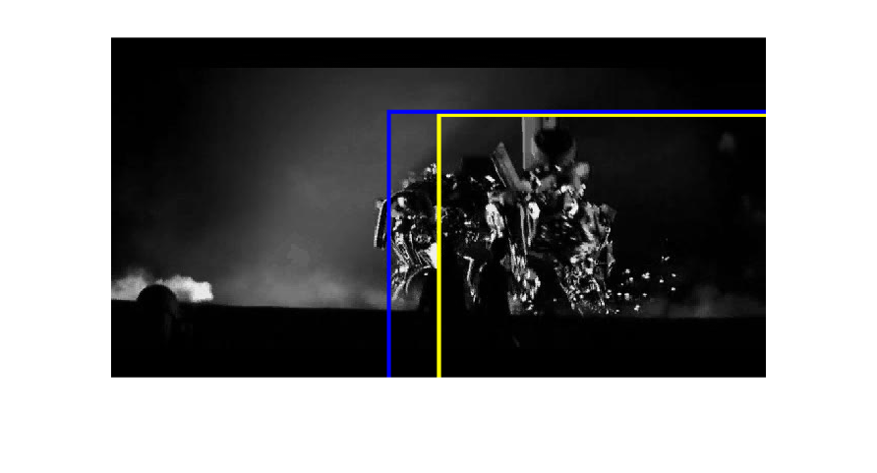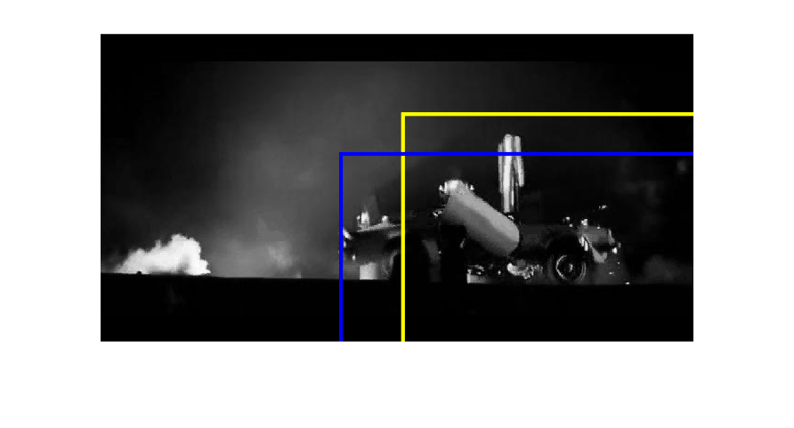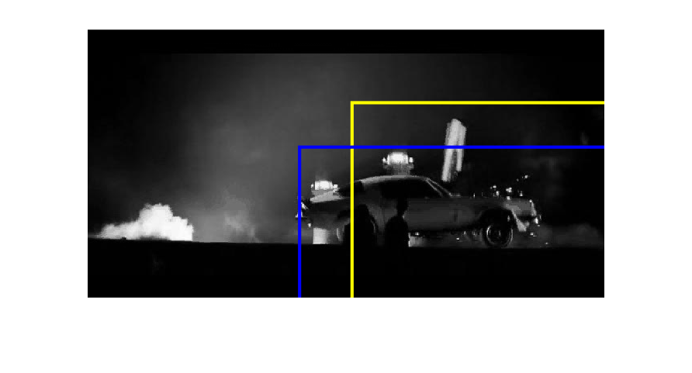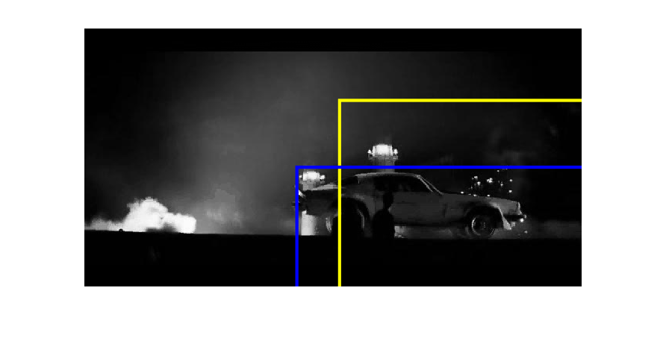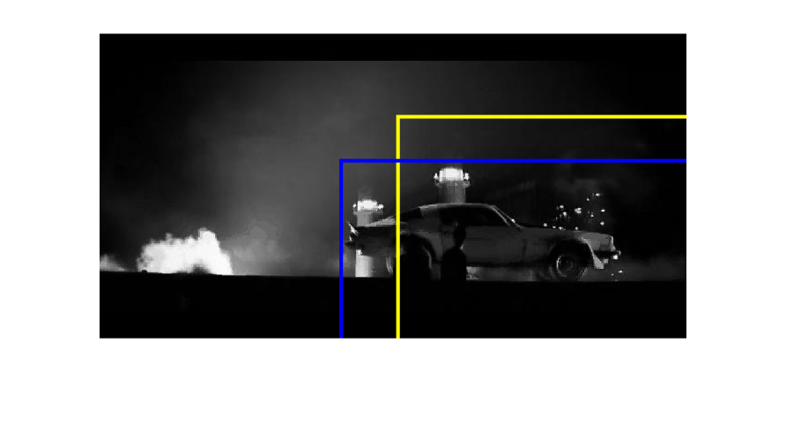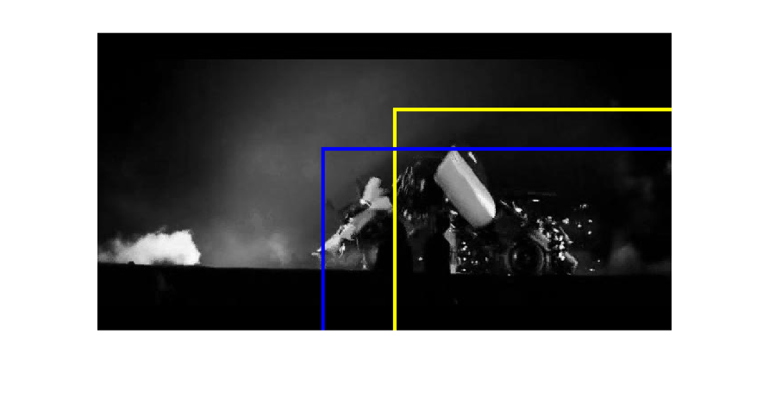

The full results are available separately in estimation.txt, error.txt and together in ResultsTable.pdf.

**Conclusion**

Overall, MATLAB’s out-of-the-box feature extraction and matching capabilities seem to be strong. It is possible to track the object reasonably closely—within about a 30 pixel distance—just by observing the median distance between matched SURF features in successive frames.

Not surprisingly, the largest errors between the estimate and ground truth bounding boxes seem to occur when the object is changing shape. Of course, we would expect that when the object changes, it will be more difficult to match points, so errors should tend to increase when this happens.