Final Report

Project Name: Small Planet

Team: Miyu Kimura, Niki Tran

# Description

We have updated the planet and the texture mapping and adjusted the colors, clouds, and sizes. We also implement and imported elements on the planets that include mountains, clouds and trees. We have a character that is able to move around and explore our planet

# Status:

We were able to finish most of everything we set out to accomplish for this assignment. On thing that we did not get to was to animate the feet of the character while it walked through the planet.

Gantt Chart:

|  |  |  |  |  |  |  |
| --- | --- | --- | --- | --- | --- | --- |
|  | Week 6 | Week 7 | Week 8 | Week 9 | Week 10 | Week 11 |
|  | 2/8 - 2/14 | 2/15-2/21 | 2/22 -28 | 2/29-3/6 | 3/7 - 13 | 3/14 |
| **~~Project Proposal - 2/11 - submit~~** |  |  |  |  |  |  |
| * ~~create a document of our project proposal~~ |  |  |  |  |  |  |
| **~~Project Plan - 2/18 - submit~~** |  |  |  |  |  |  |
| * ~~create a document of our project plan~~ |  |  |  |  |  |  |
| **~~Design 2/25 - submit~~** |  |  |  |  |  |  |
| * ~~research similar projects, and tutorials that maybe helpful to our project~~ |  |  |  |  |  |  |
| * ~~concept design~~ |  |  |  |  |  |  |
| * ~~material design~~ |  |  |  |  |  |  |
| * ~~UI design~~ |  |  |  |  |  |  |
| * ~~determine what technology is need to implement our program~~ |  |  |  |  |  |  |
| **~~Develop: CodeDrop1 - 3/3 - submit~~** |  |  |  |  |  |  |
| * ~~create the base geometry of the planet with THREE.js/JS/etc~~ |  |  |  |  |  |  |
| * ~~implement render, light, camera~~ |  |  |  |  |  |  |
| * ~~create the first pass of the planet the the elements (mesh of trees, mountains, water- transparent)~~ |  |  |  |  |  |  |
| * ~~implement shaders and textures onto the mesh in our environment~~ |  |  |  |  |  |  |
| **Develop: CodeDrop2 - 3/10 - submit** |  |  |  |  |  |  |
| * ~~iterate on the geometry of the trees/mountains/water~~ |  |  |  |  |  |  |
| * ~~create a character~~ * ~~make it move throughout the planet with the keyboard~~ |  |  |  |  |  |  |
| * ~~link the camera to the character~~ |  |  |  |  |  |  |
| **Develop: CodeDrop3 - Final - 3/15 - submit** |  |  |  |  |  |  |
| * ~~final iteration of the geometry of the tree/mountains/water~~ |  |  |  |  |  |  |
| * ~~final iteration on the character -~~ include feet animation if there is time |  |  |  |  |  |  |
| * ~~practice presentation/create powerpoint (maybe)~~ |  |  |  |  |  |  |
| * ~~final presentation (3/15)~~ |  |  |  |  |  |  |

# Sources and executables + Instructions to run

* Open index on the browser

# Output

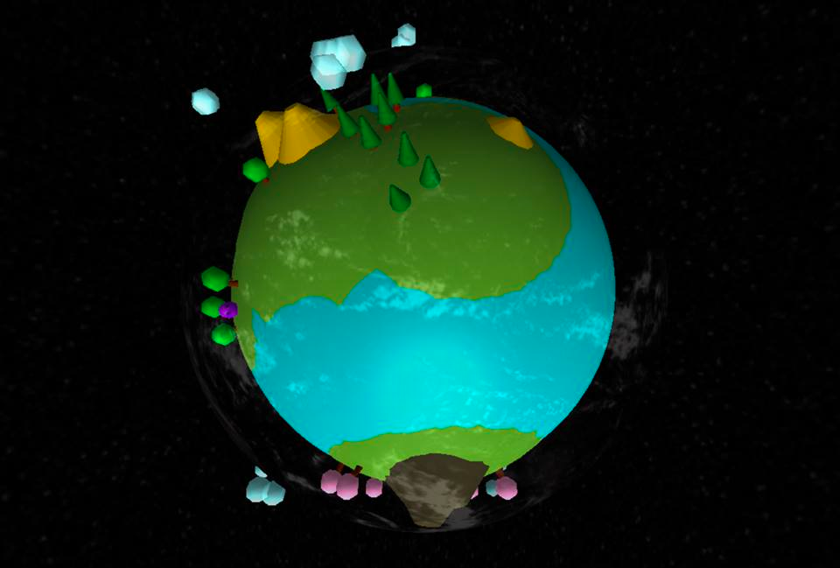

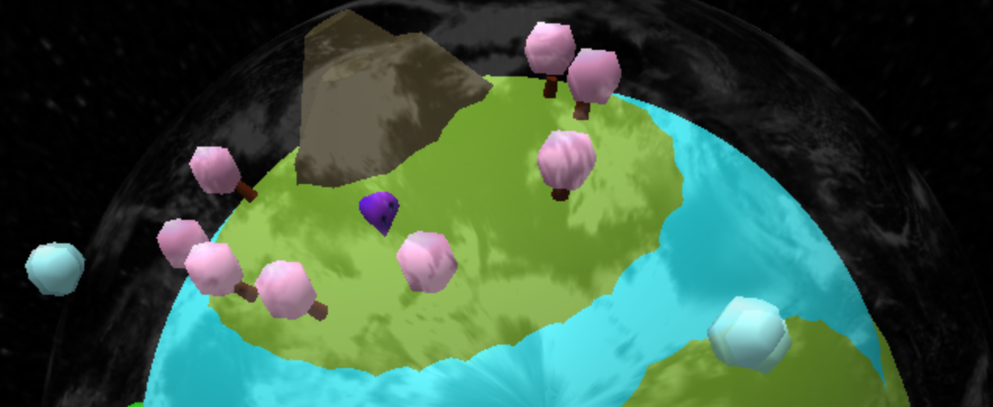

Control:

A & D: rotation

Left, right, up, down : movements