
3GPP TS 25.212 V10.1.0 (2010-12)
Technical Specification
3rd Generation Partnership Project;
Technical Specification Group Radio Access Network;
Multiplexing and channel coding (FDD)
(Release 10)

The present document has been developed within the 3rd Generation Partnership Project (3GPP TM) and may be further elaborated for the purposes of 3GPP.
The present document has not been subject to any approval process by the 3GPP Organisational Partners and shall not be implemented.
This Specification is provided for future development work within 3GPP only. The Organisational Partners accept no liability for any use of this Specification.
Specifications and reports for implementation of the 3GPP TM system should be obtained via the 3GPP Organisational Partners' Publications Offices.

Keywords
UMTS, radio, mux
3GPP
Postal address

3GPP support office address
650 Route des Lucioles - Sophia Antipolis
Valbonne - FRANCE
Tel.: +33 4 92 94 42 00 Fax: +33 4 93 65 47 16
Internet
http://www.3gpp.org
Copyright Notification
No part may be reproduced except as authorized by written permission.
The copyright and the foregoing restriction extend to reproduction in all media.

© 2010, 3GPP Organizational Partners (ARIB, ATIS, CCSA, ETSI, TTA, TTC).
All rights reserved.
UMTS™ is a Trade Mark of ETSI registered for the benefit of its members
3GPP™ is a Trade Mark of ETSI registered for the benefit of its Members and of the 3GPP Organizational Partners
LTE™ is a Trade Mark of ETSI currently being registered for the benefit of its Members and of the 3GPP Organizational Partners
GSM® and the GSM logo are registered and owned by the GSM Association

Contents
Foreword 8
1 Scope 9
2 References 9
3 Definitions, symbols and abbreviations 9
3.1 Definitions 9
3.2 Symbols 10
3.3 Abbreviations 11
4 Multiplexing, channel coding and interleaving 12
4.1 General 12
4.2 General coding/multiplexing of TrCHs 12
4.2.1 CRC attachment 15
4.2.1.1 CRC Calculation 15
4.2.1.2 Relation between input and output of the CRC attachment block 15
4.2.2 Transport block concatenation and code block segmentation 16
4.2.2.1 Concatenation of transport blocks 16
4.2.2.2 Code block segmentation 16
4.2.3 Channel coding 17
4.2.3.1 Convolutional coding 17
4.2.3.2 Turbo coding 18
4.2.3.2.1 Turbo coder 18
4.2.3.2.2 Trellis termination for Turbo coder 19
4.2.3.2.3 Turbo code internal interleaver 19
4.2.3.3 Concatenation of encoded blocks 23
4.2.4 Radio frame size equalisation 23
4.2.5 1st interleaving 23
4.2.5.1 Void 23
4.2.5.2 1st interleaver operation 23
4.2.5.3 Relation between input and output of 1st interleaving in uplink 24
4.2.5.4 Relation between input and output of 1st interleaving in downlink 25
4.2.6 Radio frame segmentation 25
4.2.6.1 Relation between input and output of the radio frame segmentation block in uplink 25
4.2.6.2 Relation between input and output of the radio frame segmentation block in downlink 25
4.2.7 Rate matching 25
4.2.7.1 Determination of rate matching parameters in uplink 27
4.2.7.1.1 Determination of SF and number of PhCHs needed 27
4.2.7.2 Determination of rate matching parameters in downlink 30
4.2.7.2.1 Determination of rate matching parameters for fixed positions of TrCHs 30
4.2.7.2.2 Determination of rate matching parameters for flexible positions of TrCHs 32
4.2.7.3 Bit separation and collection in uplink 34
4.2.7.3.1 Bit separation 36
4.2.7.3.2 Bit collection 36
4.2.7.4 Bit separation and collection in downlink 37
4.2.7.4.1 Bit separation 38
4.2.7.4.2 Bit collection 38
4.2.7.5 Rate matching pattern determination 39
4.2.8 TrCH multiplexing 40
4.2.9 Insertion of discontinuous transmission (DTX) indication bits 40
4.2.9.1 1st insertion of DTX indication bits 40
4.2.9.2 2nd insertion of DTX indication bits 41
4.2.10 Physical channel segmentation 42
4.2.10.1 Relation between input and output of the physical segmentation block in uplink 42
4.2.10.2 Relation between input and output of the physical segmentation block in downlink 42
4.2.11 2nd interleaving 42
4.2.11.1 2nd interleaving for Secondary CCPCH with 16QAM 43
4.2.12 Physical channel mapping 44
4.2.12.1 Uplink 44
4.2.12.2 Downlink 44
4.2.13 Restrictions on different types of CCTrCHs 45
4.2.13.1 Uplink Dedicated channel (DCH) 45
4.2.13.2 Random Access Channel (RACH) 45
4.2.13.3 Void 45
4.2.13.4 Downlink Dedicated Channel (DCH) 45
4.2.13.5 Void 45
4.2.13.6 Broadcast channel (BCH) 45
4.2.13.7 Forward access and paging channels (FACH and PCH) 46
4.2.13.8 High Speed Downlink Shared Channel (HS-DSCH) associated with a DCH 46
4.2.13.9 Enhanced Dedicated Channel (E-DCH) 46
4.2.14 Multiplexing of different transport channels into one CCTrCH, and mapping of one CCTrCH onto physical channels 46
4.2.14.1 Allowed CCTrCH combinations for one UE 47
4.2.14.1.1 Allowed CCTrCH combinations on the uplink 47
4.2.14.1.2 Allowed CCTrCH combinations on the downlink 47
4.3 Transport format detection 47
4.3.1 Blind transport format detection 48
4.3.1a Single transport format detection 48
4.3.2 Transport format detection based on TFCI 48
4.3.3 Coding of Transport-Format-Combination Indicator (TFCI) 49
4.3.4 Void 50
4.3.5 Mapping of TFCI words 50
4.3.5.1 Mapping of TFCI word in normal mode 50
4.3.5.1.1 Mapping of TFCI bits for Secondary CCPCH with 16QAM 50
4.3.5.2 Mapping of TFCI word in compressed mode 50
4.3.5.2.1 Uplink compressed mode 50
4.3.5.2.2 Downlink compressed mode 51
4.4 Compressed mode 52
4.4.1 Frame structure in the uplink 52
4.4.2 Frame structure types in the downlink 52
4.4.2A Frame structure in the downlink for F-DPCH 53
4.4.3 Transmission time reduction method 53
4.4.3.1 Void 53
4.4.3.2 Compressed mode by reducing the spreading factor by 2 53
4.4.3.3 Compressed mode by higher layer scheduling 53
4.4.4 Transmission gap position 53
4.4.5 Transmission gap position for E-DCH 55
4.4.5.1 E-DPDCH Transmission Gap Position during Initial Transmissions 55
4.4.5.2 E-DPDCH Transmission Gap Position during Retransmissions 56
4.4.5.3 E-DPCCH Transmission Gap Position 56
4.5 Coding for HS-DSCH 56
4.5.1 CRC attachment for HS-DSCH 57
4.5.1.1 CRC attachment method 1 for HS-DSCH 57
4.5.1.2 CRC attachment method 2 for HS-DSCH 58
4.5.1a Bit scrambling for HS-DSCH 58
4.5.2 Code block segmentation for HS-DSCH 58
4.5.3 Channel coding for HS-DSCH 59
4.5.4 Hybrid ARQ for HS-DSCH 59
4.5.4.1 HARQ bit separation 59
4.5.4.2 HARQ First Rate Matching Stage 59
4.5.4.3 HARQ Second Rate Matching Stage 60
4.5.4.4 HARQ bit collection 61
4.5.5 Physical channel segmentation for HS-DSCH 61
4.5.6 Interleaving for HS-DSCH 62
4.5.7 Constellation re-arrangement for 16 QAM and 64QAM 62
4.5.8 Physical channel mapping for HS-DSCH 63
4.6 Coding for HS-SCCH type 1 63
4.6.1 Overview 63
4.6.2 HS-SCCH information field mapping 65
4.6.2.1 Redundancy and constellation version coding 65
4.6.2.2 Modulation scheme mapping 66
4.6.2.3 Channelization code-set mapping 66
4.6.2.4 UE identity mapping 67
4.6.2.5 HARQ process identifier mapping 67
4.6.2.6 Transport block size index mapping 67
4.6.3 Multiplexing of HS-SCCH information 67
4.6.4 CRC attachment for HS-SCCH 67
4.6.5 Channel coding for HS-SCCH 68
4.6.6 Rate matching for HS-SCCH 68
4.6.7 UE specific masking for HS-SCCH 68
4.6.8 Physical channel mapping for HS-SCCH 68
4.6A Coding for HS-SCCH type 2 68
4.6A.1 Overview 68
4.6A.2 HS-SCCH Type 2 information field mapping 69
4.6A.2.1 The first transmission 69
4.6A.2.2 The second and the third transmissions 70
4.6A.2.2.1 Special Information mapping 70
4.6A.2.2.1.1 Transport-block size information mapping 70
4.6A.2.2.1.2 Pointer to the previous transmission mapping 70
4.6A.2.2.1.3 Second or third transmission mapping 70
4.6A.2.2.2 Redundancy and Constellation Version mapping 71
4.6A.2.2.3 Modulation scheme mapping 71
4.6A.2.2.4 Channelization code-set mapping 71
4.6A.2.2.5 UE identity mapping 71
4.6A.3 Multiplexing of HS-SCCH Type 2 information 71
4.6A.4 CRC attachment for HS-SCCH Type 2 71
4.6A.5 Channel coding for HS-SCCH Type 2 71
4.6A.6 Rate matching for HS-SCCH Type 2 71
4.6A.7 UE specific masking for HS-SCCH Type 2 71
4.6A.8 Physical channel mapping for HS-SCCH Type 2 71
4.6B Coding for HS-SCCH type 3 72
4.6B.1 Overview 72
4.6B.2 HS-SCCH type 3 information field mapping 73
4.6B.2.1 Redundancy and constellation version coding 73
4.6B.2.2 Modulation scheme and number of transport blocks mapping 74
4.6B.2.3 Channelization code-set mapping 74
4.6B.2.4 UE identity mapping 75
4.6B.2.5 HARQ process identifier mapping 75
4.6B.2.6 Transport block size index mapping 75
4.6B.2.7 Precoding Weight Information mapping 75
4.6B.3 Multiplexing of HS-SCCH type 3 information 76
4.6B.4 CRC attachment for HS-SCCH type 3 76
4.6B.5 Channel coding for HS-SCCH type 3 77
4.6B.6 Rate matching for HS-SCCH type 3 77
4.6B.7 UE specific masking for HS-SCCH type 3 77
4.6B.8 Physical channel mapping for HS-SCCH type 3 77
4.6C Coding for HS-SCCH orders 78
4.6C.1 Overview 78
4.6C.2 HS-SCCH Order information field mapping 78
4.6C.2.1 Order type mapping 78
4.6C.2.2 Order mapping 78
4.6C.2.2.1 Orders for activation and deactivation of DTX, DRX and HS-SCCH-less operation and for HS-DSCH serving cell change 78
4.6C.2.2.2 Orders for activation and deactivation of Secondary serving HS-DSCH cells and Secondary uplink frequency 79
4.6C.2.3 UE identity mapping 79
4.7 Coding for HS-DPCCH 79
4.7.1 Overview 79
4.7.2 Channel coding for HS-DPCCH when the UE is not configured in MIMO mode in the serving HS-DSCH cell and Secondary_Cell_Enabled is 0 or 1 and Secondary_Cell_Active is 0 82
4.7.2.1 Channel coding for HS-DPCCH HARQ-ACK 82
4.7.2.2 Channel coding for HS-DPCCH channel quality indication 83
4.7.3 Channel coding for HS-DPCCH when the UE is configured in MIMO mode in the serving HS-DSCH cell and Secondary_Cell_Enabled is 0 84
4.7.3.1 Channel coding for HS-DPCCH HARQ-ACK 84
4.7.3.2 Channel coding for HS-DPCCH composite precoding control indication and channel quality indication 84
4.7.3.2.1 Bit mapping of Type A channel quality indication 84
4.7.3.2.2 Bit mapping of Type B channel quality indication 85
4.7.3.2.3 Bit mapping of precoding control indication 85
4.7.3.2.4 Composite precoding control indication and channel quality indication bits 85
4.7.3.2.5 Block encoding of composite precoding control indication and channel quality indication bits 85
4.7.3A Channel coding for HS-DPCCH when the UE is not configured in MIMO mode in any cell and Secondary_Cell_Enabled is 1 and Secondary_Cell_Active is 1 86
4.7.3A.1 Channel coding for the composite HS-DPCCH HARQ-ACK 86
4.7.3A.2 Channel coding for HS-DPCCH composite channel quality indication 87
4.7.3A.2.1 Composite channel quality indication bits 87
4.7.3A.2.2 Block encoding of composite channel quality indication bits 88
4.7.3B Channel coding for HS-DPCCH when Secondary_Cell_Enabled is 3 or when the UE is configured in MIMO mode in at least one cell and Secondary_Cell_Enabled is greater than 0 88
4.7.3B.1 Channel coding for the composite HS-DPCCH HARQ-ACK 88
4.7.3B.2 Channel coding for HS-DPCCH composite precoding control indication and channel quality indication 90
4.7.3C Channel coding for HS-DPCCH when the UE is not configured in MIMO mode in any cell and Secondary_Cell_Enabled is 2 90
4.7.3C.1 Channel coding for the composite HS-DPCCH HARQ-ACK 90
4.7.3C.2 Channel coding for HS-DPCCH channel quality indication 91
4.7.4 Physical channel mapping for HS-DPCCH 91
4.7.4.1 Physical Channel mapping for HS-DPCCH HARQ-ACK 91
4.7.4.2 Physical Channel mapping for HS-DPCCH PCI/CQI 92
4.8 Coding for E-DCH 95
4.8.1 CRC attachment for E-DCH 96
4.8.2 Code block segmentation for E-DCH 96
4.8.3 Channel coding for E-DCH 97
4.8.4 Physical layer HARQ functionality and rate matching for E-DCH 97
4.8.4.1 Determination of SF, modulation scheme and number of PhCHs needed 97
4.8.4.2 HARQ bit separation 98
4.8.4.3 HARQ Rate Matching Stage 98
4.8.4.4 HARQ bit collection 99
4.8.5 Physical channel segmentation for E-DCH 99
4.8.6 Interleaving for E-DCH 99
4.8.7 Physical channel mapping for E-DCH 100
4.9 Coding for E-DPCCH 100
4.9.1 Overview 100
4.9.2 E-DPCCH information field mapping 101
4.9.2.1 Information field mapping of E-TFCI 101
4.9.2.2 Information field mapping of retransmission sequence number 101
4.9.2.3 Information field mapping of the "Happy" bit 102
4.9.3 Multiplexing of E-DPCCH information 102
4.9.4 Channel coding for E-DPCCH 102
4.9.5 Physical channel mapping for E-DPCCH 102
4.10 Coding for E-AGCH 102
4.10.1 Overview 102
4.10.1A E-AGCH information field mapping 103
4.10.1A.1 Information field mapping of the Absolute Grant Value 103
4.10.1A.2 Information field mapping of the Absolute Grant Scope 105
4.10.1B Multiplexing of E-AGCH information 105
4.10.2 CRC attachment for E-AGCH 106
4.10.3 Channel coding for E-AGCH 106
4.10.4 Rate matching for E-AGCH 106
4.10.5 Physical channel mapping for E-AGCH 106
4.11 Mapping for E-RGCH Relative Grant 106
4.11.1 Overview 106
4.11.2 Relative Grant mapping 106
4.12 Mapping for E-HICH ACK/NACK 106
4.12.1 Overview 106
4.12.2 ACK/NACK mapping 107
Annex A (informative): Blind transport format detection 108
A.1 Blind transport format detection using fixed positions 108
A.1.1 Blind transport format detection using received power ratio 108
A.1.2 Blind transport format detection using CRC 108
Annex B (informative): Compressed mode idle lengths 111
B.1 Idle lengths for DL, UL and DL+UL compressed mode for DPCH 111
Annex C (informative): Change history 113

Foreword
This Technical Specification (TS) has been produced by the 3rd Generation Partnership Project (3GPP).
The contents of the present document are subject to continuing work within the TSG and may change following formal TSG approval. Should the TSG modify the contents of the present document, it will be re-released by the TSG with an identifying change of release date and an increase in version number as follows:
Version x.y.z
where:
x the first digit:
1 presented to TSG for information;
2 presented to TSG for approval;
3 or greater indicates TSG approved document under change control.
y the second digit is incremented for all changes of substance, i.e. technical enhancements, corrections, updates, etc.
z the third digit is incremented when editorial only changes have been incorporated in the document.

1 Scope
The present document describes the characteristics of the Layer 1 multiplexing and channel coding in the FDD mode of UTRA.

2 References
The following documents contain provisions which, through reference in this text, constitute provisions of the present document.
- References are either specific (identified by date of publication, edition number, version number, etc.) or non-specific.
- For a specific reference, subsequent revisions do not apply.
- For a non-specific reference, the latest version applies.
[1] 3GPP TS 25.201: "Physical layer - General Description".
[2] 3GPP TS 25.211: "Physical channels and mapping of transport channels onto physical channels (FDD)".
[3] 3GPP TS 25.213: "Spreading and modulation (FDD)".
[4] 3GPP TS 25.214: "Physical layer procedures (FDD)".
[5] 3GPP TS 25.215: "Physical layer – Measurements (FDD)".
[6] 3GPP TS 25.221: "Physical channels and mapping of transport channels onto physical channels (TDD)".
[7] 3GPP TS 25.222: "Multiplexing and channel coding (TDD)".
[8] 3GPP TS 25.223: "Spreading and modulation (TDD)".
[9] 3GPP TS 25.224: "Physical layer procedures (TDD)".
[10] 3GPP TS 25.225: "Physical layer – Measurements (TDD)".
[11] 3GPP TS 25.302: "Services Provided by the Physical Layer".
[12] 3GPP TS 25.402: "Synchronisation in UTRAN, Stage 2".
[13] 3GPP TS 25.331: "Radio Resource Control (RRC); Protocol Specification".
[14] ITU-T Recommendation X.691 (12/97) "Information technology - ASN.1 encoding rules: Specification of Packed Encoding Rules (PER)"
[15] 3GPP TS 25.306: "UE Radio Access capabilities".
[16] 3GPP TS 25.321: "Medium Access Control (MAC) protocol specification".

3 Definitions, symbols and abbreviations

3.1 Definitions
For the purposes of the present document, the following terms and definitions apply:
Primary uplink frequency: If a single uplink frequency is configured for the UE, then it is the primary uplink frequency. In case more than one uplink frequency is configured for the UE, then the primary uplink frequency is the frequency on which the E-DCH corresponding to the serving E-DCH cell associated with the serving HS-DSCH cell is transmitted. The association between a pair of uplink and downlink frequencies is indicated by higher layers.
Secondary uplink frequency: A secondary uplink frequency is a frequency on which an E-DCH corresponding to a serving E-DCH cell associated with a secondary serving HS-DSCH cell is transmitted. The association between a pair of uplink and downlink frequencies is indicated by higher layers.
TG: Transmission Gap is consecutive empty slots that have been obtained with a transmission time reduction method. The transmission gap can be contained in one or two consecutive radio frames.
TGL: Transmission Gap Length is the number of consecutive empty slots that have been obtained with a transmission time reduction method. 0 ≤TGL≤ 14. The CFNs of the radio frames containing the first empty slot of the transmission gaps, the CFNs of the radio frames containing the last empty slot, the respective positions N_{first} and N_{last} within these frames of the first and last empty slots of the transmission gaps, and the transmission gap lengths can be calculated with the compressed mode parameters described in [5].
TrCH number: The transport channel number identifies a TrCH in the context of L1. The L3 transport channel identity (TrCH ID) maps onto the L1 transport channel number. The mapping between the transport channel number and the TrCH ID is as follows: TrCH 1 corresponds to the TrCH with the lowest TrCH ID, TrCH 2 corresponds to the TrCH with the next lowest TrCH ID and so on.
1st secondary serving HS-DSCH cell: If the UE is configured with two uplink frequencies, the 1st secondary serving HS-DSCH cell is the secondary serving HS-DSCH cell that is associated with the secondary uplink frequency. If the UE is configured with a single uplink frequency, the 1st secondary serving HS-DSCH cell is a secondary serving HS-DSCH cell whose index is indicated by higher layers.
2nd secondary serving HS-DSCH cell: If the UE is configured with more than two serving HS-DSCH cells, the 2nd secondary serving HS-DSCH cell is a secondary serving HS-DSCH cell whose index is indicated by higher layers.
3rd secondary serving HS-DSCH cell: If the UE is configured with four serving HS-DSCH cells, the 3rd secondary serving HS-DSCH cell is a secondary serving HS-DSCH cell whose index is indicated by higher layers.

3.2 Symbols
For the purposes of the present document, the following symbols apply:
⎡x⎤ round towards ∞, i.e. integer such that x ≤ ⎡x⎤ < x+1
⎣x⎦ round towards -∞, i.e. integer such that x-1 < ⎣x⎦ ≤ x
⎜x⎜ absolute value of x
sgn(x) signum function, i.e. 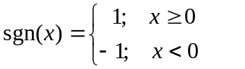
N_{first} The first slot in the TG, located in the first compressed radio frame if the TG spans two frames.
N_{last} The last slot in the TG, located in the second compressed radio frame if the TG spans two frames.
N_{tr} Number of transmitted slots in a radio frame.
Unless otherwise is explicitly stated when the symbol is used, the meaning of the following symbols is:
i TrCH number
j TFC number
k Bit number
l TF number
m Transport block number
n_{i} Radio frame number of TrCH i.
p PhCH number
r Code block number
I Number of TrCHs in a CCTrCH.
C_{i} Number of code blocks in one TTI of TrCH i.
F_{i} Number of radio frames in one TTI of TrCH i.
M_{i} Number of transport blocks in one TTI of TrCH i.
N_{data,j} Number of data bits that are available for the CCTrCH in a radio frame with TFC j.
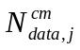 Number of data bits that are available for the CCTrCH in a compressed radio frame with TFC j.
P Number of PhCHs used for one CCTrCH.
PL Puncturing Limit for the uplink. Signalled from higher layers
RM_{i} Rate Matching attribute for TrCH i. Signalled from higher layers.
Temporary variables, i.e. variables used in several (sub)clauses with different meaning.
x, X
y, Y
z, Z

3.3 Abbreviations
For the purposes of the present document, the following abbreviations apply:
ARQ Automatic Repeat Request
BCH Broadcast Channel
BER Bit Error Rate
BLER Block Error Rate
BS Base Station
CCPCH Common Control Physical Channel
CCTrCH Coded Composite Transport Channel
CFN Connection Frame Number
CRC Cyclic Redundancy Check
DCH Dedicated Channel
DL Downlink (Forward link)
DPCCH Dedicated Physical Control Channel
DPCH Dedicated Physical Channel
DPDCH Dedicated Physical Data Channel
DS-CDMA Direct-Sequence Code Division Multiple Access
DTX Discontinuous Transmission
FACH Forward Access Channel
E-AGCH E-DCH Absolute Grant Channel
E-DCH Enhanced Dedicated Channel
E-DPCCH E-DCH Dedicated Physical Control Channel
E-DPDCH E-DCH Dedicated Physical Data Channel
E-HICH E-DCH Hybrid ARQ Indicator Channel
E-RGCH E-DCH Relative Grant Channel
FDD Frequency Division Duplex
F-DPCH Fractional Dedicated Physical Channel
FER Frame Error Rate
GF Galois Field
HARQ Hybrid Automatic Repeat reQuest
HS-DPCCH Dedicated Physical Control Channel (uplink) for HS-DSCH
HS-DSCH High Speed Downlink Shared Channel
HS-PDSCH High Speed Physical Downlink Shared Channel
HS-SCCH Shared Control Channel for HS-DSCH
MAC Medium Access Control
MBSFN MBMS over a Single Frequency Network
Mcps Mega Chip Per Second
MIMO Multiple Input Multiple Output
MS Mobile Station
OVSF Orthogonal Variable Spreading Factor (codes)
PCCC Parallel Concatenated Convolutional Code
PCH Paging Channel
PhCH Physical Channel
PRACH Physical Random Access Channel
RACH Random Access Channel
RSC Recursive Systematic Convolutional Coder
RV Redundancy Version
RX Receive
SCH Synchronisation Channel
SF Spreading Factor
SFN System Frame Number
SIR Signal-to-Interference Ratio
SNR Signal to Noise Ratio
TF Transport Format
TFC Transport Format Combination
TFCI Transport Format Combination Indicator
TPC Transmit Power Control
TrCH Transport Channel
TTI Transmission Time Interval
TX Transmit
UL Uplink (Reverse link)

4 Multiplexing, channel coding and interleaving

4.1 General
Data stream from/to MAC and higher layers (Transport block / Transport block set) is encoded/decoded to offer transport services over the radio transmission link. Channel coding scheme is a combination of error detection, error correcting, rate matching, interleaving and transport channels mapping onto/splitting from physical channels.

4.2 General coding/multiplexing of TrCHs
This section only applies to the transport channels: DCH, RACH, BCH, FACH and PCH. Other transport channels which do not use the general method are described separately below.
Data arrives to the coding/multiplexing unit in form of transport block sets once every transmission time interval. The transmission time interval is transport-channel specific from the set {10 ms, 20 ms, 40 ms, 80 ms}, where 80 ms TTI for DCH shall not be used unless SF=512.
The following coding/multiplexing steps can be identified:
- add CRC to each transport block (see subclause 4.2.1);
- transport block concatenation and code block segmentation (see subclause 4.2.2);
- channel coding (see subclause 4.2.3);
- radio frame equalisation (see subclause 4.2.4);
- rate matching (see subclause 4.2.7);
- insertion of discontinuous transmission (DTX) indication bits (see subclause 4.2.9);
- interleaving (two steps, see subclauses 4.2.5 and 4.2.11);
- radio frame segmentation (see subclause 4.2.6);
- multiplexing of transport channels (see subclause 4.2.8);
- physical channel segmentation (see subclause 4.2.10);
- mapping to physical channels (see subclause 4.2.12).
The coding/multiplexing steps for uplink and downlink are shown in figure 1 and figure 2 respectively.
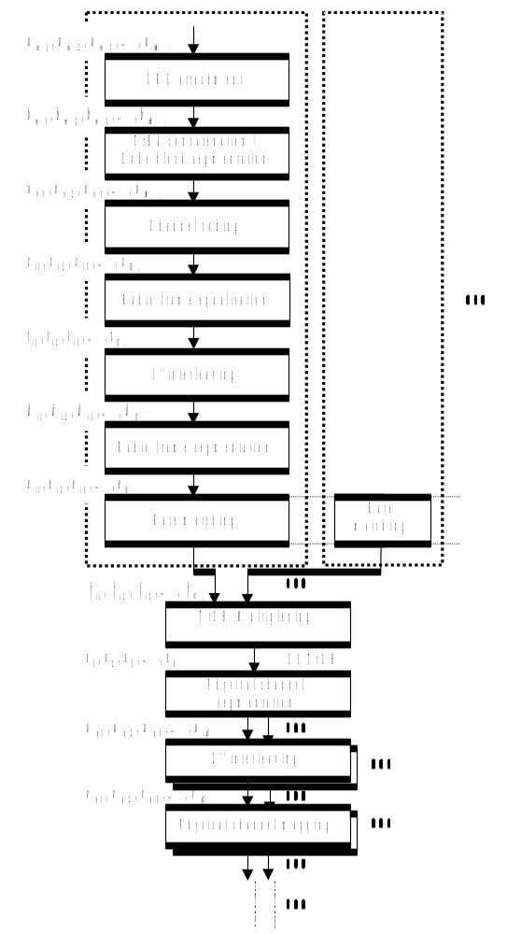
Figure 1: Transport channel multiplexing structure for uplink
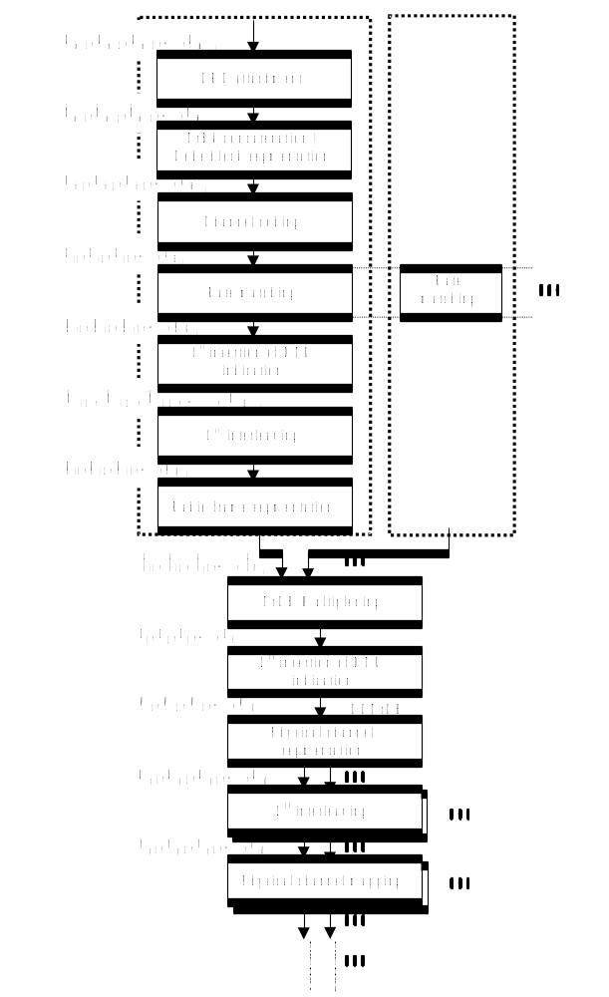
Figure 2: Transport channel multiplexing structure for downlink
The single output data stream from the TrCH multiplexing, including DTX indication bits in downlink, is denoted Coded Composite Transport Channel (CCTrCH). A CCTrCH can be mapped to one or several physical channels.

4.2.1 CRC attachment
Error detection is provided on transport blocks through a Cyclic Redundancy Check (CRC). The size of the CRC is 24, 16, 12, 8 or 0 bits and it is signalled from higher layers what CRC size that should be used for each TrCH.

4.2.1.1 CRC Calculation
The entire transport block is used to calculate the CRC parity bits for each transport block. The parity bits are generated by one of the following cyclic generator polynomials:
- g_{CRC24}(D) = D²⁴ + D²³ + D⁶ + D⁵ + D + 1;
- g_{CRC16}(D) = D¹⁶ + D¹² + D⁵ + 1;
- g_{CRC12}(D) = D¹² + D¹¹ + D³ + D² + D + 1;
- g_{CRC8}(D) = D⁸ + D⁷ + D⁴ + D³ + D + 1.
Denote the bits in a transport block delivered to layer 1 by 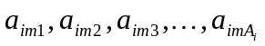, and the parity bits by 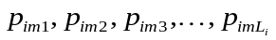. A_{i} is the size of a transport block of TrCH i, m is the transport block number, and L_{i} is the number of parity bits. L_{i} can take the values 24, 16, 12, 8, or 0 depending on what is signalled from higher layers.
The encoding is performed in a systematic form, which means that in GF(2), the polynomial:
yields a remainder equal to 0 when divided by g_{CRC24}(D), polynomial:
yields a remainder equal to 0 when divided by g_{CRC16}(D), polynomial:
yields a remainder equal to 0 when divided by g_{CRC12}(D) and polynomial:
yields a remainder equal to 0 when divided by g_{CRC8}(D).
If no transport blocks are input to the CRC calculation (M_{i} = 0), no CRC attachment shall be done. If transport blocks are input to the CRC calculation (M_{i} ≠ 0) and the size of a transport block is zero (A_{i} = 0), CRC shall be attached, i.e. all parity bits equal to zero.

4.2.1.2 Relation between input and output of the CRC attachment block
The bits after CRC attachment are denoted by 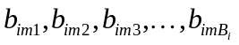, where B_{i} = A_{i}+ L_{i}. The relation between a_{imk} and b_{imk} is:
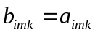 k = 1, 2, 3, …, A_{i}
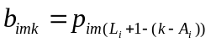 k = A_{i} + 1, A_{i} + 2, A_{i} + 3, …, A_{i} + L_{i}

4.2.2 Transport block concatenation and code block segmentation
All transport blocks in a TTI are serially concatenated. If the number of bits in a TTI is larger than Z, the maximum size of a code block in question, then code block segmentation is performed after the concatenation of the transport blocks. The maximum size of the code blocks depends on whether convolutional coding or turbo coding is used for the TrCH.

4.2.2.1 Concatenation of transport blocks
The bits input to the transport block concatenation are denoted by where i is the TrCH number, m is the transport block number, and B_{i} is the number of bits in each block (including CRC). The number of transport blocks on TrCH i is denoted by M_{i}. The bits after concatenation are denoted by 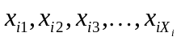, where i is the TrCH number and X_{i}=M_{i}B_{i}. They are defined by the following relations:
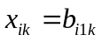 k = 1, 2, …, B_{i}
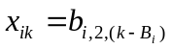 k = B_{i} + 1, B_{i} + 2, …, 2B_{i}
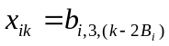 k = 2B_{i} + 1, 2B_{i} + 2, …, 3B_{i}
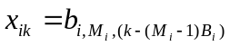 k = (M_{i} - 1)B_{i} + 1, (M_{i} - 1)B_{i} + 2, …, M_{i}B_{i}

4.2.2.2 Code block segmentation
Segmentation of the bit sequence from transport block concatenation is performed if X_{i}>Z. The code blocks after segmentation are of the same size. The number of code blocks on TrCH i is denoted by C_{i}. If the number of bits input to the segmentation, X_{i}, is not a multiple of C_{i}, filler bits are added to the beginning of the first block. If turbo coding is selected and X_{i} < 40, filler bits are added to the beginning of the code block. The filler bits are transmitted and they are always set to 0. The maximum code block sizes are:
- convolutional coding: Z = 504;
- turbo coding: Z = 5114.
The bits output from code block segmentation, for C_{i} ≠ 0, are denoted by 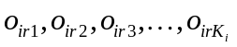, where i is the TrCH number, r is the code block number, and K_{i} is the number of bits per code block.
Number of code blocks:
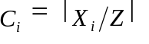
Number of bits in each code block (applicable for C_{i} ≠ 0 only):
if X_{i} < 40 and Turbo coding is used, then
K_{i} = 40
else
K_{i} = ⎡X_{i} / C_{i}⎤
end if
Number of filler bits: Y_{i} = C_{i}K_{i} - X_{i}
for k = 1 to Y_{i} -- Insertion of filler bits
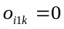
end for
for k = Y_{i}+1 to K_{i}
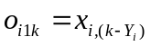
end for
r = 2 -- Segmentation
while r ≤ C_{i}
for k = 1 to K_{i}
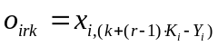_{I}
end for
r = r+1
end while

4.2.3 Channel coding
Code blocks are delivered to the channel coding block. They are denoted by , where i is the TrCH number, r is the code block number, and K_{i} is the number of bits in each code block. The number of code blocks on TrCH i is denoted by C_{i}. After encoding the bits are denoted by 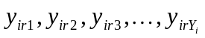, where Y_{i} is the number of encoded bits. The relation between o_{irk} and y_{irk} and between K_{i} and Y_{i} is dependent on the channel coding scheme.
The following channel coding schemes can be applied to TrCHs:
- convolutional coding;
- turbo coding.
Usage of coding scheme and coding rate for the different types of TrCH is shown in table 1.
The values of Y_{i} in connection with each coding scheme:
- convolutional coding with rate 1/2: Y_{i} = 2*K_{i} + 16; rate 1/3: Y_{i} = 3*K_{i} + 24;
- turbo coding with rate 1/3: Y_{i} = 3*K_{i} + 12.
Table 1: Usage of channel coding scheme and coding rate
Type of TrCH | Coding scheme | Coding rate
BCH | Convolutional coding | 1/2
PCH | Convolutional coding | 1/2
RACH | Convolutional coding | 1/2
DCH, FACH | Convolutional coding | 1/3, 1/2
DCH, FACH | Turbo coding | 1/3

4.2.3.1 Convolutional coding
Convolutional codes with constraint length 9 and coding rates 1/3 and 1/2 are defined.
The configuration of the convolutional coder is presented in figure 3.
Output from the rate 1/3 convolutional coder shall be done in the order output0, output1, output2, output0, output1, output 2, output 0,…,output2. Output from the rate 1/2 convolutional coder shall be done in the order output 0, output 1, output 0, output 1, output 0, …, output 1.
8 tail bits with binary value 0 shall be added to the end of the code block before encoding.
The initial value of the shift register of the coder shall be "all 0" when starting to encode the input bits.
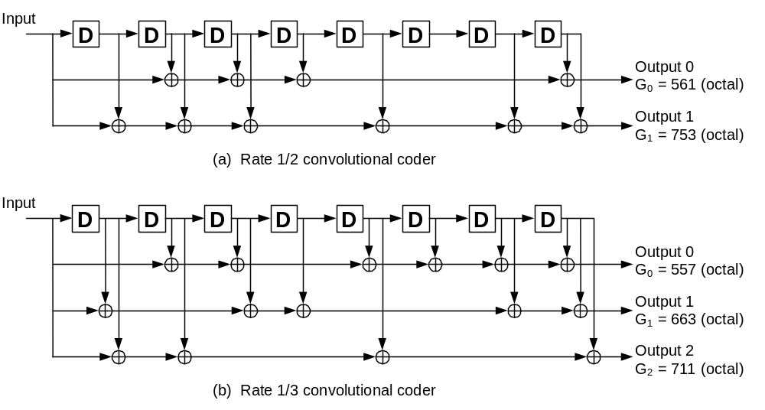
Figure 3: Rate 1/2 and rate 1/3 convolutional coders

4.2.3.2 Turbo coding

4.2.3.2.1 Turbo coder
The scheme of Turbo coder is a Parallel Concatenated Convolutional Code (PCCC) with two 8-state constituent encoders and one Turbo code internal interleaver. The coding rate of Turbo coder is 1/3. The structure of Turbo coder is illustrated in figure 4.
The transfer function of the 8-state constituent code for PCCC is:
G(D) = 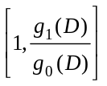,
where
g₀(D) = 1 + D² + D³,
g₁(D) = 1 + D + D³.
The initial value of the shift registers of the 8-state constituent encoders shall be all zeros when starting to encode the input bits.
Output from the Turbo coder is
x₁, z₁, z'₁, x₂, z₂, z'₂, …, x_{K}, z_{K}, z'_{K},
where x₁, x₂, …, x_{K} are the bits input to the Turbo coder i.e. both first 8-state constituent encoder and Turbo code internal interleaver, and K is the number of bits, and z₁, z₂, …, z_{K} and z'₁, z'₂, …, z'_{K} are the bits output from first and second 8-state constituent encoders, respectively.
The bits output from Turbo code internal interleaver are denoted by x'₁, x'₂, …, x'_{K}, and these bits are to be input to the second 8-state constituent encoder.
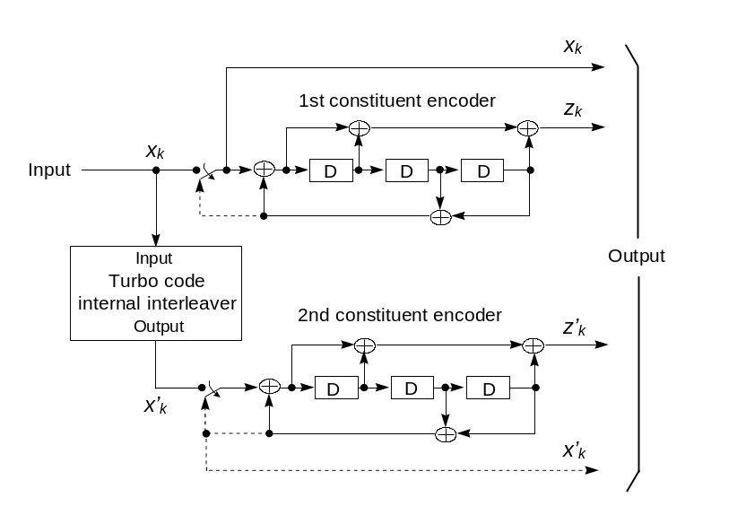
Figure 4: Structure of rate 1/3 Turbo coder (dotted lines apply for trellis termination only)

4.2.3.2.2 Trellis termination for Turbo coder
Trellis termination is performed by taking the tail bits from the shift register feedback after all information bits are encoded. Tail bits are padded after the encoding of information bits.
The first three tail bits shall be used to terminate the first constituent encoder (upper switch of figure 4 in lower position) while the second constituent encoder is disabled. The last three tail bits shall be used to terminate the second constituent encoder (lower switch of figure 4 in lower position) while the first constituent encoder is disabled.
The transmitted bits for trellis termination shall then be:
x_{K+1}, z_{K+1}, x_{K+2}, z_{K+2}, x_{K+3}, z_{K+3}, x'_{K+1}, z'_{K+1}, x'_{K+2}, z'_{K+2}, x'_{K+3}, z'_{K+3}.

4.2.3.2.3 Turbo code internal interleaver
The Turbo code internal interleaver consists of bits-input to a rectangular matrix with padding, intra-row and inter-row permutations of the rectangular matrix, and bits-output from the rectangular matrix with pruning. The bits input to the Turbo code internal interleaver are denoted by 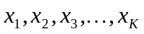, where K is the integer number of the bits and takes one value of 40 K 5114. The relation between the bits input to the Turbo code internal interleaver and the bits input to the channel coding is defined by 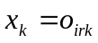 and K = K_{i}.
The following subclause specific symbols are used in subclauses 4.2.3.2.3.1 to 4.2.3.2.3.3:
K Number of bits input to Turbo code internal interleaver
R Number of rows of rectangular matrix
C Number of columns of rectangular matrix
p Prime number
v Primitive root
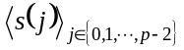 Base sequence for intra-row permutation
q_{i} Minimum prime integers
r_{i} Permuted prime integers
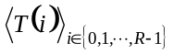 Inter-row permutation pattern
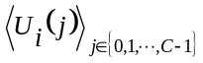 Intra-row permutation pattern of i-th row
i Index of row number of rectangular matrix
j Index of column number of rectangular matrix
k Index of bit sequence

4.2.3.2.3.1 Bits-input to rectangular matrix with padding
The bit sequence input to the Turbo code internal interleaver is written into the rectangular matrix as follows.
(1) Determine the number of rows of the rectangular matrix, R, such that:
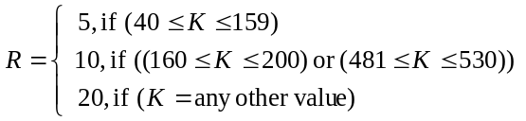.
The rows of rectangular matrix are numbered 0, 1, …, R - 1 from top to bottom.
(2) Determine the prime number to be used in the intra-permutation, p, and the number of columns of rectangular matrix, C, such that:
if (481 K 530) then
p = 53 and C = p.
else
Find minimum prime number p from table 2 such that
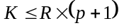,
and determine C such that
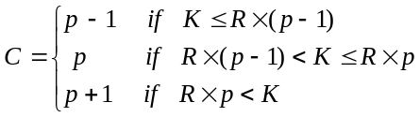.
end if
The columns of rectangular matrix are numbered 0, 1, …, C - 1 from left to right.
Table 2: List of prime number p and associated primitive root v
p | v | p | v | p | v | p | v | p | v
7 | 3 | 47 | 5 | 101 | 2 | 157 | 5 | 223 | 3
11 | 2 | 53 | 2 | 103 | 5 | 163 | 2 | 227 | 2
13 | 2 | 59 | 2 | 107 | 2 | 167 | 5 | 229 | 6
17 | 3 | 61 | 2 | 109 | 6 | 173 | 2 | 233 | 3
19 | 2 | 67 | 2 | 113 | 3 | 179 | 2 | 239 | 7
23 | 5 | 71 | 7 | 127 | 3 | 181 | 2 | 241 | 7
29 | 2 | 73 | 5 | 131 | 2 | 191 | 19 | 251 | 6
31 | 3 | 79 | 3 | 137 | 3 | 193 | 5 | 257 | 3
37 | 2 | 83 | 2 | 139 | 2 | 197 | 2
41 | 6 | 89 | 3 | 149 | 2 | 199 | 3
43 | 3 | 97 | 5 | 151 | 6 | 211 | 2

(3) Write the input bit sequence into the R C rectangular matrix row by row starting with bit y₁ in column 0 of row 0:
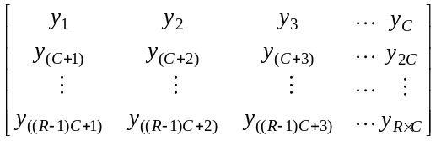
where y_{k} = x_{k} for k = 1, 2, …, K and if RCK, the dummy bits are padded such that 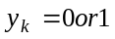 for k = K + 1, K + 2, …, RC. These dummy bits are pruned away from the output of the rectangular matrix after intra-row and inter-row permutations.

4.2.3.2.3.2 Intra-row and inter-row permutations
After the bits-input to the RC rectangular matrix, the intra-row and inter-row permutations for the RC rectangular matrix are performed stepwise by using the following algorithm with steps (1) – (6):
(1) Select a primitive root v from table 2 in section 4.2.3.2.3.1, which is indicated on the right side of the prime number p.
(2) Construct the base sequence for intra-row permutation as:
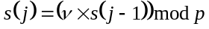, j = 1, 2,…, (p - 2), and s(0) = 1.
(3) Assign q₀ = 1 to be the first prime integer in the sequence 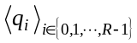, and determine the prime integer q_{i} in the sequence to be a least prime integer such that g.c.d(q_{i}, p - 1) = 1, q_{i} > 6, and q_{i} > q_{(i - 1)} for each i = 1, 2, …, R – 1. Here g.c.d. is greatest common divisor.
(4) Permute the sequence to make the sequence 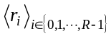 such that
r_{T(i)} = q_{i}, i = 0, 1, …, R - 1,
where is the inter-row permutation pattern defined as the one of the four kind of patterns, which are shown in table 3, depending on the number of input bits K.

Table 3: Inter-row permutation patterns for Turbo code internal interleaver
Number of input bits  K | Number of rows R | Inter-row permutation patterns  <T(0), T(1), …, T(R - 1)>
(40K159) | 5 | <4, 3, 2, 1, 0>
(160K200) or (481K530) | 10 | <9, 8, 7, 6, 5, 4, 3, 2, 1, 0>
(2281K2480) or (3161K3210) | 20 | <19, 9, 14, 4, 0, 2, 5, 7, 12, 18, 16, 13, 17, 15, 3, 1, 6, 11, 8, 10>
K = any other value | 20 | <19, 9, 14, 4, 0, 2, 5, 7, 12, 18, 10, 8, 13, 17, 3, 1, 16, 6, 15, 11>

(5) Perform the i-th (i = 0, 1, …, R - 1) intra-row permutation as:
if (C = p) then
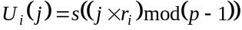, j = 0, 1, …, (p - 2), and U_{i}(p - 1) = 0,
where U_{i}(j) is the original bit position of j-th permuted bit of i-th row.
end if
if (C = p + 1) then
, j = 0, 1, …, (p - 2). U_{i}(p - 1) = 0, and U_{i}(p) = p,
where U_{i}(j) is the original bit position of j-th permuted bit of i-th row, and
if (K = RC) then
Exchange U_{R-1}(p) with U_{R-1}(0).
end if
end if
if (C = p - 1) then
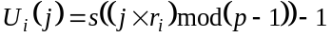, j = 0, 1, …, (p - 2),
where U_{i}(j) is the original bit position of j-th permuted bit of i-th row.
end if
(6) Perform the inter-row permutation for the rectangular matrix based on the pattern ,
where T(i) is the original row position of the i-th permuted row.

4.2.3.2.3.3 Bits-output from rectangular matrix with pruning
After intra-row and inter-row permutations, the bits of the permuted rectangular matrix are denoted by y'_{k}:
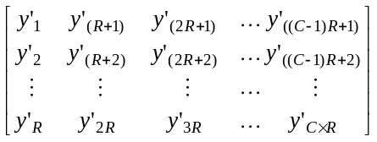
The output of the Turbo code internal interleaver is the bit sequence read out column by column from the intra-row and inter-row permuted R C rectangular matrix starting with bit y'₁ in row 0 of column 0 and ending with bit y'_{CR} in row R - 1 of column C - 1. The output is pruned by deleting dummy bits that were padded to the input of the rectangular matrix before intra-row and inter row permutations, i.e. bits y'_{k} that corresponds to bits y_{k} with k > K are removed from the output. The bits output from Turbo code internal interleaver are denoted by x'₁, x'₂, …, x'_{K}, where x'₁ corresponds to the bit y'_{k} with smallest index k after pruning, x'₂ to the bit y'_{k} with second smallest index k after pruning, and so on. The number of bits output from Turbo code internal interleaver is K and the total number of pruned bits is:
R C – K.

4.2.3.3 Concatenation of encoded blocks
After the channel coding for each code block, if C_{i} is greater than 1, the encoded blocks are serially concatenated so that the block with lowest index r is output first from the channel coding block, otherwise the encoded block is output from channel coding block as it is. The bits output are denoted by 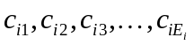, where i is the TrCH number and E_{i} = C_{i}Y_{i}. The output bits are defined by the following relations:
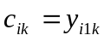 k = 1, 2, …, Y_{i}
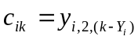 k = Y_{i} + 1, Y_{i} + 2, …, 2Y_{i}
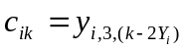 k = 2Y_{i} + 1, 2Y_{i} + 2, …, 3Y_{i}
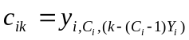 k = (C_{i} - 1)Y_{i} + 1, (C_{i} - 1)Y_{i} + 2, …, C_{i}Y_{i}
If no code blocks are input to the channel coding (C_{i} = 0), no bits shall be output from the channel coding, i.e. E_{i} = 0.

4.2.4 Radio frame size equalisation
Radio frame size equalisation is padding the input bit sequence in order to ensure that the output can be segmented in F_{i} data segments of same size as described in subclause 4.2.7. Radio frame size equalisation is only performed in the UL.
The input bit sequence to the radio frame size equalisation is denoted by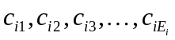, where i is TrCH number and E_{i} the number of bits. The output bit sequence is denoted by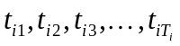, where T_{i} is the number of bits. The output bit sequence is derived as follows:
- t_{ik} = c_{ik,} for k = 1… E_{i}; and
- t_{ik} = {0, 1} for k= E_{i} +1… T_{i}, if E_{i} < T_{i};
where
- T_{i} = F_{i} * N_{i}; and
- 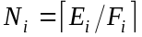 is the number of bits per segment after size equalisation.

4.2.5 1st interleaving

4.2.5.1 Void

4.2.5.2 1st interleaver operation
The 1st interleaving is a block interleaver with inter-column permutations. The input bit sequence to the block interleaver is denoted by 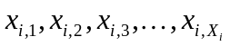, where i is TrCH number and X_{i} the number of bits. Here X_{i} is guaranteed to be an integer multiple of the number of radio frames in the TTI. The output bit sequence from the block interleaver is derived as follows:
(1) Select the number of columns C1 from table 4 depending on the TTI. The columns are numbered 0, 1, …, C1 - 1 from left to right.
(2) Determine the number of rows of the matrix, R1 defined as
R1 = X_{i} / C1.
The rows of the matrix are numbered 0, 1, …, R1 - 1 from top to bottom.
(3) Write the input bit sequence into the R1 C1 matrix row by row starting with bit 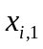 in column 0 of row 0 and ending with bit 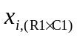 in column C1 - 1 of row R1 - 1:
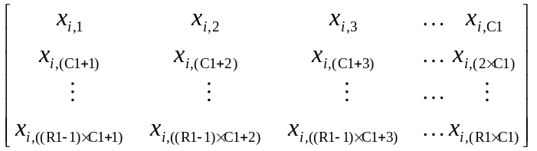
(4) Perform the inter-column permutation for the matrix based on the pattern 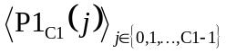 shown in table 4, where P1_{C1} (j) is the original column position of the j-th permuted column. After permutation of the columns, the bits are denoted by y_{ik}:
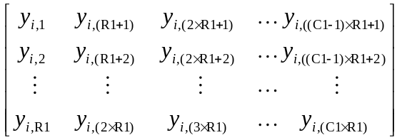
(5) Read the output bit sequence 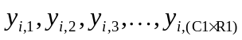 of the block interleaver column by column from the inter-column permuted R1 C1 matrix. Bit 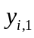 corresponds to row 0 of column 0 and bit 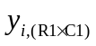 corresponds to row R1 - 1 of column C1 - 1.
Table 4 Inter-column permutation patterns for 1st interleaving
TTI | Number of columns C1 | Inter-column permutation patterns  <P1_{C1}(0), P1_{C1}(1), …, P1_{C1}(C1-1)>
10 ms | 1 | <0>
20 ms | 2 | <0,1>
40 ms | 4 | <0,2,1,3>
80 ms | 8 | <0,4,2,6,1,5,3,7>

4.2.5.3 Relation between input and output of 1st interleaving in uplink
The bits input to the 1st interleaving are denoted by 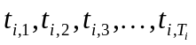, where i is the TrCH number and T_{i} the number of bits. Hence, x_{i,k} = t_{i,k} and X_{i} = T_{i}.
The bits output from the 1st interleaving are denoted by 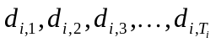, and d_{i,k} = y_{i,k}.

4.2.5.4 Relation between input and output of 1st interleaving in downlink
If fixed positions of the TrCHs in a radio frame is used then the bits input to the 1st interleaving are denoted by 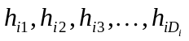, where i is the TrCH number. Hence, x_{ik} = h_{ik} and X_{i} = D_{i}.
If flexible positions of the TrCHs in a radio frame is used then the bits input to the 1st interleaving are denoted by 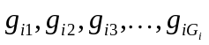, where i is the TrCH number. Hence, x_{ik} = g_{ik} and X_{i} = G_{i}.
The bits output from the 1st interleaving are denoted by 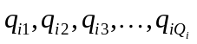, where i is the TrCH number and Q_{i} is the number of bits. Hence, q_{ik} = y_{ik}, Q_{i} = F_{i}H_{i} if fixed positions are used, and Q_{i} = G_{i} if flexible positions are used.

4.2.6 Radio frame segmentation
When the transmission time interval is longer than 10 ms, the input bit sequence is segmented and mapped onto consecutive F_{i} radio frames. Following rate matching in the DL and radio frame size equalisation in the UL the input bit sequence length is guaranteed to be an integer multiple of F_{i}.
The input bit sequence is denoted by 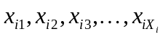 where i is the TrCH number and X_{i} is the number bits. The F_{i} output bit sequences per TTI are denoted by 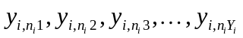where n_{i} is the radio frame number in current TTI and Y_{i} is the number of bits per radio frame for TrCH i. The output sequences are defined as follows:
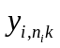= 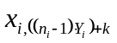, n_{i} = 1…F_{i}, k = 1…Y_{i}
where
Y_{i} = (X_{i} / F_{i}) is the number of bits per segment.
The n_{i} -th segment is mapped to the n_{i} -th radio frame of the transmission time interval.

4.2.6.1 Relation between input and output of the radio frame segmentation block in uplink
The input bit sequence to the radio frame segmentation is denoted by 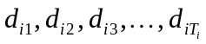, where i is the TrCH number and T_{i} the number of bits. Hence, x_{ik} = d_{ik} and X_{i} = T_{i}.
The output bit sequence corresponding to radio frame n_{i} is denoted by 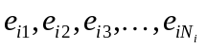, where i is the TrCH number and N_{i} is the number of bits. Hence, 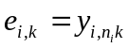and N_{i} = Y_{i}.

4.2.6.2 Relation between input and output of the radio frame segmentation block in downlink
The bits input to the radio frame segmentation are denoted by 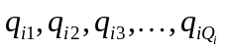, where i is the TrCH number and Q_{i} the number of bits. Hence, x_{ik} = q_{ik} and X_{i} = Q_{i}.
The output bit sequence corresponding to radio frame n_{i} is denoted by 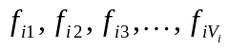, where i is the TrCH number and V_{i} is the number of bits. Hence, 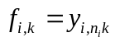and V_{i} = Y_{i}.

4.2.7 Rate matching
Rate matching means that bits on a transport channel are repeated or punctured. Higher layers assign a rate-matching attribute for each transport channel. This attribute is semi-static and can only be changed through higher layer signalling. The rate-matching attribute is used when the number of bits to be repeated or punctured is calculated.
The number of bits on a transport channel can vary between different transmission time intervals. In the downlink the transmission is interrupted if the number of bits is lower than maximum. When the number of bits between different transmission time intervals in uplink is changed, bits are repeated or punctured to ensure that the total bit rate after TrCH multiplexing is identical to the total channel bit rate of the allocated dedicated physical channels.
If no bits are input to the rate matching for all TrCHs within a CCTrCH, the rate matching shall output no bits for all TrCHs within the CCTrCH and no uplink DPDCH will be selected in the case of uplink rate matching.
Notation used in subclause 4.2.7 and subclauses:
N_{i,j}: For uplink: Number of bits in a radio frame before rate matching on TrCH i with transport format combination j .
For downlink: An intermediate calculation variable (not an integer but a multiple of 1/8).
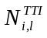: Number of bits in a transmission time interval before rate matching on TrCH i with transport format l. Used in downlink only.
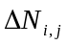: For uplink: If positive - number of bits that should be repeated in each radio frame on TrCH i with transport format combination j.
If negative - number of bits that should be punctured in each radio frame on TrCH i with transport format combination j.
For downlink : An intermediate calculation variable (not an integer but a multiple of 1/8).
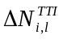: If positive - number of bits to be repeated in each transmission time interval on TrCH i with transport format l.
If negative - number of bits to be punctured in each transmission time interval on TrCH i with transport format l.
Used in downlink only.
N_{TGL}: Positive or null: number of bits in the radio frame corresponding to the gap for compressed mode for the CCTrCH.
RM_{i}: Semi-static rate matching attribute for transport channel i. RM_{i} is provided by higher layers or takes a value as indicated in section 4.2.13.
PL: Puncturing limit for uplink. This value limits the amount of puncturing that can be applied in order to avoid multicode or to enable the use of a higher spreading factor. Signalled from higher layers. The allowed puncturing in % is actually equal to (1-PL)*100.
N_{data,j}: Total number of bits that are available for the CCTrCH in a radio frame with transport format combination j.
I: Number of TrCHs in the CCTrCH.
Z_{i,j}: Intermediate calculation variable.
F_{i}: Number of radio frames in the transmission time interval of TrCH i.
n_{i}: Radio frame number in the transmission time interval of TrCH i (0 ≤ n_{i} < F_{i}).
q: Average puncturing or repetition distance (normalised to only show the remaining rate matching on top of an integer number of repetitions). Used in uplink only.
P1_{F}(n_{i}): The column permutation function of the 1st interleaver, P1_{F}(x) is the original position of column with number x after permutation. P1 is defined on table 4 of section 4.2.5.2 (note that the P1_{F} is self-inverse). Used for rate matching in uplink only.
S[n]: The shift of the puncturing or repetition pattern for radio frame n_{i} when 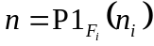. Used in uplink only.
TF_{i}(j): Transport format of TrCH i for the transport format combination j.
TFS(i) The set of transport format indexes l for TrCH i.
TFCS The set of transport format combination indexes j.
e_{ini} Initial value of variable e in the rate matching pattern determination algorithm of subclause 4.2.7.5.
e_{plus} Increment of variable e in the rate matching pattern determination algorithm of subclause4.2.7.5.
e_{minus} Decrement of variable e in the rate matching pattern determination algorithm of subclause 4.2.7.5.
b: Indicates systematic and parity bits
b=1: Systematic bit. x_{k} in subclause 4.2.3.2.1.
b=2: 1st parity bit (from the upper Turbo constituent encoder). z_{k} in subcaluse 4.2.3.2.1.
b=3: 2nd parity bit (from the lower Turbo constituent encoder). z'_{k} in subclause 4.2.3.2.1.
The * (star) notation is used to replace an index x when the indexed variable X_{x} does not depend on the index x. In the left wing of an assignment the meaning is that "X* = Y" is equivalent to "for all x do X_{x} = Y ". In the right wing of an assignment, the meaning is that "Y = X* " is equivalent to "take any x and do Y = X_{x}".
The following relations, defined for all TFC j, are used when calculating the rate matching parameters:
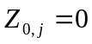
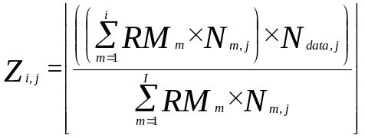 for all i = 1 … I (1)
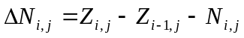 for all i = 1 … I

4.2.7.1 Determination of rate matching parameters in uplink

4.2.7.1.1 Determination of SF and number of PhCHs needed
In uplink, puncturing can be applied to match the CCTrCH bit rate to the PhCH bit rate. The bit rate of the PhCH(s) is limited by the UE capability and restrictions imposed by UTRAN, through limitations on the PhCH spreading factor. The maximum amount of puncturing that can be applied is 1-PL, PL is signalled from higher layers. The number of available bits in the radio frames of one PhCH for all possible spreading factors is given in [2]. Denote these values by N₂₅₆, N₁₂₈, N₆₄, N₃₂, N₁₆, N₈, and N₄, where the index refers to the spreading factor. The possible number of bits available to the CCTrCH on all PhCHs, N_{data}, then are { N₂₅₆, N₁₂₈, N₆₄, N₃₂, N₁₆, N₈, N_{4,} 2×N₄, 3×N₄, 4×N₄, 5×N₄, 6×N₄}.
For a RACH CCTrCH SET0 represents the set of N_{data} values allowed by the UTRAN, as set by the minimum SF provided by higher layers. SET0 may be a sub-set of { N₂₅₆, N₁₂₈, N₆₄, N₃₂ }. SET0 does not take into account the UE’s capability.
For other CCTrCHs, SET0 denotes the set of N_{data} values allowed by the UTRAN and supported by the UE, as part of the UE’s capability. SET0 can be a subset of { N₂₅₆, N₁₂₈, N₆₄, N₃₂, N₁₆, N₈, N_{4,} 2×N₄, 3×N₄, 4×N₄, 5×N₄, 6×N₄}. N_{data, j} for the transport format combination j is determined by executing the following algorithm:
SET1 = { N_{data} in SET0 such that 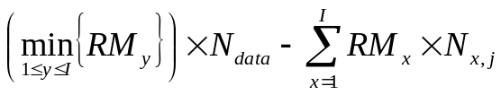 is non negative }
If SET1 is not empty and the smallest element of SET1 requires just one PhCH then
N_{data,j} = min SET1
else
SET2 = { N_{data} in SET0 such that 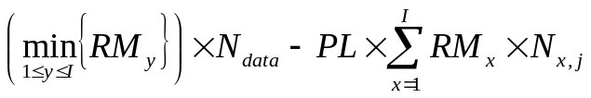 is non negative }
Sort SET2 in ascending order
N_{data} = min SET2
While N_{data} is not the max of SET2 and the follower of N_{data} requires no additional PhCH do
N_{data} = follower of N_{data} in SET2
End while
N_{data,j} = N_{data}
End if
For a RACH CCTrCH, if N_{data,j} is not part of the UE’s capability then the TFC j cannot be used.

4.2.7.1.2 Determination of parameters needed for calculating the rate matching pattern
The number of bits to be repeated or punctured, ΔN_{i,j}, within one radio frame for each TrCH i is calculated with equation 1 for all possible transport format combinations j and selected every radio frame. N_{data,j} is given from subclause 4.2.7.1.1.
In a compressed radio frame, 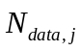 is replaced by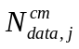 in Equation 1. is given as follows:
In a radio frame compressed by higher layer scheduling, is obtained by executing the algorithm in subclause 4.2.7.1.1 but with the number of bits in one radio frame of one PhCH reduced to 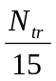 of the value in normal mode.
N_{tr} is the number of transmitted slots in a compressed radio frame and is defined by the following relation:

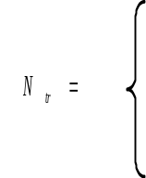 | 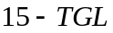, if N_{first} + TGL ≤ 15  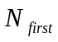, in first frame if N_{first} + TGL > 15  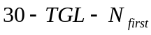, in second frame if N_{first} + TGL > 15

N_{first} and TGL are defined in subclause 4.4.
In a radio frame compressed by spreading factor reduction, 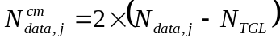, where 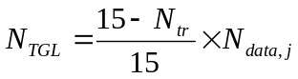
If ΔN_{i,j} = 0 then the output data of the rate matching is the same as the input data and the rate matching algorithm of subclause 4.2.7.5 does not need to be executed.
If ΔN_{i,j} ≠ 0 the parameters listed in subclauses 4.2.7.1.2.1 and 4.2.7.1.2.2 shall be used for determining e_{ini}, e_{plus}, and e_{minus} (regardless if the radio frame is compressed or not).

4.2.7.1.2.1 Convolutionally encoded TrCHs
R = ΔN_{i,j} mod N_{i,j} -- note: in this context ΔN_{i,j} mod N_{i,j} is in the range of 0 to N_{ij}-1 i.e. -1 mod 10 = 9.
if R ≠ 0 and 2×R ≤ N_{ij}
then q = ⎡ N_{i,j} / R ⎤
else
q = ⎡ N_{i,j} / (R - N_{i,j}) ⎤
endif
-- note: q is a signed quantity.
if q is even
then q' = q + gcd(⎜q⎜, F_{i})/ F_{i} -- where gcd (⎜q⎜, F_{i}) means greatest common divisor of ⎜q⎜ and F_{i}
-- note that q' is not an integer, but a multiple of 1/8
else
q' = q
endif
for x = 0 to F_{i} - 1
S[⎜ ⎣x×q'⎦ ⎜ mod F_{i}] = (⎜ ⎣x×q'⎦ ⎜ div F_{i})
end for
ΔN_{i} = ΔN_{i,j}
a = 2
For each radio frame, the rate-matching pattern is calculated with the algorithm in subclause 4.2.7.5, where :
X_{i} = N_{i,j}., and
e_{ini} = (a×S[P1_{Fi}(n_{i})]×|ΔN_{i} | + 1) mod (a⋅N_{ij}).
e_{plus} = a×N_{i,j}
e_{minus} = a×|ΔN_{i}|
puncturing for ΔN <0, repetition otherwise.

4.2.7.1.2.2 Turbo encoded TrCHs
If repetition is to be performed on turbo encoded TrCHs, i.e. ΔN_{i,j} >0, the parameters in subclause 4.2.7.1.2.1 are used.
If puncturing is to be performed, the parameters below shall be used. Index b is used to indicate systematic (b=1), 1st parity (b=2), and 2nd parity bit (b=3).
a=2 when b=2
a=1 when b=3
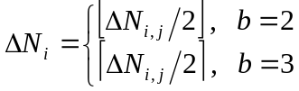
If 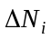 is calculated as 0 for b=2 or b=3, then the following procedure and the rate matching algorithm of subclause 4.2.7.5 don't need to be performed for the corresponding parity bit stream.
X_{i} = ⎣N_{i,j} /3⎦ ,
q = ⎣X_{i} /|ΔN_{i}| ⎦
if(q2)
for r=0 to F_{i}-1
S[(3×r+b-1) mod F_{I}] = r mod 2;
end for
else
if q is even
then q' = q – gcd( q, F_{i})/ F_{i} -- where gcd ( q, F_{i}) means greatest common divisor of q and F_{i}
-- note that q' is not an integer, but a multiple of 1/8
else q' = q
endif
for x=0 to F_{i} -1
r = ⎡x×q'⎤ mod F_{i};
S[(3×r+b-1) mod F_{i}] = ⎡x×q'⎤ div F_{i};
endfor
endif
For each radio frame, the rate-matching pattern is calculated with the algorithm in subclause 4.2.7.5, where:
X_{i} is as above:
e_{ini} = (a×S[P1_{Fi}(n_{i})] ×|ΔN_{i}| + X_{i}) mod (a×X_{i}), if e_{ini} =0 then e_{ini} = a×X_{i}
e_{plus} = a×X_{i}
e_{minus} = a×⎥ΔN_{i}⎥

4.2.7.2 Determination of rate matching parameters in downlink
For downlink channels, N_{data,j} does not depend on the transport format combination j. N_{data,*} is given by the channelization code(s) assigned by higher layers.
Denote the number of physical channels used for the CCTrCH by P. N_{data,*} is the number of bits available to the CCTrCH in one radio frame and defined as N_{data,*}=P×15×(N_{data1}+N_{data2}), where N_{data1} and N_{data2} are defined in [2]. Note that contrary to the uplink, the same rate matching patterns are used in TTIs containing no compressed radio frames and in TTIs containing radio frames compressed by spreading factor reduction or higher layer scheduling.

4.2.7.2.1 Determination of rate matching parameters for fixed positions of TrCHs

4.2.7.2.1.1 Calculation of ΔN_{i,max} for normal mode and compressed mode by spreading factor reduction
First an intermediate calculation variable 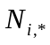 is calculated for all transport channels i by the following formula:
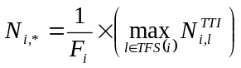
In order to compute the 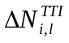 parameters for all TrCH i and all TF l, we first compute an intermediate parameter ΔN_{i,max} by the following formula, where 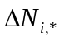 is derived from by the formula given at subclause 4.2.7:
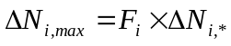
If 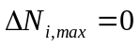 then, for TrCH i, the output data of the rate matching is the same as the input data and the rate matching algorithm of subclause 4.2.7.5 does not need to be executed. In this case we have :
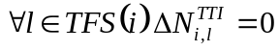
If 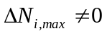 the parameters listed in subclauses 4.2.7.2.1.3 and 4.2.7.2.1.4 shall be used for determining e_{ini}, e_{plus}, and e_{minus}, and .

4.2.7.2.1.2 Void

4.2.7.2.1.3 Determination of rate matching parameters for convolutionally encoded TrCHs
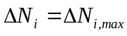
a=2
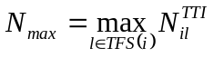
For each transmission time interval of TrCH i with TF l, the rate-matching pattern is calculated with the algorithm in subclause 4.2.7.5. The following parameters are used as input:
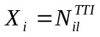
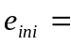1
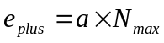
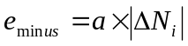
Puncturing if 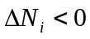, repetition otherwise. The values of 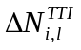may be computed by counting repetitions or puncturing when the algorithm of subclause 4.2.7.5 is run. The resulting values of can be represented with following expression.
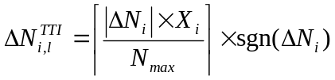

4.2.7.2.1.4 Determination of rate matching parameters for Turbo encoded TrCHs
If repetition is to be performed on turbo encoded TrCHs, i.e.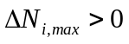, the parameters in subclause 4.2.7.2.1.3 are used.
If puncturing is to be performed, the parameters below shall be used. Index b is used to indicate systematic (b=1), 1st parity (b=2), and 2nd parity bit (b=3).
a=2 when b=2
a=1 when b=3
The bits indicated by b=1 shall not be punctured.
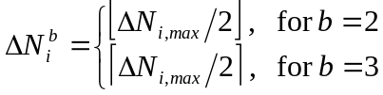
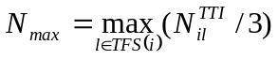
For each transmission time interval of TrCH i with TF l, the rate-matching pattern is calculated with the algorithm in subcaluse 4.2.7.5. The following parameters are used as input:
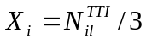
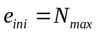
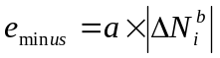
The values of may be computed by counting puncturing when the algorithm of subclause 4.2.7.5 is run. The resulting values of can be represented with following expression.
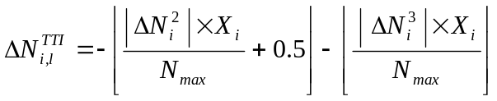
In the above equation, the first term of the right hand side represents the amount of puncturing for b=2 and the second term represents the amount of puncturing for b=3.

4.2.7.2.2 Determination of rate matching parameters for flexible positions of TrCHs

4.2.7.2.2.1 Calculations for normal mode, compressed mode by higher layer scheduling, and compressed mode by spreading factor reduction
First an intermediate calculation variable 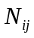 is calculated for all transport channels i and all transport format combinations j by the following formula:
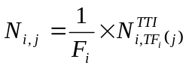
Then rate matching ratios RF_{i} are calculated for each the transport channel i in order to minimise the number of DTX bits when the bit rate of the CCTrCH is maximum. The RF_{i} ratios are defined by the following formula:
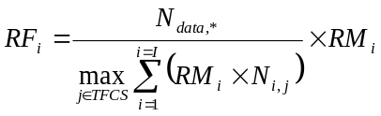
The computation of parameters is then performed in two phases. In a first phase, tentative temporary values of are computed, and in the second phase they are checked and corrected. The first phase, by use of the RF_{i} ratios, ensures that the number of DTX indication bits inserted is minimum when the CCTrCH bit rate is maximum, but it does not ensure that the maximum CCTrCH bit rate is not greater than N_{data,*}. per 10ms. The latter condition is ensured through the checking and possible corrections carried out in the second phase.
At the end of the second phase, the latest value of is the definitive value.
The first phase defines the tentative temporary for all transport channel i and any of its transport format l by use of the following formula:
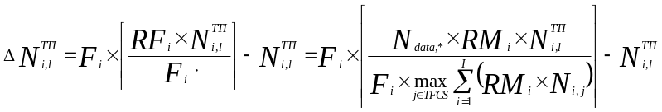
The second phase is defined by the following algorithm:
for all in TFCS in ascending order of TFCI do -- for all TFC
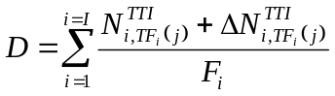 -- CCTrCH bit rate (bits per 10ms) for TFC j
if 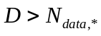 then
for i = 1 to I do -- for all TrCH
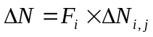 -- 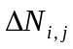 is derived from 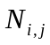 by the formula given at subclause 4.2.7.
if 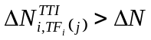then
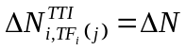
end-if
end-for
end-if
end-for
If 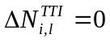 then, for TrCH i at TF l, the output data of the rate matching is the same as the input data and the rate matching algorithm of subclause 4.2.7.5 does not need to be executed.
If 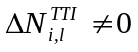 the parameters listed in subclauses 4.2.7.2.2.2 and 4.2.7.2.2.3 shall be used for determining e_{ini}, e_{plus}, and e_{minus}.

4.2.7.2.2.2 Determination of rate matching parameters for convolutionally encoded TrCHs
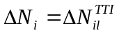
a=2
For each transmission time interval of TrCH i with TF l, the rate-matching pattern is calculated with the algorithm in subclause 4.2.7.5. The following parameters are used as input:
1
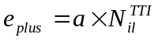
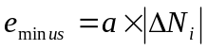
puncturing for 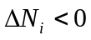, repetition otherwise.

4.2.7.2.2.3 Determination of rate matching parameters for Turbo encoded TrCHs
If repetition is to be performed on turbo encoded TrCHs, i.e. 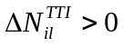, the parameters in subclause 4.2.7.2.2.2 are used.
If puncturing is to be performed, the parameters below shall be used. Index b is used to indicate systematic (b=1), 1st parity (b=2), and 2nd parity bit (b=3).
a=2 when b=2
a=1 when b=3
The bits indicated by b=1 shall not be punctured.
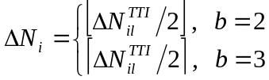
For each transmission time interval of TrCH i with TF l, the rate-matching pattern is calculated with the algorithm in subclause 4.2.7.5. The following parameters are used as input:
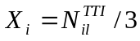,
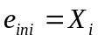,
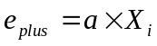

4.2.7.3 Bit separation and collection in uplink
The systematic bits of turbo encoded TrCHs shall not be punctured, the other bits may be punctured. The systematic bits, first parity bits, and second parity bits in the bit sequence input to the rate matching block are therefore separated into three sequences.
The first sequence contains:
- All of the systematic bits that are from turbo encoded TrCHs.
- From 0 to 2 first and/or second parity bits that are from turbo encoded TrCHs. These bits come into the first sequence when the total number of bits in a block after radio frame segmentation is not a multiple of three.
- Some of the systematic, first parity and second parity bits that are for trellis termination.
The second sequence contains:
- All of the first parity bits that are from turbo encoded TrCHs, except those that go into the first sequence when the total number of bits is not a multiple of three.
- Some of the systematic, first parity and second parity bits that are for trellis termination.
The third sequence contains:
- All of the second parity bits that are from turbo encoded TrCHs, except those that go into the first sequence when the total number of bits is not a multiple of three.
- Some of the systematic, first parity and second parity bits that are for trellis termination.
The second and third sequences shall be of equal length, whereas the first sequence can contain from 0 to 2 more bits. Puncturing is applied only to the second and third sequences.The bit separation function is transparent for convolutionally encoded TrCHs and for turbo encoded TrCHs with repetition. The bit separation and bit collection are illustrated in figures 5 and 6.
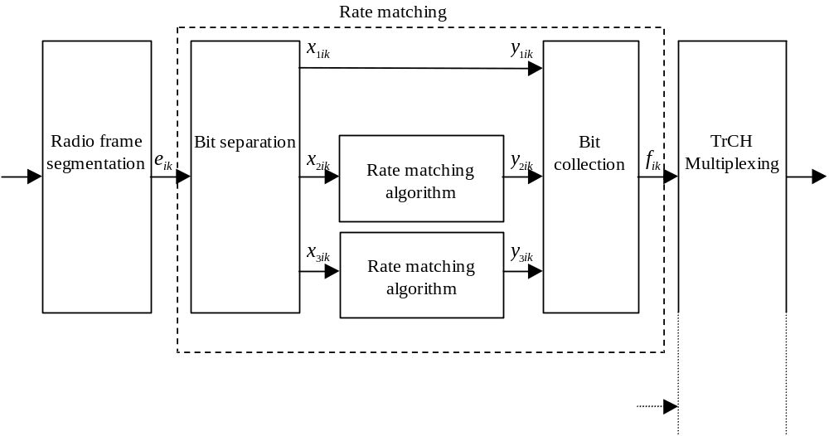
Figure 5: Puncturing of turbo encoded TrCHs in uplink
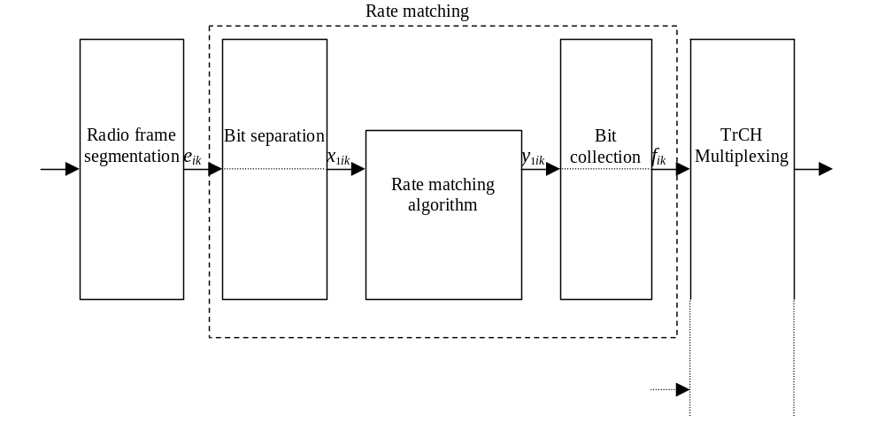
Figure 6: Rate matching for convolutionally encoded TrCHs
and for turbo encoded TrCHs with repetition in uplink
The bit separation is dependent on the 1st interleaving and offsets are used to define the separation for different TTIs. b indicates the three sequences defined in this section, with b=1 indicating the first sequence, b = 2 the second one, and b = 3 the third one. The offsets α_{b} for these sequences are listed in table 5.
Table 5: TTI dependent offset needed for bit separation
TTI (ms) | α₁ | α₂ | α₃
10, 40 | 0 | 1 | 2
20, 80 | 0 | 2 | 1

The bit separation is different for different radio frames in the TTI. A second offset is therefore needed. The radio frame number for TrCH i is denoted by n_{i}. and the offset by 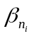.
Table 6: Radio frame dependent offset needed for bit separation
TTI (ms) | β₀ | β₁ | β₂ | β₃ | β₄ | β₅ | β₆ | β₇
10 | 0 | NA | NA | NA | NA | NA | NA | NA
20 | 0 | 1 | NA | NA | NA | NA | NA | NA
40 | 0 | 1 | 2 | 0 | NA | NA | NA | NA
80 | 0 | 1 | 2 | 0 | 1 | 2 | 0 | 1

4.2.7.3.1 Bit separation
The bits input to the rate matching are denoted by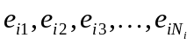, where i is the TrCH number and N_{i} is the number of bits input to the rate matching block. Note that the transport format combination number j for simplicity has been left out in the bit numbering, i.e. N_{i}=N_{ij}. The bits after separation are denoted by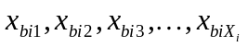. For turbo encoded TrCHs with puncturing, b indicates the three sequences defined in section 4.2.7.3, with b=1 indicating the first sequence, and so forth. For all other cases b is defined to be 1. X_{i} is the number of bits in each separated bit sequence. The relation between e_{ik} and x_{bik} is given below.
For turbo encoded TrCHs with puncturing:
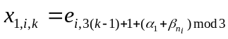 k = 1, 2, 3, …, X_{i} X_{i} = ⎣N_{i} /3⎦
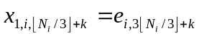 k = 1, …, N_{i} mod 3 Note: When (N_{i} mod 3) = 0 this row is not needed.
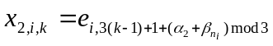 k = 1, 2, 3, …, X_{i} X_{i} = ⎣N_{i} /3⎦
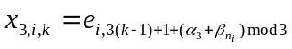 k = 1, 2, 3, …, X_{i} X_{i} = ⎣N_{i} /3⎦
For convolutionally encoded TrCHs and turbo encoded TrCHs with repetition:
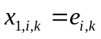 k = 1, 2, 3, …, X_{i} X_{i} = N_{i}

4.2.7.3.2 Bit collection
The bits x_{bik} are input to the rate matching algorithm described in subclause 4.2.7.5. The bits output from the rate matching algorithm are denoted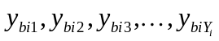.
Bit collection is the inverse function of the separation. The bits after collection are denoted by 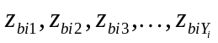. After bit collection, the bits indicated as punctured are removed and the bits are then denoted by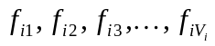, where i is the TrCH number and V_{i}= N_{ij}+ΔN_{ij}. The relations between y_{bik}, z_{bik}, and f_{ik} are given below.
For turbo encoded TrCHs with puncturing (Y_{i}=X_{i}):
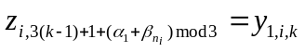 k = 1, 2, 3, …, Y_{i}
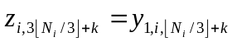 k = 1, …, N_{i} mod 3 Note: When (N_{i} mod 3) = 0 this row is not needed.
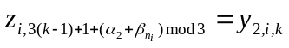 k = 1, 2, 3, …, Y_{i}
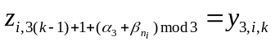 k = 1, 2, 3, …, Y_{i}
After the bit collection, bits z_{i,k} with value δ, where δ∉{0, 1}, are removed from the bit sequence. Bit f_{i,1} corresponds to the bit z_{i,k} with smallest index k after puncturing, bit f_{i,2} corresponds to the bit z_{i,k} with second smallest index k after puncturing, and so on.
For convolutionally encoded TrCHs and turbo encoded TrCHs with repetition:
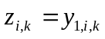 k = 1, 2, 3, …, Y_{i}
When repetition is used, f_{i,k}=z_{i,k} and Y_{i}=V_{i}.
When puncturing is used, Y_{i}=X_{i} and bits z_{i,k} with value δ, where δ∉{0, 1}, are removed from the bit sequence. Bit f_{i,1} corresponds to the bit z_{i,k} with smallest index k after puncturing, bit f_{i,2} corresponds to the bit z_{i,k} with second smallest index k after puncturing, and so on.

4.2.7.4 Bit separation and collection in downlink
The systematic bits of turbo encoded TrCHs shall not be punctured, the other bits may be punctured.
The systematic bits, first parity bits and second parity bits in the bit sequence input to the rate matching block are therefore separated into three sequences of equal lengths.
The first sequence contains :
- All of the systematic bits that are from turbo encoded TrCHs.
- Some of the systematic, first parity and second parity bits that are for trellis termination.
The second sequence contains:
- All of the first parity bits that are from turbo encoded TrCHs.
- Some of the systematic, first parity and second parity bits that are for trellis termination.
The third sequence contains:
- All of the second parity bits that are from turbo encoded TrCHs.
- Some of the systematic, first parity and second parity bits that are for trellis termination.
Puncturing is applied only to the second and third sequences.
The bit separation function is transparent for convolutionally encoded TrCHs and for turbo encoded TrCHs with repetition. The bit separation and bit collection are illustrated in figures 7 and 8.
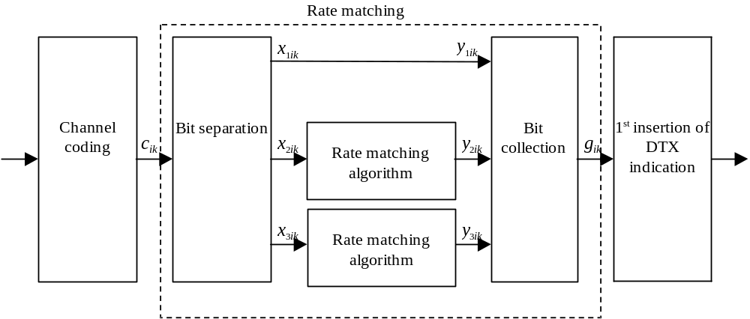
Figure 7: Puncturing of turbo encoded TrCHs in downlink
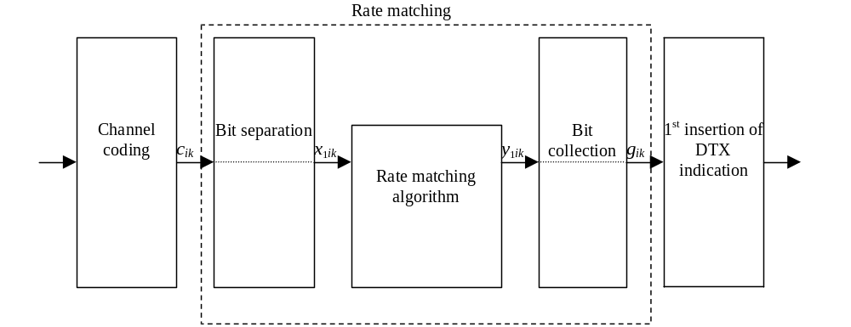
Figure 8: Rate matching for convolutionally encoded TrCHs
and for turbo encoded TrCHs with repetition in downlink

4.2.7.4.1 Bit separation
The bits input to the rate matching are denoted by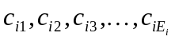, where i is the TrCH number and E_{i} is the number of bits input to the rate matching block. Note that E_{i} is a multiple of 3 for turbo encoded TrCHs and that the transport format l for simplicity has been left out in the bit numbering, i.e. E_{i}=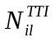. The bits after separation are denoted by. For turbo encoded TrCHs with puncturing, b indicates the three sequences defined in section 4.2.7.4, with b=1 indicating the first sequence, and so forth. For all other cases b is defined to be 1. X_{i} is the number of bits in each separated bit sequence. The relation between c_{ik} and x_{bik} is given below.
For turbo encoded TrCHs with puncturing:
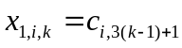 k = 1, 2, 3, …, X_{i} X_{i} = E_{i} /3
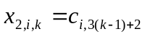 k = 1, 2, 3, …, X_{i} X_{i} = E_{i} /3
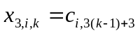 k = 1, 2, 3, …, X_{i} X_{i} = E_{i} /3
For convolutionally encoded TrCHs and turbo encoded TrCHs with repetition:
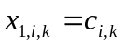 k = 1, 2, 3, …, X_{i} X_{i} = E_{i}

4.2.7.4.2 Bit collection
The bits x_{bik} are input to the rate matching algorithm described in subclause 4.2.7.5. The bits output from the rate matching algorithm are denoted.
Bit collection is the inverse function of the separation. The bits after collection are denoted by . After bit collection, the bits indicated as punctured are removed and the bits are then denoted by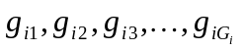, where i is the TrCH number and G_{i}= +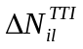. The relations between y_{bik}, z_{bik}, and g_{ik} are given below.
For turbo encoded TrCHs with puncturing (Y_{i}=X_{i}):
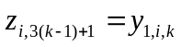 k = 1, 2, 3, …, Y_{i}
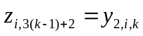 k = 1, 2, 3, …, Y_{i}
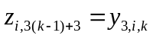 k = 1, 2, 3, …, Y_{i}
After the bit collection, bits z_{i,k} with value δ, where δ∉{0, 1}, are removed from the bit sequence. Bit g_{i,1} corresponds to the bit z_{i,k} with smallest index k after puncturing, bit g_{i,2} corresponds to the bit z_{i,k} with second smallest index k after puncturing, and so on.
For convolutionally encoded TrCHs and turbo encoded TrCHs with repetition:
k = 1, 2, 3, …, Y_{i}
When repetition is used, g_{i,k}=z_{i,k} and Y_{i}=G_{i}.
When puncturing is used, Y_{i}=X_{i} and bits z_{i,k} with value δ, where δ∉{0, 1}, are removed from the bit sequence. Bit g_{i,1} corresponds to the bit z_{i,k} with smallest index k after puncturing, bit g_{i,2} corresponds to the bit z_{i,k} with second smallest index k after puncturing, and so on.

4.2.7.5 Rate matching pattern determination
Denote the bits before rate matching by:
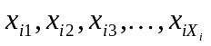, where i is the TrCH number and the sequence is defined in 4.2.7.3 for uplink or in 4.2.7.4 for downlink. Parameters X_{i}, e_{ini}, e_{plus}, and e_{minus} are given in 4.2.7.1 for uplink or in 4.2.7.2 for downlink.
The rate matching rule is as follows:
if puncturing is to be performed
e = e_{ini} -- initial error between current and desired puncturing ratio
m = 1 -- index of current bit
do while m <= X_{i}
e = e – e_{minus} -- update error
if e <= 0 then -- check if bit number m should be punctured
set bit x_{i,m} to δ where δ∉{0, 1}
e = e + e_{plus} -- update error
end if
m = m + 1 -- next bit
end do
else
e = e_{ini} -- initial error between current and desired puncturing ratio
m = 1 -- index of current bit
do while m <= X_{i}
e = e – e_{minus} -- update error
do while e <= 0 -- check if bit number m should be repeated
repeat bit x_{i,m}
e = e + e_{plus} -- update error
end do
m = m + 1 -- next bit
end do
end if
A repeated bit is placed directly after the original one.

4.2.8 TrCH multiplexing
Every 10 ms, one radio frame from each TrCH is delivered to the TrCH multiplexing. These radio frames are serially multiplexed into a coded composite transport channel (CCTrCH).
The bits input to the TrCH multiplexing are denoted by 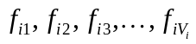, where i is the TrCH number and V_{i} is the number of bits in the radio frame of TrCH i. The number of TrCHs is denoted by I. The bits output from TrCH multiplexing are denoted by 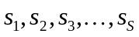, where S is the number of bits, i.e. 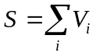. The TrCH multiplexing is defined by the following relations:
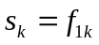 k = 1, 2, …, V₁
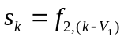 k = V₁+1, V₁+2, …, V₁+V₂
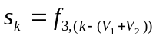 k = (V₁+V₂)+1, (V₁+V₂)+2, …, (V₁+V₂)+V₃
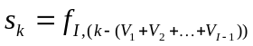 k = (V₁+V₂+…+V_{I-1})+1, (V₁+V₂+…+V_{I-1})+2, …, (V₁+V₂+…+V_{I-1})+V_{I}

4.2.9 Insertion of discontinuous transmission (DTX) indication bits
In the downlink, DTX is used to fill up the radio frame with bits. The insertion point of DTX indication bits depends on whether fixed or flexible positions of the TrCHs in the radio frame are used. It is up to the UTRAN to decide for each CCTrCH whether fixed or flexible positions are used during the connection. DTX indication bits only indicate when the transmission should be turned off, they are not transmitted.

4.2.9.1 1st insertion of DTX indication bits
This step of inserting DTX indication bits is used only if the positions of the TrCHs in the radio frame are fixed. With fixed position scheme a fixed number of bits is reserved for each TrCH in the radio frame.
The bits from rate matching are denoted by 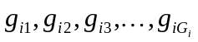, where G_{i} is the number of bits in one TTI of TrCH i. Denote the number of bits in one radio frame of TrCH i by H_{i}. Denote D_{i} the number of bits output of the first DTX insertion block.
In TTIs containing no compressed frames or frames compressed by spreading factor reduction, H_{i} is constant and corresponds to the maximum number of bits from TrCH i in one radio frame for any transport format of TrCH i and D_{i} = F_{i} × H_{i}.
The bits output from the DTX insertion are denoted by h _{i1}, h _{i2}, h _{i3}, …, h _{iDi} Note that these bits are three valued. They are defined by the following relations:
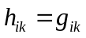 k = 1, 2, 3, …, G_{i}
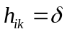 k = G_{i}+1, G_{i}+2, G_{i}+3, …, D_{i}
where DTX indication bits are denoted by δ. Here g_{ik} ∈{0, 1} and δ ∉{0, 1}.

4.2.9.2 2nd insertion of DTX indication bits
The DTX indication bits inserted in this step shall be placed at the end of the radio frame. Note that the DTX will be distributed over all slots after 2nd interleaving.
The bits input to the DTX insertion block are denoted by ,where S is the number of bits from TrCH multiplexing. The number of PhCHs is denoted by P and the number of bits in one radio frame, including DTX indication bits, for each PhCH by R..
In non-compressed frames, 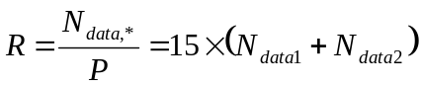, where N_{data1} and N_{data2} are defined in [2].
For compressed frames, N'_{data,*} is defined as 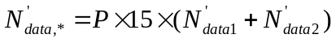. 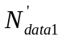and 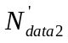 are the number of bits in the data fields of the slot format used for the current compressed frame, i.e. slot format A or B as defined in [2] corresponding to the spreading factor and the number of transmitted slots in use.
In frames compressed by higher layer scheduling, additional DTX with respect to normal mode shall be inserted if the transmission time reduction does not exactly create a transmission gap of the desired TGL.
The number of bits available to the CCTrCH in one radio frame compressed by spreading factor reduction or by higher layer scheduling is denoted by 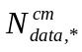 and 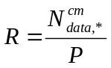.
For frames compressed by spreading factor reduction 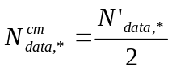.
For frames compressed by higher layer scheduling the exact value of is dependent on the TGL which is signalled from higher layers. It can be calculated as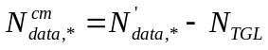.
N_{TGL} is the number of bits that are located within the transmission gap and defined as:

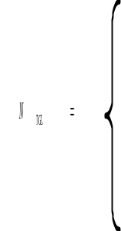 | 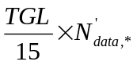, if N_{first} + TGL ≤ 15  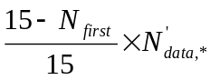, in first frame if N_{first} + TGL > 15  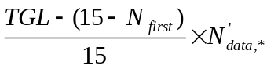, in second frame if N_{first} + TGL > 15

N_{first} and TGL are defined in subclause 4.4.
The bits output from the DTX insertion block are denoted by 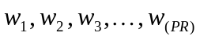. Note that these bits are three valued. They are defined by the following relations:
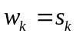 k = 1, 2, 3, …, S
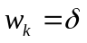 k = S+1, S+2, S+3, …, P⋅R
where DTX indication bits are denoted by δ. Here s_{k} ∈{0,1, p}and δ ∉{0,1}.

4.2.10 Physical channel segmentation
When more than one PhCH is used, physical channel segmentation divides the bits among the different PhCHs. The bits input to the physical channel segmentation are denoted by 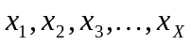, where X is the number of bits input to the physical channel segmentation block. The number of PhCHs is denoted by P.
The bits after physical channel segmentation are denoted 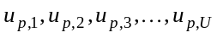, where p is PhCH number and U is the number of bits in one radio frame for each PhCH, i.e. 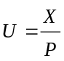. The relation between x_{k} and u_{p,k} is given below.
For all modes, some bits of the input flow are mapped to each code until the number of bits on the code is U. All bits of the input flow are taken to be mapped to the codes.
Bits on first PhCH after physical channel segmentation:
u_{1, k} = x_{k} k = 1, 2 , …, U
Bits on second PhCH after physical channel segmentation:
u_{2, k} = x_{k+U} k = 1, 2 , …, U
…
Bits on the P^{th} PhCH after physical channel segmentation:
u_{P,k} = x _{k+(P-1)×U} k = 1, 2 , …, U

4.2.10.1 Relation between input and output of the physical segmentation block in uplink
The bits input to the physical segmentation are denoted by 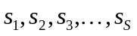. Hence, x_{k} = s_{k} and Y = S.

4.2.10.2 Relation between input and output of the physical segmentation block in downlink
The bits input to the physical segmentation are denoted by 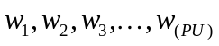. Hence, x_{k} = w_{k} and Y = PU.

4.2.11 2nd interleaving
The 2nd interleaving is a block interleaver and consists of bits input to a matrix with padding, the inter-column permutation for the matrix and bits output from the matrix with pruning. The bits input to the block interleaver are denoted by 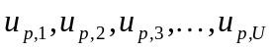, where p is PhCH number and U is the number of bits in one radio frame for one PhCH. The output bit sequence from the block interleaver is derived as follows:
(1) Assign C2 = 30 to be the number of columns of the matrix. The columns of the matrix are numbered 0, 1, 2, …, C2 - 1 from left to right.
(2) Determine the number of rows of the matrix, R2, by finding minimum integer R2 such that:
U ≤ R2 × C2.
The rows of rectangular matrix are numbered 0, 1, 2, …, R2 - 1 from top to bottom.
(3) Write the input bit sequence into the R2 C2 matrix row by row starting with bit 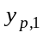 in column 0 of row 0:
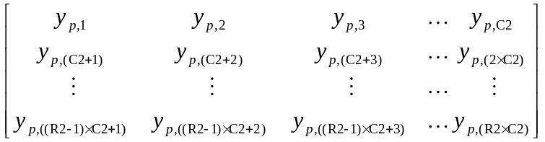
where 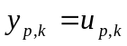 for k = 1, 2, …, U and if R2 × C2 > U, the dummy bits are padded such that 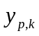 = 0 or 1 for k = U + 1, U + 2, …, R2 × C2. These dummy bits are pruned away from the output of the matrix after the inter-column permutation.
(4) Perform the inter-column permutation for the matrix based on the pattern 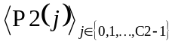 that is shown in table 7, where P2(j) is the original column position of the j-th permuted column. After permutation of the columns, the bits are denoted by 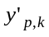.
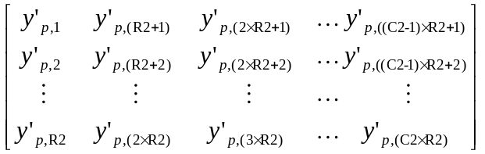
(5) The output of the block interleaver is the bit sequence read out column by column from the inter-column permuted R2 C2 matrix. The output is pruned by deleting dummy bits that were padded to the input of the matrix before the inter-column permutation, i.e. bits that corresponds to bits 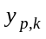 with k>U are removed from the output. The bits after 2nd interleaving are denoted by 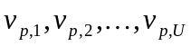, where v_{p,1} corresponds to the bit with smallest index k after pruning, v_{p,2} to the bit with second smallest index k after pruning, and so on.
Table 7 Inter-column permutation pattern for 2nd interleaving
Number of columns C2 | Inter-column permutation pattern  < P2(0), P2(1), …, P2(C2-1) >
30 | <0, 20, 10, 5, 15, 25, 3, 13, 23, 8, 18, 28, 1, 11, 21,  6, 16, 26, 4, 14, 24, 19, 9, 29, 12, 2, 7, 22, 27, 17>

4.2.11.1 2nd interleaving for Secondary CCPCH with 16QAM
For MBSFN transmissions with 16QAM, the 2nd interleaving for Secondary CCPCH is done as illustrated in figure 8a below. The basic block interleaver is as described in Section 4.2.11. For 16QAM modulated bits, there are two identical basic block interleavers of size R2×30, where R2 is the minimum integer fulfilling
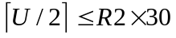,
The output bits from the physical channel segmentation are divided two by two between the interleavers: bits u_{p,k} and u_{p,k+1} go to the first interleaver and bits u_{p,k+2} and u_{p,k+3} go to the second interleaver. Bits are collected two by two from the interleavers: bits v_{p,k} and v_{p,k+1}are obtained from the first interleaver and bits v_{p,k+2} and v_{p,k+3} are obtained from the second interleaver, where k mod 4=1.
Interleaver
(R2 x 30)
Interleaver
(R2 x 30)
u
p,
k
(QPSK)
u
p,k
u
p,k+1
(16QAM)
u
p,k+2
u
p,k+3
(16QAM)
v
p,
k
(QPSK)
v
p,
k
v
p,k+1
(16QAM)
v
p,k+2
v
p,k+3
(16QAM)
Figure 8a: Interleaver structure for Secondary CCPCH

4.2.12 Physical channel mapping
The PhCH for both uplink and downlink is defined in [2]. The bits input to the physical channel mapping are denoted by , where p is the PhCH number and U is the number of bits in one radio frame for one PhCH. The bits v_{p,k} are mapped to the PhCHs so that the bits for each PhCH are transmitted over the air in ascending order with respect to k.
In compressed mode, no bits are mapped to certain slots of the PhCH(s). If N_{first} + TGL ≤ 15, no bits are mapped to slots N_{first} to N_{last}. If N_{first} + TGL > 15, i.e. the transmission gap spans two consecutive radio frames, the mapping is as follows:
- In the first radio frame, no bits are mapped to slots N_{first}, N_{first}+1, N_{first}+2, …, 14.
- In the second radio frame, no bits are mapped to the slots 0, 1, 2, …, N_{last}.
TGL, N_{first}, and N_{last} are defined in subclause 4.4.

4.2.12.1 Uplink
In uplink, the PhCHs used during a radio frame are either completely filled with bits that are transmitted over the air or not used at all. The only exception is when the UE is in compressed mode. The transmission can then be turned off during consecutive slots of the radio frame.

4.2.12.2 Downlink
In downlink, the PhCHs do not need to be completely filled with bits that are transmitted over the air. Values v_{p,k} ∉{0, 1} correspond to DTX indicators, which are mapped to the DPCCH/DPDCH fields but are not transmitted over the air.
During compressed mode by reducing the spreading factor by 2, the data bits are always mapped into 7.5 slots within a compressed frame. No bits are mapped to the DPDCH field as follows:
If N_{first} + TGL ≤ 15, i.e. the transmission gap spans one radio frame,
if N_{first} + 7 ≤ 14
no bits are mapped to slots N_{first},N_{first} + 1, N_{first} +2,…, N_{first}+6
no bits are mapped to the first (N_{Data1}+ N_{Data2})/2 bit positions of slot N_{first}+7
else
no bits are mapped to slots N_{first}, N_{first} + 1, N_{first} + 2,…, 14
no bits are mapped to slots N_{first} - 1, N_{first} - 2, N_{first} - 3, …, 8
no bits are mapped to the last (N_{Data1}+ N_{Data2})/2 bit positions of slot 7
end if
If N_{first} + TGL > 15, i.e. the transmission gap spans two consecutive radio frames,
In the first radio frame, no bits are mapped to last (N_{Data1}+ N_{Data2})/2 bit positions in slot 7 as well as to slots 8, 9, 10, ..., 14.
In the second radio frame, no bits are mapped to slots 0, 1, 2, ..., 6 as well as to first (N_{Data1}+ N_{Data2})/2 bit positions in slot 7.
N_{Data1}and N_{Data2} are defined in [2].

4.2.13 Restrictions on different types of CCTrCHs
Restrictions on the different types of CCTrCHs are described in general terms in TS 25.302[11]. In this subclause those restrictions are given with layer 1 notation.

4.2.13.1 Uplink Dedicated channel (DCH)
The maximum value of the number of TrCHs I in a CCTrCH, the maximum value of the number of transport blocks M_{i} on each transport channel, and the maximum value of the number of DPDCHs P are given from the UE capability class.

4.2.13.2 Random Access Channel (RACH)
- There can only be one TrCH in each RACH CCTrCH, i.e. I=1, s_{k} = f_{1k} and S = V₁.
- The maximum value of the number of transport blocks M₁ on the transport channel is given from the UE capability class.
- The transmission time interval is either 10 ms or 20 ms.
- Only one PRACH is used, i.e. P=1, u_{1k} = s_{k}, and U = S.
- The Static rate matching parameter RM₁ is not provided by higher layer signalling on the System information as the other transport channel parameters. Any value may be used as there is one transport channel in the CCTrCH, hence one transport channel per Transport Format Combination and no need to do any balancing between multiple transport channels.

4.2.13.3 Void

4.2.13.4 Downlink Dedicated Channel (DCH)
The maximum value of the number of TrCHs I in a CCTrCH, the maximum value of the number of transport blocks M_{i} on each transport channel, and the maximum value of the number of DPDCHs P are given from the UE capability class.

4.2.13.5 Void

4.2.13.6 Broadcast channel (BCH)
- There can only be one TrCH in the BCH CCTrCH, i.e. I=1, s_{k} = f_{1k}, and S = V₁.
- There can only be one transport block in each transmission time interval, i.e. M₁ = 1.
- All transport format attributes have predefined values which are provided in [11] apart from the rate matching RM₁.
- The Static rate matching parameter RM₁ is not provided by higher layer signalling neither fixed. Any value may be used as there is one transport channel in the CCTrCH, hence one transport channel per Transport Format Combination and no need to do any balancing between multiple transport channels.
- Only one primary CCPCH is used, i.e. P=1.

4.2.13.7 Forward access and paging channels (FACH and PCH)
- The maximum value of the number of TrCHs I in a CCTrCH and the maximum value of the number of transport blocks M_{i} on each transport channel are given from the UE capability class.
- The transmission time interval for TrCHs of PCH type is always 10 ms.
- Only one secondary CCPCH is used per CCTrCH, i.e. P=1.

4.2.13.8 High Speed Downlink Shared Channel (HS-DSCH) associated with a DCH
- There can be only one TrCH in an HS-DSCH CCTrCH, i.e. I = 1,
- In case the UE is not configured in MIMO mode or the UE is configured in MIMO mode and single-stream restriction is configured, there can only be one transport block in each transmission time interval, i.e. M₁ = 1. In case the UE is configured in MIMO mode, there can be one or two transport blocks in each transmission time interval.
- The transmission time interval for TrCHs of HS-DSCH type is always 2 ms.
- The maximum value of the number of HS-PDSCHs P are given from the UE capability class.

4.2.13.9 Enhanced Dedicated Channel (E-DCH)
- There can be only one TrCH in the E-DCH CCTrCH, i.e. I = 1.
- There can only be one transport block in each transmission time interval, i.e. M₁ = 1.
- The transmission time interval for TrCHs of E-DCH type is 2 ms or 10 ms.
- The maximum value of the number of E-DPDCHs P are given from the UE capabilities.

4.2.14 Multiplexing of different transport channels into one CCTrCH, and mapping of one CCTrCH onto physical channels
The following rules shall apply to the different transport channels which are part of the same CCTrCH:
1) Transport channels multiplexed into one CCTrCh shall have co-ordinated timings. When the TFCS of a CCTrCH is changed because one or more transport channels are added to the CCTrCH or reconfigured within the CCTrCH, or removed from the CCTrCH, the change may only be made at the start of a radio frame with CFN fulfilling the relation
CFN mod F_{max} = 0,
where F_{max} denotes the maximum number of radio frames within the transmission time intervals of all transport channels which are multiplexed into the same CCTrCH, including any transport channels i which are added, reconfigured or have been removed, and CFN denotes the connection frame number of the first radio frame of the changed CCTrCH.
After addition or reconfiguration of a transport channel i within a CCTrCH, the TTI of transport channel i may only start in radio frames with CFN fulfilling the relation:
CFN mod F_{i} = 0.
2) Only transport channels with the same active set can be mapped onto the same CCTrCH.
3) Different CCTrCHs cannot be mapped onto the same PhCH.
4) One CCTrCH shall be mapped onto one or several PhCHs. These physical channels shall all have the same SF, except for the case of four E-DPDCHs, where two E-DPDCHs have spreading factor 2 and the other two E-DPDCHs have spreading factor 4. All physical channels belonging to the same CCTrCH shall use the same modulation scheme. The 4PAM modulation shall only be used for orthogonal PhCH pairs which are orthogonal in phase and use the same OVSF code.
5) Dedicated Transport channels and common transport channels cannot be multiplexed into the same CCTrCH.
6) For the common transport channels, only the FACH and PCH may belong to the same CCTrCH.
There are hence two types of CCTrCH:
1) CCTrCH of dedicated type, corresponding to the result of coding and multiplexing of one or several DCHs or one E-DCH.
2) CCTrCH of common type, corresponding to the result of the coding and multiplexing of a common channel, RACH in the uplink, HS-DSCH, BCH, or FACH/PCH for the downlink.

4.2.14.1 Allowed CCTrCH combinations for one UE

4.2.14.1.1 Allowed CCTrCH combinations on the uplink
The following CCTrCH combinations for one UE are allowed:
1) one CCTrCH of dedicated type or
1a) two CCTrCHs of dedicated type, one being of DCH type and the other one of E-DCH type or
2) one CCTrCH of common type.

4.2.14.1.2 Allowed CCTrCH combinations on the downlink
The following CCTrCH combinations for one UE are allowed:
- x CCTrCH of dedicated type + y CCTrCH of common type. The allowed combination of CCTrCHs of dedicated and common type are given from UE radio access capabilities. There can be a maximum of one CCTrCH of common type for HS-DSCH. The maximum number of CCTrCHs of common type for FACH is determined from UE capabilities. With one CCTrCH of common type for HS-DSCH, there shall be only one CCTrCH of dedicated type.
NOTE 1: There is only one DPCCH in the uplink, hence one TPC bits flow on the uplink to control possibly the different DPDCHs on the downlink, part of the same or several CCTrCHs.
NOTE 2: There is only one DPCCH in the downlink, even with multiple CCTrCHs. With multiple CCTrCHs, the DPCCH is transmitted on one of the physical channels of that CCTrCH which has the smallest SF among the multiple CCTrCHs. Thus there is only one TPC command flow and only one TFCI word in downlink even with multiple CCTrCHs.
NOTE 3: in the current release, only 1 CCTrCH of dedicated type is supported.

4.3 Transport format detection
If the transport format set of a TrCH i contains more than one transport format, the transport format can be detected according to one of the following methods:
- TFCI based detection: This method is applicable when the transport format combination is signalled using the TFCI field;
- explicit blind detection: This method typically consists of detecting the TF of TrCH i by use of channel decoding and CRC check;
- guided detection: This method is applicable when there is at least one other TrCH i', hereafter called guiding TrCH, such that:
- the guiding TrCH has the same TTI duration as the TrCH under consideration, i.e. F_{i'} = F_{i};
- different TFs of the TrCH under consideration correspond to different TFs of the guiding TrCH;
- explicit blind detection is used on the guiding TrCH.
If the transport format set for a TrCH i does not contain more than one transport format with more than zero transport blocks, no explicit blind transport format detection needs to be performed for this TrCH. The UE can use guided detection for this TrCH or single transport format detection, where the UE always assumes the transport format corresponding to more than zero transport blocks for decoding.
For uplink, blind transport format detection is a network controlled option. For downlink, the UE shall be capable of performing blind transport format detection, if certain restrictions on the configured transport channels are fulfilled.

4.3.1 Blind transport format detection
When no TFCI is available then explicit blind detection or guided detection shall be performed on all TrCHs within the CCTrCH that have more than one transport format and that do not use single transport format detection. The UE shall only be required to support blind transport format detection if all of the following restrictions are fulfilled:
1. either only one CCTrCH is received, or one CCTrCH of dedicated type and one CCTrCH of common type for HS-DSCH are received by the UE;
If only one CCTrCH is received by the UE, the following conditions apply to that CCTrCH and those TrCHs that are multiplexed on the CCTrCH. If one CCTrCH of dedicated type and one CCTrCH of common type for HS-DSCH are received by the UE, the following conditions apply to the dedicated type CCTrCH and the TrCHs that are multiplexed on the dedicated type CCTrCH.
2. the number of CCTrCH bits received per radio frame is 600 or less;
3. the number of transport format combinations of the CCTrCH is 64 or less;
4. fixed positions of the transport channels is used on the CCTrCH to be detectable;
5. convolutional coding is used on all explicitly detectable TrCHs;
6. CRC with non-zero length is appended to all transport blocks on all explicitly detectable TrCHs;
7. at least one transport block shall be transmitted per TTI on each explicitly detectable TrCH;
8. the number of explicitly detectable TrCHs is 3 or less;
9. for all explicitly detectable TrCHs i, the number of code blocks in one TTI (C_{i}) shall not exceed 1;
10. the sum of the transport format set sizes of all explicitly detectable TrCHs, is 16 or less. The transport format set size is defined as the number of transport formats within the transport format set;
11. there is at least one TrCH that can be used as the guiding transport channel for all transport channels using guided detection.
Examples of blind transport format detection methods are given in annex A.

4.3.1a Single transport format detection
When no TFCI is available, then single transport format detection shall be applied on all TrCHs within the CCTrCH that have a transport format set not containing more than one transport format with more than zero transport blocks and that do not use guided detection. The UE shall only be required to support single transport format detection if the following restrictions are fulfilled:
1. For each transport channel that is single transport format detected, CRC with non-zero length is appended to all transport blocks within the non-zero transport block transport format;
2. fixed positions of the transport channels is used on the CCTrCH to be detectable.

4.3.2 Transport format detection based on TFCI
If a TFCI is available, then TFCI based detection shall be applicable to all TrCHs within the CCTrCH. The TFCI informs the receiver about the transport format combination of the CCTrCHs. As soon as the TFCI is detected, the transport format combination, and hence the transport formats of the individual transport channels are known.
If higher layers indicate that S-CCPCHs can be soft combined during a period of consecutive TTIs, then the same TFC is used on those S-CCPCHs for each combinable TTI. The UE may therefore detect TFCI on one S-CCPCH to determine the TFC on all S-CCPCHs that can be soft combined. (S-CCPCH soft combining is further specified in [4]).

4.3.3 Coding of Transport-Format-Combination Indicator (TFCI)
The TFCI is encoded using a (32, 10) sub-code of the second order Reed-Muller code. The coding procedure is as shown in figure 9.
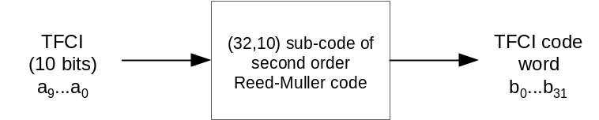
Figure 9: Channel coding of TFCI information bits
If the TFCI consist of less than 10 bits, it is padded with zeros to 10 bits, by setting the most significant bits to zero. The length of the TFCI code word is 32 bits.
The code words of the (32,10) sub-code of second order Reed-Muller code are linear combination of 10 basis sequences. The basis sequences are as in the following table 8.
Table 8: Basis sequences for (32,10) TFCI code
i | M_{i,0} | M_{i,1} | M_{i,2} | M_{i,3} | M_{i,4} | M_{i,5} | M_{i,6} | M_{i,7} | M_{i,8} | M_{i,9}
0 | 1 | 0 | 0 | 0 | 0 | 1 | 0 | 0 | 0 | 0
1 | 0 | 1 | 0 | 0 | 0 | 1 | 1 | 0 | 0 | 0
2 | 1 | 1 | 0 | 0 | 0 | 1 | 0 | 0 | 0 | 1
3 | 0 | 0 | 1 | 0 | 0 | 1 | 1 | 0 | 1 | 1
4 | 1 | 0 | 1 | 0 | 0 | 1 | 0 | 0 | 0 | 1
5 | 0 | 1 | 1 | 0 | 0 | 1 | 0 | 0 | 1 | 0
6 | 1 | 1 | 1 | 0 | 0 | 1 | 0 | 1 | 0 | 0
7 | 0 | 0 | 0 | 1 | 0 | 1 | 0 | 1 | 1 | 0
8 | 1 | 0 | 0 | 1 | 0 | 1 | 1 | 1 | 1 | 0
9 | 0 | 1 | 0 | 1 | 0 | 1 | 1 | 0 | 1 | 1
10 | 1 | 1 | 0 | 1 | 0 | 1 | 0 | 0 | 1 | 1
11 | 0 | 0 | 1 | 1 | 0 | 1 | 0 | 1 | 1 | 0
12 | 1 | 0 | 1 | 1 | 0 | 1 | 0 | 1 | 0 | 1
13 | 0 | 1 | 1 | 1 | 0 | 1 | 1 | 0 | 0 | 1
14 | 1 | 1 | 1 | 1 | 0 | 1 | 1 | 1 | 1 | 1
15 | 1 | 0 | 0 | 0 | 1 | 1 | 1 | 1 | 0 | 0
16 | 0 | 1 | 0 | 0 | 1 | 1 | 1 | 1 | 0 | 1
17 | 1 | 1 | 0 | 0 | 1 | 1 | 1 | 0 | 1 | 0
18 | 0 | 0 | 1 | 0 | 1 | 1 | 0 | 1 | 1 | 1
19 | 1 | 0 | 1 | 0 | 1 | 1 | 0 | 1 | 0 | 1
20 | 0 | 1 | 1 | 0 | 1 | 1 | 0 | 0 | 1 | 1
21 | 1 | 1 | 1 | 0 | 1 | 1 | 0 | 1 | 1 | 1
22 | 0 | 0 | 0 | 1 | 1 | 1 | 0 | 1 | 0 | 0
23 | 1 | 0 | 0 | 1 | 1 | 1 | 1 | 1 | 0 | 1
24 | 0 | 1 | 0 | 1 | 1 | 1 | 1 | 0 | 1 | 0
25 | 1 | 1 | 0 | 1 | 1 | 1 | 1 | 0 | 0 | 1
26 | 0 | 0 | 1 | 1 | 1 | 1 | 0 | 0 | 1 | 0
27 | 1 | 0 | 1 | 1 | 1 | 1 | 1 | 1 | 0 | 0
28 | 0 | 1 | 1 | 1 | 1 | 1 | 1 | 1 | 1 | 0
29 | 1 | 1 | 1 | 1 | 1 | 1 | 1 | 1 | 1 | 1
30 | 0 | 0 | 0 | 0 | 0 | 1 | 0 | 0 | 0 | 0
31 | 0 | 0 | 0 | 0 | 1 | 1 | 1 | 0 | 0 | 0

The TFCI information bits a₀ , a₁ , a₂ , a₃ , a₄ , a₅ , a₆ , a₇ , a₈ , a₉ (where a₀ is LSB and a₉ is MSB) shall correspond to the TFC index (expressed in unsigned binary form) defined by the RRC layer to reference the TFC of the CCTrCH in the associated DPCH radio frame.
The output code word bits b_{i} are given by:
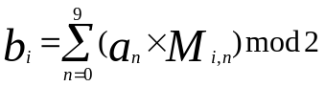
where i = 0, …, 31.
The output bits are denoted by b_{k}, k = 0, 1, 2, …, 31.
In downlink, when the SF < 128 the encoded TFCI code words are repeated yielding 8 encoded TFCI bits per slot in normal mode and 16 encoded TFCI bits per slot in compressed mode. Mapping of repeated bits to slots is explained in subclause 4.3.5.

4.3.4 Void

4.3.5 Mapping of TFCI words

4.3.5.1 Mapping of TFCI word in normal mode
The bits of the code word are directly mapped to the slots of the radio frame. Within a slot the bit with lower index is transmitted before the bit with higher index. The coded bits b_{k}, are mapped to the transmitted TFCI bits d_{k}, according to the following formula:
d_{k} = b_{k mod 32}
For uplink physical channels regardless of the SF and downlink physical channels, if SF≥128, k = 0, 1, 2, …, 29. Note that this means that bits b₃₀ and b₃₁ are not transmitted.
For downlink physical channels whose SF < 128, k = 0, 1, 2, …, 119. Note that this means that bits b₀ to b₂₃ are transmitted four times and bits b₂₄ to b₃₁ are transmitted three times.

4.3.5.1.1 Mapping of TFCI bits for Secondary CCPCH with 16QAM
For MBSFN transmissions with 16QAM, the coded bits b_{k}, are mapped to the transmitted TFCI bits according to the following formulas:
d_{4k} = b_{2k mod 32} ,
d_{4k+1} = b_{2k+1 mod 32} ,
d_{4k+2} = ( d_{4k} + d_{4k+1} ) mod 2,
d_{4k+3} = ( 1 + d_{4k} + d_{4k+1} ) mod 2,
where k = 0, 1, 2,…, 59 for SF < 128 and k = 0, 1, 2,…, 14 for SF≥128.

4.3.5.2 Mapping of TFCI word in compressed mode
The mapping of the TFCI bits in compressed mode is different for uplink, downlink with SF ≥ 128 and downlink with SF < 128.

4.3.5.2.1 Uplink compressed mode
For uplink compressed mode, the slot format is changed so that no TFCI coded bits are lost. The different slot formats in compressed mode do not match the exact number of TFCI coded bits for all possible TGLs. Repetition of the TFCI bits is therefore used.
Denote the number of bits available in the TFCI fields of one compressed radio frame by D and the number of bits in the TFCI field in a slot by N_{TFCI}. The parameter E is used to determine the number of the first TFCI bit to be repeated.
E= N_{first} N_{TFCI}, if the start of the transmission gap is allocated to the current frame.
E = 0, if the start of the transmission gap is allocated to the previous frame and the end of the transmission gap is allocated to the current frame.
The TFCI coded bits b_{k} are mapped to the bits in the TFCI fields d_{k}. The following relations define the mapping for each compressed frame.
d_{k} = b_{k}
where k = 0, 1, 2, …, min (31, D-1).
If D > 32, the remaining positions are filled by repetition (in reversed order):
d_{D-k-1} = b_{(E+k) mod 32}
where k = 0, …, D-33.

4.3.5.2.2 Downlink compressed mode
For downlink compressed mode, the slot format is changed so that no TFCI coded bits are lost. The different slot formats in compressed mode do not match the exact number of TFCI bits for all possible TGLs. DTX is therefore used if the number of bits available in the TFCI fields in one compressed frame exceeds the number of TFCI bits given from the slot format. The block of bits in the TFCI fields where DTX is used starts on the first TFCI field after the transmission gap. If there are more bits available in the TFCI fields before the transmission gap than TFCI bits, DTX is also used on the bits in the last TFCI fields before the transmission gap.
Denote the number of bits available in the TFCI fields of one compressed radio frame by D and the number of bits in the TFCI field in a slot by N_{TFCI}. The parameter E is used to determine the position of the first bit in the TFCI field on which DTX is used.
E = N_{first} N_{TFCI}, if the start of the transmission gap is allocated to the current frame.
E = 0, if the start of the transmission gap is allocated to the previous frame and the end of the transmission gap is allocated to the current frame.
Denote the total number of TFCI bits to be transmitted by F. F = 32 for slot formats nA or nB, where n = 0, 1, …, 11 (see table 11 in [2]). Otherwise, F = 128. The TFCI coded bits b_{k} are mapped to the bits in the TFCI fields d_{k}. The following relations define the mapping for each compressed frame.
If E > 0,
d_{k} = b_{k mod 32}
where k = 0, 1, 2, …, min (E, F)-1.
If E < F,
d_{k+D-F} = b_{k mod 32}
where k = E, ..., F -1.
DTX is used on d_{k} where k = min (E, F), ..., min (E, F) +D - F -1.

4.4 Compressed mode
In compressed frames, TGL slots from N_{first} to N_{last} are not used for transmission of data. As illustrated in figure 11, the instantaneous transmit power is increased in the compressed frame in order to keep the quality (BER, FER, etc.) unaffected by the reduced processing gain. The amount of power increase depends on the transmission time reduction method (see subclause 4.4.3). What frames are compressed, are decided by the network. When in compressed mode, compressed frames can occur periodically, as illustrated in figure 11, or requested on demand. The rate and type of compressed frames is variable and depends on the environment and the measurement requirements.
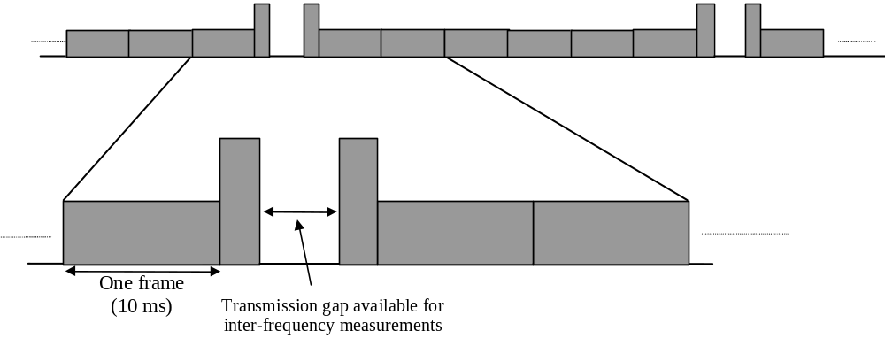
Figure 11: Compressed mode transmission

4.4.1 Frame structure in the uplink
The frame structure for uplink compressed frames is illustrated in figure 12.
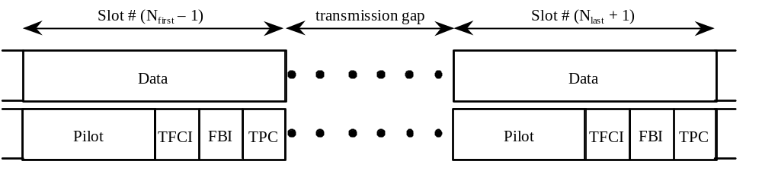
Figure 12: Frame structure in uplink compressed transmission

4.4.2 Frame structure types in the downlink
There are two different types of frame structures defined for downlink compressed frames. Type A maximises the transmission gap length and type B is optimised for power control. The frame structure type A or B is set by higher layers independent from the downlink slot format type A or B.
- With frame structure of type A, the pilot field of the last slot in the transmission gap is transmitted. Transmission is turned off during the rest of the transmission gap (figure 13(a)). In case the length of the pilot field is 2 bits and STTD is used on the radio link, the pilot bits in the last slot of the transmission gap shall be STTD encoded assuming DTX indicators as the two last bits in the Data2 field.
- With frame structure of type B, the TPC field of the first slot in the transmission gap and the pilot field of the last slot in the transmission gap is transmitted. Transmission is turned off during the rest of the transmission gap (figure 13(b)). In case the length of the pilot field is 2 bits and STTD is used on the radio link, the pilot bits in the last slot of the transmission gap shall be STTD encoded assuming DTX indicators as the two last bits of the Data2 field. Similarly, the TPC bits in the first slot of the transmission gap shall be STTD encoded assuming DTX indicators as the two last bits in the Data1 field.
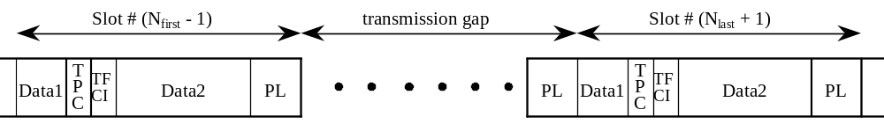
(a) Frame structure type A
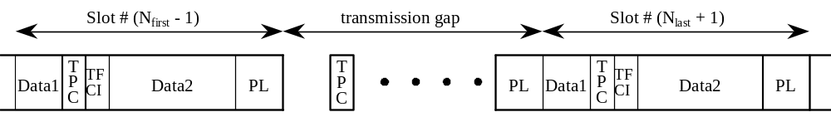
(b) Frame structure type B
Figure 13: Frame structure types in downlink compressed transmission

4.4.2A Frame structure in the downlink for F-DPCH
There is only one type of frame structure defined for downlink F-DPCH compressed frames: transmission is turned off during the whole transmission gap i.e. in slots N_{first} to N_{last}.

4.4.3 Transmission time reduction method
When in compressed mode, the information normally transmitted during a 10 ms frame is compressed in time. The mechanisms provided for achieving this are reduction of the spreading factor by a factor of two , and higher layer scheduling. In the downlink and the uplink, all methods are supported. The maximum idle length is defined to be 7 slots per one 10 ms frame. The slot formats that are used in compressed frames are listed in [2].
In case F-DPCH is configured in the downlink, no transmission time reduction method is needed during compressed frames. The same slot format is used in compressed frames and normal frames.

4.4.3.1 Void

4.4.3.2 Compressed mode by reducing the spreading factor by 2
The spreading factor (SF) can be reduced by 2 during one compressed radio frame to enable the transmission of the information bits in the remaining time slots of the compressed frame. This method is not supported for SF=4.
On the downlink, UTRAN can also order the UE to use a different scrambling code in a compressed frame than in a non-compressed frame. If the UE is ordered to use a different scrambling code in a compressed frame, then there is a one-to-one mapping between the scrambling code used in the non-compressed frame and the one used in the compressed frame, as described in [3] subclause 5.2.1.

4.4.3.3 Compressed mode by higher layer scheduling
Compressed frames can be obtained by higher layer scheduling. Higher layers then set restrictions so that only a subset of the allowed TFCs are used in a compressed frame. The maximum number of bits that will be delivered to the physical layer during the compressed radio frame is then known and a transmission gap can be generated. Note that in the downlink, the TFCI field is expanded on the expense of the data fields and this shall be taken into account by higher layers when setting the restrictions on the TFCs. Compressed mode by higher layer scheduling shall not be used with fixed starting positions of the TrCHs in the radio frame.

4.4.4 Transmission gap position
Transmission gaps can be placed at different positions as shown in figures 14 and 15 for each purpose such as interfrequency power measurement, acquisition of control channel of other system/carrier, and actual handover operation.
The restrictions listed below apply to DPCCH/DPDCH in the uplink and DPCH or F-DPCH in the downlink.
When using single frame method, the transmission gap is located within the compressed frame depending on the transmission gap length (TGL) as shown in figure 14 (1). When using double frame method, the transmission gap is located on the center of two connected frames as shown in figure 14 (2).
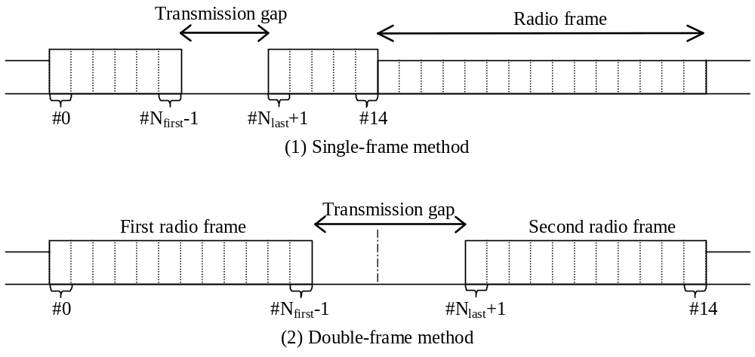
Figure 14: Transmission gap position
Parameters of the transmission gap positions are calculated as follows.
TGL is the number of consecutive idle slots during the compressed mode transmission gap:

TGL = 3, 4, 5, 7, 10, 14
N_{first} specifies the starting slot of the consecutive idle slots,
N_{first} = 0,1,2,3,…,14.
N_{last} shows the number of the final idle slot and is calculated as follows;
If N_{first} + TGL ≤ 15, then N_{last} = N_{first} + TGL –1 ( in the same frame ),
If N_{first} + TGL > 15, then N_{last} = (N_{first} + TGL – 1) mod 15 ( in the next frame ).
When the transmission gap spans two consecutive radio frames, N_{first} and TGL must be chosen so that at least 8 slots in each radio frame are transmitted.
Figure 15: Transmission gap positions with different Nfirst

4.4.5 Transmission gap position for E-DCH
In the following, the transmission gap position for E-DCH during compressed frames is specified for the case when E-DCH TTI length is 10 ms. Slots that are not idle due to uplink compressed mode are termed "available".
The parameter n_{first} and n_{last} are used to determine the transmission gap position due to uplink compressed mode in the current radio frame. If the start of the transmission gap is allocated in the current frame n_{first}=N_{first} else n_{first}=0. If the end of a transmission gap is allocated in the current frame n_{last}=N_{last} else n_{last}=14.

4.4.5.1 E-DPDCH Transmission Gap Position during Initial Transmissions
If an initial transmission overlaps with a compressed frame the starting slot of the consecutive E-DPDCH idle slots within the E-DCH TTI is n_{first}, and n_{last} is the final idle slot within the 10 ms E-DCH TTI. The number of transmitted slots n_{tx1} is given by n_{tx1}=14+n_{first}-n_{last}.
If the initial transmission occurs in a non-compressed uplink frame, n_{tx1}=15.

4.4.5.2 E-DPDCH Transmission Gap Position during Retransmissions
If the current retransmission occurs in a compressed frame the maximum number of slots available for the retransmission is given by n_{max}=14+n_{first}-n_{last}. Else the maximum number of slots available for the retransmission n_{max} is 15.
If the initial transmission was compressed and in the retransmission more than n_{tx1} slots are available for transmission (n_{max}>n_{tx1}), the last n_{dtx}=n_{max}-n_{tx1} available slots of the E-DPDCH frame are E-DPDCH idle slots. The parameter n_{tx1} refers to the number of transmitted slots calculated as defined in 4.4.5.1 for the corresponding initial transmission.
The E-DPDCH transmission gap in case a retransmission occurs in a compressed frame or a retransmission occurs in a non-compressed frame for which initial transmission was compressed is defined as follows:

If n_{max} ≤ n_{tx1}
E-DPDCH idle slots are slots n_{first}, n_{first}+1, .., n_{last}
Else
If a retransmission occurs in a compressed frame and n_{first} < n_{tx1}
E-DPDCH idle slots are the slots n_{first}, n_{first}+1, .., n_{last} and 15-n_{dtx}, 15-n_{dtx}+1, ..,14
Else
E-DPDCH idle slots are the slots n_{tx1}, n_{tx1}+1, ..,14

4.4.5.3 E-DPCCH Transmission Gap Position
If a transmission overlaps with an uplink compressed frame the starting slot of the compressed mode gap within the E-DCH TTI is n_{first}, and n_{last} is the final E-DPCCH idle slot within the 10 ms E-DCH TTI.

4.5 Coding for HS-DSCH
Data arrives to the coding unit in form of a maximum of one transport block once every transmission time interval. The transmission time interval is 2 ms which is mapped to a radio sub-frame of 3 slots.
The following coding steps can be identified:
- add CRC to each transport block (see subclause 4.5.1);
- bit scrambling (see subclause 4.5.1a);
- code block segmentation (see subclause 4.5.2);
- channel coding (see subclause 4.5.3);
- hybrid ARQ (see subclause 4.5.4);
- physical channel segmentation (see subclause 4.5.5);
- interleaving for HS-DSCH (see subclause 4.5.6);
- constellation re-arrangement for 16QAM and 64QAM (see subclause 4.5.7);
- mapping to physical channels (see subclause 4.5.8).
The coding steps for HS-DSCH are shown in the figure below.
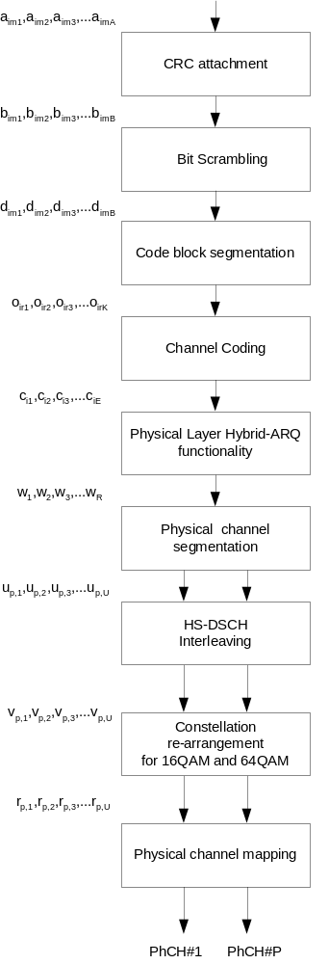
Figure 16: Coding chain for HS-DSCH
In the following the number of transport blocks and the number of transport channels is always one i.e. m=1, i=1. When referencing non HS-DSCH formulae which are used in correspondence with HS-DSCH formulae the convention is used that transport block subscripts may be omitted (e.g. X₁ may be written X).

4.5.1 CRC attachment for HS-DSCH

4.5.1.1 CRC attachment method 1 for HS-DSCH
CRC attachment method 1 for the HS-DSCH transport channel shall be done using the general method described in 4.2.1 above with the following specific parameters.
The CRC length shall always be L₁ = 24 bits.

4.5.1.2 CRC attachment method 2 for HS-DSCH
CRC attachment method 2 for the HS-DSCH transport channel shall be done according to the following method.
From the sequence of bits a₁, a₂, a₃,…, a_{A} , where A is the size of the HS-DSCH transport block, a CRC of length L₁ = 24 bits is calculated according to Section 4.2.1.1 above. This gives a sequence of bits c_{im1}, c_{im2}, c_{im3},…, c_{im24} where
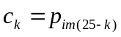 k=1,2,…,24
This sequence of bits is then masked with the UE Identity x_{ue,1}, x_{ue,2}, …, x_{ue,16} and then appended to the sequence of bits a₁, a₂, a₃,…, a_{A} to form the sequence of bits b₁, b₂, b₃,…, b_{B}, where B = A + 24, and
b_{k} = a_{k} k=1,2,…,A
b_{k} = c_{k-A} k=A+1,…,A+8
b_{k} = (c_{k-A} + x_{ue},_{k-A-8}) mod 2 k=A+9, …,A+24

4.5.1a Bit scrambling for HS-DSCH
The bits output from the HS-DSCH CRC attachment are scrambled in the bit scrambler. The bits input to the bit scrambler are denoted by 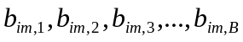, where B is the number of bits input to the HS-DSCH bit scrambler The bits after bit scrambling are denoted 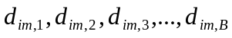.
Bit scrambling is defined by the following relation:
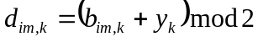 k = 1,2,…,B
and 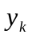 results from the following operation:
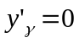 -15 < γ< 1
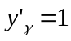 γ= 1
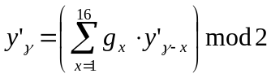 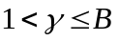,
where ,
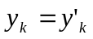 k = 1,2,…,B.

4.5.2 Code block segmentation for HS-DSCH
Code block segmentation for the HS-DSCH transport channel shall be done with the general method described in 4.2.2.2 above with the following specific parameters.
There will be a maximum of one transport block, i=1. The bits d_{im1}, d_{im2}, d_{im3},…d_{imB} input to the block are mapped to the bits x_{i1}, x_{i2}, x_{i3},…x_{iXi} directly. It follows that X₁ = B. Note that the bits x referenced here refer only to the internals of the code block segmentation function. The output bits from the code block segmentation function are o_{ir1}, o_{ir2}, o_{ir3},…o_{irK}.
The value of Z = 5114 for turbo coding shall be used.

4.5.3 Channel coding for HS-DSCH
Channel coding for the HS-DSCH transport channel shall be done with the general method described in 4.2.3 above with the following specific parameters.
There will be a maximum of one transport block, i=1. The rate 1/3 turbo coding shall be used.

4.5.4 Hybrid ARQ for HS-DSCH
The hybrid ARQ functionality matches the number of bits at the output of the channel coder to the total number of bits of the HS-PDSCH set to which the HS-DSCH is mapped. The hybrid ARQ functionality is controlled by the redundancy version (RV) parameters. The exact set of bits at the output of the hybrid ARQ functionality depends on the number of input bits, the number of output bits, and the RV parameters.
The hybrid ARQ functionality consists of two rate-matching stages and a virtual buffer as shown in the figure below.
The first rate matching stage matches the number of input bits to the virtual IR buffer, information about which is provided by higher layers. Note that, if the number of input bits does not exceed the virtual IR buffering capability, the first rate-matching stage is transparent.
The second rate matching stage matches the number of bits after first rate matching stage to the number of physical channel bits available in the HS-PDSCH set in the TTI.
Figure 17: HS-DSCH hybrid ARQ functionality

4.5.4.1 HARQ bit separation
The HARQ bit separation function shall be performed in the same way as bit separation for turbo encoded TrCHs with puncturing in 4.2.7.4.1 above.

4.5.4.2 HARQ First Rate Matching Stage
HARQ first stage rate matching for the HS-DSCH transport channel shall be done with the general method described in 4.2.7.2.2.3 above with the following specific parameters.
The maximum number of soft channel bits available in the virtual IR buffer is N_{IR} which is signalled from higher layers for each HARQ process. The number of coded bits in a TTI before rate matching is N^{TTI} this is deduced from information signalled from higher layers and parameters signalled on the HS-SCCH for each TTI. Note that HARQ processing and physical layer storage occurs independently for each HARQ process currently active.
If N_{IR} is greater than or equal to N^{TTI} (i.e. all coded bits of the corresponding TTI can be stored) the first rate matching stage shall be transparent. This can, for example, be achieved by setting e_{minus} = 0. Note that no repetition is performed.
If N_{IR} is smaller than N^{TTI} the parity bit streams are punctured as in 4.2.7.2.2.3 above by setting the rate matching parameter 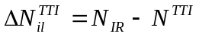where the subscripts i and l refer to transport channel and transport format in the referenced sub-clause. Note the negative value is expected when the rate matching implements puncturing. Bits selected for puncturing which appear as δ in the algorithm in 4.2.7 above shall be discarded and not counted in the totals for the streams through the virtual IR buffer.

4.5.4.3 HARQ Second Rate Matching Stage
HARQ second stage rate matching for the HS-DSCH transport channel shall be done with the general method described in 4.2.7.5 above with the following specific parameters. Bits selected for puncturing which appear as δ in the algorithm in 4.2.7.5 above shall be discarded and are not counted in the streams towards the bit collection.
The parameters of the second rate matching stage depend on the value of the RV parameters s and r. The parameter s can take the value 0 or 1 to distinguish between transmissions that prioritise systematic bits (s = 1) and non systematic bits (s = 0). The parameter r (range 0 to r_{max}-1) changes the initial error variable e_{ini} in the case of puncturing. In case of repetition both parameters r and s change the initial error variable e_{ini}. The parameters X_{i}, e_{plus} and e_{minus} are calculated as per table 10 below.
Denote the number of bits before second rate matching as N_{sys} for the systematic bits, N_{p1} for the parity 1 bits, and N_{p2} for the parity 2 bits, respectively. Denote the number of physical channels used for the HS-DSCH by P. N_{data} is the number of bits available to the HS-DSCH in one TTI and defined as N_{data}=P×3×N_{data1}, where N_{data1} is defined in [2]. The rate matching parameters are determined as follows.
For 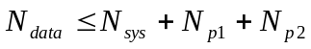, puncturing is performed in the second rate matching stage. The number of transmitted systematic bits in a transmission is 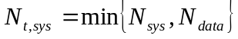 for a transmission that prioritises systematic bits and 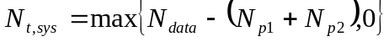 for a transmission that prioritises non systematic bits.
For 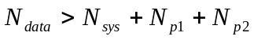 repetition is performed in the second rate matching stage. A similar repetition rate in all bit streams is achieved by setting the number of transmitted systematic bits to 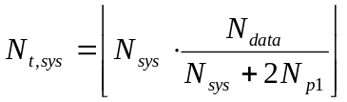.
The number of parity bits in a transmission is: 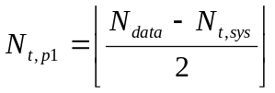 and 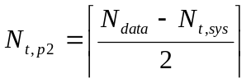 for the parity 1 and parity 2 bits, respectively.
Table 10 below summarizes the resulting parameter choice for the second rate matching stage.
Table 10: Parameters for HARQ second rate matching
 | X_{i} | e_{plus} | e_{minus}
Systematic  RM S | 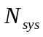 |  | 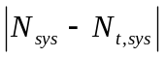
Parity 1  RM P1_2 | 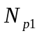 | 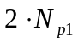 | 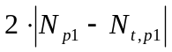
Parity 2  RM P2_2 | 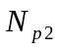 |  | 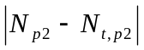

The rate matching parameter e_{ini} is calculated for each bit stream according to the RV parameters r and s using
in the case of puncturing , i.e.,, and
for repetition, i.e., . Where 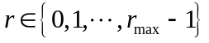and 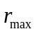 is the total number of redundancy versions allowed by varying as defined in 4.6.2. Note that r_{max} varies depending on the modulation mode, i.e. for 16QAM and 64QAM, r_{max} = 2 and for QPSK r_{max} = 4.
Note: For the modulo operation the following clarification is used: the value of (x mod y) is strictly in the range of 0 to y-1 (i.e. -1 mod 10 = 9).

4.5.4.4 HARQ bit collection
The HARQ bit collection is achieved using a rectangular interleaver of size 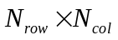.
The number of rows and columns are determined from:
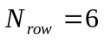 for 64QAM,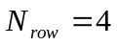 for 16QAM and 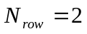 for QPSK
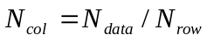
where N_{data} is used as defined in 4.5.4.3.
Data is written into the interleaver column by column, and read out of the interleaver column by column starting from the first column.
N_{t,sys} is the number of transmitted systematic bits. Intermediate values N_{r} and N_{c} are calculated using:
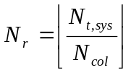 and 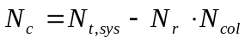.
If N_{c}=0 and N_{r} > 0, the systematic bits are written into rows 1…N_{r}.
Otherwise systematic bits are written into rows 1…N_{r}+1 in the first N_{c} columns and, if N_{r} > 0, also into rows 1…N_{r} in the remaining N_{col}-N_{c} columns.
The remaining space is filled with parity bits. The parity bits are written column wise into the remaining rows of the respective columns. Parity 1 and 2 bits are written in alternating order, starting with a parity 2 bit in the first available column with the lowest index number.
In the case of 64QAM for each column the bits are read out of the interleaver in the order row 1, row 2, row 3, row 4, row 5, row 6. In the case of 16QAM for each column the bits are read out of the interleaver in the order row 1, row 2, row 3, row 4. In the case of QPSK for each column the bits are read out of the interleaver in the order row1, row2.

4.5.5 Physical channel segmentation for HS-DSCH
When more than one HS-PDSCH is used, physical channel segmentation divides the bits among the different physical channels. The bits input to the physical channel segmentation are denoted by w₁, w₂, w₃,…w_{R}, where R is the number of bits input to the physical channel segmentation block. The number of PhCHs is denoted by P.
The bits after physical channel segmentation are denoted 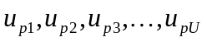, where p is PhCH number and U is the number of bits in one radio sub-frame for each HS-PDSCH, i.e. 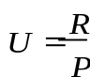. The relation between w_{k} and u_{p,k} is given below.
For all modes, some bits of the input flow are mapped to each code until the number of bits on the code is U.
Bits on first PhCH after physical channel segmentation:
u_{1, k} = w_{k} k = 1, 2 , …, U
Bits on second PhCH after physical channel segmentation:
u_{2, k} = w_{k+U} k = 1, 2 , …, U
…
Bits on the P^{th} PhCH after physical channel segmentation:
u_{P,k} = w_{k+(P-1)×U} k = 1, 2 , …, U

4.5.6 Interleaving for HS-DSCH
The interleaving for FDD is done as shown in figure 18 below, separately for each physical channel. The bits input to the block interleaver are denoted by 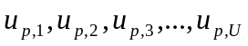, where p is PhCH number and U is the number of bits in one TTI for one PhCH. For QPSK U = 960, for 16QAM U = 1920 and for 64QAM U = 2880. The basic interleaver is as the 2nd interleaver described in Section 4.2.11. The interleaver is of fixed size: R2=32 rows and C2=30 columns.
Interleaver
(32x 30)
Interleaver
(32x 30)
u
p,
k
(QPSK)
u
p,k
u
p,k+1
(16QAM)
u
p,k+2
u
p,k+3
(16QAM)
v
p,
k
(QPSK)
v
p,
k
v
p,k+1
(16QAM)
v
p,k+2
v
p,k+3
(16QAM)
u
p,k
u
p,k+1
(64QAM)
v
p,
k
v
p,k+1
(64QAM)
u
p,k+2
u
p,k+3
(64QAM)
v
p,k+2
v
p,k+3
(64QAM)
Interleaver
(32x 30)
v
p,k+4
v
p,k+5
(64QAM)
u
p,k+4
u
p,k+5
(64QAM)
Figure 18: Interleaver structure for HS-DSCH
For 16QAM, there are two identical interleavers of the same fixed size R2×C2 = 32×30. The output bits from the physical channel segmentation are divided two by two between the interleavers: bits u_{p,k} and u_{p,k+1} go to the first interleaver and bits u_{p,k+2} and u_{p,k+3} go to the second interleaver. Bits are collected two by two from the interleavers: bits v_{p,k} and v_{p,k+1}are obtained from the first interleaver and bits v_{p,k+2} and v_{p,k+3} are obtained from the second interleaver, where k mod 4=1.
For 64QAM, there are three identical interleavers of the same fixed size R2×C2 = 32×30. The output bits from the physical channel segmentation are divided two by two between the interleavers: bits u_{p,k} and u_{p,k+1} go to the first interleaver, bits u_{p,k+2} and u_{p,k+3} go to the second interleaver and bits u_{p,k+4} and u_{p,k+5} go to the third interleaver. Bits are collected two by two from the interleavers: bits v_{p,k} and v_{p,k+1}are obtained from the first interleaver, bits v_{p,k+2} and v_{p,k+3} are obtained from the second interleaver and bits v_{p,k+4} and v_{p,k+5} are obtained from the third interleaver, where k mod 6=1.

4.5.7 Constellation re-arrangement for 16 QAM and 64QAM
This function only applies to 16QAM and 64QAM modulated bits. In case of QPSK it is transparent.
Table 11 describes the operations that produce the different rearrangements for 16QAM. The bits of the input sequence are mapped in groups of 4 so that v_{p,k}, v_{p,k+1}, v_{p,k+2}, v_{p,k+3} are used, where k mod 4 = 1. The output bit sequences map to the output bits in groups of 4, i.e. r_{p,k}, r_{p,k+1}, r_{p,k+2}, r_{p,k+3}, where k mod 4 = 1.

Table 11: Constellation re-arrangement for 16QAM
constellation version parameter b | Output bit sequence | Operation
0 |  | None
1 |  | Swapping MSBs with LSBs
2 |  | Inversion of the logical values of LSBs
3 |  | Swapping MSBs with LSBs and inversion of logical values of LSBs

Table 11A describes the operations that produce the different rearrangements for 64QAM. The bits of the input sequence are mapped in groups of 6 so that v_{p,k}, v_{p,k+1}, v_{p,k+2}, v_{p,k+3}, v_{p,k+4}, v_{p,k+5} are used, where k mod 6 = 1. The output bit sequences map to the output bits in groups of 6, i.e. r_{p,k}, r_{p,k+1}, r_{p,k+2}, r_{p,k+3}, r_{p,k+4}, r_{p,k+5}, where k mod 6 = 1.

Table 11A: Constellation re-arrangement for 64QAM
constellation version parameter b | Output bit sequence | Operation
0 |  | None
1 |  | Swapping MSBs and LSBs. Inversion of Middle SBs
2 |  | Left circular shift of pair of SBs. Inversion of Middle SBs
3 |  | Inversion of Middle SBs

4.5.8 Physical channel mapping for HS-DSCH
The HS-PDSCH is defined in [2]. The bits input to the physical channel mapping are denoted by r_{p,1}, r_{p,2},...,r_{p,U}, where p is the physical channel number and U is the number of bits in one radio sub-frame for one HS-PDSCH. The bits r_{p,k} are mapped to the PhCHs so that the bits for each PhCH are transmitted over the air in ascending order with respect to k.

4.6 Coding for HS-SCCH type 1

4.6.1 Overview
HS-SCCH shall be of type 1 when the following two conditions are both true:
- the UE is not configured in MIMO mode, and
- the conditions for usage of HS-SCCH type 2 are not met.
In this section, the terms “HS-SCCH” and “HS-SCCH type 1” are used interchangeably.
The following information is transmitted by means of the HS-SCCH type 1 physical channel.
- Channelization-code-set information (7 bits): x_{ccs,1}, x_{ccs,2}, …, x_{ccs,7}
- Modulation scheme information (1 bit): x_{ms,1}
- Transport-block size information (6 bits): x_{tbs,1}, x_{tbs,2}, …, x_{tbs,6}
- Hybrid-ARQ process information (3 bits): x_{hap,1}, x_{hap,2}, x_{hap,3}
- Redundancy and constellation version (3 bits): x_{rv,1}, x_{rv,2}, x_{rv,3}
- New data indicator (1 bit): x_{nd,1}
- UE identity (16 bits): x_{ue,1}, x_{ue,2}, …, x_{ue,16}
For an HS-SCCH order,
- x_{ccs,1}, x_{ccs,2}, …, x_{ccs,7}, x_{ms,1} shall be set to ‘11100000’
- x_{tbs,1}, x_{tbs,2}, …, x_{tbs,6} shall be set to ‘111101’
- x_{hap,1}, x_{hap,2}, x_{hap,3}, x_{rv,1}, x_{rv,2}, x_{rv,3} shall be set to x_{odt,1}, x_{odt,2}, x_{odt,3}, x_{ord,1}, x_{ord,2}, x_{ord,3}
- x_{nd,1} is reserved
where x_{odt,1}, x_{odt,2}, x_{odt,3}, x_{ord,1}, x_{ord,2}, x_{ord,3} are defined in subclause 4.6C.

Figure 19 below illustrates the overall coding chain for HS-SCCH type 1.
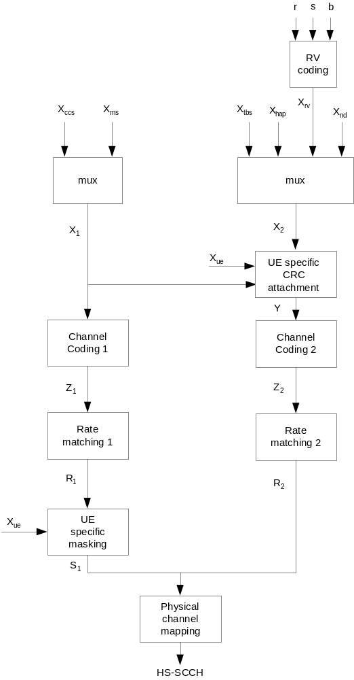
Figure 19: Coding chain for HS-SCCH type 1

4.6.2 HS-SCCH information field mapping

4.6.2.1 Redundancy and constellation version coding
The redundancy version (RV) parameters r, s and constellation version parameter b are coded jointly to produce the value X_{rv}. X_{rv} is alternatively represented as the sequence x_{rv,1}, x_{rv,2}, x_{rv,3} where x_{rv,1} is the MSB. This is done according to tables 12 and 13 according to the modulation mode used:
Table 12: RV coding for 16QAM and 64QAM
X_{rv} (value) | s | R | b
0 | 1 | 0 | 0
1 | 0 | 0 | 0
2 | 1 | 1 | 1
3 | 0 | 1 | 1
4 | 1 | 0 | 1
5 | 1 | 0 | 2
6 | 1 | 0 | 3
7 | 1 | 1 | 0

Table 13: RV coding for QPSK
X_{rv} (value) | s | r
0 | 1 | 0
1 | 0 | 0
2 | 1 | 1
3 | 0 | 1
4 | 1 | 2
5 | 0 | 2
6 | 1 | 3
7 | 0 | 3

4.6.2.2 Modulation scheme mapping
The value of x_{ms,1} is derived from the modulation and given by the following:
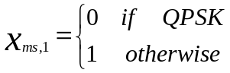

4.6.2.3 Channelization code-set mapping
The channelization code-set bits x_{ccs,1}, x_{ccs,2}, …, x_{ccs,7} are coded according to the following:
Given P (multi-)codes starting at code O, and given the HS-SCCH number if 64QAM is configured for the UE and x_{ms,1}=1, calculate the information-field using the unsigned binary representation of integers calculated by the expressions,
for the first three bits (code group indicator) of which x_{ccs,1} is the MSB:
x_{ccs,1}, x_{ccs,2}, x_{ccs,3} = min(P-1,15-P)
If 64QAM is not configured for the UE, or if 64QAM is configured and x_{ms,1}=0, then
for the last four bits (code offset indicator) of which x_{ccs,4} is the MSB:
x_{ccs,4}, x_{ccs,5,} x_{ccs,6}, x_{ccs,7} = |O-1-⎣P/8⎦ *15|
Otherwise (i.e. if 64QAM is configured for the UE and x_{ms,1}=1),
P and O shall fulfil |O-1-⎣P/8⎦ *15| mod 2 = (HS-SCCH number) mod 2, and then
x_{ccs,4}, x_{ccs,5,} x_{ccs,6}, x_{ccs,dummy} = |O-1-⎣P/8⎦ *15|, where x_{ccs,dummy} is a dummy bit that is not transmitted on HS-SCCH.
Furthermore,
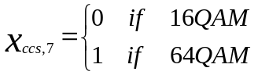.

The definitions of P and O are given in [3]. The HS-SCCH number is given by the position in the list of HS-SCCH Channelisation Code Informations signalled by higher layers. The HS-SCCH number is associated with the code offset indicator and code group indicator as described above if 64QAM is configured for the UE and x_{ms,1}=1.

4.6.2.4 UE identity mapping
The UE identity is the HS-DSCH Radio Network Identifier (H-RNTI) defined in [13]. This is mapped such that x_{ue,1} corresponds to the MSB and x_{ue,16} to the LSB, cf. [14].

4.6.2.5 HARQ process identifier mapping
Hybrid-ARQ process information (3 bits) x_{hap,1}, x_{hap,2}, x_{hap,3} is the unsigned binary representation of the HARQ process identifier where x_{hap,1} is MSB.

4.6.2.6 Transport block size index mapping
Transport-block size information (6 bits) x_{tbs,1}, x_{tbs,2}, …, x_{tbs,6} is unsigned binary representation of the transport block size index where x_{tbs,1} is MSB.

4.6.3 Multiplexing of HS-SCCH information
The channelization-code-set information x_{ccs,1}, x_{ccs,2}, …, x_{ccs,7} and modulation-scheme information x_{ms,1} are multiplexed together. This gives a sequence of bits x_{1,1}, x_{1,2}, …, x_{1,8} where
x_{1,i} = x_{ccs,i} i=1,2,…,7
x_{1,i} = x_{ms,i-7} i=8
The transport-block-size information x_{tbs,1}, x_{tbs,2}, …, x_{tbs,6}, Hybrid-ARQ-process information x_{hap,1},x_{hap,2}, x_{hap,3}, redundancy-version information x_{rv,1}, x_{rv,2}, x_{rv,3} and new-data indicator x_{nd,1} are multiplexed together. This gives a sequence of bits x_{2,1}, x_{2,2}, …, x_{2,13} where
x_{2,i} = x_{tbs,i} i=1,2,…,6
x_{2,i} = x_{hap,i-6} i=7,8,9
x_{2,i} = x_{rv,i-9} i=10,11,12
x_{2,i} = x_{nd,i-12} i=13

4.6.4 CRC attachment for HS-SCCH
From the sequence of bits x_{1,1}, x_{1,2}, …, x_{1,8,} x_{2,1}, x_{2,2}, …, x_{2,13} a 16 bits CRC is calculated according to Section 4.2.1.1. This gives a sequence of bits c₁, c₂, …, c₁₆ where
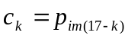 k=1,2,…,16
This sequence of bits is then masked with the UE Identity x_{ue,1}, x_{ue,2}, …, x_{ue,16} and then appended to the sequence of bits x_{2,1}, x_{2,2}, …, x_{2,13} to form the sequence of bits y₁, y₂, …, y₂₉, where
y_{i} = x_{2,i} i=1,2,…,13
y_{i} = (c_{i-13} + x_{ue},_{i-13} ) mod 2 i=14,15,…,29

4.6.5 Channel coding for HS-SCCH
Rate 1/3 convolutional coding, as described in Section 4.2.3.1, is applied to the sequence of bits x_{1,1},x_{1,2}, …,x_{1,8.} This gives a sequence of bits z_{1,1}, z_{1,2}, …, z_{1,48.}
Rate 1/3 convolutional coding, as described in Section 4.2.3.1, is applied to the sequence of bits y₁, y₂, …, y_{29.} This gives a sequence of bits z_{2,1}, z_{2,2}, …, z_{2,111.}
Note that the coded sequence lengths result from the termination of K=9 convolutional coding being fully applied.

4.6.6 Rate matching for HS-SCCH
From the input sequence z_{1,1}, z_{1,2}, …, z_{1,48} the bits z_{1,1}, z_{1,2}, z_{1,4}, z_{1,8}, z_{1,42}, z_{1,45}, z_{1,47}, z_{1,48} are punctured to obtain the output sequence r_{1,1},r_{1,2}…r_{1,40}.
From the input sequence z_{2,1}, z_{2,2}, …, z_{2,111} the bits z_{2,1}, z_{2,2}, z_{2,3}, z_{2,4}, z_{2,5}, z_{2,6}, z_{2,7}, z_{2,8}, z_{2,12}, z_{2,14}, z_{2,15}, z_{2,24}, z_{2,42}, z_{2,48}, z_{2,54}, z_{2,57}, z_{2,60}, z_{2,66}, z_{2,69}, z_{2,96}, z_{2,99}, z_{2,101}, z_{2,102}, z_{2,104}, z_{2,105}, z_{2,106}, z_{2,107}, z_{2,108}, z_{2,109}, z_{2,110}, z_{2,111} are punctured to obtain the output sequence r_{2,1},r_{2,2}…r_{2,80}.

4.6.7 UE specific masking for HS-SCCH
The rate matched bits r_{1,1},r_{1,2}…r_{1,40} shall be masked in an UE specific way using the UE identity x_{ue,1}, x_{ue,2}, …, x_{ue,16}, to produce the bits s_{1,1},s_{1,2}…s_{1,40}.
Intermediate code word bits b_{i}, i=1,2…,48, are defined by encoding the UE identity bits using the rate ½ convolutional coding described in Section 4.2.3.1. Eight bits out of the resulting 48 convolutionally encoded bits are punctured using the rate matching rule of Section 4.6.6 for the HS-SCCH part 1 sequence, that is, the intermediate code word bits b₁, b₂, b₄, b₈, b₄₂, b₄₅, b₄₇, b_{48,} are punctured to obtain the 40 bit UE specific scrambling sequence c₁, c₂, ….c₄₀. .
The mask output bits s_{1,1},s_{1,2}…s_{1,40} are calculated as follows:
s_{1,k} =(r_{1,k} + c_{k}) mod 2 for k = 1,2…40

4.6.8 Physical channel mapping for HS-SCCH
The HS-SCCH sub-frame is described in[2].
The sequence of bits s_{1,1}, s_{1,2},, …, s_{1,40} is mapped to the first slot of the HS-SCCH sub frame. The bits s_{1,k} are mapped to the PhCHs so that the bits for each PhCH are transmitted over the air in ascending order with respect to k.
The sequence of bits r_{2,1}, r_{2,2},, …,,r_{2,80} is mapped to the second and third slot of the HS-SCCH sub frame. The bits r_{2,k} are mapped to the PhCHs so that the bits for each PhCH are transmitted over the air in ascending order with respect to k.

4.6A Coding for HS-SCCH type 2

4.6A.1 Overview
HS-SCCH type 2 is used for HS-SCCH-less operation. HS-SCCH type 2 is not used when the UE is configured in MIMO mode. During second and third transmission, the following information is transmitted by means of the HS-SCCH type 2 physical channel.
- Channelization-code-set information (7 bits): x_{ccs,1}, x_{ccs,2}, …, x_{ccs,7}
- Modulation scheme information (1 bit): x_{ms,1}
- Special Information type (6 bits): x_{type,1}, x_{type,2}, …, x_{type,6}
- Special Information (7 bits): x_{info,1}, x_{info,2}, x_{info,3}, x_{info,4}, x_{info,5}, x_{info,6}, x_{info,7}
- UE identity (16 bits): x_{ue,1}, x_{ue,2}, …, x_{ue,16}
Figure 19A below illustrates the overall coding chain for HS-SCCH type 2.
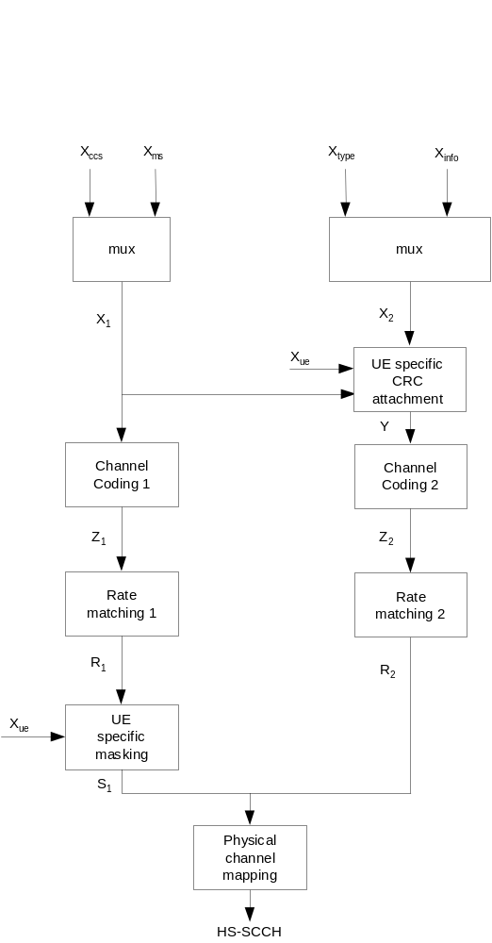
Figure 19A: Coding chain for HS-SCCH type 2

4.6A.2 HS-SCCH Type 2 information field mapping

4.6A.2.1 The first transmission
When HS-SCCH_less_mode=1 for a UE (as defined in [4]), the first transmission of an HS-DSCH transport block using CRC attachment method 2 shall be sent without an associated HS-SCCH. In this case, the UE shall use the following signalling values in order to attempt to decode the transport block:
- Channelization-code-set information: Configured by higher layers
- Modulation scheme information: QPSK
- Transport-block size information: Each of four possible sizes configured by higher layers
- Redundancy and constellation version: X_{rv} =0 (see 4.6.2.1)
- UE identity: Configured by higher layers

4.6A.2.2 The second and the third transmissions
For HS-SCCH_less_mode=1 there are at maximum 3 transmissions for a HS-DSCH transport block using CRC attachment method 2. The 2nd and 3rd transmissions of a transport block that was sent without an associated HS-SCCH in the first transmission, as described in subclause 4.6A.2.1.1, are associated with an HS-SCCH of type 2.

4.6A.2.2.1 Special Information mapping
The Special Information type x_{type,1}, x_{type,2}, …, x_{type,6} shall be set to ‘111110’ to indicate HS-SCCH less operation.
The Special Information bits x_{info,1}, x_{info,2}, …, x_{info,7} are comprised of:
- Transport-block size information (2 bits): x_{info,1}, x_{info,2} = x_{tbs,1}, x_{tbs,2}
- Pointer to the previous transmission (3 bits): x_{info,3}, x_{info,4}, x_{info,5} = x_{ptr,1}, x_{ptr,2}, x_{ptr,3}
- Second or third transmission (1 bit): x_{info,6} = x_{sec,3}
- Reserved (1 bit): x_{info,7} = x_{res,1}

4.6A.2.2.1.1 Transport-block size information mapping
The Transport-block size information (2 bits) x_{tbs,1}, x_{tbs,2} is the unsigned binary representation of a reference to one of the four Transport-block sizes and the associated number of HS-PDSCH codes for the first transmission configured by higher layers.

x_{tbs,1}, x_{tbs,2} | Entry in “Transport Block size list” as signalled in the HS-SCCH-less Information of HS_SCCH_LESS_PARAMS [13]
‘00’ | 1st entry
‘01’ | 2nd entry
‘10’ | 3rd entry
‘11’ | 4th entry

4.6A.2.2.1.2 Pointer to the previous transmission mapping
Pointer to the previous transmission (3 bits) x_{ptr,1}, x_{ptr,2}, x_{ptr,3} is the unsigned binary representation of s, such that the previous transmission of the same transport block started (6+s) subframes before the start of this transmission.

4.6A.2.2.1.3 Second or third transmission mapping
Second or Third transmission (1 bit) indicates whether this is the second or third transmission.
If x_{sec,1}= ‘0’, this is a second transmission.
If x_{sec,1}= ‘1’, this is a third transmission.

4.6A.2.2.2 Redundancy and Constellation Version mapping
The redundancy version X_{rv} for the second and third transmissions shall be equal to 3 and 4 respectively, as defined in Table 13.

4.6A.2.2.3 Modulation scheme mapping
The value of x_{ms,1} shall be set to ‘0’ (QPSK).

4.6A.2.2.4 Channelization code-set mapping
The channelization code-set bits x_{ccs,1}, x_{ccs,2}, …, x_{ccs,7} are coded as per section 4.6.2.3 where the value of P shall be set to either 1 or 2.

4.6A.2.2.5 UE identity mapping
The UE identity is encoded as per section 4.6.2.4.

4.6A.3 Multiplexing of HS-SCCH Type 2 information
The channelization-code-set information x_{ccs,1}, x_{ccs,2}, …, x_{ccs,7} and modulation-scheme information x_{ms,1} are multiplexed together. This gives a sequence of bits x_{1,1}, x_{1,2}, …, x_{1,8} where
x_{1,i} = x_{ccs,i} i=1,2,…,7
x_{1,i} = x_{ms,i-7} i=8
The Special Information type x_{type,1}, x_{type,2}, …, x_{type,6}, and Special Information x_{info,1}, x_{info,2}, x_{info,3}, x_{info,4}, x_{info,5}, x_{info,6}, x_{info,7} are multiplexed together. This gives a sequence of bits x_{2,1}, x_{2,2}, …, x_{2,13} where
x_{2,i} = x_{type,i} i=1,2,…,6
x_{2,i} = x_{info,i-6} i=7,8,…,13

4.6A.4 CRC attachment for HS-SCCH Type 2
The sequence of bits y₁, y₂, …, y₂₉, is calculated according to Section 4.6.4.

4.6A.5 Channel coding for HS-SCCH Type 2
Channel coding is performed according to Section 4.6.5.

4.6A.6 Rate matching for HS-SCCH Type 2
Rate matching is performed according to Section 4.6.6.

4.6A.7 UE specific masking for HS-SCCH Type 2
The mask output bits s_{1,1},s_{1,2}…s_{1,40} are calculated according to Section 4.6.7.

4.6A.8 Physical channel mapping for HS-SCCH Type 2
Physical channel mapping is performed according to Section 4.6.8.

4.6B Coding for HS-SCCH type 3

4.6B.1 Overview
HS-SCCH type 3 is used when the UE is configured in MIMO mode. If one transport block is transmitted on the associated HS-PDSCH(s) or an HS-SCCH order is transmitted, the following information is transmitted by means of the HS-SCCH type 3 physical channel:
- Channelization-code-set information (7 bits): x_{ccs,1}, x_{ccs,2}, …, x_{ccs,7}
- Modulation scheme and number of transport blocks information (3 bits): x_{ms,1}, x_{ms,2}, x_{ms,3}
- Precoding weight information (2 bits): x_{pwipb,1}, x_{pwipb,2}
- Transport-block size information (6 bits): x_{tbspb,1}, x_{tbspb,2}, …, x_{tbspb,6}
- Hybrid-ARQ process information (4 bits): x_{hap,1}, x_{hap,2}, …, x_{hap,4}
- Redundancy and constellation version (2 bits): x_{rvpb,1}, x_{rvpb,2}
- UE identity (16 bits): x_{ue,1}, x_{ue,2}, …, x_{ue,16}
For an HS-SCCH order,
- x_{ccs,1}, x_{ccs,2}, …, x_{ccs,7}, x_{ms,1}, x_{ms,2}, x_{ms,3}, x_{pwipb,1}, x_{pwipb,2} shall be set to ‘111000000000’
- x_{tbspb,1}, x_{tbspb,2}, …, x_{tbspb,6} shall be set to ‘111101’
- x_{hap,1}, x_{hap,2}, x_{hap,3}, x_{hap,4}, x_{rvpb,1}, x_{rvpb,2} shall be set to x_{odt,1}, x_{odt,2}, x_{odt,3}, x_{ord,1}, x_{ord,2}, x_{ord,3}
where x_{odt,1}, x_{odt,2}, x_{odt,3}, x_{ord,1}, x_{ord,2}, x_{ord,3} are defined in subclause 4.6C.

If two transport blocks are transmitted on the associated HS-PDSCHs (not applicable when single-stream restriction is configured), the following information is transmitted by means of the HS-SCCH type 3 physical channel:
- Channelization-code-set information (7 bits): x_{ccs,1}, x_{ccs,2}, …, x_{ccs,7}
- Modulation scheme and number of transport blocks information (3 bits): x_{ms,1}, x_{ms,2}, x_{ms,3}
- Precoding weight information for the primary transport block (2 bits): x_{pwipb,1}, x_{pwipb,2}
- Transport-block size information for the primary transport block (6 bits): x_{tbspb,1}, x_{tbspb,2}, …, x_{tbspb,6}
- Transport-block size information for the secondary transport block (6 bits): x_{tbssb,1}, x_{tbssb,2}, …, x_{tbssb,6}
- Hybrid-ARQ process information (4 bits): x_{hap,1}, x_{hap,2},…, x_{hap,4}
- Redundancy and constellation version for the primary transport block (2 bits): x_{rvpb,1}, x_{rvpb,2}
- Redundancy and constellation version for the secondary transport block (2 bits): x_{rvsb,1}, x_{rvsb,2}
- UE identity (16 bits): x_{ue,1}, x_{ue,2}, …, x_{ue,16}

Figure 19B below illustrates the overall coding chain for HS-SCCH type 3. Note that some information shown is not present if only one transport block is transmitted on the associated HS-PDSCH(s).
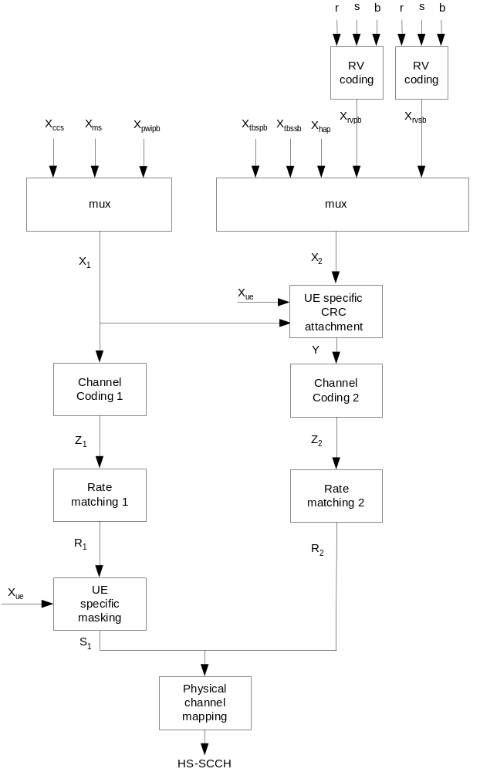
Figure 19B: Coding chain for HS-SCCH type 3

4.6B.2 HS-SCCH type 3 information field mapping

4.6B.2.1 Redundancy and constellation version coding
For each of the primary transport block and a secondary transport block if two transport blocks are transmitted on the associated HS-PDSCH(s), the redundancy version (RV) parameters r, s and constellation version parameter b are coded jointly to produce the values X_{rvpb} and X_{rvsb} respectively. The transmitted sequences x_{rvpb,1}, x_{rvpb,2} and x_{rvsb,1}, x_{rvsb,2} are the binary representations of X_{rvpb} and X_{rvsb}, respectively, where x_{rvpb,1} and x_{rvsb,1} are the MSBs.
For the primary transport block if only one transport block is transmitted on the associated HS-PDSCH(s), the redundancy version (RV) parameters r, s and constellation version parameter b are coded jointly to produce the value X_{rvpb}. The transmitted sequence x_{rvpb,1}, x_{rvpb,2} is the binary representation of X_{rvpb}, where x_{rvpb,1} is the MSB.
Joint coding of parameters r, s and constellation version parameter b is done according to tables 13A and 13B according to the modulation mode used. If X_{rvpb} = 0 or X_{rvsb} = 0, the UE shall treat the corresponding transport block as an initial transmission.
Table 13A: RV coding for 16QAM and 64QAM for HS-SCCH type 3
X_{rvpb} or X_{rvsb} (value) | N_{sys} / N_{data} < 1/2 |  |  | N_{sys} / N_{data} ≥ 1/2
X_{rvpb} or X_{rvsb} (value) | s | r | b | s | r | b
0 | 1 | 0 | 0 | 1 | 0 | 0
1 | 1 | 1 | 1 | 0 | 1 | 1
2 | 1 | 0 | 2 | 0 | 0 | 0
3 | 1 | 0 | 3 | 1 | 0 | 2

Table 13B: RV coding for QPSK for HS-SCCH type 3
X_{rvpb} or X_{rvsb} (value) | N_{sys} / N_{data} <1/2 |  | N_{sys} / N_{data} ≥ 1/2
X_{rvpb} or X_{rvsb} (value) | s | r | s | r
0 | 1 | 0 | 1 | 0
1 | 1 | 1 | 0 | 1
2 | 1 | 2 | 0 | 3
3 | 1 | 3 | 1 | 2

4.6B.2.2 Modulation scheme and number of transport blocks mapping
The number of transport blocks transmitted on the associated HS-PDSCH(s) and the modulation scheme information are jointly coded as shown in Table 14:
Table 14: Mapping of x_{ms}
xms,1, xms,2,  xms,3 | Modulation for primary transport block | Modulation for secondary transport block | Number of transport blocks
111 | 16QAM | 16QAM | 2
110 | 16QAM | QPSK | 2
101 | 64QAM | Indicated by xccs,7 | Indicated by xccs,7
100 | 16QAM | n/a | 1
011 | QPSK | QPSK | 2
010 | 64QAM | 64QAM | 2
001 | 64QAM | 16QAM | 2
000 | QPSK | n/a | 1

In case x_{ms,1}, x_{ms,2}, x_{ms,3} equals “101” x_{ccs,7} is used as an extra bit in modulation scheme information.

4.6B.2.3 Channelization code-set mapping
The channelization code-set bits x_{ccs,1}, x_{ccs,2}, …, x_{ccs,7} are coded according to the following:
Given P (multi-)codes starting at code O, and given the HS-SCCH number if 64QAM is configured for the UE and x_{ms,1}, x_{ms,2}, x_{ms,3} is equal to “101”, calculate the information-field using the unsigned binary representation of integers calculated by the expressions,
for the first three bits (code group indicator) of which x_{ccs,1} is the MSB:
x_{ccs,1}, x_{ccs,2}, x_{ccs,3} = min(P-1,15-P)
If 64QAM is not configured for the UE, or if 64QAM is configured and x_{ms,1}, x_{ms,2}, x_{ms,3} is not equal to “101”, then
for the last four bits (code offset indicator) of which x_{ccs,4} is the MSB:
x_{ccs,4}, x_{ccs,5,} x_{ccs,6}, x_{ccs,7} = |O-1-⎣P/8⎦ *15|
Otherwise (i.e. if 64QAM is configured for the UE and x_{ms,1}, x_{ms,2}, x_{ms,3} is equal to “101”),
P and O shall fulfil |O-1-⎣P/8⎦ *15| mod 2 = (HS-SCCH number) mod 2, and then
x_{ccs,4}, x_{ccs,5,} x_{ccs,6}, x_{ccs,dummy} = |O-1-⎣P/8⎦ *15|, where x_{ccs,dummy} is a dummy bit that is not transmitted on HS-SCCH.
Furthermore,
x_{ccs,7} = 0 if the modulation for the secondary transport block is QPSK, and
x_{ccs,7} = 1 if the number of transport blocks = 1.
The definitions of P and O are given in [3]. The HS-SCCH number is given by the position in the list of HS-SCCH Channelisation Code Informations signalled by higher layers. The HS-SCCH number is associated with the code offset indicator and code group indicator as described above if 64QAM is configured for the UE and x_{ms,1}, x_{ms,2}, x_{ms,3} is equal to “101”.
If two transport blocks are transmitted on the associated HS-PDSCH(s), the same set of channelization codes shall be used for both transport blocks.

4.6B.2.4 UE identity mapping
The UE identity is the HS-DSCH Radio Network Identifier (H-RNTI) defined in [13]. This is mapped such that x_{ue,1} corresponds to the MSB and x_{ue,16} to the LSB, cf. [14].

4.6B.2.5 HARQ process identifier mapping
If two transport blocks are transmitted on the associated HS-PDSCH(s), the mapping relationship between the hybrid-ARQ processes and the transport blocks is such that when the HARQ-process with identifier HAP_{pb} is mapped to the primary transport block, the HARQ-process with the identifier given by  shall be mapped to the secondary transport block, where N_{proc} is the number of HARQ processes configured by higher layers. The combination of HARQ-processes is indicated by the hybrid-ARQ process information (4 bits) x_{hap,1}, x_{hap,2}, x_{hap,3}, x_{hap,4} which are the unsigned binary representation of HAP_{pb} where x_{hap,1} is MSB.
If only one transport block is transmitted on the associated HS-PDSCH(s), the above mapping is ignored and the hybrid-ARQ process information x_{hap,1}, x_{hap,2}, x_{hap,3}, x_{hap,4} is the unsigned binary representation of the HARQ process identifier where x_{hap,1} is MSB.

4.6B.2.6 Transport block size index mapping
The transport-block size information x_{tbspb,1}, x_{tbspb,2}, …, x_{tbspb,6} is the unsigned binary representation of the transport block size index for the primary transport block, where x_{tbspb,1} is the MSB.
If two transport blocks are transmitted on the associated HS-PDSCH(s), the transport-block size information x_{tbssb,1}, x_{tbssb,2}, …, x_{tbssb,6} is the unsigned binary representation of the transport block size index for the secondary transport block, where x_{tbssb,1} is the MSB.

4.6B.2.7 Precoding Weight Information mapping
The precoding weight information for the primary transport block x_{pwipb,1}, x_{pwipb,2} is derived from the precoding weight factor w₂ as defined in [4], according to Table 14A.
Table 14A: Mapping of precoding weight information for primary transport block
w₂ | x_{pwipb,1}, x_{pwipb,2}
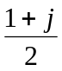 | 00
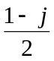 | 01
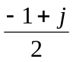 | 10
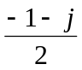 | 11

4.6B.3 Multiplexing of HS-SCCH type 3 information
The channelization-code-set information x_{ccs,1}, x_{ccs,2}, …, x_{ccs,7}, modulation-scheme and number of transport blocks information x_{ms,1}, x_{ms,2}, x_{ms,3} and precoding weight information x_{pwipb,1}, x_{pwipb,2} are multiplexed together. This gives a sequence of bits x_{1,1}, x_{1,2}, …, x_{1,12,} where
x_{1,i} = x_{ccs,i} i=1,2,…,7
x_{1,i} = x_{ms,i-7} i=8,9,10
x_{1,i} = x_{pwipb,i-10} i=11,12
If one transport block is transmitted on the associated HS-PDSCH(s), the transport-block-size information x_{tbspb,1}, x_{tbspb,2}, …, x_{tbspb,6}, Hybrid-ARQ-process information x_{hap,1},x_{hap,2}, …, x_{hap,4} and redundancy-version information x_{rvpb,1}, x_{rvpb,2} are multiplexed together. This gives a sequence of bits x_{2,1}, x_{2,2}, …, x_{2,12} where
x_{2,i} = x_{tbs,i} i=1,2,…,6
x_{2,i} = x_{hap,i-6} i=7,8,…,10
x_{2,i} = x_{rv,i-10} i=11,12
If two transport blocks are transmitted on the associated HS-PDSCHs, the transport-block-size information for the primary transport block x_{tbspb,1}, x_{tbspb,2}, …, x_{tbspb,6}, transport-block-size information for the secondary transport block x_{tbssb,1}, x_{tbssb,2}, …, x_{tbssb,6}, Hybrid-ARQ-process information x_{hap,1},x_{hap,2}, …, x_{hap,4}, redundancy-version information for the primary transport block x_{rvpb,1}, x_{rvpb,2}, and redundancy-version information for the secondary transport block x_{rvsb,1}, x_{rvsb,2} are multiplexed together. This gives a sequence of bits x_{2,1}, x_{2,2}, …, x_{2,20} where
x_{2,i} = x_{tbspb,i} i=1,2,…,6
x_{2,i} = x_{tbssb,i-6} i=7,8,…,12
x_{2,i} = x_{hap,i-12} i=13,14,...,16
x_{2,i} = x_{rvpb,i-16} i=17,18
x_{2,i} = x_{rvsb,i-18} i=19,20

4.6B.4 CRC attachment for HS-SCCH type 3
If one transport block is transmitted on the associated HS-PDSCH(s), from the sequence of bits x_{1,1}, x_{1,2}, …, x_{1,12,} x_{2,1}, x_{2,2}, …, x_{2,12} a 16-bit CRC is calculated according to Section 4.2.1.1. This gives a sequence of bits c₁, c₂, …, c₁₆ where
k=1,2,…,16
This sequence of bits is then masked with the UE Identity x_{ue,1}, x_{ue,2}, …, x_{ue,16} and then appended to the sequence of bits x_{2,1}, x_{2,2}, …, x_{2,12} to form the sequence of bits y₁, y₂, …, y₂₈, where
y_{i} = x_{2,i} i=1,2,…,12
y_{i} = (c_{i-12} + x_{ue},_{i-12} ) mod 2 i=13,14,…,28

If two transport blocks are transmitted on the associated HS-PDSCHs, from the sequence of bits x_{1,1}, x_{1,2}, …, x_{1,12,} x_{2,1}, x_{2,2}, …, x_{2,20} a 16-bit CRC is calculated according to Section 4.2.1.1. This gives a sequence of bits c₁, c₂, …, c₁₆ where
k=1,2,…,16
This sequence of bits is then masked with the UE Identity x_{ue,1}, x_{ue,2}, …, x_{ue,16} and then appended to the sequence of bits x_{2,1}, x_{2,2}, …, x_{2,20} to form the sequence of bits y₁, y₂, …, y₃₆, where
y_{i} = x_{2,i} i=1,2,…,20
y_{i} = (c_{i-20} + x_{ue},_{i-20}) mod 2 i=21,22,…,36

4.6B.5 Channel coding for HS-SCCH type 3
Rate 1/3 convolutional coding, as described in Section 4.2.3.1, is applied to the sequence of bits x_{1,1},x_{1,2}, …,x_{1,12.} This gives a sequence of bits z_{1,1}, z_{1,2}, …, z_{1,60.}
If one transport block is transmitted on the associated HS-PDSCH(s), rate 1/3 convolutional coding, as described in Section 4.2.3.1, is applied to the sequence of bits y₁, y₂, …, y_{28.} This gives a sequence of bits z_{2,1}, z_{2,2}, …, z_{2,108.}
If two transport blocks are transmitted on the associated HS-PDSCHs, rate 1/3 convolutional coding, as described in Section 4.2.3.1, is applied to the sequence of bits y₁, y₂, …, y_{36.} This gives a sequence of bits z_{2,1}, z_{2,2}, …, z_{2,132.}
Note that the coded sequence lengths result from the termination of K=9 convolutional coding being fully applied.

4.6B.6 Rate matching for HS-SCCH type 3
From the input sequence z_{1,1}, z_{1,2}, …, z_{1, 60} the bits z_{1,1}, z_{1,2}, z_{1,4}, z_{1,6}, z_{1,8}, z_{1,12}, z_{1,15}, z_{1,18}, z_{1,21}, z_{1,24}, z_{1,37}, z_{1,40}, z_{1,43}, z_{1,46}, z_{1,49}, z_{1,53}, z_{1,55}, z_{1,57}, z_{1,59}, z_{1,60} are punctured to obtain the output sequence r_{1,1},r_{1,2}…r_{1,40}.
If one transport block is transmitted on the associated HS-PDSCH(s), from the input sequence z_{2,1}, z_{2,2}, …, z_{2,108} the bits z_{2,1}, z_{2,2}, z_{2,3}, z_{2,4}, z_{2,5}, z_{2,6}, z_{2,7}, z_{2,8}, z_{2,12}, z_{2,14}, z_{2,15}, z_{2,24}, z_{2,42}, z_{2,48}, z_{2,63}, z_{2,66}, z_{2,93}, z_{2,96}, z_{2,98}, z_{2,99}, z_{2,101}, z_{2,102}, z_{2,103}, z_{2,104}, z_{2,105}, z_{2,106}, z_{2,107}, z_{2,108} are punctured to obtain the output sequence r_{2,1},r_{2,2}…r_{2,80}.
If two transport blocks are transmitted on the associated HS-PDSCHs, from the input sequence z_{2,1}, z_{2,2}, …, z_{2,132} the bits z_{2,1}, z_{2,2}, z_{2,3}, z_{2,4}, z_{2,5}, z_{2,6}, z_{2,7}, z_{2,8}, z_{2,10}, z_{2,11}, z_{2,13}, z_{2,14}, z_{2,16}, z_{2,19}, z_{2,22}, z_{2,25}, z_{2,28}, z_{2,31}, z_{2,34}, z_{2,37}, z_{2,40}, z_{2,43}, z_{2,46}, z_{2,49}, z_{2,55}, z_{2,61}, z_{2,72}, z_{2,78}, z_{2,84}, z_{2,87}, z_{2,90}, z_{2,93}, z_{2,96}, z_{2,99}, z_{2,102} , z_{2,105}, z_{2,108}, z_{2,111}, z_{2,114}, z_{2,117}, z_{2,119}, z_{2,120}, z_{2,122}, z_{2,123}, z_{2,125}, z_{2,126}, z_{2,127}, z_{2,128}, z_{2,129}, z_{2,130}, z_{2,131}, z_{2,132} are punctured to obtain the output sequence r_{2,1},r_{2,2}…r_{2,80}.

4.6B.7 UE specific masking for HS-SCCH type 3
The output bits s_{1,1},s_{1,2}…s_{1,40} are calculated as described in subclause 4.6.7.

4.6B.8 Physical channel mapping for HS-SCCH type 3
The HS-SCCH sub-frame is described in [2]. The physical channel mapping is carried out as described in subclause 4.6.8.

4.6C Coding for HS-SCCH orders

4.6C.1 Overview
HS-SCCH orders are commands sent to the UE using HS-SCCH. No HS-PDSCH is associated with HS-SCCH orders.
The following information is transmitted by means of the HS-SCCH order physical channel.
- Order type (3 bits): x_{odt,1}, x_{odt,2}, x_{odt,3}
- Order (3 bits): x_{ord,1}, x_{ord,2}, x_{ord,3}
- UE identity (16 bits): x_{ue,1}, x_{ue,2}, …, x_{ue,16}
The coding for HS-SCCH orders is specified in subclause 4.6.1 for a cell where the UE is not configured in MIMO mode and in subclause 4.6B.1 for a cell where the UE is configured in MIMO mode.

4.6C.2 HS-SCCH Order information field mapping

4.6C.2.1 Order type mapping
If Order type x_{odt,1}, x_{odt,2}, x_{odt,3} = ‘000’, then the mapping for x_{ord,1}, x_{ord,2}, x_{ord,3} is according to subclause 4.6C.2.2.1.
If Order type x_{odt,1}, x_{odt,2}, x_{odt,3} = ‘001’, then the mapping for x_{ord,1}, x_{ord,2}, x_{ord,3} is according to subclause 4.6C.2.2.2.
If Order type x_{odt,1}, x_{odt,2}, x_{odt,3} = ‘010’, then the mapping for x_{ord,1}, x_{ord,2}, x_{ord,3} is according to subclause 4.6C.2.2.2.

4.6C.2.2 Order mapping

4.6C.2.2.1 Orders for activation and deactivation of DTX, DRX and HS-SCCH-less operation and for HS-DSCH serving cell change
If the order is transmitted from the serving HS-DSCH cell or a secondary serving HS-DSCH cell, for this Order type, x_{ord,1}, x_{ord,2}, x_{ord,3} is comprised of:
- DRX activation (1 bit): x_{ord,1} = x_{drx,1}
- DTX activation (1 bit): x_{ord,2} = x_{dtx,1}
- HS-SCCH-less operation activation (1 bit): x_{ord,3} = x_{hs-scch-less,1}
If x_{drx,1}= ‘0’, then the HS-SCCH order is a DRX De-activation order.
If x_{drx,1}= ‘1’, then the HS-SCCH order is a DRX Activation order.
If x_{dtx,1}= ‘0’, then the HS-SCCH order is a DTX De-activation order.
If x_{dtx,1}= ‘1’, then the HS-SCCH order is a DTX Activation order.
If x_{hs-scch-less,1}= ‘0’, then the HS-SCCH order is a HS-SCCH-less operation De-activation order.
If x_{hs-scch-less,1}= ‘1’, then the HS-SCCH order is a HS-SCCH-less operation Activation order.
If the order is transmitted from a non-serving cell and x_{ord,1}, x_{ord,2}, x_{ord,3} = ‘000’, then it is an HS-DSCH serving cell change order .
x_{drx,1}, x_{dtx,1} = ‘10’ is a reserved combination (not used in this release).

4.6C.2.2.2 Orders for activation and deactivation of Secondary serving HS-DSCH cells and Secondary uplink frequency
For these Order types, the meaning of the orders is listed in Table 14B.
Table 14B: Orders for activation and deactivation of Secondary serving HS-DSCH cells and Secondary uplink frequency
Order Type | Order Mapping |  |  | Activation Status of Secondary Serving HS-DSCH cells and Secondary Uplink Frequency A= Activate; D = De-activate
x_{odt,1}, x_{odt,2}, x_{odt,3} | x_{ord,1} | x_{ord,2} | x_{ord,3} | 1st Secondary Serving HS-DSCH cell | 2nd Secondary Serving HS-DSCH cell | 3rd Secondary Serving HS-DSCH cell | Secondary Uplink Frequency
001 | 0 | 0 | 0 | D | D | D | D
001 | 0 | 0 | 1 | A | D | D | D
001 | 0 | 1 | 1 | A | D | D | A
001 | 0 | 1 | 0 | D | A | D | D
001 | 1 | 0 | 0 | A | A | D | D
001 | 1 | 0 | 1 | A | A | D | A
001 | 1 | 1 | 0 | D | D | A | D
001 | 1 | 1 | 1 | A | D | A | D
010 | 0 | 0 | 0 | A | D | A | A
010 | 0 | 0 | 1 | D | A | A | D
010 | 0 | 1 | 0 | A | A | A | D
010 | 0 | 1 | 1 | A | A | A | A
010 | 1 | 0 | 0 | Unused (Reserved)
010 | 1 | 0 | 1 | Unused (Reserved)
010 | 1 | 1 | 0 | Unused (Reserved)
010 | 1 | 1 | 1 | Unused (Reserved)

4.6C.2.3 UE identity mapping
The UE identity is the HS-DSCH Radio Network Identifier (H-RNTI) defined in [13]. This is mapped such that x_{ue,1} corresponds to the MSB and x_{ue,16} to the LSB, cf. [14].

4.7 Coding for HS-DPCCH

4.7.1 Overview
Data arrives to the coding unit in form of indicators for measurement indication and HARQ acknowledgement.
The following coding/multiplexing steps can be identified:
- channel coding (see subclauses 4.7.2, 4.7.3, 4.7.3A, 4.7.3B and 4.7.3C);
- mapping to physical channels (see subclause 4.7.4).
The coding/multiplexing for HS-DPCCH is defined separately for the following cases:
- when the UE is not configured in MIMO mode in the serving HS-DSCH cell, and Secondary_Cell_Enabled is 0 or 1 and Secondary_Cell_Active is 0 (see subclause 4.7.2);
- when the UE is configured in MIMO mode in the serving HS-DSCH cell and Secondary_Cell_Enabled is 0 (see subclause 4.7.3);
- when the UE is configured in MIMO mode in at least the serving HS-DSCH cell, and Secondary_Cell_Enabled is 1 and Secondary_Cell_Active is 0 (see subclause 4.7.3B);
- when the UE is not configured in MIMO mode in any cell and Secondary_Cell_Enabled is 1 and Secondary_Cell_Active is 1 (see subclause 4.7.3A);
- when the UE is configured in MIMO mode in at least one cell and Secondary_Cell_Enabled is 1 and Secondary_Cell_Active is 1 (see subclause 4.7.3B);
- when Secondary_Cell_Enabled is more than 1 (see applicable subclauses in Table 14C and 14D)
where Secondary_Cell_Enabled and Secondary_Cell_Active are defined in [4].
Table 14C: Coding for HARQ-ACK when Secondary_Cell_Enabled is more than 1
 | Secondary Cell Enabled is 2 UE is configured with two secondary serving HS-DSCH cells
Secondary_Cell_Active | Condition | Serving HS-DSCH cell | 1st Secondary Serving HS-DSCH cell | 2nd Secondary Serving HS-DSCH cell | 3rd Secondary Serving HS-DSCH cell
0, 1, 2 | MIMO is not configured in any cell | 4.7.3C.1 (Note 1) |  |  | N/A
0 | MIMO is configured in at least one cell | 4.7.3B.1 (Note 3) |  |  | N/A
1 | MIMO is configured in at least one cell | 4.7.3B.1 (Note 2) |  |  | N/A
2 | MIMO is configured in at least one cell | 4.7.3B.1 |  | 4.7.3B.1 (Note 4) | N/A
 | Secondary Cell Enabled is 3 UE is configured with three secondary serving HS-DSCH cells
Secondary_Cell_Active | Condition | Serving HS-DSCH cell | 1st Secondary Serving HS-DSCH cell | 2nd Secondary Serving HS-DSCH cell | 3rd Secondary Serving HS-DSCH cell
0 | - | 4.7.3B.1 (Note 3)
1 | - | 4.7.3B.1 (Note 2)
2, 3 | - | 4.7.3B.1 (Note 1) |  | 4.7.3B.1 (Note 1)
Note 1: When a cell is deactivated, DTX message is indicated for that cell.
Note 2: HARQ-ACK information is jointly encoded for the pair of serving HS-DSCH cell and the active secondary serving HS-DSCH cell and repeated to fill the whole HARQ-ACK slot in the HS-DPCCH sub-frame as described in subclause 4.7.4.1.
Note 3: HARQ-ACK information for the serving HS-DSCH cell is repeated to fill the whole HARQ-ACK slot in the HS-DPCCH sub-frame as described in subclause 4.7.4.1.
Note 4: HARQ-ACK information for the 2nd secondary serving HS-DSCH cell is jointly encoded with a DTX message in place of the 3rd secondary serving HS-DSCH cell as described in subclause 4.7.3B.1.
The order of the cells in HARQ-ACK joint encoding is specified in detail in subclause 4.7.4.1.
Table 14D: Coding for PCI/CQI when Secondary_Cell_Enabled is more than 1
 | Secondary Cell Enabled is 2 UE is configured with two secondary serving HS-DSCH cells
Secondary_Cell_Active | Serving HS-DSCH cell | 1st Secondary Serving HS-DSCH cell | 2nd Secondary Serving HS-DSCH cell | 3rd Secondary Serving HS-DSCH cell
0, 1 | The CQI information for a cell not configured in MIMO is encoded according to subclause 4.7.2.2(Note 1)The composite PCI/CQI information for a cell configured with MIMO is encoded according to subclause 4.7.3.2 (Note 3) |  |  | N/A
2 MIMO is not configured in any cell | The CQI information for the serving HS-DSCH cell is encoded using subclause 4.7.2.2 | The CQI information for the 1st secondary serving HS-DSCH cell and the 2nd secondary serving HS-DSCH cell is encoded according to subclause 4.7.3A.2 |  | N/A
2 (Otherwise) Note 4 | The CQI information for a cell not configured in MIMO is encoded according to subclause 4.7.2.2. The composite PCI/CQI information for a cell configured with MIMO is encoded according to subclause 4.7.3.2 |  |  | N/A
 | Secondary Cell Enabled is 3 UE is configured with three secondary serving HS-DSCH cells
Secondary_Cell_Active | Serving HS-DSCH cell | 1st Secondary Serving HS-DSCH cell | 2nd Secondary Serving HS-DSCH cell | 3rd Secondary Serving HS-DSCH cell
0, 1 Note 3 | The CQI information for a cell not configured in MIMO is encoded according to subclause 4.7.2.2. The composite PCI/CQI information for a cell configured with MIMO is encoded according to subclause 4.7.3.2
2, 3 Note 2
Note 1: If the UE is configured with MIMO in at least one cell, the CQI field for each active cell is repeated to fill the two slot CQI field in the HS-DPCCH sub-frame as described in subclause 4.7.4.2.
Note 2: In the deactivated cell, the PCI/CQI field is DTXed.
Note 3: The CQI or PCI/CQI for each active cell is repeated to fill the two slot CQI or PCI/CQI field in the HS-DPCCH sub-frame as described in subclause 4.7.4.2.
Note 4: The PCI/CQI field for the 3rd secondary serving HS-DSCH cell is DTXed
The general coding flow when the UE is not configured in MIMO mode is shown in the figure 20. This is done in parallel for the HARQ-ACK and CQI as the flows are not directly multiplexed but are transmitted at different times. If Secondary_Cell_Active is 0, the number of CQI information bits is 5, otherwise it is 10 bits.
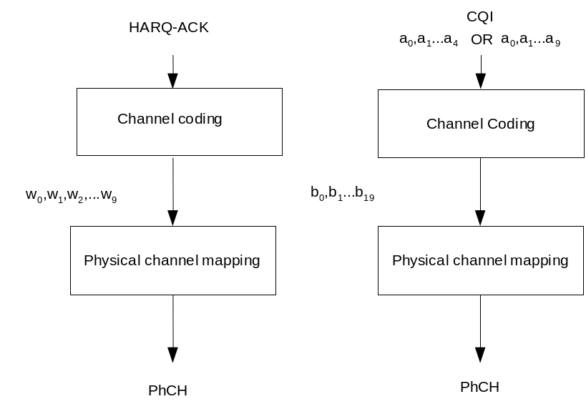
Figure 20: Coding for HS-DPCCH when the UE is not configured in MIMO mode
In case the UE is configured in MIMO mode, the measurement indication consists of precoding control indication (PCI) and channel quality indication (CQI). The general coding flow when the UE is configured in MIMO mode is shown in the figure below. This is done in parallel for the flow of HARQ-ACK and for the flow of composite PCI/CQI reports as the two flows are not directly multiplexed but are transmitted at different times
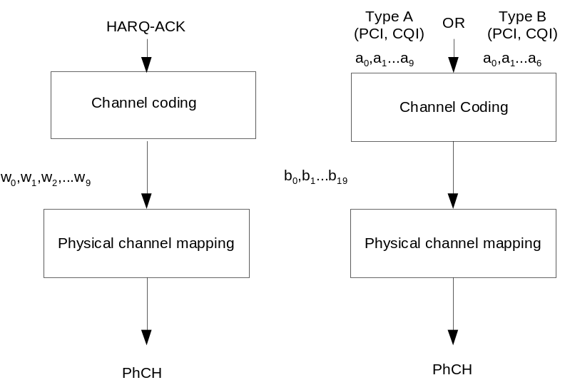
Figure 20A: Coding for HS-DPCCH when the UE is configured in MIMO mode

4.7.2 Channel coding for HS-DPCCH when the UE is not configured in MIMO mode in the serving HS-DSCH cell and Secondary_Cell_Enabled is 0 or 1 and Secondary_Cell_Active is 0
Two forms of channel coding are used, one for the channel quality indication (CQI) and another for HARQ-ACK (acknowledgement).

4.7.2.1 Channel coding for HS-DPCCH HARQ-ACK
The HARQ acknowledgement message to be transmitted, as defined in [4], shall be coded to 10 bits as shown in Table 15. The output is denoted w₀, w₁,…w₉.
Table 15: Channel coding of HARQ-ACK when the UE is not configured in MIMO mode in the serving HS-DSCH cell and Secondary_Cell_Enabled is 0 or 1 and Secondary_Cell_Active is 0
HARQ-ACK message to be transmitted | w₀ | w₁ | w₂ | w₃ | w₄ | w₅ | w₆ | w₇ | w₈ | w₉
ACK | 1 | 1 | 1 | 1 | 1 | 1 | 1 | 1 | 1 | 1
NACK | 0 | 0 | 0 | 0 | 0 | 0 | 0 | 0 | 0 | 0
PRE | 0 | 0 | 1 | 0 | 0 | 1 | 0 | 0 | 1 | 0
POST | 0 | 1 | 0 | 0 | 1 | 0 | 0 | 1 | 0 | 0

4.7.2.2 Channel coding for HS-DPCCH channel quality indication
The channel quality indication is coded using a (20,5) code. The code words of the (20,5) code are a linear combination of the 5 basis sequences denoted M_{i,n} defined in the table below.
Table 15A: Basis sequences for (20,5) code
i | M_{i,0} | M_{i,1} | M_{i,2} | M_{i,3} | M_{i,4}
0 | 1 | 0 | 0 | 0 | 1
1 | 0 | 1 | 0 | 0 | 1
2 | 1 | 1 | 0 | 0 | 1
3 | 0 | 0 | 1 | 0 | 1
4 | 1 | 0 | 1 | 0 | 1
5 | 0 | 1 | 1 | 0 | 1
6 | 1 | 1 | 1 | 0 | 1
7 | 0 | 0 | 0 | 1 | 1
8 | 1 | 0 | 0 | 1 | 1
9 | 0 | 1 | 0 | 1 | 1
10 | 1 | 1 | 0 | 1 | 1
11 | 0 | 0 | 1 | 1 | 1
12 | 1 | 0 | 1 | 1 | 1
13 | 0 | 1 | 1 | 1 | 1
14 | 1 | 1 | 1 | 1 | 1
15 | 0 | 0 | 0 | 0 | 1
16 | 0 | 0 | 0 | 0 | 1
17 | 0 | 0 | 0 | 0 | 1
18 | 0 | 0 | 0 | 0 | 1
19 | 0 | 0 | 0 | 0 | 1

The CQI values 0 ... 30 as defined in [4] are converted from decimal to binary to map them to the channel quality indication bits (1 0 0 0 0) to (1 1 1 1 1) respectively. The information bit pattern (0 0 0 0 0) shall not be used in this release. The channel quality indication bits are a₀ , a₁ , a₂ , a₃ , a₄ (where a₀ is LSB and a₄ is MSB). The output code word bits b_{i} are given by:
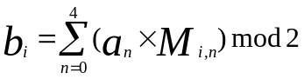
where i = 0, …, 19.

4.7.3 Channel coding for HS-DPCCH when the UE is configured in MIMO mode in the serving HS-DSCH cell and Secondary_Cell_Enabled is 0
Two forms of channel coding are used, one for the composite precoding control indication (PCI) and channel quality indication (CQI) and another for HARQ-ACK (acknowledgement).

4.7.3.1 Channel coding for HS-DPCCH HARQ-ACK
The HARQ acknowledgement message to be transmitted, as defined in [4], shall be coded to 10 bits as shown in Table 15B. The output is denoted w₀, w₁,…w₉.
Table 15B: Channel coding of HARQ-ACK when the UE is configured in MIMO mode in the serving HS-DSCH cell and Secondary_Cell_Enabled is 0
HARQ-ACK  message to be transmitted |  | w₀ | w₁ | w₂ | w₃ | w₄ | w₅ | w₆ | w₇ | w₈ | w₉
HARQ-ACK in response to a single scheduled transport block
ACK |  | 1 | 1 | 1 | 1 | 1 | 1 | 1 | 1 | 1 | 1
NACK |  | 0 | 0 | 0 | 0 | 0 | 0 | 0 | 0 | 0 | 0
HARQ-ACK in response to two scheduled transport blocks
Response to primary transport block | Response to secondary transport block
ACK | ACK | 1 | 0 | 1 | 0 | 1 | 1 | 1 | 1 | 0 | 1
ACK | NACK | 1 | 1 | 0 | 1 | 0 | 1 | 0 | 1 | 1 | 1
NACK | ACK | 0 | 1 | 1 | 1 | 1 | 0 | 1 | 0 | 1 | 1
NACK | NACK | 1 | 0 | 0 | 1 | 0 | 0 | 1 | 0 | 0 | 0
PRE/POST indication
PRE |  | 0 | 0 | 1 | 0 | 0 | 1 | 0 | 0 | 1 | 0
POST |  | 0 | 1 | 0 | 0 | 1 | 0 | 0 | 1 | 0 | 0

4.7.3.2 Channel coding for HS-DPCCH composite precoding control indication and channel quality indication
When the UE is configured in MIMO mode and single-stream restriction is not configured, two types of CQI reports shall be supported by the UE. According to the definition of the CQI reporting procedure in [4], type A CQI reports use values 0 … 255 and type B CQI reports use values 0 … 30, respectively. When the UE is configured in MIMO mode and single-stream restriction is configured, only type B shall be supported by the UE.

4.7.3.2.1 Bit mapping of Type A channel quality indication
In case a type A CQI shall be reported, the CQI values 0 ... 255 as defined in [4] are converted from decimal to binary to map them to the channel quality indication bits (0 0 0 0 0 0 0 0) to (1 1 1 1 1 1 1 1), respectively. The channel quality indication bits are cqi₀ , cqi₁ , cqi₂ , cqi₃ , cqi₄, cqi₅, cqi₆, cqi₇ (where cqi₀ is LSB and cqi₇ is MSB).

4.7.3.2.2 Bit mapping of Type B channel quality indication
In case a type B CQI shall be reported, the CQI values 0 ... 30 as defined in [4] are converted from decimal to binary to map them to the channel quality indication bits (1 0 0 0 0) to (1 1 1 1 1), respectively. The information bit pattern (0 0 0 0 0) shall not be used in this release. The channel quality indication bits are cqi_{0,} cqi_{1,} cqi_{2,} cqi_{3,} cqi₄ (where cqi₀ is LSB and cqi₄ is MSB).

4.7.3.2.3 Bit mapping of precoding control indication
According to the PCI definition in [4], the range of possible PCI values is 0 ... 3. The PCI values 0 ... 3 as defined in [4] are converted from decimal to binary to map them to the precoding control indication bits (0 0) to (1 1) respectively. The precoding control indication bits are pci₀ , pci₁ (where pci₀ is LSB and pci₁ is MSB).

4.7.3.2.4 Composite precoding control indication and channel quality indication bits
Two formats for composite PCI/CQI information words are possible depending on the type of the reported CQI value. The two formats shall be constructed according to the scheme depicted in Figure 20B.
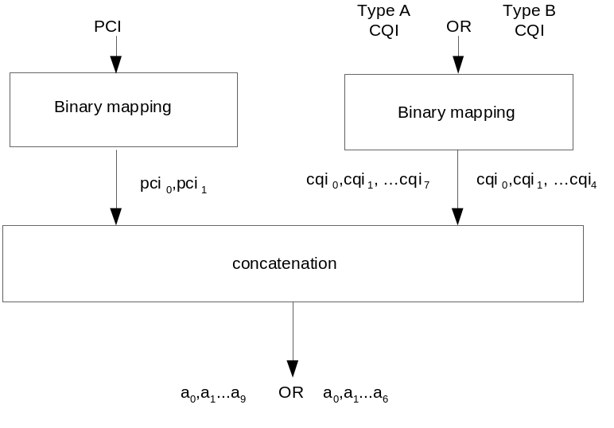
- Figure 20B: Construction of composite PCI/CQI report
In case a type A CQI shall be reported, the precoding control indication bits pci₀ , pci₁, and the channel quality indication bits cqi₀ , cqi₁ , cqi₂ , cqi₃ , cqi₄, cqi₅, cqi₆, cqi₇ are concatenated to the composite precoding control indication and channel quality indication bits according to the relation
In case a type B CQI shall be reported, the precoding control indication bits pci₀ , pci₁, and the channel quality indication bits cqi₀ , cqi₁ , cqi₂ , cqi₃ , cqi₄ are concatenated to the composite precoding control indication and channel quality indication bits according to the relation

4.7.3.2.5 Block encoding of composite precoding control indication and channel quality indication bits
In case a type A CQI needs to be reported, the composite precoding control indication and channel quality indication is coded using a (20,10) code. The code words of the (20,10) code are a linear combination of the 10 basis sequences denoted M_{i,n} defined in the table 15C below.
Table 15C: Basis sequences for channel encoding of composite PCI/CQI reports
i | M_{i,0} | M_{i,1} | M_{i,2} | M_{i,3} | M_{i,4} | M_{i,5} | M_{i,6} | M_{i,7} | M_{i,8} | M_{i,9} | M_{i,10}
0 | 1 | 0 | 0 | 0 | 0 | 0 | 0 | 0 | 0 | 0 | 0
1 | 0 | 1 | 0 | 0 | 0 | 0 | 0 | 0 | 0 | 0 | 0
2 | 0 | 0 | 0 | 1 | 0 | 0 | 0 | 0 | 0 | 0 | 0
3 | 0 | 0 | 0 | 0 | 1 | 0 | 0 | 0 | 0 | 0 | 0
4 | 0 | 0 | 0 | 0 | 0 | 1 | 0 | 0 | 0 | 0 | 0
5 | 0 | 0 | 0 | 0 | 0 | 0 | 0 | 1 | 0 | 0 | 0
6 | 0 | 0 | 0 | 0 | 0 | 0 | 0 | 0 | 1 | 0 | 1
7 | 0 | 0 | 0 | 0 | 0 | 0 | 0 | 0 | 0 | 1 | 1
8 | 1 | 0 | 1 | 0 | 0 | 0 | 1 | 1 | 1 | 0 | 1
9 | 1 | 1 | 0 | 1 | 0 | 0 | 0 | 1 | 1 | 1 | 1
10 | 0 | 1 | 1 | 0 | 1 | 0 | 0 | 0 | 1 | 1 | 1
11 | 1 | 0 | 1 | 1 | 0 | 1 | 0 | 0 | 0 | 1 | 0
12 | 1 | 1 | 0 | 1 | 1 | 0 | 1 | 0 | 0 | 0 | 0
13 | 1 | 1 | 1 | 0 | 1 | 1 | 0 | 1 | 0 | 0 | 0
14 | 0 | 1 | 1 | 1 | 0 | 1 | 1 | 0 | 1 | 0 | 1
15 | 0 | 0 | 1 | 1 | 1 | 0 | 1 | 1 | 0 | 1 | 0
16 | 0 | 0 | 0 | 1 | 1 | 1 | 0 | 1 | 1 | 0 | 1
17 | 1 | 0 | 0 | 0 | 1 | 1 | 1 | 0 | 1 | 1 | 1
18 | 0 | 1 | 0 | 0 | 0 | 1 | 1 | 1 | 0 | 1 | 0
19 | 1 | 1 | 1 | 1 | 1 | 1 | 1 | 1 | 1 | 1 | 1

The output code word bits b_{i} are given by:
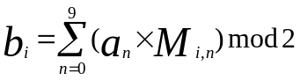
where i = 0, …, 19.
In case a type B CQI needs to be reported, the composite precoding control indication and channel quality indication is coded using a (20,7) code. The code words of the (20,7) code are a linear combination of the basis sequences denoted M_{i,n} defined in the table 15C for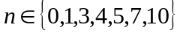.
The output code word bits b_{i} are given by:
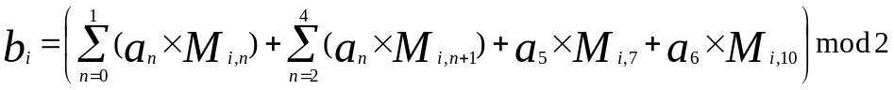
where i = 0, …, 19.

4.7.3A Channel coding for HS-DPCCH when the UE is not configured in MIMO mode in any cell and Secondary_Cell_Enabled is 1 and Secondary_Cell_Active is 1
Two forms of channel coding are used, one for the composite channel quality indication (CQI) and another for the composite HARQ-ACK (acknowledgement).

4.7.3A.1 Channel coding for the composite HS-DPCCH HARQ-ACK
The composite HARQ acknowledgement message to be transmitted, as defined in [4], shall be coded to 10 bits as shown in Table 15C.1. The output is denoted w₀, w₁,…w₉.

Table 15C.1: Channel coding of HARQ-ACK when the UE is not configured in MIMO mode in a pair of serving HS-DSCH cells and Secondary_Cell_Enabled is 1 and Secondary_Cell_Active is 1
HARQ-ACK  message to be transmitted |  | w₀ | w₁ | w₂ | w₃ | w₄ | w₅ | w₆ | w₇ | w₈ | w₉
HARQ-ACK when UE detects a single scheduled transport block on the serving HS-DSCH cell
ACK |  | 1 | 1 | 1 | 1 | 1 | 1 | 1 | 1 | 1 | 1
NACK |  | 0 | 0 | 0 | 0 | 0 | 0 | 0 | 0 | 0 | 0
HARQ-ACK when UE detects a single scheduled transport block on the secondary serving HS-DSCH cell
ACK |  | 1 | 1 | 1 | 1 | 1 | 0 | 0 | 0 | 0 | 0
NACK |  | 0 | 0 | 0 | 0 | 0 | 1 | 1 | 1 | 1 | 1
HARQ-ACK when UE detects a single scheduled transport block on each of the serving and secondary serving HS-DSCH cells
Response to transport block from serving HS-DSCH cell | Response to transport block from secondary serving HS-DSCH cell
ACK | ACK | 1 | 0 | 1 | 0 | 1 | 0 | 1 | 0 | 1 | 0
ACK | NACK | 1 | 1 | 0 | 0 | 1 | 1 | 0 | 0 | 1 | 1
NACK | ACK | 0 | 0 | 1 | 1 | 0 | 0 | 1 | 1 | 0 | 0
NACK | NACK | 0 | 1 | 0 | 1 | 0 | 1 | 0 | 1 | 0 | 1
PRE/POST indication
PRE |  | 0 | 0 | 1 | 0 | 0 | 1 | 0 | 0 | 1 | 0
POST |  | 0 | 1 | 0 | 0 | 1 | 0 | 0 | 1 | 0 | 0

4.7.3A.2 Channel coding for HS-DPCCH composite channel quality indication

4.7.3A.2.1 Composite channel quality indication bits
The composite CQI report is constructed from two individual CQI reports that are represented by CQI1 and CQI2. CQI1 corresponds to the serving HS-DSCH cell and CQI2 corresponds to the secondary serving HS-DSCH cell.
Each constituent CQI report uses values 0 … 30 in accordance with the definition of the CQI reporting procedure in [4]. The individual CQI values are converted from decimal to binary to map them to the channel quality indication bits (1 0 0 0 0) to (1 1 1 1 1) respectively. The information bit pattern (0 0 0 0 0) shall not be used in this release.
The channel quality indication bits corresponding to CQI1 are cqi1_{0,} cqi1_{1,} cqi1_{2,} cqi1_{3,} cqi1₄ (where cqi1₀ is LSB and cqi1₄ is MSB) and those corresponding to CQI2 are cqi2_{0,} cqi2_{1,} cqi2_{2,} cqi2_{3,} cqi2₄ (where cqi2₀ is LSB and cqi2₄ is MSB).
The composite CQI report is constructed according to the scheme depicted in Figure 20C
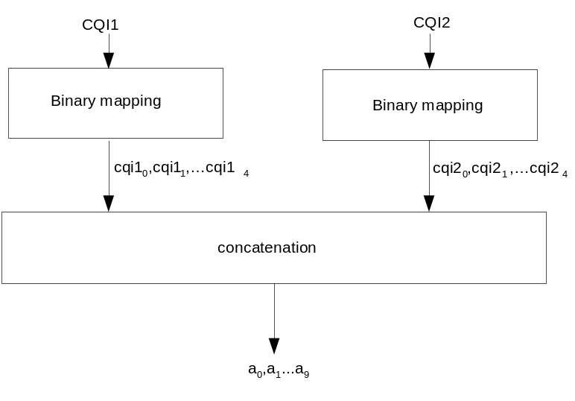
Figure 20C: Construction of composite CQI report
The two individual CQI reports are concatenated to form the composite channel quality indication according to the relation

4.7.3A.2.2 Block encoding of composite channel quality indication bits
The composite channel quality indication is coded using a (20,10) code. The code words of the (20,10) code are a linear combination of the 10 basis sequences denoted M_{i,n} defined in Table 15C.
The output code word bits b_{i} are given by:
where i = 0, …, 19 and a₀,…, a₉ are defined in the previous subclause.

4.7.3B Channel coding for HS-DPCCH when Secondary_Cell_Enabled is 3 or when the UE is configured in MIMO mode in at least one cell and Secondary_Cell_Enabled is greater than 0
Two forms of channel coding are used, one for the composite precoding control indication (PCI) and channel quality indication (CQI) and another for the composite HARQ-ACK (acknowledgement).

4.7.3B.1 Channel coding for the composite HS-DPCCH HARQ-ACK
The composite HARQ acknowledgement message to be transmitted, as defined in [4], shall be coded to 10 bits as shown in Table 15C.2. The feedback related to the first cell is given before the divider sign and the feedback related to the second cell is given after the divider sign. ‘A’ means ‘ACK’, ‘N’ means ‘NACK’ and ‘D’ means ‘no transmission’ (‘DTX’). ‘AA’, ‘AN’, ‘NA’ and ‘NN’ refer to feedback for dual-stream transmission in a cell. For example, ‘AN’ means ACK on the primary stream and NACK on the secondary stream. The output is denoted w₀, w₁,…w₉.
When Secondary_Cell_Enabled is 2, and when Secondary_Cell_Active is 2, HARQ-ACK information for the 2nd secondary serving HS-DSCH cell is jointly encoded with a DTX message in place of the 3rd secondary serving HS-DSCH cell.
Table 15C.2: Channel coding of HARQ-ACK when Secondary_Cell_Enabled = 3 or the UE is configured in MIMO mode in at least one cell and Secondary_Cell_Enabled is greater than 0
HARQ-ACK message to be transmitted | w₀ | w₁ | w₂ | w₃ | w₄ | w₅ | w₆ | w₇ | w₈ | w₉ |  | HARQ-ACK message to be transmitted | w₀ | w₁ | w₂ | w₃ | w₄ | w₅ | w₆ | w₇ | w₈ | w₉
A/D | 1 | 1 | 1 | 1 | 1 | 1 | 1 | 1 | 1 | 1 |  | AA/A | 0 | 1 | 1 | 0 | 0 | 0 | 0 | 1 | 0 | 0
N/D | 0 | 0 | 0 | 0 | 0 | 0 | 0 | 0 | 0 | 0 |  | AA/N | 1 | 1 | 1 | 0 | 0 | 1 | 1 | 0 | 1 | 0
AA/D | 1 | 0 | 1 | 0 | 1 | 1 | 1 | 1 | 0 | 1 |  | AN/A | 1 | 0 | 1 | 1 | 1 | 0 | 0 | 1 | 1 | 0
AN/D | 1 | 1 | 0 | 1 | 0 | 1 | 0 | 1 | 1 | 1 |  | AN/N | 0 | 0 | 1 | 1 | 0 | 1 | 0 | 0 | 0 | 1
NA/D | 0 | 1 | 1 | 1 | 1 | 0 | 1 | 0 | 1 | 1 |  | NA/A | 0 | 1 | 0 | 1 | 1 | 1 | 1 | 1 | 0 | 0
NN/D | 1 | 0 | 0 | 1 | 0 | 0 | 1 | 0 | 0 | 0 |  | NA/N | 1 | 1 | 0 | 0 | 1 | 0 | 0 | 0 | 0 | 1
D/A | 0 | 0 | 0 | 0 | 0 | 0 | 1 | 1 | 1 | 1 |  | NN/A | 0 | 0 | 0 | 0 | 1 | 1 | 0 | 0 | 1 | 0
D/N | 1 | 1 | 1 | 1 | 1 | 1 | 0 | 0 | 0 | 0 |  | NN/N | 0 | 1 | 0 | 0 | 0 | 1 | 1 | 0 | 0 | 1
D/AA | 1 | 0 | 0 | 0 | 1 | 0 | 0 | 0 | 1 | 1 |  | AA/AA | 0 | 1 | 1 | 0 | 1 | 1 | 0 | 1 | 1 | 1
D/AN | 0 | 1 | 0 | 0 | 0 | 0 | 1 | 1 | 0 | 1 |  | AA/AN | 1 | 0 | 1 | 1 | 0 | 0 | 1 | 1 | 1 | 1
D/NA | 0 | 0 | 0 | 1 | 1 | 1 | 1 | 1 | 1 | 0 |  | AA/NA | 1 | 1 | 0 | 1 | 1 | 1 | 1 | 0 | 0 | 1
D/NN | 1 | 1 | 1 | 1 | 1 | 0 | 0 | 1 | 0 | 0 |  | AA/NN | 0 | 1 | 1 | 1 | 0 | 1 | 1 | 1 | 0 | 0
A/A | 1 | 1 | 0 | 1 | 0 | 0 | 0 | 0 | 1 | 1 |  | AN/AA | 0 | 0 | 0 | 1 | 1 | 0 | 0 | 1 | 0 | 1
A/N | 0 | 0 | 1 | 1 | 1 | 0 | 1 | 0 | 0 | 1 |  | AN/AN | 1 | 1 | 1 | 0 | 0 | 0 | 0 | 0 | 0 | 1
N/A | 1 | 0 | 0 | 1 | 0 | 1 | 1 | 1 | 0 | 0 |  | AN/NA | 1 | 0 | 0 | 0 | 0 | 1 | 0 | 1 | 0 | 0
N/N | 0 | 1 | 1 | 0 | 0 | 1 | 0 | 1 | 0 | 1 |  | AN/NN | 0 | 0 | 1 | 1 | 0 | 1 | 0 | 0 | 0 | 1
A/AA | 1 | 0 | 1 | 0 | 0 | 1 | 1 | 0 | 0 | 0 |  | NA/AA | 1 | 1 | 0 | 0 | 1 | 0 | 1 | 1 | 1 | 0
A/AN | 1 | 0 | 0 | 1 | 0 | 1 | 0 | 1 | 0 | 1 |  | NA/AN | 0 | 0 | 1 | 0 | 1 | 0 | 1 | 0 | 0 | 0
A/NA | 0 | 0 | 1 | 1 | 1 | 0 | 1 | 0 | 0 | 1 |  | NA/NA | 1 | 0 | 1 | 1 | 1 | 1 | 0 | 0 | 1 | 0
A/NN | 0 | 1 | 1 | 1 | 0 | 1 | 0 | 0 | 1 | 1 |  | NA/NN | 1 | 1 | 1 | 0 | 0 | 1 | 1 | 0 | 1 | 0
N/AA | 1 | 1 | 0 | 1 | 0 | 0 | 1 | 0 | 1 | 0 |  | NN/AA | 0 | 1 | 0 | 1 | 0 | 0 | 0 | 0 | 1 | 0
N/AN | 1 | 1 | 0 | 0 | 0 | 1 | 0 | 1 | 1 | 0 |  | NN/AN | 0 | 0 | 1 | 0 | 0 | 0 | 0 | 1 | 1 | 0
N/NA | 0 | 1 | 1 | 0 | 1 | 0 | 1 | 0 | 1 | 0 |  | NN/NA | 0 | 1 | 0 | 0 | 1 | 1 | 0 | 0 | 0 | 0
N/NN | 0 | 0 | 1 | 0 | 1 | 1 | 0 | 1 | 0 | 1 |  | NN/NN | 0 | 0 | 0 | 0 | 0 | 1 | 1 | 0 | 1 | 1
PRE/POST
PRE | 0 | 0 | 1 | 0 | 0 | 1 | 0 | 0 | 1 | 0 |  | POST | 0 | 1 | 0 | 0 | 1 | 0 | 0 | 1 | 0 | 0

When Secondary_Cell_Active is 2 or 3, and when DTX message is indicated for the cells, whose HARQ-ACK information is jointly encoded, the specific DTX code word as defined in Table 15C.2A is transmitted except for the case when DTX message is indicated for all active cells, in which case the HARQ-ACK slot is DTXed. The slot containing HARQ-ACK information is either transmitted or DTXed.
Table 15C.2A: Channel coding of HARQ-ACK for a pair of DTX messages when Secondary_Cell_Active is 2 or 3
HARQ-ACK message to be transmitted | w₀ | w₁ | w₂ | w₃ | w₄ | w₅ | w₆ | w₇ | w₈ | w₉
D/D | 0 | 0 | 1 | 1 | 0 | 1 | 1 | 0 | 1 | 0

4.7.3B.2 Channel coding for HS-DPCCH composite precoding control indication and channel quality indication
The channel coding for CQI associated with a cell for which the UE is not configured in MIMO mode is specified in subclause 4.7.2.2.
The channel coding for PCI and CQI associated with a cell for which the UE is configured in MIMO mode is specified in subclause 4.7.3.2.

4.7.3C Channel coding for HS-DPCCH when the UE is not configured in MIMO mode in any cell and Secondary_Cell_Enabled is 2
Two forms of channel coding are used, one for the composite channel quality indication (CQI) and another for the composite HARQ-ACK (acknowledgement).

4.7.3C.1 Channel coding for the composite HS-DPCCH HARQ-ACK
Table 15C.3: Channel coding of HARQ-ACK when the UE is not configured in MIMO mode in any cell and Secondary_Cell_Enabled is 2
HARQ-ACK message to be transmitted |  |  |  |  | w₀ |  |  | w₁ |  |  | w₂ |  |  | w₃ |  | w₄ | w₅ |  |  | w₆ |  |  | w₇ |  |  | w₈ |  |  | w₉
A/D/D |  |  |  |  | 1 |  |  | 1 |  |  | 1 |  |  | 1 |  | 1 | 1 |  |  | 1 |  |  | 1 |  |  | 1 |  |  | 1
N/D/D |  |  |  |  | 0 |  |  | 0 |  |  | 0 |  |  | 0 |  | 0 | 0 |  |  | 0 |  |  | 0 |  |  | 0 |  |  | 0
D/A/D |  |  |  |  | 1 |  |  | 1 |  |  | 1 |  |  | 1 |  | 1 | 0 |  |  | 0 |  |  | 0 |  |  | 0 |  |  | 0
D/N/D |  |  |  |  | 0 |  |  | 0 |  |  | 0 |  |  | 0 |  | 0 | 1 |  |  | 1 |  |  | 1 |  |  | 1 |  |  | 1
D/D/A |  |  |  |  | 1 |  |  | 1 |  |  | 0 |  |  | 0 |  | 0 | 1 |  |  | 1 |  |  | 0 |  |  | 0 |  |  | 0
D/D/N |  |  |  |  | 0 |  |  | 0 |  |  | 1 |  |  | 1 |  | 1 | 0 |  |  | 0 |  |  | 1 |  |  | 1 |  |  | 1
A/A/D |  |  |  |  | 1 |  |  | 0 |  |  | 1 |  |  | 0 |  | 1 | 0 |  |  | 1 |  |  | 0 |  |  | 1 |  |  | 0
A/N/D |  |  |  |  | 1 |  |  | 1 |  |  | 0 |  |  | 0 |  | 1 | 1 |  |  | 0 |  |  | 0 |  |  | 1 |  |  | 1
N/A/D |  |  |  |  | 0 |  |  | 0 |  |  | 1 |  |  | 1 |  | 0 | 0 |  |  | 1 |  |  | 1 |  |  | 0 |  |  | 0
N/N/D |  |  |  |  | 0 |  |  | 1 |  |  | 0 |  |  | 1 |  | 0 | 1 |  |  | 0 |  |  | 1 |  |  | 0 |  |  | 1
A/D/A |  |  |  |  | 1 |  |  | 0 |  |  | 1 |  |  | 1 |  | 0 | 1 |  |  | 1 |  |  | 0 |  |  | 0 |  |  | 1
A/D/N |  |  |  |  | 0 |  |  | 1 |  |  | 0 |  |  | 1 |  | 1 | 0 |  |  | 1 |  |  | 0 |  |  | 0 |  |  | 1
N/D/A |  |  |  |  | 0 |  |  | 0 |  |  | 0 |  |  | 1 |  | 1 | 1 |  |  | 1 |  |  | 0 |  |  | 1 |  |  | 0
N/D/N |  |  |  |  | 1 |  |  | 0 |  |  | 0 |  |  | 1 |  | 1 | 1 |  |  | 0 |  |  | 1 |  |  | 0 |  |  | 0
D/A/A |  |  |  |  | 0 |  |  | 1 |  |  | 1 |  |  | 1 |  | 0 | 1 |  |  | 0 |  |  | 0 |  |  | 1 |  |  | 0
D/A/N |  |  |  |  | 1 |  |  | 0 |  |  | 1 |  |  | 0 |  | 0 | 1 |  |  | 0 |  |  | 1 |  |  | 1 |  |  | 0
D/N/A |  |  |  |  | 0 |  |  | 1 |  |  | 1 |  |  | 0 |  | 0 | 0 |  |  | 1 |  |  | 0 |  |  | 1 |  |  | 1
D/N/N |  |  |  |  | 0 |  |  | 0 |  |  | 0 |  |  | 0 |  | 1 | 0 |  |  | 1 |  |  | 0 |  |  | 1 |  |  | 1
A/A/A |  |  |  |  | 1 |  |  | 1 |  |  | 0 |  |  | 1 |  | 0 | 0 |  |  | 1 |  |  | 1 |  |  | 1 |  |  | 0
A/A/N |  |  |  |  | 0 |  |  | 1 |  |  | 1 |  |  | 0 |  | 1 | 1 |  |  | 1 |  |  | 1 |  |  | 0 |  |  | 0
A/N/A |  |  |  |  | 1 |  |  | 0 |  |  | 0 |  |  | 1 |  | 0 | 0 |  |  | 0 |  |  | 0 |  |  | 1 |  |  | 1
A/N/N |  |  |  |  | 0 |  |  | 0 |  |  | 1 |  |  | 0 |  | 1 | 1 |  |  | 0 |  |  | 0 |  |  | 0 |  |  | 1
N/A/A |  |  |  |  | 1 |  |  | 1 |  |  | 1 |  |  | 0 |  | 0 | 0 |  |  | 0 |  |  | 1 |  |  | 0 |  |  | 1
N/A/N |  |  |  |  | 0 |  |  | 1 |  |  | 0 |  |  | 0 |  | 1 | 0 |  |  | 0 |  |  | 1 |  |  | 1 |  |  | 0
N/N/A |  |  |  |  | 1 |  |  | 0 |  |  | 0 |  |  | 0 |  | 1 | 0 |  |  | 1 |  |  | 1 |  |  | 0 |  |  | 1
N/N/N |  |  |  |  | 1 |  |  | 1 |  |  | 1 |  |  | 1 |  | 0 | 1 |  |  | 0 |  |  | 1 |  |  | 0 |  |  | 0
PRE/POST
PRE | 0 | 0 | 1 | 0 | 0 | 1 | 0 |  | 0 | 1 |  | 0 |  |  | POST |  |  | 0 | 1 |  | 0 | 0 |  | 1 | 0 |  | 0 | 1 | 0 | 0

4.7.3C.2 Channel coding for HS-DPCCH channel quality indication
The channel coding for CQI is specified in subclause 4.7.2.2 for the serving HS-DSCH cell, and in subclause 4.7.3A.2 for the 1st and 2nd secondary serving HS-DSCH cells.

4.7.4 Physical channel mapping for HS-DPCCH

4.7.4.1 Physical Channel mapping for HS-DPCCH HARQ-ACK
If the HS-DPCCH slot format 0 as defined in [2], is used t he HS-DPCCH physical channel mapping function shall map the input bits w_{k} directly to physical channel so that bits are transmitted over the air in ascending order with respect to k.
If the HS-DPCCH slot format 1 as defined in [2], is used, the HS-DPCCH physical channel mapping function shall map the input bits w_{k} to the physical channel so that bits are transmitted over the air in ascending order with respect to k as follows:
- If Secondary_Cell_Enabled is 3 and Secondary_Cell_Active is 2 or 3 then the following two HARQ-ACK messages are encoded and concatenated into the same slot according to Figure 20D :
  - HARQ-ACK1 comprising the HARQ acknowledgement messages for the pair of serving HS-DSCH cell and 1st secondary serving HS-DSCH cell in that order and
  - HARQ-ACK2 comprising the HARQ acknowledgement messages for the pair of 2nd secondary serving HS-DSCH cell and the 3rd secondary serving HS-DSCH cell in that order
- If Secondary_Cell_Enabled is 2 with MIMO configured in at least one of the cells and Secondary_Cell_Active is 2 then the following two HARQ-ACK messages, are encoded and concatenated into the same slot according to Figure 20D:
  - HARQ-ACK1 comprising the HARQ acknowledgement messages for the pair of serving HS-DSCH cell and 1st secondary serving HS-DSCH cell in that order and
  - HARQ-ACK2 comprising the HARQ acknowledgement messages for the 2nd secondary serving HS-DSCH cell and a DTX message in that order
- If Secondary_Cell_Enabled is more than 1 and Secondary_Cell_Active is 0 or 1 then the transmission of the HARQ-ACK message is repeated according to Figure 20E.
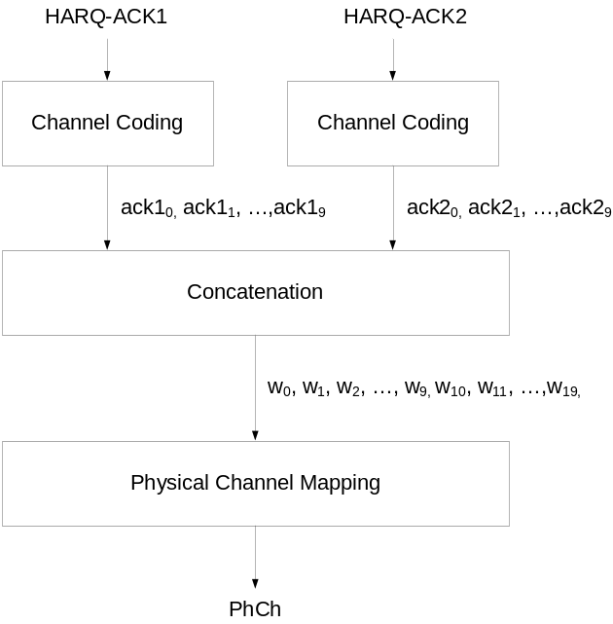
Figure 20D: Concatenation of 2 HARQ-ACK messages
In Figure 20D, the concatenation of the 2 HARQ-ACK messages is according to the relation:
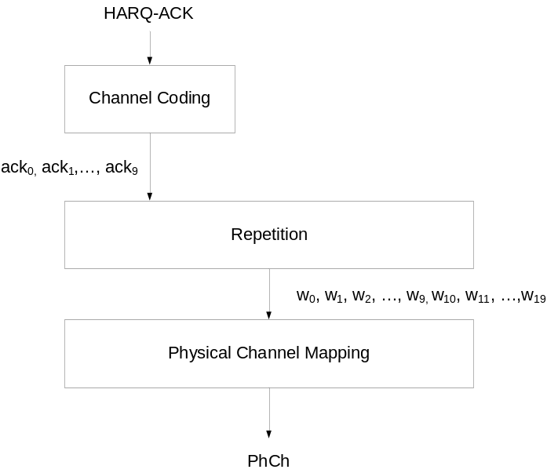
Figure 20E: Repetition of HARQ-ACK message
In Figure 20E, the repetition of the HARQ-ACK message is according to the relation:

4.7.4.2 Physical Channel mapping for HS-DPCCH PCI/CQI
Table 15C.4 lists the CQI and PCI/CQI report mapping scenarios. The transmission timing and repetition of the 1st and the 2nd CQI and PCI/CQI report is defined in [4].
Table 15C.4: The CQI and PCI/CQI report mapping scenarios
Case | Secondary_  Cell_  Enabled | MIMO configured in any cell | HS-DPCCH slot format | Secondary_  Cell_  Active | 1st CQI or PCI/CQI report |  | 2nd CQI or PCI/CQI report
 |  |  |  |  | CQI or  PCI/CQI Type A/B |  | CQI or  PCI/CQI Type A/B
1 | 0 | No | 0 | 0 | CQI |  | Not applicable
2 | 0 | Yes | 0 | 0 | PCI/CQI |  | Not applicable
3 | 1  Note 2 | No | 0 | 1 | CQI₀ & CQI₁  Note 5 |  | Not applicable
4 | 1  Note 2 | No | 0 | 0 | CQI₀ |  | Not applicable
5 | 1  Note 2 | Yes  Note 1 | 0 | 1 | PCI/CQI₀ |  | PCI/CQI₁
6 | 1  Note 2 | Yes  Note 1 | 0 | 0 | PCI/CQI₀ |  | Not applicable
7 | 2  Note 2 | No | 0 | 2 | CQI₀ |  | CQI₁ & CQI₂  Note 5
8 | 2  Note 2 | No | 0 | 1 | CQI₀ |  | CQI_{n}  Note 4
9 | 2  Note 2 | No | 0 | 0 | CQI₀ |  | Not applicable
 |  |  |  |  | CQI 1 or PCI/CQI 1 Type A/B | CQI 2 or PCI/CQI 2  Type A/B | CQI 1 or PCI/CQI 1  Type A/B | CQI 2 or PCI/CQI 2  Type A/B
10 | 2  Note 2 | Yes  Note 1 | 1 | 2 | PCI/CQI₀ | PCI/CQI₂ | PCI/CQI₁ | DTX
11 | 2  Note 2 | Yes  Note 1 | 1 | 1 | PCI/CQI₀ | PCI/CQI₀ | PCI/CQI_{n}  Note 4 | PCI/CQI_{n}  Note 4
12 | 2  Note 2 | Yes  Note 1 | 1 | 0 | PCI/CQI₀ | PCI/CQI₀ | Not applicable
13 | 3  Note 2 | No | 1 | 3 | CQI₀ | CQI₂ | CQI₁ | CQI₃
14 | 3  Note 2 | No | 1 | 2 | CQI₀ | CQI₂  Note 3 | CQI₁  Note 3 | CQI₃  Note 3
15 | 3  Note 2 | No | 1 | 1 | CQI₀ | CQI₀ | CQI_{n}  Note 4 | CQI_{n}  Note 4
16 | 3  Note 2 | No | 1 | 0 | CQI₀ | CQI₀ | Not applicable
17 | 3  Note 2 | Yes  Note 1 | 1 | 3 | PCI/CQI₀ | PCI/CQI₂ | PCI/CQI₁ | PCI/CQI₃
18 | 3  Note 2 | Yes  Note 1 | 1 | 2 | PCI/CQI₀ | PCI/CQI₂  Note 3 | PCI/CQI₁  Note 3 | PCI/CQI₃  Note 3
19 | 3  Note 2 | Yes  Note 1 | 1 | 1 | PCI/CQI₀ | PCI/CQI₀ | PCI/CQI_{n}  Note 4 | PCI/CQI_{n}  Note 4
20 | 3  Note 2 | Yes  Note 1 | 1 | 0 | PCI/CQI₀ | PCI/CQI₀ | Not applicable
Note 1: If the UE is configured in MIMO mode in at least one cell, but not in all cells, a CQI value is reported instead of PCI/CQI value for the non-MIMO cell(s).
Note 2: The CQI₀ and PCI/CQI₀ refer to the serving HS-DSCH cell’s CQI and PCI/CQI reports respectively, the CQI_{n} and PCI/CQI_{n} refer to the n^{th} secondary serving HS-DSCH cell’s reports.
Note 3: The deactivated secondary cell’s CQI or PCI/CQI is not transmitted (DTX’d).
Note 4: The CQI or the PCI/CQI of the single active secondary cell is transmitted.
Note 5: The two CQI values are jointly encoded.

If the HS-DPCCH slot format 0 as defined in [2] is used, the HS-DPCCH physical channel mapping function shall map the input bits b_{k} directly to physical channel so that bits are transmitted over the air in ascending order with respect to k. When Secondary_Cell_Active is 2, the CQI reports for each of the following groups are mapped to separate subframes as specified in [4]:
- The report for the serving HS-DSCH cell (CQI) is mapped according to the physical channel mapping of CQI in Figure 20.
- The report for the 1st secondary serving HS-DSCH cell (CQI 1) and the 2nd secondary serving HS-DSCH cell (CQI 2) are mapped according to Figure 20C and according to the physical channel mapping of CQI in Figure 20.
If the HS-DPCCH slot format 1 as defined in [2] is used, the HS-DPCCH physical channel mapping function shall map the input bits b_{k} to the physical channel so that bits are transmitted over the air in ascending order with respect to k as follows:
- When Secondary_Cell_Active is 3, the CQI or PCI/CQI reports for each of the following pairs are mapped to separate subframes as specified in [4]:
  - The report for the serving HS-DSCH cell (CQI 1 or PCI/CQI 1) and the 2nd secondary serving HS-DSCH cell (CQI 2 or PCI/CQI 2) are mapped according to Figure 20F.
  - The report for the 1st secondary serving HS-DSCH cell (CQI 1 or PCI/CQI 1) and the 3rd secondary serving HS-DSCH cell (CQI 2 or PCI/CQI 2) are mapped according to Figure 20F.
- When Secondary_Cell_Active is 2, the mapping of the CQI or PCI/CQI reports is the same as the case when Secondary_Cell_Active is 3 with the following exception: In the subframe in which only one active cell is mapped, the HS-DPCCH physical channel mapping function shall map the input bits b_{k} directly to the physical channel in the corresponding slot of the CQI (or PCI/CQI) field of that subframe while the other slot of the CQI (or PCI/CQI) field is DTXed.
- When Secondary_Cell_Active is 0 or 1, the CQI or PCI/CQI report for each active cell is mapped to a separate subframe as specified in [4]. In each subframe, the HS-DPCCH physical channel mapping function shall map the input bits to the physical channel according to Figure 20G.

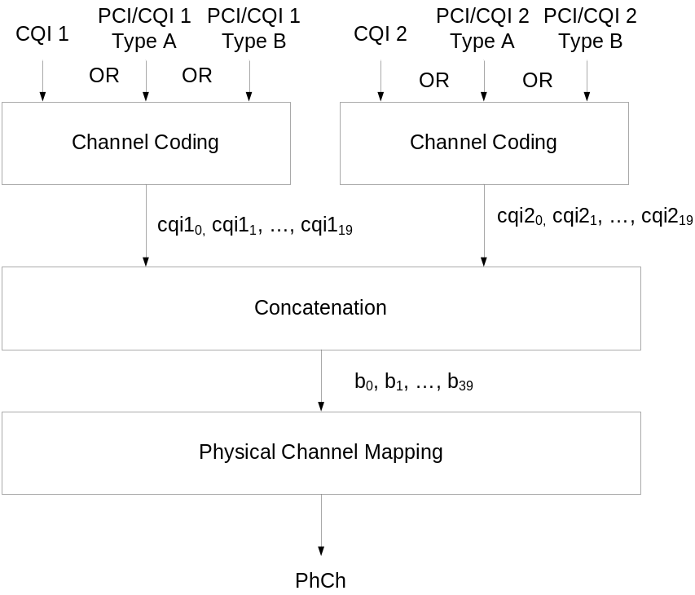
Figure 20F: Concatenation of CQI (or PCI/CQI) reports in the CQI (or PCI/CQI) field of a sub-frame
In Figure 20F, the two individual CQI (or PCI/CQI) reports are concatenated to form the composite channel quality indication according to the relation
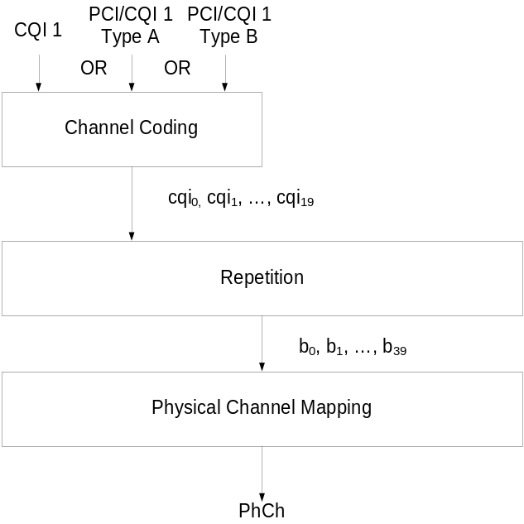
Figure 20G: Repetition of CQI or PCI/CQI reports
In Figure 20G, the CQI (or PCI/CQI) report is repeated according to the relation

4.8 Coding for E-DCH
Figure 21 shows the processing structure for the E-DCH transport channel mapped onto a separate CCTrCH. Data arrives to the coding unit in form of a maximum of one transport block once every transmission time interval (TTI). The following coding steps can be identified:
- Add CRC to the transport block
- Code block segmentation
- Channel coding
- Physical layer hybrid ARQ and rate matching
- Physical channel segmentation
- Interleaving
- Physical channel mapping
The coding steps for E-DCH transport channel are shown in the figure below.
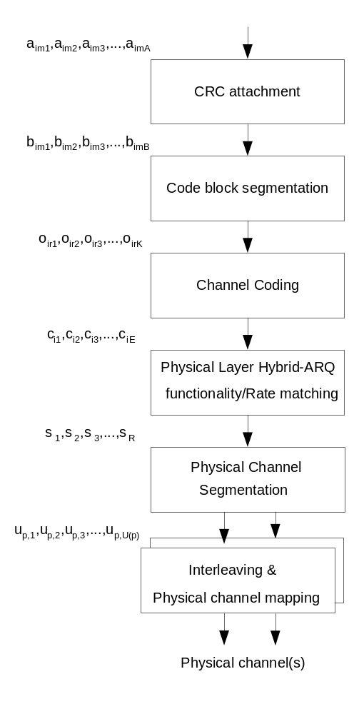
Figure 21: Transport channel processing for E-DCH
In the following the number of transport blocks per TTI and the number of transport channels is always one i.e. m=1 and i=1. When referencing non E-DCH formulae which are used in correspondence with E-DCH formulae the convention is used that transport block subscripts may be omitted (e.g. X₁ may be written X).

4.8.1 CRC attachment for E-DCH
CRC attachment for the E-DCH transport channel shall be performed according to the general method described in 4.2.1 above with the following specific parameters.
The CRC length shall always be L₁=24 bits.

4.8.2 Code block segmentation for E-DCH
Code block segmentation for the E-DCH transport channel shall be performed according to the general method described in 4.2.2.2 with the following specific parameters.
There is a maximum of one transport block. The bits 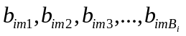 input to the block are mapped to the bits 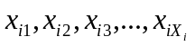 directly. It follows that X_{i} = B_{i}. Note that the bits x referenced here refer only to the internals of the code block segmentation function. The output bits from the code block segmentation function are o_{ir1}, o_{ir2}, o_{ir3}, …, o_{irK}.
The value of Z = 5114 for turbo coding shall be used.

4.8.3 Channel coding for E-DCH
Channel coding for the E-DCH transport channel shall be performed according to the general method described in section 4.2.3 above with the following specific parameters.
There is a maximum of one transport block, i=1. The rate 1/3 turbo coding shall be used.

4.8.4 Physical layer HARQ functionality and rate matching for E-DCH
The hybrid ARQ functionality matches the number of bits at the output of the channel coder to the total number of bits of the E-DPDCH set to which the E-DCH transport channel is mapped. The hybrid ARQ functionality is controlled by the redundancy version (RV) parameters.
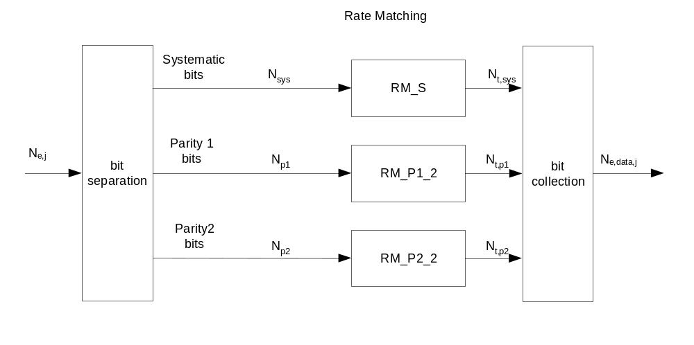
Figure 22: E-DCH hybrid ARQ functionality

4.8.4.1 Determination of SF, modulation scheme and number of PhCHs needed
The maximum amount of puncturing that can be applied is
- 1-PL_{non-max} if the modulation scheme or the number of code channels is less than the maximum allowed by the UE capability and restrictions imposed by UTRAN.
- 1-PL_{mod}__{switch} if the modulation scheme is BPSK, the number of E-DPDCH code channels equals to 4 and the usage of 4PAM is allowed by the UE capability and restrictions imposed by UTRAN.
- 1-PL_{max} if the modulation scheme and the number of code channels equals to the maximum allowed by the UE capability and restrictions imposed by UTRAN.
The number of available bits per TTI of one E-DPDCH for all possible spreading factors and modulation schemes is denoted by N₂₅₆, N₁₂₈, N₆₄, N₃₂, N₁₆, N₈, N_{4,} N₂, M₄ and M₂ where the index refers to the spreading factor. N refers to BPSK modulation and M to 4PAM modulation.
The possible number of bits available to the CCTrCH of E-DCH type on all PhCHs, N_{e,data}, then are {N₂₅₆, N₁₂₈, N₆₄, N₃₂, N₁₆, N₈, N₄, 2×N₄, 2×N₂, 2×N₂+2×N_{4,} 2×M₂+2×M₄}.
SET0 denotes the set of N_{e,data} values allowed by the UTRAN and supported by the UE, as part of the UE’s capability. SET0 can be a subset of {N₂₅₆, N₁₂₈, N₆₄, N₃₂, N₁₆, N₈, N₄, 2×N₄, 2×N₂, 2×N₂+2×N_{4,} 2×M₂+2×M₄}.
The total number of bits in a TTI before rate matching with transport format j is N_{e,j}. The total number of bits available for the E-DCH transmission per TTI with transport format j, N_{e,data,j}, is determined by executing the following algorithm, where PL_{non-max} is signalled from higher layers, PL_{mod}__{,switch} is equal to 0.468 and PL_{max} is equal to 0.44 , except when the N_{e,data} = 2×N₂+2×N₄ or 2×M₂+2×M₄ is allowed by the UTRAN and supported by the UE, in which case PL_{max} is equal to 0.33:
SET1 = { N_{e,data} in SET0 such that N_{e,data} – N_{e,j} is non negative }
If SET1 is not empty and the smallest element of SET1 requires just one E-DPDCH then
N_{e,data,j} = min SET1
Else
SET2 = { N_{e,data} in SET0 such that N_{e,data} – PL_{non-max} × N_{e,j} is non negative }
If SET2 is not empty then
Sort SET2 in ascending order
N_{e,data} = min SET2
While N_{e,data} is not the max of SET2 and the follower of N_{e,data} requires only one E-DPDCH do
N_{e,data} = follower of N_{e,data} in SET2
End while
If N_{e,data} is equal to 2×M₂+2×M₄ and N_{e,data} / N_{e,j} ≥ PL_{mod_switch}
N_{e,data} = 2×N₂+2×N₄
End if
If N_{e,data} is equal to 2×N₂+2×N₄ and N_{e,data} / N_{e,j} < PL_{mod_switch}
N_{e,data} = max SET0
End if
N_{e,data,j} = N_{e,data}
Else
N_{e,data,j} = max SET0 provided that N_{e,data,j} - PL_{max} × N_{e,j} is non negative
End if
End if
While E-DCH TTI length is 10 ms, if an initial transmission occurs in a compressed frame, or a retransmission occurs in a compressed frame, or a retransmission occurs in a non-compressed frame for which initial transmission was compressed, the number of available bits per TTI of one E-DPDCH for all possible spreading factors denoted by N₂₅₆, N₁₂₈, N₆₄, N₃₂, N₁₆, N₈, N₄ and N₂ used in the algorithm above is replaced by k×N₂₅₆, k×N₁₂₈, k×N₆₄, k× N₃₂, k× N₁₆, k× N₈, k×N₄ and k×N₂. The parameter k is equal to n_{tx1}/15 and n_{tx1} is defined in 4.4.5.1.

4.8.4.2 HARQ bit separation
The HARQ bit separation function shall be performed in the same way as bit separation for turbo encoded TrCHs with puncturing in 4.2.7.4.1 above.

4.8.4.3 HARQ Rate Matching Stage
The hybrid ARQ rate matching for the E-DCH transport channel shall be done with the general method described in 4.2.7.5 with the following specific parameters.
The parameters of the rate matching stage depend on the value of the RV parameters s and r. The s and r combinations corresponding to each RV allowed for the E-DCH are listed in the table below.
Table 15D: RV for E-DCH
E-DCH RV Index | s | r
0 | 1 | 0
1 | 0 | 0
2 | 1 | 1
3 | 0 | 1

The parameter e_{plus}, e_{minus} and e_{ini} are calculated with the general method for QPSK as described in 4.5.4.3 above. The following parameters are used as input:
N_{sys} = N_{p1} = N_{p2} = N_{e,j}/3
N_{data} = N_{e,data,j}
r_{max} = 2
During uplink compressed frames while E-DCH TTI length is 10 ms and if N_{data}>N_{e,j}:
- If N_{data} mod 3 = 1, one δ bit is added to the N_{t,sys} bits as the last systematic bit and another δ bit is added to the N_{t,p1} bits as the last N_{t,p1} bit.
- If N_{data} mod 3 = 2, one δ bit is added to the N_{t,sys} bits as the last systematic bit.

4.8.4.4 HARQ bit collection
The HARQ bit collection shall be performed according to the general method for bit collection for turbo encoded TrCHs with puncturing as specified in 4.2.7.4.2 including the removal of the bits with value δ.

4.8.5 Physical channel segmentation for E-DCH
When more than one E-DPDCH is used, physical channel segmentation distributes the bits among the different physical channels. The bits input to the physical channel segmentation are denoted by s₁, s₂, s₃, …,s_{R}, where R is the number of bits input to the physical channel segmentation block. The number of PhCHs is denoted by P.
The bits after physical channel segmentation are denoted u_{p,k} where p is the PhCH number. U(p) is the number of physical channel bits in one E-DCH TTI for the p^{th} E-DPDCH. The relation between s_{k} and u_{p,k} is given below.
Bits on first PhCH after physical channel segmentation:
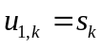 k = 1, 2, ..., U(1)
Bits on p^{th} PhCH after physical channel segmentation:
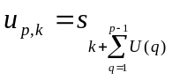 k = 1, 2, ..., U(p)

4.8.6 Interleaving for E-DCH
The interleaving is done as shown in figure 22A below, separately for each physical channel. The bits input to the block interleaver are denoted by , where p is PhCH number and U=U(p) is the number of bits in one TTI for one PhCH.
Interleaver
(R2 x 30)
Interleaver
(R2 x 30)
u
p,
k
(BPSK)
u
p,k
(4PAM)
u
p,k+1
(4PAM)
v
p,
k
(BPSK)
v
p,
k
(4PAM)
v
p,k+1
(4PAM)
Figure 22A: Interleaver structure for E-DCH
The basic interleaver is as the 2nd interleaver described in Section 4.2.11. However, for 4PAM, there are two identical interleavers of the same size R2×30, where R2 is the minimum integer fulfilling . The output bits from the physical channel segmentation are divided one by one between the interleavers: bit u_{p,k} goes to the first interleaver and bit u_{p,k+1} goes to the second interleaver. Bits are collected one by one from the interleavers: bit v_{p,k} is obtained from the first interleaver and bit v_{p,k+1} is obtained from the second interleaver, where k mod 2=1.

4.8.7 Physical channel mapping for E-DCH
The E-DCH structure is described in [2]. The bits input to the physical channel mapping are denoted ν_{p,1}, ν_{p,2}, ..., ν_{p,U(p)}. The bits ν_{p,k} are mapped to the PhCHs such that the bits for each PhCH are transmitted over the air in ascending order with respect to k.
During compressed frames in the uplink and when E-DCH TTI is 10 ms:
- For the initial transmission the bits shall be consecutively mapped to the non-idle slots. The UE shall not map any bit to the E-DPDCH idle slots specified in 4.4.5.1.
- In case a retransmission occurs in a compressed frame or a retransmission occurs in a non-compressed frame for which initial transmission was compressed:
  - If n_{tx1}>n_{max}: The bits shall be consecutively mapped to the n_{max} available slots. The remaining bits are not transmitted.
  - If n_{tx1}≤n_{max}: The bits shall be consecutively mapped to the n_{tx1} non-idle slots, whilst no bits are mapped to the idle slots.
  - The transmission gap position and the parameters n_{tx1} and n_{max} are specified in 4.4.5.2.

4.9 Coding for E-DPCCH
The following information is transmitted by means of the E-DPCCH:
- Retransmission sequence number (RSN): x_{rsn,1}, x_{rsn,2}
- E-TFCI: x_{tfci,1}, x_{tfci,2}, ..., x_{tfci,7}
- "Happy" bit: x_{h,1}

4.9.1 Overview
The figure below illustrates the overall coding chain for E-DPCCH.
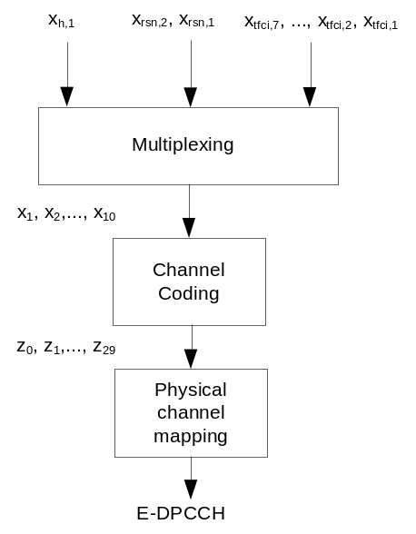
Figure 23: Coding chain for E-DPCCH

4.9.2 E-DPCCH information field mapping

4.9.2.1 Information field mapping of E-TFCI
The E-TFCI is mapped such that x_{tfci,1} corresponds to the MSB.

4.9.2.2 Information field mapping of retransmission sequence number
To indicate the redundancy version (RV) of each HARQ transmission and to assist the Node B soft buffer management a two bit retransmission sequence number (RSN) is signalled from the UE to the Node B. The Node B can avoid soft buffer corruption by flushing the soft buffer associated to one HARQ process in case more than 3 consecutive E-DPCCH transmissions on that HARQ process can not be decoded or the last received RSN is incompatible with the current one.
The RSN is set by higher layers as described in [16]. The RSN is mapped such that x_{rsn,1} corresponds to the MSB.
The applied E-DCH RV index specifying the used RV (s and r parameter) depends on the RSN, on N_{sys} / N_{e,data,j}, and if RSN=3 also on the TTIN (TTI number). For 10 ms TTI the TTI number is equal to the CFN, for 2 ms TTI
TTIN = 5*CFN + subframe number
where the subframe number counts the five TTIs which are within a given CFN, starting from 0 for the first TTI to 4 for the last TTI. N_{ARQ} is the number of Hybrid ARQ processes.
Table 16: Relation between RSN value and E-DCH RV Index
RSN Value | N_{sys} / N_{e,data,j} <1/2 | 1/2 ≤ N_{sys} / N_{e,data,j}
RSN Value | E-DCH RV Index | E-DCH RV Index
0 | 0 | 0
1 | 2 | 3
2 | 0 | 2
3 | [ ⎣TTIN/N_{ARQ}⎦ mod 2 ] x 2 | ⎣TTIN/N_{ARQ}⎦ mod 4

The UE shall use either
- an RV index as indicated in Table 16 and according to the RSN
- or, if signalled by higher layers only E-DCH RV index 0 independently of the RSN.

4.9.2.3 Information field mapping of the "Happy" bit
The UE shall set x_{h,1} as specified in Table 16A.
Table 16A: Mapping of "Happy" bit
"Happy" bit | x_{h,1}
Happy | 1
Not happy | 0

4.9.3 Multiplexing of E-DPCCH information
The E-TFCI x_{tfci,1}, x_{tfci,2}, …, x_{tfci,7}, the retransmission sequence number x_{rsn,1}, x_{rsn,2} and the "happy" bit x_{h,1} are multiplexed together. This gives a sequence of bits x₁, x₂, …, x₁₀ where

x_{k} = x_{h,1} k=1
x_{k} = x_{rsn,4-k} k=2,3
x_{k} = x_{tfci,11-k} k=4,5,…,10

4.9.4 Channel coding for E-DPCCH
Channel coding of the E-DPCCH is done using a sub-code of the second order Reed-Muller code. Coding is applied to the output x₁, x₂, ..., x₁₀ from the E-DPCCH multiplexing, resulting in:

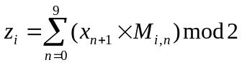 i=0, 1, ..., 29

The basis sequences are as described in 4.3.3 for i=0, 1, ..., 29.

4.9.5 Physical channel mapping for E-DPCCH
The E-DPCCH is described in [2]. The sequence of bits z₀, z₁, ..., z₂₉ output from the E-DPCCH channel coding is mapped to the corresponding E-DPCCH sub frame. The bits are mapped so that they are transmitted over the air in ascending order with respect to i. If the E-DCH TTI is equal to 10 ms the sequence of bits is transmitted in all the E-DPCCH sub frames of the E-DPCCH radio frame.
For compressed frames in the uplink and the case when E-DCH TTI length is 10 ms, the bits mapped to the E-DPCCH idle slots specified in 4.4.5.3 shall not be transmitted.

4.10 Coding for E-AGCH
The following information is transmitted by means of the absolute grant channel (E-AGCH):
- Absolute Grant Value: x_{agv,1}, x_{agv,2}, …, x_{agv,5}
- Absolute Grant Scope: x_{ags,1}

4.10.1 Overview
Figure 24 below illustrates the overall coding chain for the E-AGCH.

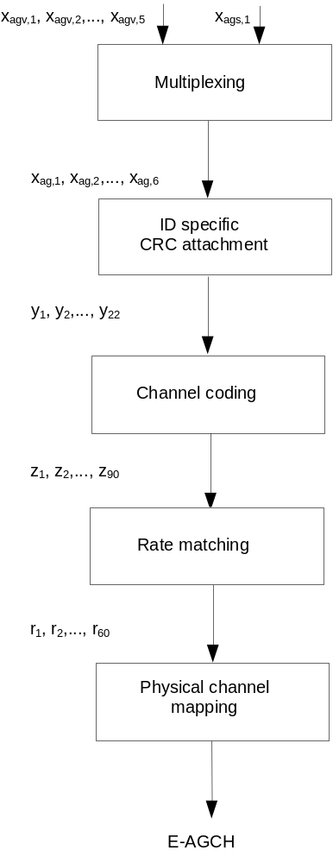
Figure 24: Coding for E-AGCH

4.10.1A E-AGCH information field mapping

4.10.1A.1 Information field mapping of the Absolute Grant Value
The Absolute Grant Value information is specified in Table 16B and Table 16.B.1. The values are mapped such that x_{agv,1} corresponds to the MSB of the index.
Based on higher layer signalling, either Table 16B or Table 16.B.1 is selected.
Table 16B: Mapping of Absolute Grant Value
Absolute Grant Value | Index
(168/15)²x6 | 31
(150/15)²x6 | 30
(168/15)²x4 | 29
(150/15)²x4 | 28
(134/15)²x4 | 27
(119/15)²x4 | 26
(150/15)²x2 | 25
(95/15)²x4 | 24
(168/15)² | 23
(150/15)² | 22
(134/15)² | 21
(119/15)² | 20
(106/15)² | 19
(95/15)² | 18
(84/15)² | 17
(75/15)² | 16
(67/15)² | 15
(60/15)² | 14
(53/15)² | 13
(47/15)² | 12
(42/15)² | 11
(38/15)² | 10
(34/15)² | 9
(30/15)² | 8
(27/15)² | 7
(24/15)² | 6
(19/15)² | 5
(15/15)² | 4
(11/15)² | 3
(7/15)² | 2
ZERO_GRANT* | 1
INACTIVE* | 0

NOTE *: These values are specified in [16].

Table 16B.1: Alternative Mapping of Absolute Grant Value
Absolute Grant Value | Index
(377/15)²x4 | 31
(237/15)²x6 | 30
(168/15)²*6 | 29
(150/15)²*6 | 28
(168/15)²*4 | 27
(150/15)²x4 | 26
(134/15)²x4 | 25
(119/15)²x4 | 24
(150/15)²x2 | 23
(95/15)²x4 | 22
(168/15)² | 21
(150/15)² | 20
(134/15)² | 19
(119/15)² | 18
(106/15)² | 17
(95/15)² | 16
(84/15)² | 15
(75/15)² | 14
(67/15)² | 13
(60/15)² | 12
(53/15)² | 11
(47/15)² | 10
(42/15)² | 9
(38/15)² | 8
(34/15)² | 7
(30/15)² | 6
(27/15)² | 5
(24/15)² | 4
(19/15)² | 3
(15/15)² | 2
ZERO_GRANT* | 1
INACTIVE* | 0

NOTE *: These values are specified in [16].

4.10.1A.2 Information field mapping of the Absolute Grant Scope
The value of x_{ags,1} is set as specified in Table 16C.
Table 16C: Mapping of Absolute Grant Scope
Absolute Grant Scope | x_{ags,1}
"Per HARQ process" | 1
"All HARQ processes" | 0

4.10.1B Multiplexing of E-AGCH information
The Absolute Grant Value information x_{agv,1}, x_{agv,2}, …, x_{agv,5} and the Absolute Grant Scope information x_{ags,1} are multiplexed together. This gives a sequence of bits x_{ag,1}, x_{ag,2}, ..., x_{ag, 6} where

x_{ag,k} = x_{agv,k} k=1,2,…,5
x_{ag,k} = x_{ags,7-k} k=6

4.10.2 CRC attachment for E-AGCH
The E-RNTI is the E-DCH Radio Network Identifier defined in [13]. It is mapped such that x_{id,1} corresponds to the MSB.
From the sequence of bits x_{ag,1}, x_{ag,2}, ..., x_{ag,6} a 16 bit CRC is calculated according to section 4.2.1.1. That gives the sequence of bits c₁, c₂, ..., c₁₆ where
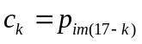 k=1,2,…,16
This sequence of bits is then masked with x_{id,1}, x_{id,2}, ..., x_{id,16} and appended to the sequence of bits x_{ag,1}, x_{ag,2}, ..., x_{ag,6} to form the sequence of bits y₁, y₂, ..., y₂₂ where
y_{i}=x_{ag,i} i=1,2, ...,6
y_{i}=(c_{i-6} + x_{id},_{i-6}) mod 2 i= 7, ..., 22

4.10.3 Channel coding for E-AGCH
Rate 1/3 convolutional coding, as described in Section 4.2.3.1 is applied to the sequence of bits y₁, y₂, …, y₂₂, resulting in the sequence of bits z₁, z₂, …, z₉₀.

4.10.4 Rate matching for E-AGCH
From the input sequence z₁, z₂, …, z₉₀ the bits z₁, z₂, z₅, z₆, z₇, z₁₁, z₁₂, z₁₄, z₁₅, z₁₇, z₂₃, z₂₄, z₃₁, z₃₇, z₄₄, z₄₇, z₆₁, z₆₃, z₆₄, z₇₁, z₇₂, z₇₅, z₇₇, z₈₀, z₈₃, z₈₄, z₈₅, z₈₇, z₈₈, z₉₀ are punctured to obtain the output sequence r₁, r₂, …, r₆₀.

4.10.5 Physical channel mapping for E-AGCH
The E-AGCH sub frame is described in [2]. The sequence of bits r₁, r₂, …, r₆₀ is mapped to the corresponding E-AGCH sub frame. The bits r_{k} are mapped so that they are transmitted over the air in ascending order with respect to k. If the E-DCH TTI is equal to 10 ms the same sequence of bits is transmitted in all the E-AGCH sub frames of the E-AGCH radio frame.

4.11 Mapping for E-RGCH Relative Grant

4.11.1 Overview
The relative grant is transmitted on the E-RGCH as described in [2].

4.11.2 Relative Grant mapping
The relative grant (RG) command is mapped to the relative grant value as described in the table below.
Table 17: Mapping of RG value
Command | RG Value (serving E-DCH RLS) | RG Value (other radio links)
UP | +1 | not allowed
HOLD | 0 | 0
DOWN | -1 | -1

4.12 Mapping for E-HICH ACK/NACK

4.12.1 Overview
The ACK/NACK is transmitted on the E-HICH as described in [2].

4.12.2 ACK/NACK mapping
The ACK/NACK command is mapped to the HARQ acknowledgement indicator as described in the table below.
Table 18: Mapping of HARQ Acknowledgement
Command | HARQ acknowledgement indicator
ACK | +1
NACK (RLSs not containing the serving E-DCH cell) | 0
NACK (RLS containing the serving E-DCH cell) | -1

Annex A (informative):
Blind transport format detection

A.1 Blind transport format detection using fixed positions

A.1.1 Blind transport format detection using received power ratio
For the dual transport format case (the possible data rates are 0 and full rate, and CRC is only transmitted for full rate), blind transport format detection using received power ratio can be used.
The transport format detection is then done using average received power ratio of DPDCH to DPCCH. Define the following:
- Pc: Received power per bit of DPCCH calculated from all pilot and TPC bits per slot over a radio frame;
- Pd: Received power per bit of DPDCH calculated from X bits per slot over a radio frame;
- X: the number of DPDCH bits per slot when transport format corresponds to full rate;
- T: Threshold of average received power ratio of DPDCH to DPCCH for transport format detection.
The decision rule can then be formulated as:
If Pd/Pc >T then:
- full rate transport format detected;
else
- zero rate transport format detected.

A.1.2 Blind transport format detection using CRC
For the multiple transport format case (the possible data rates are 0, …, (full rate)/r, …, full rate, and CRC is transmitted for all transport formats), blind transport format detection using CRC can be used.
At the transmitter, the data stream with variable number of bits from higher layers is block-encoded using a cyclic redundancy check (CRC) and then convolutionally encoded. CRC parity bits are attached just after the data stream with variable number of bits as shown in figure A.1.
The receiver knows only the possible transport formats (or the possible end bit position {n_{end}}) by Layer-3 negotiation. The receiver performs Viterbi-decoding on the soft decision sample sequence. The correct trellis path of the Viterbi-decoder ends at the zero state at the correct end bit position.
The blind transport format detection method using CRC traces back the surviving trellis path ending at the zero state (hypothetical trellis path) at each possible end bit position to recover the data sequence. For each recovered data sequence error-detection is performed by checking the CRC, and if there is no error, the recovered sequence is declared to be correct.
The following variable is defined:
s(n_{end}) = - 10 log ( (a₀(n_{end}) – a_{min}(n_{end}) ) / (a_{max}(n_{end})-a_{min}(n_{end}) ) ) [dB] (Eq. 1)
where a_{max}(n_{end}) and a_{min}(n_{end}) are the maximum and minimum path-metric values among all survivors at end bit position n_{end}, and a₀(n_{end}) is the path-metric value at zero state.
In order to reduce the probability of false detection (this happens if the selected path is wrong but the CRC misses the error detection), a path selection threshold D is introduced. The threshold D determines whether the hypothetical trellis path connected to the zero state should be traced back or not at each end bit position n_{end}. If the hypothetical trellis path connected to the zero state that satisfies:
s(n_{end}) ≤ D (Eq. 2)
is found, the path is traced back to recover the frame data, where D is the path selection threshold and a design parameter.
If more than one end bit positions satisfying Eq. 2 is found, the end bit position which has minimum value of s(n_{end}) is declared to be correct. If no path satisfying Eq. 2 is found even after all possible end bit positions have been exhausted, the received frame data is declared to be in error.
Figure A-2 shows the procedure of blind transport format detection using CRC.
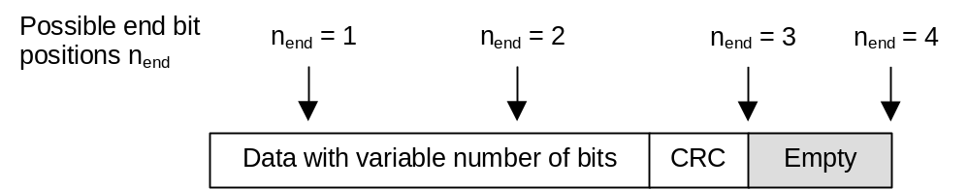
Figure A.1: An example of data with variable number of bits.
Four possible transport formats, and transmitted end bit position nend = 3
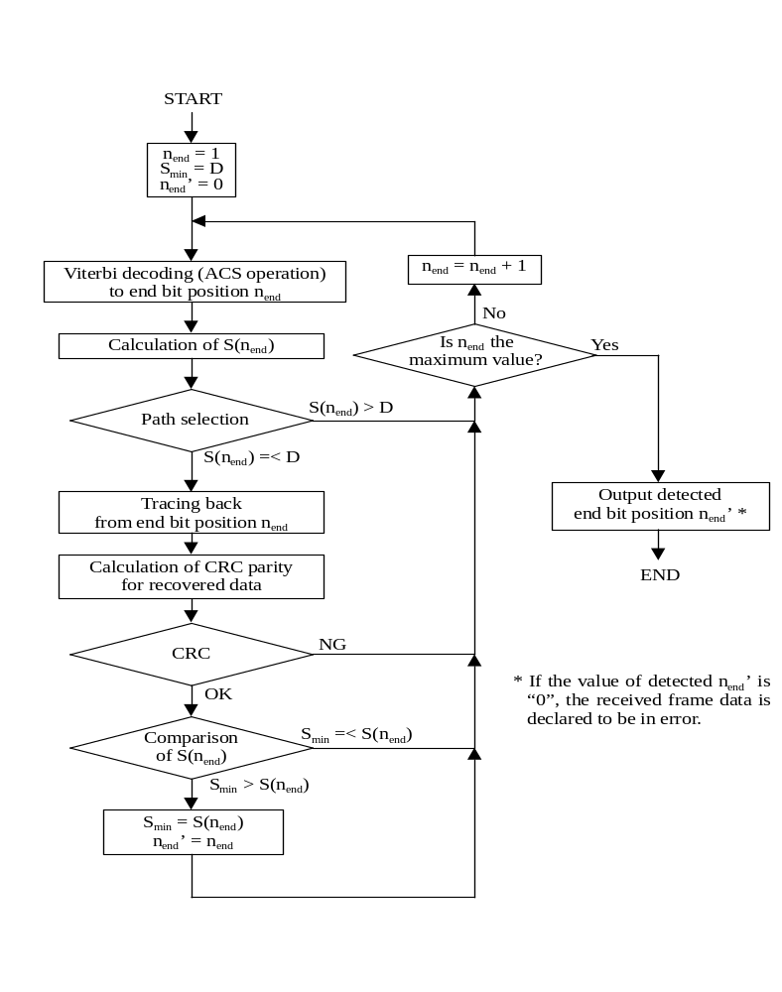
Figure A.2: Basic processing flow of blind transport format detection

Annex B (informative):
Compressed mode idle lengths
The tables B.1-B.3 show the resulting idle lengths for different transmission gap lengths, UL/DL modes and DL frame types when DPCCH/DPDCH are used in the uplink and DPCH in the downlink. The idle lengths given are calculated purely from the slot and frame structures and the UL/DL offset. They do not contain margins for e.g. synthesizer switching.

B.1 Idle lengths for DL, UL and DL+UL compressed mode for DPCH
Table B.1: Parameters for DL compressed mode
TGL | DL Frame  Type | Spreading Factor | Idle length [ms] | Transmission time  Reduction method | Idle frame  Combining
3 | A | 512 – 4 | 1.73 – 1.99 | Spreading factor division by 2 or  Higher layer scheduling | (S)  (D) =(1,2) or (2,1)
3 | B | 512 – 4 | 1.60 – 1.86 | Spreading factor division by 2 or  Higher layer scheduling | (S)  (D) =(1,2) or (2,1)
4 | A | 512 – 4 | 2.40 – 2.66 | Spreading factor division by 2 or  Higher layer scheduling | (S)  (D) =(1,3), (2,2) or (3,1)
4 | B | 512 – 4 | 2.27 – 2.53 | Spreading factor division by 2 or  Higher layer scheduling | (S)  (D) =(1,3), (2,2) or (3,1)
5 | A | 512 – 4 | 3.07 – 3.33 | Spreading factor division by 2 or  Higher layer scheduling | (S)  (D) = (1,4), (2,3), (3, 2) or (4,1)
5 | B | 512 – 4 | 2.93 – 3.19 | Spreading factor division by 2 or  Higher layer scheduling | (S)  (D) = (1,4), (2,3), (3, 2) or (4,1)
7 | A | 512 – 4 | 4.40 – 4.66 | Spreading factor division by 2 or  Higher layer scheduling | (S)  (D)=(1,6), (2,5), (3,4), (4,3), (5,2) or (6,1)
7 | B | 512 – 4 | 4.27 – 4.53 | Spreading factor division by 2 or  Higher layer scheduling | (S)  (D)=(1,6), (2,5), (3,4), (4,3), (5,2) or (6,1)
10 | A | 512 – 4 | 6.40 – 6.66 | Spreading factor division by 2 or  Higher layer scheduling | (D)=(3,7), (4,6), (5,5), (6,4) or (7,3)
10 | B | 512 – 4 | 6.27 – 6.53 | Spreading factor division by 2 or  Higher layer scheduling | (D)=(3,7), (4,6), (5,5), (6,4) or (7,3)
14 | A | 512 – 4 | 9.07 – 9.33 | Spreading factor division by 2 or  Higher layer scheduling | (D) =(7,7)
14 | B | 512 – 4 | 8.93 – 9.19 | Spreading factor division by 2 or  Higher layer scheduling | (D) =(7,7)

Table B.2: Parameters for UL compressed mode
TGL | Spreading Factor | Idle length [ms] | Transmission time  Reduction method | Idle frame  Combining
3 | 256 – 4 | 2.00 | Spreading factor division by 2 or  Higher layer scheduling | (S)  (D) =(1,2) or (2,1)
4 | 256 – 4 | 2.67 | Spreading factor division by 2 or  Higher layer scheduling | (S)  (D) =(1,3), (2,2) or (3,1)
5 | 256 – 4 | 3.33 | Spreading factor division by 2 or  Higher layer scheduling | (S)  (D) = (1,4), (2,3), (3, 2) or (4,1)
7 | 256 – 4 | 4.67 | Spreading factor division by 2 or  Higher layer scheduling | (S)  (D)=(1,6), (2,5), (3,4), (4,3), (5,2) or (6,1)
10 | 256 – 4 | 6.67 | Spreading factor division by 2 or  Higher layer scheduling | (D)=(3,7), (4,6), (5,5), (6,4) or (7,3)
14 | 256 – 4 | 9.33 | Spreading factor division by 2 or  Higher layer scheduling | (D) =(7,7)

Table B.3: Parameters for combined UL/DL compressed mode
TGL | DL Frame  Type | Spreading Factor | Idle length [ms] | Transmission time  Reduction method | Idle frame  Combining
3 | A or B | DL:  512 – 4  UL:  256 – 4 | 1.47 – 1.73 | Spreading factor division by 2 or  Higher layer scheduling | (S)  (D) =(1,2) or (2,1)
4 | A or B | DL:  512 – 4  UL:  256 – 4 | 2.13 – 2.39 | Spreading factor division by 2 or  Higher layer scheduling | (S)  (D) =(1,3), (2,2) or (3,1)
5 | A or B | DL:  512 – 4  UL:  256 – 4 | 2.80 – 3.06 | Spreading factor division by 2 or  Higher layer scheduling | (S)  (D) = (1,4), (2,3), (3, 2) or (4,1)
7 | A or B | DL:  512 – 4  UL:  256 – 4 | 4.13 – 4.39 | Spreading factor division by 2 or  Higher layer scheduling | (S)  (D)=(1,6), (2,5), (3,4), (4,3), (5,2) or (6,1)
10 | A or B | DL:  512 – 4  UL:  256 – 4 | 6.13 – 6.39 | Spreading factor division by 2 or  Higher layer scheduling | (D)=(3,7), (4,6), (5,5), (6,4) or (7,3)
14 | A or B | DL:  512 – 4  UL:  256 – 4 | 8.80 – 9.06 | Spreading factor division by 2 or  Higher layer scheduling | (D) =(7,7)

(S): Single-frame method as shown in figure 14 (1).
(D): Double-frame method as shown in figure 14 (2). (x,y) indicates x: the number of idle slots in the first frame, y: the number of idle slots in the second frame.
NOTE: Compressed mode by spreading factor reduction is not supported when SF=4 is used in normal mode

Annex C (informative):
Change history
Change history
Date | TSG # | TSG Doc. | CR | Rev | Subject/Comment | Old | New
 | RAN_05 | RP-99588 | - |  | Approved at TSG RAN #5 and placed under Change Control | - | 3.0.0
14/01/00 | RAN_06 | RP-99680 | 001 | 3 | Correction of rate matching parameters for repetition after 1st unterleaving in 25.212 | 3.0.0 | 3.1.0
14/01/00 | RAN_06 | RP-99680 | 004 | - | Changing the initial offset value for convolutional code rate matching | 3.0.0 | 3.1.0
14/01/00 | RAN_06 | RP-99681 | 005 | 1 | Introduction of compressed mode by higher layer scheduling | 3.0.0 | 3.1.0
14/01/00 | RAN_06 | RP-99679 | 008 | - | Editorial corrections to TS 25.212 | 3.0.0 | 3.1.0
14/01/00 | RAN_06 | RP-99680 | 009 | - | Removal of SFN multiplexing | 3.0.0 | 3.1.0
14/01/00 | RAN_06 | RP-99680 | 010 | 1 | Clarification of bit separation and collection | 3.0.0 | 3.1.0
14/01/00 | RAN_06 | RP-99680 | 011 | 2 | Connection between TTI and CFN | 3.0.0 | 3.1.0
14/01/00 | RAN_06 | RP-99680 | 012 | 2 | Zero length transport blocks | 3.0.0 | 3.1.0
14/01/00 | RAN_06 | RP-99679 | 014 | - | Update of channel coding sections | 3.0.0 | 3.1.0
14/01/00 | RAN_06 | RP-99680 | 016 | - | Removal of TrCH restriction in DSCH CCTrCH | 3.0.0 | 3.1.0
14/01/00 | RAN_06 | RP-99681 | 017 | - | 20 ms RACH message length | 3.0.0 | 3.1.0
14/01/00 | RAN_06 | RP-99680 | 018 | - | Minimum SF in UL | 3.0.0 | 3.1.0
14/01/00 | RAN_06 | RP-99680 | 024 | - | Rate matching parameter determination in DL and fixed positions | 3.0.0 | 3.1.0
14/01/00 | RAN_06 | RP-99680 | 026 | 1 | Corrections to TS 25.212 | 3.0.0 | 3.1.0
14/01/00 | RAN_06 | RP-99679 | 027 | - | Modification of BTFD description in 25.212 Annex | 3.0.0 | 3.1.0
14/01/00 | RAN_06 | RP-99681 | 028 | - | TFCI coding and mapping including compressed mode | 3.0.0 | 3.1.0
14/01/00 | - | - | - |  | Change history was added by the editor | 3.1.0 | 3.1.1
31/03/00 | RAN_07 | RP-000061 | 025 | 2 | CR for parity bit attachment to 0 bit transport block | 3.1.1 | 3.2.0
31/03/00 | RAN_07 | RP-000061 | 029 | 1 | Limitations of blind transport format detection | 3.1.1 | 3.2.0
31/03/00 | RAN_07 | RP-000061 | 034 | 1 | Clarification of fixed position rate matching | 3.1.1 | 3.2.0
31/03/00 | RAN_07 | RP-000061 | 035 | 1 | Clarification of DL compressed mode | 3.1.1 | 3.2.0
31/03/00 | RAN_07 | RP-000061 | 036 | - | Reconfiguration of TFCS | 3.1.1 | 3.2.0
31/03/00 | RAN_07 | RP-000061 | 037 | 1 | Removal of fixed gap position in 25.212 | 3.1.1 | 3.2.0
31/03/00 | RAN_07 | RP-000061 | 038 | 2 | Definition clarification for TS 25.212 | 3.1.1 | 3.2.0
31/03/00 | RAN_07 | RP-000061 | 039 | 1 | Clarification on TFCI coding input | 3.1.1 | 3.2.0
31/03/00 | RAN_07 | RP-000061 | 041 | 2 | Correction of UL compressed mode by higher layer scheduling | 3.1.1 | 3.2.0
31/03/00 | RAN_07 | RP-000061 | 042 | 5 | Downlink Compressed Mode by puncturing | 3.1.1 | 3.2.0
31/03/00 | RAN_07 | RP-000061 | 044 | - | Modification of Turbo code internal interleaver | 3.1.1 | 3.2.0
31/03/00 | RAN_07 | RP-000061 | 045 | - | Editorial corrections | 3.1.1 | 3.2.0
31/03/00 | RAN_07 | RP-000061 | 046 | - | SF/2 method: DTX insertion after 2nd interleaver | 3.1.1 | 3.2.0
31/03/00 | RAN_07 | RP-000061 | 047 | 1 | TFCI coding for FDD | 3.1.1 | 3.2.0
31/03/00 | RAN_07 | RP-000061 | 048 | - | Mapping of TFCI in downlink compressed mode | 3.1.1 | 3.2.0
31/03/00 | RAN_07 | RP-000061 | 049 | - | Editorial changes to Annex A | 3.1.1 | 3.2.0
31/03/00 | RAN_07 | RP-000061 | 050 | - | Removal of rate matching attribute setting for RACH | 3.1.1 | 3.2.0
31/03/00 | RAN_07 | RP-000061 | 052 | - | Padding Function for Turbo coding of small blocks | 3.1.1 | 3.2.0
31/03/00 | RAN_07 | RP-000061 | 055 | 2 | Clarifications relating to DSCH | 3.1.1 | 3.2.0
31/03/00 | RAN_07 | RP-000061 | 056 | - | Editorial modification of uplink shifting parameter calculation for turbo code puncturing | 3.1.1 | 3.2.0
31/03/00 | RAN_07 | RP-000062 | 059 | 1 | Revision: Editorial correction to the calculation of Rate Matching parameters | 3.1.1 | 3.2.0
31/03/00 | RAN_07 | RP-000062 | 060 | 1 | Editorial changes of channel coding section | 3.1.1 | 3.2.0
31/03/00 | RAN_07 | RP-000062 | 061 | - | Removal of DL compressed mode by higher layer scheduling with fixed positions | 3.1.1 | 3.2.0
26/06/00 | RAN_08 | RP-000266 | 066 | 1 | Section 4.4.5 and table 9 is moved to informative annex | 3.2.0 | 3.3.0
26/06/00 | RAN_08 | RP-000266 | 068 | - | Editorial modifications of 25.212 | 3.2.0 | 3.3.0
26/06/00 | RAN_08 | RP-000266 | 069 | - | Removal of BTFD for flexible positions in Release 99 | 3.2.0 | 3.3.0
26/06/00 | RAN_08 | RP-000266 | 070 | 1 | Editorial modifications | 3.2.0 | 3.3.0
26/06/00 | RAN_08 | RP-000266 | 071 | 1 | Corrections and editorial modifications of 25.212 for 2nd insertion of DTX bits for CM | 3.2.0 | 3.3.0
26/06/00 | RAN_08 | RP-000266 | 072 | 4 | Corrections to 25.212 (Rate Matching, p-bit insertion, PhCH segmentation) | 3.2.0 | 3.3.0
26/06/00 | RAN_08 | RP-000266 | 073 | - | Editorial correction in 25.212 coding/multiplexing | 3.2.0 | 3.3.0
26/06/00 | RAN_08 | RP-000266 | 074 | 2 | Bit separation of the Turbo encoded data | 3.2.0 | 3.3.0
26/06/00 | RAN_08 | RP-000266 | 076 | 1 | Revision of code block segmentation description | 3.2.0 | 3.3.0
26/06/00 | RAN_08 | RP-000266 | 077 | - | Clarifications for TFCI coding | 3.2.0 | 3.3.0
26/06/00 | RAN_08 | RP-000266 | 078 | 2 | Clarifying the rate matching parameter setting for the RACH and BCH | 3.2.0 | 3.3.0
26/06/00 | RAN_08 | RP-000266 | 080 | - | Clarification on BTFD utilisation (single CCTrCH) | 3.2.0 | 3.3.0
26/06/00 | RAN_08 | RP-000266 | 081 | - | Correction of order of checking TFC during flexible position RM parameter determination | 3.2.0 | 3.3.0
26/06/00 | RAN_08 | RP-000266 | 082 | - | Editorial corrections in channel coding section | 3.2.0 | 3.3.0
26/06/00 | RAN_08 | RP-000266 | 083 | - | Correction for bit separation and bit collection | 3.2.0 | 3.3.0
26/06/00 | RAN_08 | RP-000266 | 084 | 1 | Correction on the spreading factor selection for the RACH | 3.2.0 | 3.3.0
23/09/00 | RAN_09 | RP-000341 | 079 | - | Clarification of compressed mode terminology | 3.3.0 | 3.4.0
23/09/00 | RAN_09 | RP-000341 | 085 | 1 | Editorial corrections in Turbo code internal interleaver section | 3.3.0 | 3.4.0
23/09/00 | RAN_09 | RP-000341 | 086 | 1 | Clarification on DL slot format for compressed mode by SF/2 | 3.3.0 | 3.4.0
23/09/00 | RAN_09 | RP-000341 | 087 | - | Corrections | 3.3.0 | 3.4.0
23/09/00 | RAN_09 | RP-000341 | 088 | 1 | Clarifications to TS 25.212 | 3.3.0 | 3.4.0
23/09/00 | RAN_09 | RP-000341 | 089 | - | Correction regarding DSCH | 3.3.0 | 3.4.0
23/09/00 | RAN_09 | RP-000341 | 090 | - | Correction regarding CPCH | 3.3.0 | 3.4.0
23/09/00 | RAN_09 | RP-000341 | 092 | 1 | Bit separation and collection for rate matching | 3.3.0 | 3.4.0
23/09/00 | RAN_09 | RP-000341 | 093 | - | Puncturing Limit definition in WG1 specification | 3.3.0 | 3.4.0
15/12/00 | RAN_10 | RP-000538 | 094 | 2 | Correction of BTFD limitations | 3.4.0 | 3.5.0
15/12/00 | RAN_10 | RP-000538 | 096 | - | Compressed mode by puncturing | 3.4.0 | 3.5.0
15/12/00 | RAN_10 | RP-000538 | 097 | - | Clarification on the Ci formula | 3.4.0 | 3.5.0
15/12/00 | RAN_10 | RP-000538 | 099 | - | Editorial modification in RM section | 3.4.0 | 3.5.0
15/12/00 | RAN_10 | RP-000538 | 100 | 1 | Editorial corrections in TS 25.212 | 3.4.0 | 3.5.0
15/12/00 | RAN_10 | RP-000538 | 101 | - | Correction to code block segmentation | 3.4.0 | 3.5.0
16/03/01 | RAN_11 | - | - | - | Approved as Release 4 specification (v4.0.0) at TSG RAN #11 | 3.5.0 | 4.0.0
15/06/01 | RAN_12 | RP-010332 | 106 | - | Correction of compressed mode by puncturing | 4.0.0 | 4.1.0
15/06/01 | RAN_12 | RP-010332 | 108 | 1 | Dual transport format detection | 4.0.0 | 4.1.0
15/06/01 | RAN_12 | RP-010332 | 112 | 1 | Correction for downlink rate matching for the DSCH | 4.0.0 | 4.1.0
21/09/01 | RAN_13 | RP-010519 | 115 | - | Correction of PDSCH spreading factor signalling | 4.1.0 | 4.2.0
14/12/01 | RAN_14 | RP-010737 | 118 | - | Clarification of compressed mode | 4.2.0 | 4.3.0
14/12/01 | RAN_14 | RP-010737 | 122 | - | Support of multiple CCTrChs of dedicated type | 4.2.0 | 4.3.0
08/03/02 | RAN_15 | RP-020231 | 128 | 2 | Removal of channel coding option “no coding” for FDD | 4.3.0 | 4.4.0
08/03/02 | RAN_15 | RP-020054 | 123 | 4 | Inclusion of flexible hard split mode TFCI operation | 4.3.0 | 5.0.0
08/03/02 | RAN_15 | RP-020058 | 126 | 1 | Changes to 25.212 for HSDPA work item | 4.3.0 | 5.0.0
07/06/02 | RAN_16 | RP-020308 | 136 | - | Downlink bit mapping | 5.0.0 | 5.1.0
07/06/02 | RAN_16 | RP-020316 | 130 | 5 | Correction of Errata noted by RAN1 delegates | 5.0.0 | 5.1.0
07/06/02 | RAN_16 | RP-020316 | 131 | 2 | Removal of inconsistencies and ambiguities in the HARQ description | 5.0.0 | 5.1.0
07/06/02 | RAN_16 | RP-020316 | 132 | - | Rate Matching and Channel Coding for HS-SCCH | 5.0.0 | 5.1.0
07/06/02 | RAN_16 | RP-020316 | 137 | - | Basis sequences for HS-DPCCH Channel Quality information code | 5.0.0 | 5.1.0
07/06/02 | RAN_16 | RP-020316 | 145 | 5 | UE specific masking for HS-SCCH part1 | 5.0.0 | 5.1.0
14/09/02 | RAN_17 | RP-020582 | 141 | 1 | Bit scrambling for HS-DSCH | 5.1.0 | 5.2.0
15/09/02 | RAN_17 | RP-020582 | 148 |  | Physical channel mapping for HS-DPCCH | 5.1.0 | 5.2.0
15/09/02 | RAN_17 | RP-020582 | 149 |  | HARQ bit collection | 5.1.0 | 5.2.0
15/09/02 | RAN_17 | RP-020582 | 150 | 1 | Coding for HS-SCCH | 5.1.0 | 5.2.0
15/09/02 | RAN_17 | RP-020582 | 151 |  | Correction to UE specific masking for HS-SCCH part1 | 5.1.0 | 5.2.0
15/09/02 | RAN_17 | RP-020568 | 155 | 2 | Clarification of the definition of layer 1 transport channel numbers | 5.1.0 | 5.2.0
15/09/02 | RAN_17 | RP-020573 | 157 |  | Numbering Corrections | 5.1.0 | 5.2.0
15/09/02 | RAN_17 | RP-020645 | 158 | 1 | Specification of H-RNTI to UE identity mapping | 5.1.0 | 5.2.0
20/12/02 | RAN_18 | RP-020846 | 163 | - | Correction of CQI index to bit mapping | 5.2.0 | 5.3.0
20/12/02 | RAN_18 | RP-020846 | 164 | - | Correction of mapping of HARQ-ACK | 5.2.0 | 5.3.0
26/03/03 | RAN_19 | RP-030134 | 165 | 1 | Correction of CQI index to bit mapping | 5.3.0 | 5.4.0
26/03/03 | RAN_19 | RP-030134 | 166 | 3 | Correction of bit scrambling of HS-DSCH | 5.3.0 | 5.4.0
26/03/03 | RAN_19 | RP-030134 |  |  | Correction of subscript for modulation scheme information | 5.3.0 | 5.4.0
23/06/03 | RAN_20 | RP-030272 | 172 | 1 | Clarification of TPC and Pilot transmission with STTD in compressed mode | 5.4.0 | 5.5.0
23/06/03 | RAN_20 | RP-030272 | 173 | 2 | Correction on the flexible TFCI coding in the DSCH hard split mode for Rel5 | 5.4.0 | 5.5.0
21/09/03 | RAN_21 | RP-030456 | 178 | 4 | Clarification on Single Transport Format Detection | 5.5.0 | 5.6.0
21/09/03 | RAN_21 | RP-030456 | 179 | - | Correction on table number in first interleave description | 5.5.0 | 5.6.0
21/09/03 | RAN_21 | RP-030456 | 180 | 3 | Broadening the conditions that require UEs to perform BTFD for the case of HS-DSCH reception | 5.5.0 | 5.6.0
06/01/04 | RAN_22 | RP-030647 | 183 | - | Clarification of the CRC attachment procedure for HS-SCCH | 5.6.0 | 5.7.0
06/01/04 | RAN_22 | RP-030647 | 184 | 1 | Correction of UE identity notation | 5.6.0 | 5.7.0
06/01/04 | RAN_22 | RP-030644 | 185 | - | HARQ process identifier mapping | 5.6.0 | 5.7.0
06/01/04 | RAN_22 | RP-030712 | 186 |  | Alignment of terminology across 3GPP documentation | 5.6.0 | 5.7.0
13/01/04 | RAN_22 | - | - | - | Created for M.1457 update | 5.7.0 | 6.0.0
23/03/04 | RAN_23 | RP-040085 | 187 | 1 | CCTrCH definition extension to HS-DSCH | 6.0.0 | 6.1.0
09/06/04 | RAN_24 | RP-040230 | 191 | 1 | Clarification of Channelization Code-Set Mapping | 6.1.0 | 6.2.0
13/12/04 | RAN_26 | RP-040446 | 192 | 2 | Introduction of MBMS Soft Combining | 6.2.0 | 6.3.0
13/12/04 | RAN_26 | RP-040527 | 195 | - | Preamble and Postamble to reduce HS-DPCCH transmit power | 6.2.0 | 6.3.0
13/12/04 | RAN_26 | RP-040449 | 196 | 2 | Introduction of E-DCH | 6.2.0 | 6.3.0
14/03/05 | RAN_27 | RP-050088 | 193 | 1 | Introduction of F-DPCH | 6.3.0 | 6.4.0
14/03/05 | RAN_27 | RP-050044 | 198 | 1 | PLnon-max and PLmax | 6.3.0 | 6.4.0
14/03/05 | RAN_27 | RP-050045 | 199 | - | HARQ bit collection for E-DCH | 6.3.0 | 6.4.0
16/06/05 | RAN_28 | RP-050241 | 203 | - | Correction of HSDPA Bit Separation | 6.4.0 | 6.5.0
16/06/05 | RAN_28 | RP-050252 | 204 | 2 | E-DCH Corrections | 6.4.0 | 6.5.0
16/06/05 | RAN_28 | RP-050252 | 205 | 1 | Compressed mode operation for the Enhanced Uplink | 6.4.0 | 6.5.0
16/06/05 | RAN_28 | RP-050357 | 206 | 1 | E-HICH and E-RGCH serving/non-serving definition clarification | 6.4.0 | 6.5.0
16/06/05 | RAN_28 | RP-050250 | 208 | 1 | Feature Clean Up: Removal of “CPCH” | 6.4.0 | 6.5.0
16/06/05 | RAN_28 | RP-050248 | 210 | - | Feature Clean Up: Removal of DSCH (FDD mode) | 6.4.0 | 6.5.0
16/06/05 | RAN_28 | RP-050243 | 212 | 1 | Feature Clean-Up: Removal of 80 ms TTI for DCH for all other cases but when the UE supports SF512 | 6.4.0 | 6.5.0
16/06/05 | RAN_28 | RP-050252 | 215 | - | Clarification on E-AGCH bit mapping | 6.4.0 | 6.5.0
16/06/05 | RAN_28 | RP-050252 | 216 | - | Determination of SF and number of PhCHs considering SF2 | 6.4.0 | 6.5.0
16/06/05 | RAN_28 | RP-050251 | 217 | 1 | MBMS related corrections | 6.4.0 | 6.5.0
16/06/05 | RAN_28 | RP-050249 | 218 | 1 | Feature clean up: Removal of the 'compressed mode by puncturing' | 6.4.0 | 6.5.0
16/06/05 | RAN_28 | RP-050252 | 219 | - | Re-ordering of the E-DPCCH bit mapping | 6.4.0 | 6.5.0
16/06/05 | RAN_28 | RP-050252 | 220 | - | Coding for E-AGCH | 6.4.0 | 6.5.0
26/09/05 | RAN_29 | RP-050450 | 0222 | - | SF max for E-DPDCH | 6.5.0 | 6.6.0
26/09/05 | RAN_29 | RP-050450 | 0223 | 1 | Compressed mode operation for the Enhanced Uplink | 6.5.0 | 6.6.0
26/09/05 | RAN_29 | RP-050450 | 0225 | 1 | Absolute grant values | 6.5.0 | 6.6.0
26/09/05 | RAN_29 | RP-050450 | 0227 | - | Removal of description on RSN setting | 6.5.0 | 6.6.0
12/12/05 | RAN_30 | RP-050727 | 0228 | - | PLmax alignment over all UE categories | 6.6.0 | 6.7.0
12/12/05 | RAN_30 | RP-050727 | 0229 | - | Correction of SF when a CCTrCH is mapped onto four E-DPDCHs | 6.6.0 | 6.7.0
12/12/05 | RAN_30 | RP-050727 | 0231 | 1 | Usage of 2xSF4 with puncturing | 6.6.0 | 6.7.0
20/03/06 | RAN_31 | - | - | - | Creation of Release 7 specification (v.7.0.0) at RAN#31 | 6.7.0 | 7.0.0
12/06/06 | RAN_32 | RP-060370 | 0236 | - | Clarification of E-TFCI terminology | 7.0.0 | 7.1.0
29/09/06 | RAN_33 | RP-060490 | 0240 | - | Correction to the E-DCH HARQ rate matching for compressed mode | 7.1.0 | 7.2.0
11/12/06 | RAN_34 | RP-060727 | 0244 | 1 | Clarification on the number of physical channels, transmission gap positioning and physical channel mapping for E-DCH in relation to compressed mode | 7.2.0 | 7.3.0
07/03/07 | RAN_35 | RP-070115 | 0238 | 5 | Support of CPC feature | 7.3.0 | 7.4.0
07/03/07 | RAN_35 | RP-070114 | 0241 | 4 | Coding of HS-SCCH to support FDD MIMO | 7.3.0 | 7.4.0
07/03/07 | RAN_35 | RP-070114 | 0242 | 7 | Coding of HS-DPCCH to support operation of FDD MIMO | 7.3.0 | 7.4.0
07/03/07 | RAN_35 | RP-070116 | 0245 | 4 | Introduction of 64QAM for HSDPA | 7.3.0 | 7.4.0
30/05/07 | RAN_36 | RP-070387 | 0249 | - | MIMO HS-SCCH rate matching | 7.4.0 | 7.5.0
30/05/07 | RAN_36 | RP-070387 | 0248 | 1 | Correction to coding of HS-SCCH to support FDD MIMO | 7.4.0 | 7.5.0
30/05/07 | RAN_36 | RP-070387 | 0251 | 1 | HS-SCCH orders in MIMO mode | 7.4.0 | 7.5.0
30/05/07 | RAN_36 | RP-070388 | 0246 | 5 | Introduction of 16QAM for HSUPA | 7.4.0 | 7.5.0
30/05/07 | RAN_36 | RP-070384 | 0247 | 1 | Support for DL only SFN operation for MBMS FDD | 7.4.0 | 7.5.0
11/09/07 | RAN_37 | RP-070644 | 0252 | - | 16QAM modulation selection for HSUPA | 7.5.0 | 7.6.0
11/09/07 | RAN_37 | RP-070642 | 0253 | - | Clarifications of MIMO | 7.5.0 | 7.6.0
11/09/07 | RAN_37 | RP-070641 | 0254 | - | Clarifications of CPC and MIMO | 7.5.0 | 7.6.0
27/11/07 | RAN_38 | RP-070941 | 0257 | - | Correction of decimal to binary mapping in case of type B CQI | 7.6.0 | 7.7.0
27/11/07 | RAN_38 | RP-070941 | 0259 | - | Correction of number of TBs in a TTI in case of MIMO | 7.6.0 | 7.7.0
28/11/07 | RAN_38 | RP-070950 | 0256 | - | HS-SCCH information field mapping for 64QAM MIMO | 7.7.0 | 8.0.0
05/04/08 | RAN_39 | RP-080146 | 0261 | - | Correction to RV-coding in case of simultaneous usage of 64QAM and MIMO | 8.0.0 | 8.1.0
28/05/08 | RAN_40 | RP-080440 | 0262 | 1 | HS-SCCH orders for HS-SCCH-less operation | 8.1.0 | 8.2.0
28/05/08 | RAN_40 | RP-080349 | 0264 | 2 | Clarification to number of HS-PDSCH codes in HS-SCCH less operations | 8.1.0 | 8.2.0
09/09/08 | RAN_41 | RP-080673 | 270 | 2 | Introduction of HS-PDSCH Serving Cell Change Enhancements | 8.2.0 | 8.3.0
09/09/08 | RAN_41 | RP-080665 | 272 | - | Correction to the table name and the quoted name | 8.2.0 | 8.3.0
03/12/08 | RAN_42 | RP-080989 | 267 | 5 | Introduction of Dual-Cell HSDPA Operation on Adjacent Carriers | 8.3.0 | 8.4.0
03/12/08 | RAN_42 | RP-080988 | 270 | 3 | Introduction of HS-PDSCH Serving Cell Change Enhancements | 8.3.0 | 8.4.0
03/03/09 | RAN_43 | RP-090228 | 274 | 1 | Correction to the puncturing limit allowed when UL 4PAM modulation is allowed | 8.4.0 | 8.5.0
15/09/09 | RAN_45 | RP-090885 | 278 | 1 | Reservation of HS-SCCH order combination not used by CPC | 8.5.0 | 8.6.0
15/09/09 | RAN_45 | RP-090889 | 280 | 1 | Alignment with RAN2 decisions on HS-SCCH orders for activation and deactivation of DTX and DRX operation | 8.5.0 | 8.6.0
18/09/09 | RAN_45 | RP-090975 | 276 | 4 | Introduction of TxAA extension for non-MIMO UEs | 8.6.0 | 9.0.0
18/09/09 | RAN_45 | RP-090974 | 282 | 1 | Combination of DC-HSDPA with MIMO | 8.6.0 | 9.0.0
01/12/09 | RAN_46 | RP-091170 | 281 | 2 | Introduction of DC-HSUPA | 9.0.0 | 9.1.0
01/12/09 | RAN_46 | RP-091171 | 283 | 3 | MIMO configuration per downlink frequency in DC-MIMO operation | 9.0.0 | 9.1.0
16/03/10 | RAN_47 | RP-100206 | 286 | 1 | Clarification of MIMO configuration per downlink frequency in DC-MIMO operation | 9.1.0 | 9.2.0
14/09/10 | RAN_49 | RP-100897 | 287 | 1 | Clarification of uplink frequencies | 9.2.0 | 9.3.0
16/09/10 | RAN_49 | RP-100902 | 288 | 3 | Release 10 created with the introduction of 4C-HSDPA | 9.3.0 | 10.0.0
07/12/10 | RAN_50 | RP-101318 | 290 | 3 | Clarification of 4C-HSDPA | 10.0.0 | 10.1.0
07/12/10 | RAN_50 | RP-101318 | 295 | - | 4C-HSDPA summary of CQI reporting configurations | 10.0.0 | 10.1.0

