Національний технічний університет України «КПІ ім. Ігоря Сікорського»

Факультет Інформатики та Обчислювальної Техніки

Кафедра обчислювальної техніки

Лабораторна робота № 5

з дисципліни «Чисельні методи»

на тему

**“Інтерполяційні поліноми”**

Виконав:

студент гр. ІП-93

Завальнюк Максим

Викладач:

доц. Рибачук Л.В.

Київ – 2021

### Зміст

Зміст 2

1 Постановка задачі 3

2 Розв’язок 4

3 Розв’язок за допомогою NumPy 9

4 Лістинг програми 10

### 1 Постановка задачі

Створити програму, яка для заданої функції по заданим точкам будує інтерполяційний

поліном $P_{n}$ (x) у формі Ньютона, а також здійснює інтерполяцію кубічними сплайнами.

Програма має розрахувавати значення похибки ε = $\left|P_{n}\left(x\right)-y(x)\right|$.

Знайти кубічний інтерполяційний сплайн для заданої функції у SciPy. Вивести

графік результатів.

### 2 Розв’язок

Функція: $\sin{\frac{α}{2}*x}$ + $\sqrt[3]{x*α}$

Вузли та значення у них:

########## X and Y values ##########

[4, 6, 8, 10, 12]

[2.01001 3.03286 2.34793 3.75752 2.55094]

Поліном у формі Ньютона:

########## Newton eval ##########

+(2.01001) +(0.51142) (x-4) +(-0.21347) (x-4)(x-6) +(0.07921) (x-4)(x-6)(x-8) +(-0.02217) (x-4)(x-6)(x-8)(x-10) = y

-62.93331 + 38.19706 x**1 - 7.93542 x**2 + 0.69996 x**3 - 0.02217 x**4

Коефіцієнти сплайнів:

########## Spline coeffiecients ##########

[ 0.83831 -0.14234 0.23794 0.27758 -0. -0.49033 0.68047 -0.66065

-0.08172 0.19513 -0.22352 0.11011]

Рівняння сплайнів:

########## Spline equations ##########

2.010012986907738 +(0.83831)(x-4) +-0.0(x-4)**2 +-0.08172(x-4)**3

3.032859879450653 +(-0.14234)(x-6) +-0.49033(x-6)**2 +0.19513(x-6)**3

2.3479262226143818 +(0.23794)(x-8) +0.68047(x-8)**2 +-0.22352(x-8)**3

3.7575203461109754 +(0.27758)(x-10) +-0.66065(x-10)**2 +0.11011(x-10)**3

Похибки:

########## Faults ##########

X value: 4.0

Newton polynomial 0.0

Cubic spline 0.0

SciPy cubic spline 0.0

X value: 4.5

Newton polynomial 0.12269

Cubic spline 0.4122

SciPy cubic spline 0.08099

X value: 5.0

Newton polynomial 0.09912

Cubic spline 0.6376

SciPy cubic spline 0.29864

X value: 5.5

Newton polynomial 0.19559

Cubic spline 0.4768

SciPy cubic spline 0.29951

X value: 6.0

Newton polynomial 0.0

Cubic spline 0.0

SciPy cubic spline 0.0

X value: 6.5

Newton polynomial 0.35563

Cubic spline 0.4914

SciPy cubic spline 0.41798

X value: 7.0

Newton polynomial 0.58747

Cubic spline 0.7161

SciPy cubic spline 0.65398

X value: 7.5

Newton polynomial 0.47054

Cubic spline 0.5194

SciPy cubic spline 0.49964

X value: 8.0

Newton polynomial 0.0

Cubic spline 0.0

SciPy cubic spline 0.0

X value: 8.5

Newton polynomial 0.58349

Cubic spline 0.5169

SciPy cubic spline 0.5544

X value: 9.0

Newton polynomial 0.91798

Cubic spline 0.761

SciPy cubic spline 0.85147

X value: 9.5

Newton polynomial 0.72731

Cubic spline 0.5667

SciPy cubic spline 0.66496

X value: 10.0

Newton polynomial 0.0

Cubic spline 0.0

SciPy cubic spline 0.0

X value: 10.5

Newton polynomial 0.95605

Cubic spline 0.6288

SciPy cubic spline 0.85213

X value: 11.0

Newton polynomial 1.61246

Cubic spline 0.9888

SciPy cubic spline 1.41294

X value: 11.5

Newton polynomial 1.41971

Cubic spline 0.8032

SciPy cubic spline 1.21603

X value: 12.0

Newton polynomial 0.0

Cubic spline 0.0

SciPy cubic spline 0.0

Графіки:

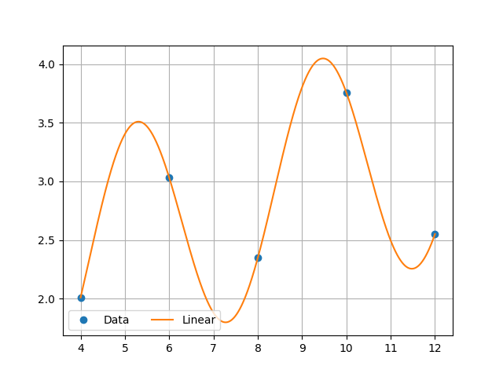

Поліном Ньютона:

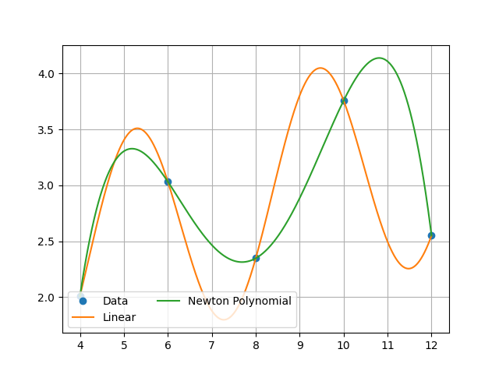

Інтерполяція кубічними сплайнами:

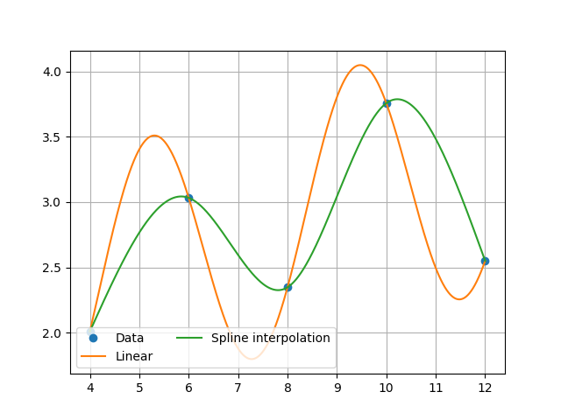

Інтерполяція кубічними сплайнами із SciPy:

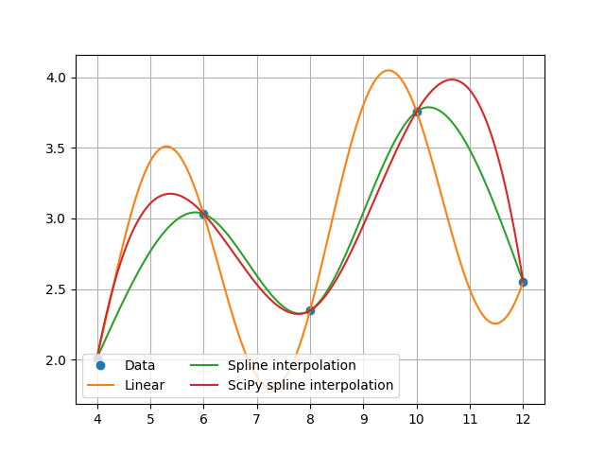

### 3 Розв’язок за допомогою SciPy

Нижче наведено розв’язок системи у SciPy:

cs = CubicSpline(x_values.copy(), y_values.copy())

### 4 Лістинг програми

from scipy.interpolate import CubicSpline  
import numpy as np  
import matplotlib.pyplot as plt  
from string import Template  
from math import sin  
  
template = Template(**'#'** * 10 + **' $string '** + **'#'** * 10)  
  
  
def linear_function(x: int, alpha=3) -> float:  
 *"""  
 Main linear function  
 :param x: x value  
 :param alpha: some value  
 :return: result y = f(x)  
 """* y_value = sin(alpha / 2 * x) + (x * alpha) ** (1 / 3)  
 return y_value  
  
  
def create_indexes(x_values: list) -> dict:  
 *"""  
 Function that creates indexes for spline coefficients matrix  
 :param x_values: our nodes  
 :return: dictionary with indexes  
 """* indexes = {}  
 length = len(x_values)  
 for i in range(length - 1):  
 indexes[**f'b**{i + 1}**'**] = i  
 indexes[**f'c**{i + 1}**'**] = i + length - 1  
 indexes[**f'd**{i + 1}**'**] = i + length * 2 - 2  
 indexes[**'y'**] = (length - 1) * 3  
 return indexes  
  
  
def get_coeffs_for_newton_polynomial(x_elements: list, y_elements: list) -> list:  
 *"""  
 Creates pyramid and extracts coefficients  
 :param x_elements: our nodes  
 :param y_elements: results of f(x)  
 :return: list of coefficients  
 """* length = len(y_elements)  
 pyramid = []  
 for _ in range(length):  
 tmp_array = []  
 for _ in range(length):  
 tmp_array.append(0)  
 pyramid.append(tmp_array)  
 print(template.substitute(string=**'Zero pyramid'**))  
 print(np.matrix(pyramid))  
 for index in range(length):  
 pyramid[index][0] = y_elements[index]  
 print(template.substitute(string=**'Pyramid with first y_elements'**))  
 print(np.matrix(pyramid))  
 for step in range(1, length):  
 for index in range(length - step):  
 pyramid[index][step] = (pyramid[index + 1][step - 1] - pyramid[index][step - 1]) / (  
 x_elements[index + step] - x_elements[index])  
 print(template.substitute(string=**'Final pyramid'**))  
 print(np.matrix(pyramid))  
 return pyramid[0] *# return first row*def print_newton_polynomial(x_values: list, newton_coeffs: list) -> None:  
 *"""  
 Function that prints our newton polynomial  
 :param x_values: our nodes  
 :param newton_coeffs: coefficients for newton polynomial  
 :return: nothing to return  
 """* print(template.substitute(string=**'Newton eval'**))  
 for i in range(len(newton_coeffs)):  
 print(**f' +(**{round(newton_coeffs[i], 5)}**) '**, end=**''**)  
 for j in range(i):  
 print(**f'(x-**{x_values[j]}**)'**, end=**''**)  
 print(**' = y'**, end=**'**\n**'**)  
  
 *# Create polynomial with NumPy* final_polynomial = np.polynomial.Polynomial([0.]) *# our target polynomial* length = len(newton_coeffs)  
 for i in range(length):  
 polynomial = np.polynomial.Polynomial([1.]) *# create a dummy polynomial* for j in range(i):  
 p_temp = np.polynomial.Polynomial([-x_values[j], 1.]) *# (x_elements - x_j)* polynomial = np.polymul(polynomial, p_temp) *# multiply dummy with expression* polynomial *= newton_coeffs[i] *# apply coefficient* final_polynomial = np.polyadd(final_polynomial, polynomial) *# add to target polynomial* final_polynomial[0].coef = np.round_(final_polynomial[0].coef, decimals=5)  
 print(final_polynomial[0])  
  
  
def solve_newton_polynomial(newton_coeffs: list, x_values: list, x_value: float) -> float:  
 *"""  
 Function that calculate newton polynomial at x_valuew  
 :param newton_coeffs: coefficients for newton polynomial  
 :param x_values: our nodes  
 :param x_value: current x  
 :return: f(x)  
 """* length = len(x_values) - 1  
 result = newton_coeffs[length]  
 for k in range(1, length + 1):  
 result = newton_coeffs[length - k] + (x_value - x_values[length - k]) * result  
 return result  
  
  
def show_plot(x_values: list, y_values: list, newton_coeffs=None, spline_coeffs=None, indexes=None, cubic_spline=None) -> None:  
 *"""  
 Function for creating plots  
 :param x_values: our nodes  
 :param y_values: values at this nodes  
 :param newton_coeffs: coefficients for newton polynomial  
 :param spline_coeffs: coefficients for spline equations  
 :param indexes: dictionary with indexes for spline equations  
 :param cubic_spline: CubicSpline class from SciPy  
 :return: nothing to return  
 """* x_axis = np.linspace(4, 12, num=10000)  
 x_axis_2 = np.linspace(4, 12, num=2000)  
 fig, ax = plt.subplots()  
 ax.plot(x_values, y_values, **'o'**, label=**'Data'**)  
 ax.plot(x_axis, [linear_function(x) for x in x_axis], label=**'Linear'**)  
 if cubic_spline is not None:  
 ax.plot(x_axis_2, [solve_spline_equation(x_values, y_values, x, spline_coeffs, indexes) for x in x_axis_2],  
 label=**'Spline interpolation'**)  
 ax.plot(x_axis_2, cubic_spline(x_axis_2), label=**'SciPy spline interpolation'**)  
 elif newton_coeffs is not None:  
 ax.plot(x_axis_2, [solve_newton_polynomial(newton_coeffs, x_values, x) for x in x_axis_2],  
 label=**'Newton Polynomial'**)  
 elif spline_coeffs is not None:  
 ax.plot(x_axis_2, [solve_spline_equation(x_values, y_values, x, spline_coeffs, indexes) for x in x_axis_2],  
 label=**'Spline interpolation'**)  
 ax.legend(loc=**'lower left'**, ncol=2)  
 plt.grid()  
 plt.show()  
  
  
def create_matrix(x_values: list, y_values: list, indexes: dict) -> [list, list]:  
 *"""  
 Function that create matrix to find coefficients for spline equations  
 :param x_values: our nodes  
 :param y_values: values at this nodes  
 :param indexes: indexes for matrix  
 :return: matrix a and vector b  
 """* matrix_a = []  
 indexes_length = len(indexes)  
 *# I* for i in range(1, len(x_values)):  
 row = np.zeros(indexes_length)  
 h = x_values[i] - x_values[i - 1]  
 row[indexes[**f'b**{i}**'**]] = h  
 row[indexes[**f'c**{i}**'**]] = h ** 2  
 row[indexes[**f'd**{i}**'**]] = h ** 3  
 row[indexes[**'y'**]] = y_values[i] - y_values[i - 1]  
 matrix_a.append(row)  
 *# II* for i in range(1, len(x_values) - 1):  
 row = np.zeros(indexes_length)  
 h = x_values[i] - x_values[i - 1]  
 row[indexes[**f'b**{i + 1}**'**]] = 1  
 row[indexes[**f'b**{i}**'**]] = -1  
 row[indexes[**f'c**{i}**'**]] = -2 * h  
 row[indexes[**f'd**{i}**'**]] = -3 * h ** 2  
 row[indexes[**'y'**]] = 0  
 matrix_a.append(row)  
 *# III* for i in range(1, len(x_values) - 1):  
 row = np.zeros(indexes_length)  
 h = x_values[i] - x_values[i - 1]  
 row[indexes[**f'c**{i + 1}**'**]] = 1  
 row[indexes[**f'c**{i}**'**]] = -1  
 row[indexes[**f'd**{i}**'**]] = -3 * h  
 row[indexes[**'y'**]] = 0  
 matrix_a.append(row)  
 *# IV* row = np.zeros(indexes_length)  
 row[indexes[**f'c**{len(x_values) - 1}**'**]] = 1  
 row[indexes[**f'd**{len(x_values) - 1}**'**]] = 3 * (x_values[-1] - x_values[-2])  
 row[indexes[**'y'**]] = 0  
 matrix_a.append(row)  
 row = np.zeros(indexes_length)  
 row[indexes[**'c1'**]] = 1  
 row[indexes[**'y'**]] = 0  
 matrix_a.append(row)  
 vector_b = np.zeros(indexes_length - 1)  
 for i in range(len(matrix_a)):  
 vector_b[i] = matrix_a[i][-1]  
 matrix_a = np.delete(matrix_a, np.s_[-1:], axis=1)  
 print(template.substitute(string=**'Matrix A and vector B'**))  
 print(np.matrix(matrix_a))  
 print(vector_b)  
 return matrix_a, vector_b  
  
  
def solve_kramer_method(matrix_a: list, vector_b: list, matrix_c: list) -> list:  
 *"""  
 Kramer function to find spline coeffiecents  
 :param matrix_a: matrix a  
 :param vector_b: vector b  
 :param matrix_c: matrix a copy  
 :return: list of spline coefficients  
 """* spline_coeffs = []  
 for i in range(0, len(vector_b)):  
 for j in range(0, len(vector_b)):  
 matrix_c[j][i] = vector_b[j]  
 if i > 0:  
 matrix_c[j][i - 1] = matrix_a[j][i - 1]  
 spline_coeffs.append(np.linalg.det(matrix_c) / np.linalg.det(matrix_a))  
 spline_coeffs = np.array(spline_coeffs).round(5)  
 return spline_coeffs  
  
  
def print_spline_equations(x_values: list, y_values: list, spline_coeffs: list, indexes: dict) -> None:  
 *"""  
 Function that print spline equations  
 :param x_values: our nodes  
 :param y_values: values at this nodes  
 :param spline_coeffs: coefficients for spline equations  
 :param indexes: indexes for spline equations  
 :return: nothing to return  
 """* print(template.substitute(string=**'Spline equations'**))  
 for i in range(len(x_values) - 1):  
 print(  
 **f"**{y_values[i]} **+(**{spline_coeffs[indexes[**f'b**{i + 1}**'**]]}**)(x-**{x_values[i]}**) +**{spline_coeffs[indexes[**f'c**{i + 1}**'**]]}**(x-**{x_values[i]}**)**2 +**{spline_coeffs[indexes[**f'd**{i + 1}**'**]]}**(x-**{x_values[i]}**)**3"**)  
  
  
def solve_spline_equation(x_values: list, y_values: list, x_value: float, spline_coeffs: list, indexes: dict) -> float:  
 *"""  
 Function to get value at x point of spline equation  
 :param x_values: our nodes  
 :param y_values: values at this nodes  
 :param x_value: current x point  
 :param spline_coeffs: coefficients for spline equations  
 :param indexes: dictionary with indexes for spline equations  
 :return: f(x)  
 """* for i in range(len(x_values) - 1):  
 if x_values[i] <= x_value <= x_values[i + 1]:  
 return y_values[i] + spline_coeffs[indexes[**f'b**{i + 1}**'**]] * (x_value - x_values[i]) + spline_coeffs[  
 indexes[**f'c**{i + 1}**'**]] * (x_value - x_values[i]) ** 2 + spline_coeffs[indexes[**f'd**{i + 1}**'**]] * (  
 x_value - x_values[i]) ** 3  
  
  
def get_faults(x_values: list, y_values: list, newton_coeffs: list, spline_coeffs: list, indexes: dict, cubic_spline: CubicSpline) -> None:  
 *"""  
 Function that prints faults for math functions  
 :param x_values: our nodes  
 :param y_values: values at this nodes  
 :param newton_coeffs: coefficients for newton polynomial  
 :param spline_coeffs: coefficients for spline equations  
 :param indexes: dictionary with indexes for spline equations  
 :param cubic_spline: CubicSpline class from SciPy  
 :return: nothing to return  
 """* x_axis = np.arange(4, 12.5, 0.5)  
 print(template.substitute(string=**'Faults'**))  
 for x_value in x_axis:  
 print(**'X value:'**, x_value)  
 print(**'Newton polynomial'**, round(abs(solve_newton_polynomial(newton_coeffs, x_values, x_value) - linear_function(x_value)), 5))  
 print(**'Cubic spline'**, round(abs(solve_spline_equation(x_values, y_values, x_value, spline_coeffs, indexes) - linear_function(x_value)), 4))  
 print(**'SciPy cubic spline'**, round(abs(cubic_spline(x_value) - linear_function(x_value)), 5))  
 print()  
  
  
def main():  
 *"""Main function"""* k = 10 - 1  
 x_values = [-5 + k, -3 + k, -1 + k, 1 + k, 3 + k]  
 y_values = [linear_function(x) for x in x_values]  
 print(template.substitute(string=**'X and Y values'**))  
 print(x_values)  
 print(np.array(y_values).round(5))  
 show_plot(x_values=x_values.copy(), y_values=y_values.copy())  
 *# Newton Polynomial* newton_coeffs = get_coeffs_for_newton_polynomial(x_values.copy(), y_values.copy())  
 print(template.substitute(string=**'Coefficients'**))  
 print(np.array(newton_coeffs).round(5))  
 print_newton_polynomial(x_values.copy(), newton_coeffs.copy())  
 show_plot(x_values=x_values.copy(), y_values=y_values.copy(), newton_coeffs=newton_coeffs.copy())  
 *# Cubic spline  
 # x_values_2 = [2, 3, 5, 7]  
 # y_values_2 = [4, -2, 6, -3]* indexes = create_indexes(x_values.copy())  
 print(template.substitute(string=**'Indexes'**))  
 print(indexes)  
 matrix_a, vector_b = create_matrix(x_values.copy(), y_values.copy(), indexes.copy())  
 matrix_c = matrix_a.copy()  
 spline_coeffs = solve_kramer_method(matrix_a, vector_b, matrix_c)  
 print(template.substitute(string=**'Spline coeffiecients'**))  
 print(spline_coeffs)  
 print_spline_equations(x_values.copy(), y_values.copy(), spline_coeffs.copy(), indexes.copy())  
 show_plot(x_values=x_values.copy(), y_values=y_values.copy(), spline_coeffs=spline_coeffs.copy(),  
 indexes=indexes.copy())  
 *# SciPy spline* cs = CubicSpline(x_values.copy(), y_values.copy())  
 show_plot(x_values=x_values.copy(), y_values=y_values.copy(), spline_coeffs=spline_coeffs.copy(), indexes=indexes.copy(), cubic_spline=cs)  
 *# Get faults* get_faults(x_values.copy(), y_values.copy(), newton_coeffs.copy(), spline_coeffs.copy(), indexes.copy(), cs)  
  
  
main()