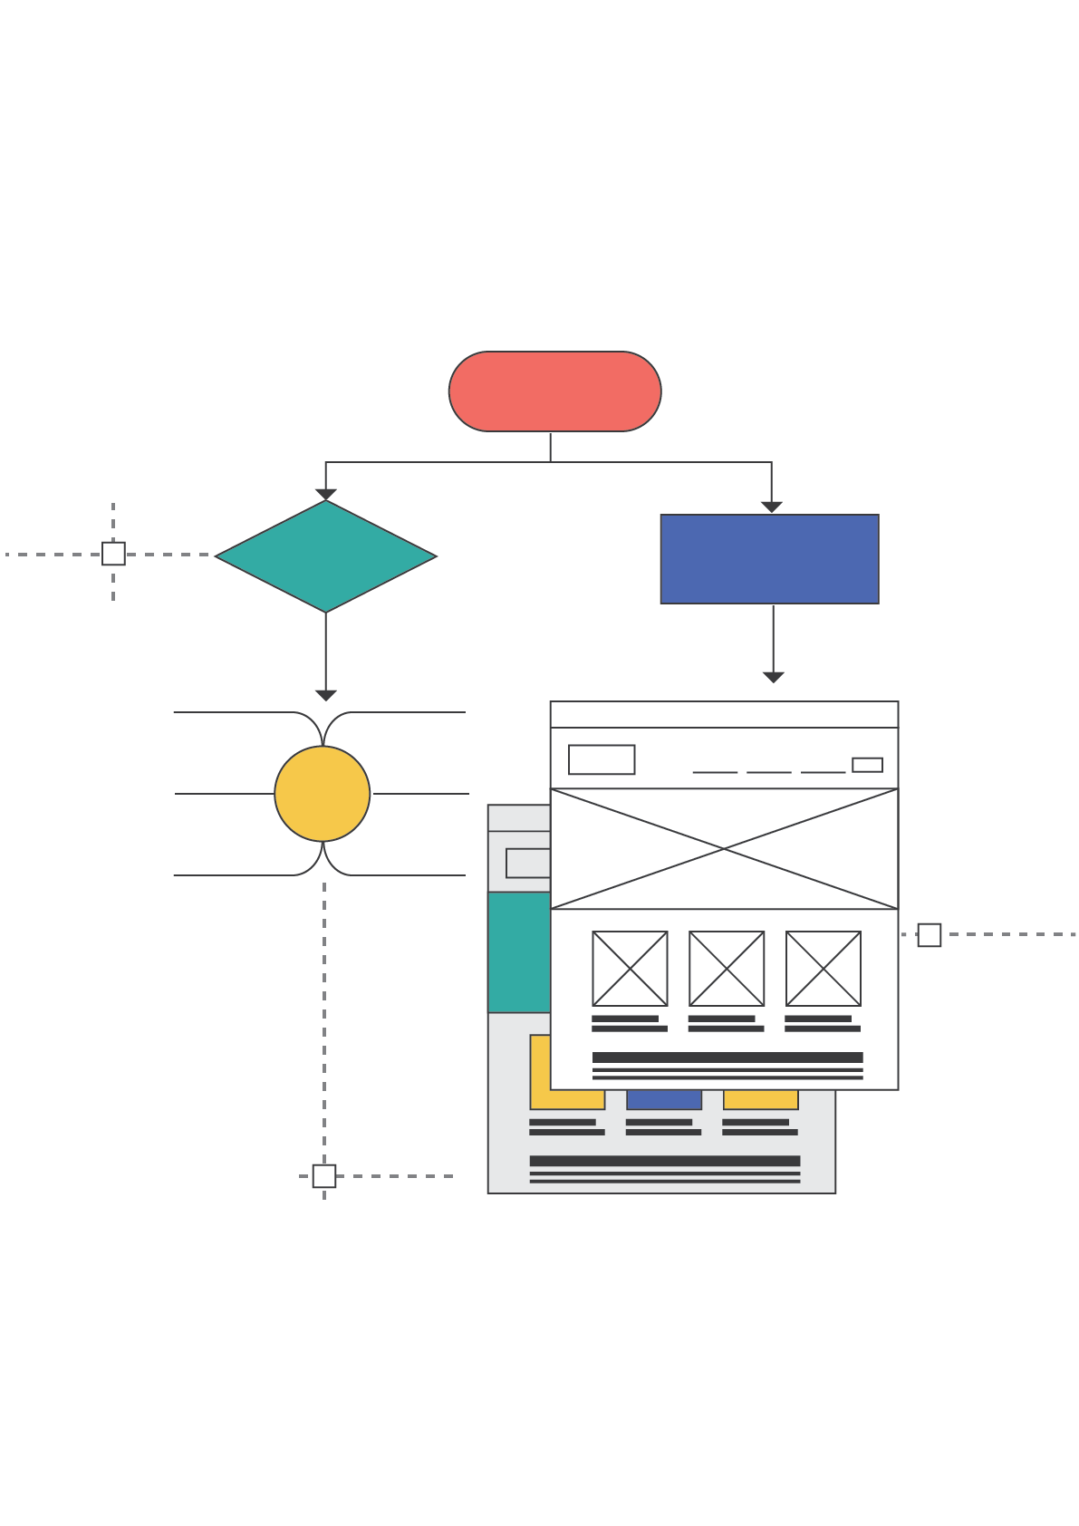

**Website Planning Template for wadielnil.com**

**PHASE 1: PRE – PLANNING**

**WEBSITE OBJECTIVES**

The website is for an agricultural development company. Which deals with agrochemicals, including, bio stimulants, bio-pesticides, natural pesticides, public health products, liquid fertilizers, plant stimulants and enhancers, seeds, and sprayers. The company checks plants and agriculture for farms and lands then support their plants with fertilizers for each plant. What I am trying to achieve through this website is to be able to present the fertilizers products that the company own online with their specs and what they are used for. Also trying to help customers know what fertilizer they should use for the problems appearing in their plants. I want to make it easy for regular people facing problems with their plants to search their problems on the website and we provide the solution we have. Then they can buy it through contacting us.

Objectives:

|  |  |
| --- | --- |
| Generate more traffic | yes |
| Improve lead conversion rates | yes |
| Increase brand awareness | yes |
| Improve user satisfaction | yes |
| Increase ecommerce sales | yes |
| Improve sales support | yes |
| Promote content online | Yes |

**ANALYSIS OF TOP COMPETITORS AND THE MARKET**

**Key Competitors:**

1. Nufarm
2. Bajamilagro
3. Agrostulln
4. idainature

**Keywords:**

1. Agricultural Development
2. Agrochemicals
3. Farmers
4. Distributors

**PHASE 2: INFORMATION ARCHITECTURE AND USER FLOWS**

### WEBSITE STRUCTURE

### *<You can highlight the key areas of your site using a site map. This initial map will help you when developing your site’s wireframe later>*

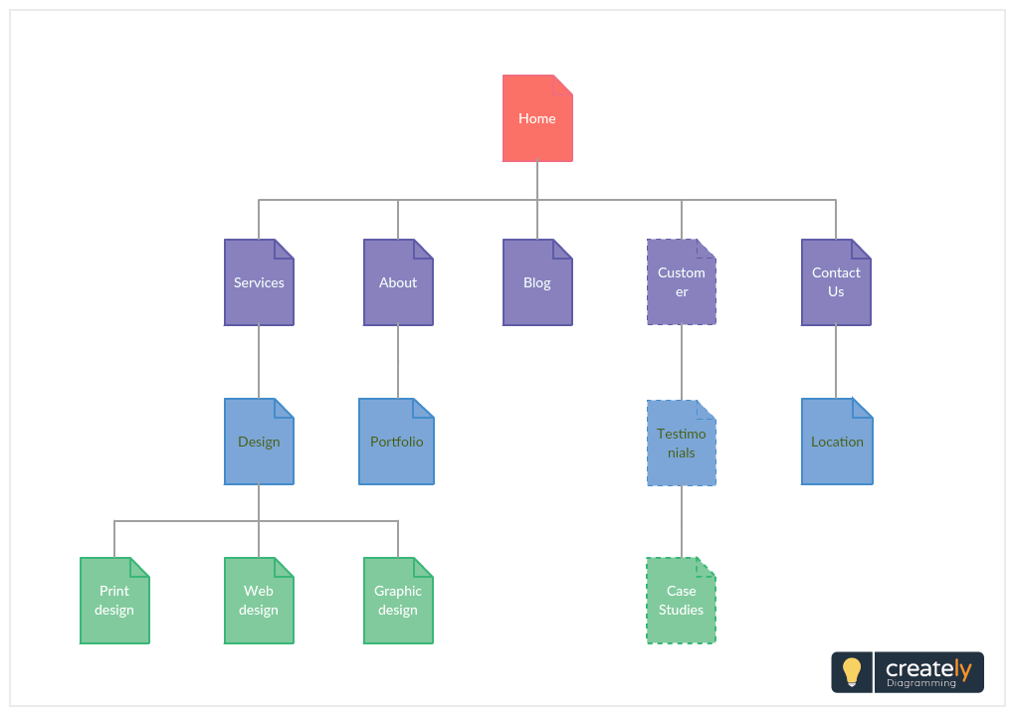<http://creately.com/creately-start?tempID=jfaqp9br1>

**NAVIGATION FLOW**

*<Using a flowchart, you can map how your visitor would navigate through your site. Identifying this will help you decide on the key phrases, key paragraphs, key images etc. you should place on each page>*

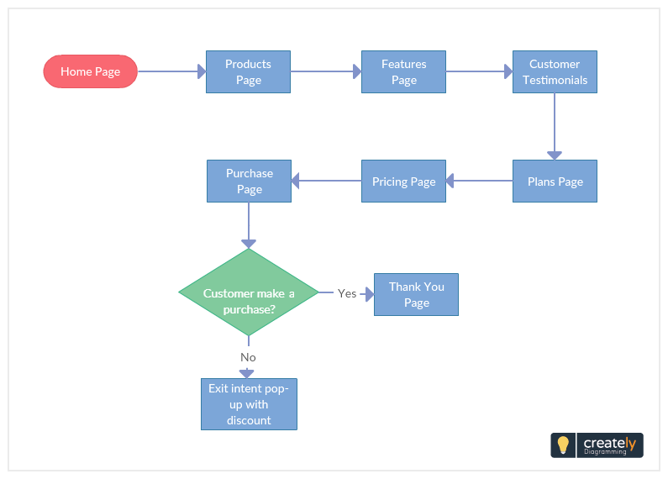

<http://creately.com/creately-start?tempID=jfareluk1>

Want to create your own user flow? Draw it quickly with [Creately flowchart software](https://creately.com/Flowcharts-and-Workflow-Diagrams-Online).

**PHASE 3: DESIGN LAYOUTS AND SITE INFRASTRUCTURE**

### KEY COLORS, ELEMENTS AND STYLES

### *<Mood boards are a great way to document the inspirational instances you find while you are doing research for your website design. You can use them to come up with your own style guide for your website>*

<http://creately.com/creately-start?tempID=jfareluk2>

**WEBSITE WIREFRAMES**

*<With wireframes you can create a blueprint of your website. This will help demonstrate how key interface elements should be placed on pages for a better user experience>*

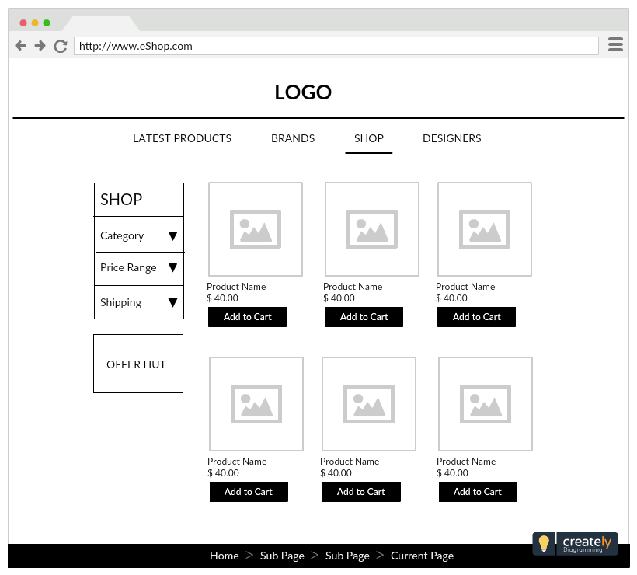

<http://creately.com/creately-start?tempID=gsy8pdq41>

**WEBSITE UI MOCKUPS**

*<Revise the design choices for color themes, typography, iconography, layouts, and visuals of navigation with UI mockups. They can help you detect any faults before you go ahead with the final design>*

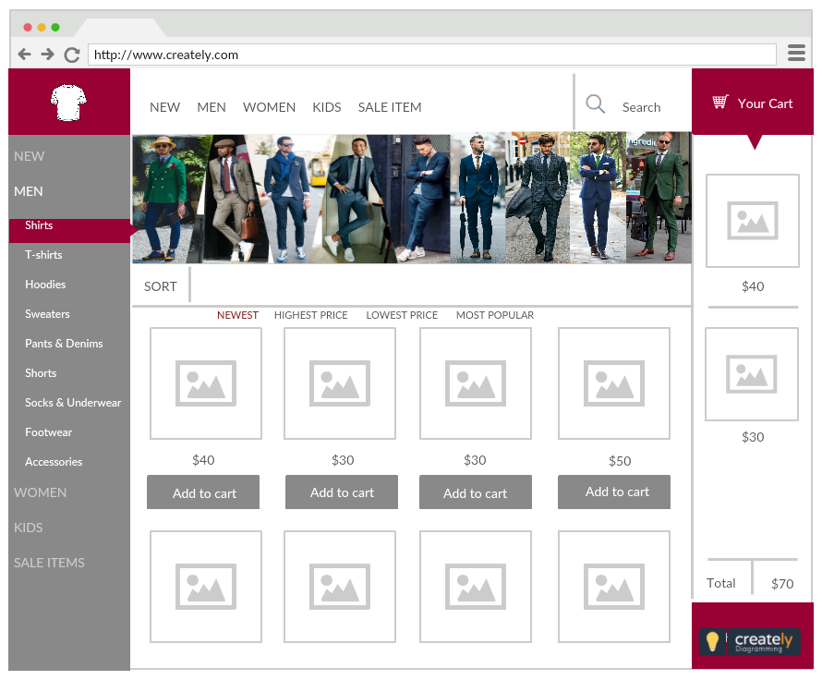

<http://creately.com/creately-start?tempID=ipt6bcpc1>

**PHASE 4: PROMOTION AND MARKETING**

### WEBSITE PROMOTION AND MARKETING

### *<Building your website is just the initial phase of it all. Then comes marketing. There are several ways you can promote and drive traffic to your website. Get your team together and sketch out a step by step plan on how to get your website in front of an interested audience >*

### 

<http://creately.com/creately-start?tempID=jfaw7i0a1>