3GPP TS 38.323 V16.0.0 (2020-03)
Technical Specification
3rd Generation Partnership Project;
Technical Specification Group Radio Access Network;
NR;
Packet Data Convergence Protocol (PDCP) specification
(Release 16)


The present document has been developed within the 3rd Generation Partnership Project (3GPP TM) and may be further elaborated for the purposes of 3GPP.
The present document has not been subject to any approval process by the 3GPP Organizational Partners and shall not be implemented.
This Specification is provided for future development work within 3GPP only. The Organizational Partners accept no liability for any use of this Specification.
Specifications and Reports for implementation of the 3GPP TM system should be obtained via the 3GPP Organizational Partners' Publications Offices.

3GPP
Postal address

3GPP support office address
650 Route des Lucioles - Sophia Antipolis
Valbonne - FRANCE
Tel.: +33 4 92 94 42 00 Fax: +33 4 93 65 47 16
Internet
http://www.3gpp.org

Copyright Notification
No part may be reproduced except as authorized by written permission.
The copyright and the foregoing restriction extend to reproduction in all media.

© 2020, 3GPP Organizational Partners (ARIB, ATIS, CCSA, ETSI, TSDSI, TTA, TTC).
All rights reserved.

UMTS™ is a Trade Mark of ETSI registered for the benefit of its members
3GPP™ is a Trade Mark of ETSI registered for the benefit of its Members and of the 3GPP Organizational Partners
LTE™ is a Trade Mark of ETSI registered for the benefit of its Members and of the 3GPP Organizational Partners
GSM® and the GSM logo are registered and owned by the GSM Association
Contents
Foreword 4
1 Scope 5
2 References 5
3 Definitions and abbreviations 6
3.1 Definitions 6
3.2 Abbreviations 6
4 General 7
4.1 Introduction 7
4.2 Architecture 7
4.2.1 PDCP structure 7
4.2.2 PDCP entities 8
4.3 Services 9
4.3.1 Services provided to upper layers 9
4.3.2 Services expected from lower layers 9
4.4 Functions 10
5 Procedures 10
5.1 PDCP entity handling 10
5.1.1 PDCP entity establishment 10
5.1.2 PDCP entity re-establishment 10
5.1.3 PDCP entity release 12
5.1.4 PDCP entity suspend 12
5.1.5 PDCP entity reconfiguration 12
5.2 Data transfer 13
5.2.1 Transmit operation 13
5.2.2 Receive operation 14
5.2.2.1 Actions when a PDCP Data PDU is received from lower layers 14
5.2.2.2 Actions when a t-Reordering expires 15
5.2.2.3 Actions when the value of t-Reordering is reconfigured 16
5.2.3 Sidelink transmit operation 16
5.2.4 Sidelink receive operation 16
5.3 SDU discard 16
5.4 Status reporting 16
5.4.1 Transmit operation 16
5.4.2 Receive operation 17
5.5 Data recovery 17
5.6 Data volume calculation 17
5.7 Robust header compression and decompression 18
5.7.1 Supported header compression protocols and profiles 18
5.7.2 Configuration of ROHC 19
5.7.3 Protocol parameters 19
5.7.4 Header compression using ROHC 19
5.7.5 Header decompression using ROHC 20
5.7.6 PDCP Control PDU for interspersed ROHC feedback 20
5.7.6.1 Transmit Operation 20
5.7.6.2 Receive Operation 20
5.8 Ciphering and deciphering 20
5.9 Integrity protection and verification 21
5.10 Handling of unknown, unforeseen, and erroneous protocol data 21
5.11 PDCP duplication 22
5.11.1 Activation/Deactivation of PDCP duplication 22
5.11.2 Duplicate PDU discard 22
5.12 Ethernet header compression and decompression 22
5.12.1 Supported header compression protocols 22
5.12.2 Configuration of EHC 22
5.12.3 Protocol parameters 22
5.12.4 Header compression using EHC 22
5.12.5 Header decompression using EHC 23
5.12.6 PDCP Control PDU for EHC feedback 23
5.12.6.1 Transmit Operation 23
5.12.6.2 Receive Operation 23
5.12.7 Simultaneous configuration of ROHC and EHC 23
5.13 Uplink data switching 24
6 Protocol data units, formats, and parameters 24
6.1 Protocol data units 24
6.1.1 Data PDU 24
6.1.2 Control PDU 24
6.2 Formats 24
6.2.1 General 24
6.2.2 Data PDU 25
6.2.2.1 Data PDU for SRBs 25
6.2.2.2 Data PDU for DRBs with 12 bits PDCP SN 25
6.2.2.3 Data PDU for DRBs with 18 bits PDCP SN 26
6.2.2.4 Data PDU for SLRBs for groupcast and broadcast 26
6.2.3 Control PDU 27
6.2.3.1 Control PDU for PDCP status report 27
6.2.3.2 Control PDU for interspersed ROHC feedback 27
6.2.3.3 Control PDU for EHC feedback 28
6.3 Parameters 28
6.3.1 General 28
6.3.2 PDCP SN 28
6.3.3 Data 29
6.3.4 MAC-I 29
6.3.5 COUNT 29
6.3.6 R 29
6.3.7 D/C 29
6.3.8 PDU type 30
6.3.9 FMC 30
6.3.10 Bitmap 30
6.3.11 Interspersed ROHC feedback 30
6.3.12 SDU Type 30
7 State variables, constants, and timers 31
7.1 State variables 31
7.2 Constants 31
7.3 Timers 31
Annex A (normative): Ethernet Header Compression (EHC) protocol 32
A.1 EHC principle 32
A.2 EHC packet format and parameters 33
A.2.1 EHC packet format 33
A.2.1.1 EHC Full Header packet and EHC Compressed Header packet 33
A.2.1.2 EHC feedback packet 34
A.2.2 Parameters 35
A.2.2.1 F/C 35
A.2.2.2 CID 35
Annex B (informative): Change history 36

Foreword
This Technical Specification has been produced by the 3rd Generation Partnership Project (3GPP).
The contents of the present document are subject to continuing work within the TSG and may change following formal TSG approval. Should the TSG modify the contents of the present document, it will be re-released by the TSG with an identifying change of release date and an increase in version number as follows:
Version x.y.z
where:
x the first digit:
1 presented to TSG for information;
2 presented to TSG for approval;
3 or greater indicates TSG approved document under change control.
y the second digit is incremented for all changes of substance, i.e. technical enhancements, corrections, updates, etc.
z the third digit is incremented when editorial only changes have been incorporated in the document.

1 Scope
The present document provides the description of the Packet Data Convergence Protocol (PDCP).

2 References
The following documents contain provisions which, through reference in this text, constitute provisions of the present document.
- References are either specific (identified by date of publication, edition number, version number, etc.) or non-specific.
- For a specific reference, subsequent revisions do not apply.
- For a non-specific reference, the latest version applies. In the case of a reference to a 3GPP document (including a GSM document), a non-specific reference implicitly refers to the latest version of that document in the same Release as the present document.
[1] 3GPP TR 21.905: "Vocabulary for 3GPP Specifications".
[2] 3GPP TS 38.300: "NG Radio Access Network; Overall description".
[3] 3GPP TS 38.331: "NR Radio Resource Control (RRC); Protocol Specification".
[4] 3GPP TS 38.321: "NR Medium Access Control (MAC) protocol specification".
[5] 3GPP TS 38.322: "NR Radio Link Control (RLC) protocol specification".
[6] 3GPP TS 33.501: "Security Architecture and Procedures for 5G System ".
[7] IETF RFC 5795: "The RObust Header Compression (ROHC) Framework".
[8] IETF RFC 3095: "RObust Header Compression (ROHC): Framework and four profiles: RTP, UDP, ESP and uncompressed".
[9] IETF RFC 4815: "RObust Header Compression (ROHC): Corrections and Clarifications to RFC 3095".
[10] IETF RFC 6846: "RObust Header Compression (ROHC): A Profile for TCP/IP (ROHC-TCP)".
[11] IETF RFC 5225: "RObust Header Compression (ROHC) Version 2: Profiles for RTP, UDP, IP, ESP and UDP Lite".
[12] 3GPP TS 36.321: "Evolved Universal Terrestrial Radio Access (E-UTRA) Medium Access Control (MAC) protocol specification".
[13] 3GPP TS 23.287: "Architecture enhancements for 5G System (5GS) to support Vehicle-to-Everything (V2X) services".
[14] 3GPP TS 33.536: "Security Aspect of 3GPP Support for Advanced V2X Services".
[15] IEEE Standard 802.3™-2018: "Ethernet".

3 Definitions and abbreviations

3.1 Definitions
For the purposes of the present document, the terms and definitions given in TR 21.905 [1] and the following apply. A term defined in the present document takes precedence over the definition of the same term, if any, in TR 21.905 [1].
AM DRB: a data radio bearer which utilizes RLC AM.
DAPS bearer: a bearer whose radio protocols are located in both the source gNB and the target gNB during DAPS handover to use both source gNB and target gNB resources.
Non-split bearer: a bearer whose radio protocols are located in either the MgNB or the SgNB to use MgNB or SgNB resource, respectively.
NR sidelink communication: AS functionality enabling at least V2X communication as defined in TS 23.287 [13], between two or more nearby UEs, using NR technology but not traversing any network node.
PDCP data volume: the amount of data available for transmission in a PDCP entity.
Split bearer: in dual connectivity, a bearer whose radio protocols are located in both the MgNB and the SgNB to use both MgNB and SgNB resources.
Split secondary RLC entity: in dual connectivity, the RLC entity other than the primary RLC entity which is responsible for split bearer operation.
UM DRB: a data radio bearer which utilizes RLC UM.

3.2 Abbreviations
For the purposes of the present document, the abbreviations given in TR 21.905 [1] and the following apply. An abbreviation defined in the present document takes precedence over the definition of the same abbreviation, if any, in TR 21.905 [1].
AM Acknowledged Mode
CID Context Identifier
DAPS Dual Active Protocol Stack
DRB Data Radio Bearer carrying user plane data
EHC Ethernet Header Compression
gNB NR Node B
HFN Hyper Frame Number
IETF Internet Engineering Task Force
IP Internet Protocol
MAC Medium Access Control
MAC-I Message Authentication Code for Integrity
PDCP Packet Data Convergence Protocol
PDU Protocol Data Unit
RB Radio Bearer
RFC Request For Comments
RLC Radio Link Control
ROHC RObust Header Compression
RRC Radio Resource Control
RTP Real Time Protocol
SAP Service Access Point
SCCH Sidelink Control Channel
SDU Service Data Unit
SLRB Sidelink Radio Bearer carrying NR sidelink communication
SN Sequence Number
SRB Signalling Radio Bearer carrying control plane data
STCH Sidelink Traffic Channel
TCP Transmission Control Protocol
UDP User Datagram Protocol
UE User Equipment
UM Unacknowledged Mode
X-MAC Computed MAC-I

4 General

4.1 Introduction
The present document describes the functionality of the PDCP.

4.2 Architecture

4.2.1 PDCP structure
Figure 4.2.1.1 represents one possible structure for the PDCP sublayer; it should not restrict implementation. The figure is based on the radio interface protocol architecture defined in TS 38.300 [2].
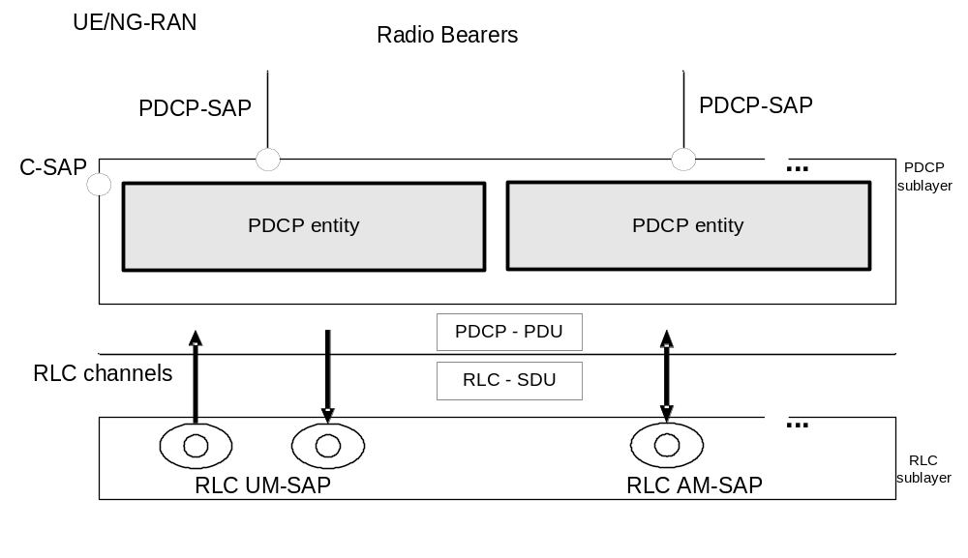
Figure 4.2.1-1: PDCP layer, structure view
The PDCP sublayer is configured by upper layers TS 38.331 [3]. The PDCP sublayer is used for RBs mapped on DCCH, DTCH, SCCH, and STCH type of logical channels. The PDCP sublayer is not used for any other type of logical channels.
Each RB (except for SRB0) is associated with one PDCP entity. Each PDCP entity is associated with one, two, three, four, six, or eight RLC entities depending on the RB characteristic (e.g uni-directional/bi-directional or split/non-split) or RLC mode:
- For split bearers, each PDCP entity is associated with two UM RLC entities (for same direction), four UM RLC entities (two for each direction), or two AM RLC entities (for same direction);
- For RBs configured with PDCP duplication, each PDCP entity is associated with N UM RLC entities (for same direction), 2 × N UM RLC entities (N for each direction), or N AM RLC entities (for same direction), where 2 <= N <= 4;
- For DAPS bearers, each PDCP entity is associated with two UM RLC entities (for same direction, one for source and one for target cell), four UM RLC entities (two for each direction on source cell and target cell), or two AM RLC entities (for same direction, one for source cell and one for target cell);
- Otherwise, each PDCP entity is associated with one UM RLC entity, two UM RLC entities (one for each direction), or one AM RLC entity.

4.2.2 PDCP entities
The PDCP entities are located in the PDCP sublayer. Several PDCP entities may be defined for a UE. Each PDCP entity is carrying the data of one radio bearer. A PDCP entity is associated either to the control plane or the user plane depending on which radio bearer it is carrying data for.
Figure 4.2.2.1 represents the functional view of the PDCP entity for the PDCP sublayer; it should not restrict implementation. The figure is based on the radio interface protocol architecture defined in TS 38.300 [2].
For split bearers and DAPS bearers, routing is performed in the transmitting PDCP entity.
A PDCP entity associated with DRB can be configured by upper layers TS 38.331 [3] to use header compression. In this version of the specification, the robust header compression protocol (ROHC) and the Ethernet header compression protocol (EHC) are supported. Each header compression protocol is independently configured for a DRB.
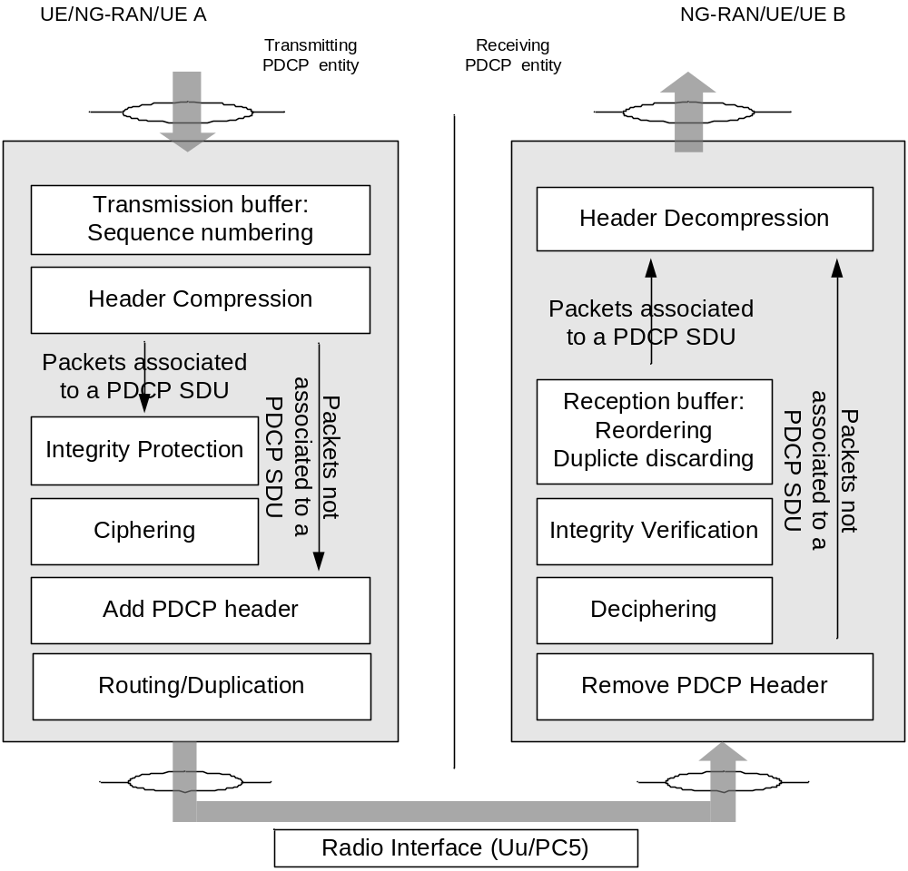
Figure 4.2.2-1: PDCP layer, functional view
Figure 4.2.2-2 represents the functional view of the PDCP entity associated with the DAPS bearer for the PDCP sublayer; it should not restrict implementation. The figure is based on the radio interface protocol architecture defined in TS 38.300 [2].
For DAPS bearers, the PDCP entity is configured with two sets of security functions and keys and two sets of header compression protocols.
Editor's note: FFS on how to handle PDCP entities of SRB, DAPS DRB and non-DAPS DRB in case of DAPS HO without key change.
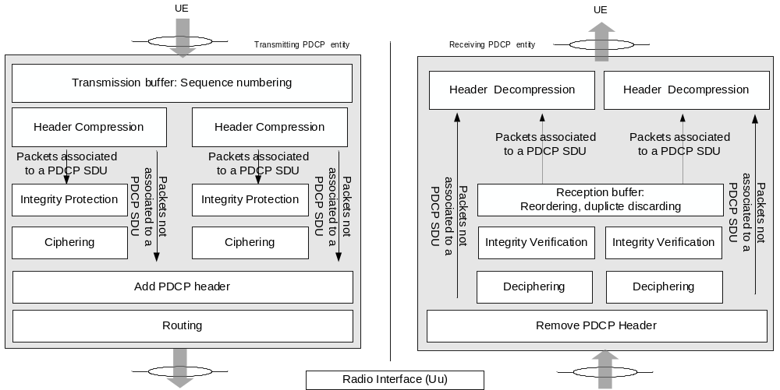
Figure 4.2.2-2: PDCP layer with DAPS, functional view

4.3 Services

4.3.1 Services provided to upper layers
The PDCP layer provides its services to the RRC or SDAP layers. The following services are provided by PDCP to upper layers:
- transfer of user plane data;
- transfer of control plane data;
- header compression;
- ciphering;
- integrity protection.
The maximum supported size of a PDCP SDU is 9000 bytes. The maximum supported size of a PDCP Control PDU is 9000 bytes.

4.3.2 Services expected from lower layers
A PDCP entity expects the following services from lower layers per RLC entity (for a detailed description see TS 38.322 [5]):
- acknowledged data transfer service, including indication of successful delivery of PDCP PDUs;
- unacknowledged data transfer service.

4.4 Functions
The PDCP layer supports the following functions:
- transfer of data (user plane or control plane);
- maintenance of PDCP SNs;
- header compression and decompression using the ROHC protocol;
- header compression and decompression using the EHC protocol;
- ciphering and deciphering;
- integrity protection and integrity verification;
- timer based SDU discard;
- for split bearers and DAPS bearer, routing;
- duplication;
- reordering and in-order delivery;
- out-of-order delivery;
- duplicate discarding.

5 Procedures

5.1 PDCP entity handling

5.1.1 PDCP entity establishment
When upper layers request a PDCP entity establishment for a radio bearer or an SLRB; or for NR sidelink communication for groupcast and broadcast, when receiving the first PDCP PDU from a UM RLC entity, and there is not yet a corresponding PDCP entity for an SLRB, the UE shall:
- establish a PDCP entity for the radio bearer or the SLRB;
- set the state variables of the PDCP entity to initial values;
- follow the procedures in clause 5.2.

5.1.2 PDCP entity re-establishment
When upper layers request a PDCP entity re-establishment, the UE shall additionally perform once the procedures described in this clause. After performing the procedures in this clause, the UE shall follow the procedures in clause 5.2.
When upper layers request a PDCP entity re-establishment, the transmitting PDCP entity shall:
- for UM DRBs and AM DRBs, reset the ROHC protocol for uplink and start with an IR state in U-mode (as defined in RFC 3095 [8] and RFC 4815 [9]) if drb-ContinueROHC is not configured in TS 38.331 [3];
- for UM DRBs and AM DRBs, reset the EHC protocol for uplink if drb-ContinueEHC-UL is not configured in TS 38.331 [3];
- for UM DRBs and SRBs, set TX_NEXT to the initial value;
- for SRBs, discard all stored PDCP SDUs and PDCP PDUs;
- apply the ciphering algorithm and key provided by upper layers during the PDCP entity re-establishment procedure;
- apply the integrity protection algorithm and key provided by upper layers during the PDCP entity re-establishment procedure;
- for UM DRBs, for each PDCP SDU already associated with a PDCP SN but for which a corresponding PDU has not previously been submitted to lower layers, and;
- for suspended AM DRBs, from the first PDCP SDU for which the successful delivery of the corresponding PDCP Data PDU has not been confirmed by lower layers, for each PDCP SDU already associated with a PDCP SN:
- consider the PDCP SDUs as received from upper layer;
- perform transmission of the PDCP SDUs in ascending order of the COUNT value associated to the PDCP SDU prior to the PDCP re-establishment without restarting the discardTimer, as specified in clause 5.2.1;
- for AM DRBs which were not suspended, from the first PDCP SDU for which the successful delivery of the corresponding PDCP Data PDU has not been confirmed by lower layers, perform retransmission or transmission of all the PDCP SDUs already associated with PDCP SNs in ascending order of the COUNT values associated to the PDCP SDU prior to the PDCP entity re-establishment as specified below:
- perform header compression of the PDCP SDU using ROHC as specified in the clause 5.7.4 and/or using EHC as specified in the clause 5.12.4;
- perform integrity protection and ciphering of the PDCP SDU using the COUNT value associated with this PDCP SDU as specified in the clause 5.9 and 5.8;
- submit the resulting PDCP Data PDU to lower layer, as specified in clause 5.2.1.
When upper layers request a PDCP entity re-establishment, the receiving PDCP entity shall:
- process the PDCP Data PDUs that are received from lower layers due to the re-establishment of the lower layers, as specified in the clause 5.2.2.1;
- for SRBs, discard all stored PDCP SDUs and PDCP PDUs;
- for SRBs and UM DRBs, if t-Reordering is running:
- stop and reset t-Reordering;
- for UM DRBs, deliver all stored PDCP SDUs to the upper layers in ascending order of associated COUNT values after performing header decompression;
- for AM DRBs, perform header decompression using ROHC for all stored PDCP SDUs if drb-ContinueROHC is not configured in TS 38.331 [3];
- for AM DRBs, perform header decompression using EHC for all stored PDCP SDUs if drb-ContinueEHC-DL is not configured in TS 38.331 [3];
- for UM DRBs and AM DRBs, reset the ROHC protocol for downlink and start with NC state in U-mode (as defined in RFC 3095 [8] and RFC 4815 [9]) if drb-ContinueROHC is not configured in TS 38.331 [3];
- for UM DRBs and AM DRBs, reset the EHC protocol for downlink if drb-ContinueEHC-DL is not configured in TS 38.331 [3];
- for UM DRBs and SRBs, set RX_NEXT and RX_DELIV to the initial value;
- apply the ciphering algorithm and key provided by upper layers during the PDCP entity re-establishment procedure;
- apply the integrity protection algorithm and key provided by upper layers during the PDCP entity re-establishment procedure.

5.1.3 PDCP entity release
When upper layers request a PDCP entity release for a radio bearer or an SLRB, the UE shall:
- discard all stored PDCP SDUs and PDCP PDUs in the transmitting PDCP entity;
- for UM DRBs and AM DRBs (including sidelink DRBs), deliver the PDCP SDUs stored in the receiving PDCP entity to upper layers in ascending order of associated COUNT values after performing header decompression, if not decompressed before;
- release the PDCP entity for the radio bearer.
NOTE: For NR sidelink communication for groupcast and broadcast, the receiving PDCP entity release for an SLRB is up to UE implementation.

5.1.4 PDCP entity suspend
When upper layers request a PDCP entity suspend, the transmitting PDCP entity shall:
- set TX_NEXT to the initial value;
- discard all stored PDCP PDUs;
When upper layers request a PDCP entity suspend, the receiving PDCP entity shall:
- if t-Reordering is running:
- stop and reset t-Reordering;
- deliver all stored PDCP SDUs to the upper layers in ascending order of associated COUNT values after performing header decompression;
- set RX_NEXT and RX_DELIV to the initial value.

5.1.5 PDCP entity reconfiguration
When upper layers request a PDCP entity reconfiguration and DAPS is configured for a data radio bearer, UE shall:
- establish a ciphering function for the radio bearer and apply the ciphering algorithm and key provided by upper layers for the ciphering function;
- establish an integrity protection function for the radio bearer and apply the integrity protection algorithm and key provided by upper layers for the integrity protection function;
- establish a header compression protocol for the radio bearer and apply the header compression configuration provided by upper layers for the header compression protocol.
When upper layers request a PDCP entity reconfiguration and the associated RLC entity is released for a radio bearer, UE shall:
- release the ciphering function associated to the released RLC entity for the radio bearer;
- release the integrity protection function associated to the released RLC entity for the radio bearer;
- release the header compression protocol associated to the released RLC entity for the radio bearer.
NOTE 1: The state variables which control the transmission and reception operation should not be reset, and the timers including t-Reordering and discardTimer keep running during PDCP entity reconfiguration procedure.
NOTE 2: Before releasing the header compression protocol associated to the released RLC entity, how to handle all stored PDCP SDUs received from the released RLC entity is left up to UE implementation.

5.2 Data transfer

5.2.1 Transmit operation
At reception of a PDCP SDU from upper layers, the transmitting PDCP entity shall:
- start the discardTimer associated with this PDCP SDU (if configured).
For a PDCP SDU received from upper layers, the transmitting PDCP entity shall:
- associate the COUNT value corresponding to TX_NEXT to this PDCP SDU;
NOTE 1: Associating more than half of the PDCP SN space of contiguous PDCP SDUs with PDCP SNs, when e.g., the PDCP SDUs are discarded or transmitted without acknowledgement, may cause HFN desynchronization problem. How to prevent HFN desynchronization problem is left up to UE implementation.
- perform header compression of the PDCP SDU using ROHC as specified in the clause 5.7.4 and/or using EHC as specified in the clause 5.12.4;
- perform integrity protection, and ciphering using the TX_NEXT as specified in the clause 5.9 and 5.8, respectively;
- set the PDCP SN of the PDCP Data PDU to TX_NEXT modulo 2^{[pdcp-SN-SizeUL]};
- increment TX_NEXT by one;
- submit the resulting PDCP Data PDU to lower layer as specified below.
When submitting a PDCP PDU to lower layer, the transmitting PDCP entity shall:
- if the transmitting PDCP entity is associated with one RLC entity:
- submit the PDCP PDU to the associated RLC entity;
- else, if the transmitting PDCP entity is associated with at least two RLC entities:
- if the PDCP duplication is activated:
- if the PDCP PDU is a PDCP Data PDU:
- duplicate the PDCP Data PDU and submit the PDCP Data PDU to the associated RLC entities activated for PDCP duplication;
- else:
- submit the PDCP Control PDU to the primary RLC entity;
- else:
- if the split secondary RLC entity is configured; and
- if the transmitting PDCP entity is not associated with a DAPS bearer; and
- if the total amount of PDCP data volume and RLC data volume pending for initial transmission (as specified in TS 38.322 [5]) in the primary RLC entity and the split secondary RLC entity is equal to or larger than ul-DataSplitThreshold:
- submit the PDCP PDU to either the primary RLC entity or the split secondary RLC entity;
- else, if the transmitting PDCP entity is associated with the DAPS bearer:
- if the uplink data switching has not been requested:
- submit the PDCP PDU to the RLC entity associated with the source cell;
- else:
- if the PDCP PDU is a PDCP Data PDU:
- submit the PDCP Data PDU to the RLC entity associated with the target cell;
- else:
- if the PDCP Control PDU is associated with source cell:
- submit the PDCP Control PDU to the RLC entity associated with the source cell;
- else:
- submit the PDCP Control PDU to the RLC entity associated with the target cell;
- else:
- submit the PDCP PDU to the primary RLC entity.
NOTE 2: If the transmitting PDCP entity is associated with two RLC entities, the UE should minimize the amount of PDCP PDUs submitted to lower layers before receiving request from lower layers and minimize the PDCP SN gap between PDCP PDUs submitted to two associated RLC entities to minimize PDCP reordering delay in the receiving PDCP entity.

5.2.2 Receive operation

5.2.2.1 Actions when a PDCP Data PDU is received from lower layers
In this clause, following definitions are used:
- HFN(State Variable): the HFN part (i.e. the number of most significant bits equal to HFN length) of the State Variable;
- SN(State Variable): the SN part (i.e. the number of least significant bits equal to PDCP SN length) of the State Variable;
- RCVD_SN: the PDCP SN of the received PDCP Data PDU, included in the PDU header;
- RCVD_HFN: the HFN of the received PDCP Data PDU, calculated by the receiving PDCP entity;
- RCVD_COUNT: the COUNT of the received PDCP Data PDU = [RCVD_HFN, RCVD_SN].
At reception of a PDCP Data PDU from lower layers, the receiving PDCP entity shall determine the COUNT value of the received PDCP Data PDU, i.e. RCVD_COUNT, as follows:
- if RCVD_SN < SN(RX_DELIV) – Window_Size:
- RCVD_HFN = HFN(RX_DELIV) + 1.
- else if RCVD_SN >= SN(RX_DELIV) + Window_Size:
- RCVD_HFN = HFN(RX_DELIV) – 1.
- else:
- RCVD_HFN = HFN(RX_DELIV);
- RCVD_COUNT = [RCVD_HFN, RCVD_SN].
After determining the COUNT value of the received PDCP Data PDU = RCVD_COUNT, the receiving PDCP entity shall:
- perform deciphering and integrity verification of the PDCP Data PDU using COUNT = RCVD_COUNT;
- if integrity verification fails:
- indicate the integrity verification failure to upper layer;
- discard the PDCP Data PDU;
- if RCVD_COUNT < RX_DELIV; or
- if the PDCP Data PDU with COUNT = RCVD_COUNT has been received before:
- discard the PDCP Data PDU;
If the received PDCP Data PDU with COUNT value = RCVD_COUNT is not discarded above, the receiving PDCP entity shall:
- store the resulting PDCP SDU in the reception buffer;
- if RCVD_COUNT >= RX_NEXT:
- update RX_NEXT to RCVD_COUNT + 1.
- if outOfOrderDelivery is configured:
- deliver the resulting PDCP SDU to upper layers.
- if RCVD_COUNT = RX_DELIV:
- deliver to upper layers in ascending order of the associated COUNT value after performing header decompression, if not decompressed before;
- all stored PDCP SDU(s) with consecutively associated COUNT value(s) starting from COUNT = RX_DELIV;
- update RX_DELIV to the COUNT value of the first PDCP SDU which has not been delivered to upper layers, with COUNT value > RX_DELIV;
- if t-Reordering is running, and if RX_DELIV >= RX_REORD:
- stop and reset t-Reordering.
- if t-Reordering is not running (includes the case when t-Reordering is stopped due to actions above), and RX_DELIV < RX_NEXT:
- update RX_REORD to RX_NEXT;
- start t-Reordering.

5.2.2.2 Actions when a t-Reordering expires
When t-Reordering expires, the receiving PDCP entity shall:
- deliver to upper layers in ascending order of the associated COUNT value after performing header decompression, if not decompressed before:
- all stored PDCP SDU(s) with associated COUNT value(s) < RX_REORD;
- all stored PDCP SDU(s) with consecutively associated COUNT value(s) starting from RX_REORD;
- update RX_DELIV to the COUNT value of the first PDCP SDU which has not been delivered to upper layers, with COUNT value >= RX_REORD;
- if RX_DELIV < RX_NEXT:
- update RX_REORD to RX_NEXT;
- start t-Reordering.

5.2.2.3 Actions when the value of t-Reordering is reconfigured
When the value of the t-Reordering is reconfigured by upper layers while the t-Reordering is running, the receiving PDCP entity shall:
- update RX_REORD to RX_NEXT;
- stop and restart t-Reordering.

5.2.3 Sidelink transmit operation
For sidelink transmission of the SLRB, the UE shall follow the procedures in clause 5.2.1 with following modification:
- perform the header compression using ROHC as specified in clause 5.7.4, if SDU Type is IP.

5.2.4 Sidelink receive operation
For sidelink reception of the SLRB, the UE shall follow the procedures in clause 5.2.2 with following modification:
- perform the header decompression using ROHC as specified in clause 5.7.5, if SDU Type is IP.

5.3 SDU discard
When the discardTimer expires for a PDCP SDU, or the successful delivery of a PDCP SDU is confirmed by PDCP status report, the transmitting PDCP entity shall discard the PDCP SDU along with the corresponding PDCP Data PDU. If the corresponding PDCP Data PDU has already been submitted to lower layers, the discard is indicated to lower layers.
For SRBs, when upper layers request a PDCP SDU discard, the PDCP entity shall discard all stored PDCP SDUs and PDCP PDUs.
NOTE: Discarding a PDCP SDU already associated with a PDCP SN causes a SN gap in the transmitted PDCP Data PDUs, which increases PDCP reordering delay in the receiving PDCP entity. It is up to UE implementation how to minimize SN gap after SDU discard.

5.4 Status reporting

5.4.1 Transmit operation
For AM DRBs configured by upper layers to send a PDCP status report in the uplink (statusReportRequired in TS 38.331 [3]), the receiving PDCP entity shall trigger a PDCP status report when:
- upper layer requests a PDCP entity re-establishment;
- upper layer requests a PDCP data recovery;
- upper layer requests a uplink data switching;
- upper layer requests a PDCP entity reconfiguration and the associated RLC entity is released for a radio bearer.
If a PDCP status report is triggered, the receiving PDCP entity shall:
- compile a PDCP status report as indicated below by:
- setting the FMC field to RX_DELIV;
- if RX_DELIV < RX_NEXT:
- allocating a Bitmap field of length in bits equal to the number of COUNTs from and not including the first missing PDCP SDU up to and including the last out-of-sequence PDCP SDUs, rounded up to the next multiple of 8, or up to and including a PDCP SDU for which the resulting PDCP Control PDU size is equal to 9000 bytes, whichever comes first;
- setting in the bitmap field as '0' for all PDCP SDUs that have not been received, and optionally PDCP SDUs for which decompression have failed;
- setting in the bitmap field as '1' for all PDCP SDUs that have been received;
- submit the PDCP status report to lower layers as the first PDCP PDU for transmission via the transmitting PDCP entity as specified in clause 5.2.1.
Editor's note: FFS on whether PDCP status reporting for DAPS bearers is needed for UL or DL for RLC UM.

5.4.2 Receive operation
For AM DRBs, when a PDCP status report is received in the downlink, the transmitting PDCP entity shall:
- consider for each PDCP SDU, if any, with the bit in the bitmap set to '1', or with the associated COUNT value less than the value of FMC field as successfully delivered, and discard the PDCP SDU as specified in clause 5.3.

5.5 Data recovery
For AM DRBs, when upper layers request a PDCP data recovery for a radio bearer, the transmitting PDCP entity shall:
- perform retransmission of all the PDCP Data PDUs previously submitted to re-established or released AM RLC entities in ascending order of the associated COUNT values for which the successful delivery has not been confirmed by lower layers, following the data submission procedure in clause 5.2.1.
After performing the above procedures, the transmitting PDCP entity shall follow the procedures in clause 5.2.1.

5.6 Data volume calculation
For the purpose of MAC buffer status reporting, the transmitting PDCP entity shall consider the following as PDCP data volume:
- the PDCP SDUs for which no PDCP Data PDUs have been constructed;
- the PDCP Data PDUs that have not been submitted to lower layers;
- the PDCP Control PDUs;
- for AM DRBs, the PDCP SDUs to be retransmitted according to clause 5.1.2;
- for AM DRBs, the PDCP Data PDUs to be retransmitted according to clause 5.5.
If the transmitting PDCP entity is associated with at least two RLC entities, when indicating the PDCP data volume to a MAC entity for BSR triggering and Buffer Size calculation (as specified in TS 38.321 [4] and TS 36.321 [12]), the transmitting PDCP entity shall:
- if the PDCP duplication is activated:
- indicate the PDCP data volume to the MAC entity associated with the primary RLC entity;
- indicate the PDCP data volume excluding the PDCP Control PDU to the MAC entity associated with the RLC entity other than the primary RLC entity activated for PDCP duplication;
- indicate the PDCP data volume as 0 to the MAC entity associated with RLC entity deactivated for PDCP duplication;
- else:
- if the split secondary RLC entity is configured; and
- if the transmitting PDCP entity is not associated with a DAPS bearer; and
- if the total amount of PDCP data volume and RLC data volume pending for initial transmission (as specified in TS 38.322 [5]) in the primary RLC entity and the split secondary RLC entity is equal to or larger than ul-DataSplitThreshold:
- indicate the PDCP data volume to both the MAC entity associated with the primary RLC entity and the MAC entity associated with the split secondary RLC entity;
- indicate the PDCP data volume as 0 to the MAC entity associated with RLC entity other than the primary RLC entity and the split secondary RLC entity;
- else, if the transmitting PDCP entity is associated with the DAPS bearer:
- if the uplink data switching has not been requested:
- indicate the PDCP data volume to the MAC entity associated with the source cell;
- else:
- indicate the PDCP data volume excluding the PDCP Control PDU for interspersed ROHC feedback associated with the source cell to the MAC entity associated with the target cell;
- indicate the PDCP data volume of PDCP Control PDU for interspersed ROHC feedback associated with the source cell to the MAC entity associated with the source cell;
- else:
- indicate the PDCP data volume to the MAC entity associated with the primary RLC entity;
- indicate the PDCP data volume as 0 to the MAC entity associated with the RLC entity other than the primary RLC entity.

5.7 Robust header compression and decompression

5.7.1 Supported header compression protocols and profiles
The ROHC protocol is based on the Robust Header Compression (ROHC) framework defined in RFC 5795 [7]. There are multiple ROHC algorithms, called profiles, defined for the ROHC framework. Each profile is specific to the particular network layer, transport layer or upper layer protocol combination e.g. TCP/IP and RTP/UDP/IP.
The detailed definition of the ROHC channel is specified as part of the ROHC framework defined in RFC 5795 [7]. This includes how to multiplex different flows (header compressed or not) over the ROHC channel, as well as how to associate a specific IP flow with a specific context state during initialization of the compression algorithm for that flow.
The implementation of the functionality of the ROHC framework and of the functionality of the supported header compression profiles is not covered in this specification.
In this version of the specification the support of the following profiles is described:
Table 5.7.1-1: Supported ROHC protocols and profiles
Profile Identifier | Usage | Reference
0x0000 | No compression | RFC 5795
0x0001 | RTP/UDP/IP | RFC 3095, RFC 4815
0x0002 | UDP/IP | RFC 3095, RFC 4815
0x0003 | ESP/IP | RFC 3095, RFC 4815
0x0004 | IP | RFC 3843, RFC 4815
0x0006 | TCP/IP | RFC 6846
0x0101 | RTP/UDP/IP | RFC 5225
0x0102 | UDP/IP | RFC 5225
0x0103 | ESP/IP | RFC 5225
0x0104 | IP | RFC 5225

5.7.2 Configuration of ROHC
PDCP entities associated with DRBs can be configured by upper layers TS 38.331 [3] to use ROHC. Each PDCP entity carrying user plane data may be configured to use ROHC. PDCP entities associated with SLRBs can be configured to use ROHC for IP SDUs. For DRBs other than DAPS bearers, the PDCP entity uses at most one ROHC compressor instance and at most one ROHC decompressor instance. For DAPS bearers, the PDCP entity uses at most one ROHC compressor instance and at most two ROHC decompressor instances.

5.7.3 Protocol parameters
RFC 5795 [7] has configuration parameters that are mandatory and that must be configured by upper layers between compressor and decompressor peers ; these parameters define the ROHC channel. The ROHC channel is a unidirectional channel, i.e. if rohc is configured there is one channel for the downlink and one for the uplink, and if uplinkOnlyROHC is configured there is only one channel for the uplink. There is thus one set of parameters for each channel, and if rohc is configured the same values shall be used for both channels belonging to the same PDCP entity.
These parameters are categorized in two different groups, as defined below:
- M: Mandatory and configured by upper layers;
- N/A: Not used in this specification.
The usage and definition of the parameters shall be as specified below.
- MAX_CID (M): This is the maximum CID value that can be used. One CID value shall always be reserved for uncompressed flows. The parameter MAX_CID is configured by upper layers (maxCID in TS 38.331 [3]);
- LARGE_CIDS: This value is not configured by upper layers, but rather it is inferred from the configured value of MAX_CID according to the following rule:
- If MAX_CID > 15 then LARGE_CIDS = TRUE else LARGE_CIDS = FALSE;
- PROFILES (M): Profiles are used to define which profiles are allowed to be used by the UE. The list of supported profiles is described in clause 5.7.1. The parameter PROFILES is configured by upper layers (profiles for uplink, downlink, and sidelink in TS 38.331 [3]);
- FEEDBACK_FOR (N/A): This is a reference to the channel in the opposite direction between two compression endpoints and indicates to what channel any feedback sent refers to. Feedback received on one ROHC channel for this PDCP entity shall always refer to the ROHC channel in the opposite direction for this same PDCP entity;
- MRRU (N/A): ROHC segmentation is not used.

5.7.4 Header compression using ROHC
If ROHC is configured, the ROHC protocol generates two types of output packets:
- ROHC compressed packets, each associated with one PDCP SDU;
- standalone packets not associated with a PDCP SDU, i.e. interspersed ROHC feedback.
A ROHC compressed packet is associated with the same PDCP SN and COUNT value as the related PDCP SDU. The header compression is not applicable to the SDAP header and the SDAP Control PDU if included in the PDCP SDU.
For DAPS bearers, the PDCP entity shall perform the header compression for the PDCP SDU using the ROHC protocol either configured for the source cell or configured for the target cell, based on to which cell the PDCP SDU is transmitted.
Interspersed ROHC feedback are not associated with a PDCP SDU. They are not associated with a PDCP SN and are not ciphered.
NOTE: If the MAX_CID number of ROHC contexts are already established for the compressed flows and a new IP flow does not match any established ROHC context, the compressor should associate the new IP flow with one of the ROHC CIDs allocated for the existing compressed flows or send PDCP SDUs belonging to the IP flow as uncompressed packet.
Editor's note: FFS on whether/how to specify network behavior and how to handle source/target, regarding agreement "The target cell always transmits the PDCP PDUs containing IR packet until releasing the source cell".

5.7.5 Header decompression using ROHC
If ROHC is configured by upper layers for PDCP entities associated with user plane data, the PDCP Data PDUs are decompressed by the ROHC protocol after performing deciphering as explained in clause 5.8. The header decompression is not applicable to the SDAP header and the SDAP Control PDU if included in the PDCP Data PDU.
For DAPS bearers, the PDCP entity shall perform the header decompression for the PDCP SDU using the ROHC protocol either configured for the source cell or configured for the target cell, based on from which cell the PDCP SDU is received.

5.7.6 PDCP Control PDU for interspersed ROHC feedback

5.7.6.1 Transmit Operation
When an interspersed ROHC feedback is generated by the ROHC protocol, the transmitting PDCP entity shall:
- submit to lower layers the corresponding PDCP Control PDU as specified in clause 6.2.3.2 i.e. without associating a PDCP SN, nor performing ciphering, as specified in clause 5.2.1.

5.7.6.2 Receive Operation
At reception of a PDCP Control PDU for interspersed ROHC feedback from lower layers, the receiving PDCP entity shall:
- deliver the corresponding interspersed ROHC feedback to the associated ROHC protocol without performing deciphering.

5.8 Ciphering and deciphering
The ciphering function includes both ciphering and deciphering and is performed in PDCP, if configured. The data unit that is ciphered is the MAC-I (see clause 6.3.4) and the data part of the PDCP Data PDU (see clause 6.3.3) except the SDAP header and the SDAP Control PDU if included in the PDCP SDU. The ciphering is not applicable to PDCP Control PDUs.
For downlink and uplink, the ciphering algorithm and key to be used by the PDCP entity are configured by upper layers TS 38.331 [3] and the ciphering method shall be applied as specified in TS 33.501 [6].
The ciphering function is activated/suspended/resumed by upper layers TS 38.331 [3]. When security is activated and not suspended, the ciphering function shall be applied to all PDCP Data PDUs indicated by upper layers TS 38.331 [3] for the downlink, the uplink, and the sidelink, respectively.
For DAPS bearers, the PDCP entity shall perform the ciphering or deciphering for the PDCP SDU using the ciphering algorithm and key either configured for the source cell or configured for the target cell, based on to/from which cell the PDCP SDU is transmitted/received.
For downlink and uplink ciphering and deciphering, the parameters that are required by PDCP for ciphering are defined in TS 33.501 [6] and are input to the ciphering algorithm. The required inputs to the ciphering function include the COUNT value, and DIRECTION (direction of the transmission: set as specified in TS 33.501 [6]).The parameters required by PDCP which are provided by upper layers TS 38.331 [3] are listed below:
- BEARER (defined as the radio bearer identifier in TS 33.501 [6]. It will use the value RB identity –1 as in TS 38.331 [3]);
- KEY (the ciphering keys for the control plane and for the user plane are K_{RRCenc} and K_{UPenc}, respectively).
For NR sidelink communication, the ciphering function as specified in TS 33.501 [6] is applied with KEY (PEK), COUNT, BEARER and DIRECTION (which value shall be set is specified in TS 33.536 [14]) as input.

5.9 Integrity protection and verification
The integrity protection function includes both integrity protection and integrity verification and is performed in PDCP, if configured. The data unit that is integrity protected is the PDU header and the data part of the PDU before ciphering. The integrity protection is always applied to PDCP Data PDUs of SRBs. The integrity protection is applied to sidelink SRBs except for the sidelink SRB carrying unprotected PC5-S message (e.g. Direct Communication Request). The integrity protection is applied to PDCP Data PDUs of DRBs and sidelink DRBs of NR sidelink communication for unicast for which integrity protection is configured. The integrity protection is not applicable to PDCP Control PDUs.
For downlink and uplink, the integrity protection algorithm and key to be used by the PDCP entity are configured by upper layers TS 38.331 [3] and the integrity protection method shall be applied as specified in TS 33.501 [6].
The integrity protection function is activated/suspended/resumed by upper layers TS 38.331 [3]. When security is activated and not suspended, the integrity protection function shall be applied to all PDUs including and subsequent to the PDU indicated by upper layers TS 38.331 [3] for the downlink, the uplink, and the sidelink, respectively.
NOTE 1: As the RRC message which activates the integrity protection function is itself integrity protected with the configuration included in this RRC message, this message needs first be decoded by RRC before the integrity protection verification could be performed for the PDU in which the message was received.
NOTE 2: As the PC5-S message which activates the integrity protection function is itself integrity protected with the configuration included in this PC5-S message, this message needs first be decoded by upper layer before the integrity protection verification could be performed for the PDU in which the message was received.
For DAPS bearers, the PDCP entity shall perform the integrity protection or verification for the PDCP SDU using the integrity protection algorithm and key either configured for the source cell or configured for the target cell, based on to/from which cell the PDCP SDU is transmitted/received.
For downlink and uplink integrity protection and verification, the parameters that are required by PDCP for integrity protection are defined in TS 33.501 [6] and are input to the integrity protection algorithm. The required inputs to the integrity protection function include the COUNT value, and DIRECTION (direction of the transmission: set as specified in TS 33.501 [6]). The parameters required by PDCP which are provided by upper layers TS 38.331 [3] are listed below:
- BEARER (defined as the radio bearer identifier in TS 33.501 [6]. It will use the value RB identity –1 as in TS 38.331 [3]);
- KEY (the integrity protection keys for the control plane and for the user plane are K_{RRCint} and K_{UPint}, respectively).
For the SLRB that needs integrity protection and verification, the parameters that are required by PDCP for integrity protection are defined in TS 33.536 [14] and are input to the integrity protection algorithm. The required inputs to the integrity protection function include the KEY (PIK), COUNT, BEARER and DIRECTION (which value shall be set is specified in TS 33.536 [14]).
At transmission, the UE computes the value of the MAC-I field and at reception it verifies the integrity of the PDCP Data PDU by calculating the X-MAC based on the input parameters as specified above. If the calculated X-MAC corresponds to the received MAC-I, integrity protection is verified successfully.

5.10 Handling of unknown, unforeseen, and erroneous protocol data
When a PDCP PDU that contains reserved or invalid values is received, the receiving PDCP entity shall:
- discard the received PDU.

5.11 PDCP duplication

5.11.1 Activation/Deactivation of PDCP duplication
For the PDCP entity configured with pdcp-Duplication, the transmitting PDCP entity shall:
- for SRBs:
- activate the PDCP duplication;
- for DRBs:
- if the activation of PDCP duplication is indicated:
- activate the PDCP duplication for the indicated associated RLC entities;
- if the deactivation of PDCP duplication is indicated:
- deactivate the PDCP duplication for the indicated associated RLC entities.
Editor's Note: The text needs to be updated after the roles of Rel-15 Duplication MAC CE and Rel-16 Duplication MAC CE are decided.

5.11.2 Duplicate PDU discard
For the PDCP entity configured with pdcp-Duplication, the transmitting PDCP entity shall:
- if the successful delivery of a PDCP Data PDU is confirmed by one of the associated AM RLC entities:
- indicate to the other AM RLC entities to discard the duplicated PDCP Data PDU;
- if the deactivation of PDCP duplication is indicated:
- indicate to the RLC entities deactivated for PDCP duplication to discard all duplicated PDCP Data PDUs.

5.12 Ethernet header compression and decompression

5.12.1 Supported header compression protocols
The EHC protocol is based on the Ethernet Header Compression (EHC) framework defined in Annex A.

5.12.2 Configuration of EHC
PDCP entities associated with DRBs can be configured by upper layers TS 38.331 [3] to use EHC. Each PDCP entity carrying user plane data may be configured to use EHC. Every PDCP entity uses at most one EHC compressor instance and at most one EHC decompressor instance.

5.12.3 Protocol parameters
Editor's Note: The need for configuration parameters is FFS.

5.12.4 Header compression using EHC
If EHC is configured, the EHC protocol generates two types of output packets:
- EHC compressed packets, each associated with one PDCP SDU;
- standalone packets not associated with a PDCP SDU, i.e. EHC feedback.
An EHC compressed packet is associated with the same PDCP SN and COUNT value as the related PDCP SDU. The header compression is not applicable to the SDAP header and the SDAP Control PDU if included in the PDCP SDU.
EHC feedback are not associated with a PDCP SDU. They are not associated with a PDCP SN and are not ciphered.

5.12.5 Header decompression using EHC
If EHC is configured by upper layers for PDCP entities associated with user plane data, the PDCP Data PDUs are decompressed by the EHC protocol after performing deciphering as explained in clause 5.8. The header decompression is not applicable to the SDAP header and the SDAP Control PDU if included in the PDCP Data PDU.

5.12.6 PDCP Control PDU for EHC feedback

5.12.6.1 Transmit Operation
When an EHC feedback is generated by the EHC protocol, the transmitting PDCP entity shall:
- submit to lower layers the corresponding PDCP Control PDU as specified in clause 6.2.3.3 i.e. without associating a PDCP SN, nor performing ciphering.

5.12.6.2 Receive Operation
At reception of a PDCP Control PDU for EHC feedback from lower layers, the receiving PDCP entity shall:
- deliver the corresponding EHC feedback to the EHC protocol without performing deciphering.

5.12.7 Simultaneous configuration of ROHC and EHC
If both ROHC and EHC are configured for a DRB, the ROHC header shall be located after the EHC header. Figure 5.12.7-1 shows the location of the ROHC header and the EHC header in a PDCP Data PDU.
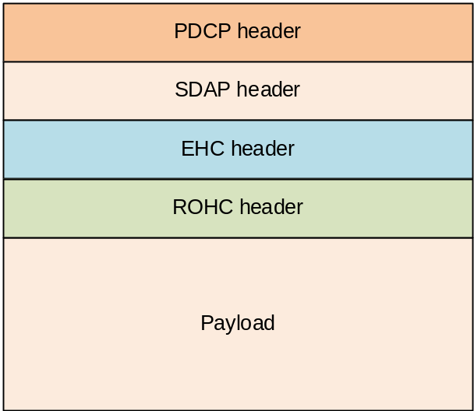
Figure 5.12.7-1: Location of ROHC header and EHC header in a PDCP Data PDU
If a PDCP SDU including non-IP Ethernet packet is received from upper layers, the EHC compressor shall bypass the ROHC compressor and submit the EHC compressed non-IP Ethernet packet to lower layers according to clause 5.2.1.
If a PDCP Data PDU including non-IP Ethernet packet is received from lower layers, the EHC decompressor shall bypass the ROHC decompressor and deliver the EHC decompressed non-IP Ethernet packet to upper layers according to clause 5.2.2.

5.13 Uplink data switching
For DAPS bearers, when upper layers request uplink data switching, the transmitting PDCP entity shall:
- for AM DRBs, from the first PDCP SDU for which the successful delivery of the corresponding PDCP Data PDU has not been confirmed by the RLC entity associated with the source cell, perform retransmission or transmission of all the PDCP SDUs already associated with PDCP SNs in ascending order of the COUNT values associated to the PDCP SDU prior to uplink data switching to the RLC entity associated with the target cell as specified below:
- perform header compression of the PDCP SDU using ROHC as specified in the clause 5.7.4;
- perform integrity protection and ciphering of the PDCP SDU using the COUNT value associated with this PDCP SDU as specified in the clause 5.9 and 5.8;
- submit the resulting PDCP Data PDU to lower layer, as specified in clause 5.2.1.
- for UM DRBs, for all PDCP SDUs which have been processed by PDCP but which have not yet been submitted to lower layers, perform transmission of the PDCP SDUs in ascending order of the COUNT values to the RLC entity associated with the target cell as specified below:
- perform header compression of the PDCP SDU using ROHC as specified in the clause 5.7.4;
- perform integrity protection and ciphering of the PDCP SDU using the COUNT value associated with this PDCP SDU as specified in the clause 5.9 and 5.8;
- submit the resulting PDCP Data PDU to lower layer, as specified in clause 5.2.1.

6 Protocol data units, formats, and parameters

6.1 Protocol data units

6.1.1 Data PDU
The PDCP Data PDU is used to convey one or more of followings in addition to the PDU header:
- user plane data;
- control plane data;
- a MAC-I.

6.1.2 Control PDU
The PDCP Control PDU is used to convey one of followings in addition to the PDU header:
- a PDCP status report;
- an interspersed ROHC feedback;
- an EHC feedback.

6.2 Formats

6.2.1 General
A PDCP PDU is a bit string that is byte aligned (i.e. multiple of 8 bits) in length. In the figures in clause 6.2, bit strings are represented by tables in which the most significant bit is the leftmost bit of the first line of the table, the least significant bit is the rightmost bit on the last line of the table, and more generally the bit string is to be read from left to right and then in the reading order of the lines. The bit order of each parameter field within a PDCP PDU is represented with the first and most significant bit in the leftmost bit and the last and least significant bit in the rightmost bit.
PDCP SDUs are bit strings that are byte aligned (i.e. multiple of 8 bits) in length. A compressed or uncompressed SDU is included into a PDCP Data PDU from the first bit onward.

6.2.2 Data PDU

6.2.2.1 Data PDU for SRBs
Figure 6.2.2.1-1 shows the format of the PDCP Data PDU with 12 bits PDCP SN. This format is applicable for SRBs.
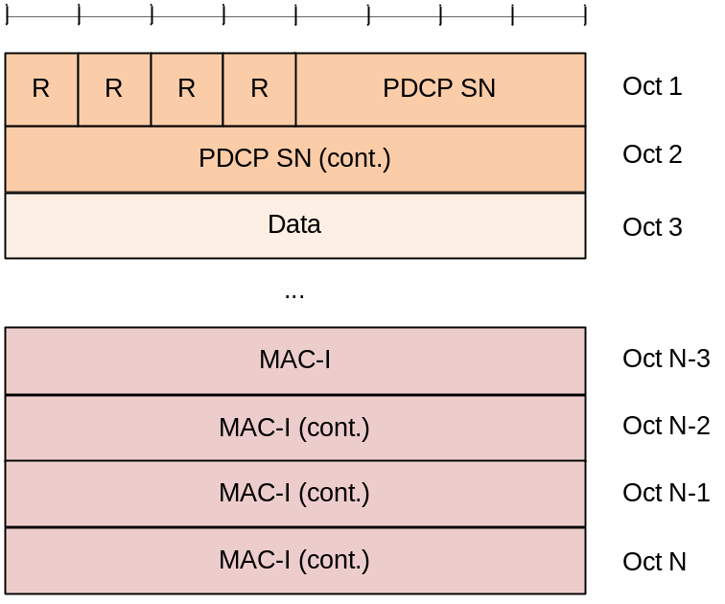
Figure 6.2.2.1-1: PDCP Data PDU format for SRBs

6.2.2.2 Data PDU for DRBs with 12 bits PDCP SN
Figure 6.2.2.2-1 shows the format of the PDCP Data PDU with 12 bits PDCP SN. This format is applicable for UM DRBs and AM DRBs.
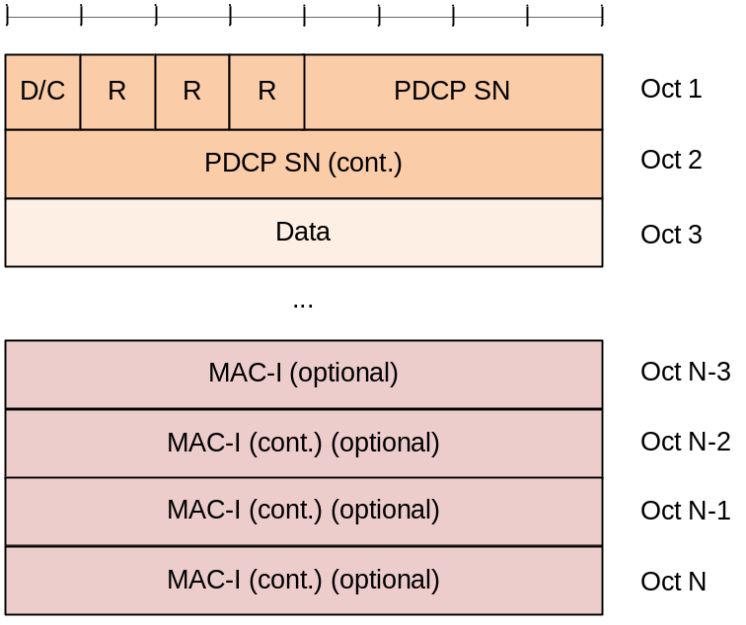
Figure 6.2.2.2-1: PDCP Data PDU format with 12 bits PDCP SN

6.2.2.3 Data PDU for DRBs with 18 bits PDCP SN
Figure 6.2.2.3-1 shows the format of the PDCP Data PDU with 18 bits PDCP SN. This format is applicable for UM DRBs and AM DRBs.
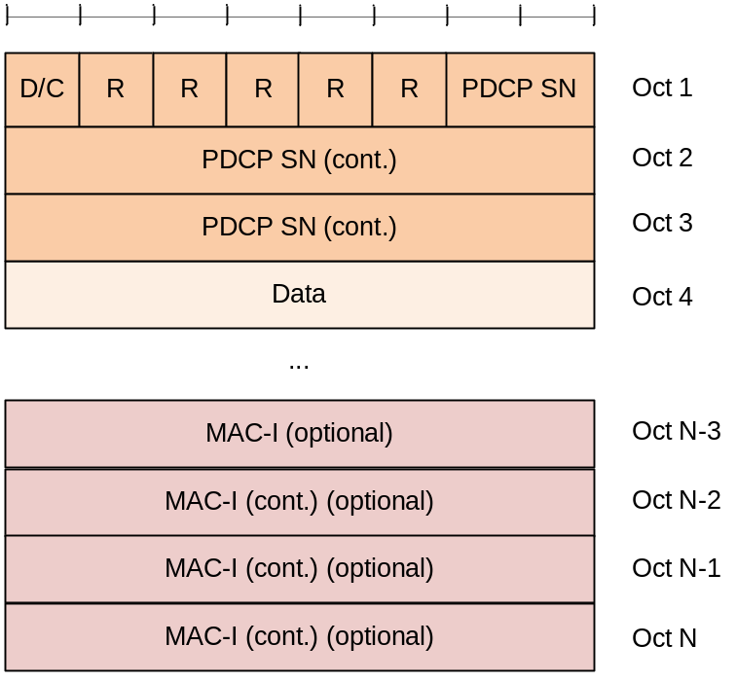
Figure 6.2.2.3-1: PDCP Data PDU format for DRBs with 18 bits PDCP SN

6.2.2.4 Data PDU for SLRBs for groupcast and broadcast
Figure 6.2.2.4-1 shows the format of the PDCP Data PDU with 18 bits PDCP SN. This format is applicable for sidelink DRBs for groupcast and broadcast and for the sidelink SRB carrying the unprotected PC5-S message (e.g. Direct Communication Request).
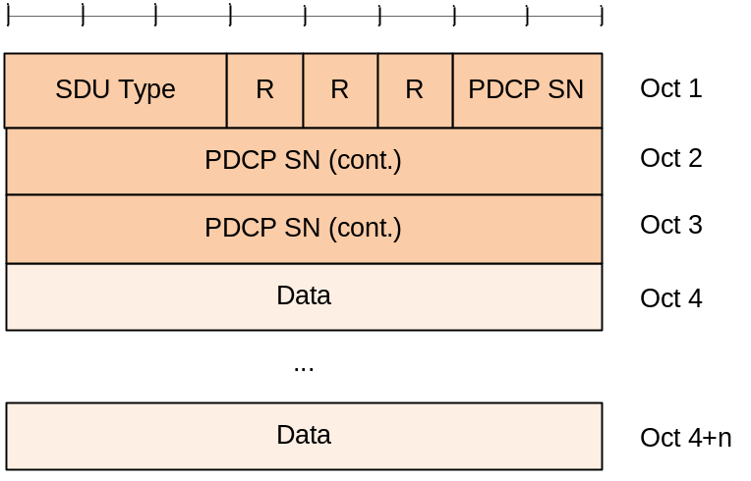
Figure 6.2.2.4-1: PDCP Data PDU format for SLRBs for groupcast and broadcast
NOTE: There is no control PDU for SLRBs for groupcast and broadcast. Thus, there is no D/C field in the PDCP Data PDU format for SLRBs for groupcast and broadcast.

6.2.3 Control PDU

6.2.3.1 Control PDU for PDCP status report
Figure 6.2.3.1-1 shows the format of the PDCP Control PDU carrying one PDCP status report. This format is applicable for AM DRBs.
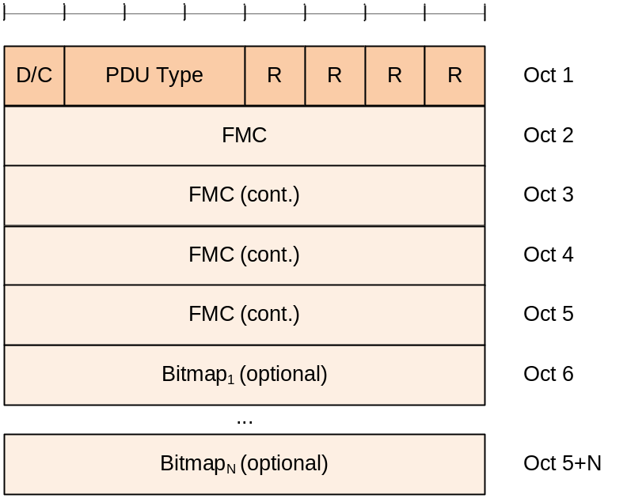
Figure 6.2.3.1-1: PDCP Control PDU format for PDCP status report

6.2.3.2 Control PDU for interspersed ROHC feedback
Figure 6.2.3.2-1 shows the format of the PDCP Control PDU carrying one interspersed ROHC feedback. This format is applicable for UM DRBs and AM DRBs.
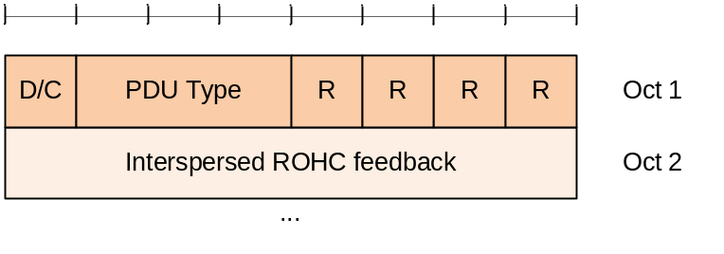
Figure 6.2.3.2-1: PDCP Control PDU format for interspersed ROHC feedback

6.2.3.3 Control PDU for EHC feedback
Figure 6.2.3.3-1 shows the format of the PDCP Control PDU carrying one EHC feedback. This format is applicable for UM DRBs and AM DRBs.
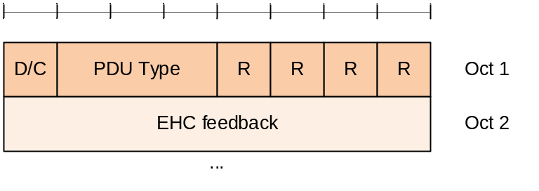
Figure 6.2.3.3-1: PDCP Control PDU format for EHC feedback

6.3 Parameters

6.3.1 General
If not otherwise mentioned in the definition of each field then the bits in the parameters shall be interpreted as follows: the left most bit string is the first and most significant and the right most bit is the last and least significant bit.
Unless otherwise mentioned, integers are encoded in standard binary encoding for unsigned integers. In all cases the bits appear ordered from MSB to LSB when read in the PDU.

6.3.2 PDCP SN
Length: 12, or 18 bits as indicated in table 6.3.2.1. The length of the PDCP SN is configured by upper layers (pdcp-SN-SizeUL, pdcp-SN-SizeDL, or sl-PDCP-SN-Size in TS 38.331 [3]).
Table 6.3.2-1: PDCP SN length
Length | Description
12 | UM DRBs, AM DRBs, and SRBs (including sidelink DRBs and sidelink SRBs except for the sidelink SRB carrying unprotected PC5-S message)
18 | UM DRBs, AM DRBs (including sidelink DRBs) and the sidelink SRB carrying unprotected PC5-S message (e.g. Direct Communication Request)

NOTE: For NR sidelink communication for groupcast and broadcast, only 18 bits PDCP SN length is used for the sidelink DRBs.

6.3.3 Data
Length: Variable
This field includes one of the followings:
- Uncompressed PDCP SDU (user plane data, or control plane data);
- Compressed PDCP SDU (user plane data only).

6.3.4 MAC-I
Length: 32 bits
This field carries a message authentication code calculated as specified in clause 5.9.
For SRBs, the MAC-I field is always present. If integrity protection is not configured, the MAC-I field is still present but should be padded with padding bits set to 0.
For DRBs, the MAC-I field is present only when the DRB is configured with integrity protection.
For sidelink DRBs in NR sidelink communication for unicast, the MAC-I field is present only when the sidelink DRB is configured with integrity protection.
For sidelink SRBs, the MAC-I field is always present except for the sidelink SRB carrying unprotected PC5-S message (e.g. Direct Communication Request).

6.3.5 COUNT
Length: 32 bits
The COUNT value is composed of a HFN and the PDCP SN. The size of the HFN part in bits is equal to 32 minus the length of the PDCP SN.
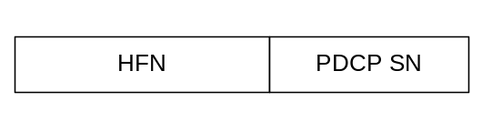
Figure 6.3.5-1: Format of COUNT
NOTE: COUNT does not wrap around.

6.3.6 R
Length: 1 bit
Reserved. In this version of the specification reserved bits shall be set to 0. Reserved bits shall be ignored by the receiver.

6.3.7 D/C
Length: 1 bit
This field indicates whether the corresponding PDCP PDU is a PDCP Data PDU or a PDCP Control PDU.
Table 6.3.7-1: D/C field
Bit | Description
0 | Control PDU
1 | Data PDU

6.3.8 PDU type
Length: 3 bits
This field indicates the type of control information included in the corresponding PDCP Control PDU.
Table 6.3.8-1: PDU type
Bit | Description
000 | PDCP status report
001 | Interspersed ROHC feedback
010 | EHC feedback
011-111 | Reserved

6.3.9 FMC
Length: 32 bits
First Missing COUNT. This field indicates the COUNT value of the first missing PDCP SDU within the reordering window, i.e. RX_DELIV.

6.3.10 Bitmap
Length: Variable. The length of the bitmap field can be 0.
This field indicates which SDUs are missing and which SDUs are correctly received in the receiving PDCP entity. The bit position of N^{th} bit in the Bitmap is N, i.e., the bit position of the first bit in the Bitmap is 1.
Table 6.3.10-1 Bitmap
Bit | Description
0 | PDCP SDU with COUNT = (FMC + bit position) modulo 2³² is missing.
1 | PDCP SDU with COUNT = (FMC + bit position) modulo 2³² is correctly received.

6.3.11 Interspersed ROHC feedback
Length: Variable
This field contains one ROHC packet with only feedback, i.e. a ROHC packet that is not associated with a PDCP SDU as defined in clause 5.7.4.

6.3.12 SDU Type
Length: 3 bits
PDCP SDU type, i.e. Layer-3 Protocol Data Unit type as specified in [13]. PDCP entity may handle the SDU differently per SDU Type, e.g. ROHC is applicable to IP SDU but not Non-IP SDU.
Table 6.3.12-1: SDU Type
Bit | Description
000 | IP
001 | Non-IP
010-111 | Reserved

7 State variables, constants, and timers

7.1 State variables
This sub clause describes the state variables used in PDCP entities in order to specify the PDCP protocol. The state variables defined in this clause are normative.
All state variables are non-negative integers, and take values from 0 to [2³² – 1].
PDCP Data PDUs are numbered integer sequence numbers (SN) cycling through the field: 0 to [2^{[pdcp-SN-SizeUL]} – 1] or 0 to [2^{[pdcp-SN-SizeDL]} – 1] or 0 to [2^{[sl-PDCP-SN-Size]} – 1].
The transmitting PDCP entity shall maintain the following state variables:
a) TX_NEXT
This state variable indicates the COUNT value of the next PDCP SDU to be transmitted. The initial value is 0.
The receiving PDCP entity shall maintain the following state variables:
a) RX_NEXT
This state variable indicates the COUNT value of the next PDCP SDU expected to be received. The initial value is 0, except for sidelink broadcast and groupcast. For NR sidelink communication for broadcast and groupcast, the initial value of the SN part of RX_NEXT is (x +1) modulo (2^{[sl-PDCP-SN-Size]}), where x is the SN of the first received PDCP Data PDU.
NOTE: It is up to UE implementation to select HFN for RX_NEXT as such that initial value of RX_DELIV should be a positive value.
b) RX_DELIV
This state variable indicates the COUNT value of the first PDCP SDU not delivered to the upper layers, but still waited for. The initial value is 0, except for sidelink broadcast and groupcast. For NR sidelink communication for broadcast and groupcast, the initial value of the SN part of RX_DELIV is (x – 0.5 × 2^{[sl-PDCP-SN-Size–1]}) modulo (2^{[sl-PDCP-SN-Size]}), where x is the SN of the first received PDCP Data PDU.
c) RX_REORD
This state variable indicates the COUNT value following the COUNT value associated with the PDCP Data PDU which triggered t-Reordering.

7.2 Constants
a) Window_Size
This constant indicates the size of the reordering window. The value equals to 2^{[pdcp-SN-SizeDL] – 1}.

7.3 Timers
The transmitting PDCP entity shall maintain the following timers:
a) discardTimer
This timer is configured only for DRBs. The duration of the timer is configured by upper layers TS 38.331 [3]. In the transmitter, a new timer is started upon reception of an SDU from upper layer.
The receiving PDCP entity shall maintain the following timers:
b) t-Reordering
The duration of the timer is configured by upper layers TS 38.331 [3], except for the case of NR sidelink communication. For NR sidelink communication, the t-Reordering timer is determined by the UE implementation. This timer is used to detect loss of PDCP Data PDUs as specified in clause 5.2.2. If t-Reordering is running, t-Reordering shall not be started additionally, i.e. only one t-Reordering per receiving PDCP entity is running at a given time.

Annex A (normative):
Ethernet Header Compression (EHC) protocol

A.1 EHC principle
The Ethernet header compression (EHC) protocol compresses Ethernet header as shown in Figure A.1-1 [15]. The fields that are compressed by the EHC protocol are: DESTINATION ADDRESS, SOURCE ADDRESS, 802.1Q TAG, and LENGTH/TYPE. The fields PREAMBLE, SFD, and FCS are not transmitted in 3GPP system, and thus not considered in EHC protocol. There may be more than one 802.1Q TAG fields in the Ethernet header, and all are compressed by the EHC protocol. The padding (PAD) is not compressed by the EHC protocol.
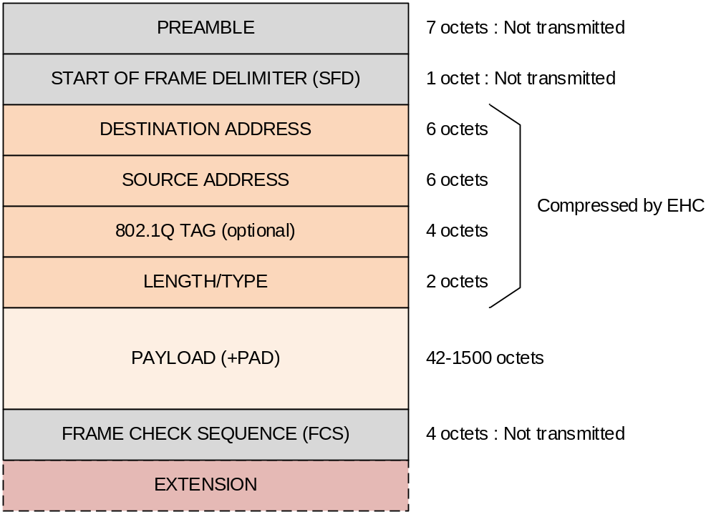
Figure A.1-1: Ethernet packet format [15]
The EHC compressor and the EHC decompressor store original header field information as a "EHC context". Each EHC context is identified by a unique identifier, called Context ID (CID). The EHC context must be synchronized between the EHC compressor and the EHC decompressor; otherwise, the EHC decompressor erroneously decompresses the "Compressed Header (CH)" packets.
For an Ethernet packet stream, the EHC compressor establishes the EHC context and associates it with the CID. Then, the EHC compressor transmits the "Full Header (FH)" packet to the EHC decompressor including the associated CID. The EHC compressor keeps transmitting the FH packets until the EHC feedback is received from the EHC decompressor.
NOTE: If the maximum number of EHC contexts are already established for the compressed flows and a new Ethernet flow does not match any established EHC context, the compressor should associate the new Ethernet flow with one of the EHC CIDs allocated for the existing compressed flows or send PDCP SDUs belonging to the Ethernet flow as uncompressed packet.
When the EHC decompressor receives the FH packet, the EHC decompressor establishes the EHC context identified by the CID, and transmits the EHC feedback to the EHC compressor to indicate that the EHC context associated with the CID is successfully established in the EHC decompressor.
After receiving the EHC feedback, the EHC compressor starts to transmit the CH packets to the EHC decompressor including the associated CID. The CH packet includes only the header fields not stored in the EHC context.
When the EHC decompressor receives the CH packet, the EHC decompressor restores original header fields based on the stored EHC context identified by the associated CID.
Figure A.1-2 represents a conceptual view of EHC operation.
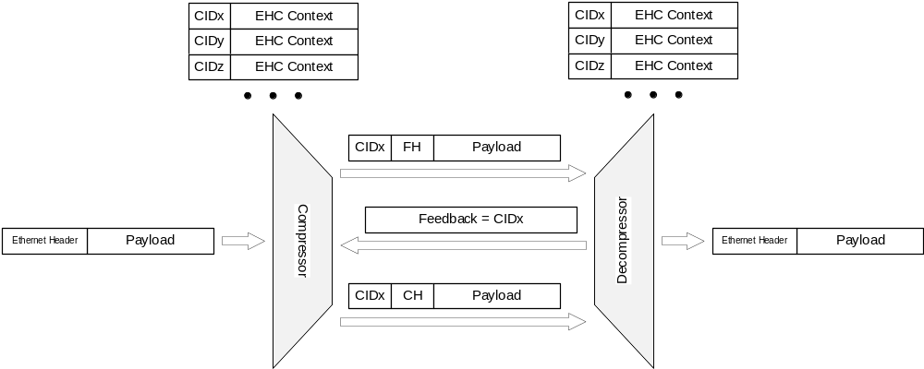
Figure A.1-2: EHC operation

A.2 EHC packet format and parameters

A.2.1 EHC packet format

A.2.1.1 EHC Full Header packet and EHC Compressed Header packet
Figure A.2.1.1-1 and Figure A.2.1.1-2 show the formats of EHC FH packet and EHC CH packet, respectively.
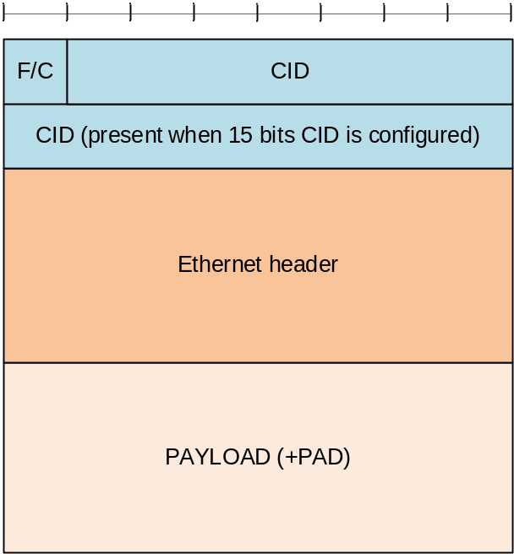
Figure A.2.1.1-1: EHC Full Header packet format
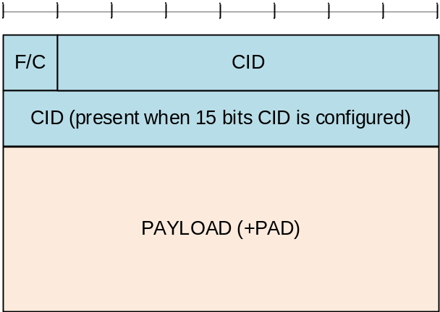
Figure A.2.1.1-2: EHC Compressed Header packet format
Editor's Note: It is FFS whether and how many reserved bits are included in the EHC header.

A.2.1.2 EHC feedback packet
Figure A.2.1.2-1 shows the format of the EHC feedback packet.
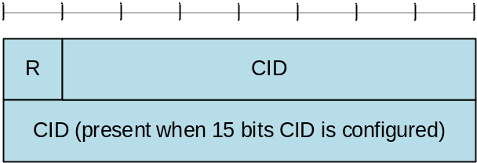
Figure A.2.1.2-1: EHC feedback packet format
Editor's Note: It is FFS how many reserved bits are included in the EHC feedback packet.

A.2.2 Parameters

A.2.2.1 F/C
Length: 1 bit
This field indicates whether the corresponding EHC packet is a FH packet or a CH packet.
Table A.2.2.1-1: F/C field
Bit | Description
0 | FH packet
1 | CH packet

A.2.2.2 CID
Length: 7, or 15 bits. The length of the CID is configured by upper layers (ehc-CIDLength in TS 38.331 [3]).
Editor's Note: It is decided that 1 or 2 bytes are allocated for CID field. However, exact length of the CID field is not decided yet.
The CID = "all zeros" indicates that the corresponding Ethernet header is "uncompressed". The EHC decompressor does not establish the EHC context identified by the CID = "all zeros".

Annex B (informative):
Change history
Change history
Date | Meeting | TDoc | CR | Rev | Cat | Subject/Comment | New Version
2017.03 | RAN2#97bis | R2-1703512 | - | - | - | First version. | x.y.z
2017.04 | RAN2#97bis | R2-1703916 | - | - | - | Change section name "Retransmission" to "Data recovery" | 0.0.1
2017.05 | RAN2#98 | R2-1704076 | - | - | - | Initial draft TS capturing outcome of e-mail discussion [97bis#24] | 0.0.5
2017.06 | RAN2 NR AH | R2-1706868 | - | - | - | Capture agreements made in RAN2#98 | 0.1.0
2017.08 | RAN2 NR AH | R2-1707507 | - | - | - | Capture agreements made in RAN2 NR AH#2 | 0.2.0
2017.08 | RAN2#99 | R2-1709097 | - | - | - | Adding integrity protection in section 5.1.2 | 0.2.1
2017.08 | RAN2#99 | R2-1709753 | - | - | - | Capture agreements made in RAN2#99 | 0.3.0
2017.09 | RANP#77 | RP-171993 | - | - | - | Provided for information to RAN | 1.0.0
2017.10 | RAN2#99bis | R2-1713660 | - | - | - | Capture agreements made in RAN2#99bis | 1.0.1
2017.11 | RAN2#100 | R2-1714273 | - | - | - | Capture agreements made in RAN2#100 | 1.1.0
2017.12 | RP-78 | RP-172335 | - | - | - | Provided for approval to RAN | 2.0.0
2017/12 | RP-78 |  |  |  |  | Upgraded to Rel-15 (MCC) | 15.0.0
2018/03 | RP-79 | RP-180440 | 0002 | 1 | F | Corrections to PDCP specification | 15.1.0
2018/06 | RP-80 | RP-181215 | 0006 | 3 | F | Corrections to PDCP specification | 15.2.0
 | RP-80 | RP-181215 | 0009 | 1 | B | Introduction of PDCP duplication | 15.2.0
2018/09 | RP-81 | RP-181942 | 0011 | 4 | F | Clarification on PDCP transmission | 15.3.0
2018/12 | RP-82 | RP-182650 | 0022 | 1 | F | Suspend and resume of security | 15.4.0
 | RP-82 | RP-182655 | 0023 | - | F | Introducing PDCP suspend procedure | 15.4.0
 | RP-82 | RP-182656 | 0024 | - | F | Clarification on ciphering MAC-I | 15.4.0
2019/03 | RP-83 | RP-190544 | 0025 | 2 | F | Correction on the PDCP re-establishment for AM DRB | 15.5.0
 | RP-83 | RP-190540 | 0027 | 1 | F | Correction on PDCP SN length | 15.5.0
2019/06 | RP-84 | RP-191375 | 0031 | 1 | F | PDCP association with RLC for RBs configured with PDCP duplication | 15.6.0
2020/03 | RP-87 | RP-200346 | 0038 | 2 | B | 38.323 CR for NR V2X | 16.0.0
 | RP-87 | RP-200352 | 0039 | 3 | B | Introduction of NR IIOT | 16.0.0
 | RP-87 | RP-200347 | 0042 | 2 | B | Introduction of DAPS handover | 16.0.0

