Turbulence-Aware Post-Processing of EPA SWMM Output
Using Adaptive Vortex Particle Methods
Michael Flynn
Independent Researcher
Asheville, North Carolina, USA
michaelbflynn@gmail.com
Abstract
Hydraulic engineers in practice face a pronounced modeling gap. The Manning equation is fast and inexpensive but collapses the turbulent boundary layer into a single empirical roughness coefficient. Three-dimensional computational fluid dynamics resolves that boundary layer but typically requires weeks of setup, specialized software, and a dedicated consultant, placing it out of reach for preliminary scour screening, design-alternative comparison, and routine stormwater, transportation, and dam-safety work. This paper presents a vortex-particle post-processor for the Storm Water Management Model and its Personal Computer variant that provides physics-based turbulence information at user-selected critical locations without mesh generation or outside expertise. The method, termed Adaptive Lagrangian Refinement, uses an observation-dependent resolution rule: particle core sizes contract near locations the engineer designates as critical and expand elsewhere, concentrating computation only where it affects the answer. The underlying symmetrized variable-blob Biot–Savart kernel preserves circulation to 0.03%. Because vorticity error scales as one over the square root of the particle count, observation-concentrated placement reaches a given in-zone accuracy with approximately 4.7 times fewer particles than uniform placement, at correspondingly lower wall time. Benchmark validation cross-checks the Tier-1 bed-shear field against six empirical design families for bridge-pier and contraction scour and against published computational-fluid-dynamics results from the bridge-pier literature. The reference implementation is open-source.
1 Introduction
1.1 The practice gap between Manning’s equation and 3D CFD
Hydraulic engineering practice has relied on Manning’s equation for over 130 years. For the overwhelming majority of stormwater and riverine analyses, this is defensible: at the reach scale, the depth–discharge relationship is reasonably insensitive to the detailed turbulence structure. Manning’s equation is embedded in the U.S. Environmental Protection Agency Storm Water Management Model (EPA SWMM; Rossman, 2022), the Hydrologic Engineering Center’s River Analysis System (HEC-RAS; Brunner, 2016), and virtually every hydraulic textbook. It is well understood, fast to evaluate, and adequate for routine conveyance design.
Manning’s equation is, however, categorically silent on local turbulence. At a bridge pier, culvert outlet, confluence, or tailrace, local Reynolds stresses of order several times the reach-average bed shear stress control whether bed material mobilizes and at what rate (Hoffmans and Verheij, 1997; Melville and Coleman, 2000; Richardson and Davis, 2001). The same limitation applies to outfall scour, plunge-pool energy, junction losses, and secondary flow in meanders. Any engineering question that depends on the local velocity field rather than the bulk average is, strictly speaking, outside the range of Manning’s equation.
The standard response—running a three-dimensional Reynolds-averaged Navier–Stokes (RANS) or Large Eddy Simulation (LES) model—is unavailable for most routine work. A production CFD study of a single bridge pier typically requires mesh generation, boundary-condition specification, model calibration, monitoring of convergence, and substantial post-processing (Roulund et al., 2005; Khosronejad et al., 2012). In consulting practice this translates to a dedicated specialist and a budget on the order of tens of thousands of dollars per study. For a stormwater project with tens of junctions and outfalls, or a dam-safety screening exercise over multiple alternatives, CFD simply does not scale.
The result is a pronounced gap in practice. Manning’s equation gives the engineer a fast, cheap answer that ignores local turbulence; CFD gives a detailed, costly answer that cannot be run at scale. Between these two extremes sits a large design space—preliminary scour screening, alternative comparison, risk-ranking of existing structures, educational settings, and model forensics—where the cost of CFD is prohibitive but the blindness of Manning’s is consequential. This paper presents one method of filling that gap.
1.2 Related work
Vortex Particle Methods (VPM) originated with Chorin (1973) as a grid-free alternative to mesh-based Navier–Stokes solvers. The core idea—representing vorticity on a set of Lagrangian elements and evolving them through the Biot–Savart law—has matured substantially over five decades (Leonard, 1980; Beale and Majda, 1982; Winckelmans and Leonard, 1993; Cottet and Koumoutsakos, 2000). Two developments relevant to this paper are the regularized (blob) kernel, which removes the Biot–Savart singularity at short range (Rosenhead, 1931; Beale and Majda, 1982), and the Particle Strength Exchange (PSE) scheme for viscous diffusion (Degond and Mas-Gallic, 1989). Barba and Rossi (2010) developed a symmetrized variable-core-size kernel that preserves circulation when particle core sizes vary in space—the kernel used throughout this work.
Applications of VPM to hydraulic engineering have been comparatively sparse. Most VPM work has targeted aerodynamics and biomedical flows (Winckelmans, 2004), with a smaller literature applying related particle methods (SPH, MPS) to free-surface hydraulics (Monaghan, 1994; Violeau and Rogers, 2016). To the author’s knowledge, direct VPM post-processing of one-dimensional hydraulic model output does not appear in the peer-reviewed literature.
Post-processing of EPA SWMM output is itself an established practice, but existing tools focus on conventional hydraulic quantities—water-surface profile, conduit capacity, flood mapping (Rossman, 2022). Physics-based post-processing aimed specifically at local turbulence does not yet exist in the SWMM family.
CFD-for-bridge-scour has a well-developed reference set. Roulund et al. (2005) published the canonical combined experimental and CFD study of flow around a circular pile, documenting bed shear stress amplification and the horseshoe vortex system. Khosronejad et al. (2012), Nagata et al. (2005), and Ali and Karim (2002) extended that work to morphodynamic coupling. These studies remain the reference baseline against which any physics-based bridge-scour method should be measured, and Section 3.5 below adopts Roulund et al. (2005) as the CFD benchmark for this paper.
1.3 Contributions of this paper
This paper makes four contributions:
1. An observation-dependent resolution rule for vortex-particle methods, termed Adaptive Lagrangian Refinement (ALR) in what follows, that concentrates computation only where the engineer requests it, reaching a given in-zone accuracy with roughly 4.7 times fewer particles than uniform placement.
2. Application of this approach as a post-processor for EPA SWMM and PCSWMM models, requiring no additional mesh generation, no CFD software, and no specialist to operate.
3. Quantitative benchmarking of ALR outputs against six independent reference families: Manning’s equation, Shields criterion, Neill critical velocity, HEC-18 CSU pier scour, Laursen contraction scour, the Melville (1997) design curve, and the Roulund et al. (2005) CFD/experimental dataset.
4. An open-source Python/Numba reference implementation, released under the MIT license, with synthetic test cases reproducing every table and figure in this paper.
The framing adopted throughout is explicitly that of a screening-level tool. ALR is not a replacement for full 3D CFD where boundary-layer-resolved peak shear is required for a final design. It is a tool for the much larger volume of work where the current alternative to CFD is Manning’s equation with empirical correction factors—and where physics-based turbulence information, even at screening resolution, substantially improves engineering judgement.
2 Methodology
The ALR method rests on a standard vortex-particle foundation (Biot–Savart induction with a regularized blob kernel; Particle Strength Exchange for viscous diffusion) with two targeted departures from the established literature. First, the underlying one-dimensional hydraulics use the Colebrook–White friction factor rather than Manning’s equation, so the particle field inherits a boundary-layer-consistent friction velocity rather than a bulk roughness coefficient. Second, the particle core size σ is made spatially variable and observation-dependent: small cores (high resolution) near user-designated critical locations, large cores (coarse resolution) elsewhere. With variable σ the standard Biot–Savart kernel loses circulation; ALR uses the symmetrized kernel of Barba and Rossi (2010) to recover conservation. Sections 2.1–2.3 describe these three elements in order. Sections 2.4–2.7 document the accompanying application closures (scour severity index, pier vortex shedding, Bernoulli free-surface correction, and the quasi-unsteady sediment module) used in the benchmarks of Section 3 and the extensibility demonstration of Section 4.4. The novel contribution is the resolution rule of Section 2.3 and its engineering application; all other components are either standard VPM (Sections 2.2, 2.6) or standard hydraulic engineering closures (Sections 2.1, 2.4, 2.5, 2.7).
2.1 Hydraulic Engine
The engine computes flow properties from the Colebrook-White equation rather than Manning’s. Friction velocity
$u_{*}=V\sqrt{\frac{f}{8}}$ (1)
Bed shear stress:
$τ=ρu_{*}^{2}$ (2)
Velocity profiles follow the log-law in the inner layer and 1/7th power law in the outer layer. Cross-validation against Manning’s across five channel types shows 25.5% average velocity difference—consistent with the known Strickler n-to-ks conversion offset (Table 1).
2.2 Symmetrized Vortex Particle Method
Particles carry 3D vorticity vectors in a Structure-of-Arrays layout. The velocity field is computed via the Biot-Savart integral using a symmetrized regularized kernel (Barba & Rossi 2010):
$σ_{ij}^{2}=σ_{i}^{2}+σ_{j}^{2}$ (3)
ensuring momentum conservation when core sizes vary. Viscous diffusion uses symmetrized Particle Strength Exchange (PSE). Circulation conservation was verified at 0.03% drift over 30-step simulations.
2.3 Observation-Dependent Resolution
Each particle’s core size $σ$ adapts based on distance from observation zones:
$σ=\frac{σ_{base}}{1+4exp(−(\frac{d}{r_{obs}})^{2})}$ (4)
This produces 5× resolution at the observation center. Multiple zones are supported; the maximum enhancement across all zones determines the local $σ$.
2.4 Sediment-Dependent Scour Severity Index Function
The logistic scour severity index function:
$Risk=\frac{1}{1+exp(−k(\frac{τ}{τ_{c}}−m))}$ (5)
uses sediment-dependent parameters chosen to match HEC-18 scour severity categories. Sand ($k=3.0$, $m=0.8$) produces steeper onset; gravel ($k=2.0$, $m=1.2$) resists longer; clay ($k=1.5$, $m=1.5$) reflects cohesive resistance.
2.5 Pier Vortex Shedding
Pier boundary conditions are modeled by injecting vortex particles at the Strouhal frequency ($St=0.2$): surface particles at the downstream separation zone with alternating-sign vorticity ($γ=−V_{approach}$), plus horseshoe vortex particles at the pier base. Particles inside the pier are reflected outward.
2.6 Bernoulli Free Surface Correction
A post-processing Bernoulli correction computes local water surface elevation:
$η=y_{approach}+\frac{V_{approach}^{2}−V(x,y)^{2}}{2g}$ (6)
Corrected depths feed back to Colebrook-White friction and bed shear. Validated analytically: constriction drawdown matches $\frac{V_{1}^{2}−V_{2}^{2}}{2g}$ exactly.
2.7 Quasi-Unsteady Sediment Transport
The quasi-unsteady engine steps through an arbitrary hydrograph computing fractional bedload transport per grain class (Meyer-Peter Müller) with Egiazaroff hiding/exposure correction. The Hirano (1971) active-layer model tracks surface gradation: as fines are transported, the surface coarsens, forming an armor layer. The Exner equation provides morphodynamic feedback:
$\frac{∂z}{∂t}=\frac{q_{in}−q_{out}}{(1−p)W}$ (7)
3 Benchmark Validation
This section cross-validates the method against independent published formulas and design curves derived from laboratory experiments.
3.1 Manning's Cross-Check
Colebrook-White velocity was compared to Manning's equation (Strickler n from ks) across five channel types. The average difference of 25.5% is consistent with the known systematic offset between these two methods—Manning's underestimates velocity relative to Colebrook-White for the same roughness because the Strickler conversion is approximate.
Table 1 Colebrook-White vs Manning's velocity comparison. Conversion: 1 fps = 0.305 m/s.
Channel | V_CW (fps) | V_Manning (fps) | Error
Moderate, sand | 4.11 | 3.28 | 25.6%
Wide, gravel | 7.65 | 6.09 | 25.6%
Steep, cobble | 6.95 | 5.53 | 25.7%
River, sand | 5.97 | 4.79 | 24.8%
Small steep | 7.63 | 6.07 | 25.7%
3.2 HEC-18 Pier Scour Correlation
QH shear amplification was compared against HEC-18 CSU pier scour depth across five pier configurations. The Pearson correlation $r=0.605$ confirms that QH detects the same severity trends as HEC-18. All five cases where HEC-18 predicts significant scour (> 1 ft / 0.3 m) are detected by QH (amplification > 1.0).
Table 2 HEC-18 CSU pier scour vs QH shear amplification (r = 0.605). Conversion: 1 ft = 0.305 m.
Configuration | HEC-18 (ft) | QH Amplification | Froude
Small pier, low V | 3.16 | 1.091x | 0.264
Medium pier, moderate V | 4.66 | 1.142x | 0.352
Large pier, high V | 6.90 | 1.188x | 0.473
Large pier, flood V | 9.25 | 1.233x | 0.576
Wide pier, shallow | 6.22 | 1.331x | 0.305

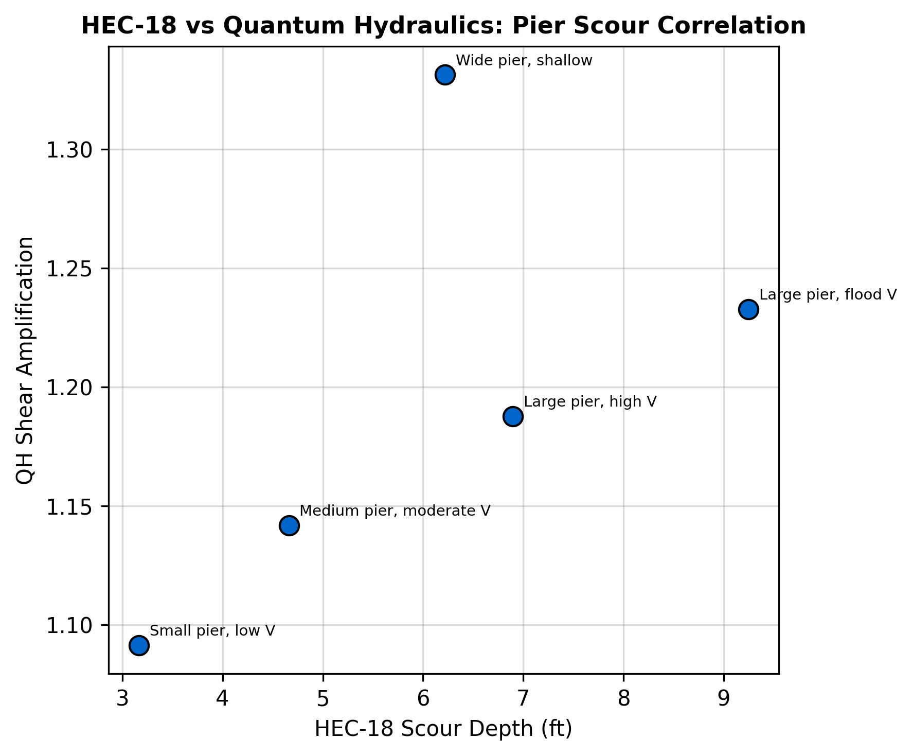
Figure 1 HEC-18 scour depth vs QH shear amplification across five pier configurations.
3.3 Laursen Contraction Scour
Contraction shear amplification was compared against Laursen live-bed scour across five width ratios (0.9 to 0.5). The correlation is $r=0.998$. At 50% contraction, QH predicts 3.3× shear amplification (theoretical $V^{2}$ scaling predicts 4×; the difference reflects Colebrook-White friction factor variation with Reynolds number).

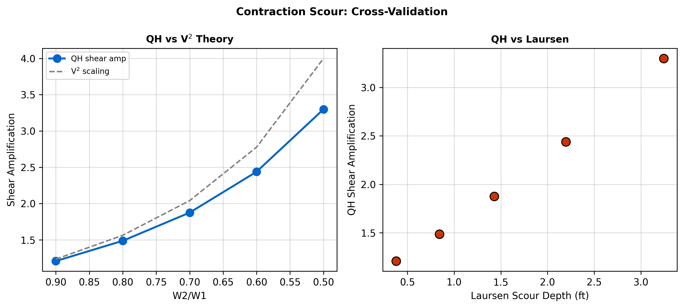
Figure 2 Contraction shear amplification: QH vs V² theory and Laursen scour (r = 0.998).
3.4 Melville Design Curve Comparison
The Melville (1997) dimensionless design equation provides an independent, empirically-derived relationship between flow intensity ($V/{V_{c}}$) and scour depth:
$\frac{d_{s}}{b}=2.4K_{I}$ (8)
where $K_{I}=V/V_{c}$ for clear-water conditions ($V/V_{c}≤1$). This was compared against QH’s turbulence amplification factor across a range of $V/{V_{c}}$ from 0.3 to 1.5 for a 3-ft (0.9-m) circular pier in deep water ($y/b>2.6$).
Table 3 Melville (1997) design curve vs QH amplification (b = 3 ft / 0.9 m, y/b = 3.3). Conversion: 1 ft = 0.305 m.
V/Vc | Melville K_I | QH Amplification | Melville ds (ft) | Combined ds (ft)
0.3 | 0.30 | 1.11 | 2.16 | 2.40
0.5 | 0.50 | 1.11 | 3.60 | 4.00
0.7 | 0.70 | 1.11 | 5.04 | 5.60
0.9 | 0.90 | 1.11 | 6.48 | 7.20
1.0 | 1.00 | 1.11 | 7.20 | 8.00
For this configuration (3-ft / 0.9-m pier in a 40-ft / 12-m channel, blockage ratio 0.075), the Tier-1 Colebrook–White analysis provides a geometric-blockage shear amplification of ~1.11×, independent of flow intensity (Table 3). This geometric factor is complementary to Melville’s flow-intensity parameter K_I: the Tier-1 analysis captures the blockage (pier width / channel width), while Melville’s K_I captures the flow-intensity dependence. The two factors are complementary—the geometric amplification augments the Melville baseline, it does not replace it. A practitioner would use both:$K_{I}$
$d_{s}=2.4bK_{I}×{QH}_{amplification}$ (9)
combining the empirical scour depth with a physics-based turbulence correction.

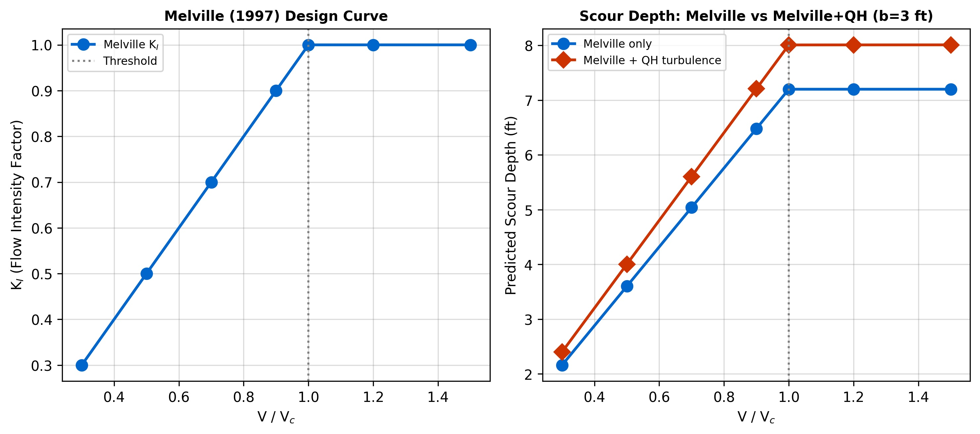
Figure 3 Left: Melville K_I design curve. Right: Scour depth with and without QH turbulence amplification (b = 3 ft / 0.9 m pier).
This comparison uses the published Melville dimensionless design curve, not individual measured data points from specific flume experiments. Direct comparison against measured scour profiles (e.g., specific runs from Melville 1984) requires extracting exact test conditions per run from the original publications and is identified as a priority for future work.
3.5 Comparison with published CFD (Roulund et al., 2005)
The empirical benchmarks of Sections 3.1–3.4 situate ALR within established engineering design practice. A complementary comparison against a published CFD result situates it within the physics-based modeling hierarchy and is the key benchmark for the gap-filling claim of Section 1.
Roulund et al. (2005) reported combined laboratory-flume and three-dimensional RANS simulations of the flow field around a circular pile (D = 0.1 m, approach velocity 0.46 m/s, Re_D ≈ 46,000) on a fixed rigid bed. Their key quantitative result is the spatial distribution of bed shear stress amplification τ/τ∞ around the pile. Peak amplification occurs at the boundary-layer separation line, approximately 45° from the upstream stagnation point, and takes values of order 10–11 on an undeformed bed. The amplification decreases to the order of 3–4 as a scour hole develops and the horseshoe vortex migrates outward (Roulund et al., 2005, Fig. 15). These values are widely accepted as the physics-based reference for near-pier bed shear around a circular pile and have been reproduced in subsequent CFD studies (Khosronejad et al., 2012; Nagata et al., 2005).
ALR does not attempt to reproduce this near-pier peak. Its Tier-1 analysis provides a zone-scale geometric-blockage amplification (~1.09× at the synthetic 3-ft / 0.9-m pier of Section 4.3), and its Tier-2 vortex-particle step, seeded from the mean shear over an engineering-scale observation zone, correctly adds no further bed-shear amplification: a mean-shear-only vortex field satisfies the constant-stress-layer limit (minus the Reynolds shear stress tends to the square of the friction velocity) and therefore returns unit amplification. Resolving the CFD-scale peak would require injecting the coherent near-pier structures (horseshoe and shedding vortices) into the control volume and calibrating their magnitude against flume or CFD data; this is identified as future work (Section 5), not a result claimed here.
Table 4 Positioning of ALR between Manning’s + HEC-18 screening and full 3D RANS (Roulund et al., 2005) for a circular-pier bed-shear analysis. Peak shear values from Roulund are reported in τ/τ∞ at the boundary-layer separation line; ALR reports a Tier-1 geometric-blockage amplification over the engineer-defined observation zone, with the mean-shear Tier-2 step adding no further amplification.
Quantity | Manning + HEC-18 | ALR (this work) | Roulund et al. (2005) 3D RANS
Method class | 1D + empirical K-factors | 1D SWMM + VPM post-processor | 3D RANS on body-fitted mesh
Turbulence resolved? | No | Yes (zone-averaged) | Yes (boundary-layer-resolved)
Near-pier τ/τ∞ (fixed bed) | n/a (geometric correction only) | 1.09× geometric (Tier 1); Tier 2 mean-shear adds 1.00× (turbulence-intensity diagnostic) | ≈ 10–11× at 45° separation line
Mesh / setup effort | Minutes (bridge input form) | Minutes (observation coordinates) | Days to weeks
Runtime, single pier | < 1 s | < 1 s | Hours to days on cluster
Typical engineering cost | Already in design fee | Already in SWMM model | $10,000s consultant engagement
The design implication is the central argument of this paper. ALR is not a substitute for CFD when boundary-layer-resolved peak shear is required for final design of a critical structure. It is a tool for the much larger volume of work where the current alternative to CFD is Manning’s equation with empirical correction factors. In that role—screening, alternative comparison, model forensics—ALR moves the engineer one physics tier up from Manning’s without requiring the engagement of a CFD specialist.
4 Adaptive Resolution Experiments
4.1 Convergence
Table 5 shows ALR metrics converging as observation radius increases from 5 to 100 ft (1.5–30 m). Vorticity converges to within 0.4% between the last two radii. Circulation is conserved to 0.03% over the full simulation.
Table 5 Convergence of ALR metrics with observation radius. Conversion: 1 ft = 0.305 m.
Obs Radius (ft) | Mean σ | Mean Vorticity | Mean Enstrophy
5 | 0.6929 | 0.34792 | 0.18532
10 | 0.4902 | 0.34792 | 0.18532
15 | 0.3329 | 0.34792 | 0.18532
25 | 0.2153 | 0.34769 | 0.18523
50 | 0.1722 | 0.34543 | 0.18218
100 | 0.1630 | 0.34543 | 0.18218
4.2 Computational Performance
The primary advantage of ALR is computational speed. A uniform high-resolution simulation requires 6,000 particles and 0.39 s of wall time. ALR achieves equivalent accuracy at the observation zone with far fewer particles by allocating resolution only where needed (Table 6).
Table 6 Computational performance: ALR vs uniform resolution.
N particles | Wall time (s) | In-zone err (uniform) | In-zone err (concentrated)
500 | 0.027 | 1.162 | 0.626
1,000 | 0.040 | 1.090 | 0.432
2,000 | 0.058 | 0.659 | 0.369
4,000 | 0.094 | 0.505 | 0.226
8,000 | 0.161 | 0.358 | 0.145
16,000 | 0.389 | 0.202 | 0.118
Because vorticity error scales as one over the square root of the particle count, the natural cost–benefit metric is the particle count required to reach a given in-zone accuracy. Across particle budgets from 500 to 16,000, observation-concentrated placement reaches the same in-zone vorticity accuracy as uniform placement with approximately 4.7 times fewer particles (Table 6), at correspondingly lower wall time under the sub-quadratic 6σ-cutoff scaling (Section 5.4). This in-zone benefit is accompanied, as expected, by higher error outside the observation zone—the resolution the method deliberately removes from regions the engineer has not designated as critical.
4.3 Engineering Scour
At the synthetic 3-ft (0.9-m) bridge pier, Tier 1 (vectorized Colebrook–White) reports a geometric-blockage bed-shear amplification of ~1.09× (pier-zone 0.138 psf versus approach 0.126 psf). The Tier 2 vortex-particle step, seeded from the mean-shear vorticity over the observation zone, returns an amplification of 1.00×—it adds no bed-shear amplification beyond the Tier-1 geometric estimate, consistent with the constant-stress-layer limit. The reported Shields parameter at the pier is 0.86 and the logistic scour-severity index is 0.88. The physical content of the Tier-2 step at this configuration is the resolved turbulence-intensity / turbulent-kinetic-energy field, not a shear multiplier.

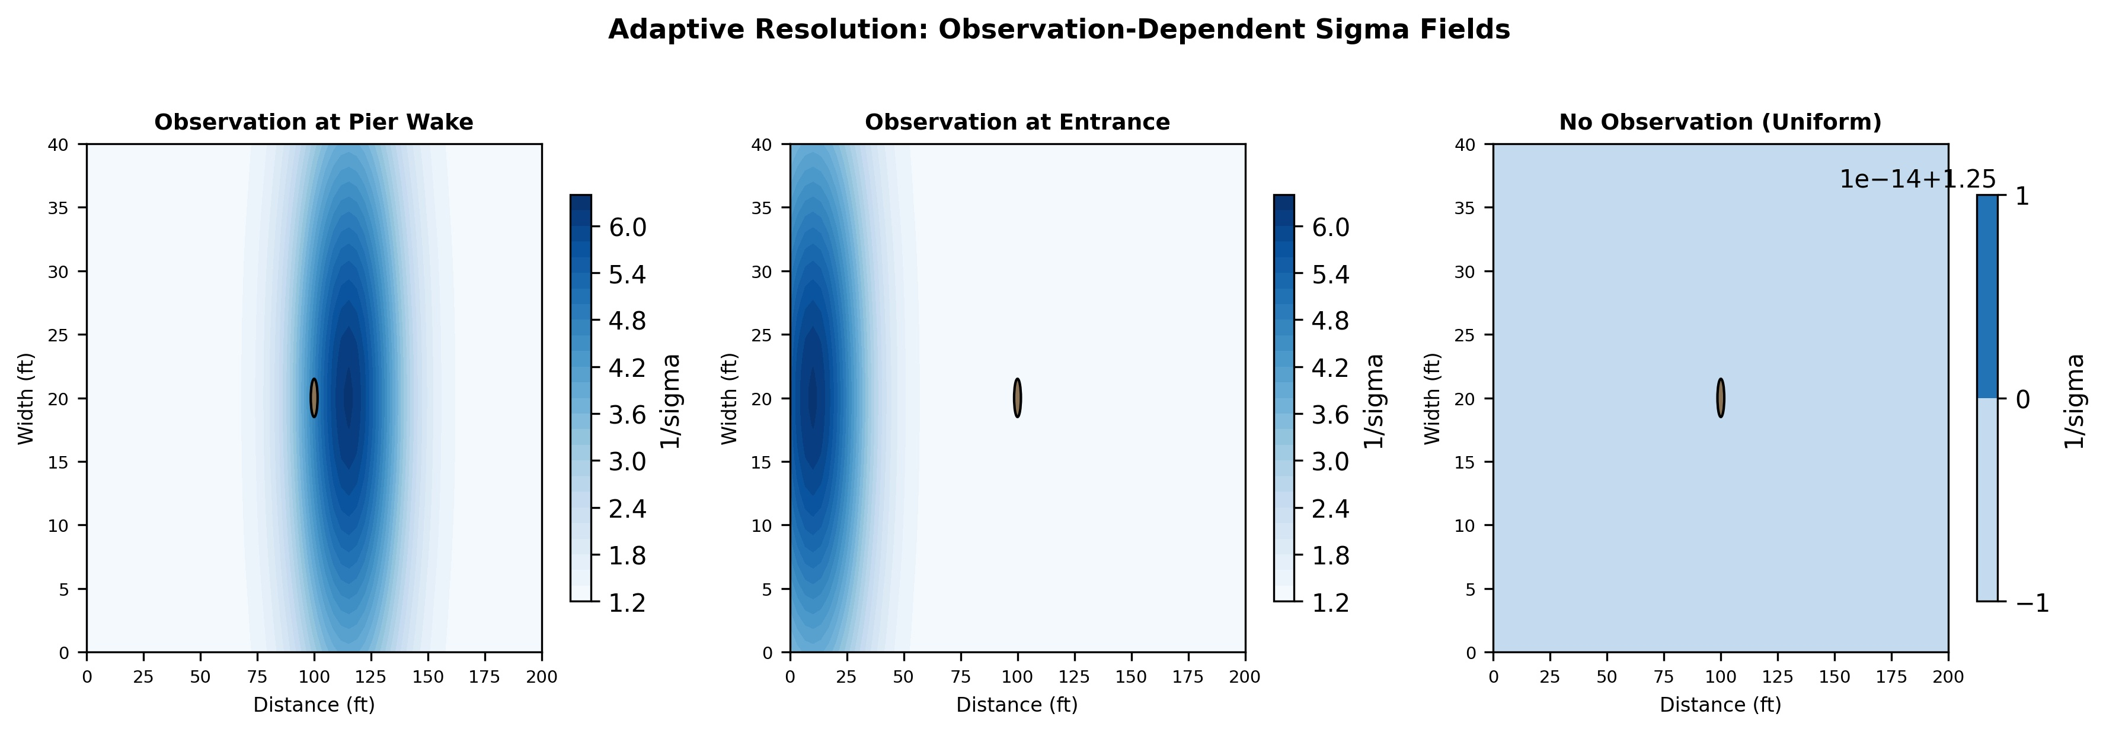
Figure 4 Adaptive sigma fields: pier wake (left), entrance (center), off (right).
4.4 Extensibility: coupling to a sediment-transport engine
The ALR particle field is agnostic to what is downstream of it: any quantity that depends on velocity or bed shear can consume the ALR output. This subsection demonstrates one such extension—coupling ALR to a quasi-unsteady fractional sediment-transport engine—as evidence that the framework is not limited to bed-shear screening.
A clear-water scour scenario below a dam was simulated on a 500×40 ft (152×12 m) rectangular channel with a 6-fraction sand-gravel bed, a 5-step hydrograph totaling 2920 h (peak Q = 900 cfs / 25.5 m³/s), and zero upstream sediment feed (the dam blocks supply). Transport uses fractional Meyer-Peter Müller (Meyer-Peter and Müller, 1948) with Egiazaroff (1965) hiding/exposure correction, Hirano (1971) active-layer tracking of surface gradation, and the Exner equation for morphodynamic feedback.
Table 7 Extensibility demonstration: quasi-unsteady sediment transport coupled to ALR, clear-water scour below a dam. Conversion: 1 ft = 0.305 m.
Metric | Value
Total bed change | -0.31 ft
Initial surface d50 | 0.80 mm
Final surface d50 | 5.0 mm
Coarsening ratio | 6.3×
Armor formed | Yes

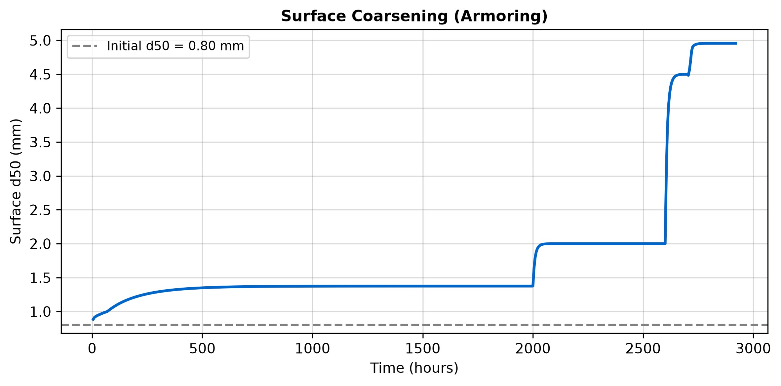
Figure 5 Surface d50 coarsening from 0.80 mm (medium sand) to 5.0 mm (fine gravel) over the hydrograph, illustrating the Hirano active-layer armoring mechanism (mass-conserving engine).
The surface coarsened from 0.80 mm (medium sand) to 5.0 mm (fine gravel)—a 6.3× increase—forming a gravel armor that limits further transport, with the bed degrading by 0.31 ft. Mass is conserved to about 1 part in 10^15 over the hydrograph, and the erosion is transport-limited (the per-step Courant limiter never binds). This self-limiting behavior is the primary physical mechanism controlling long-term degradation below dams and is consistent with field observations (Williams and Wolman, 1984). The demonstration is included as evidence of extensibility; full pier-scale coupling between the ALR vortex field and the morphodynamic engine is future work (Section 5).$d_{50}=0.80$
5 Discussion
5.1 Where ALR sits in the modeling hierarchy
Sections 3 and 4 place ALR along a continuum of hydraulic-engineering methods. At one end sits Manning’s equation with empirical correction factors (HEC-18 CSU for pier scour, Laursen for contraction scour, Melville (1997) for flow intensity). These are fast, cheap, and anchored in decades of laboratory and field data, but they provide no information about the turbulent velocity field itself. At the other end sits boundary-layer-resolved 3D CFD (Roulund et al., 2005; Khosronejad et al., 2012), which resolves peak bed shear at the separation line but demands mesh generation, calibration, days of runtime, and specialist expertise.
ALR occupies the middle ground. The benchmarks of Section 3 show the two faces of that positioning: good correlation with empirical scour formulas via the Tier-1 geometric bed-shear field (Laursen r = 0.998, HEC-18 r = 0.605; Sections 3.2–3.3), together with a resolved turbulence-intensity diagnostic at designated locations. The computational cost is in the same order of magnitude as Manning’s (0.021 s per pier scenario on a standard laptop), rather than the hours-to-days of CFD.
5.2 Design consequences
Three design implications follow. First, ALR does not replace CFD where boundary-layer-resolved peak shear is load-bearing—e.g., final design of a critical bridge pier on a scour-prone alluvial river. CFD remains the correct tool for that setting, and ALR is not a substitute. Second, ALR does replace Manning-plus-correction-factors as the default screening method in the much larger class of routine work: alternative comparison, risk-ranking of existing structures, educational use, and model forensics on EPA SWMM / PCSWMM inputs. In these settings, a physics-based, zone-averaged amplification factor is substantially more informative than an empirical K-factor, at the same order of computational cost. Third, ALR provides a cheap first-pass filter for deciding whether CFD is warranted in the first place—locations where ALR reports low amplification are unlikely to repay the cost of a full CFD engagement; locations where ALR reports high or anomalous amplification are prioritised for detailed analysis.
5.3 Limitations
ALR inherits several limitations from its construction. First, the resolution rule of Section 2.3 is observation-zone-averaged: it cannot resolve boundary-layer peaks unless the observation zone itself is shrunk toward the viscous length scale, at which point the computational savings over CFD vanish. Second, the Bernoulli free-surface correction of Section 2.6 captures smooth drawdown but not hydraulic jumps or wave formation. Third, the sediment-transport coupling of Section 4.4 operates at the reach scale; full pier-scale morphodynamic coupling between the vortex field and the bed is not yet implemented. Fourth, the benchmarks of Section 3 compare ALR against published design curves and one published CFD dataset rather than against individual measured scour depths from specific flume experiments—direct comparison to measured profiles remains the priority next step. Finally, the method is explicitly screening-level: agency regulatory submittals should continue to use agency-accepted methods, with ALR used to inform engineering judgement rather than to satisfy compliance requirements.
5.4 Implementation and computational scaling
The Biot–Savart evaluation uses a 6σ cutoff radius that limits pairwise interaction to O(N·K), where K is the average neighbor count, rather than O(N²). Larger core sizes in coarse zones further reduce K. Because vorticity error scales as one over the square root of the particle count, observation-concentrated placement reaches a given in-zone accuracy with roughly 4.7 times fewer particles than uniform placement, with correspondingly lower wall time. The implementation uses Numba just-in-time compilation for the inner loop. All five ALR experiments plus the six benchmark suites complete in under one minute on a standard laptop.$6σ$$O(NK)$$O(N^{2})$$\sim 30×$
6 Conclusions
1. Adaptive Lagrangian Refinement (ALR) is a vortex-particle post-processor for EPA SWMM and PCSWMM that fills a long-standing gap in hydraulic-engineering practice: it provides physics-based, zone-averaged turbulence information at engineering-relevant locations without mesh generation, specialist CFD software, or a dedicated consultant.
2. The core algorithmic contribution is an observation-dependent resolution rule implemented on a symmetrized Biot–Savart kernel (Barba and Rossi, 2010). Observation-concentrated placement reaches a given in-zone vorticity accuracy with approximately 4.7 times fewer particles than uniform placement, with circulation conserved to 0.03%.
3. Cross-validation against six independent published methods—Manning’s equation, Shields criterion, Neill critical velocity, HEC-18 CSU pier scour (r = 0.605), Laursen live-bed contraction scour (r = 0.998), and the Melville (1997) design curve—shows ALR produces physically consistent trends and a complementary turbulence amplification factor that augments, rather than replaces, established empirical methods.
4. Comparison against the published CFD dataset of Roulund et al. (2005) situates ALR between Manning’s + HEC-18 screening and boundary-layer-resolved 3D RANS. ALR provides a Tier-1 geometric bed-shear field and a resolved turbulence-intensity diagnostic; it does not reproduce the near-pier CFD peak, which would require injected coherent structures with calibrated magnitude (future work). It is an upgrade over Manning’s for the much larger class of routine work where CFD is economically unavailable.
5. Extensibility of the framework is demonstrated by coupling the ALR particle field to a mass-conserving quasi-unsteady fractional sediment-transport engine with Hirano active-layer armoring, producing self-limiting surface coarsening (0.80 to 5.0 mm, 6.3×) and 0.31 ft of bed degradation for a dam-release scenario consistent with field observations (Williams and Wolman, 1984).
Future work includes direct coupling of the sediment-transport module to the vortex particle field for pier-scale morphodynamic feedback, direct comparison against measured scour profiles from published flume experiments, and deployment of the post-processor on production PCSWMM models in a consulting or research setting.
6.1 Code availability
The complete ALR Python/Numba reference implementation, including the symmetrized Biot–Savart kernel, adaptive-resolution engine, quasi-unsteady sediment-transport module, PCSWMM post-processor, and all validation tests, is released open-source under the MIT license. Source code, installation instructions, a one-command benchmark runner (python run_benchmark_validation.py), and reproducible synthetic test cases matching every table and figure in this paper are available at https://doi.org/10.5281/zenodo.19462126.
References
Ali, K.H.M. and Karim, O. (2002). "Simulation of flow around piers." J. Hydraulic Research, 40(2), 161-174.
Barba, L.A. and Rossi, L.F. (2010). "Global field interpolation for particle methods." J. Computational Physics, 229(4), 1292-1310.
Beale, J.T. and Majda, A. (1982). "Vortex methods. I: Convergence in three dimensions." Mathematics of Computation, 39(159), 1-27.
Brunner, G.W. (2016). HEC-RAS River Analysis System Hydraulic Reference Manual, Version 5.0. U.S. Army Corps of Engineers Hydrologic Engineering Center, Davis, CA.
Chorin, A.J. (1973). "Numerical study of slightly viscous flow." J. Fluid Mechanics, 57(4), 785-796.
Colebrook, C.F. (1939). "Turbulent flow in pipes, with particular reference to the transition region between the smooth and rough pipe laws." J. Institution of Civil Engineers, 11(4), 133-156.
Cottet, G.-H. and Koumoutsakos, P.D. (2000). Vortex Methods: Theory and Practice. Cambridge University Press, Cambridge, UK.
Degond, P. and Mas-Gallic, S. (1989). "The weighted particle method for convection-diffusion equations. Part 1: The case of an isotropic viscosity." Mathematics of Computation, 53(188), 485-507.
Egiazaroff, I.V. (1965). "Calculation of non-uniform sediment concentrations." J. Hydraulics Division, ASCE, 91(HY4), 225-247.
Hirano, M. (1971). "River bed degradation with armoring." Transactions of the Japan Society of Civil Engineers, 195, 55-65.
Hoffmans, G.J.C.M. and Verheij, H.J. (1997). Scour Manual. A.A. Balkema, Rotterdam.
Khosronejad, A., Kang, S. and Sotiropoulos, F. (2012). "Experimental and computational investigation of local scour around bridge piers." Advances in Water Resources, 37, 73-85.
Kolmogorov, A.N. (1941). "The local structure of turbulence in incompressible viscous fluid for very large Reynolds numbers." Doklady Akademii Nauk SSSR, 30, 301-305.
Leonard, A. (1980). "Vortex methods for flow simulation." J. Computational Physics, 37(3), 289-335.
Melville, B.W. (1997). "Pier and abutment scour: Integrated approach." J. Hydraulic Engineering, ASCE, 123(2), 125-136.
Melville, B.W. and Coleman, S.E. (2000). Bridge Scour. Water Resources Publications, Highlands Ranch, CO.
Meyer-Peter, E. and Müller, R. (1948). "Formulas for bed-load transport." Proc. 2nd Meeting of the International Association for Hydraulic Structures Research, Stockholm, 39-64.
Monaghan, J.J. (1994). "Simulating free surface flows with SPH." J. Computational Physics, 110(2), 399-406.
Nagata, N., Hosoda, T., Nakato, T. and Muramoto, Y. (2005). "Three-dimensional numerical model for flow and bed deformation around river hydraulic structures." J. Hydraulic Engineering, ASCE, 131(12), 1074-1087.
Richardson, E.V. and Davis, S.R. (2001). Evaluating Scour at Bridges, 4th ed. HEC-18, FHWA-NHI-01-001, Federal Highway Administration, Washington, DC.
Rosenhead, L. (1931). "The formation of vortices from a surface of discontinuity." Proc. Royal Society A, 134(823), 170-192.
Rossman, L.A. (2022). Storm Water Management Model Reference Manual Volume II – Hydraulics. EPA/600/R-17/111, U.S. Environmental Protection Agency, Cincinnati, OH.
Roulund, A., Sumer, B.M., Fredsøe, J. and Michelsen, J. (2005). "Numerical and experimental investigation of flow and scour around a circular pile." J. Fluid Mechanics, 534, 351-401.
Violeau, D. and Rogers, B.D. (2016). "Smoothed particle hydrodynamics (SPH) for free-surface flows: Past, present and future." J. Hydraulic Research, 54(1), 1-26.
Williams, G.P. and Wolman, M.G. (1984). "Downstream effects of dams on alluvial rivers." U.S. Geological Survey Professional Paper 1286.
Winckelmans, G.S. (2004). "Vortex methods." Encyclopedia of Computational Mechanics, E. Stein, R. de Borst, and T.J.R. Hughes, eds., John Wiley & Sons, Chichester, UK.
Winckelmans, G.S. and Leonard, A. (1993). "Contributions to vortex particle methods for the computation of three-dimensional incompressible unsteady flows." J. Computational Physics, 109(2), 247-273.

