 

# SYNOPSIS

**OF**

Attandence Management sysytem

Submitted by:

Name of Student: Vhora Mohammadfaiz I.

Enrollment No.: 3060822058

Semester: 5

Course Code:PRJT 311

**Name of Guide:** Dr. X.U.Shukla

**Signature of Guide: _____________**

**Date:** ______________

## College of Agricultural Information Technology

## Anand Agricultural University, Anand

**Index**

**Table of Contents**

1. Introduction 3
2. Purpose………………………………………………………………....3
3. Objective………………………………………………………………..3
4. Module………………………………………………………………….4
5. Platform / Hardware and Software……………………………………..4
6. Context Level Data Flow Diagram……………………………………..5
7. ER Diagram……………………………………………………………..6
8. Data Dictionary………………………………………………………...7

**Introduction:**

The project entitled **Online Attendance System** is a web-based platform designed to automate attendance tracking and management for educational institutions. It provides a streamlined process for teachers to record attendance, for students to view their attendance status, and for administrators to generate reports and manage the entire system. This project was designed and developed in **PHP** and **MySQL**, ensuring an efficient and user-friendly solution for real-time attendance monitoring and communication

**Purpose:**

The purpose of this system is to automate attendance management processes and minimize manual errors. It provides an easy-to-use interface for students to view their attendance, for teachers to mark attendance, and for administrators to generate reports.

**Objective:**

To provide students access to their attendance records.

To avoid use of pages and maintain files of attendance reports.

**Module:**

**admin:** Manage users (students, teachers).

Generate and export detailed attendance reports.

Can add student:

1)by form

2)through csv files

**faculty:** Mark and update student attendance.

**Technology and software:**

* **Technology:**

**Front-end:** html,css,javaScript

**Back-end:** php

**DataBase:**mysql

* **Software (Development tool):** Xampp(management package),Visusal Studio Code(richtext editor)

**Data Flow Diagram:**

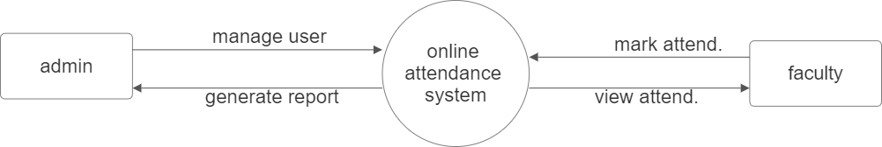

**ER-diagram:**

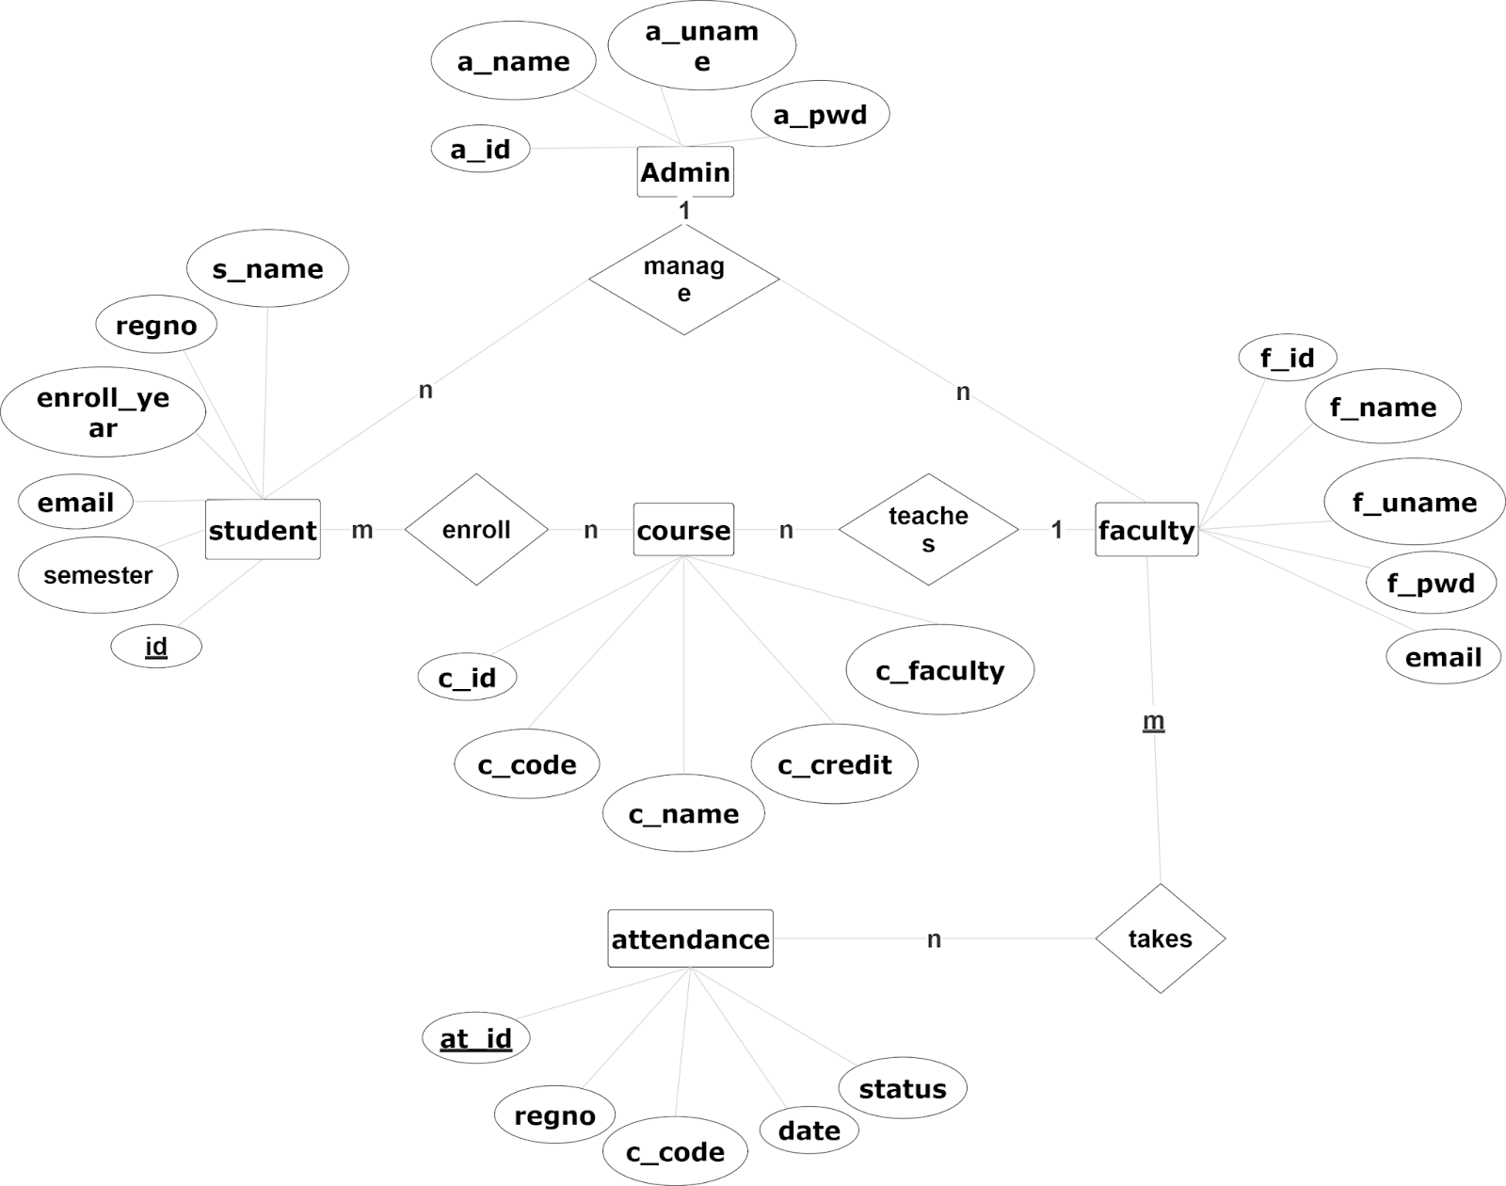

**Data dictionary:**

**Admin**:

|  |  |  |  |
| --- | --- | --- | --- |
| **Field Name** | **Data Type** | **Constraints** | **Description** |
| a_id | INT | PRIMARY KEY,  AUTO_INCREMENT | - |
| a_uname | VARCHAR(50) | NOT NULL | Username for admin login |
| pwd | VARCHAR(30) | NOT NULL | Password for admin |
| a_name | VARCHAR(50) | NOT NULL | Admin’s full name |

**Faculty**:

|  |  |  |  |
| --- | --- | --- | --- |
| **Field Name** | **Data Type** | **Constraints** | **Description** |
| f_id | INT | PRIMARY KEY, AUTO_INCREMENT | Unique identifier for each faculty member |
| f_name | VARCHAR(50) | NOT NULL | Faculty member's full name |
| f_uname | VARCHAR(50) | NOT NULL | Username for faculty login |
| pwd | VARCHAR(30) | NOT NULL | Password for faculty |
| email | VARCHAR(70) | NOT NULL | Email address of the faculty |

**Student**:

|  |  |  |  |
| --- | --- | --- | --- |
| **Field Name** | **Data Type** | **Constraints** | **Description** |
| id | INT | PRIMARY KEY, AUTO_INCREMENT | Enrollment number |
| s_name | VARCHAR(50) | NOT NULL | Student's full name |
| email | VARCHAR(70) | NOT NULL | Email address of the student |
| regno | VARCHAR(50) | UNIQUE, NOT NULL | Enrollment number of the student |
| semester | VARCHAR(7) | Foreign Key(course) | Current semester of the student |
| Enroll_Year | VARCHAR (15) | NOT NULL | Student’s enrollment year |

|  |  |  |  |
| --- | --- | --- | --- |
| **Field name** | **Data types** | **Constraints** | **Description** |
| c_id | INT | PRIMARY KEY, AUTO_INCREMENT | - |
| c_code | Varchar(20) | UNIQUE, NOT NULL | Couse code |
| c_name | Varchar(50) | Not Null | Name |
| c_credit | Varchar(20) | Not null | - |
| c_faculty | Varchar(50) | Foreign key(faculty) | - |

**Course**:

|  |  |  |  |
| --- | --- | --- | --- |
|  |  |  |  |
|  |  |  |  |
|  |  |  |  |
|  |  |  |  |
|  |  |  |  |
|  |  |  |  |
|  |  |  |  |

**Attendance**:

|  |  |  |  |
| --- | --- | --- | --- |
| **Field name** | **Data type** | **Constraints** | **Description** |
| at_id | Int | Primary_key | - |
| regno | Varchar(20) | Foreign key(student) | Enrollment number |
| c_code | Varchar(10) | Foreign key(course) | Course code |
| status | Varchar(10) | Check(‘Present’,’Absent’) | Attendance status |
| date | Datetime | NOT NULL | Date of attendance |