**Deliverable 2: A written report on the UFO Analysis (Mia Fullerton)**

Initialize your repository with a README, and write your analysis of Deliverable 1.

Overview of Project:

The deliverables of this project is to provide a webpage which lets Dana filter multiple criteria like date, city, state, country, and shape simultaneously. The filtered data is displayed into table dynamically providing an in-dept analysis of UFO sightings.

Results:

In the webpage, Dana can either enter each date, city, state, country, and shape criteria or all criteria simultaneously to filter her search. The JavaScript we wrote will store the text criteria she entered with the associated object. See image below.

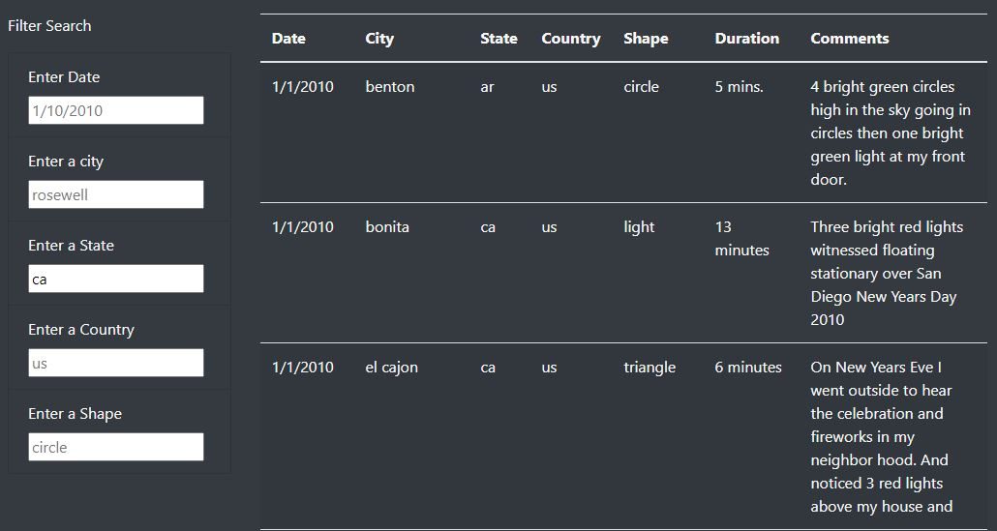

Filter Search Image.

Summary

After creating the webpage and dynamic table, the one drawback that I noticed is that the code only allows pull data from a single source. I recommend to update the script to pull from multiple sources and to keep data hidden until search criteria is entered.