NoSQL Project DOM & Collections - Pharmacy

Madison Roche - 20112525
The pharmacy management system is designed to support the handling of patient records, prescriptions, prescribers, pharmacists and medicine stock using a document-oriented model. It helps pharmacy staff store patient profiles, such as personal information, allergies, multiple addresses and scheme details (for example a medical card or Drugs Payment Scheme number). All of this is stored within a single document, giving the pharmacist fast access to everything needed to dispense a prescription safely.
Prescribers are tracked with their names, Medical Council registration number, practice details and contact information, letting each prescription be traced back to the doctor who issued it. Pharmacists are recorded with their PSI registration number and role, so the system shows who dispensed each prescription. Each prescription references the patient, the prescriber and the pharmacist, and embeds a list of the items prescribed. These embedded items record the quantity, dosage and the price charged at the time of dispensing, and reference the matching medicine in the pharmacy's stock.
The medicine collection holds product details, whether a prescription is required, the current price, stock levels and a list of batches with expiry dates, allowing the pharmacy to track inventory and reorder when stock runs low. By embedding items directly in prescriptions and using ids to reference patients, prescribers, pharmacists and medicines, the system balances performance with consistency. Prescriptions keep an accurate history of what was dispensed and charged, while stock and pricing are updated in one place.
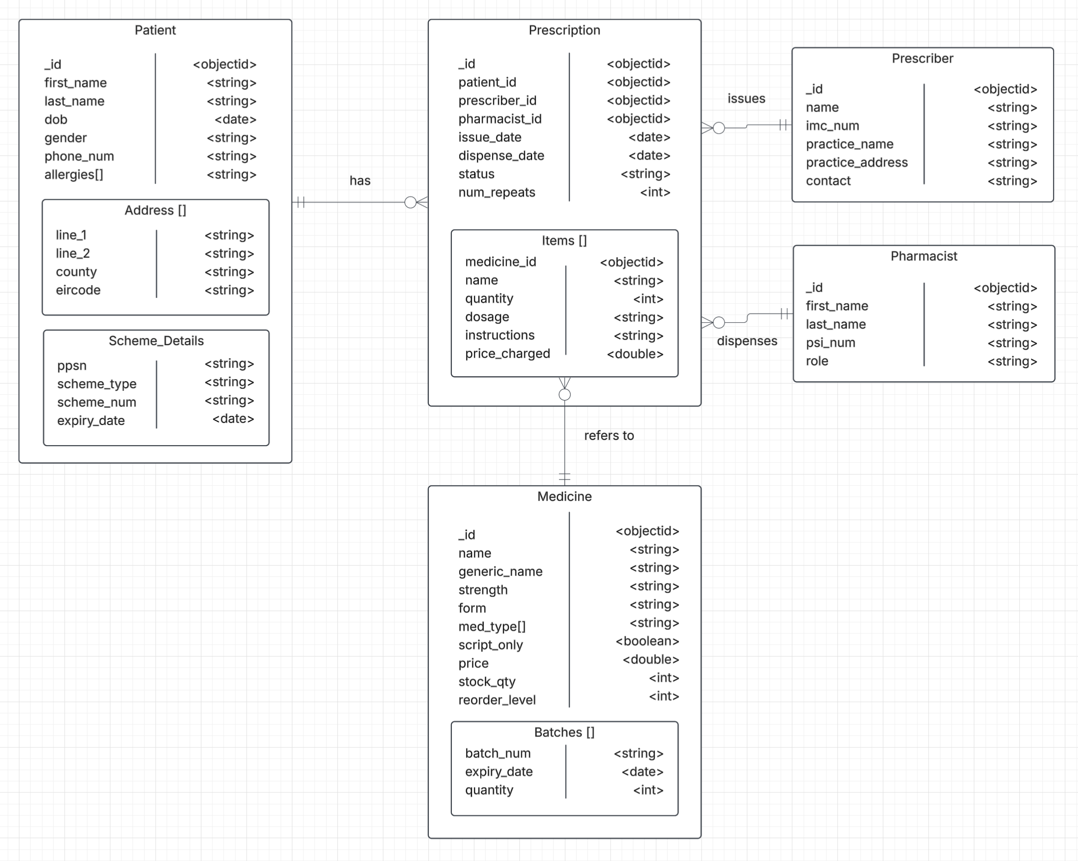
Patients Collection
The patients collection stores everything the pharmacist needs at the counter in a single document, so a patient's record can be checked in one read before a prescription is dispensed. The patient id, first name, last name, date of birth, gender and phone number are stored. Allergies are stored as an array of strings, because a patient can have several allergies and each one needs to be checked against the medicines being dispensed.
A patient can have more than one address, such as a home address and a nursing home or work address, so addresses are stored as an embedded array of subdocuments. Each address holds the first and second lines, county and Eircode. The patient's state scheme details are stored as a single embedded subdocument, as each patient has only one set of scheme details. This holds the PPSN, scheme type (Medical Card, GP Visit Card, Drugs Payment Scheme, Long-Term Illness or None), scheme number and expiry date.
Field | Datatype | Example | Description
_id | ObjectId | ObjectId("6716a1000000000000000001") | Unique patient identifier
first_name | String | "Aoife" | Patient's first name
last_name | String | "Murphy" | Patient's surname
dob | Date | new Date("1984-03-12") | Date of birth, used to confirm identity and check age-related dosing
gender | String | "Female" | Patient's gender
phone_num | String | "087-1234567" | Contact number; a string to keep the leading zero and dash
allergies | Array of String | ["Aspirin", "Latex"] | Known allergies, checked before dispensing; empty array if none
address | Array of Object | see below | One or more addresses (home, work, care home)
scheme_details | Object | see below | PPSN and state scheme membership

address (embedded array)
Field | Datatype | Example | Description
line_1 | String | "14 Ard na Gréine" | First line of the address
line_2 | String | "Ballytruckle" | Second line; optional, left out when not needed
county | String | "Waterford" | County
eircode | String | "X91 K2P7" | Irish postcode

scheme_details (embedded subdocument)
Field | Datatype | Example | Description
ppsn | String | "1234567TA" | Personal Public Service Number
scheme_type | String | "Medical Card" | One of Medical Card, GP Visit Card, Drugs Payment Scheme, Long-Term Illness, or None
scheme_num | String | "MC2049381" | Card or scheme membership number
expiry_date | Date | new Date("2027-05-31") | Date the card or scheme membership expires

Prescriptions Collection
The prescriptions collection stores one document for each prescription received by the pharmacy. The prescription id, issue date, dispense date, status (Pending, Dispensed or Cancelled) and number of repeats remaining are stored. Each prescription must belong to one and only one patient, be issued by one prescriber and be dispensed by one pharmacist, so the patient id, prescriber id and pharmacist id are stored as references to those collections. The pharmacist id and dispense date are left as null until the prescription is dispensed.
A prescription can contain one or more medicines, so the items are stored as an embedded array of subdocuments. Each item references the medicine it was dispensed from by its medicine id, and stores the medicine name, quantity, dosage and label instructions. The price charged is stored on each item at the time of dispensing. Because this is a copy and not a reference to the current price, the prescription keeps an accurate record of what the patient paid even if the medicine's price changes later.
Field | Datatype | Example | Description
_id | ObjectId | ObjectId("6716a3000000000000000001") | Unique prescription identifier
patient_id | ObjectId | ObjectId("6716a1000000000000000001") | Reference to patients._id
prescriber_id | ObjectId | ObjectId("6716a4000000000000000001") | Reference to prescribers._id; the doctor who issued it
pharmacist_id | ObjectId | ObjectId("6716a5000000000000000001") | Reference to pharmacists._id; who dispensed it; null while pending or cancelled
issue_date | Date | new Date("2026-10-14") | Date the doctor wrote the prescription
dispense_date | Date | new Date("2026-10-15") | Date it was dispensed; null while still pending
status | String | "Dispensed" | One of Pending, Dispensed, Cancelled
num_repeats | Int | NumberInt(2) | Number of repeats remaining
items | Array of Object | see below | The medicines on the prescription

items (embedded array)
Field | Datatype | Example | Description
medicine_id | ObjectId | ObjectId("6716a2000000000000000003") | Reference to medicines._id
name | String | "Amoxicillin 500mg Capsules" | Medicine name copied at dispensing, so the label text is kept even if the product record changes
quantity | Int | NumberInt(21) | Number of units dispensed
dosage | String | "500mg" | Dose per administration
instructions | String | "Take one capsule three times daily for 7 days" | Directions printed on the label
price_charged | Double | 8.95 | Price charged for this item at the time of dispensing, in euro; left blank until item is dispensed

Medicines Collection
The medicines collection stores one document for each product the pharmacy stocks. The medicine id, brand name, generic name, strength, form and medicine types are stored, with the medicine types held as an array of strings because a medicine can belong to more than one category. The collection also stores whether the medicine is prescription-only, its current price, the total stock quantity and the reorder level, so staff can see when stock is running low. The current price and stock are stored here only, so they are updated in one place.
The pharmacy receives each medicine in batches, and each batch has its own expiry date, so batches are stored as an embedded array of subdocuments. Each batch holds the batch number, expiry date and quantity remaining. Storing batches inside the medicine allows the pharmacy to find stock that is close to expiring without searching another collection. The stock quantity should always equal the total quantity across the batches.
Field | Datatype | Example | Description
_id | ObjectId | ObjectId("6716a2000000000000000003") | Unique medicine identifier
name | String | "Amoxil" | Brand or product name
generic_name | String | "Amoxicillin" | Active ingredient
strength | String | "500mg" | Strength per unit
form | String | "Capsule" | Dosage form, e.g. Tablet, Capsule, Oral Suspension, Cream
med_type | Array of String | ["Antibiotic", "Anti-infective"] | Therapeutic categories, used for filtering and grouping
script_only | Boolean | true | true if a prescription is required; false for over-the-counter
price | Double | 8.95 | Current selling price per pack, in euro
stock_qty | Int32 | NumberInt(120) | Total units in stock; should equal the sum of batches.quantity
reorder_level | Int32 | NumberInt(50) | Stock level at or below which the product should be reordered
batches | Array of Object | see below | Batches currently in stock

batches (embedded array)
Field | Datatype | Example | Description
batch_num | String | "AMX2407B" | Manufacturer's batch number
expiry_date | Date | new Date("2027-07-31") | Batch expiry date, used to find stock nearing expiry
quantity | Int32 | NumberInt(60) | Units remaining from this batch

Prescribers Collection
The prescribers collection stores the doctors who issue prescriptions, so every prescription can be traced back to the person who wrote it. The prescriber id, name, Irish Medical Council registration number, practice name, practice address and contact number are stored. Prescribers are kept in their own collection and referenced from prescriptions, as one prescriber issues many prescriptions and their details only need to be updated in one place.
Field | Datatype | Example | Description
_id | ObjectId | ObjectId("6716a4000000000000000001") | Unique prescriber identifier
name | String | "Dr Ciarán Walsh" | Prescriber's full name and title
imc_num | String | "412345" | Irish Medical Council registration number
practice_name | String | "Riverside Family Practice" | Name of the GP practice or clinic
practice_address | String | "The Quay, Waterford, X91 R2T4" | Address of the practice
contact | String | "051-876543" | Practice phone number

Pharmacists Collection
The pharmacists collection stores the pharmacists working in the pharmacy, so the system records who dispensed each prescription. The pharmacist id, first name, last name, Pharmaceutical Society of Ireland registration number and role (Pharmacist, Supervising Pharmacist or Superintendent Pharmacist) are stored. Like prescribers, pharmacists are referenced from prescriptions, since one pharmacist dispenses many prescriptions.
Field | Datatype | Example | Description
_id | ObjectId | ObjectId("6716a5000000000000000001") | Unique pharmacist identifier
first_name | String | "Niamh" | Pharmacist's first name
last_name | String | "Byrne" | Pharmacist's surname
psi_num | String | "18432" | Pharmaceutical Society of Ireland registration number
role | String | "Supervising Pharmacist" | Pharmacist, Supervising Pharmacist, or Superindendent Pharmacist

Artificial Intelligence (AI) Declaration

I declare that any use of Generative Artificial Intelligence (GenAI) tools in the development of this submission has been disclosed below and used in accordance with SETU's Academic Integrity requirements. I remain fully responsible for the originality, accuracy, and integrity of all work submitted.

AI tools used (if any):
Tool | Purpose of Use

[x] No AI tools were used in the completion of this submission.

Where AI tools were used, I have included an appendix containing screenshots of the relevant prompts and AI-generated responses, together with a brief explanation of how they contributed to the submission.

Name: Madison Roche
Student Number: 20112525
Programme: BSc in Computer Science
Signature:
Date: 30/10/26

