NORCO
GENERAL TRADING L.L.C.
Energy Storage · Houseware Distribution

BUSINESS PLAN & INVESTMENT PROPOSAL
A Two-Division Distribution Platform for North & East Africa
VESTWOODS  Haier Energy lithium battery  energy storage systems | AL REEM PLASTICS  Premium houseware &  plastic products from Türkiye

Egypt · Sudan · Libya · Algeria | August 2026 – July 2031
Investment Sought: USD 2,000,000
core raise (band USD 1,000,000 – 2,500,000)

Prepared by Fadi Jannan — Managing Director
Dubai, UAE · Cairo, Egypt | +971 58 509 3383 · +20 10 5544 2066
f.jannan@norcotrading.com · www.norcotrading.com
14 July 2026 · Version 5.0 (Group) · Strictly Private & Confidential

1 Executive Summary
NORCO General Trading L.L.C. is a UAE- and Egypt-registered distribution company operating two complementary product divisions across four high-growth North and East African markets. Commercial operations begin in August 2026 from an already-renovated, operating showroom in 6th October City, Cairo.
Two divisions, one platform
▪ Vestwoods (Haier Energy) — NORCO is the exclusive distributor of Vestwoods lithium battery energy storage systems for Egypt, with three live export corridors: a committed Sudan buyer ready to order on arrival of the first containers, an Algerian company in advanced agency negotiation, and Libya launching in Year 2.
▪ Al Reem Plastics — a verified 147-SKU range of premium houseware and plastic products sourced from Türkiye. High-turnover, lower-ticket, cash-generative goods that diversify NORCO's revenue, deepen its dealer relationships and share the same warehouse, showroom and logistics platform — at low incremental cost.

$101.4M | $13.8M | Month 3 | 60% / 28%
5-YEAR GROUP REVENUE | 5-YEAR NET PROFIT | OPERATING BREAK-EVEN | INVESTOR IRR — OPT A / B

Why the two divisions fit together
Vestwoods is a high-value, capital-intensive business: every container is prepaid in Year 1, so it needs working capital up front but delivers large gross-profit dollars. Al Reem Plastics is the mirror image — low unit cost, fast inventory turns, everyday demand that is insensitive to the economic cycle. Together they smooth NORCO's cash flow, keep the sales team and showrooms productive between battery shipments, and turn one distribution licence, one warehouse and one management team into two revenue engines.
The ask
USD 2,000,000 core raise, released in three milestone-gated tranches (Section 8), fully deployable within 18 months of the August 2026 start. Band: USD 1.0M minimum to USD 2.5M full acceleration. The capital funds Vestwoods' Year-1 container prepayments and Al Reem's opening houseware inventory; from Month 13 Vestwoods converts to supplier credit and the group becomes self-funding.
The returns
▪ Group 5-year performance — USD 101.4M revenue, USD 28.2M gross profit, USD 13.8M net profit. Year 1: USD 7.61M revenue and USD 857K net profit, with operating break-even in Month 3.
▪ Option A — 50% equity: dividends plus retained stake deliver a 60% IRR and 8.8x MOIC; dividends alone return 2.12x the capital inside five years.
▪ Option B — 25% profit share + capital redemption at Year 5: 28% IRR, 2.73x MOIC, with the investor's capital repaid at par.
Proof already on the table
The founder has invested USD 14,517 pre-launch — including EGP 31,948.50 of product stock purchased and sold through the operating showroom before launch. UAE and Egypt registration, import permits, GOEIC application, fit-out and branding are complete. The Al Reem Plastics range is fully costed at the SKU level and the supplier relationship is in place.
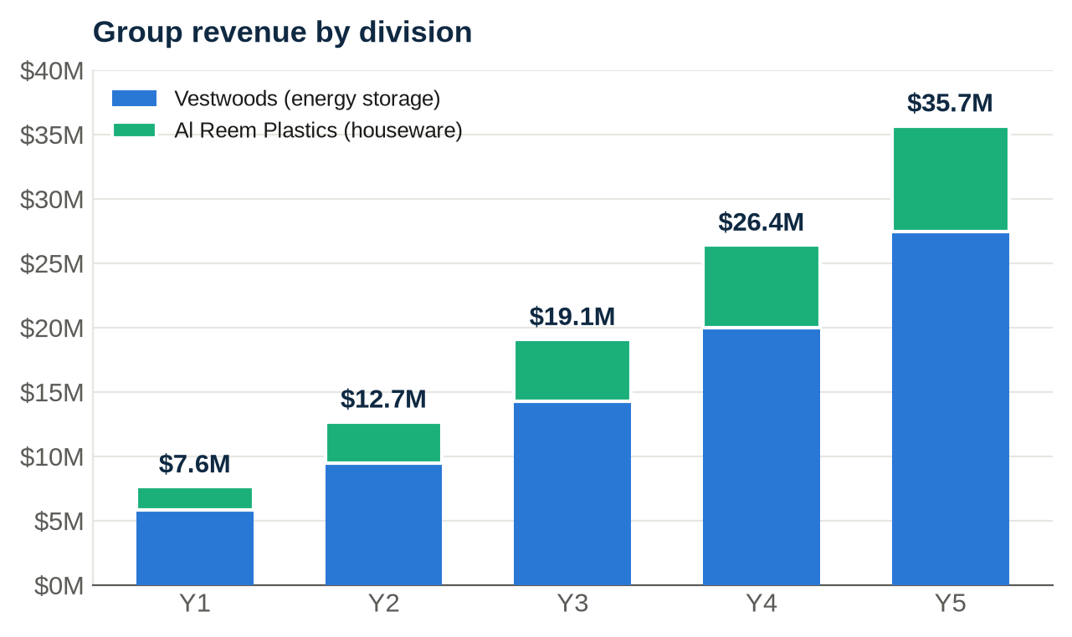

2 Company Description & Ownership
▪ Legal structure — NORCO General Trading L.L.C., UAE-registered (Dubai trade licence active) with Egyptian commercial registration, import permits and GOEIC application complete. Operations are led from Cairo; supplier and treasury relationships from Dubai.
▪ Business model — an asset-light import-and-distribute platform. NORCO imports finished goods, holds them in its 6th October City warehouse, and sells through its own showrooms, a growing dealer network, and export sub-distributors — across two product divisions.
▪ Locations — Showroom #1: 6th October City (operational, 2-year lease). Showroom #2: Fifth Settlement (opens Month 1). Office: Fifth Settlement, 100 sqm. Warehouse: 6th October City, 300–500 sqm — shared by both divisions.
2.1 Proposed distribution of shares
The company currently has three shareholders. Under the proposed 50% investor scenario, the existing partners dilute proportionally as follows:
Shareholder | Current | Post-investment (50%)
Investor (USD 2.0M core capital) | — | 50%
Mohammed Fadi Jannan - Chairman & Founder | 80% | 40%
Partner A | 10% | 5%
Partner B | 10% | 5%
Total | 100% | 100%

Alternative structure available: no equity — 25% net-profit share plus capital redemption at par at the end of Year 5 (Section 8). The Chairman remains executive lead and exclusive-agency holder under both structures.
2.2 Pre-operational investment — USD 14,517 already spent
Item | Original | USD
Showroom renovation — 6th October City | EGP 82,000 | 1,640
Showroom furniture & fittings | EGP 85,000 | 1,700
Security cameras & CCTV | EGP 7,500 | 150
Additional setup & equipment | EGP 50,000 | 1,000
Legal & licensing — Egypt registration (2025) | EGP 87,000 | 1,740
Legal & licensing — import permits (2026) | EGP 80,000 | 1,600
UAE business licence — NORCO LLC | AED 15,000 | 4,084
Showroom rent — 2 months pre-operations | EGP 20,000 | 400
Sales representative — 2 months pre-launch | 2 × USD 500 | 1,000
Products purchased & sold in showroom (pre-launch trading) | EGP 31,948.50 | 603
Branding, logo & stationery | USD 300 | 300
Corporate website — norcotrading.com | USD 300 | 300
Total pre-operational investment |  | 14,517

3 The Two Divisions
3.1 Vestwoods — Haier Energy battery storage
Vestwoods is a Haier Energy brand of lithium (LFP) battery energy storage systems, hybrid inverters and telecom power. NORCO holds the exclusive Egypt agency with price control. The product answers a purchase of necessity: chronic load-shedding, diesel-price escalation and a national solar push across residential, telecom and commercial & industrial (C&I) segments. Vestwoods prices 15–25% below premium brands with Haier-backed quality and a 5-year warranty; grey-market imports cannot match warranty, service or price control.
Full Vestwoods range ships in 40ft FCL containers (340 units, landed USD 239,805 each), China → Alexandria, 45–55 day lead time. Verified pricing (USD, EGP 53):
Model | Description | Factory | Landed | Wholesale | Retail
VE51100L | Smart Battery 5.12 kWh | 672 | 853 | 1,137 | 1,364
VE51200L | Smart Battery 10.24 kWh | 1,200 | 1,508 | 2,011 | 2,413
VE51314L | Smart Battery 16.07 kWh | 1,560 | 1,955 | 2,607 | 3,128
HEH-S6KB3-LV | Hybrid Inverter 6 kW | 390 | 504 | 670 | 804
VEP1K20 | Rescube All-in-One 2 kWh | 365 | 473 | 628 | 754
VEB 704 / 832 | C&I Cabinets 221 / 261 kWh | 27,300+ | 33,880+ | 38,973+ | project
VT48100E / VT48200 | Telecom 48V batteries | 563 / 980 | 943 / 1,380 | 1,044 / 1,530 | B2B

3.2 Al Reem Plastics — premium houseware from Türkiye
Al Reem Plastics is a full range of 147 stock-keeping units of household plastic products — storage drawers and boxes, kitchen and food containers, laundry and cleaning ware, bowls and tableware, planters, chairs and tables. The goods are sourced from established Türkiye manufacturers and imported in mixed 40ft containers. Every SKU is costed to the cent: landed cost, wholesale price (COGS ×15%) and retail price (COGS ×38%) are already modelled in NORCO's pricing sheet.
Strategically, Al Reem does four things for NORCO:
▪ Diversification — everyday, cycle-resistant demand that is uncorrelated with the energy-capex cycle and unaffected by grid policy.
▪ Cash velocity — low unit cost and fast turns generate working capital that helps fund the heavier Vestwoods inventory.
▪ Platform leverage — shares the same warehouse, showrooms, logistics and management, so gross margin drops almost straight to contribution.
▪ Channel depth — gives NORCO a second reason to call on every retailer and wholesaler, widening the dealer network that also sells Vestwoods.
Representative Al Reem unit economics (verified, USD):
Representative SKU | Landed COGS | Wholesale | Retail | GM% W/R
Storage Drawers (4) w/ compartment | 23.98 | 27.75 | 33.30 | 16 / 39%
Clothes Drier | 19.95 | 23.12 | 27.74 | 16 / 39%
90L Waste bin with cover | 11.33 | 13.21 | 15.85 | 17 / 40%
50L Waste bin | 9.04 | 10.57 | 12.68 | 17 / 40%
Large Laundry Basket with Lid | 9.78 | 11.43 | 13.71 | 17 / 40%
13.5L Rectangular Food Container | 3.77 | 4.51 | 5.41 | 20 / 43%
Sugar box with cover & spoon | 0.67 | 0.94 | 1.13 | 40 / 68%

Across the 147-SKU range, blended gross margin runs ~19% wholesale to ~28% at retail; NORCO models the division at a 19% blended margin in Year 1, rising to 23% by Year 5 as the own-showroom retail mix and brand pull grow.

4 Market Analysis
4.1 Vestwoods — four energy-storage corridors
▪ Egypt — chronic load-shedding, diesel escalation and the national solar push make lithium storage a purchase of necessity across residential, telecom and C&I segments. Vestwoods' price/quality position and warranty beat both premium brands and grey-market imports. 12 → 40 containers over five years.
▪ Sudan — committed buyer already identified; orders trigger on arrival of the first containers at NORCO's warehouse, on 50% advance + 50% on delivery. Grid instability makes solar-household and telecom kits essential goods. 4 → 20 containers.
▪ Algeria — NORCO is in active negotiation with an Algerian company to take the agency and place first orders by the end of Year 1. Structured FOB Jebel Ali to a licensed importer under the bank-domiciliation regime, 100% LC before shipment, zero in-country exposure. 1 → 9 containers.
▪ Libya — dual-hub distributors (Tripoli + Benghazi) from Year 2 on advance/LC terms; 2 → 7 containers.
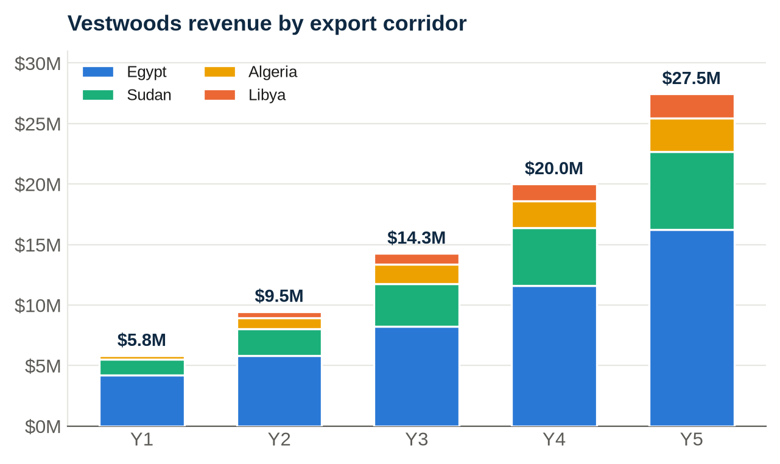
4.2 Al Reem Plastics — everyday houseware demand
Egypt's ~110 million people, rapid new-city housing (New Cairo, 6th October, the New Administrative Capital) and a large informal-retail base drive constant replacement demand for affordable, durable household plastics. Türkiye-made goods carry a quality-and-design premium over local production while remaining price-competitive after duty. The same Sudan and Libya corridors that take Vestwoods also absorb houseware through NORCO's export sub-distributors. NORCO enters at wholesale to retailers and hypermarkets, and at retail through its own showrooms and online channel.
4.3 SWOT — NORCO Group
Strengths  Two complementary divisions on one platform; Vestwoods exclusive agency + price control; operating showroom with pre-launch sales; committed Sudan buyer; Al Reem fully SKU-costed; Haier brand. | Weaknesses  Year-1 Vestwoods prepayment strains working capital; execution depends on the raise closing on time; two supply chains to manage; new houseware brand-building in Egypt.
Opportunities  Egypt energy tenders (NUCA/EEHC, Law 5/2015 CKD roadmap); telecom fleet contracts; houseware hypermarket listings; four-market compounding across both divisions. | Threats  EGP devaluation; customs delays; grey-market pricing; regional instability in export corridors; low-cost local plastics competition.

5 Supplier & Customer Terms — the Cash-Flow Engine
The structure of the plan is driven by payment terms. Vestwoods requires full prepayment in Year 1, which is exactly why the raise is needed; Al Reem and the export customers generate cash quickly, which is exactly what funds the group thereafter.
Party / period | Terms | Cash impact
Vestwoods — Year 1 (POs Aug-26 – Jul-27) | 100% payment before shipment, every container | Capital sits ~2 months ahead of revenue; peak working-capital need in Month 4
Vestwoods — Year 2+ (POs from Month 13) | 10% downpayment + 90% at 3-month credit | ~90% of container capital released; Year 2+ growth self-funding
Al Reem Plastics — supplier | Deposit + balance against shipping documents | Lower ticket size; inventory turns fast, releasing cash within the quarter
Egypt customers | 30–60 days (avg 45); 1-month collection lag | Held to agreed limits; stop-supply discipline
Sudan / Libya | 50% advance + 50% on delivery (same month) | Cash received before/at shipment — working-capital positive
Algeria | 100% LC before shipment | Zero receivable risk; zero in-country exposure

6 Financial Plan
All figures USD thousands unless noted. Vestwoods figures follow the founder's vetted Business Plan V4; Al Reem Plastics figures are planning projections built on the verified April-2026 catalogue unit economics. Planning FX: USD 1 = EGP 53 (spot ~49–51, conservative). Corporate tax 22.5% on net profit.
6.1 Consolidated 5-year P&L
USD 000 | Year 1 | Year 2 | Year 3 | Year 4 | Year 5
Vestwoods revenue | 5,811 | 9,452 | 14,260 | 19,999 | 27,452
Al Reem Plastics revenue | 1,800 | 3,200 | 4,800 | 6,400 | 8,200
Total revenue | 7,611 | 12,652 | 19,060 | 26,399 | 35,652
Gross profit | 2,070 | 3,318 | 5,096 | 7,321 | 10,423
Gross margin % | 27% | 26% | 27% | 28% | 29%
Operating expenses | 964 | 1,424 | 1,946 | 2,538 | 3,512
EBIT | 1,106 | 1,894 | 3,150 | 4,783 | 6,911
Corporate tax (22.5%) | 249 | 426 | 709 | 1,076 | 1,555
Net profit | 857 | 1,468 | 2,441 | 3,707 | 5,356
Net margin % | 11.3% | 11.6% | 12.8% | 14.0% | 15.0%

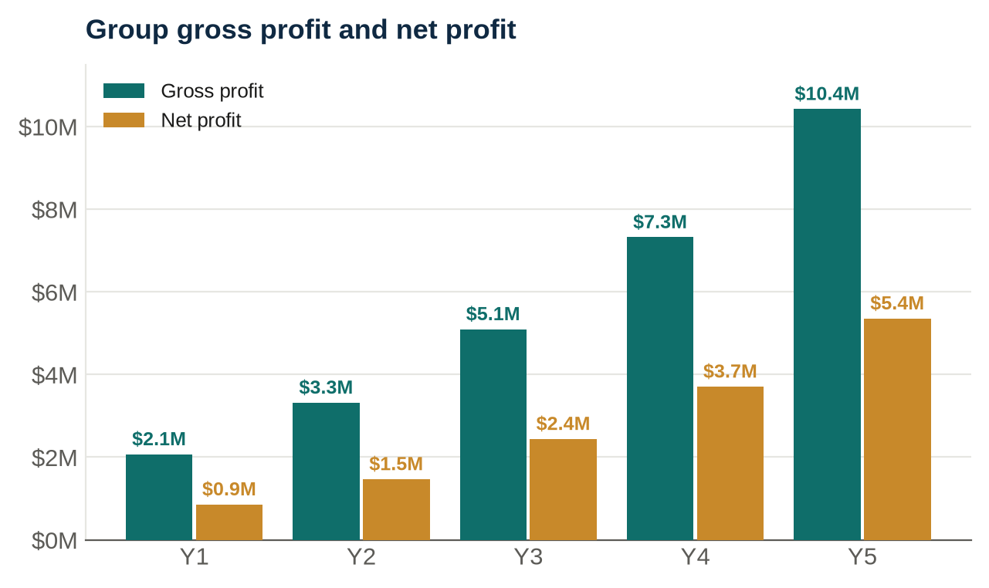
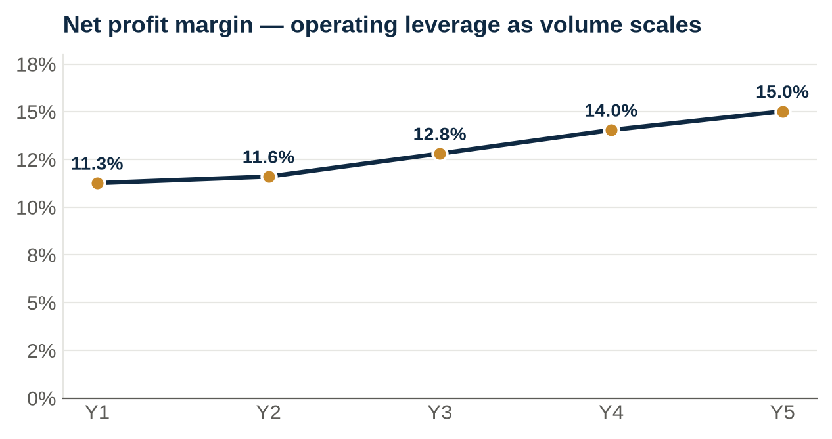

6.2 Revenue build — markets & divisions
USD 000 | Year 1 | Year 2 | Year 3 | Year 4 | Year 5
Egypt (Vestwoods) | 4,232 | 5,814 | 8,243 | 11,603 | 16,257
Sudan (Vestwoods) | 1,279 | 2,238 | 3,517 | 4,796 | 6,395
Libya (Vestwoods) | 0 | 500 | 900 | 1,400 | 2,000
Algeria (Vestwoods) | 300 | 900 | 1,600 | 2,200 | 2,800
Al Reem Plastics (all markets) | 1,800 | 3,200 | 4,800 | 6,400 | 8,200
Total group revenue | 7,611 | 12,652 | 19,060 | 26,399 | 35,652

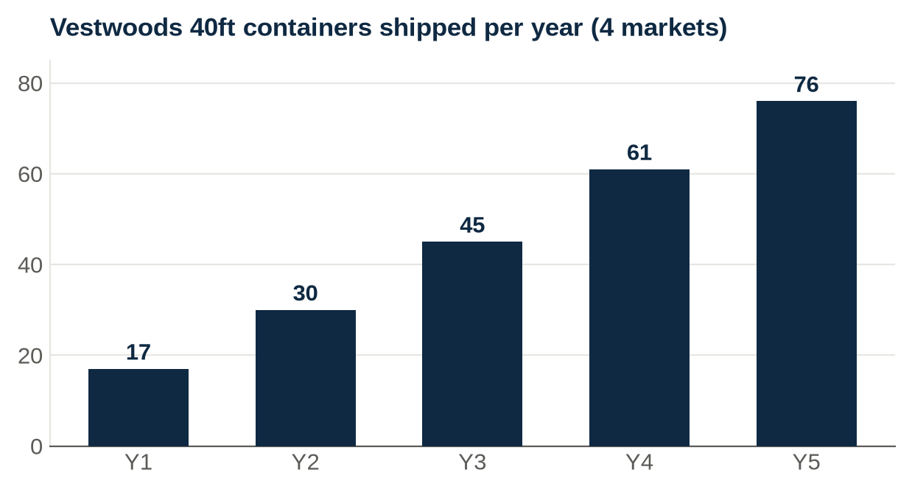
6.3 Cash flow & the working-capital story
Year 1 is the only year that depends on the raise. Vestwoods' 100%-prepayment terms mean container capital sits roughly two months ahead of revenue, creating a peak funding need in the opening months. From Month 13 the Vestwoods credit switch (10% down + 90% on 3-month credit) releases the vast majority of that capital, and Al Reem's fast-turning inventory throws off cash from the first quarter. The combined effect: closing cash rises every year thereafter, even while paying dividends and rising taxes, with no capital call after Tranche 3.
USD 000 | Year 1 | Year 2 | Year 3 | Year 4 | Year 5
Customer collections | 6,400 | 12,050 | 18,300 | 25,500 | 34,600
Investor capital (T1–T3) | 2,000 | — | — | — | —
Supplier & inventory payments | (5,540) | (8,930) | (13,760) | (18,940) | (25,120)
Operating expenses (cash) | (945) | (1,400) | (1,915) | (2,500) | (3,465)
Tax paid (prior year, arrears) | — | (249) | (426) | (709) | (1,076)
Investor dividends (Option A, 50%) | — | (428) | (734) | (1,220) | (1,853)
Capex | (50) | (25) | (30) | (35) | (40)
Closing cash position | 1,865 | 2,883 | 4,318 | 6,414 | 9,280

Illustrative group cash flow; the formula-driven companion workbook carries the full monthly Year-1 detail and the five-year build.

7 Staffing Plan
Institutional management from day one, shared across both divisions: CEO/MD, CFO and COO hired in Month 1, Director of Sales in Month 2, Marketing and HR in Month 3. Headcount reaches 21 by Month 12 and grows to ~58 by Year 5. Egyptian social insurance at 15% and 4% Egypt sales commissions are included. A dedicated houseware sales desk is added within the existing structure, keeping Al Reem's incremental personnel cost low.
Year & additions | Headcount | Total personnel (USD)
Year 1 — launch team (CEO, CFO, COO, Directors, showrooms, warehouse, sales) | 21 | 547,515
Year 2 — + BD Director, Logistics, Customer Service, houseware desk | 29 | 751,440
Year 3 — + Alexandria branch, installation engineers, analysts | 38 | 1,014,200
Year 4 — + B2G/Tenders, C&I sales, IT/CRM, Sudan coordinator | 47 | 1,303,160
Year 5 — + Algeria/Libya export desk, service & warehouse scale | 58 | 1,935,060

8 Funding Requirements & Investor Proposal
8.1 The ask
USD 2,000,000 core raise for the combined two-division plan — an expansion of the Vestwoods-only requirement to fund Al Reem's opening inventory alongside Vestwoods' Year-1 container prepayments. Released in three milestone-gated tranches; band USD 1.0M – 2.5M.
Tranche | USD | Timing | Purpose / gate
Tranche 1 - Launch | 1,000,000 | Month 1 (Aug-26, at close) | Vestwoods container waves 1-3, group setup, 12-month opex runway
Tranche 2 - Scale | 500,000 | Month 4 (Nov-26), milestone-gated | Vestwoods waves 4-6; released on >=3 containers sold through + Sudan advances received
Tranche 3 - Diversify | 500,000 | Months 6-12 | Al Reem Plastics houseware inventory + Sudan/Libya export working capital

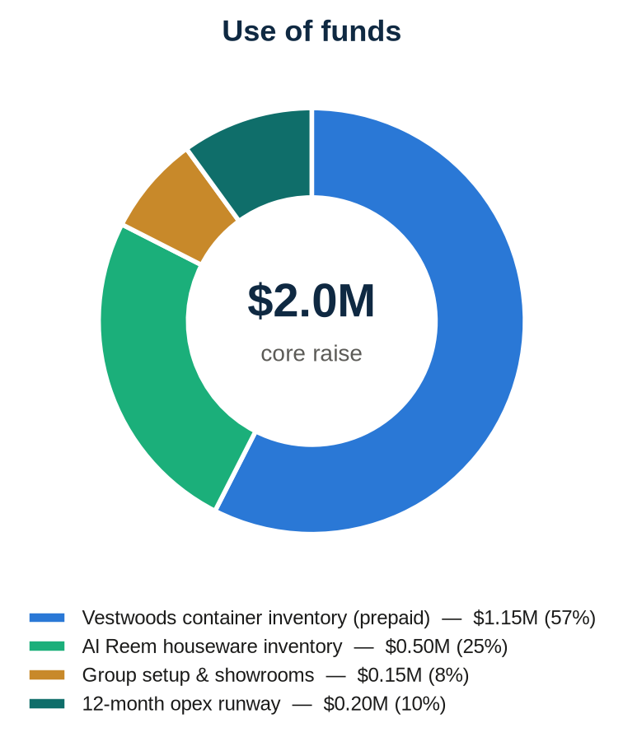
8.2 Investor structures
▪ Option A — 50% equity: the investor takes 50% of the company (existing shareholders dilute per Section 2.1). Dividends at 50% of net profit plus the retained stake deliver a 60% IRR and 8.8x MOIC over five years; dividends alone return 2.12x the capital, before counting a 50% share of a business earning USD 5.4M net profit by Year 5.
▪ Option B — no equity: 25% net-profit share plus capital redemption at par at the end of Year 5 — 28% IRR, 2.73x MOIC, with the investor's principal returned.
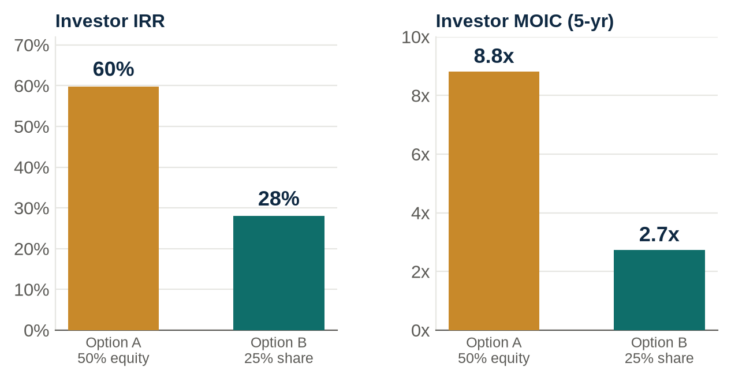
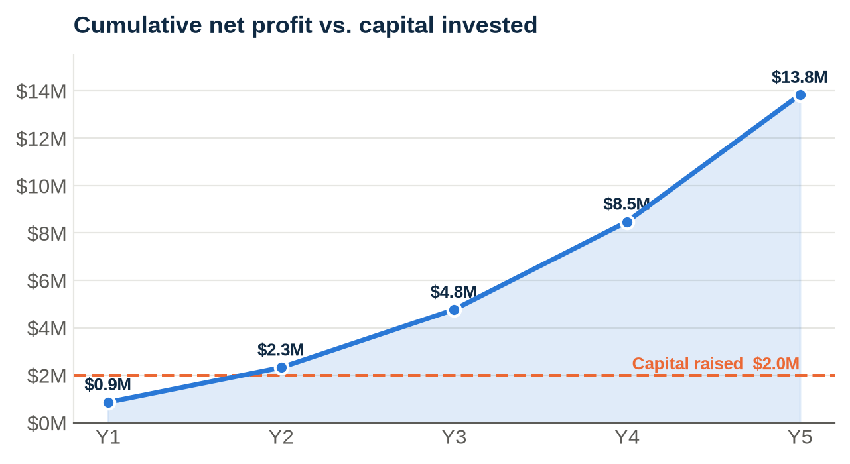
8.3 Investor protections (both options)
▪ Milestone-gated tranches — Tranche 2 released only against verified Month-4 milestones (containers sold through + Sudan advances received); Tranche 3 against houseware sell-through.
▪ Quarterly management accounts from the formula-driven model; monthly cash and inventory reporting across both divisions.
▪ USD-denominated books; Egypt customers on max 60-day terms; Sudan/Libya cash-before-shipment; Algeria LC only.
▪ Exclusive Vestwoods agency (with first right of engagement and non-circumvention) assignable as security.
▪ Founder pre-investment of USD 14,517 already deployed — operational showroom, licences and import permits complete.

9 Operations, Risks & Mitigation
▪ Supply chain (Vestwoods) — PO (100% prepaid Y1) → factory 15–20 days → sea 18 days → clearance 7–10 days (5% duty, 2% GOEIC, 14% VAT recoverable) → 6th October warehouse; roughly one container every three weeks in Year 1.
▪ Supply chain (Al Reem) — mixed 40ft containers from Türkiye on a shorter Mediterranean lead time; higher SKU count managed by the shared warehouse team and a simple min/max reorder system.
Risk | Mitigation
EGP devaluation | USD-indexed pricing at EGP 53 planning rate (spot ~49–51); 30-day quote validity; USD books
Y1 Vestwoods prepayment exposure | Haier-backed counterparty; staged POs; credit switch contractually anchored at Month 13
Raise timing | Tranche 1 must close before first PO; container schedule flexes with drawdown
Customs / GOEIC delays | Permits issued; broker retained; 45–60 day inventory cover
Egypt receivables | 45-day terms; anchor accounts on agreed limits; stop-supply discipline
Export instability (Sudan/Libya) | Cash before shipment; no in-country assets
Algeria regime | Licensed-importer FOB + 100% LC; zero NORCO exposure
Grey-market / local plastics pricing | 5-yr warranty + Cairo service bench (Vestwoods); Türkiye quality + brand (Al Reem)
Two supply chains to manage | Shared platform, single ERP/inventory system, one management team

10 Execution Roadmap
Phase | Timing | Milestones
Launch | M1–M3 | T1 drawn; Vestwoods containers 1–3 prepaid; showroom #2 opens; Sudan buyer inspects warehouse stock and places first order; first Al Reem houseware container ordered
Prove | M4–M6 | T2 drawn; operating break-even confirmed; dealers signed; first Cairo energy exhibition; Al Reem retail sell-through established; Algeria negotiation to term sheet
Convert | M7–M12 | T3 drawn for houseware inventory; second exhibition; Algeria agency signed — first LC order ships; Libya distributor due diligence
Compound | M13–M18 | Vestwoods credit terms activate; Libya first containers; four-market, two-division operation running on self-generated cash
Scale | Y3–Y5 | 40 Egypt + 20 Sudan + 7 Libya + 9 Algeria Vestwoods containers by Y5; Al Reem houseware scaled across retail & export; CKD assembly evaluation; closing cash ~USD 9.3M

The opportunity
USD 2.0M funds a de-risked, two-division distribution platform with an exclusive energy-storage agency, a fully-costed houseware range, live export corridors and a founder already invested and operational — targeting USD 101M of revenue and USD 13.8M of net profit over five years, at a 60% investor IRR.

Companion workbook: NORCO_Group_Investor_Model.xlsx — consolidated 5-year P&L, revenue build by market and division, cash flow, Al Reem catalogue economics, funding scenarios, investor returns and shareholding, all formula-driven.

