NORCO
EGYPT · GENERAL TRADING
Exclusive Distributor of Vestwoods (Haier Energy) Battery Storage

VESTWOODS BUSINESS PLAN & INVESTMENT PROPOSAL
Lithium Battery Energy Storage for Egypt, Sudan, Algeria & Libya
August 2026 – July 2031 | Investment into NORCO Egypt
Investment Sought: USD 1,000,000 — 50% of NORCO Egypt
core raise · optional USD 500,000 accelerator (ceiling USD 1.5M)

Prepared by Fadi Jannan — Managing Director
Dubai, UAE · Cairo, Egypt | +971 58 509 3383 · +20 10 5544 2066
f.jannan@norcotrading.com · www.norcotrading.com
14 July 2026 · Version 7.0 (Vestwoods) · Strictly Private & Confidential

1 Executive Summary
NORCO Egypt is the exclusive distributor of Vestwoods (Haier Energy) lithium battery energy storage systems for Egypt, with three live export corridors across North and East Africa. The company is Cairo-based and backed by NORCO General Trading L.L.C. (UAE), which holds the exclusive Vestwoods agency and 20% of the Egyptian operating company. Commercial operations begin in August 2026 from an already-renovated, operating showroom in 6th October City.
Four markets, one agency
▪ Egypt — the core market: chronic load-shedding, diesel escalation and the national solar push make lithium storage a purchase of necessity across residential, telecom and commercial & industrial (C&I) segments. 6 containers in Year 1 growing to 15 by Year 5.
▪ Sudan — committed buyer already identified; orders trigger on arrival of the first containers on 50% advance + 50% delivery terms. 4 → 10 containers.
▪ Algeria — agency in advanced negotiation; first orders on 100% letters of credit from Month 8, FOB Jebel Ali to a licensed importer. 3 → 8 containers.
▪ Libya — dual-hub distributors (Tripoli + Benghazi) from Year 2 on advance/LC terms. 0 → 8 containers. Total across four markets: 13 in Year 1 to 41 by Year 5.

$48.32M | $9.44M | Month 6 | 69% / 10.0x
5-YEAR REVENUE | 5-YEAR NET PROFIT | BREAK-EVEN (OP. & CUM.) | INVESTOR IRR / MOIC

The ask and the return
▪ USD 1,000,000 for 50% of NORCO Egypt released in two milestone-gated tranches of USD 500,000 — plus an optional USD 500,000 accelerator (ceiling USD 1.5M). The capital covers the Year-1 working-capital requirement of USD 915,603 created by Vestwoods' import terms; Sinosure-approved supplier credit (10% down + 90% at 3-month credit) keeps the need this low.
▪ Profitable in Year 1 — USD $5.36M revenue and USD 897,753 net profit, with operating and cumulative break-even both in Month 6 (January 2027). Five-year net profit USD $9.44M; Year-1 profit alone approaches the full USD 1.0M investment and cumulative profit clears it inside Year 2.
▪ Investor cash flow — 100% of net profit is distributed annually in arrears; the investor receives half of every distribution — 3.4x the capital in dividends alone (40% IRR) — plus a 50% share of the terminal value (5× Year-5 net profit), lifting the total to 10.0x and a 69% IRR.
Proof already on the table
The founder has invested USD 14,517 pre-launch — including EGP 31,948.50 of product stock purchased and sold through the operating showroom before launch. UAE and Egypt registration, import permits, GOEIC application, fit-out and branding are complete, and Vestwoods pricing is verified against the supplier's container packing list.
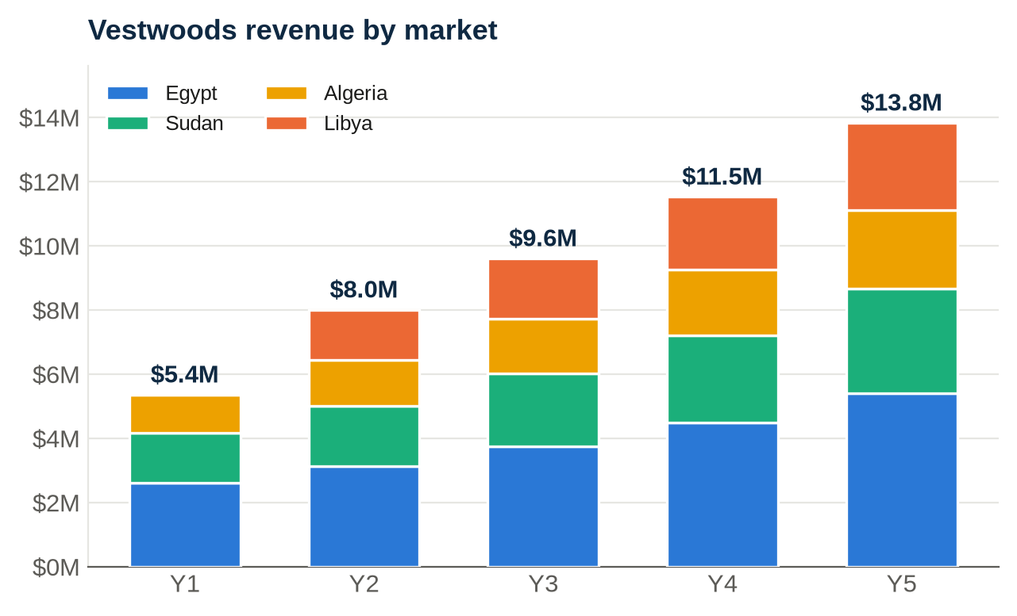

2 Company, Structure & Ownership
▪ The investment vehicle — investors subscribe directly into NORCO Egypt, the operating company that owns the showrooms, inventory, receivables and Egyptian licences. NORCO General Trading L.L.C. (UAE, Dubai trade licence active) is a 20% shareholder and contributes the exclusive Vestwoods agency under a long-term agreement.
▪ Facilities — Showroom #1: 6th October City (operational, 2-year lease, EGP 10,000/month). Showroom #2: New Cairo, ~100 sqm, opens Month 1 (USD 2,500/month). Office: New Cairo, ~100 sqm fully furnished (USD 3,000/month). Warehouse: 300–700 sqm in 6th October, Sheikh Zayed or New Cairo, selected on cost (USD 3,000/month planned).
2.1 Shareholding of NORCO Egypt
Shareholder | NORCO Egypt | Notes
Investor (USD 1.0M capital) | 50% | Cash for 50% of NORCO Egypt; board seat; reserved matters
NORCO General Trading L.L.C. (UAE) | 20% | Holds the Vestwoods exclusive agency
Mohammed Fadi Jannan — Chairman & Founder | 20% | Executive lead; combined founder-side interest 40% (20% direct + 20% via NORCO UAE)
Partner A | 5% | Existing partner
Partner B | 5% | Existing partner
Total | 100%

The founder's combined interest is 40% — 20% held directly plus 20% held through NORCO UAE, which he controls. The Chairman remains executive lead and agency holder.
2.2 Pre-operational investment — USD 14,517 already spent
Item | Original | USD
Showroom renovation — 6th October City | EGP 82,000 | 1,640
Showroom furniture & fittings | EGP 85,000 | 1,700
Security cameras & CCTV | EGP 7,500 | 150
Additional setup & equipment | EGP 50,000 | 1,000
Legal & licensing — Egypt registration (2025) | EGP 87,000 | 1,740
Legal & licensing — import permits (2026) | EGP 80,000 | 1,600
UAE business licence — NORCO LLC | AED 15,000 | 4,084
Showroom rent — 2 months pre-operations | EGP 20,000 | 400
Sales representative — 2 months pre-launch | 2 × USD 500 | 1,000
Products purchased & sold in showroom (pre-launch trading) | EGP 31,948.50 | 603
Branding, logo & stationery | USD 300 | 300
Corporate website — norcotrading.com | USD 300 | 300
Total pre-operational investment |  | 14,517

3 Products & Pricing
Vestwoods is a Haier Energy brand of lithium (LFP) battery energy storage, hybrid inverters and telecom power. NORCO holds the exclusive Egypt agency with price control. The product answers a purchase of necessity — chronic load-shedding, diesel-price escalation and a national solar push across residential, telecom and C&I segments. Vestwoods prices 15–25% below premium brands with Haier-backed quality and a 5-year warranty; grey-market imports cannot match warranty, service or price control.
The full range ships in 40ft FCL containers (340 units, landed USD 342,316 each), China → Alexandria, 45–55 day lead time. In Egypt the container sells at a 50/50 retail-wholesale mix for USD 433,281 (21% blended margin); export containers to Sudan, Algeria and Libya are billed at USD 393,861 wholesale. Verified pricing (USD, EGP 53):
Model | Description | Qty | Factory | Landed COGS | Wholesale | Retail
VE51100L | Smart Battery 5.12kWh | 70 | 672 | 988 | 1,137 | 1,364
VE51200L | Smart Battery 10.24kWh | 24 | 1,200 | 1,748 | 2,011 | 2,413
VE51314L | Smart Battery 16.07kWh | 32 | 1,560 | 2,266 | 2,607 | 3,129
VEH-T20KA3 | 3-Phase Inverter 20kW | 24 | 1,870 | 2,713 | 3,121 | 3,745
HEH-S6KB3 | Hybrid Inverter 6kW | 70 | 390 | 582 | 670 | 804
VEP500W | Rescube Portable 0.5kW/1kWh | 40 | 145 | 229 | 264 | 317
VEP1K20 | Rescube All-in-One 1kW/2kWh | 80 | 365 | 546 | 628 | 754
Container | 340 units, 40ft FCL | 340 | 239,805 | 342,316 | 393,861 | 472,680

COGS includes freight (USD 6,865/40ft), 5% duty, 2% GOEIC and handling — the full landed basis. The five verified battery, inverter and Rescube lines above make up the standard container mix; C&I cabinets and telecom 48V lines are added to order.

4 Market Analysis & Competitive Pricing Study
4.1 Egypt energy storage — the demand driver
Egypt's grid has run structural summer deficits since 2023; load-shedding, diesel-price escalation and net-metering under Law 87/2015 have made battery storage a mainstream purchase for villas, clinics, telecom towers and light industry. The segments NORCO serves — residential hybrid systems, telecom DC power and C&I backup — are precisely where lithium replaces lead-acid and diesel.
4.2 Battery price benchmarking — where Vestwoods wins
NORCO's June-2026 market survey of Cairo retail prices for 5 kWh-class lithium batteries (installed base brands, incl. VAT, at EGP 53/USD):
Brand | Model (5 kWh class) | Retail USD | USD/kWh | Warranty & service | Position
Vestwoods (NORCO) | VE51100L 5.12 kWh | 1,364 | 266 | 5 years + Cairo service bench | Haier-backed challenger
Pylontech | US5000 4.8 kWh | 1,850 | 385 | 7 years | Premium tier-1
Huawei | LUNA2000-5 5 kWh | 2,300 | 460 | 10 years (bundled) | Premium tier-1
Deye | SE-G5.1 5.12 kWh | 1,550 | 303 | 5 years | Mid-tier
Growatt | ARK 5.12 kWh | 1,600 | 312 | 5 years | Mid-tier
Grey-market imports | unbranded 5.12 kWh | 1,150 | 225 | None / seller-only | No service, no warranty

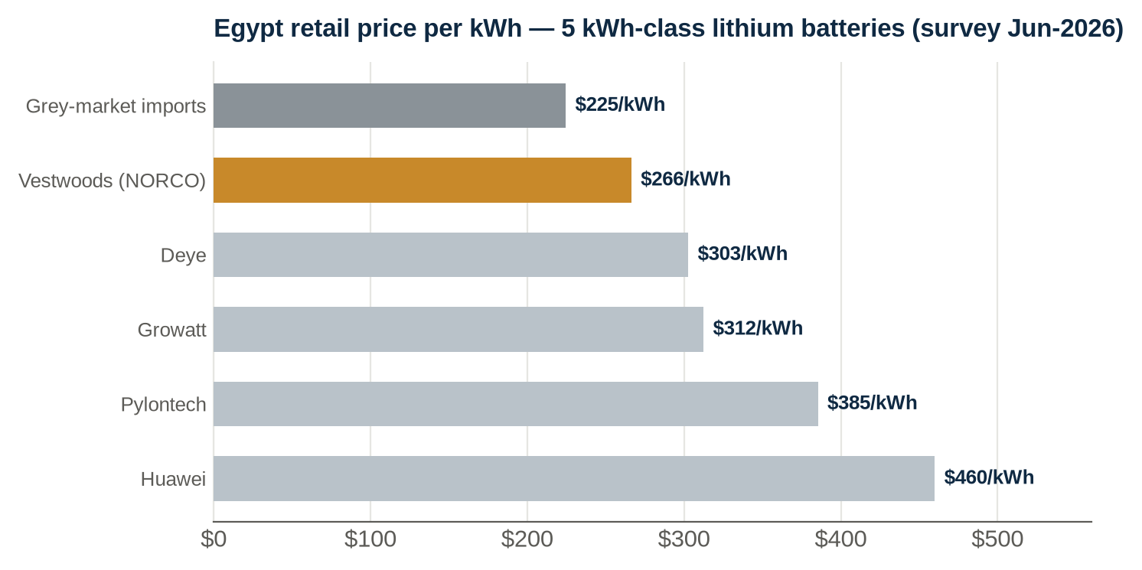
▪ The pricing wedge — Vestwoods retails 15–26% below tier-1 premium brands (Pylontech, Huawei) on a per-kWh basis while carrying Haier manufacturing pedigree and a 5-year warranty backed by NORCO's Cairo service bench.
▪ Against the grey market — unbranded imports undercut everyone by ~15% but carry no warranty, no BMS support and no spare parts. Vestwoods' exclusive agency lets NORCO hold price while winning the warranty-sensitive buyer — installers, telecoms and C&I clients.
Indicative street prices, NORCO market survey June 2026; tier-1 pricing varies with FX and customs cycles.
4.3 Export corridors
▪ Sudan — committed buyer; orders trigger on arrival of the first containers on 50% advance + 50% delivery. Post-conflict reconstruction demand for solar-household and telecom kits. 4 → 10 containers.
▪ Algeria — agency negotiation in progress with first Vestwoods orders by Month 8; structured FOB Jebel Ali to a licensed importer under the bank-domiciliation regime, 100% LC before shipment — zero in-country exposure. 3 → 8 containers.
▪ Libya — dual-hub distributors (Tripoli + Benghazi) from Year 2 on advance/LC terms; chronic-outage residential and telecom demand. 0 → 8 containers.
4.4 SWOT — NORCO / Vestwoods
Strengths  Exclusive Vestwoods agency + price control; operating showroom with pre-launch sales; committed Sudan buyer; Algeria agency advanced; Haier-backed quality priced under the premium brands. | Weaknesses  Single-brand dependence; Year-1 import terms strain working capital; thin export (wholesale) margins demand volume discipline; execution depends on the raise closing on time.
Opportunities  Egypt tenders (NUCA/EEHC, Law 5/2015 CKD roadmap); telecom fleet contracts; C&I backup; four-market compounding; local CKD assembly evaluation. | Threats  EGP devaluation; customs delays; grey-market pricing; regional instability in export corridors.

5 Supplier & Customer Terms — the Cash-Flow Engine
Party / period | Terms | Cash impact
Vestwoods — Year 1 (Sinosure approved) | Containers 1–4 paid to the shipping schedule; containers 5–13 at 10% down + 90% on 3-month credit | Sinosure cover converts most Year-1 container capital to credit — the raise stays at USD 1.0M
Vestwoods — Year 2+ | 10% down + 90% at 3-month credit on all POs | ~22.5% of purchases outstanding at year end; growth self-funding
Egypt customers | 30–60 days (avg 45); 1-month collection lag | Anchor accounts on agreed limits; stop-supply discipline
Sudan | 50% advance at order + 50% on delivery | Advances arrive ~2 months before delivery; working-capital positive
Algeria | 100% LC before shipment (FOB Jebel Ali) | Zero receivable risk; zero in-country exposure
Libya (Year 2+) | Advance / confirmed LC | Cash before shipment

6 Financial Plan
All figures USD, tying 1:1 to the companion workbook. Egypt product cost is booked at 79% of Egypt revenue (the full landed container cost against the 50/50 retail-wholesale mix); export product cost is booked at 50% of export revenue per the founder's negotiated export supply pricing. Planning FX EGP 53; corporate tax 22.5% with Year-1 loss carry-forward.
6.1 5-year P&L
USD | Year 1 | Year 2 | Year 3 | Year 4 | Year 5
Total revenue | 5,356,510 | 8,003,813 | 9,604,575 | 11,525,489 | 13,830,588
Cost of goods sold | 3,432,105 | 4,906,527 | 5,887,832 | 7,065,398 | 8,478,478
Gross profit | 1,924,405 | 3,097,286 | 3,716,743 | 4,460,092 | 5,352,110
Gross margin % | 35.9% | 38.7% | 38.7% | 38.7% | 38.7%
Operating expenses | 766,014 | 947,715 | 1,190,470 | 1,498,176 | 1,968,912
EBIT (after interest) | 1,158,391 | 2,149,571 | 2,526,273 | 2,961,916 | 3,383,198
Corporate tax (22.5%) | 260,638 | 483,654 | 568,412 | 666,431 | 761,220
Net profit | 897,753 | 1,665,918 | 1,957,862 | 2,295,484 | 2,621,979
Net margin % | 16.8% | 20.8% | 20.4% | 19.9% | 19.0%

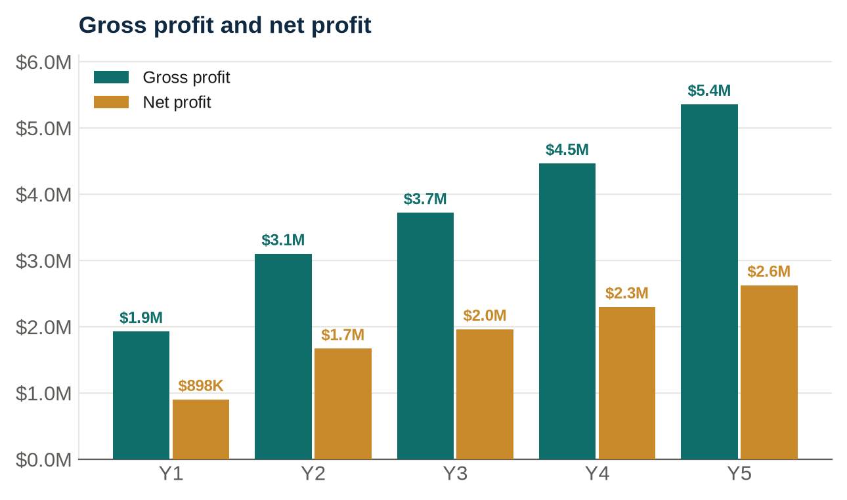
6.2 Revenue build — markets & containers
USD | Year 1 | Year 2 | Year 3 | Year 4 | Year 5
Egypt (6→15 containers) | 2,599,483 | 3,119,380 | 3,743,256 | 4,491,907 | 5,390,288
Sudan (4→10 containers) | 1,575,444 | 1,890,533 | 2,268,639 | 2,722,367 | 3,266,841
Algeria (3→8, 100% LC) | 1,181,583 | 1,417,900 | 1,701,480 | 2,041,775 | 2,450,131
Libya (0→8, from Y2) | 0 | 1,576,000 | 1,891,200 | 2,269,440 | 2,723,328
Total revenue | 5,356,510 | 8,003,813 | 9,604,575 | 11,525,489 | 13,830,588

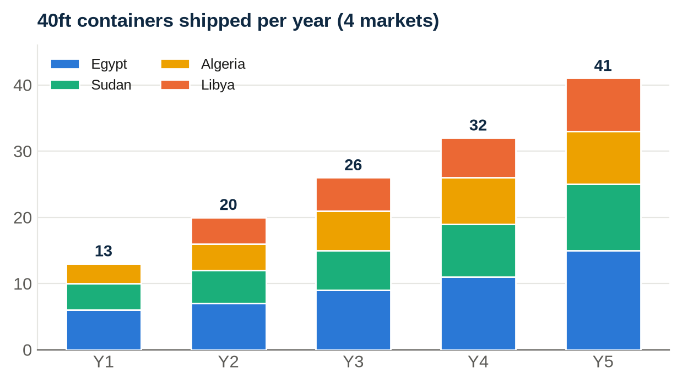

6.3 Year 1 — monthly profitability and cash
Year 1 is modelled month-by-month in the workbook. Egypt revenue ramps from the operating showroom in August to a two-showroom, four-salesperson run-rate by summer; Sudan orders land in alternate months from January; Algeria's first LC orders ship from March. Operating and cumulative break-even both arrive in Month 6 (January 2027), and Year-1 net profit of USD 897,753 nearly matches the full raise.
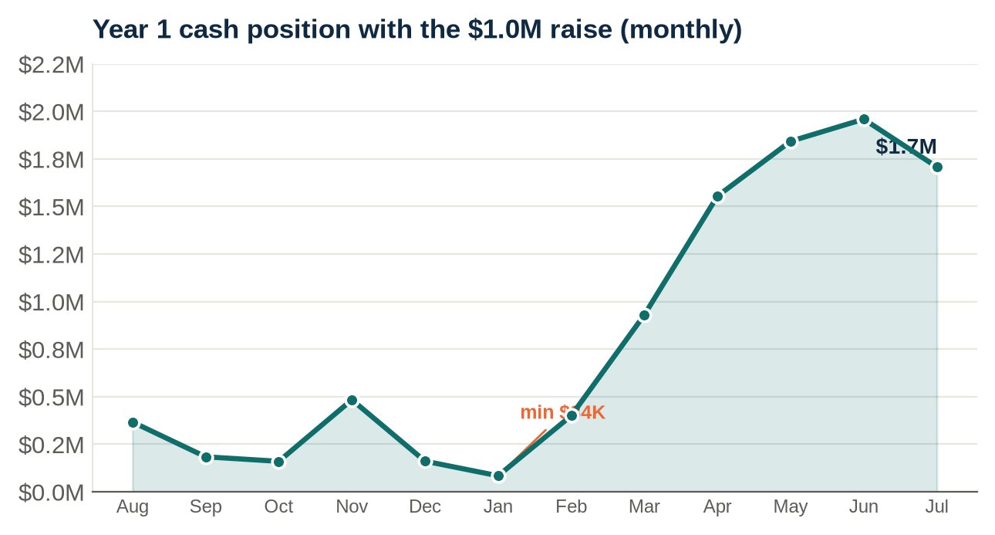
Minimum cash USD 84,397 (Jan-27); Year-1 ending cash USD 1,708,073.
6.4 Five-year cash flow
USD | Year 1 | Year 2 | Year 3 | Year 4 | Year 5
Customer collections | 4,748,684 | 8,351,691 | 9,552,585 | 11,463,101 | 13,755,723
Investor capital (T1 + T2) | 1,000,000 | — | — | — | —
Supplier payments (current + prior yr) | (3,246,897) | (3,987,766) | (5,667,038) | (6,800,445) | (8,160,534)
Operating expenses (cash) | (793,714) | (930,915) | (1,173,670) | (1,478,176) | (1,938,912)
Tax paid (prior year, arrears) | — | (260,638) | (483,654) | (568,412) | (666,431)
Dividends (100% of prior-year profit) | — | (897,753) | (1,665,918) | (1,957,862) | (2,295,484)
Capex | — | (25,000) | (30,000) | (35,000) | (40,000)
Net annual cash flow | 1,708,073 | 2,249,618 | 532,306 | 623,207 | 654,361
Closing cash position | 1,708,073 | 3,957,691 | 4,489,997 | 5,113,204 | 5,767,565

▪ Credit-powered growth — Sinosure-backed supplier credit (10% down + 90% at 3-month credit) carries ~22.5% of each year's purchases into the next year. Closing cash rises every year even while distributing 100% of profits — no capital call after Tranche 2.
▪ Risk stated plainly — Year 1 depends on the raise: the peak self-funded deficit is USD 915,603 in January 2027, and minimum cash with the raise is USD 84,397 — a thin buffer that the optional accelerator widens. This is a working-capital risk, not a demand risk.
▪ Diligence note — export sales are booked at a 50% product-cost margin per the founder's negotiated supply pricing. An investor comparing the USD 342,316 landed container cost to the USD 393,861 wholesale container price should confirm this margin in the supply agreement; at standard wholesale pricing the export margin is ~13% and Year-5 net profit rebases accordingly.

7 Staffing Plan
Institutional management from day one: CEO, Financial Manager and Operations Manager in Month 1, Sales Manager in Month 2, Marketing and HR in Month 3. Two showroom managers run 6th October and New Cairo. Headcount reaches 21 by Month 12 and 55 by Year 5. Sales staff earn salary plus 4% commission on Egypt sales; social insurance at 15% of base is included.
Year & additions | Headcount | Personnel cost (USD)
Year 1 — launch team (CEO, managers, 2 showrooms, warehouse, 4 sales, drivers) | 21 | 496,014
Year 2 — + logistics coordinator, customer service, technical specialist, 2 sales | 26 | 625,715
Year 3 — + Alexandria branch, installation engineers, analysts | 35 | 788,670
Year 4 — + B2G/tenders, C&I sales desk, IT/CRM, Sudan coordinator | 44 | 973,176
Year 5 — + Libya market manager, field engineers, compliance (senior raises applied) | 55 | 1,298,912

Full role-by-role rosters with salaries and start months are in the Staff Plan sheet of the companion workbook. Personnel cost includes base salaries, 15% benefits and 4% Egypt sales commissions.
8 Funding Requirements & Investor Proposal
8.1 The ask
USD 1,000,000 into NORCO Egypt for 50% of its shares, released in two milestone-gated tranches of USD 500,000. An optional USD 500,000 accelerator (by mutual agreement, Months 6–12) lifts the ceiling to USD 1.5M — adding standing buffer and pulling Libya and Algeria volumes forward.
Tranche | USD | Timing | Purpose / gate
Tranche 1 — Launch | 500,000 | Month 1 (Aug-26, at close) | First Vestwoods containers (Sinosure credit approved), setup, opex runway
Tranche 2 — Scale | 500,000 | Month 4 (Nov-26), milestone-gated | Released on ≥3 containers sold through + Sudan advances received; funds container waves 4–13
Optional accelerator | 500,000 | Months 6–12, by mutual agreement | Standing buffer / faster Libya & Algeria ramp; brings total to the USD 1.5M ceiling
Core total (T1 + T2) | 1,000,000

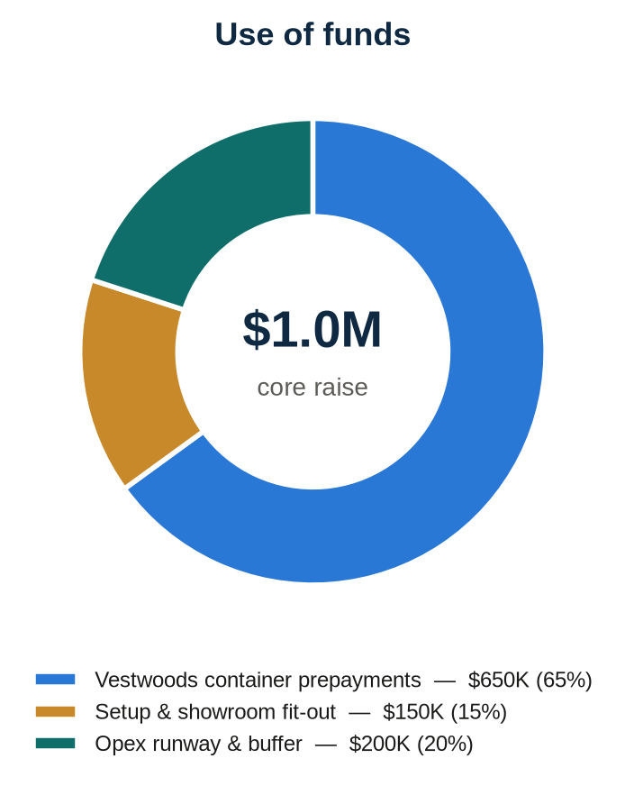
8.2 Investor returns
Dividend policy: 100% of net profit distributed annually in arrears — the investor receives half of every distribution: USD 3,408,508 over the five-year window, 3.4x the capital from dividends alone (40% IRR). Valuing the retained 50% stake at 5× Year-5 net profit adds USD 6,554,947 of terminal value, lifting the total return to 10.0x (69% IRR):
USD | Y0 | Y1 | Y2 | Y3 | Y4 | Y5
Capital invested | (1,000,000) | — | — | — | — | —
Dividends (50% of prior-year NP) | — | — | 448,876 | 832,959 | 978,931 | 1,147,742
Terminal value (50% × 5 × Y5 NP) | — | — | — | — | — | 6,554,947
Net investor cash flow | (1,000,000) | — | 448,876 | 832,959 | 978,931 | 7,702,689

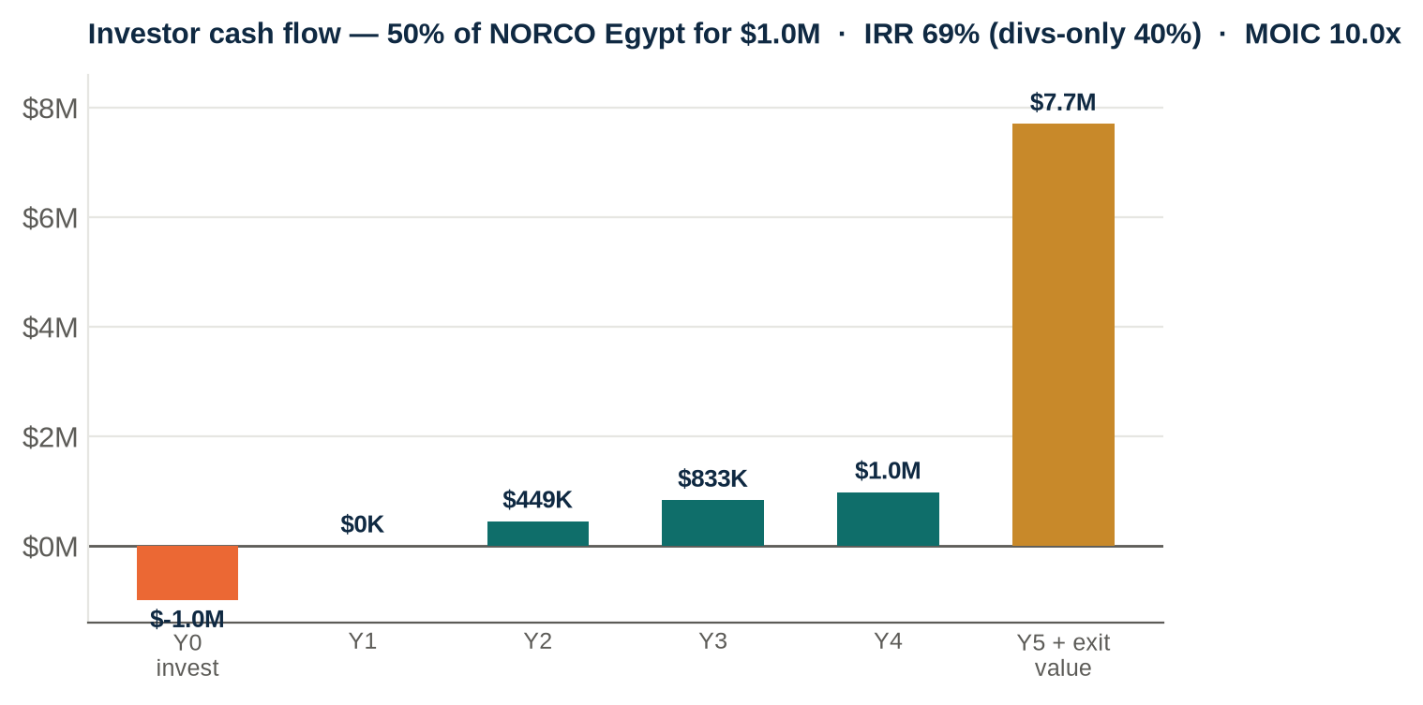
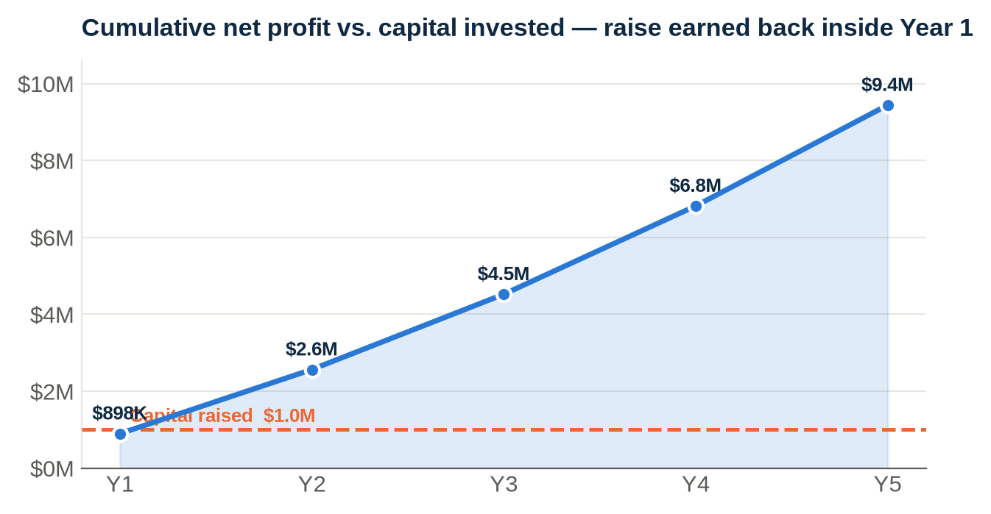
8.3 Investor protections
▪ Tranche 2 released only against verified Month-4 milestones: ≥3 containers sold through and Sudan advances received.
▪ Quarterly management accounts from the formula-driven model; monthly cash and inventory reporting; USD books.
▪ Egypt customers on maximum 60-day terms; Sudan cash-before-shipment; Algeria LC only.
▪ Exclusive Vestwoods agency (with first right of engagement and non-circumvention) held within the group and assignable as security.
▪ Founder pre-investment of USD 14,517 already deployed; board seat and reserved matters for the investor.

9 Operations, Risks & Mitigation
▪ Supply chain — PO → factory 15–20 days → sea 18 days → clearance 7–10 days (5% duty, 2% GOEIC, 14% VAT recoverable) → 6th October warehouse. Roughly one container every 3–4 weeks in Year 1, financed under Sinosure-backed supplier credit.
Risk | Mitigation
EGP devaluation | USD-indexed pricing at EGP 53 planning rate (spot ~49–51); 30-day quote validity; USD books
Y1 working-capital exposure | Haier-backed counterparty; Sinosure credit; staged POs; credit terms anchored from Year 2
Thin export (wholesale) margins | Volume discipline; Egypt retail mix defended at 50%; commissions tied to sales
Raise timing | Tranche 1 must close before first PO; container schedule flexes with drawdown
Customs / GOEIC delays | Permits issued; broker retained; 45–60 day inventory cover
Egypt receivables | 45-day terms; anchor accounts on agreed limits; stop-supply discipline
Export instability (Sudan/Libya) | Cash before shipment; no in-country assets
Algeria regime | Licensed-importer FOB + 100% LC; zero NORCO exposure
Single-brand dependence | Exclusive agency with first right of engagement; deep Haier product range across segments

10 Execution Roadmap
Phase | Timing | Milestones
Launch | M1–M3 | T1 drawn; first Vestwoods POs placed under Sinosure credit; New Cairo showroom opens; Sudan buyer inspects stock and places first order (50% advance)
Prove | M4–M6 | T2 drawn against milestones; operating & cumulative break-even (M6); dealers signed; first Cairo energy exhibition; Algeria agency to term sheet
Convert | M7–M12 | Algeria first LC orders ship (M8); second exhibition; telecom and C&I pipeline; Libya distributor due diligence
Compound | M13–M18 | Credit terms activate on all POs; Libya first containers; full dividend distributions begin; four-market operation on self-generated cash
Scale | Y3–Y5 | 41 containers/yr across four markets by Y5; Alexandria branch; B2G/tenders desk; CKD assembly evaluation; closing cash USD 5,767,565

The opportunity
USD 1.0M buys half of a business that is already built: an exclusive energy-storage agency priced 15–26% under the premium brands, four markets in motion, a committed Sudan buyer and a founder already invested and operational — producing USD 9.4M of net profit over five years, 3.4x back in dividends alone, and every dollar of profit distributed.

Companion workbook: NORCO_Vestwoods_Investor_Model.xlsx — key assumptions, pre-op investment, pricing reference, staff plan, monthly Year-1 P&L and cash flow, 5-year P&L and cash flow, market detail, funding & returns, shareholding and dashboard.

