Design Document

Project-Phase No:01

Home Tools Rental

Abdulmalik Abdullatif alsheddi (439016735) – Coordinator

Abdulaziz Fahad AlOthman (439013755)

Abdulaziz Mohammed AlBarrak (439015815)

Mohamed Fahad Ghunaim (439013912)

Supervisor

Dr.Sultan AL Qahtani

**Table of Contents**

Abstract: 3

1. Introduction 3

2. Design: 3

2.1 System-Level diagram: 3

2.1.1 Use Class Diagram: 3

2.1.2 MVC Pattern: 4

2.2 Class Diagram: 4

2.3 flowcharts. 7

3. User Interface Design: 8

3.1 Login page: 8

3.2 Register page: 9

3.3 Profile page: 9

3.4 Your offers page: 10

3.5 Your rentals page: 10

3.6 Offer creation page: 11

3.7 Search page: 11

3.8 Side\Quick menu: 12

4. Team Members Contributions 12

5. Conclusion 13

# Abstract:

Home tools rental is a desktop application. Programmed for helping people to get benefits from the tools that they don't use instead of throwing them and get tools for cheap price. the application will provide only those functionalities:

Account for this function the user should input: name, password, address, phone number, credit card (optional).

Modifying Account in case the user wants to change his account information this function helps him.

Search option for make it easier for customers to find the items that they need.

Payment method that help the customers for choosing which way they going to pay credit card or cash.

Renting and offering tools this function let the customer to offering his tools and renting the tools that he needed.

Modifying tools this function provides the ability to change the price and the name of the tool.

# 1. Introduction

The “Home Tools Rental” is an application which will allow users to rent tools and place them up for rent in an easy and reliable environment. The user shall be allowed to create an account, search for tools, and rent tools. The application requires internet connection to work and the user’s location. We have progressed a lot since starting on the SRS document, we’ve finished designing the project’s system including the user interface design.

# 2. Design:

## 2.1 System-Level diagram:

### 2.1.1 Use Class Diagram:

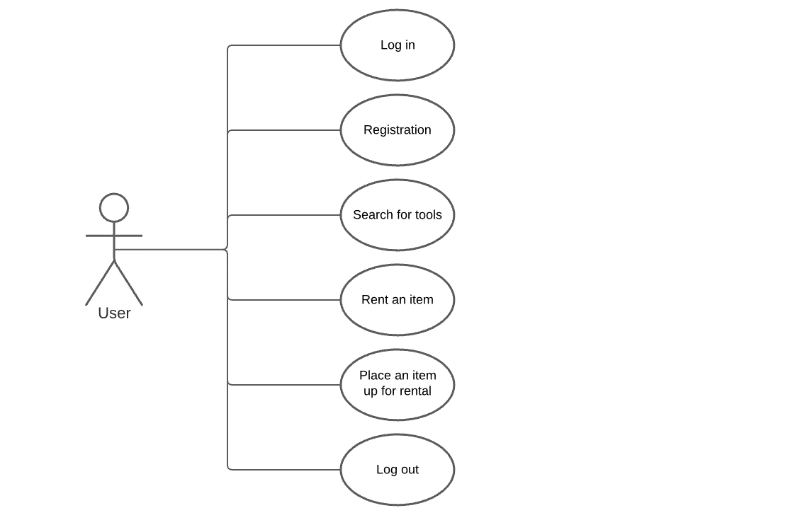

Figure 1- Use Class Diagram

### 2.1.2 MVC Pattern:

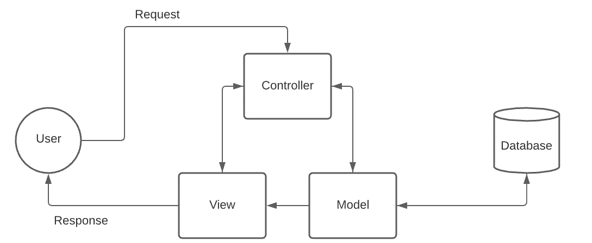

Figure 2 - MVC Pattern

## 2.2 Class Diagram:

In the class diagram (Figure 3) we will show the classes and most of the methods inside the classes.

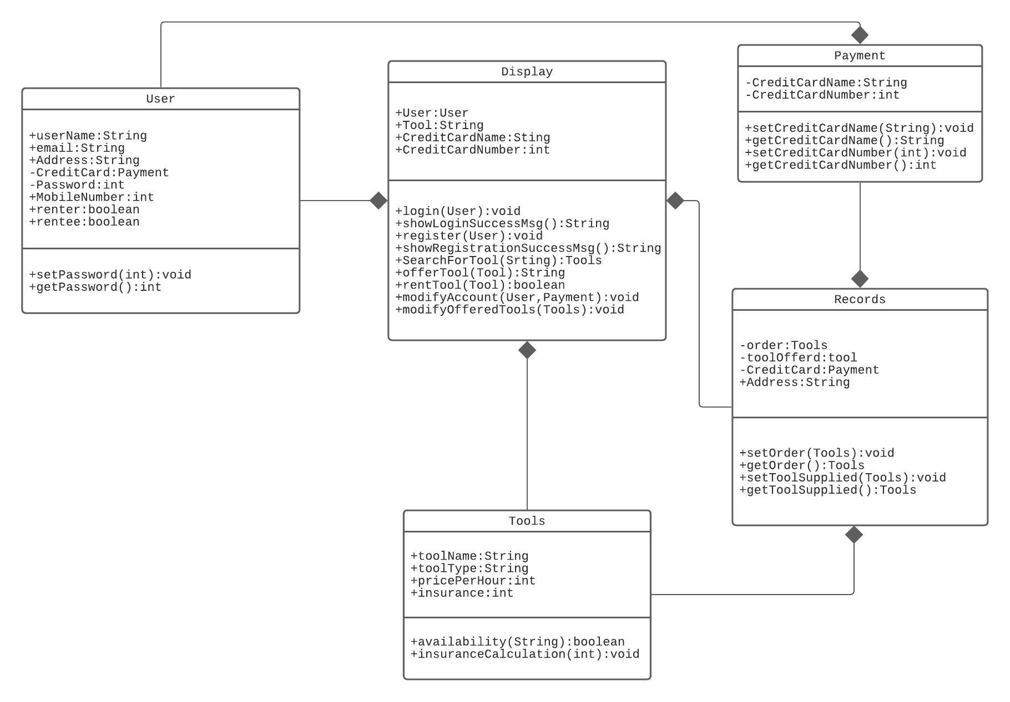

Figure 3 - Class Diagram

**Method 1:** login

Description: this method allows the user to login for his account if he is registered.

**Method 2:** showLoginSuccessMsg

Description: this method shows the user that his login has been successful.

**Method3:** Register

Description: this method allows the user to register a new account.

**Method4:** showRegistrationSuccessMsg.

Description: this method shows the user that his register has been successful.

**Method5:** SearchForTool

Description: this method allows the user to search for a specific tool.

**Method6:** OfferTool

Description: this method allows the user to place a tool for rent.

**Method7:** RentTool

Description: this method allows the user to order a tool from the search page.

**Method8:** ModifyAccount

Description: this method allows the user to change its profile details.

**Method9:** ModifyOfferdTools

Description: this method allows the user to modify his tools information.

**Method10:** Availability

Description: this method shows the user the availability status of a tool.

**Method11:** insuranceCalculation

Description: this method calculate the insurance price of a tool.

**Method12:** setCreditCardName

Description: this method sets a name for the user credit card.

**Method13:** getCreditCardName

Description: this method retrieve the user's credit card name.

**Method14:** setCreditCardNumber

Description: this method sets a value for the user credit card number.

**Method15:** getCreditCardNumber

Description: this method retrieve the user's credit card number.

**Method16:** setOrder

Description: this method confirm and set an order in the user's record.

**Method17:** getOrder

Description: this method retrieve the user's order infomation.

**Method18:** setToolsupplied

Description: this method add the tool to the search page and to the user's record.

**Method19:** getToolsupplied

Description: this method retrieve the tool's information.

## 2.3 flowcharts.

In this section we will show a flow chart (Figure 4) scenario of the program.

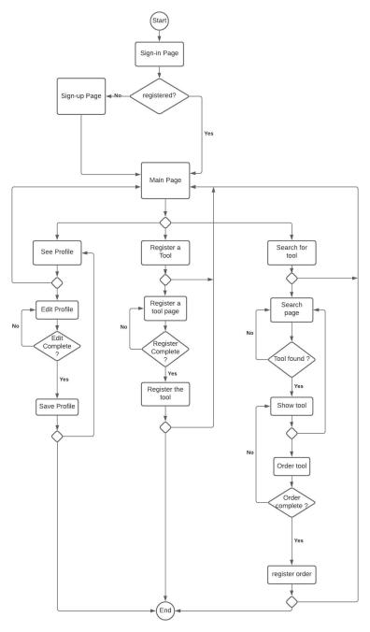

Figure 4 - Flowchart Diagram

# 3. User Interface Design:

In this section we will showcase the varies user interfaces of our application.

## 3.1 Login page:

The login page will greet the user first when he\she opens up our app. And in it he\she can login to his\her account or make a new account by pressing “Not registered yet?”

صورة تحتوي على نص

تم إنشاء الوصف تلقائياً

Figure 5

## 3.2 Register page:

If the user doesn’t have an account or wants to make a new one he\she will get to the “Register” page via the “Login” page, then he\ she can fill in the text fields with the appropriate data, after that the system will check the inputs if correct an account will be made if not an error massage will be displayed.

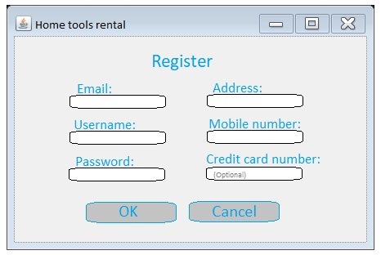

Figure 6

## 3.3 Profile page:

The user can access this page via the side menu -see figure 3.8-. In this page the user can see all of his\her account information, also he\she can choose to modify his\her account information. And the user can choose to go to “Your offers” page -see figure 3.4- or “Your rentals” page -see figure 3.5- via the buttons below. Also, like everywhere else in the application the user can access the side menu via the button in the top right corner.

صورة تحتوي على نص

تم إنشاء الوصف تلقائياً

Figure 7

## 3.4 Your offers page:

In this page the user can see all of his\her active or inactive offers. Also, he\she can choose to go back to the “Profile” page -see figure 3.3- via the “Back” button. Also, like everywhere else in the application the user can access the side menu via the button in the top right corner.

صورة تحتوي على منضدة

تم إنشاء الوصف تلقائياً

Figure 8

## 3.5 Your rentals page:

In this page the user can see his\her rental record. Also, he\she can choose to go back to the “Profile” page -see figure 3.3- via the “Back” button. Also, like everywhere else in the application the user can access the side menu via the button in the top right corner.

صورة تحتوي على منضدة

تم إنشاء الوصف تلقائياً

Figure 9

## 3.6 Offer creation page:

In this page the user can create a new offer by filling the text fields with the appropriate data the pressing the “OK” button, then the system will check if the inputs are correct or not, if yes the a new offer will be created otherwise an error massage will be displayed. Also, like everywhere else in the application the user can access the side menu via the button in the top right corner.

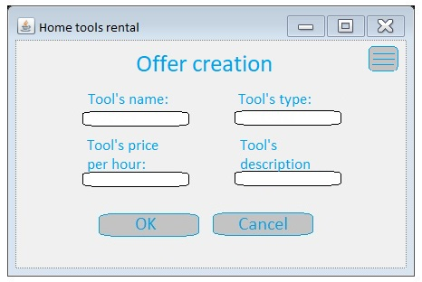

Figure 10

## 3.7 Search page:

In this page the user can search for the tool that he\she wants via entering the tool’s name or type. Then the system will search for the entered data in the database and show the results. Also, like everywhere else in the application the user can access the side menu via the button in the top right corner.

صورة تحتوي على منضدة

تم إنشاء الوصف تلقائياً

Figure 11

## 3.8 Side\Quick menu:

This menu will be the main way of traversing the application. It can be accessed via the button in the top right corner in every page of the application, in it the user will find the names of the main pages of the application and can choose to go to any one of them by clicking the desired page. Also, in it the user can choose to log out of his\her account by clicking “Log out”.

**صورة تحتوي على منضدة

تم إنشاء الوصف تلقائياً**

Figure 12

# 4. Team Members Contributions

|  |  |
| --- | --- |
| **Team member** | **Contributions** |
| **Abdulmalik alsheddi** | The organizer of all of the document, worked on 3.1 ,3.2 , 3.3 , 3.4 ,3.5 , 3.6 , 3.7 , 3.8 |
| **Mohamed Ghunaim** | Worked on 1.0 – 2.1 – 5.0 |
| **Abdulaziz AlBarrak** | Worked on 2.2 - 2.3 |
| **Abdulaziz AlOthman** | Worked on Abstract |

# 5. Conclusion

In conclusion, providing a reliable environment for renting tools is the goal of this application. This design document will help the reader to understand the key points of our project implementation. This document allows the reader to review the interface designs, class diagram, and use case diagram. This document provides the reader with class descriptions and method descriptions. In the end using this application will provide the user with potential income and savings from not having to buy a power tool.