|  |  |
| --- | --- |
| **Soal Proyek**  *Project Case* |  |
| T0063  Visual Programming |
| **Teknik Informatika**  *Computer Science* | **O2-T0063-AV01** |
| **Periode Berlaku** Semester Ganjil 2015/2016  ***Valid on*** *Odd Semester Year 2015/2016* | **Revisi 02**  *Revision 02* |

1. Seluruh kelompok tidak diperkenankan untuk :

*The whole group is not allowed to:*

* + - Melihat sebagian atau seluruh proyek kelompok lain,

*Seeing a part or the whole project from other groups*

* + - Menyadur sebagian maupun seluruh proyek dari buku,

*Adapted a part or the whole project from the book*

* + - Mendownload sebagian maupun seluruh proyek dari internet,

*Downloading a part or the whole project from the internet,*

* + - Mengerjakan soal yang tidak sesuai dengan tema yang ada di soal proyek,

*Working with another theme which is not in accordance with the existing theme in the matter of the project,*

* + - Melakukan tindakan kecurangan lainnya,

*Committing other dishonest actions,*

* + - Secara sengaja maupun tidak sengaja melakukan segala tindakan kelalaian yang menyebabkan hasil karyanya berhasil dicontek oleh orang lain / kelompok lain.

*Accidentally or intentionally conduct any failure action that cause the results of the project was copied by someone else / other groups.*

1. Jika kelompok terbukti melakukan tindakan seperti yang dijelaskan butir 1 di atas, maka **nilai kelompok** yang melakukan kecurangan (menyontek maupun dicontek) akan di – **NOL** – kan.

*If the group is proved to the actions described in point 1 above, the score of the group which committed dishonest acts (cheating or being cheated) will be “Zero”*

1. Perhatikan jadwal pengumpulan proyek, segala jenis pengumpulan proyek di luar jadwal tidak dilayani.

*Pay attention to the submission schedule for the project, all kinds of submission outside the project schedule will not be accepted*

1. Jangan lupa untuk melihat kriteria penilaian proyek yang ditempel di papan pengumuman, atau tanya asisten anda.

*Don’t forget to look at the project assessment criteria that posted on the announcement board, or ask your teaching assistant.*

1. Persentase penilaiaan untuk matakuliah ini adalah sebagai berikut:

*Marking percentage for this subject is described as follows:*

|  |  |  |
| --- | --- | --- |
| **Tugas Mandiri**  *Assignment* | **Proyek**  *Project* | **UAP**  *Final Exam* |
| 40% | 60% | **-** |

1. Software yang digunakan pada matakuliah ini adalah sebagai berikut:

*Software will be used in this subject are described as follows:*

|  |
| --- |
| **Software**  *Software* |
| Visual VB.NET Express Edition 2010 |

## Ekstensi file yang harus disertakan dalam pengumpulan tugas mandiri dan proyek untuk matakuliah ini adalah sebagai berikut:

*File extensions should be included in assignment and project collection for this subject are described as follows:*

|  |  |
| --- | --- |
| **Tugas Mandiri**  *Assignment* | **Proyek**  *Project* |
| Folder Project (SLN, CONFIG, VB, XSC, XSD, XSS, LAYOUT, RESX, VBPROJ, USER, EXE, PDB, MANIFEST, XML, image files(JPG/PNG/GIF), MYAPP, SETTINGS, CACHE, TLOG, RESOURCES, TXT, DLL) | Folder Project (SLN, CONFIG, VB, MDF, LDF, XSC, XSD, XSS, DBML, LAYOUT, RESX, VBPROJ, USER, EXE, PDB, MANIFEST, XML, image files(JPG/PNG/GIF), MYAPP, SETTINGS, CACHE, TLOG, RESOURCES, TXT, DLL) |

## Soal

*Case*

**Bluejek**

“**Bluejek**” is a social enterprise that partners with a group of experienced and trustworthy *ojek* drivers to deliver a one-stop-shop convenience service for Indonesians. **Bluejek** services include transport. As the time goes, the store is overwhelmed by the number of orders that call the *Ojek* and it is more difficult to manage data, the *ojek* needs an application to manage their transactions and record the Commission payment. “**Bluejek**” has decided to hire your service as a programmer to create an application. Here are the requirements that need to be done:

**Database:**

* **Header**

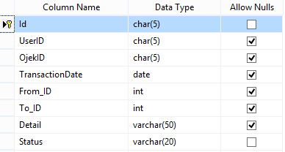

* **Location**

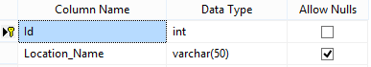

* **Ojek**

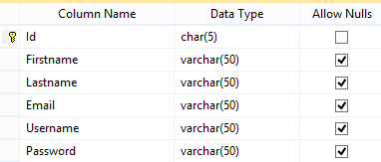

* **User**

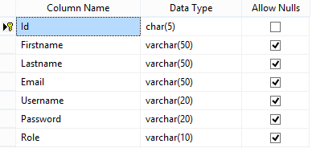

**Application:**

* + - 1. **Main Form**

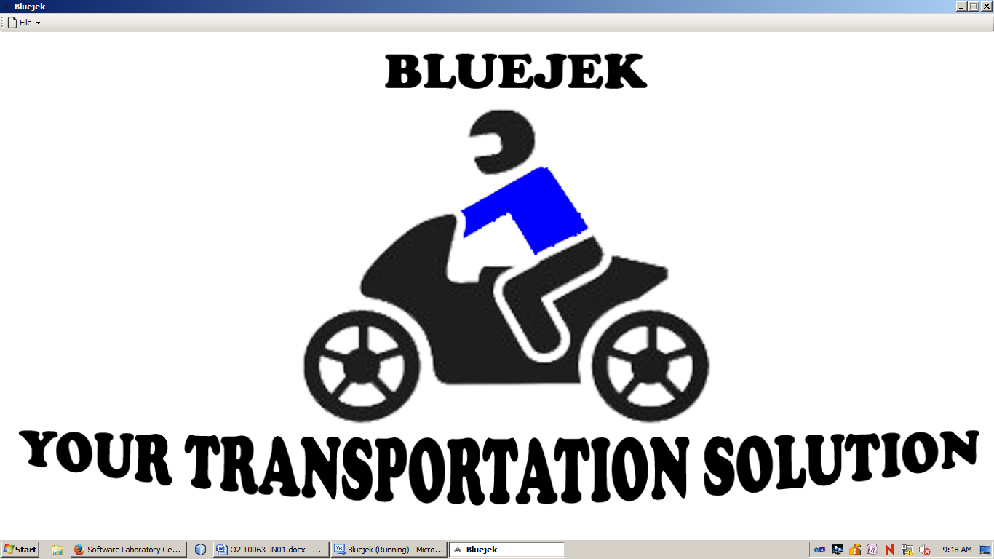

**Main Form Before Login**

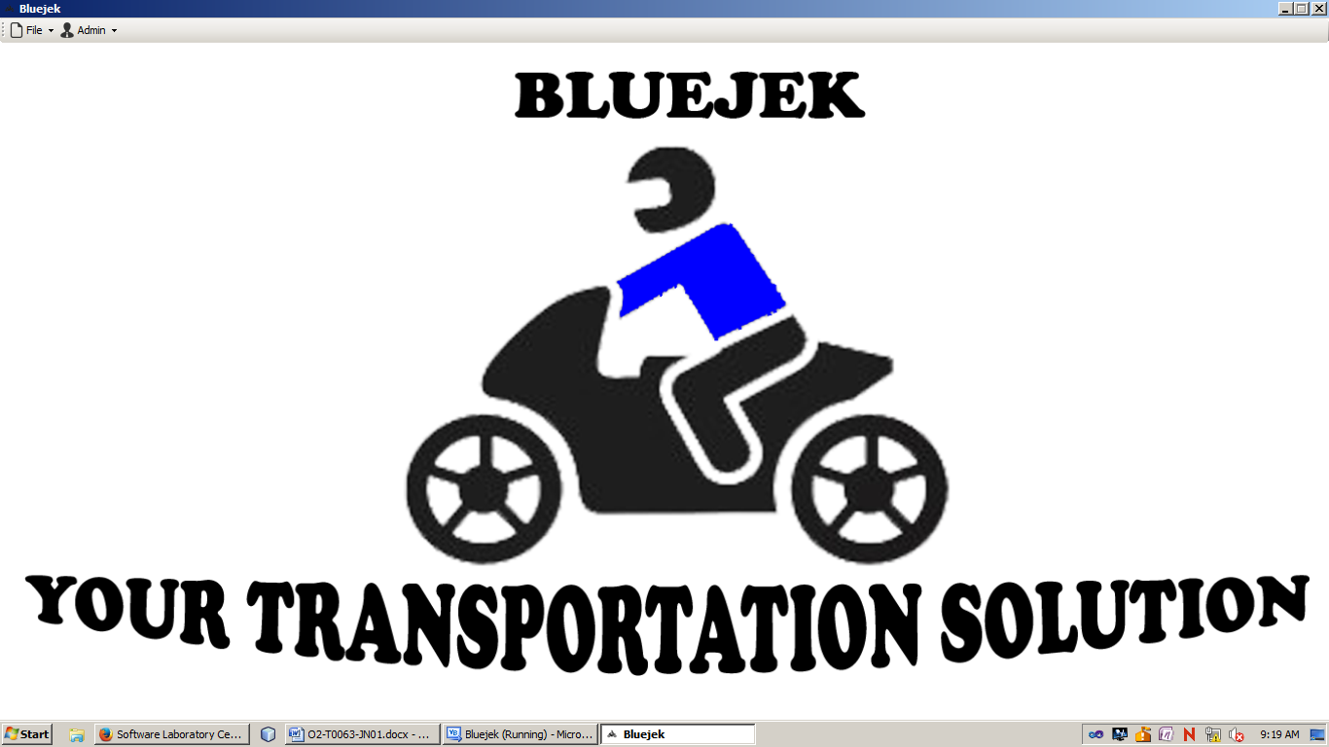

**Main Form After Login as Admin**

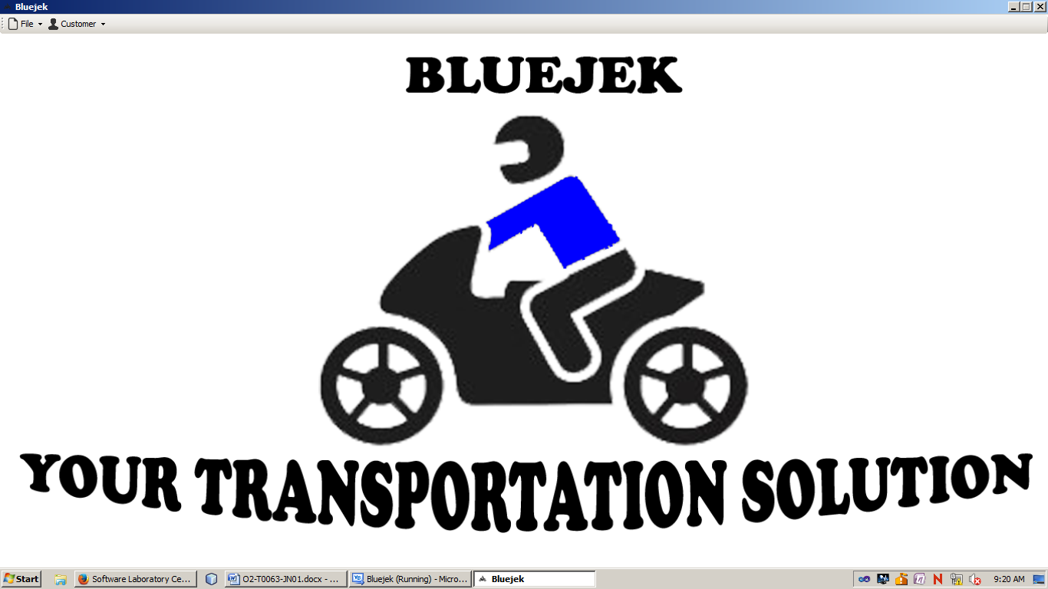

**Main Form After Login as Customer**

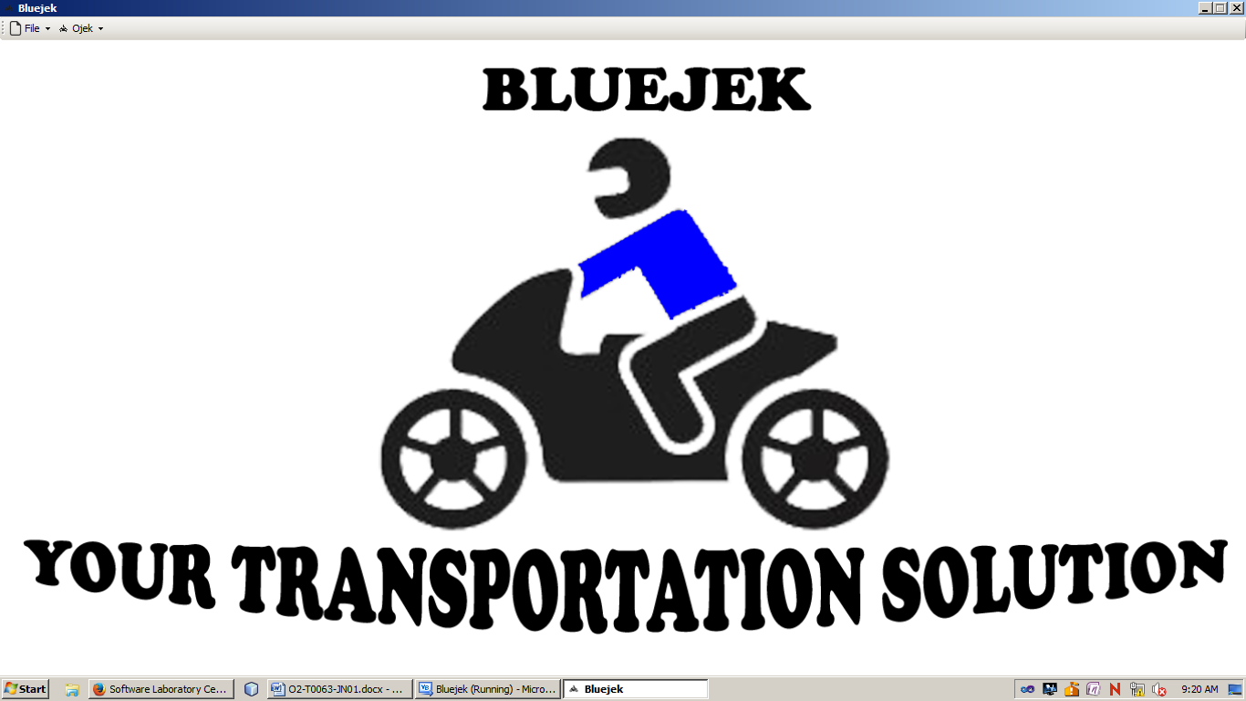

**Main Form After Login as Ojek**

Main Form contains menu to open other forms. The Main Form **always** in **maximized** state and the **Maximize** control box is disable

**Components:**

* **Tool Strip** for the main menu

**Main menu:**

* **File**
* **Login / Logout =>** Show **Login Form** for unlogged user and **Logout** for registered user
* **Exit =>** Close application
* **Ojek**
* **Take Order From Customer =>** Show **Order from Customer Form**
* **Order History =>** Show **Taken Order History Form**
* **Customer**
* **Make Order =>** Show **Order Form**
* **Order History =>** Show **Order History Form**
* **Admin**
* **Ojek =>** Show **Master Ojek Form**
* **Customer =>** Show **Master Customer Form**
* **Location =>** Show **Master Location Form**

**Description:**

* When the main form is opened, all menus are **hidden** except for **Login** and **Exit** Menu.
* Ifuserlogged inas **Admin** (**role**:”**ADM**”), then change **Login** to **Logout** and show **Admin** menu
* Ifuserlogged inas **Customer** (**role**:”**USR**”), then change **Login** to **Logout** and show **Customer** menu
* Ifuserlogged inas **Ojek**, then change **Login** to **Logout** and show **Ojek** menu
* If user choose **Logout**, then hide the **logged in menu** and change **Logout** to **Login**.
  + - 1. **Login Form(Unlogged User)**

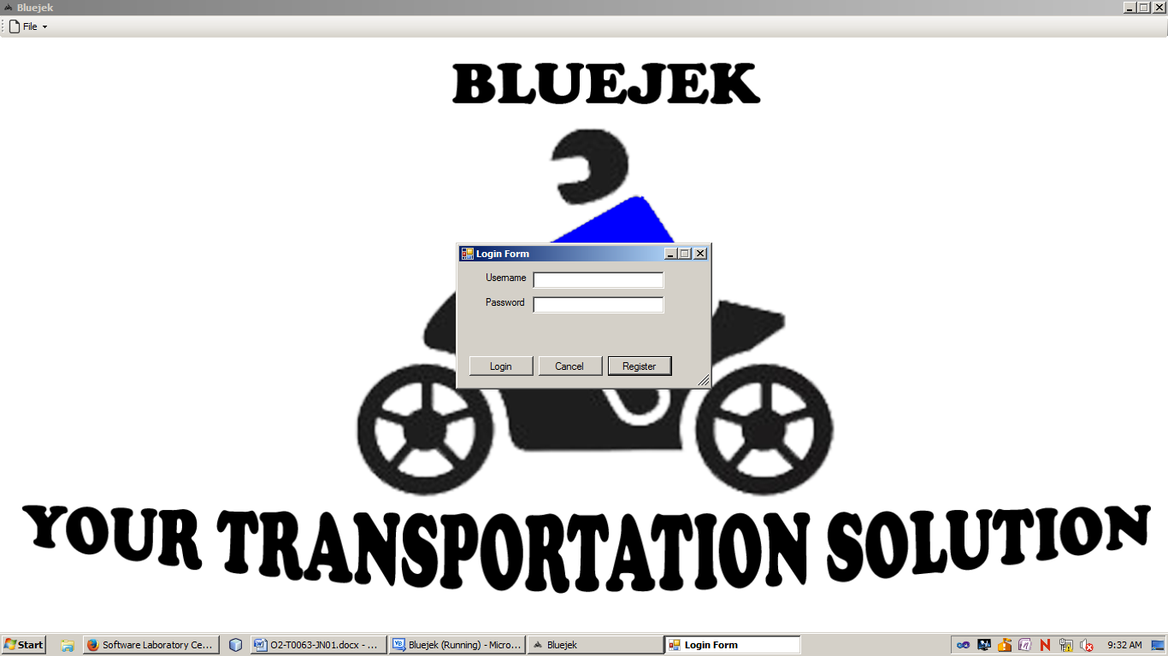

**Login Form**

**Components:**

* **Label** for Username and Password
* **TextBox** for Username and Password
* **Button** for Login, Cancel, and Register

**Description:**

- When **Login Button** is clicked then validate:

* + - * + If username is **empty**, then show error message “**Username must be filled**”.
        + If username **length** is **more than 20 or less than 5 characters**, then show error message “**Username cannot be more than 20 characters or less than 5 characters**”.
        + If password is **empty**, then show error message “**Password must be filled**”.
        + If password **length** is **more than 20 or less than 5 characters**, then show error message “**Password cannot be more than 20 characters or less than 5 characters**”.
        + If username, password (**case sensitive**), and typedo **not** match with data in **User** or **Ojek** table, then show error message “**Please Provide Correct Login Information**”.
        + If username, password, and typematch with record in **User** or **Ojek** table, then show message “**Welcome**” and show the menu according to the **role.**
      1. **Register Form(Customer Menu)**

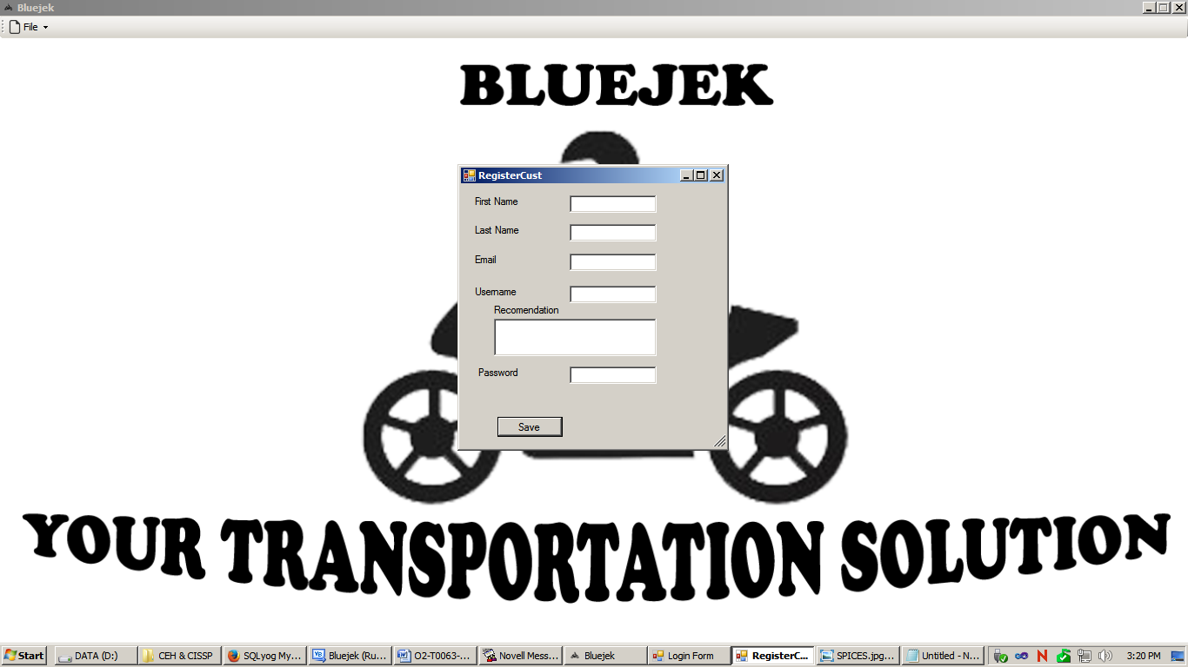

**Register Form**

**Components:**

* **Label** for Firstname, Lastname, Email, Username, Recommendation, and Password.
* **ListBox** for Recommendation.
* **Button** for Save.
* **TextBox** for Firstname, Lastname, Email, Username, and Password.

**Description:**

* When save button is clicked, save user’s data into **User** table with “**USR**” role**.**
* **Recommendation ListBox** will give you list of recommendation **username** based on **Firstname** and **Lastname** with these combination :
* First letter of **Firstname** + **Lastname**
* **Firstname +** first letter of **Lastname**
* **Firstname + Lastname**
* **Firstname +** first letter of **Lastname + random number** between 10 and 98

**Validation:**

* When **Save Button** is clicked, then validate :
  + - * + If Firstname is **empty**, then show error message “**Firstname must be filled**”.
        + If Lastname is **empty**, then show error message “**Lastname** **must be filled**”.
        + If Email is **empty**, then show error message “**Email** **must be filled**”.
        + If Email **not contains** “**@**”, then show error message “**Email must contains @**”.
        + If Email **not contains** “**.com**”, then show error message “**Email must contains .com**”.
        + If username is **empty**, then show error message “**Username must be filled**”.
        + If username **length** is **more than 20 or less than 5 characters**, then show error message “**Username cannot be more than 20 characters or less than 5 characters**”.
        + If password is **empty**, then show error message “**Password must be filled**”.
        + If password **length** is **more than 20 or less than 5 characters**, then show error message “**Password cannot be more than 20 characters or less than 5 characters**”.
        + If there is no more problem, than generate the new ID with **USXXX** where X is the number and starts from 1 and continue.

Example: If Number is 1 then the ID will be US001

If Number is 100 then the ID will be US100

* + - 1. **New Order(Customer Menu)**

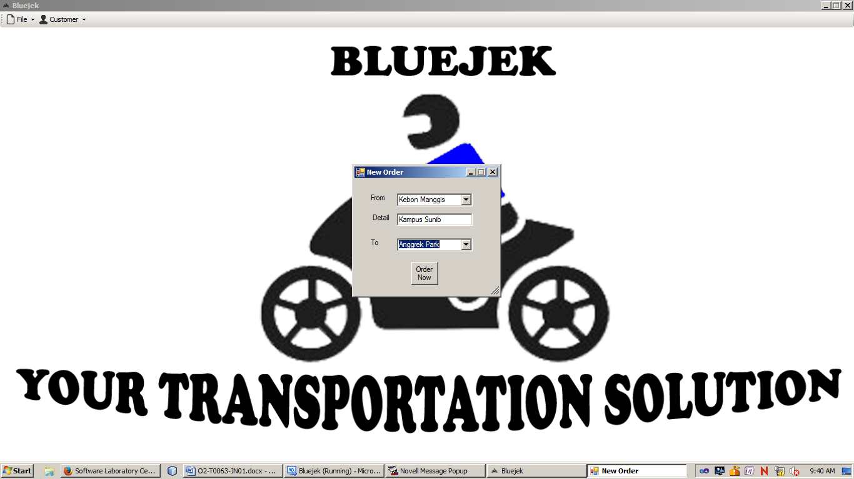

*Before Order*

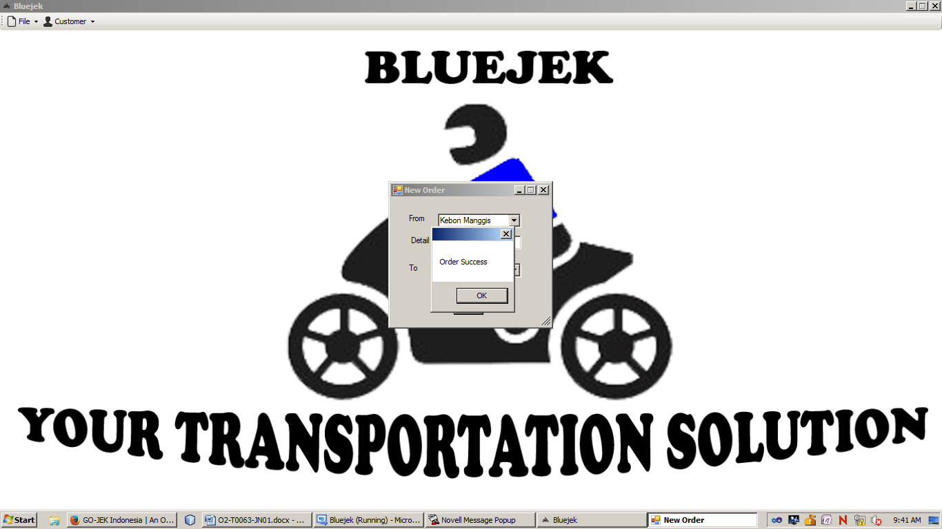

*After Click Order Now*

**Components:**

* **Label** for From, Detail, To
* **TextBox** for Detail
* **ComboBox** for From, To
* **Button** for Order Now

**Description:**

* **From ComboBox** and **To ComboBox** values is obtained from **Location** table.
* If Order Now Button is **Clicked** then Insert the Order data to **Header** table
  + - * + **TransactionDate** is the date when the customer do order.
        + Set **OjekID** as **null**
        + Generate **ID** as numeric, that starts from 1 and continue.
        + Set **Status** as “**Not Arrived**”.
      1. **Order History Customer(Customer Menu)**

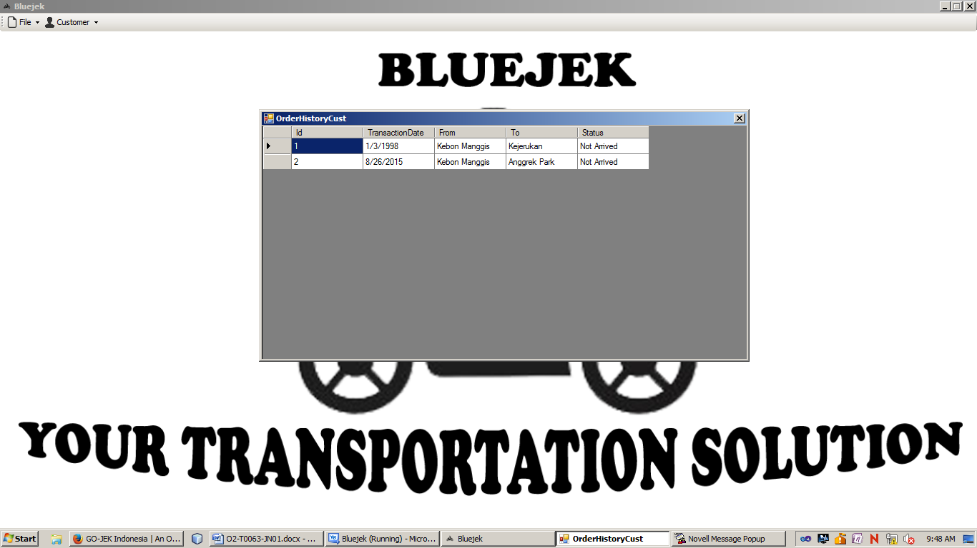

**Components:**

* **DataGridView** to show **Order History** from **user that currently login** by **joining Header** and **Location** table.

**Description:**

* **DataGridView** is consists of 5 columns :
* **Id** => Order Id
* **TransactionDate**  => Order Date
* **From =>** Start Location
* **To =>** Destination Location
* **Status** => Delivery Status (If the customer has arrived then the

status is “**Arrived**”, else the status is “**Not Arrived**”)

* + - 1. **Order From Customer Form(Ojek Menu)**

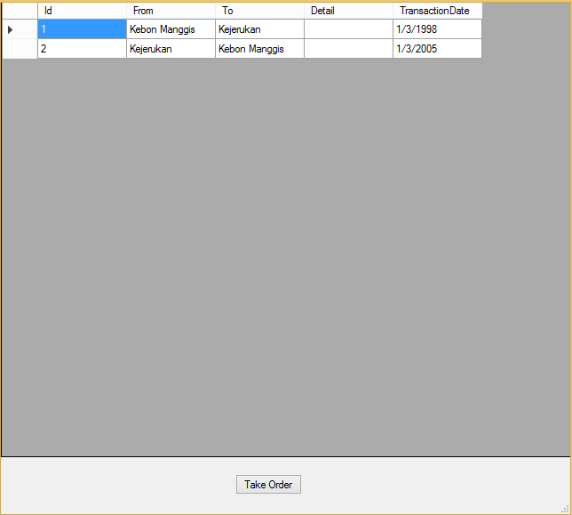



**Components:**

* **DataGridView** to show order data that **not taken** by **other ojek** by **joining Header** and **Location** table. **Not taken** means the **OjekID** in **Header** still **null**.
* **Button** for Take Order

**Description:**

* If **DataGridView** is clicked, then the order is selected.
* If **Take Order Button** is clicked, then
* Change **OjekID** from **Header** table from **null** to **OjekID** from user that take the order and show message “**Success**”.

**Validation:**

* If **Take Order Button** is clicked but there are no selected data yet, show error message “**You need to select the order first**”.
  + - 1. **Order History(Ojek Menu)**

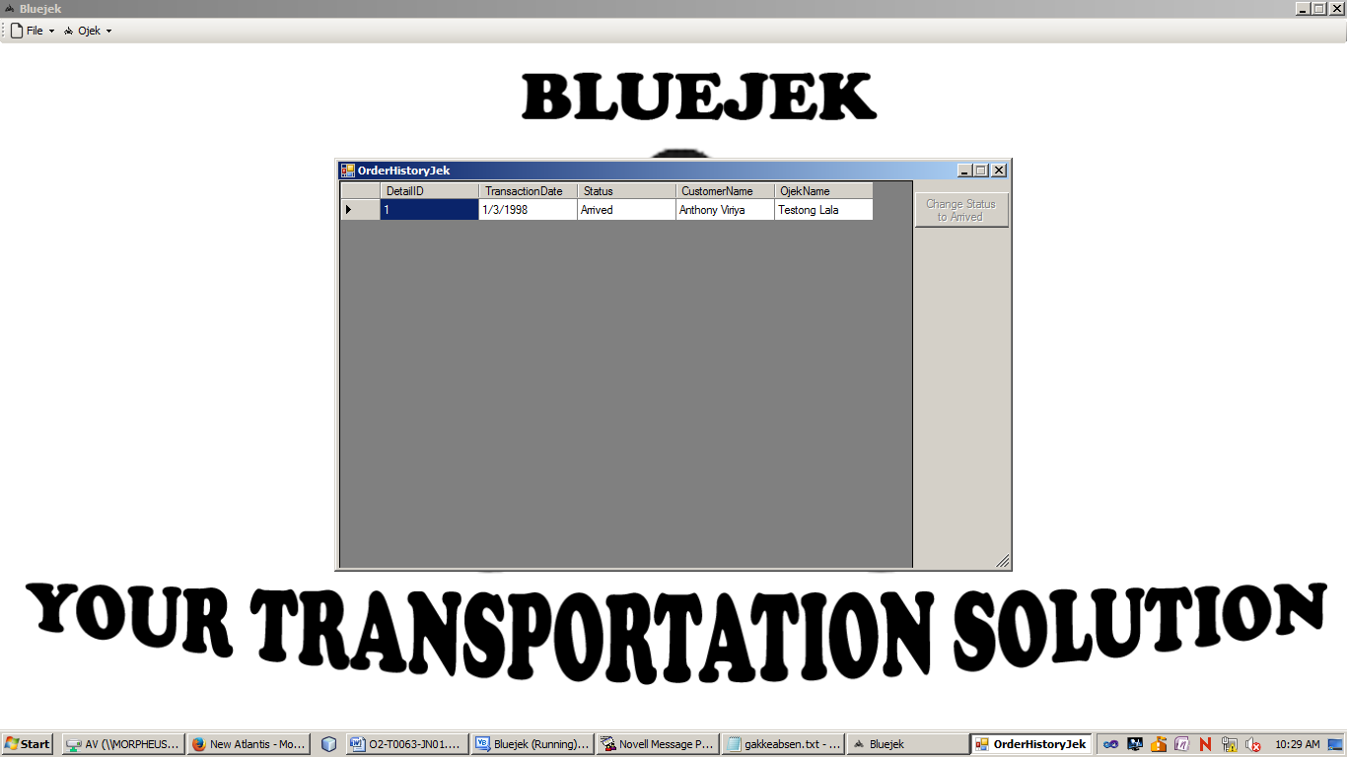

**Components:**

* **DataGridView** to show **History Taken Order** data by **joining** **Header**, **User** and **Ojek** table.
* **Button** for Change Status to Arrived

**Description:**

* The initial state of form:
* **Change Status to Arrived** buttonis **disable**
* If **DataGridView** is clicked, then **select** the **Header** data.
* If the **Order** **Status** is “**Not Arrived”** then **enable** the **Button** for “**Change Status to Arrived**”
* If the **Order** **Status** is “**Arrived”** then **disable** the **Button** for “**Change Status to Arrived**”
* If **Change Status to Arrived Button** is clicked, then change the **Order Status** from “**Not Arrived**”to “**Arrived**”
  + - 1. **Master Ojek Form (Admin Menu)**

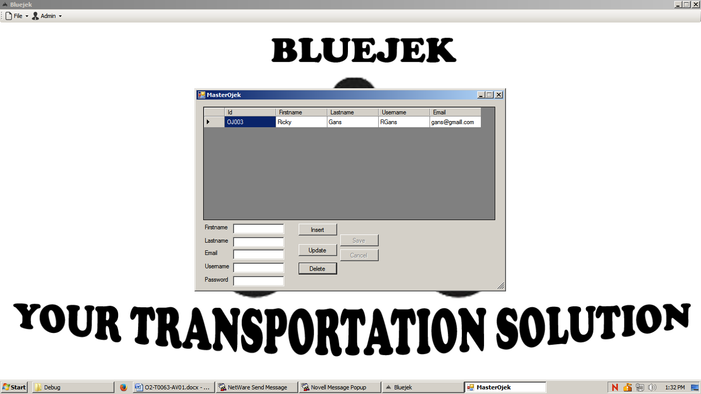

*If there is no ojek selected*

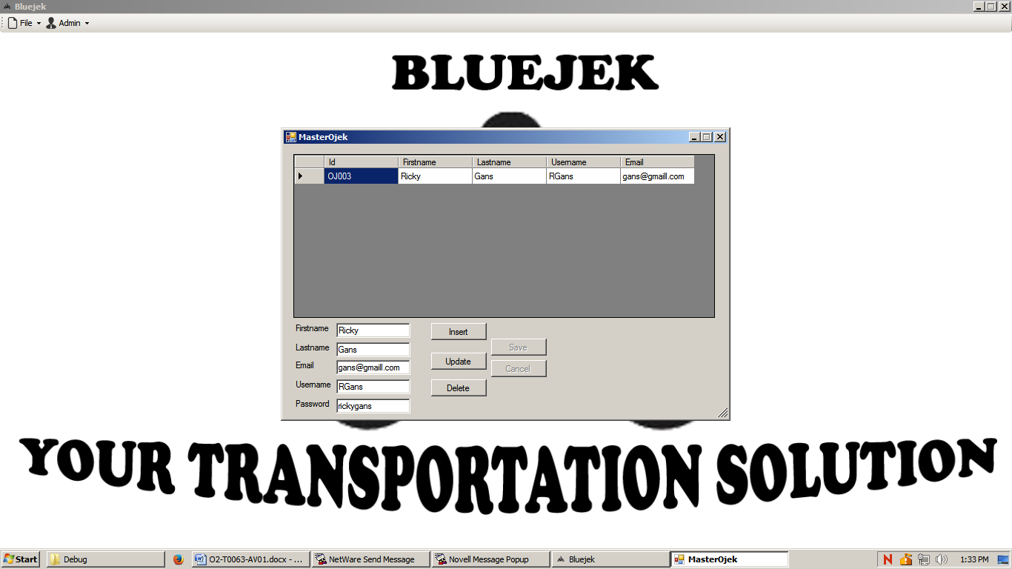

*If the ojek has been selected*

**Components**:

* **Label** for Firstname, Lastname, Email, Username, and Password.
* **DataGridView** to show data from **Ojek** table.
* **Button** for Insert, Update, Delete, Update, Save, and Cancel.
* **TextBox** for Firstname, Lastname, Email, Username, and Password.

**Description:**

* The Initial state of form:
* **Maximize** control box is **disable.**
  + - * + **DataGridview** forshowing all data from **Ojek** table.
        + **All Buttons** is **enable except Save and Cancel** button.
        + **All Fields** is **blank.**
* If **DataGridView** is clicked, then display the data from **DataGridView** to **fields** in all textbox
* If **Update** **Button** is clicked, then **enable** the **Save**, **Cancel Button** and **disable** the **Insert**, **Update**, and **Delete Button**
* If **Insert** **Button** is clicked, then **enable** the **Save**, **Cancel Button** and **disable** the **Insert**, **Update**, and **Delete Button**
* If **Delete** **Button** is clicked, then **delete** the selected Ojek from **Ojek** table
* If **Save Button** is clicked, and the previous button is **Insert** then insert **all data** from **fields** in form into **Ojek** table. After that return the **form** to its **Initial State**.
* If **Save Button** is clicked, and the previous button is **Update** then update the selected **ojek** with **data** from **fields** in form and **apply** it to **Ojek** table. After that return the **form** to its **Initial State**.
* If **Cancel** **Button** is clicked, then return the **form** to its **Initial State**.

**Validation:**

* If **Update Button** is clicked but there are no selected data yet, show error message “**You must choose the ojek first**”.
* When **Save Button** is clicked, then validate :
  + - * + If Firstname is **empty**, then show error message “**Firstname must be filled**”.
        + If Lastname is **empty**, then show error message “**Lastname** **must be filled**”.
        + If Email is **empty**, then show error message “**Email** **must be filled**”.
        + If Email **not contains** “**@**”, then show error message “**Email must contains @**”.
        + If Email **not contains** “**.com**”, then show error message “**Email must contains .com**”.
        + If username is **empty**, then show error message “**Username must be filled**”.
        + If username **length** is **more than 20 or less than 5 characters**, then show error message “**Username cannot be more than 20 characters or less than 5 characters**”.
        + If password is **empty**, then show error message “**Password must be filled**”.
        + If password **length** is **more than 20 or less than 5 characters**, then show error message “**Password cannot be more than 20 characters or less than 5 characters**”.
        + If there is no more problem, than generate the new ID with **OJXXX** where X is the number and starts from 1 and continue.

Example: If Number is 1 then the ID will be OJ001

If Number is 100 then the ID will be OJ100

* + - 1. **Master Customer Form(Admin Menu)**

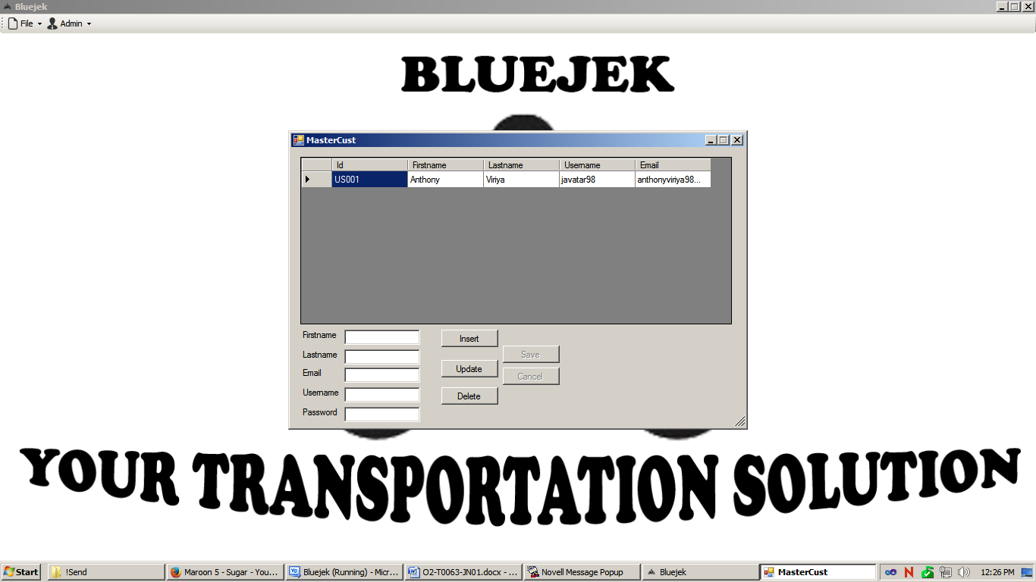

*If there is no customer selected*

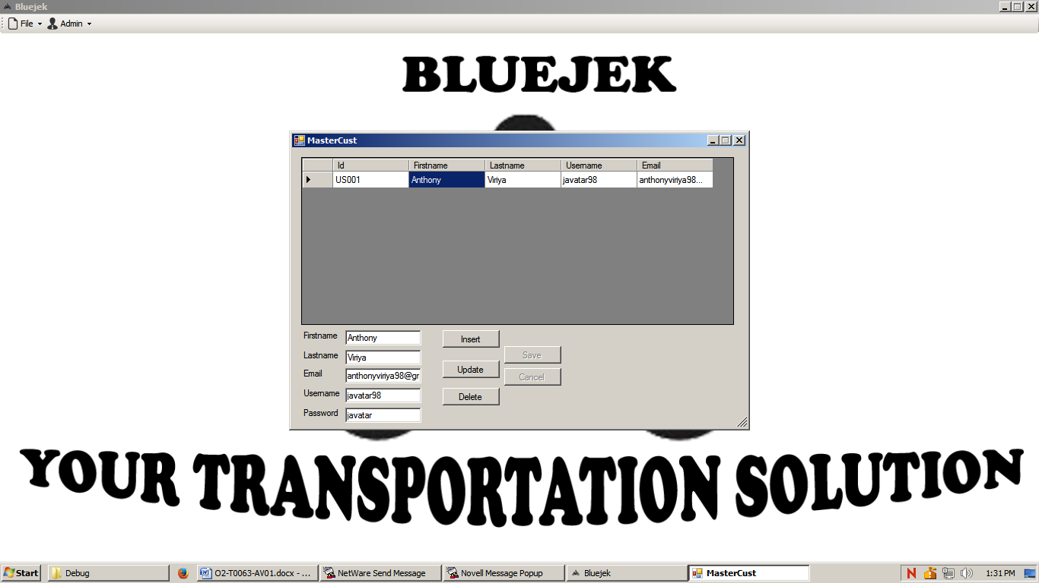

*If the customer has been selected*

**Components**:

* **Label** for Firstname, Lastname, Email, Username, and Password.
* **DataGridView** to show data from **User** table where the **Role** is “**USR**”.
* **Button** for Insert, Update, Delete, Update, Save, and Cancel.
* **TextBox** for Firstname, Lastname, Email, Username, and Password.

**Description:**

* The Initial state of form:
* **Maximize** control box is **disable.**
  + - * + **DataGridview** forshow all data from **User** table with “**USR**” role.
        + **All Buttons** is **enable except Save and Cancel** button.
        + **All Fields** is **blank.**
* If **DataGridView** is clicked, then display the data from **DataGridView** to **fields** in form
* If **Update** **Button** is clicked, then **enable** the **Save**, **Cancel Button** and **disable** the **Insert**, **Update**, and **Delete Button**
* If **Insert** **Button** is clicked, then **enable** the **Save**, **Cancel Button** and **disable** the **Insert**, **Update**, and **Delete Button**
* If **Delete** **Button** is clicked, then **delete** the selected Ojek from **User** table
* If **Save Button** is clicked, and the previous button is **Insert** then insert **all data** from **fields** in form into **User** table with “**USR**” role. After that return the **form** to its **Initial State**.
* If **Save Button** is clicked, and the previous button is **Update** then update the selected **user** with **data** from **fields** in form and **apply** it to **User** table. After that return the **form** to its **Initial State**.
* If **Cancel** **Button** is clicked, then return the **form** to its **Initial State**.

**Validation:**

* If **Update Button** is clicked but there are no selected data yet, show error message “**You must choose the user first**”.
* When **Save Button** is clicked, then validate :
  + - * + If Firstname is **empty**, then show error message “**Firstname must be filled**”.
        + If Lastname is **empty**, then show error message “**Lastname** **must be filled**”.
        + If Email is **empty**, then show error message “**Email** **must be filled**”.
        + If Email **not contains** “**@**”, then show error message “**Email must contains @**”.
        + If Email **not contains** “**.com**”, then show error message “**Email must contains .com**”.
        + If username is **empty**, then show error message “**Username must be filled**”.
        + If username **length** is **more than 20 or less than 5 characters**, then show error message “**Username cannot be more than 20 characters or less than 5 characters**”.
        + If password is **empty**, then show error message “**Password must be filled**”.
        + If password **length** is **more than 20 or less than 5 characters**, then show error message “**Password cannot be more than 20 characters or less than 5 characters**”.
        + If there is no more problem, than generate the new ID with **USXXX** where X is the number and starts from 1 and continue.

Example: If Number is 1 then the ID will be US001

If Number is 100 then the ID will be US100

* 10
  + - 1. **Master Location Form (Admin Menu)**

*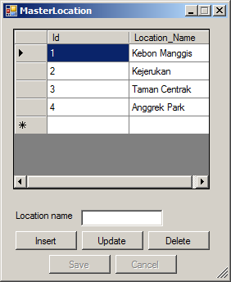  
If there is no location selected*

*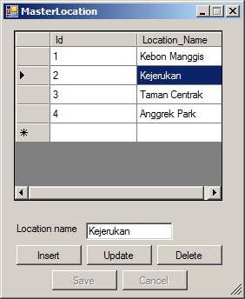   
If the location has been selected*

**Components**:

* **Label** for Location Name.
* **DataGridView** to show data from **Location** table.
* **Button** for Insert, Update, Delete, Update, Save, and Cancel.
* **TextBox** for Location Name.

**Description:**

* The Initial state of form:
* **Maximize** control box is **disable.**
  + - * + **DataGridview** forshow all data from **Location** table.
        + **All Buttons** is **enable except Save and Cancel** button.
        + **All Fields** is **blank.**
* If **DataGridView** is clicked, then display the data from **DataGridView** to **fields** in form
* If **Update** **Button** is clicked, then **enable** the **Save**, **Cancel Button** and **disable** the **Insert**, **Update**, and **Delete Button**
* If **Insert** **Button** is clicked, then **enable** the **Save**, **Cancel Button** and **disable** the **Insert**, **Update**, and **Delete Button**
* If **Delete** **Button** is clicked, then **delete** the selected Location from **Location** table
* If **Save Button** is clicked, and the previous button is **Insert** then insert **all data** from **fields** in form into **Location** table. After that return the **form** to its **Initial State**.
* If **Save Button** is clicked, and the previous button is **Update** then update the selected **location** with **data** from **fields** in form and **apply** it to **Location** table. After that return the **form** to its **Initial State**.

If **Cancel** **Button** is clicked, then return the **form** to its **Initial State**.

**Validation:**

* If **Update Button** is clicked but there are no selected data yet, show error message “**You must choose the location first**”.
* When **Save Button** is clicked, then validate :
  + - * + If Location name is **empty**, then show error message “**Location Name must be filled**”.
        + If there is no more problem, than generate **ID** as numeric, that starts from 1 and continue.

**Notes:**Please use **LINQ** as the language syntax for querying data

You can create admin in **User** table with role “**ADM**”

**References**:

* http://ww3.veryicon.com/icon/png/System/Icons8%20Metro%20Style/Very%20Basic%20File.png
* http://www.veryicon.com/icon/png/System/Icons8%20Metro%20Style/Users%20Edit%20user.png
* http://png-1.findicons.com/files/icons/2711/free_icons_for_windows8_metro/512/exit.png
* http://rlv.zcache.com.au/motorcycle_icon_canvas_print-r9717a506ba8a48eeaaf4defd26c5cc7d_wto_8byvr_324.jpg
* https://cdn2.iconfinder.com/data/icons/windows-8-metro-style/128/user.png
* https://cdn2.iconfinder.com/data/icons/windows-8-metro-style/512/administrator.png

Here are the rules that you must follow to create your project:

1. Use appropriate software for this subject based on **Sistem Praktikum** that can be downloaded from Binusmaya.
2. All validations must use the **techniques** taught during **practicum**. (Another language or Regular Expression is **prohibited**).
3. Collect appropriate files for this subject based on **Sistem Praktikum** that can be downloaded from Binusmaya.
4. Please use **LINQ** as the language syntax for querying data
5. Include the other files that can support your project, such as:
   * All files in your project
   * Other files (image, audio, video, etc.) used in your project
   * *.DOC file (documentation of your project) that contains the reference links of additional files (image, audio, video, etc.) used in your project