HW2 – Testing Data-Screenshot

“Multiple_year_stock_data -

Tab 2016

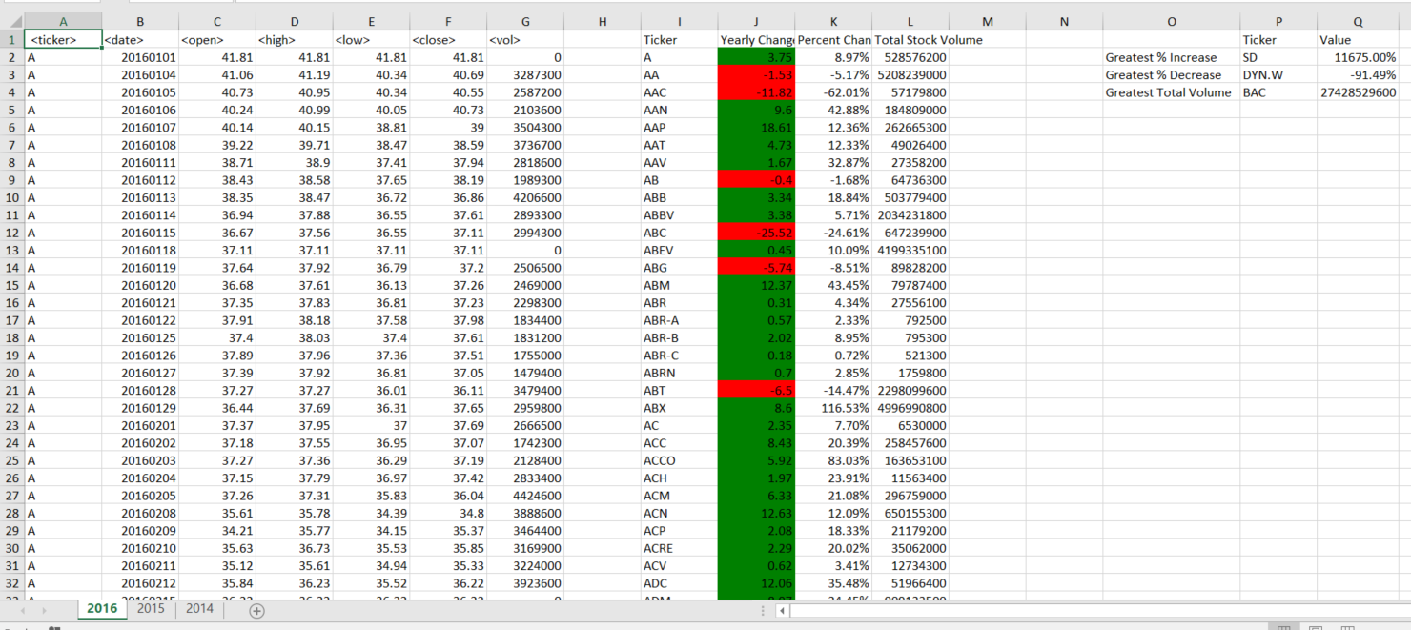

Tab 2015

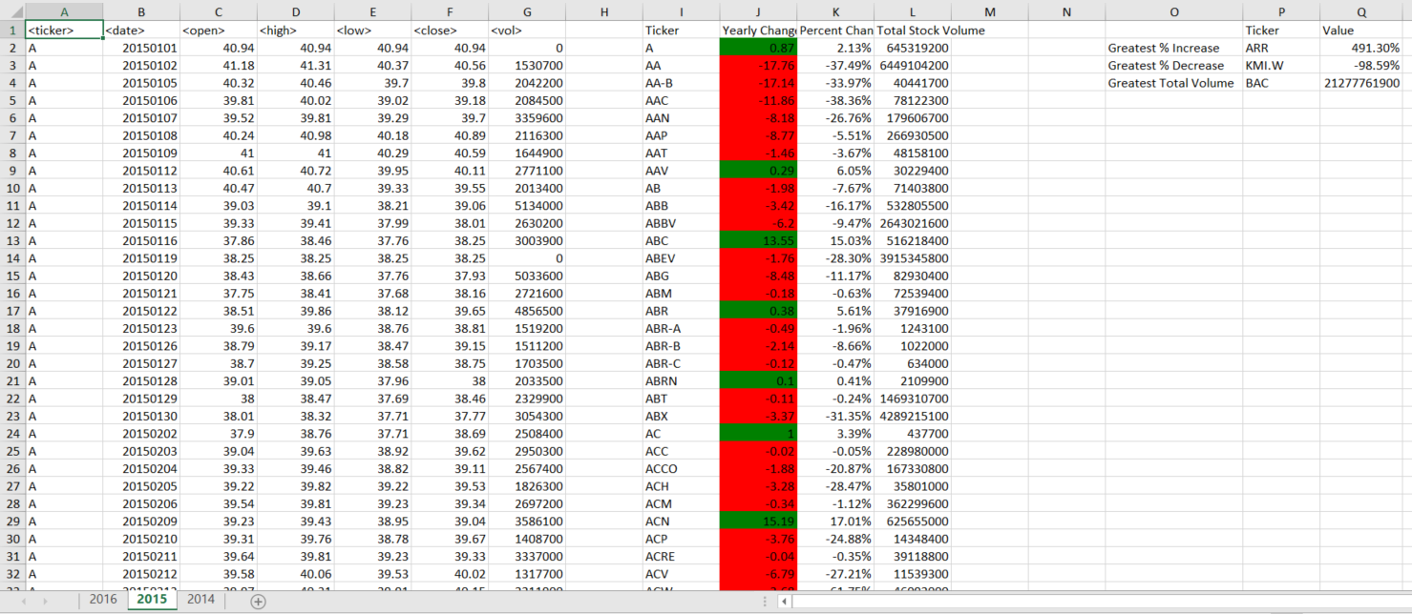

Tab 2014

