Mark Fajet’s FTP Client and Server in Python
Mark Fajet
4937203
Introduction
For this project, the goal was to create an FTP client and server from scratch in python using sockets. In order to do this, I needed to learn about TCP, sockets, and FTP. I learned about TCP and sockets in class and through the class textbook, Computer Networking: A Top Down Approach. In addition, I needed to learn about the specification of FTP which I did by reading through the RFC specifications at https://www.ietf.org/rfc/rfc959.txt. The final product of this assignment is a multithreaded FTP Server that can accept multiple clients and a multithreaded FTP client that can communicate with that server or other FTP servers that follow the RFC specifcations.

Problem Statement
Create a multithreaded FTP client and server that follow the RFC specifications defined at https://www.ietf.org/rfc/rfc959.txt.

Methodology
I began the project by reading through all of the requirements and doing one small section at a a time. The first thing I did after that was read over and analyze the provided FTP client that implemented only 9 commands. From there, I was able to gain a general understanding of how FTP works. Over TCP, it sends and FTP server certain keywords that the server will process and reply to.
One command at a time, I would look at the RFC specifications to see the syntax required and the expected result. I’d send the syntactically proper command through my FTP client to the already-made server hosted on the school. I continued doing this until I had all of the required commands implemented.
Once the basic commands of the FTP client were completed (working when testing against the school server), I began working on an FTP server. I began by creating a basic TCP server using sockets. From then on, it was a matter of checking what command was sent and acting accordingly. In order to implement many of the commands, I had to use the python os library. This allowed me to do many things like renaming files, checking if files or directory exists, and listing files. For most commands, it was easy to implement because it required only receiving a message, doing one thing, and sending a reply. The difficult part came up when doing the commands that require a data channel.
In order to implement the commands that require a data channel, I had to figure out the proper order in which to send and receive messages. After I figured out the proper order of messages to receive and send, all of the commands that required data channels behaved the same way.
In order to multithread the server, every time I accept a new connection, I handle it in a separate thread in order to allow me to accept more connections. I did so using the threading library provided by python. In order to multithread the client, all of the commands that require data channels are executed in separate threads. The goal of this is to prevent blocking when the commands take a long time to execute, like when you’re sending a large file over ftp.
In order to simplify the command line arguments, I used argparse. This allowed me to list the command line arguments that will be accepted along with their types. In order to easily parse config files, I used ConfigParser. This allowed me to easily parse various config files. The one exception to this is the users file which I felt was easier to simply load into an array with string parsing line by line.
The next hard part was implementing the service port. The service port was difficult because it involved constantly listening for the scripts telling it to stop or start. I created a separate thread that listens for those scripts. I had to use a trick where I connect to the socket to make it stop listening to others.
I also had to manage the users and permissions. My main method of doing this was with controlling where a certain user can go. The idea was that a user can’t get to folders they’re not allowed to go to. If they’re logged in as a normal user. They’re only allowed to get what is within their directory. One issue to be fixed was to create the user’s directory if it did not already exist.

Results
I was successfully able to create a functioning multhreaded FTP client and FTP server. The list of commands able to be run on the client is:
delete
dir
image
disconnect
lcd
rhelp
append
rmdir
ascii
type
exit
lpwd (local directory)
put
binary
ls
pwd
send
bye
quit
usage
user
cd
ftp
verbose
cdup
open
get
mkdir
?
close
debug
help
rename
sunique

lls
noop
The final list of commands implemented in the FTP server is as follows:
QUIT
HELP
PWD
MKD
RMD
LIST
CWD
CDUP
PORT
USER
PASS
RETR
NOOP
DELE
STOR
STOU
RNFR
RNTO
APPE
TYPE
In addition, one can user the python scripts “ftp_server_start.py” and “ftp_server_stop.py” to resume and pause the server so that it won’t accept any new messages or clients.
From the test files, you can see that all of the commands execute properly. You can also see that, bad input or wrong permissions won’t cause it to crash nor will it allow illegal actions to take place.

Example output:
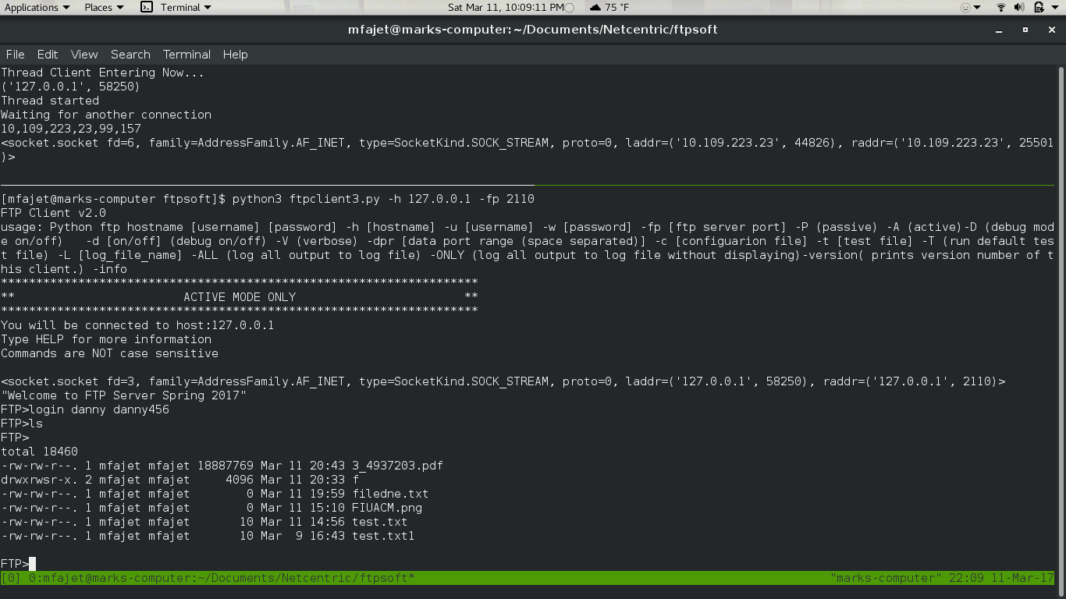

More example output:
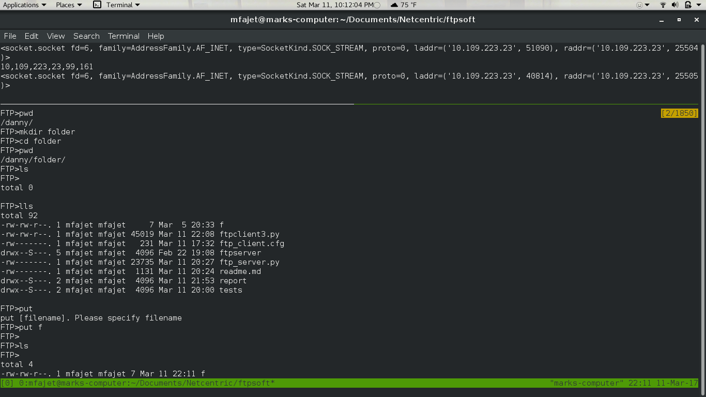

Example of four clients connected at once:
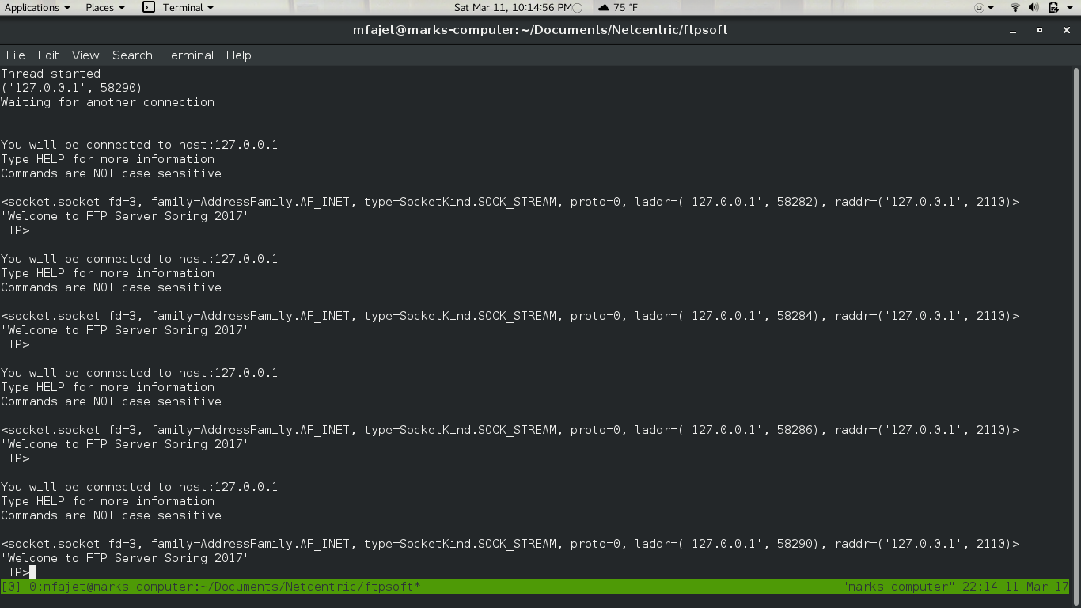
Analysis
The project turned out to be a very lengthy one. It involved lots of testing and careful ordering of messages. I learned that if certain messages are sent or received in the wrong order, a client or server may end up hanging as they wait for the other to send a message that has already been sent or will not be sent. This really shows the importance of protocols. When I failed to properly follow the protocol, the programs would not work right.
This project also emphasized a side of multithreading I had, until now, not experienced. In the past, I used multithreading for performance enhancements. In this project, I was able to use it as a way to prevent blocking and increase the capabilities of a server. This method of multithreading is very common and very important.
Aside from the stress of being unsure if I could complete such a hefty task, the creation of this ftp client and server was overall a rewarding experience that allowed me to get additional, more formal, experience with Python.
One problem I had to deal with was neatly terminating. Threads would be kept waiting on a receive or an accept so I had to find ways around that in order to deal with these problems. One way to get around the accept was to connect to a socket within the server and then close the socket. To get around the waiting for a receive, I found out that socket had a shutdown method that allowed mt to stop incoming receives. This allowed my threads to terminate so I could call join and exit gracefully.
In addition, error handling had to be done throughout the entire project. This is because there are so many chances for errors, especially since the project relies heavily on communication between two different programs and on user input.
References
For mapping of aliases to FTP server commands: http://ftpguide.com/Aliases.htm
For argparse: https://docs.python.org/3/library/argparse.html
For ConfigParser: https://docs.python.org/3/library/configparser.html
For os: https://docs.python.org/3/library/os.html
For subprocess: https://docs.python.org/3/library/subprocess.html
For RFC specifications: https://www.ietf.org/rfc/rfc959.txt

