Abdullah & Co. Staffing
goabdullah.com —------------------- Domain
marketing slogan: "Need top talent? Go Abdullah.
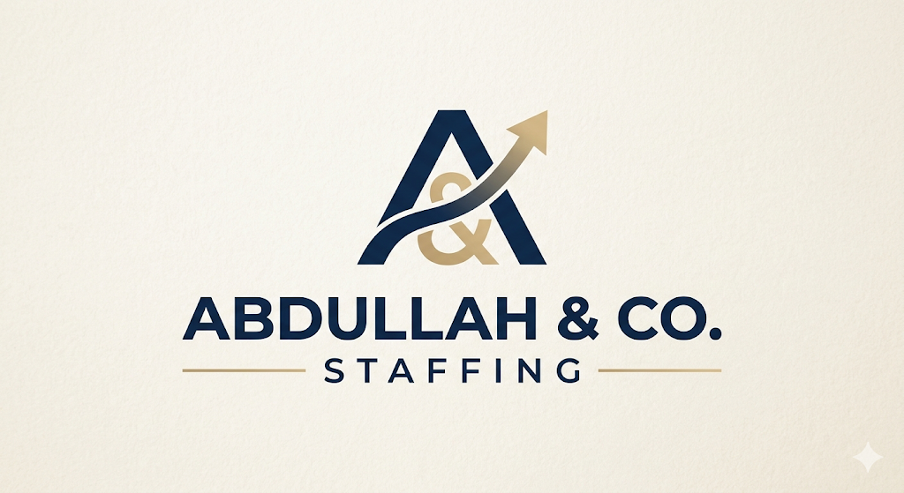

Abdullah & Co. is an elite U.S. executive search and staffing agency specializing in technical IT recruitment and high-caliber attorney placements. Combining active headhunting precision with a relationship-driven approach, we connect top-tier professionals with leading organizations to drive seamless corporate growth.
Abdullah Ashfaq
Founder & CEO
Abdullah Ashfaq is an executive recruiter specializing in high-caliber U.S. attorney placements and elite talent acquisition. As the driving force behind Abdullah & Co., he brings a sophisticated, relationship-driven approach to connecting top-tier legal and executive professionals with leading organizations across the United States.
Abdullah has built a diverse recruitment portfolio spanning legal headhunting, technical hiring, and comprehensive HR operations. His hands-on experience includes executing targeted attorney searches for U.S.-based law firms, as well as managing full-cycle technical talent acquisition pipelines globally. Having successfully operated across the U.S., Pakistan, and Bangladesh markets, he possesses a deep, nuanced understanding of cross-border hiring dynamics and modern sourcing strategies. This global perspective allows him to build highly resilient candidate networks and deliver streamlined, efficient hiring solutions for his clients.
Abdullah holds a Bachelor of Business Administration (BBA) from the UVAS Business School in Lahore. Mirroring the dedication and focus he brings to executive search, his academic tenure was defined by strong leadership and athletic excellence. He served as a Coordinator for the UVAS Sports Society and represented his university on the national stage as a competitive boxing championship athlete.
Driven by a people-first philosophy, Abdullah combines active, aggressive headhunting techniques with exceptional communication skills to act as a trusted advisor to both clients and candidates navigating today’s competitive talent landscape.

Industries We Serve

💻 Information Technology & Technical Hiring
In a fast-evolving digital market, speed and technical accuracy are everything. We manage full-cycle technical recruitment across a diverse array of IT roles. From software engineers and data scientists to infrastructure architects, we utilize advanced sourcing methodologies to deliver agile, top-tier tech talent capable of driving innovation from day one.

⚖️ Legal Placement & Executive Search
The U.S. legal landscape demands absolute precision, discretion, and elite talent. We specialize in identifying, vetting, and placing high-caliber attorneys, lateral partners, and senior legal executives into leading law firms and corporate legal departments. Leveraging a relationship-driven approach and active headhunting techniques, we ensure your firm secures professionals who align with both your billable standards and corporate culture.

Why Choose Us?
At Abdullah & Co., we don’t just fill vacancies—we engineer strategic talent matches. Here is why U.S. law firms and corporate enterprises trust us with their critical hires:
- Active Headhunting vs. Passive Sourcing: We don't just post jobs and wait for resumes. We proactively map out the market, utilizing aggressive, active headhunting techniques to reach passive, elite professionals who aren't looking at job boards.
- Cross-Border Talent Network: With a proven recruitment footprint spanning the U.S. and South Asian markets, we bring a sophisticated understanding of global sourcing dynamics, giving our clients a broader, more resilient talent pipeline.
- A People-First, Relationship-Driven Approach: We act as an extension of your own brand. By building deep, trusted relationships with our candidate networks, we ensure higher retention rates, seamless onboarding, and streamlined hiring processes.
- Unyielding Grit & Discipline: Led by a founder with a background rooted in competitive athletic excellence and corporate leadership, our agency operates with the discipline, focus, and resilience required to close the toughest, most competitive executive searches.
Page: About us
1. Company introduction (mission, vission, vaues)
2. Overview of our working process
3. Our Team
4. Our services
Page: Hire talent
Hire Talent | 1. Industries served : IT & Legal  2. Benefits (outsourcing from us)  3. Inquiry form:  . Company name  . Hiring needs  . contact info
Benefits (outsourcing from us)
Partnering with Abdullah & Co. gives U.S. organizations a distinct competitive edge. By outsourcing your IT and legal recruitment to us, your firm eliminates the friction of talent acquisition while unlocking a faster, more cost-effective path to growth.
Here are the strategic benefits of outsourcing your hiring needs to our agency:

1. Significant Cost Reduction & Higher ROI
- Zero Overhead: Maintaining an in-house talent acquisition team in the U.S. comes with high fixed salaries, software licenses, and benefits. Partnering with us converts those fixed costs into a variable, success-based model.
- Minimized Cost-of-Vacancy: Every day a critical software architecture or attorney position remains open, your company loses revenue. Our active sourcing framework significantly reduces your time-to-hire, keeping your projects moving and billable hours flowing.

2. Immediate Access to "Invisible" Passive Talent
- Beyond Job Boards: The highest-caliber U.S. attorneys and elite tech professionals rarely look at job postings. They are busy performing at their current firms.
- The Headhunting Advantage: Because we utilize active, aggressive headhunting methods rather than passive sourcing, we actively penetrate the market to engage top-tier professionals who are completely invisible to your internal HR team.

3. Accelerated Sourcing Speed Through Global Scale
- The 24/7 Recruitment Engine: Leveraging a unique cross-border footprint, our team can map out U.S. markets, source candidates, and vet tech stacks or practice portfolios around the clock.
- Rapid Talent Pipelines: While your U.S. competitors sleep, our sourcing engine is actively building your talent pipeline, allowing us to deliver high-quality shortlists in a fraction of the standard industry time.

Page; Blogs
Here are four highly optimized, ready-to-publish SEO blog posts tailored specifically for goabdullah.com.
They are structured to establish your authority in both the IT and Legal sectors, using clear formatting, bolded keywords for search engines, and persuasive calls-to-action to convert reading managers into high-value clients.

Pillar 1: Information Technology & Tech Hiring

Blog 1: The Financial Drain of Open Tech Roles

Title: How to Reduce the Cost of Vacancy for Senior Software Engineers in the U.S.
When a critical engineering seat sits empty, most companies look at the money they are "saving" on a salary. This is a dangerous financial illusion. In the fast-moving U.S. tech landscape, the cost of vacancy for senior software engineers is a hidden profit killer that actively drains corporate resources every single day.
When a key technical position remains open, the negative impacts ripple across your entire engineering ecosystem:
- Delayed Product Launches: Missed milestones stall market entry, giving your competitors a massive head start.
- Team Burnout and Churn: Your remaining developers must absorb the extra workload, leading to fatigue, dropped code quality, and eventual resignation.
- Lost Strategic Momentum: Innovation takes a backseat to basic system maintenance.

Shifting to a Success-Driven Model
To protect your bottom line, tech leaders must transition from slow, passive hiring to a high-velocity framework. Traditional HR departments are often bogged down by generic applicant tracking systems (ATS) that flood inboxes with unqualified resumes.
Accelerating your time-to-hire requires a continuous, proactive pipeline. By outsourcing tech recruitment in the U.S. to an agile partner, you convert high fixed HR overhead into a lean, variable, success-based model.

The 24/7 Sourcing Advantage
At Abdullah & Co., we eliminate the friction of tech talent acquisition. Utilizing a sophisticated, cross-border sourcing engine, we actively map the market and engage top-tier talent around the clock. While your local market sleeps, our team is vetting tech stacks and shortlisting candidates.
If you are ready to stop losing revenue to open tech vacancies and want to hire senior software engineers fast, partner with an agency built for speed.
Ready to close your technical talent gaps? Connect with our specialized team today at goabdullah.com to secure your next high-performing engineer.

Blog 2: Penetrating the Passive Tech Market

Title: Active Headhunting vs. Job Boards: Sourcing Passive Elite Tech Talent
The traditional hiring model is officially broken for highly specialized technical roles. If your corporate growth strategy relies on posting an opening on standard job boards and waiting for the perfect applicant, you are missing out on the top 10% of developers in the market. To secure game-changing engineering talent, companies must learn how to recruit software engineers who aren't even looking for a job.

The Reality of the Tech Talent Market
Elite software developers, cybersecurity architects, and data scientists rarely browse job boards. They are well-compensated, highly valued, and deeply embedded in their current roles. Standard job postings typically attract active job seekers—frequently resulting in high-volume, low-quality resume spam that exhausts your internal HR team.
True talent acquisition requires a shift from passive processing to aggressive market penetration.
- Passive Sourcing: Posting a job ad and filtering through hundreds of mismatched profiles.
- Active Headhunting: Directly identifying top-performing engineers at competitor firms and mapping out custom talent networks.

The Art of the Precision Pitch
Engaging passive, top-tier tech professionals requires deep industry credibility and a highly personalized approach. You cannot attract an elite engineer with a generic copy-pasted email. It takes an explicit understanding of their tech stack, their career trajectory, and a compelling narrative about your company’s technical challenges.
Our specialized technical staffing solutions are built on direct, multi-channel outreach. At Abdullah & Co., we don't wait for talent to find us. We actively headhunt the quiet networks, engaging elite professionals through relationship-driven recruiting to deliver pre-vetted, exact-match shortlists straight to your hiring managers.
Stop waiting for top talent to apply. Let us hunt for you. Discover our active sourcing framework at goabdullah.com.

Pillar 2: Legal Placement & Executive Search

Blog 3: Navigating High-Stakes Legal Hiring

Title: Lateral Partner Moving Checklist: A Discretion-First Guide to Attorney Placements
In the elite tiers of the U.S. legal sector, lateral partner acquisitions are among the most lucrative growth strategies a law firm can execute. However, they are also the highest-risk. When dealing with high-caliber attorneys possessing substantial books of business, absolute discretion isn't just a preference—it is a strict professional requirement. A single leak can damage reputations, fracture client trust, and dismantle millions in revenue.
If your firm is planning a strategic practice group expansion, navigating the lateral market requires a meticulous, structured approach.

1. Prioritize Strict Confidentiality From Day One
Before any financial data or client portfolios are discussed, ensure absolute operational firewalls are in place. Communication must happen through secure, private channels entirely outside of normal business hours. This protects both the acquiring firm and the moving partner from premature market exposure.

2. Meticulously Audit the Transferable Book of Business
A successful lateral partner legal recruitment strategy hinges on realistic financial vetting. Firms must look past surface-level numbers and deeply analyze:
- Real client portability and historical realization rates.
- Potential conflicts of interest within the firm's existing client roster.
- How the incoming practice group aligns with the firm’s long-term billable hour structures.

3. Utilize an Expert Intermediary
Managing partners rarely have the time or the structural buffer to quietly court peer talent without raising flags in the legal community. This is where a dedicated third-party legal executive search firm becomes indispensable.
At Abdullah & Co., we act as your confidential first line of defense. We quietly map out practice groups, clear preliminary hurdles, and facilitate highly sensitive attorney placement services with the extreme discretion and executive polish your firm demands.
Expand your firm’s practice groups with zero market disruption. Contact us confidentially at goabdullah.com to initiate your strategic talent search.

Blog 4: Streamlining Law Firm Operations

Title: Why U.S. Law Firms are Outsourcing Associate Recruitment to Specialized Agencies
The billable hour is the lifeblood of any successful law firm. Yet, managing partners and practice group leaders routinely find themselves losing highly profitable hours to a frustrating administrative task: sorting through mountains of legal resumes to find qualified corporate associates.
As the legal market grows increasingly competitive, top-tier firms are scaling back their internal HR burdens and embracing specialized legal recruitment outsourcing.

The Hidden Drain on In-House Teams
While internal HR teams are excellent at managing day-to-day corporate operations, they often lack the highly specialized networks required to track down elite legal talent. Identifying a high-performing associate from an Am Law 200 firm requires deep, industry-specific headhunting techniques—not generic keyword matching.
When your senior partners spend their evenings sourcing candidates instead of billing clients, your firm faces a massive operational deficit.

The Strategic Benefits of Specialized Legal Search
Partnering with a boutique agency that understands the precise nuances of law firm executive search unlocks immediate advantages:
- Immediate Billable Impact: Your internal leadership stays focused on client revenue while expert recruiters build your pipeline in the background.
- Pre-Vetted Professional Quality: You only interview associates who have already been rigorously screened for academic pedigree, practice alignment, and billable expectations.
- Dramatically Higher Retention: Specialized headhunters align long-term career goals with firm culture, drastically lowering associate churn.
At Abdullah & Co., we combine aggressive headhunting discipline with a deep respect for legal standards. We seamlessly manage the heavy lifting of attorney talent acquisition, allowing your firm to scale efficiently without sacrificing valuable billable hours.
Streamline your firm's legal hiring pipeline today. Partner with our executive search team by visiting goabdullah.com.

Page; Pricing
Our Engagement Models
At Abdullah & Co., we understand that every talent search carries unique demands regarding speed, complexity, and confidentiality. We offer flexible, transparent engagement structures tailored to your specific organizational goals.

💼 Contingent Search
- Success-Driven Results: Ideal for mid-to-senior level technical expansions and standard associate placements.
- Structure: Our fee is fully contingent upon the successful identification, placement, and onboarding of your selected professional. You only pay for results.

🎯 Engaged / Container Search
- Prioritized Project Sourcing: Designed for critical, time-sensitive technical roles or highly specialized legal counsel.
- Structure: A small, upfront commitment fee prioritizes your search within our global pipeline, ensuring dedicated active headhunting resources until the position is successfully closed.

🏛️ Retained Executive Search
- Elite & Discreet Headhunting: Tailored for high-stakes leadership roles, including lateral partners with portable books of business, CTOs, and C-suite executives.
- Structure: A structured, multi-phase retainer that secures exclusive market mapping, exhaustive vetting, and absolute discretion from our senior advisors.

Our Professional Guarantee
We stand firmly behind the caliber of our network. Every placement we make comes backed by an industry-standard 90-day retention guarantee. In the rare event that a candidate exits within their first 90 days, our team will source and secure a replacement at zero additional cost to your organization.
Request a Custom Rate Proposal
Every hiring pipeline is different. Contact our executive team today at goabdullah.com to receive a tailored fee structure aligned with your firm's specific timeline and target talent profile.

