(d)

Following figures shows the simulation results on required grid resolutions:

* 30 pressure cells across $x_{2}$ axis:

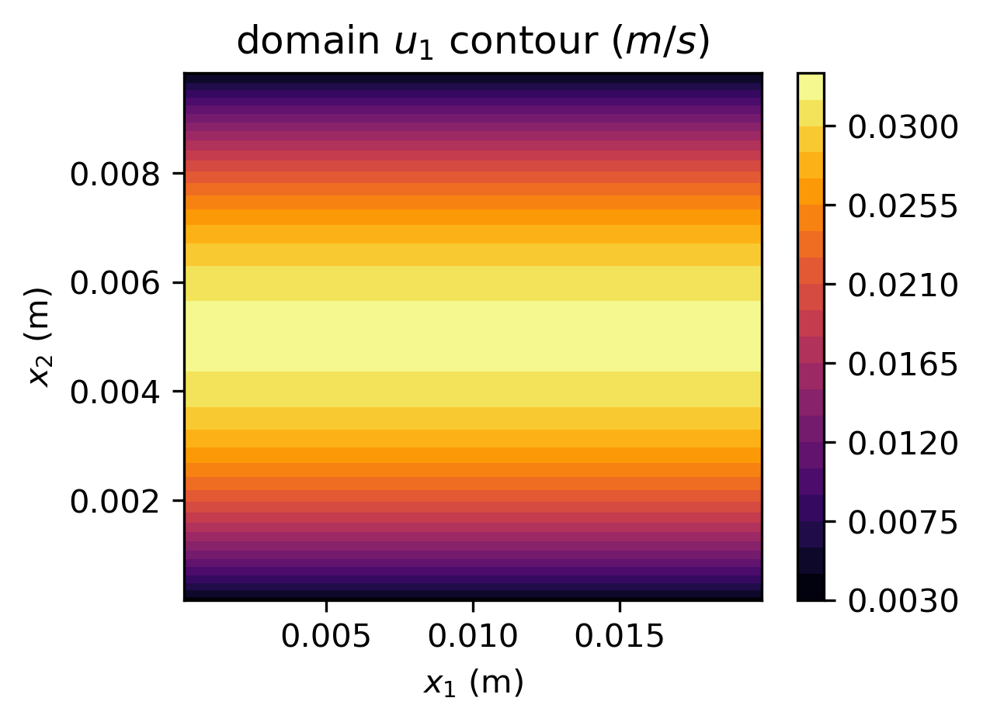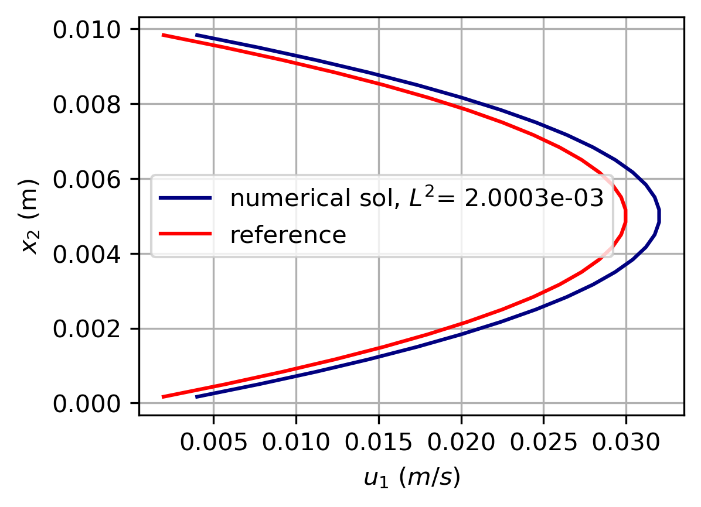

* 50 pressure cells across $x_{2}$ axis

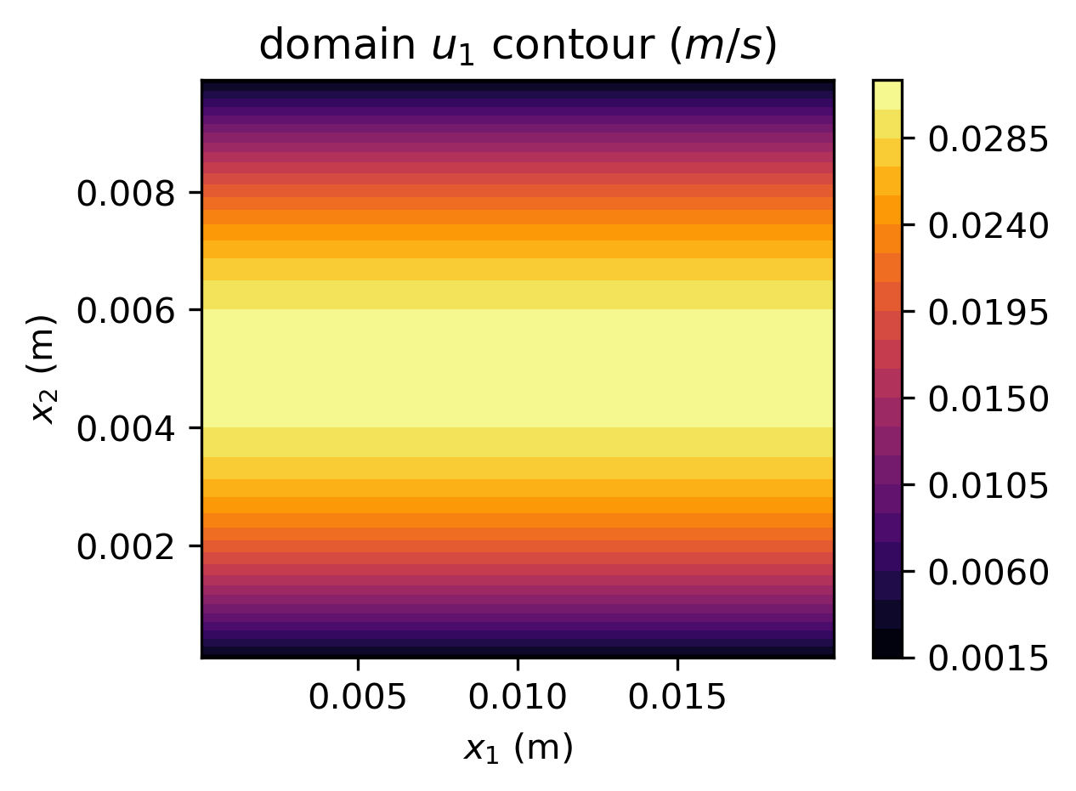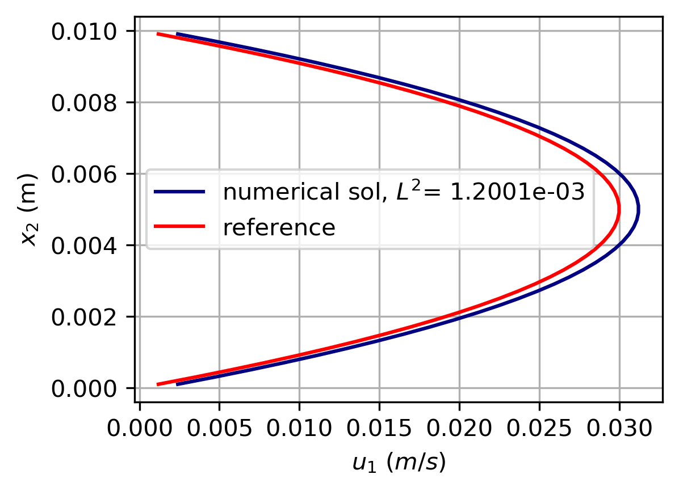

* 70 pressure cells across $x_{2}$ axis

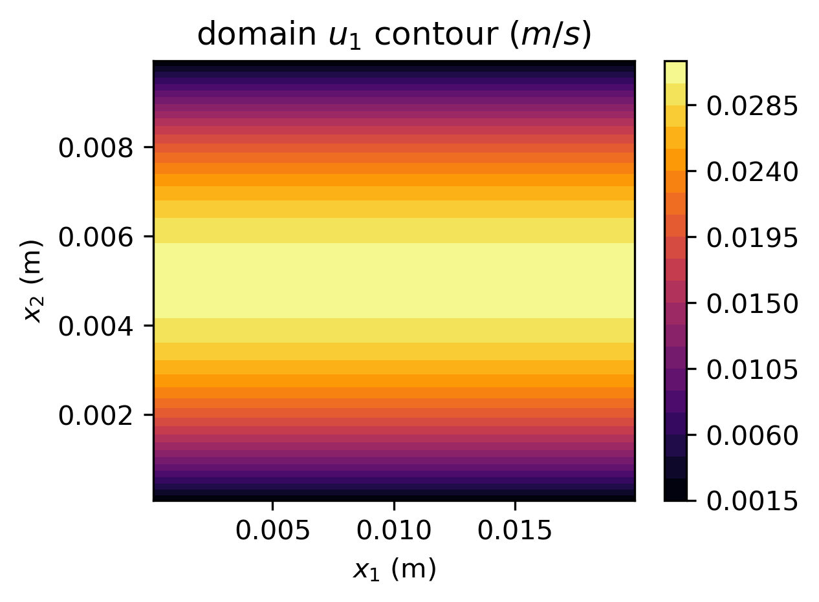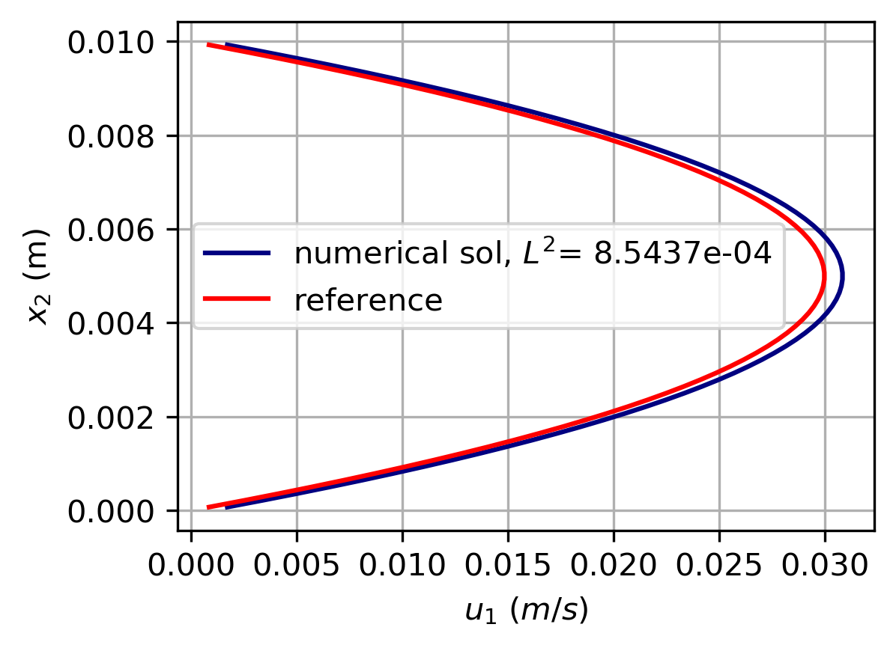

According to results shown above, generally, as grid resolution increases, the steady-state velocity profiles has less $L^{2}$ error. In all cases, though with uniform $\overline{u_{1}}$ profile as initial condition, the resulting velocity profile arrives at parabolic velocity shape with slight deviation particularly at the nose region. It is expected that the accuracy will be improved as grid resolution gets finer.

(e)

Following are the simulation results of steady-state velocity profile in cases of different initial velocity profiles, all performed on grid with 30 pressure cells across $x_{2}$ axis.

* Uniform $0 m/s$ initial condition

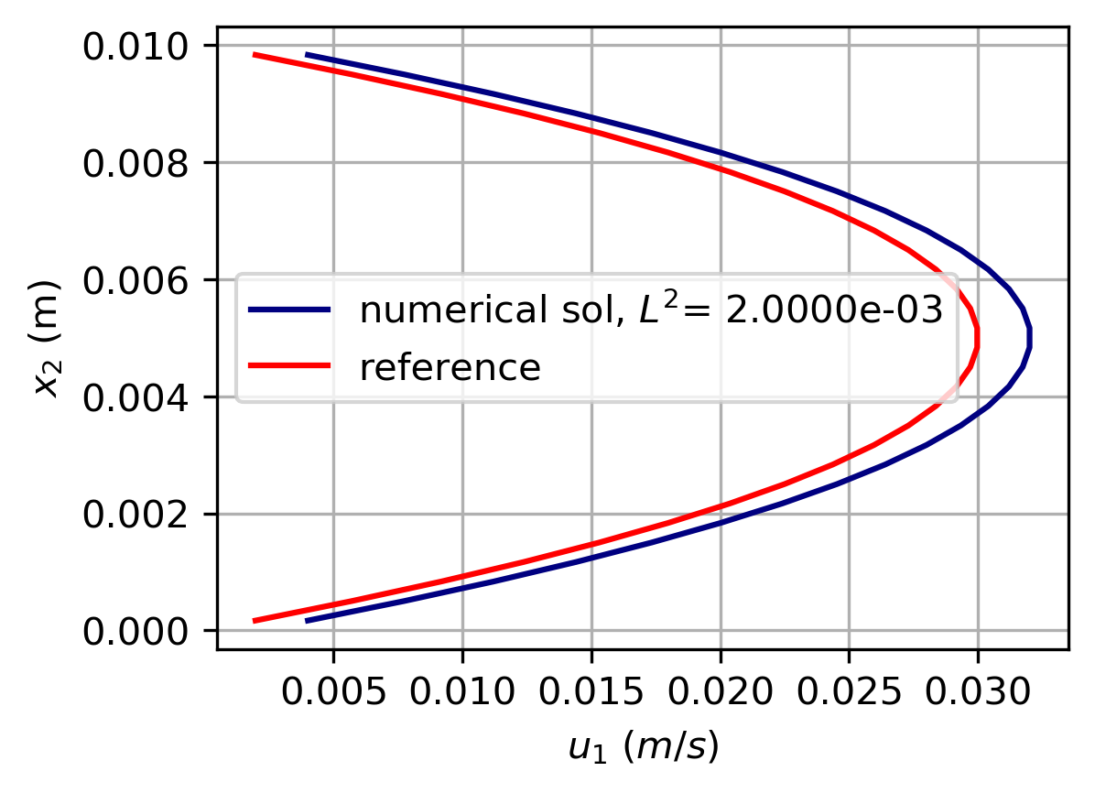

* Uniform $0.03 m/s$ initial condition

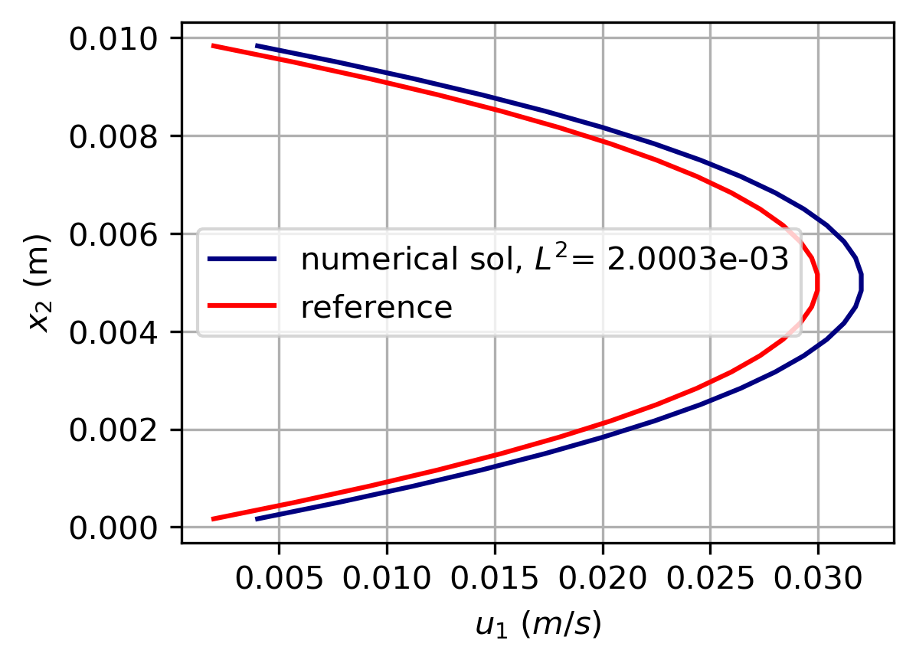

From the results, it can be concluded that the steady-state velocity profile in this case is independent of the initial velocity profile. The final shape and magnitude of velocity profile is the result of correction step and boundary conditions applied. According to the correction step: $u_{1}^{n+1}=u_{1}^{*}-\frac{Δt}{ρ} (\frac{dP}{dx_{1}})$, the amount of correction depends on the pressure gradient applied, which is a fixed value over all nodes in the domain (originally pressure field need to be iterated as well to satisfy divergence-free velocity field in INS solvers). Therefore, the resulting velocity profile is the same regardless of the initial condition.