**#5.2**

(a)

Initial level-set as required, 20 cells across domain height

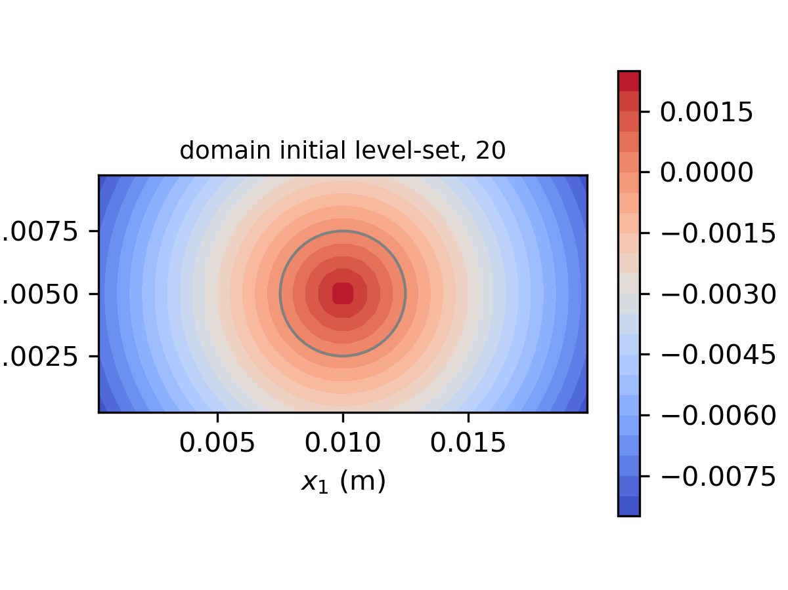

Initial level-set as required, 60 cells across domain height

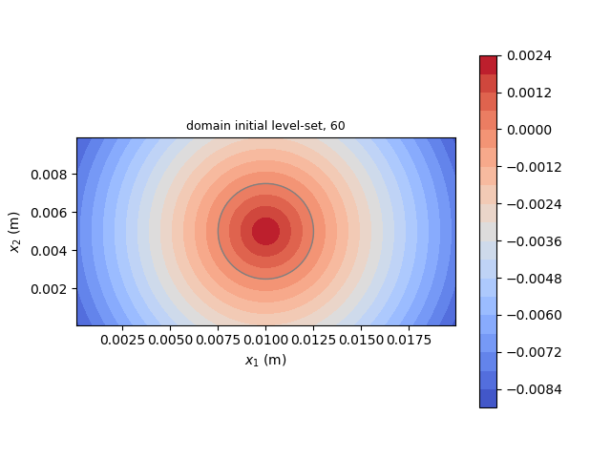

The mesh resolution mainly affects the maximum resolvable level-set despite smoothness in contour. The finer mesh case has higher droplet-center level-set, which is closer to reference (radius of the droplet).

(b)

Advected level-set field, 20 cells across domain height

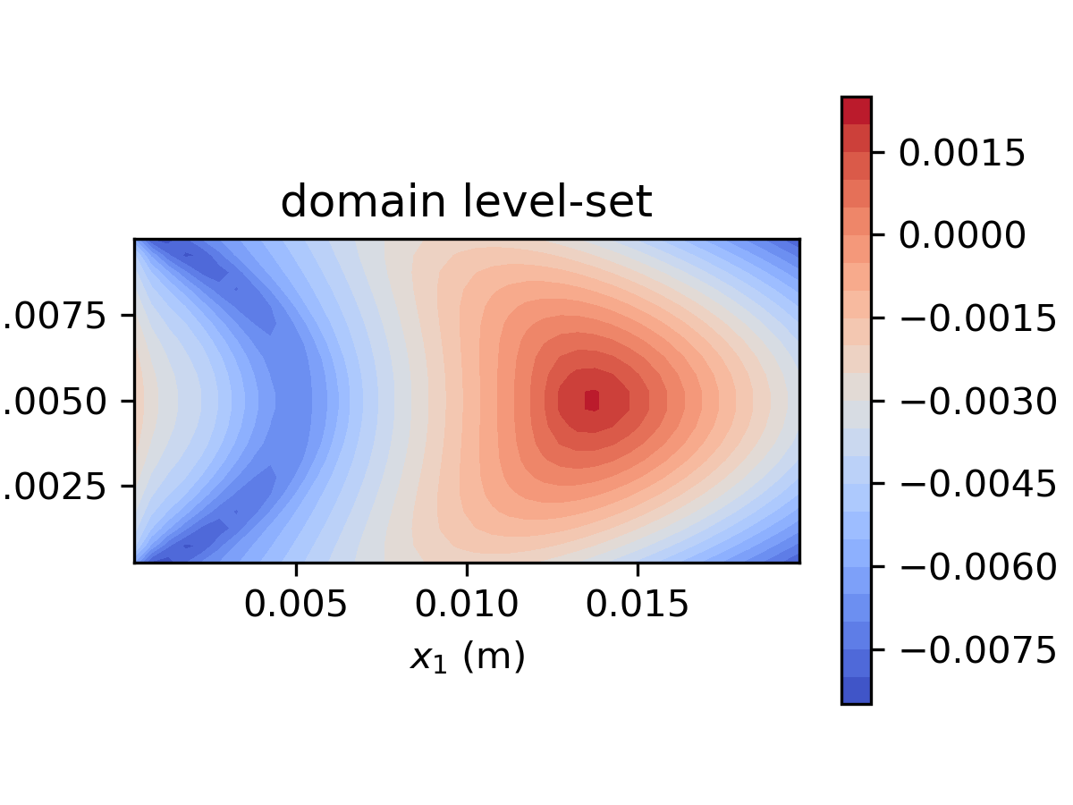

Advected level-set field,60 cells across domain height

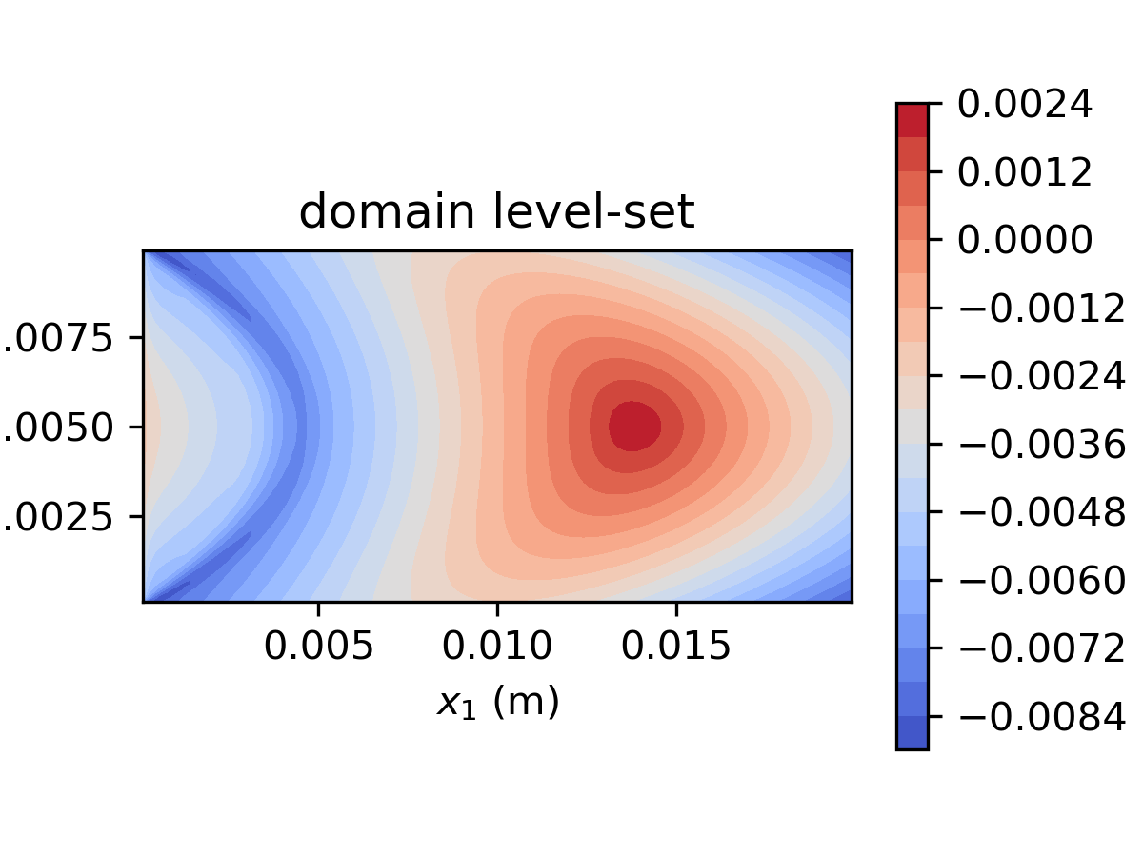

Due to level-set re-distancing is not enabled in the scope of this problem, the level-set field is advected along with the parabolic velocity profile across the channel. The advected droplet was elongated on the direction and the surrounding level-set field becomes bell-shaped. The distortion is more obvious at the near-wall region.

(c)

Initial level-set, initialized at , 20 cells across domain height

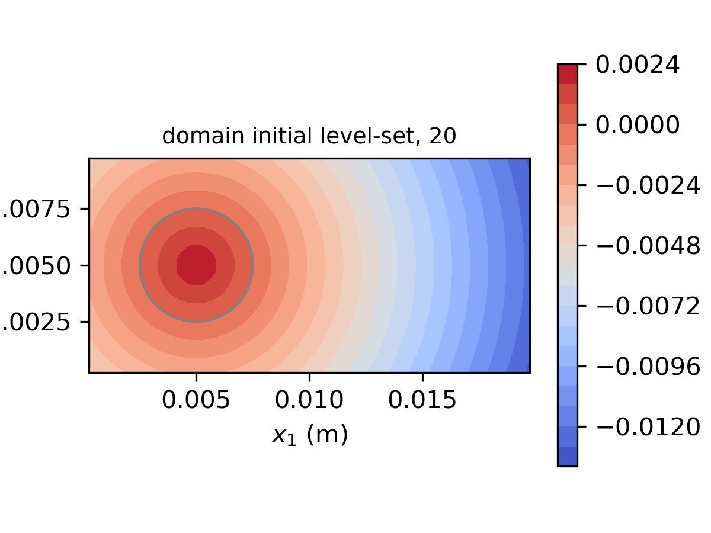

Advected level-set, initialized at , 20 cells across domain height

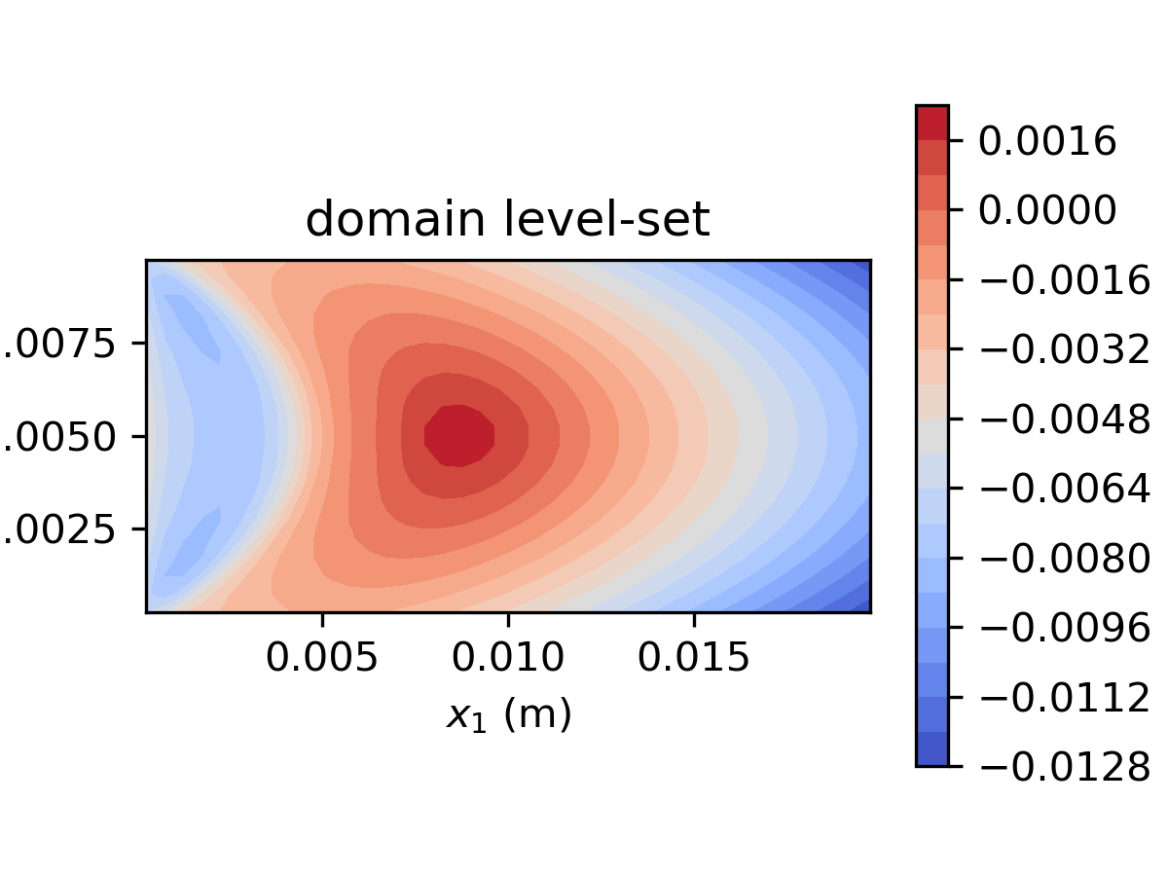

Compare results from different initial drop position, the (c) option is better since the less distortion of level-set at the wake region of the droplet.

(code is attached)

#5.3

The density distribution corresponding to is plotted as below:

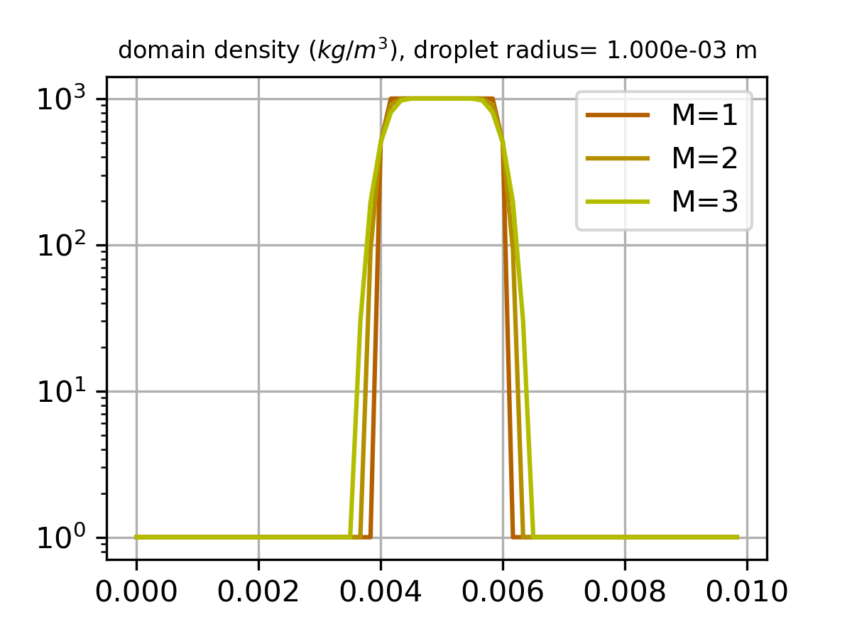

Mass of droplet corresponding to listed options:

|  |  |  |  |
| --- | --- | --- | --- |
|  | Option 1 | Option 2 | Option 3 |
|  | 1.833 | 1.833 | 2.00 |
|  | 1.833 | 1.803 | 2.00 |
|  | 1.833 | 1.759 | 2.00 |

(Reference mass of the 1-D droplet )

From observation, option 3 seems to be the best option to estimate mass of droplet since the loss of mass across smoothed level-set is insignificant compared to option 1 and 2. The option 2 is the most undesired option since the mass loss increases as M increases.

(code is attached)

Code for #5.2 (a), (b), (c)

import numpy as np

import math

import matplotlib

import matplotlib.pyplot as plt

#problem constants

nu=1e-6

mu=1e-3

rho=1e+3

dt=0.00001

gradP=-2.4

n_iter=0

'''

node generation section

'''

#domain length

Lx1=0.02

Lx2=0.01

r_dpl=0.25*Lx2

#number of cells on each direction

Nx1=40

Nx2=20

cell_vol=(Lx1/Nx1)*(Lx2/Nx2)

#mesh spacing

h=Lx1/Nx1

#uave

u1_ave=0.02

def Adv_x_n(i,j):

return (1/h)*((0.5*(cell_S_x_un[i,j]+cell_S_x_un[i+1,j]))**2-(0.5*(cell_S_x_un[i,j]+cell_S_x_un[i-1,j]))**2+(0.5*(cell_S_x_un[i,j+1]+cell_S_x_un[i,j]))*(cell_S_y_vn[i,j+1]+cell_S_y_vn[i+1,j+1])-(0.5*(cell_S_x_un[i,j]+cell_S_x_un[i,j-1]))*(0.5*(cell_S_y_vn[i,j]+cell_S_y_vn[i+1,j])))

def Dif_x_n(i,j):

return (1/(h**2))*(cell_S_x_un[i+1,j]+cell_S_x_un[i-1,j]+cell_S_x_un[i,j+1]+cell_S_x_un[i,j-1]-4*cell_S_x_un[i,j])

#def Adv_y_n(i,j):

# return (1/h)*((0.5*())**2-(0.5*())**2+(0.5*())*(0.5*())-(0.5*())*(0.5*()))

def Dif_y_n(i,j):

return (1/(h**2))*(cell_S_y_vn[i+1,j]+cell_S_y_vn[i-1,j]+cell_S_y_vn[i,j+1]+cell_S_y_vn[i,j-1]-4*cell_S_y_vn[i,j])

def ref_vel_prof(x2):

'''

function returning reference analytic sol

'''

return -1200*((x2-0.005)**2)+0.03

def lvlset_init(x,y):

def ls_dpl(x,y):

return -1*(math.sqrt((x-0.005)**2+(y-0.005)**2)-r_dpl)

return ls_dpl(x,y)

def D_x_p_n(i,j):

return cell_cent_phin[i+1,j]-cell_cent_phin[i,j]

def D_x_m_n(i,j):

return cell_cent_phin[i,j]-cell_cent_phin[i-1,j]

def D_y_p_n(i,j):

return cell_cent_phin[i,j+1]-cell_cent_phin[i,j]

def D_y_m_n(i,j):

return cell_cent_phin[i,j]-cell_cent_phin[i-1,j]

def D_x_p_s(i,j):

return cell_cent_phis[i+1,j]-cell_cent_phis[i,j]

def D_x_m_s(i,j):

return cell_cent_phis[i,j]-cell_cent_phis[i-1,j]

def D_y_p_s(i,j):

return cell_cent_phis[i,j+1]-cell_cent_phis[i,j]

def D_y_m_s(i,j):

return cell_cent_phis[i,j]-cell_cent_phis[i-1,j]

def L_phi_n(i,j):

def phi_xh_n(i,j):

if 0.5*(cell_S_x_unn[i+1,j]+cell_S_x_unn[i,j])>0:

return cell_cent_phin[i,j]+0.5*min(D_x_p_n(i,j), D_x_m_n(i,j))

elif 0.5*(cell_S_x_unn[i+1,j]+cell_S_x_unn[i,j])<0:

return cell_cent_phin[i+1,j]-0.5*min(D_x_p_n(i+1,j), D_x_p_n(i+1,j))

def phi_hx_n(i,j):

if 0.5*(cell_S_x_unn[i,j]+cell_S_x_unn[i-1,j])<0:

return cell_cent_phin[i,j]-0.5*min(D_x_p_n(i,j), D_x_m_n(i,j))

elif 0.5*(cell_S_x_unn[i,j]+cell_S_x_unn[i-1,j])>0:

return cell_cent_phin[i-1,j]+0.5*min(D_x_p_n(i-1,j), D_x_m_n(i-1,j))

def phi_yh_n(i,j):

if 0.5*(cell_S_y_vnn[i,j+1]+cell_S_y_vnn[i,j])>0:

return cell_cent_phin[i,j]+0.5*min(D_y_p_n(i.j), D_y_m_n(i,j))

elif 0.5*(cell_S_y_vnn[i,j+1]+cell_S_y_vnn[i,j])<0:

return cell_cent_phin[i,j+1]+0.5*min(D_y_p_n(i,j+1), D_y_m_n(i,j+1))

def phi_hy_n(i,j):

if 0.5*(cell_S_y_vnn[i,j]+cell_S_y_vnn[i,j-1])<0:

return cell_cent_phin[i,j]-0.5*min(D_y_p_n(i,j), D_y_m_n(i,j))

elif 0.5*(cell_S_y_vnn[i,j]+cell_S_y_vnn[i,j-1])>0:

return cell_cent_phin[i,j-1]+0.5*min(D_y_p_n(i,j-1), D_y_m_n(i,j-1))

#return -1*(cell_S_x_unn[i,j])*(phi_xh_n(i,j)-phi_hx_n(i,j))/h-(cell_S_y_vnn[i,j])*(phi_yh_n(i,j)-phi_hy_n(i,j))/h

return -1*(cell_S_x_unn[i,j])*(phi_xh_n(i,j)-phi_hx_n(i,j))/h

def L_phi_s(i,j):

def phi_xh_s(i,j):

if 0.5*(cell_S_x_unn[i+1,j]+cell_S_x_unn[i,j])>0:

return cell_cent_phis[i,j]+0.5*min(D_x_p_s(i,j), D_x_m_s(i,j))

elif 0.5*(cell_S_x_unn[i+1,j]+cell_S_x_unn[i,j])<0:

return cell_cent_phis[i+1,j]-0.5*min(D_x_p_s(i+1,j), D_x_p_s(i+1,j))

def phi_hx_s(i,j):

if 0.5*(cell_S_x_unn[i,j]+cell_S_x_unn[i-1,j])<0:

return cell_cent_phis[i,j]-0.5*min(D_x_p_s(i,j), D_x_m_s(i,j))

elif 0.5*(cell_S_x_unn[i,j]+cell_S_x_unn[i-1,j])>0:

return cell_cent_phis[i-1,j]+0.5*min(D_x_p_s(i-1,j), D_x_m_s(i-1,j))

def phi_yh_s(i,j):

if 0.5*(cell_S_y_vnn[i,j+1]+cell_S_y_vnn[i,j])>0:

return cell_cent_phis[i,j]+0.5*min(D_y_p_s(i.j), D_y_m_s(i,j))

elif 0.5*(cell_S_y_vnn[i,j+1]+cell_S_y_vnn[i,j])<0:

return cell_cent_phis[i,j+1]+0.5*min(D_y_p_s(i,j+1), D_y_m_s(i,j+1))

def phi_hy_s(i,j):

if 0.5*(cell_S_y_vnn[i,j]+cell_S_y_vnn[i,j-1])<0:

return cell_cent_phis[i,j]-0.5*min(D_y_p_s(i,j), D_y_m_s(i,j))

elif 0.5*(cell_S_y_vnn[i,j]+cell_S_y_vnn[i,j-1])>0:

return cell_cent_phis[i,j-1]+0.5*min(D_y_p_s(i,j-1), D_y_m_s(i,j-1))

#return -1*(cell_S_x_unn[i,j])*(phi_xh_s(i,j)-phi_hx_s(i,j))/h-(cell_S_y_vnn[i,j])*(phi_yh_s(i,j)-phi_hy_s(i,j))/h

return -1*(cell_S_x_unn[i,j])*(phi_xh_s(i,j)-phi_hx_s(i,j))/h

epstot=100.0

p_iter=0

#cell centroid coor

#the +2 stands for ghost cells on each direction

cell_cent_x=np.zeros([Nx1+2,Nx2+2])

cell_cent_y=np.zeros([Nx1+2,Nx2+2])

#cell_cent_un=np.zeros([Nx1+2,Nx2+2])

#cell_cent_us=np.zeros([Nx1+2,Nx2+2])

#cell_cent_unn=np.zeros([Nx1+2,Nx2+2])

cell_cent_pn=np.zeros([Nx1+2,Nx2+2])

cell_cent_pnn=np.zeros([Nx1+2,Nx2+2])

cell_cent_phin=np.zeros([Nx1+2,Nx2+2])

cell_cent_phis=np.zeros([Nx1+2,Nx2+2])

cell_cent_phinn=np.zeros([Nx1+2,Nx2+2])

#cell corner coor

cell_cor_x=np.zeros([Nx1+3,Nx2+3])

cell_cor_y=np.zeros([Nx1+3,Nx2+3])

#surf area of the cell

cell_S_x=np.zeros([Nx1+2,Nx2+2])

cell_S_y=np.zeros([Nx1+2,Nx2+2])

cell_S_x_coor_x=np.zeros([Nx1+2,Nx2+2])

cell_S_x_coor_y=np.zeros([Nx1+2,Nx2+2])

cell_S_y_coor_x=np.zeros([Nx1+2,Nx2+2])

cell_S_y_coor_y=np.zeros([Nx1+2,Nx2+2])

#normal vector of cell surfaces

cell_S_x_nx=np.zeros([Nx1+2,Nx2+2])

cell_S_x_ny=np.zeros([Nx1+2,Nx2+2])

cell_S_y_nx=np.zeros([Nx1+2,Nx2+2])

cell_S_y_ny=np.zeros([Nx1+2,Nx2+2])

#surface velocities

cell_S_x_un=np.zeros([Nx1+2,Nx2+2])

cell_S_x_us=np.zeros([Nx1+2,Nx2+2])

cell_S_x_unn=np.zeros([Nx1+2,Nx2+2])

#cell_S_x_vn=np.zeros([Nx1+2,Nx2+2])

#cell_S_x_vs=np.zeros([Nx1+2,Nx2+2])

#cell_S_x_vnn=np.zeros([Nx1+2,Nx2+2])

#cell_S_x_v=np.zeros([Nx1+2,Nx2+2])

#cell_S_y_un=np.zeros([Nx1+2,Nx2+2])

#cell_S_y_us=np.zeros([Nx1+2,Nx2+2])

#cell_S_y_unn=np.zeros([Nx1+2,Nx2+2])

cell_S_y_vn=np.zeros([Nx1+2,Nx2+2])

cell_S_y_vs=np.zeros([Nx1+2,Nx2+2])

cell_S_y_vnn=np.zeros([Nx1+2,Nx2+2])

#cell_S_y_v=np.zeros([Nx1+2,Nx2+2])

#reference velocity profile

ref_S_u=np.zeros([Nx2+2])

L_sq=np.array([1.0,1.0])

#corner coor initialization

for j in range(0,Nx2+3):

for i in range(0, Nx1+3):

cell_cor_x[i,j]=(Lx1/Nx1)*(i-1)

cell_cor_y[i,j]=(Lx2/Nx2)*(j-1)

#cell cent coor storage

for j in range(0, Nx2+2):

for i in range(0, Nx1+2):

cell_cent_x[i,j]='{:10.6e}'.format(0.25*(cell_cor_x[i,j]+cell_cor_x[i+1,j]+cell_cor_x[i,j+1]+cell_cor_x[i+1,j+1]))

cell_cent_y[i,j]='{:10.6e}'.format(0.25*(cell_cor_y[i,j]+cell_cor_y[i+1,j]+cell_cor_y[i,j+1]+cell_cor_y[i+1,j+1]))

#lvlset init

cell_cent_phin[i,j]=lvlset_init(cell_cent_x[i,j], cell_cent_y[i,j])

cell_S_x_coor_x[i,j]=(cell_cor_x[i,j]+cell_cor_x[i,j+1])/2

cell_S_x_coor_y[i,j]=(cell_cor_y[i,j]+cell_cor_y[i,j+1])/2

cell_S_y_coor_x[i,j]=(cell_cor_x[i,j]+cell_cor_x[i+1,j])/2

cell_S_y_coor_y[i,j]=(cell_cor_y[i,j]+cell_cor_y[i+1,j])/2

#initial conditions

cell_S_x_un[i,j]=ref_vel_prof(cell_cent_y[i,j])

#cell_S_y_un[i,j]=0.00

cell_S_x[i,j]=abs(cell_cor_y[i,j]-cell_cor_y[i,j+1])

cell_S_y[i,j]=abs(cell_cor_x[i,j]-cell_cor_x[i+1,j])

cell_S_x_nx[i,j]=(cell_cor_y[i,j+1]-cell_cor_y[i,j])/cell_S_x[i,j]

cell_S_x_ny[i,j]=(cell_cor_x[i,j+1]-cell_cor_x[i,j])/cell_S_x[i,j]

cell_S_y_nx[i,j]=(cell_cor_y[i+1,j]-cell_cor_y[i,j])/cell_S_y[i,j]

cell_S_y_ny[i,j]=(cell_cor_x[i+1,j]-cell_cor_x[i,j])/cell_S_y[i,j]

bub=plt.Circle((0.005, 0.005), r_dpl, color='grey', fill=False)

fig, ax=plt.subplots()

plt.contourf(cell_cent_x[1:Nx1+1, 1:Nx2+1], cell_cent_y[1:Nx1+1, 1:Nx2+1], cell_cent_phin[1:Nx1+1, 1:Nx2+1], 20, cmap='coolwarm')

plt.colorbar()

ax.add_artist(bub)

plt.xlabel('$x_1$ (m)')

plt.ylabel('$x_2$ (m)')

plt.title('domain initial level-set, '+str(Nx2), fontsize=9)

plt.gca().set_aspect('equal')

plt.savefig('hw5_2_'+str(Nx2)+'_init_ref_ls_init.png')

plt.show()

L_sq_r=L_sq[1]/L_sq[0]

for i in range(1, Nx2+1):

ref_S_u[i]=ref_vel_prof(cell_S_x_coor_y[0,i])

#while L_sq[1]>=1e-5:

while n_iter<=13000:

L_sq[0]=L_sq[1]

#predictor step:

for j in range(1, Nx2+1):

for i in range(1, Nx1+1):

#cell_S_x_us[i,j]=cell_S_x_un[i,j]+dt*(-Adv_x_n(i,j)+nu*Dif_x_n(i,j))

cell_S_x_us[i,j]=cell_S_x_un[i,j]+dt*(nu*Dif_x_n(i,j)-gradP/rho)

epstot=100.0

while epstot>1e-4:

epstot=0.0

for j in range(2, Nx2):

U_s=(rho/(dt*(Lx1/Nx1)))*(cell_S_x_us[2,j]-cell_S_x_unn[1,j]+cell_S_y_vs[1,j+1]-cell_S_y_vs[1,j])

cell_cent_pnn[1,j]=(cell_vol*U_s-(cell_cent_pn[2,j]+cell_cent_pn[1,j+1]+cell_cent_pn[1,j-1]))/(-3)

epstot+=(cell_cent_pnn[1,j]-cell_cent_pn[1,j])**2

cell_cent_pn[1,j]=cell_cent_pnn[1,j]

for i in range(2, Nx1):

for j in range(1,Nx2+1):

U_s=(rho/(dt*(Lx1/Nx1)))*(cell_S_x_us[i+1,j]-cell_S_x_us[i,j]+cell_S_y_vs[i,j+1]-cell_S_y_vs[i,j])

cell_cent_pnn[i,j]=(cell_vol*U_s-(cell_cent_pn[i+1,j]+cell_cent_pn[i-1,j]+cell_cent_pn[i,j+1]+cell_cent_pn[i,j-1]))/(-4)

#print('{:4.4e}, {:4.4e}'.format(cell_cent_pnn[i,j], cell_cent_pn[i,j]))

epstot+=(cell_cent_pnn[i,j]-cell_cent_pn[i,j])**2

cell_cent_pn[i,j]=cell_cent_pnn[i,j]

for j in range(2, Nx2):

U_s=(rho/(dt*(Lx1/Nx1)))*(cell_S_x_unn[-1,j]-cell_S_x_us[-2,j]+cell_S_y_vs[-2,j+1]-cell_S_y_vs[-2,j])

cell_cent_pnn[-2,j]=(cell_vol*U_s-(cell_cent_pn[-3,j]+cell_cent_pn[-2,j+1]+cell_cent_pn[-2,j-1]))/(-3)

epstot+=(cell_cent_pnn[-2,j]-cell_cent_pn[-2,j])**2

cell_cent_pn[-2,j]=cell_cent_pnn[-2,j]

#coroner update

U_s=(rho/(dt*(Lx1/Nx1)))*(cell_S_x_us[2,1]-cell_S_x_unn[1,1]+cell_S_y_vs[1,2]-cell_S_y_vnn[1,1])

cell_cent_pnn[1,1]=(cell_vol*U_s-(cell_cent_pn[2,1]+cell_cent_pn[1,2]))/(-2)

epstot+=(cell_cent_pnn[1,1]-cell_cent_pn[1,1])**2

cell_cent_pn[1,1]=cell_cent_pnn[1,1]

U_s=(rho/(dt*(Lx1/Nx1)))*(cell_S_x_us[2,-2]-cell_S_x_unn[1,-2]+cell_S_y_vnn[1,-2]-cell_S_y_vnn[1,-3])

cell_cent_pnn[1,-2]=(cell_vol*U_s-(cell_cent_pn[2,-2]+cell_cent_pn[1,-3]))/(-2)

epstot+=(cell_cent_pnn[1,-2]-cell_cent_pn[1,-2])**2

cell_cent_pn[1,-2]=cell_cent_pnn[1,-2]

U_s=(rho/(dt*(Lx1/Nx1)))*(cell_S_x_unn[-2+1,1]-cell_S_x_us[-2,1]+cell_S_y_vs[-2,2]-cell_S_y_vnn[-2,1])

cell_cent_pnn[-2,1]=(cell_vol*U_s-(cell_cent_pn[-2-1,1]+cell_cent_pn[-2,2]))/(-2)

epstot+=(cell_cent_pnn[-2,1]-cell_cent_pn[-2,1])**2

cell_cent_pn[-2,1]=cell_cent_pnn[-2,1]

U_s=(rho/(dt*(Lx1/Nx1)))*(cell_S_x_unn[-2+1,-2]-cell_S_x_us[-2,-2]+cell_S_y_vnn[-2,-2+1]-cell_S_y_vs[-2,-2])

cell_cent_pnn[-2,-2]=(cell_vol*U_s-(cell_cent_pn[-2-1,-2]+cell_cent_pn[-2,-2-1]))/(-2)

epstot+=(cell_cent_pnn[-2,-2]-cell_cent_pn[-2,-2])**2

cell_cent_pn[-2,-2]=cell_cent_pnn[-2,-2]

for j in range(0, Nx2+2):

cell_cent_pn[0,j]=cell_cent_pn[-2,j]

cell_cent_pn[-1,j]=cell_cent_pn[1,j]

for i in range(0, Nx1+2):

cell_cent_pn[i,0]=cell_cent_pn[i,1]

cell_cent_pn[i,-1]=cell_cent_pn[i,-2]

if p_iter%500==0:

plt.contourf(cell_cent_x[1:Nx1+1, 1:Nx2+1], cell_cent_y[1:Nx1+1, 1:Nx2+1], cell_cent_pnn[1:Nx1+1, 1:Nx2+1], 20, cmap='jet')

plt.colorbar()

plt.xlabel('$x_1$ (m)')

plt.ylabel('$x_2$ (m)')

plt.title('domain $p^{n+1}$ contour ($Pa$)')

plt.savefig('hw5_2_'+str(Nx2)+'_init_ref_p_contour.png')

plt.gca().set_aspect('equal')

plt.show()

print('eps_tot= {:5.4e}'.format(epstot))

p_iter+=1

#print('eps_tot= {:5.4e}'.format(epstot))

#corrector step:

for j in range(1, Nx2+1):

for i in range(1, Nx1+1):

cell_S_x_unn[i,j]=cell_S_x_us[i,j]-(1/rho)*(dt)*(cell_cent_pnn[i,j]-cell_cent_pnn[i-1,j])

#B.C. update

for j in range(0, Nx2+2):

cell_S_x_unn[0,j]=cell_S_x_unn[-2,j]

cell_S_x_unn[-1,j]=cell_S_x_unn[1,j]

for i in range(0, Nx1+2):

cell_S_x_unn[i,0]=cell_S_x_unn[i,1]

cell_S_x_unn[i,-1]=cell_S_x_unn[i,-2]

for j in range(1, Nx2+1):

for i in range(1, Nx1+1):

cell_cent_phis[i,j]=cell_cent_phin[i,j]+dt*L_phi_n(i, j)

cell_cent_phinn[i,j]=cell_cent_phin[i,j]+0.5*dt*(L_phi_n(i,j)+L_phi_s(i,j))

cell_cent_phin[i,j]=cell_cent_phinn[i,j]

cell_S_x_un[i,j]=cell_S_x_unn[i,j]

for j in range(0, Nx2+2):

cell_S_x_un[0,j]=cell_S_x_un[-2,j]

cell_S_x_un[-1,j]=cell_S_x_un[1,j]

cell_cent_phin[0,j]=cell_cent_phin[-2,j]

cell_cent_phin[-1,j]=cell_cent_phin[1,j]

for i in range(0, Nx1+2):

cell_S_x_un[i,0]=-cell_S_x_un[i,1]

cell_S_x_un[i,-1]=-cell_S_x_un[i,-2]

cell_cent_phin[i,0]=-cell_cent_phin[i,1]

cell_cent_phin[i,-1]=-cell_cent_phin[i,-2]

sq_sum_error=0

for i in range(1,Nx2+1):

sq_sum_error+=(ref_S_u[i]-cell_S_x_un[int(0.5*Nx1),i])**2

L_sq[1]=math.sqrt(sq_sum_error/(Nx2+1))

if n_iter%500==0:

print('iter= '+str(n_iter)+', L_sq= {:.4e}'.format(L_sq[0]))

plt.plot(cell_S_x_un[int(0.5*Nx1),1:Nx2+1],cell_S_x_coor_y[int(0.5*Nx1),1:Nx2+1], color='navy', label='numerical sol, $L^2$= {:10.4e}'.format(L_sq[0]))

plt.plot(ref_S_u[1:Nx2+1] ,cell_S_x_coor_y[int(0.5*Nx1),1:Nx2+1], color='red', label='reference')

plt.xlabel('$u_1$ ($m/s$)')

plt.ylabel('$x_2$ (m)')

plt.legend()

plt.grid()

plt.gca().set_aspect('equal')

plt.savefig('hw5_2_'+str(Nx2)+'_init_ref_v_profile.png')

plt.show()

plt.contourf(cell_cent_x[1:Nx1+1, 1:Nx2+1], cell_cent_y[1:Nx1+1, 1:Nx2+1], cell_S_x_un[1:Nx1+1, 1:Nx2+1], 20, cmap='inferno')

plt.colorbar()

plt.xlabel('$x_1$ (m)')

plt.ylabel('$x_2$ (m)')

plt.title('domain $u_1$ contour ($m/s$)')

plt.gca().set_aspect('equal')

plt.savefig('hw5_2_'+str(Nx2)+'_init_ref_v_contour.png')

plt.show()

plt.contourf(cell_cent_x[1:Nx1+1, 1:Nx2+1], cell_cent_y[1:Nx1+1, 1:Nx2+1], cell_cent_phin[1:Nx1+1, 1:Nx2+1], 20, cmap='coolwarm')

plt.colorbar()

plt.xlabel('$x_1$ (m)')

plt.ylabel('$x_2$ (m)')

plt.title('domain level-set')

plt.gca().set_aspect('equal')

plt.savefig('hw5_2_'+str(Nx2)+'_init_ref_ls.png')

plt.show()

print('{:10d}, {:5.7e}'.format(n_iter, L_sq[1]))

L_sq_r=L_sq[1]/L_sq[0]

n_iter+=1

print('iter= '+str(n_iter)+', L_sq= {:.4e}'.format(L_sq[0]))

plt.plot(cell_S_x_un[int(0.5*Nx1),1:Nx2+1],cell_S_x_coor_y[int(0.5*Nx1),1:Nx2+1], color='navy', label='numerical sol, $L^2$= {:10.4e}'.format(L_sq[0]))

plt.plot(ref_S_u[1:Nx2+1] ,cell_S_x_coor_y[int(0.5*Nx1),1:Nx2+1], color='red', label='reference')

plt.xlabel('$u_1$ ($m/s$)')

plt.ylabel('$x_2$ (m)')

plt.legend()

plt.gca().set_aspect('equal')

plt.savefig('hw5_2_'+str(Nx2)+'_init_ref_v_profile.png')

plt.grid()

plt.show()

plt.contourf(cell_cent_x[1:Nx1+1, 1:Nx2+1], cell_cent_y[1:Nx1+1, 1:Nx2+1], cell_S_x_un[1:Nx1+1, 1:Nx2+1], 20, cmap='inferno')

plt.colorbar()

plt.xlabel('$x_1$ (m)')

plt.ylabel('$x_2$ (m)')

plt.title('domain $u_1$ contour ($Pa$)')

plt.gca().set_aspect('equal')

plt.savefig('hw5_2_'+str(Nx2)+'_init_ref_v_contour.png')

plt.show()

plt.contourf(cell_cent_x[1:Nx1+1, 1:Nx2+1], cell_cent_y[1:Nx1+1, 1:Nx2+1], cell_cent_phin[1:Nx1+1, 1:Nx2+1], 20, cmap='coolwarm')

plt.colorbar()

plt.xlabel('$x_1$ (m)')

plt.ylabel('$x_2$ (m)')

plt.title('domain level-set')

plt.gca().set_aspect('equal')

plt.savefig('hw5_2_'+str(Nx2)+'_init_ref_ls.png')

plt.show()

Code for #5.3

import numpy as np

import math

import matplotlib

import matplotlib.pyplot as plt

L=0.01

N_n=60

r_dpl=0.001

x_dpl=0.005

global h

h=L/N_n

rho_l=1000

rho_g=1

m_1=0

m_2=0

m_3=0

cell_x=np.zeros(N_n)

cell_phi=np.zeros(N_n)

cell_rho=np.zeros(N_n)

def m_o1():

return rho_l*h

def m_o2(rho):

return rho*h

def m_o3(rho):

w=(rho-rho_g)/(rho_l-rho_g)

return rho_l*w*h

def lvlset(x):

if x > (x_dpl-r_dpl) and x < (x_dpl+r_dpl):

return min(abs(x-(x_dpl-r_dpl)), abs(x-(x_dpl+r_dpl)))

else:

return -1*min(abs(x-(x_dpl-r_dpl)), abs(x-(x_dpl+r_dpl)))

def hvsd(phi, M):

if phi< -1*M*h:

return 0

elif abs(phi)<= M*h:

return 0.5*(1+phi/(M*h)+math.sin(math.pi*phi/(M*h))/math.pi)

elif phi> M*h:

return 1

for M in range(1,4):

m_1=0

m_2=0

m_3=0

for i in range(0, len(cell_x)):

cell_x[i]=0.0+i*h

cell_phi[i]=lvlset(cell_x[i])

cell_rho[i]=rho_l*hvsd(cell_phi[i], M)+rho_g*(1-hvsd(cell_phi[i], M))

m_3+=m_o3(cell_rho[i])

if cell_phi[i]>0:

m_1+=m_o1()

m_2+=m_o2(cell_rho[i])

print('{:4.3e}, {:4.3e}, {:4.3e}, {:1d}'.format(m_1, m_2, m_3, M))

#plt.plot(cell_x, cell_phi, color='red', label='domain level-set')

plt.plot(cell_x, cell_rho, color=(0.7, 0.18*M+0.2, 0), label='M={:1d}'.format(M))

plt.yscale('log')

plt.legend()

plt.title('domain density $(kg/m^3)$, droplet radius= {:4.3e} m'.format(r_dpl), fontsize=8)

plt.grid()

plt.savefig('hw5_3_density_distr.png')

plt.show()

#plt.plot(cell_x, cell_rho, color='navy', label='domain density $(kg/m^3)$')

#plt.show()