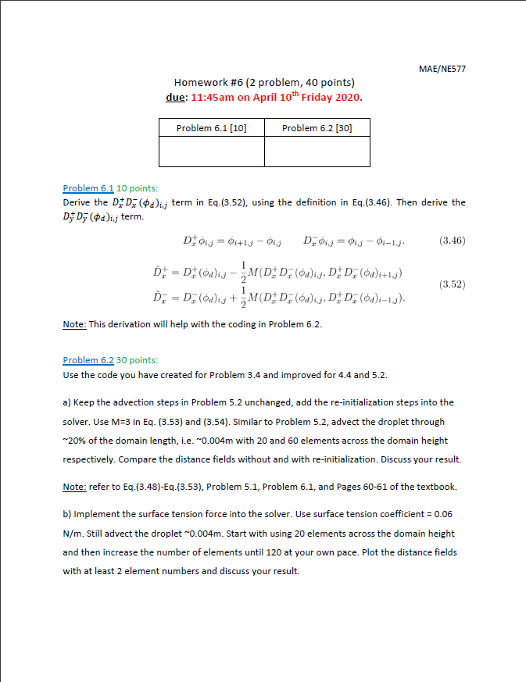

**#Problem 6.2**

**(a)**

INS solver with level-set redistancing feature:

Compare with the results from hw5, with re-distancing, the level-set field near domain boundary is more physical. Moreover, re-initialized level-set is elongated at the center of the bubble, which is consistent with the shape of the interface.

Mesh with 20 cells across the domain height

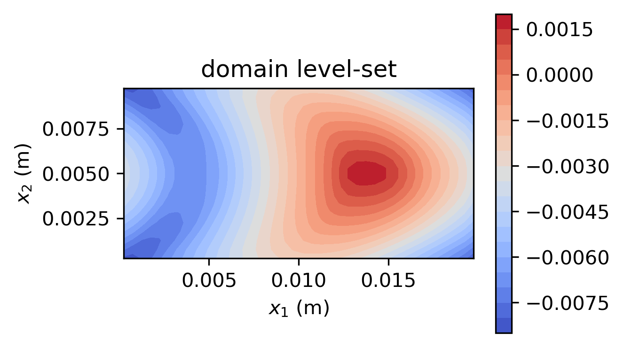

Mesh with 60 cells across the domain height

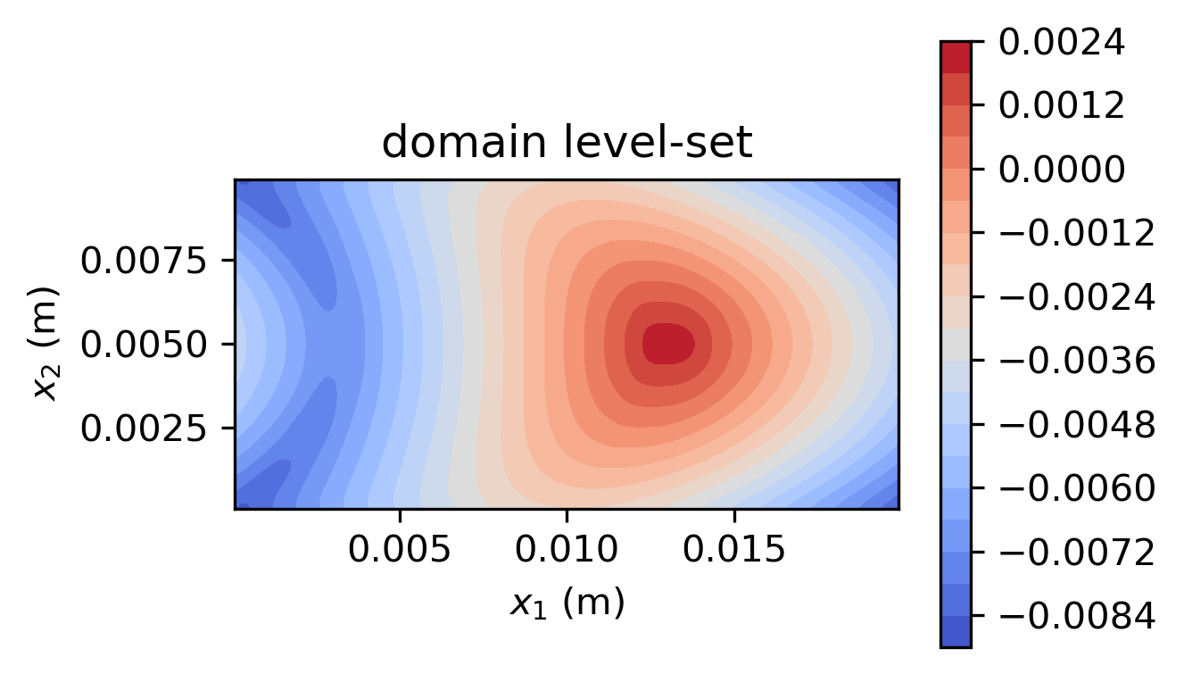

**(b)**

INS solver with level-set redistancing, and surface tension treatment:

Level-set field of mesh with 20 cells across the domain height

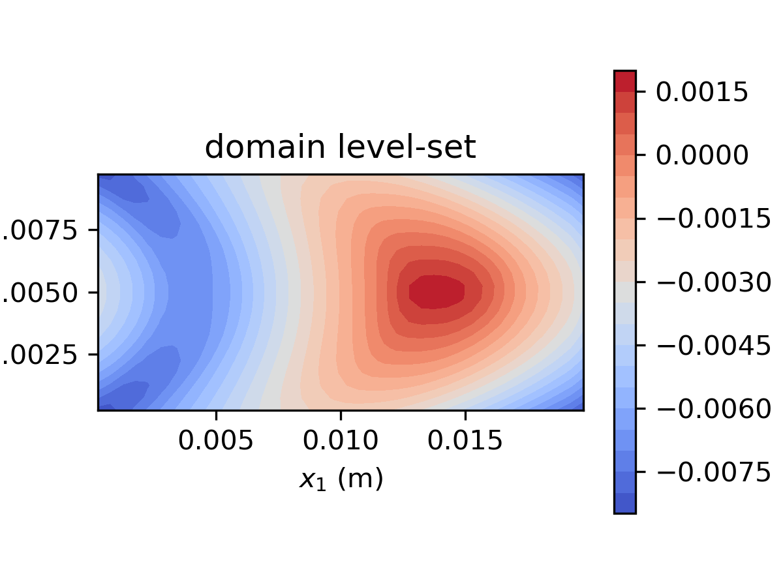

Level-set field of mesh with 50 cells across the domain height

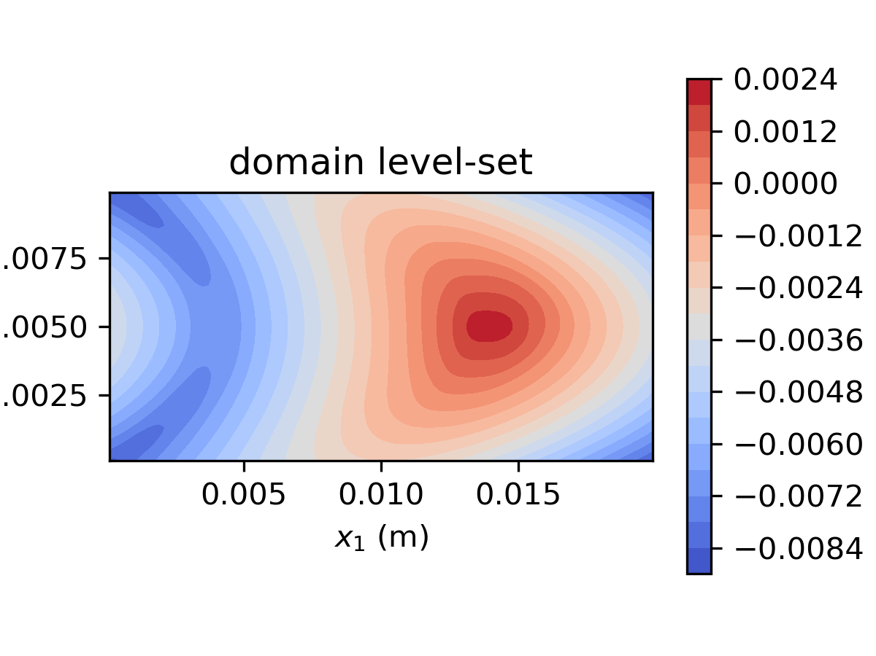

Level-set field of mesh with 60 cells across the domain height

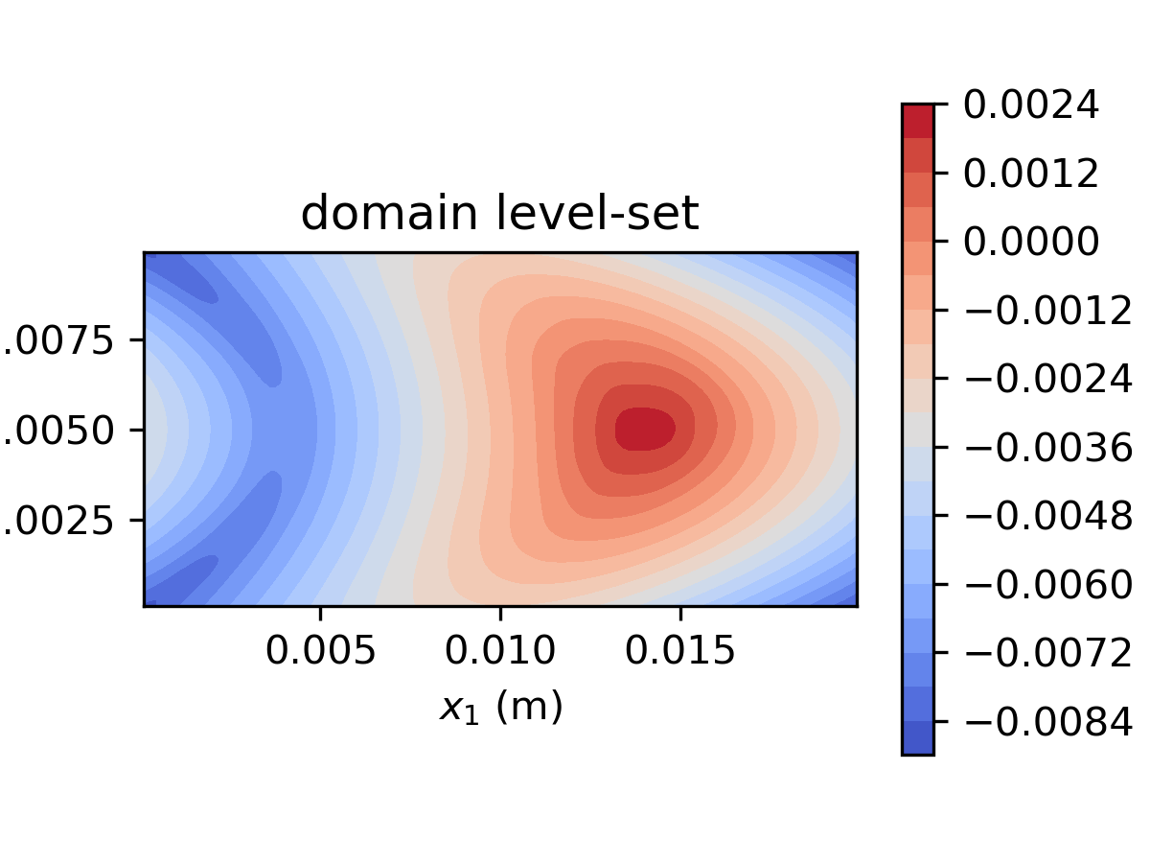

Level-set field of mesh with 80 cells across the domain height

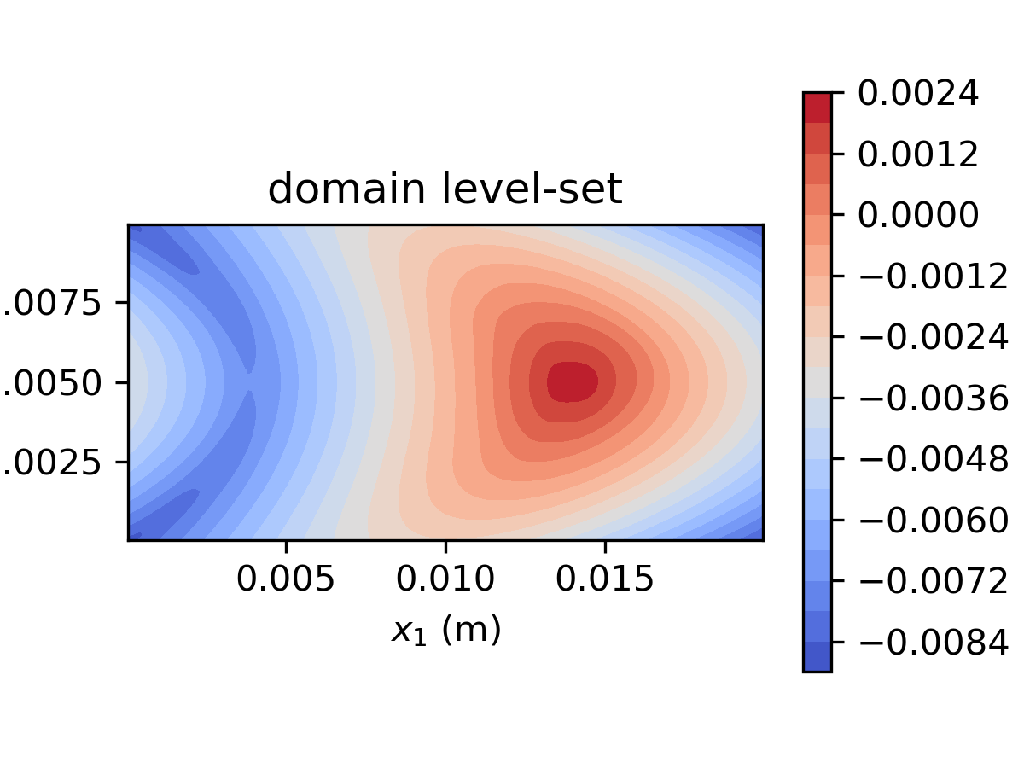

Level-set field of mesh with 120 cells across the domain height

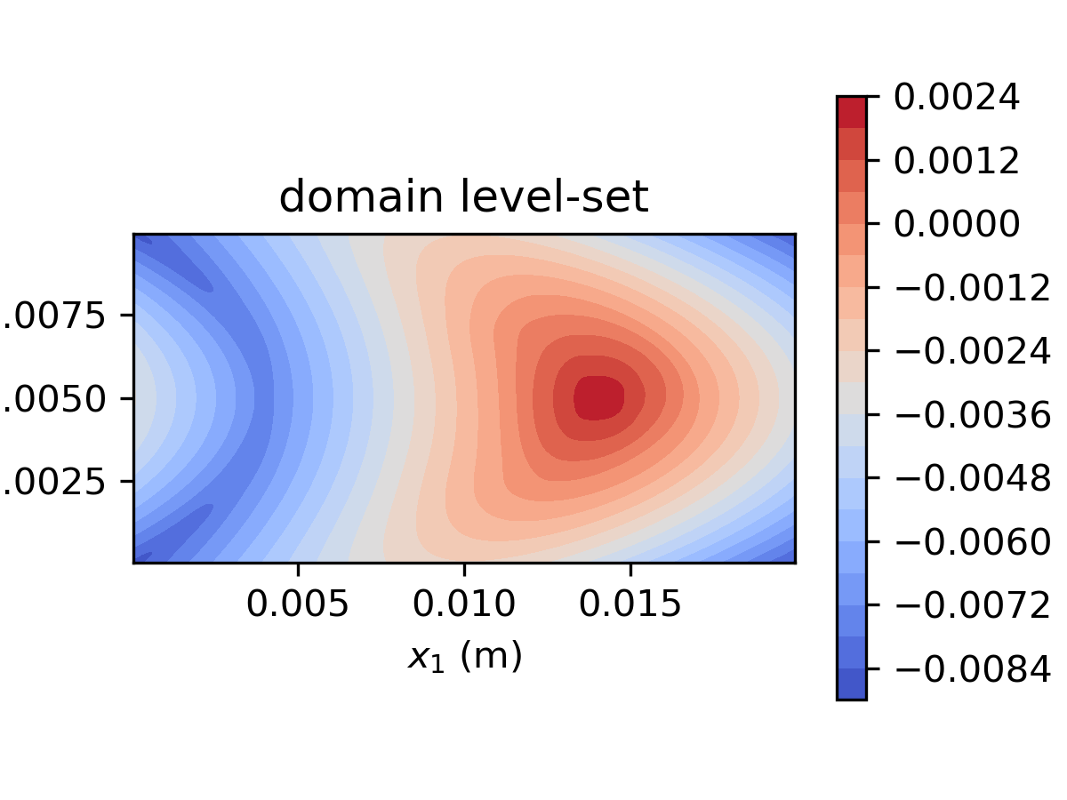

As the refinement of the mesh goes, the shape of the interface gets smoother. The case with only 20 meshes across shows mere difference compared to result from (a). As mesh gets finer, the bubble shape gets rounder and rounder. The area with largest level-set also becomes less elongated.

**(c)**

Attempted to run the code using and but diverged. Following runs uses with different gas viscosity.

* Level-set field, density and viscosity distribution,

:

* + 20 Meshes across the domain height:

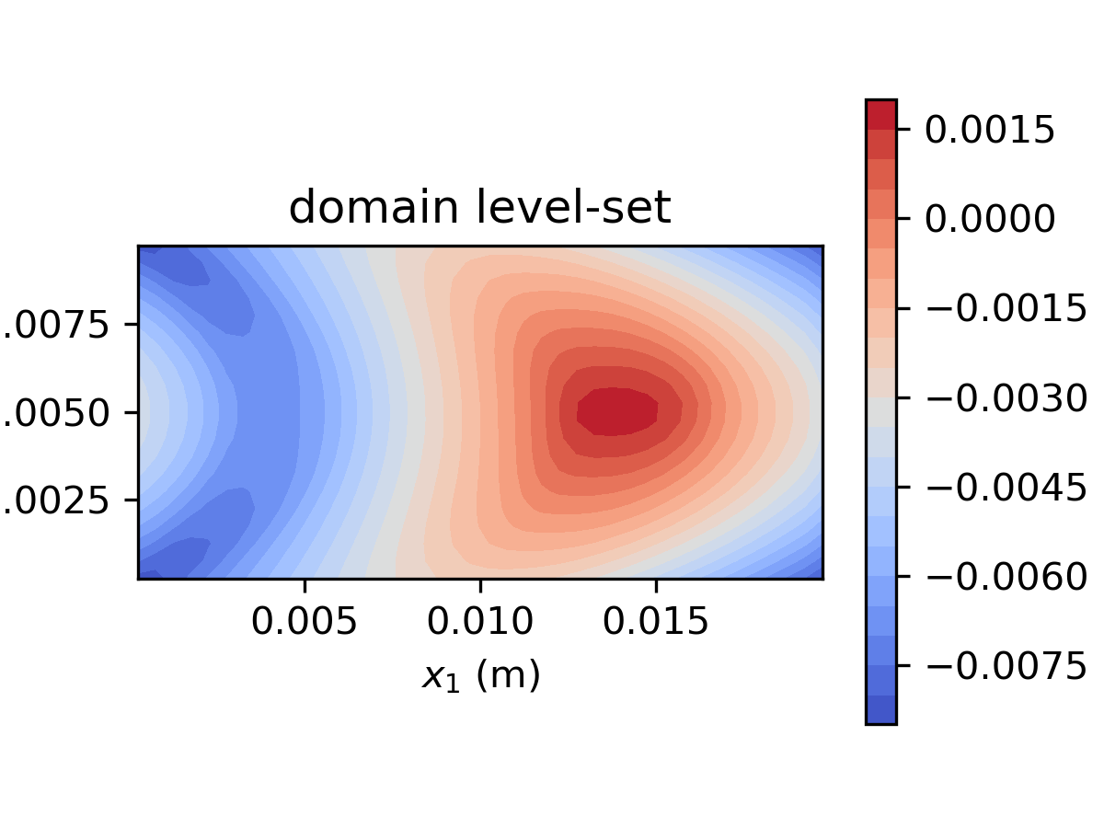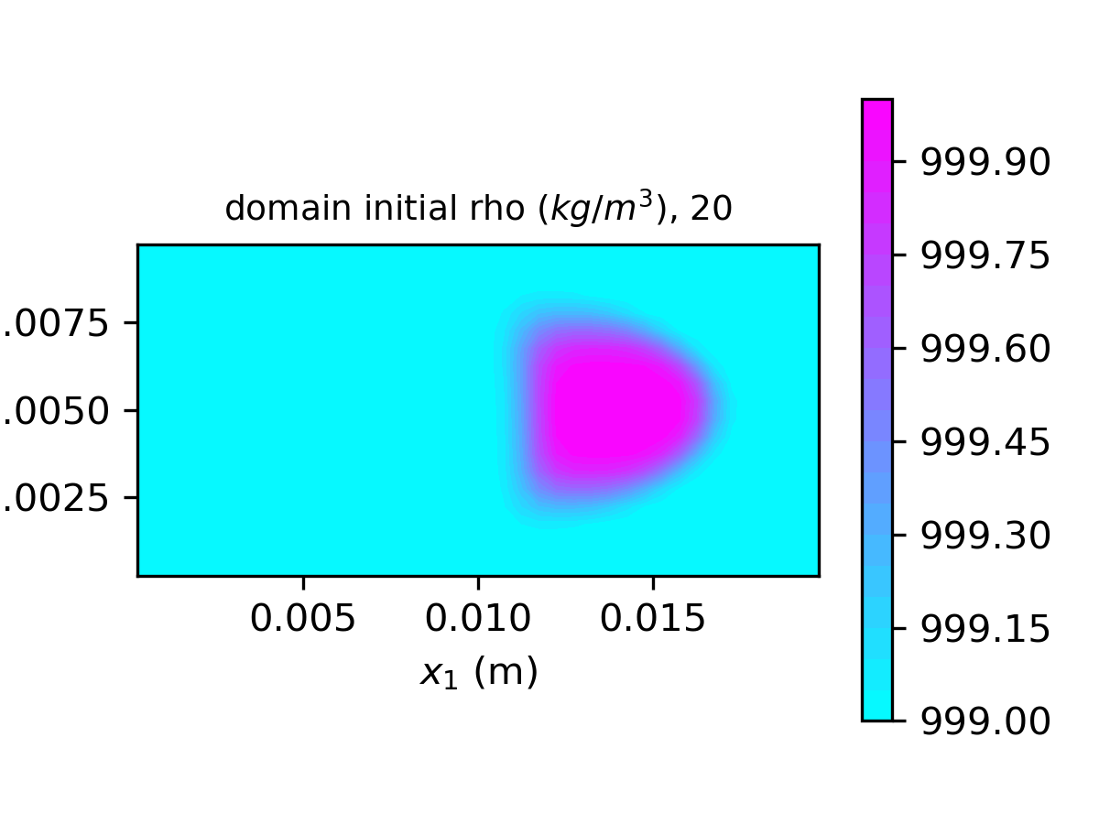

* + 50 Meshes across the domain height:

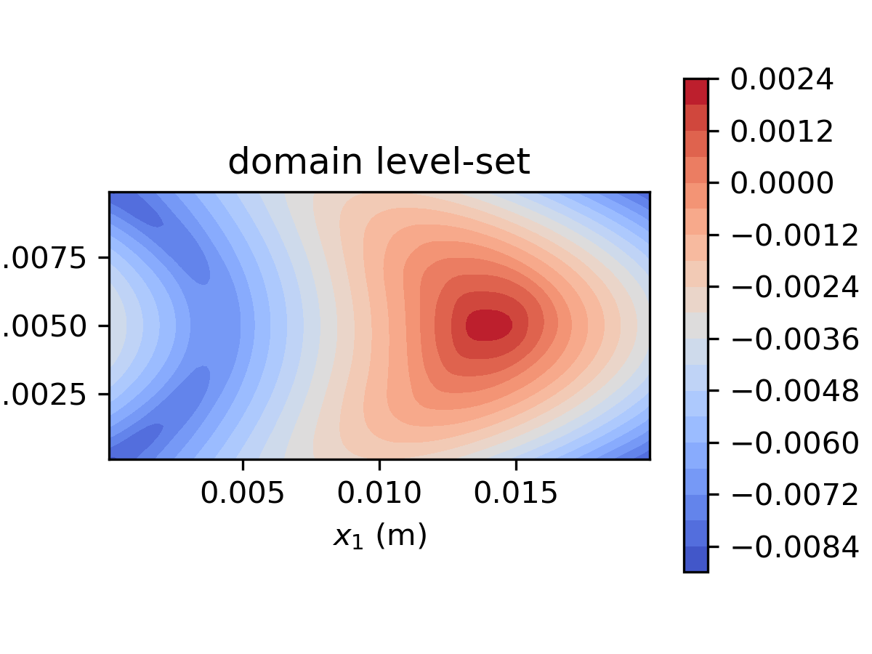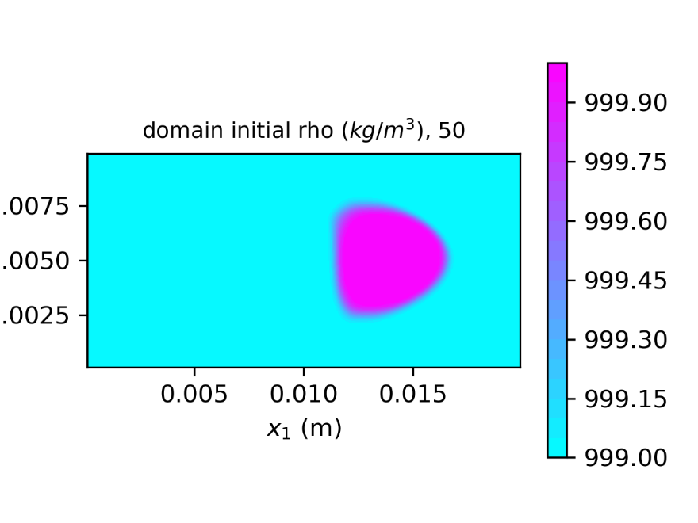

* Level-set field, density and viscosity distribution,

:

* + 20 Meshes across the domain height:

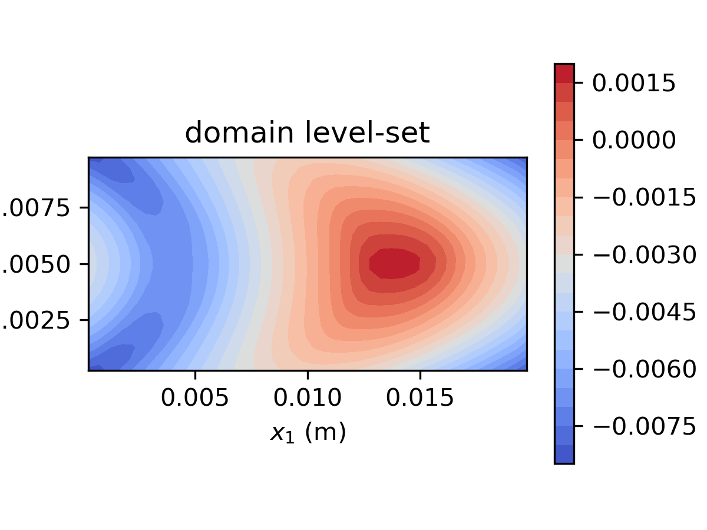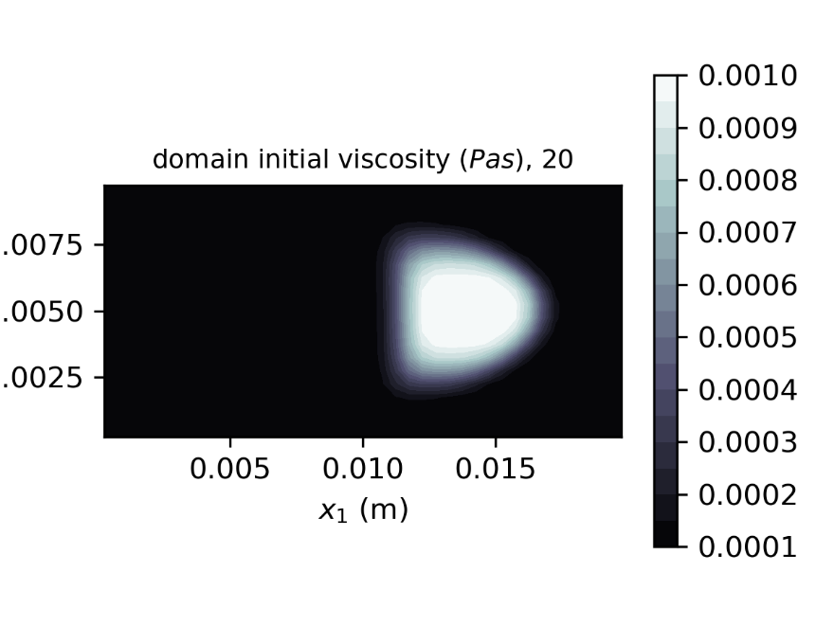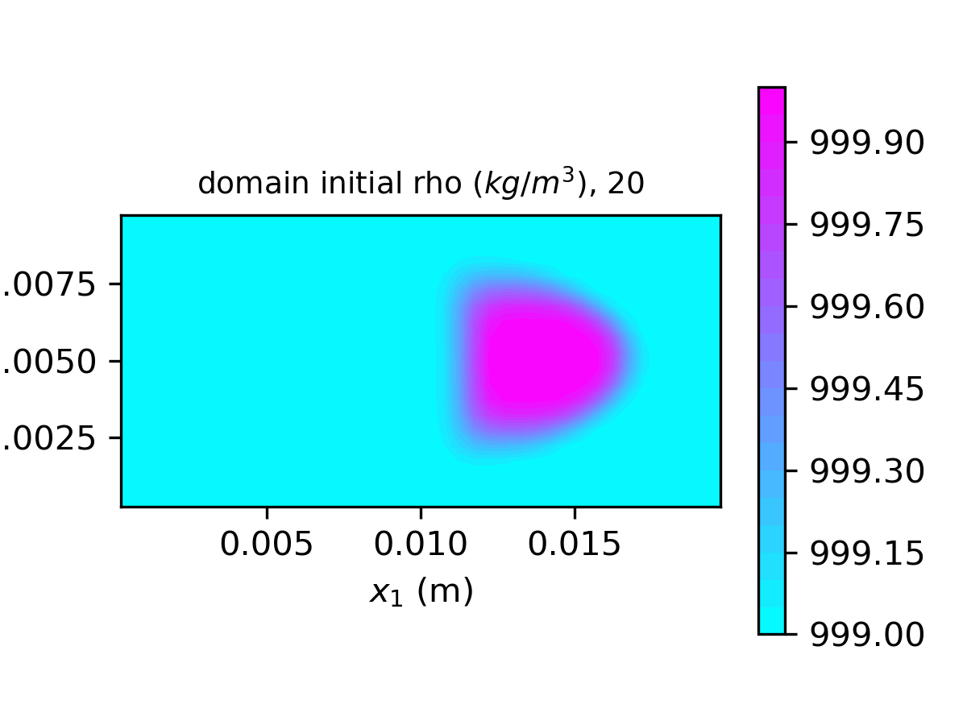

* + 50 Meshes across the domain height:

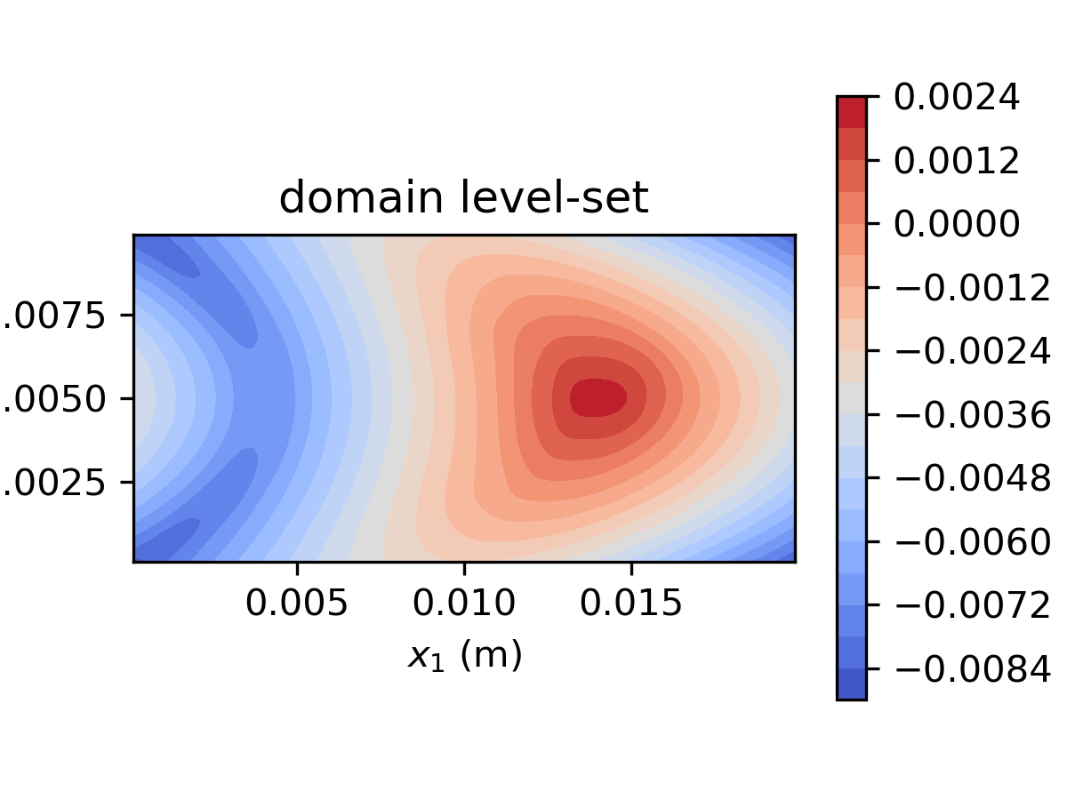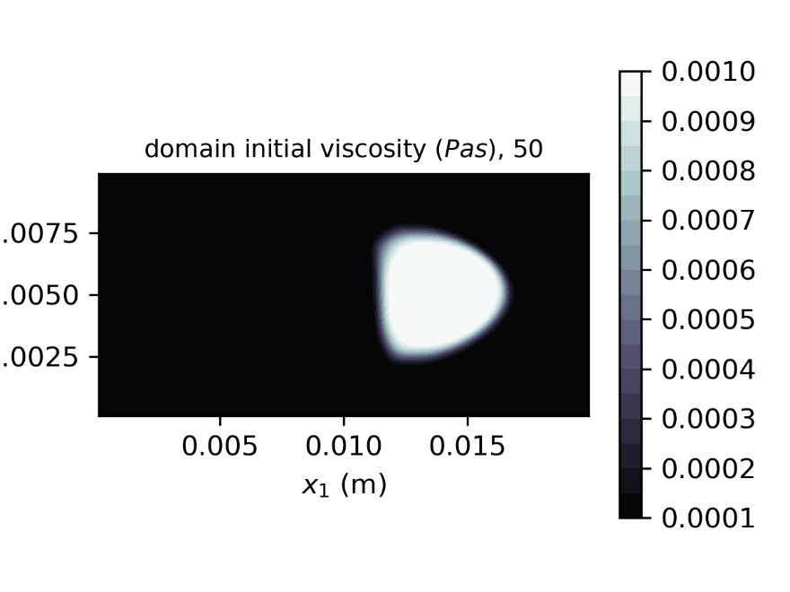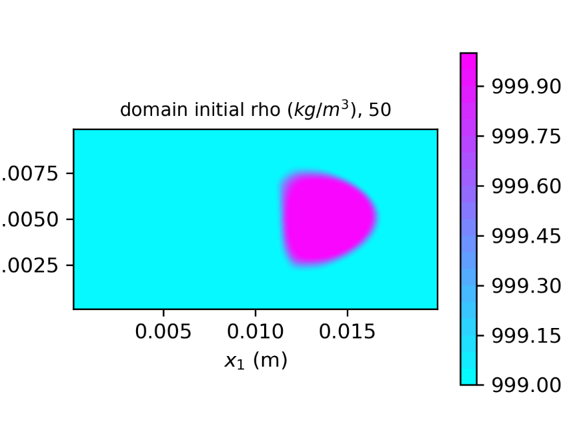

* Level-set field, density and viscosity distribution,

:

* + 20 Meshes across the domain height:

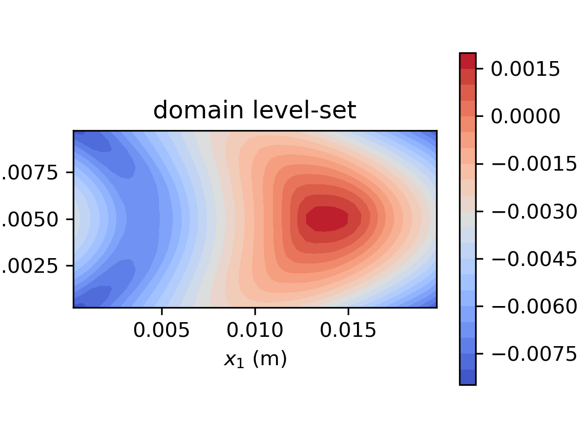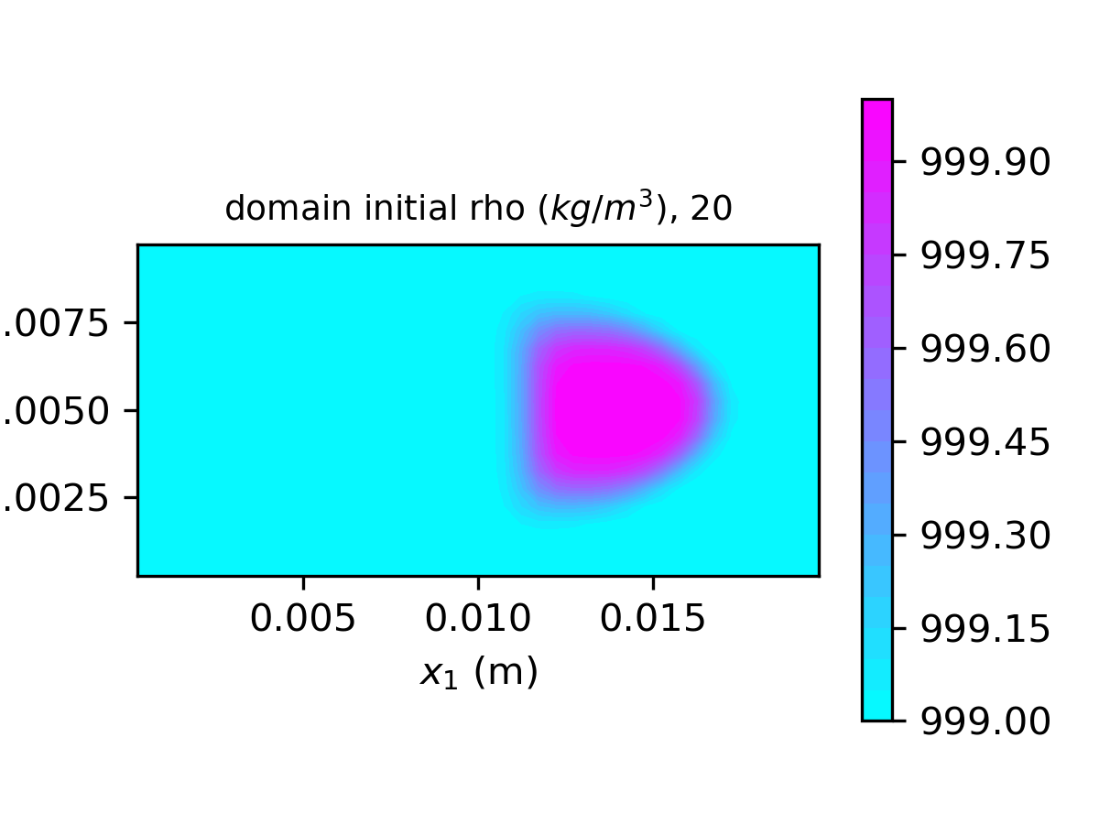

* + 50 Meshes across the domain height:

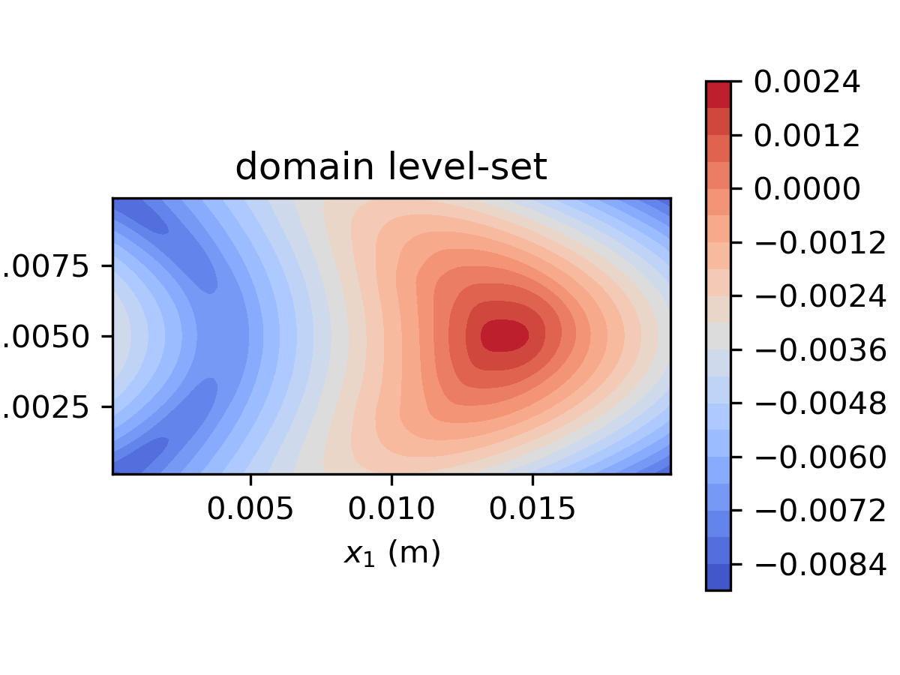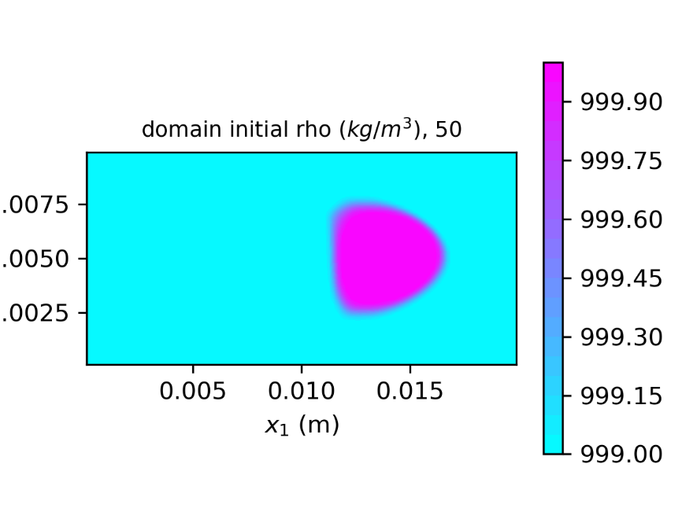

Additional tests are conducted with high viscosity contrast conditions (). The pressure field failed to converge:

