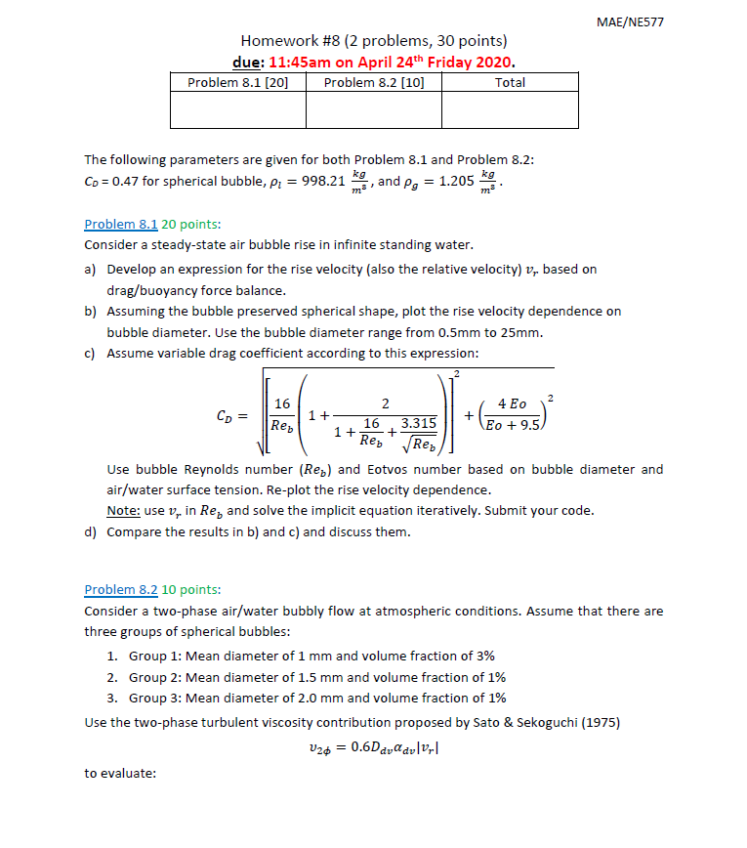

#8.1

(a)

(b)

(c) (d)

In the case (b) where drag coefficient has no dependence on relative velocity and bubble deformation, the time needed for bubbles to reach terminal velocity increases as size increases. Moreover, the magnitude of terminal velocity is also positively correlated to bubble size. In case (d), where drag coefficient has dependency on relative velocity, bubble size and shape, the time required for bubbles to reach terminal velocity became more uniform. Magnitude of terminal velocity also became more concentrated between to . Larger bubbles are the group effected the most. The effect is expected to be caused by the dependence of on bubble size. is roughly proportional to , where is between due to the and dependence in the equation. Therefore, larger bubbles tend to have larger drag coefficient and results in faster arrival of terminal velocity.

