Integrating Urdu Language with AI Agent for Intelligent Database Querying

A thesis submitted by
Muhammad Fasih u din Khalid
24-NTU-MSSE-FL-0001
In partial fulfillment of requirements for the degree of
Master of Science
In
Software Engineering
Directorate of Graduate Studies & Research
School of Sciences

NATIONAL TEXTILE UNIVERSITY, FAISALABAD
October 2026

DEDICATION
This research work is dedicated to my respected teachers, parents, family members, colleagues, and friends whose support, encouragement, and prayers made the completion of this work possible.

CERTIFICATE
NATIONAL TEXTILE UNIVERSITY, FAISALABAD
This thesis, entitled “Integrating Urdu Language with AI Agent for Intelligent Database Querying,” is submitted by Muhammad Fasih u din Khalid (Registration No. 24-NTU-MSSE-FL-0001) in partial fulfillment of the requirements for the degree of Master of Science in Software Engineering. The research has been carried out under the supervision of Dr. Isma Hamid and is presented for evaluation according to the rules and regulations of National Textile University, Faisalabad.
Supervisor: ____________________________
Co-Supervisor: __________________________
Internal Examiner: ______________________
External Examiner: ______________________
Coordinator / HOD: ______________________
Dean / Director, Graduate Studies & Research: ______________________
Date: __________________________

ACKNOWLEDGEMENTS
Above all, I am thankful to ALLAH Almighty, the Most Beneficent and the Most Merciful, for giving me the ability, patience, and opportunity to complete this research. I offer respect and gratitude to the Holy Prophet Muhammad (SAW), whose teachings remain a source of guidance and knowledge.
I express my sincere gratitude to my supervisor, Dr. Isma Hamid, National Textile University, Faisalabad, for her guidance, constructive feedback, and continuous encouragement throughout this research. Her supervision helped shape the research problem from an early Urdu-language database querying concept into an implementable system focused on practical access to enterprise information.
I am sincerely thankful to my co-supervisor, Mr. Muhammad Aslam, GM MIS, J.K. Spinning Mills Ltd., for his professional guidance, practical insights, and support throughout this research.
I am also thankful to my teachers, classmates, colleagues, friends, and family for their support. I acknowledge the practical learning gained from working with Oracle-based enterprise systems, which provided the real-world motivation for developing an Urdu/English language interface that can reduce the communication gap between database information and non-technical users.
Muhammad Fasih u din Khalid
24-NTU-MSSE-FL-0001

ABSTRACT
Organizations already rely on predefined reports and dashboards to answer routine operational questions, so retrieving standard employee information is already a normal part of enterprise practice. However, predefined reports are fixed and can only answer the specific questions for which they were designed. When a new or slightly different information need arises, users must either locate an appropriate existing report or depend on technical staff to create a new one. This research addresses that limitation by investigating an AI-assisted database querying approach centered primarily on Urdu, allowing users to request information through Urdu or English using either speech or text. Voice interaction is supported through Whisper speech-to-text. The proposed research framework converts the user’s question into a read-only Oracle SELECT query and presents the retrieved information through a browser-based conversational interface.
The research system is implemented using Oracle Database, Python, FastAPI, a Groq-hosted large language model, and Groq Whisper. The AI is provided with a controlled description of permitted database tables, columns, and relationships so that it can generate appropriate filters, joins, and query structures.
Security is incorporated at multiple levels. Users authenticate using Oracle database credentials, inactive sessions automatically expire after one minute, generated SQL is restricted to a single read-only SELECT statement, unsupported or out-of-domain requests are rejected, and unusually large result requests are controlled through configurable result-size restrictions.
The research demonstrates how Urdu-focused database interaction, multilingual support, speech input, schema-guided SQL generation, automatic relational joins, and practical security controls can be integrated into a unified enterprise-oriented database querying framework. The study also establishes a foundation for systematic evaluation of query correctness, language-based performance, relational query handling, security enforcement, and response efficiency. Future work may extend the research to larger enterprise schemas, broader Urdu and Roman Urdu evaluation datasets, role-based authorization, local language models, and production-scale deployment.

Keywords: Natural Language Query (NLQ), Text-to-SQL, Large Language Model (LLM), Oracle Database, FastAPI, Groq, Whisper, Urdu, Roman Urdu, AI Agent.

TABLE OF CONTENTS
Chapter 1 Introduction 1
1.1 Overview 1
1.2 Problem Background 2
1.3 Research Gap 3
1.4 Research Question 3
1.5 Problem Statement 3
1.6 Research Objective 3
1.7 Research Aim 4
1.8 Research Scope 4
1.9 Summary 5
Chapter 2 Literature Review 6
2.1 Overview 6
2.2 Text-to-SQL and Cross-Domain Generalization 6
2.3 Schema Encoding and Schema Linking 7
2.4 Constrained and Safe SQL Generation 7
2.5 Conversational and LLM-Based Approaches 7
2.6 Real-World Database Benchmarks 8
2.7 Speech Recognition for Multilingual Interaction 8
2.8 Comparative Review of Selected Studies 9
2.9 Research Gap and Proposed Response 10
2.10 Summary 10
Chapter 3 Research Methodology 11
3.1 Research Design 11
3.2 Operational Framework 11
3.3 Functional and Nonfunctional Requirements 16
3.4 Experimental Query Design 16
3.5 Evaluation Metrics 18
3.6 Reproducibility and Validity 20
3.7 Ethics and Privacy 20
3.8 Summary 20
Chapter 4 System Implementation and Evaluation 21
4.1 System Implementation 21
4.2 Experimental Setup and Evidence Status 22
4.3 Query Categories and Functional Observations 23
4.4 Evaluation Metrics and Reporting Rules 24
4.5 Quantitative Results 24
4.6 Language Based Evaluation 25
4.7 Relational and JOIN Query Evaluation 26
4.8 Urdu Voice Evaluation 27
4.9 Security and Session Validation 27
4.10 Performance and Response Time 28
4.11 Screenshot Based Prototype Evidence 28
4.12 Discussion 35
4.13 Research Question and Objective Evidence Mapping 35
4.14 Summary 36
Chapter 5 Conclusion and Future Work 37
5.1 Conclusion 37
5.2 Limitations 37
5.3 Future Work 38
5.4 Final Remarks 38
References 39
Appendix A Experimental Case Record 41
Appendix B FastAPI Service Contract 42
Appendix C SQL Safety and Verification Rules 43

LIST OF ABBREVIATIONS
Abbreviation | Meaning
AI | Artificial Intelligence
API | Application Programming Interface
ASR | Automatic Speech Recognition
DBMS | Database Management System
DDL | Data Definition Language
DML | Data Manipulation Language
LLM | Large Language Model
NL | Natural Language
NLIDB | Natural Language Interface to Database
NLP | Natural Language Processing
NLQ | Natural Language Query
REST | Representational State Transfer
SQL | Structured Query Language
STT | Speech-to-Text
RQ | Research Question
WER | Word Error Rate

LIST OF FIGURES
Figure 3.1: FastAPI Architecture and AI Data Boundary 12
Figure 3.2: Text Query Processing Flow 13
Figure 3.3: Voice to Database Query Flow 14
Figure 3.4: Schema Relationship and Automatic JOIN Logic 15
Figure 3.5: SQL Safety Validation Flow 16
Figure 4.1: Secure Oracle Database Authentication Interface 29
Figure 4.2: FastAPI Based AI Database Assistant Interface 29
Figure 4.3: Urdu Language Database Query and Result 30
Figure 4.4: Read Only Enforcement and Relational Information Retrieval 31
Figure 4.5: Urdu Voice Query Capture through the Speech Interface 32
Figure 4.6: Automatic Session Expiration after Inactivity 32
Figure 4.7: Documented Capabilities by Research Dimension 33
Figure 4.8: Coverage of Designed Evaluation Categories 34
Figure 4.9: Empirical Execution and Answer Accuracy Across Designed Query Categories (C01 to C09) 35
Figure 4.10: Multilingual Performance Distribution Across Urdu Script, Roman Urdu, and English 36
Figure 4.11: Mean and Median Latency Distribution by Query Classification 38

LIST OF TABLES
Table 2.1: Comparative Literature Review 9
Table 2.2: Research Gap and Proposed Response 10
Table 3.1: Core Database Schema 14
Table 3.2: Research Prototype Requirements 16
Table 3.3: Designed Evaluation Categories 17
Table 3.4: Evaluation Metrics and Denominators 19
Table 4.1: Current Technology Stack 21
Table 4.2: Experimental Setup Record 23
Table 4.3: Functional Evidence and Its Limits 24
Table 4.4: Measured Query Category Results 25
Table 4.5: Measured Language Performance Results 26
Table 4.6: Representative Oracle SQL Transformations 26
Table 4.7: Voice Evaluation Template Not Yet Measured 27
Table 4.8: Security and Session Test Record 28
Table 4.9: Measured Response Time by Query Group 28
Table 4.10: ASRB Evidence Mapping 36
Table A.1: Per Case Evaluation Record 41
Table B.1: Logical FastAPI Services 42

Chapter 1
Introduction

1.1 Overview
Modern organizations already use predefined reports and dashboards for routine employee, finance, production and inventory information. Each report covers a defined set of questions, layouts and filters. When an information need changes, a user must locate a suitable report, combine existing outputs or request a new report from technical staff. An Urdu/English conversational interface provides a more flexible route: users express the question directly and receive the retrieved information in the same interaction.
The text-to-SQL research field has developed from rule-based systems toward neural semantic parsers and, more recently, large language model approaches. The Spider benchmark demonstrated the difficulty of generating complex SQL that generalizes across unseen schemas [1]. Later work such as SyntaxSQLNet, RAT-SQL, PICARD, RESDSQL, DIN-SQL, DAIL-SQL, and multi-agent approaches progressively improved schema linking, constrained decoding, decomposition, prompting, and correction [2]-[8], [10]. These advances make it increasingly realistic to build domain-specific NLQ systems that operate on enterprise relational databases rather than only on academic benchmark datasets.
This research investigates an Urdu-focused AI-assisted interface for employee information stored in Oracle Database. English and Roman Urdu provide additional input options. A request such as “IT department me kitne employees hain?” enters the conversational interface as text or speech. FastAPI coordinates controlled schema context, SQL generation, validation and Oracle execution, then returns the locally formatted answer. The query-generation process operates within the backend.
A key feature of the proposed system is multilingual interaction. The interface is intended for users who may naturally switch between English, Urdu, and Roman Urdu. Voice input is supported through a Whisper-based speech-to-text stage. Whisper was trained at large scale with multilingual weak supervision and is designed to generalize across diverse audio conditions [9]. By combining multilingual speech recognition with LLM-based text-to-SQL generation, the system moves beyond a conventional typed English-only database interface.

1.2 Problem Background
Organizations commonly rely on predefined reports to support routine operational and management work. These reports are usually built for specific purposes, such as employee details, department-wise listings, designations, joining dates, salaries, or attendance. Although they are useful, the answer a manager needs is not always found in a single report. The required combination of fields, filters, or conditions may be spread across several reports, or may not be covered by any existing report.
In such cases, users often have to go through several reports, apply different filters, and combine the results manually, or ask the IT/MIS department to write a new query or build a customized report. Even when the data already exists in the database, access to it may therefore depend on the availability of technical staff and on how the existing reports are structured. This research addresses the problem through an AI-assisted querying approach in which users ask for information directly. Urdu is the primary interaction language, and Roman Urdu and English are also supported through text and speech.
The proposed framework lets users state what they need instead of first finding the right report or requesting a new one. Spoken questions are converted to text using Whisper speech-to-text, while typed questions can be entered in Urdu, Roman Urdu, or English. The FastAPI backend prepares a controlled schema context, obtains a read-only Oracle SELECT query from the language model, validates the generated SQL, executes the approved statement against Oracle Database, and returns the result through a browser-based conversational interface.
SQL generated by a language model also raises concerns about correctness, privacy, and security. A model may produce invalid SQL, refer to schema objects that do not exist, build incorrect relationships, or attempt operations that modify data. For this reason, the research keeps SQL generation separate from database execution. Each generated statement is validated before execution and must be a single read-only SELECT query. Oracle credentials remain within the authenticated session, inactive sessions expire automatically after one minute, and the language model is not given unrestricted access to database records. These controls allow the study to examine flexible Urdu-language querying while keeping access to enterprise data controlled and read-only.

1.3 Research Gap
Existing text-to-SQL research mainly focuses on benchmark datasets and English-language interaction. In enterprise environments, users may still depend on multiple predefined reports or IT/MIS staff when the required information is not directly available.
This research addresses that gap through an Urdu-focused AI-assisted Oracle querying interface that also supports Roman Urdu, English, and voice interaction. The contribution lies in providing and evaluating a more flexible way for non-technical users to retrieve required employee information directly from an enterprise database.

1.4 Research Question
RQ1: How can an AI agent handle query complexity to allow users to retrieve information from the Employees module using natural Urdu speech or text?
The effectiveness of the proposed system is evaluated through query correctness, Urdu language understanding, voice transcription, and accurate information retrieval.

1.5 Problem Statement
Predefined Oracle reports provide a working route to routine employee information, but their layouts and filters may not cover a new or slightly different question. Such requests can require locating a suitable report or asking technical staff to create or modify one. This research investigates an Urdu-focused AI-assisted querying framework that accepts employee-information requests through text or speech and returns the retrieved information through a browser-based conversational interface.

1.6 Research Objective
To reduce dependence on intermediaries or IT staff by enabling users to retrieve required employee information directly through Urdu language interaction.
The objective focuses on information requests that are not directly available through existing predefined reports. The proposed research interface allows users to ask these questions primarily in Urdu, with Roman Urdu and English as additional supported forms. Existing reports continue to serve routine needs, while the AI-assisted interface provides a more flexible conversational route for specific information retrieval. The effectiveness of this approach can be evaluated through answer correctness, task completion, need for technical assistance, and response time.

1.7 Research Aim
The aim of this research is to investigate and implement a secure, Urdu-focused AI-assisted querying framework for Oracle employee information. Users submit questions through speech or text and receive answers through a browser-based conversational interface. FastAPI coordinates multilingual input, schema-guided SQL generation, relational query handling, validation and local result presentation. The framework supports flexible information needs beyond predefined reports and establishes a basis for systematic evaluation.

1.8 Research Scope
This research is limited to Oracle Database 26ai and an employee information domain. Urdu is the primary interaction language, while Roman Urdu and English are also supported. Voice input is handled through Whisper speech-to-text, and the application uses a FastAPI backend with a browser-based interface.
The current research system is intentionally designed for information retrieval only. It allows users to request and view database information through conversational queries, while data modification operations such as INSERT, UPDATE, and DELETE are excluded from the present scope. This restriction keeps the research focused on safe and controlled access to enterprise information. Such write operations could be introduced in future work with appropriate authorization, validation, and role-based security controls.
The employee module is used as a bounded research case to demonstrate the feasibility of the proposed AI-assisted framework. The same approach can later be extended to other enterprise modules such as sales, customer balances, production, finance, and management reporting. For example, future versions could answer questions about monthly or annual sales, customer-wise transactions and outstanding balances, overall business performance, profit and loss, or other cross-department information stored in the organization’s database.
Therefore, the present study should be viewed as a focused research implementation of a broader enterprise querying concept. Its future potential lies in expanding the framework across larger schemas and business modules so that decision-makers can retrieve a wider range of organizational information through the same Urdu-focused conversational approach.

1.9 Summary
This chapter established the need for flexible Urdu/English querying beyond predefined reports and defined the research question, objective and scope. The next chapter reviews the studies that inform the framework.

Chapter 2
Literature Review

2.1 Overview
This chapter reviews previous research related to AI-assisted database querying, text-to-SQL generation, schema understanding, safe SQL generation, conversational database interfaces, and multilingual speech recognition. Particular attention is given to approaches that help users retrieve database information through everyday language without requiring SQL knowledge. These studies provide the technical and research foundation for the proposed Urdu-focused framework, which allows users to query an Oracle database through Urdu, Roman Urdu, English, and voice interaction.

2.2 Text-to-SQL and Cross-Domain Generalization
Spider is a foundational benchmark for complex and cross-domain text-to-SQL. It contains 10,181 questions and 5,693 unique SQL queries across 200 databases and 138 domains, and it was intentionally designed so that databases and SQL patterns differ between training and test splits [1]. This shifted research attention away from memorizing templates and toward generalizing to unseen schema structures. For the present study, the important lesson is that database structure must be represented explicitly when generating SQL; a language model cannot safely rely only on the wording of a question.
SyntaxSQLNet introduced a syntax-tree-oriented approach for generating complex SQL with multiple clauses and subqueries [2]. Although the present research uses a general LLM rather than the same neural architecture, the work demonstrates the value of decomposing SQL generation around its structural components instead of treating SQL as unconstrained text.
Earlier neural systems also shaped modern text-to-SQL design. Seq2SQL introduced reinforcement learning with execution feedback and released WikiSQL [13]. SQLNet then used a sketch-based, sequence-to-set approach to reduce the ordering problem in SQL generation [14]. X-SQL later strengthened schema representation by combining contextual language-model features with column type information [15]. These studies show why SQL structure and schema information should be made explicit instead of asking a model to generate unrestricted text.

2.3 Schema Encoding and Schema Linking
RAT-SQL addresses two closely related challenges: representing relations within a database schema and aligning words in a question with the correct tables and columns [3]. It uses relation-aware self-attention so that foreign keys, primary keys, and schema relations are visible during parsing. This is especially relevant to the proposed Urdu AI database-querying system because department and designation names are not directly stored as free-text fields in the employee record; they are reached through codes and foreign-key relationships.
RESDSQL later separated schema linking from SQL skeleton generation. Its ranking-enhanced encoder emphasizes relevant schema items, while skeleton-aware decoding first captures SQL structure before filling specific schema elements [6]. The proposed system follows the same practical principle at an application level: only the allowed schema and relationship context are injected, and the prompt explicitly describes how department and designation codes relate to their lookup tables.
IRNet uses schema linking and an intermediate representation to reduce the gap between natural-language meaning and SQL details [17]. BRIDGE connects question text, schema elements, and relevant cell values in one contextual representation [18]. These ideas support the present design choice of giving the AI clear schema relationships and only the context needed to produce a valid query.

2.4 Constrained and Safe SQL Generation
PICARD constrains language-model decoding through incremental parsing to reject inadmissible continuations [4]. The present prototype does not reproduce that decoder. It applies application-level SQL validation after generation. This distinction separates syntactic constraints from the authorization policy that allows only a single read-only SELECT statement. Neither approach alone proves semantic correctness or complete resistance to hostile requests.
This distinction is important because syntactic validity alone is not enough for an enterprise system. A query may be valid SQL but still perform an unauthorized modification. Therefore, application-level policy validation is treated as a separate component from LLM generation.

2.5 Conversational and LLM-Based Approaches
CoSQL extends text-to-SQL into conversational interaction where later questions depend on previous context [5]. This is relevant to chat-based NLQ systems because real users often ask follow-up questions rather than fully restating the query. Although the current prototype is primarily evaluated through individual employee-information questions, its chat architecture leaves room for contextual follow-up handling in future work.
DIN-SQL shows that complex text-to-SQL can benefit from decomposition into smaller reasoning steps and self-correction [7]. DAIL-SQL systematically studies prompt representation, example selection, and organization for LLM-based text-to-SQL and demonstrates that prompt design strongly influences execution accuracy and token efficiency [10]. MAC-SQL further explores collaboration between specialized agents for decomposition, database reduction, and SQL correction [8]. Together, these studies motivate a modular design rather than a single unconstrained prompt.
SParC extends database semantic parsing to context-dependent question sequences and shows that follow-up questions are harder than isolated requests [16]. NatSQL simplifies the target representation so that difficult SQL structures are easier to infer from natural language [19], while SmBoP demonstrates an efficient bottom-up parsing strategy for complex semantic parsing [20]. Although the present prototype uses an LLM rather than these exact architectures, their results support structured reasoning, controlled context, and future conversational extensions.

2.6 Real-World Database Benchmarks
BIRD was introduced to narrow the gap between small academic schemas and large databases containing extensive real-world values. It includes 12,751 question-SQL pairs, 95 databases, and 37 professional domains, and emphasizes challenges such as dirty database contents, external knowledge, and SQL efficiency [11]. This supports the argument that practical NLQ systems should be evaluated not only on SQL syntax but also on database values, schema relevance, and execution behavior.

2.7 Speech Recognition for Multilingual Interaction
Whisper is a large-scale speech recognition system trained on approximately 680,000 hours of multilingual and multitask supervision [9]. Its broad multilingual capability makes it suitable as a speech-to-text component for a prototype that accepts Urdu and English voice input. In the proposed architecture, Whisper does not generate SQL directly. It converts audio into text, after which the transcript is passed through the same schema-aware NLQ-to-SQL pipeline used for typed questions. This separation simplifies testing because speech recognition and SQL generation remain distinct stages.

2.8 Comparative Review of Selected Studies
Table 2.1: Comparative Literature Review
Ref. | Study | Technique | Main Contribution | Relevance to Proposed Work
[1] Yu et al., 2018 | Spider | Cross-domain benchmark | Complex SQL; unseen schemas | Benchmark motivation; schema generalization
[2] Yu et al., 2018 | SyntaxSQLNet | Syntax-tree SQL generation | Complex/nested queries | SQL structure awareness
[3] Wang et al., 2020 | RAT-SQL | Relation-aware schema encoding | Schema linking and relations | Foreign-key/JOIN grounding
[4] Scholak et al., 2021 | PICARD | Constrained decoding | Invalid SQL prevention | Safety/constrained generation principle
[5] Yu et al., 2019 | CoSQL | Conversational text-to-SQL | Multi-turn interaction | Chat-oriented future extension
[6] Li et al., 2023 | RESDSQL | Schema ranking + skeleton parsing | Robust schema selection | Relevant schema injection
[7] Pourreza & Rafiei, 2023 | DIN-SQL | Decomposition + self-correction | LLM reasoning for SQL | Modular prompting and correction
[8] Wang et al., 2023 | MAC-SQL | Multi-agent collaboration | Complex DB/questions | Agent-oriented future architecture
[9] Radford et al., 2023 | Whisper | Large-scale multilingual ASR | Speech-to-text | Urdu/English voice input
[10] Gao et al., 2023 | DAIL-SQL | Prompt engineering benchmark | LLM-based SQL generation | Prompt/schema design
[11] Li et al., 2023 | BIRD | Large DB grounded benchmark | Database values and efficiency | Real-world evaluation motivation
[12] Zhu et al., 2024 | LLM Text-to-SQL Survey | Survey of LLM approaches | Prompting, fine-tuning, agents | Research positioning
[13] Zhong et al., 2017 | Seq2SQL | RL + execution feedback | Neural NL-to-SQL; WikiSQL | Early execution-guided generation
[14] Xu et al., 2017 | SQLNet | Sketch + column attention | Reduces SQL ordering problem | Structured generation motivation
[15] He et al., 2019 | X-SQL | Contextual schema representation | Schema/type-aware encoding | Schema grounding motivation
[16] Yu et al., 2019 | SParC | Context-dependent text-to-SQL | Multi-turn database questions | Conversational extension
[17] Guo et al., 2019 | IRNet | Schema linking + IR | Bridges NL and SQL structure | Relationship-aware generation
[18] Lin et al., 2020 | BRIDGE | Text-schema-value encoding | Cross-domain schema grounding | Controlled context design
[19] Gan et al., 2021 | NatSQL | Simplified SQL IR | Easier mapping from NL to SQL | Structured reasoning insight
[20] Rubin & Berant, 2021 | SmBoP | Bottom-up semantic parsing | Efficient complex parsing | Complex-query design insight

2.9 Research Gap and Proposed Response
Table 2.2: Research Gap and Proposed Response
Research need | Practical effect | Response in this study
Urdu-focused access | Users cannot express every request through existing reports | Urdu speech/text interface; English and Roman Urdu as supporting inputs
Relational complexity | Business terms map to codes across tables | Controlled schema and explicit foreign-key relationships
Reliable retrieval | Executable SQL may still answer the wrong question | Gold SQL, result comparison and independent answer checking
Read-only operation | Generated SQL must not modify records | FastAPI validation before Oracle execution
Workflow evaluation | Task benefits require measurement | Compare report and conversational tasks

2.10 Summary
The reviewed studies inform schema-guided SQL generation, validation and speech processing for this Urdu-focused framework.

Chapter 3
Research Methodology

3.1 Research Design
The study follows an artifact-based design and evaluation approach. The artifact is an Urdu-focused employee-information interface connected to Oracle Database 26ai. The work proceeds through problem identification, schema modeling, construction of the interface and query pipeline, case-based demonstration, and a controlled evaluation protocol. The system has been implemented and tested through practical query examples, and these examples show that it can perform the intended tasks. A structured test set and a timed user comparison are left for future work, so that accuracy, task completion, and response time can be measured more clearly.
For query evaluation, each user request is tested against a fixed database state to check whether the system returns the correct information for the intended question, including relational and language-specific queries. A separate user-task comparison could be used to compare the existing reporting process with the conversational interface. This keeps query correctness distinct from other factors such as response time and reliance on technical staff.
The evaluation design draws on execution-oriented text-to-SQL benchmarking [1], the handling of schema relationships in RAT-SQL [3], and the distinction between constrained SQL generation and application policy [4]. Whisper motivates evaluating speech transcription separately from downstream SQL correctness [9]. These studies were evaluated on their own datasets and system environments, so their reported results cannot be applied directly to the proposed Oracle-based system, which has to be evaluated through its own testing.

3.2 Operational Framework
The user authenticates with authorized Oracle credentials and submits Urdu, Roman Urdu or English text through the browser. Voice recordings are forwarded through FastAPI to Groq Whisper, which returns a transcript. FastAPI prepares the question and permitted schema context for the Groq-hosted LLM. The returned Oracle SELECT SQL is validated before execution in the authenticated Oracle session. FastAPI formats the rows and returns the answer to the browser. No result-generation call sends those rows back to the LLM.
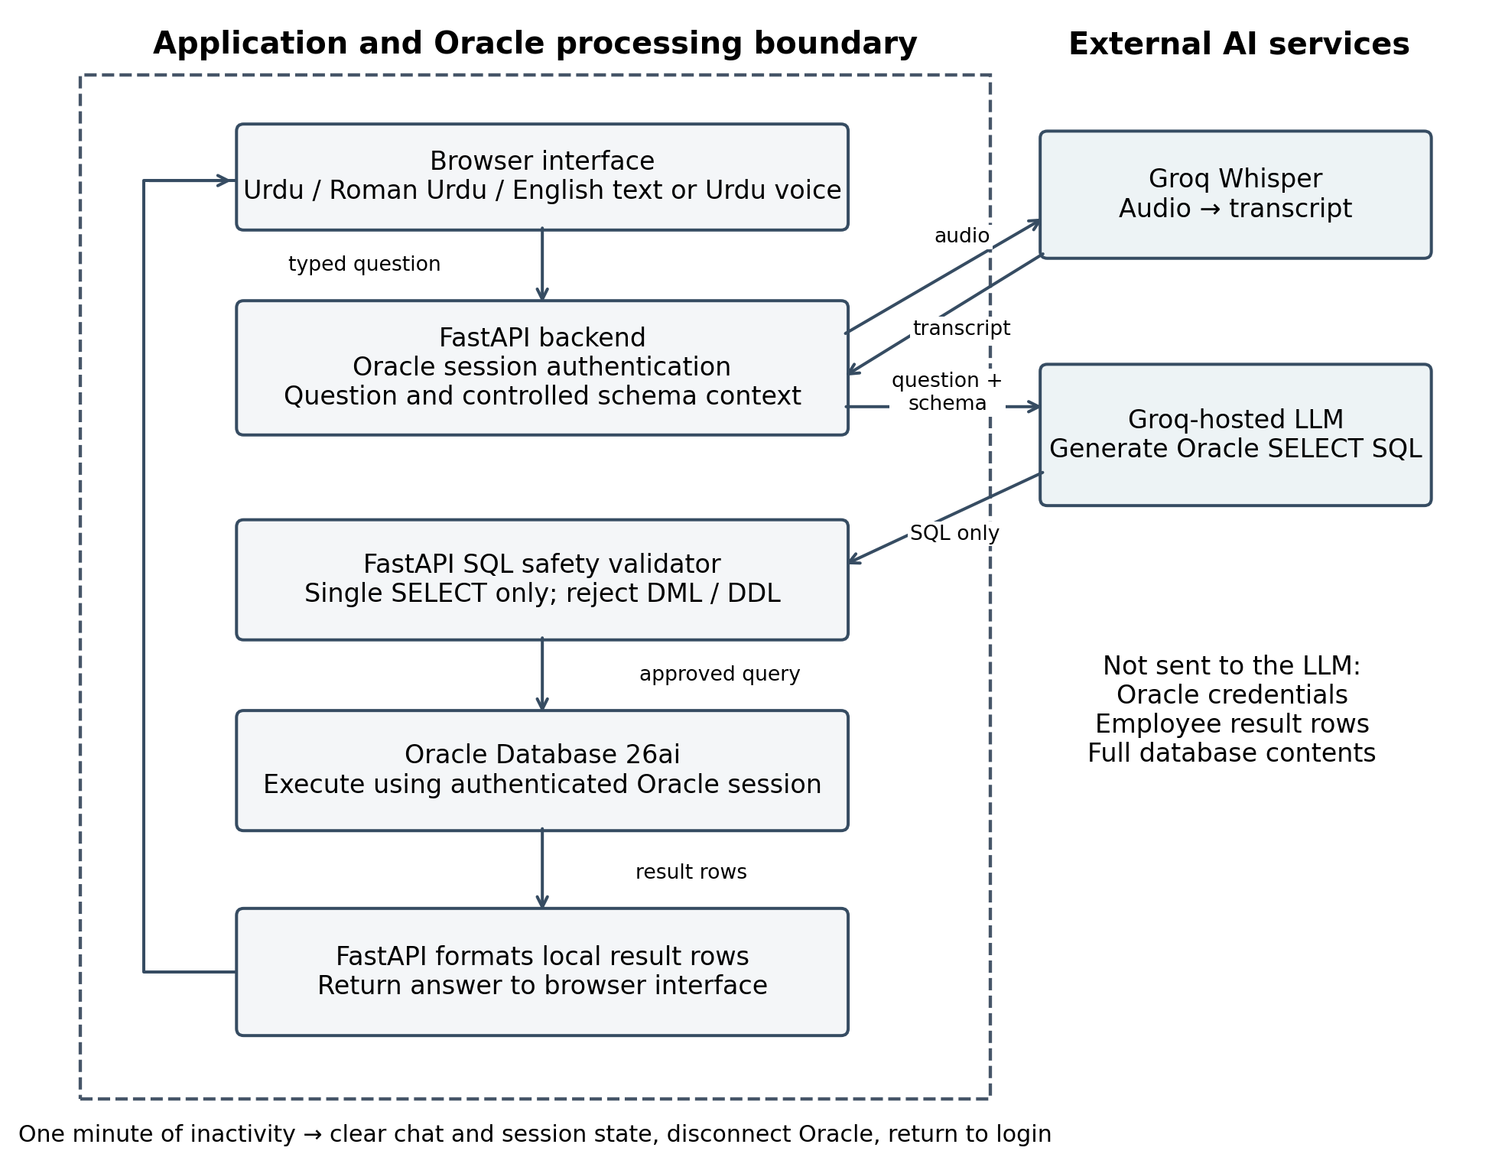
Figure 3.1: FastAPI Architecture and AI Data Boundary

3.2.1 Text Input and Controlled Context
The user’s question is processed using only the permitted schema information, such as relevant table names, column names, and relationships. For example, department and designation names are stored in related tables rather than in the EMPLOYEES table, so the system uses this relationship information when it generates the query. Any department or designation name that the user mentions may be included in the request sent to the external AI service. However, the system does not send complete employee records, full database contents, Oracle credentials, or returned query rows to the LLM. The model therefore only generates the SQL, while the database data stays within the application and the Oracle environment.
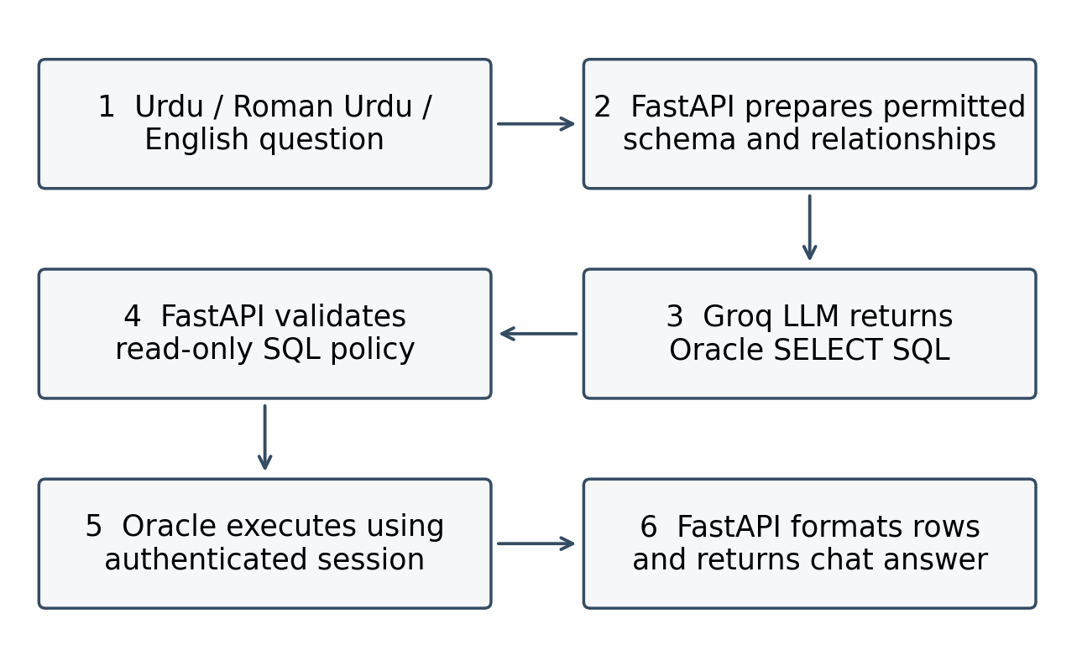
Figure 3.2: Text Query Processing Flow

3.2.2 Urdu Voice Input
Groq Whisper converts recorded speech into text, after which the same FastAPI SQL-generation and validation path is used. Urdu is the principal speech scenario. Roman Urdu denotes a written representation and is evaluated as text; it is not treated as a separate spoken language. A recording indicator demonstrates capture, whereas transcription accuracy requires recorded speech paired with a checked transcript.
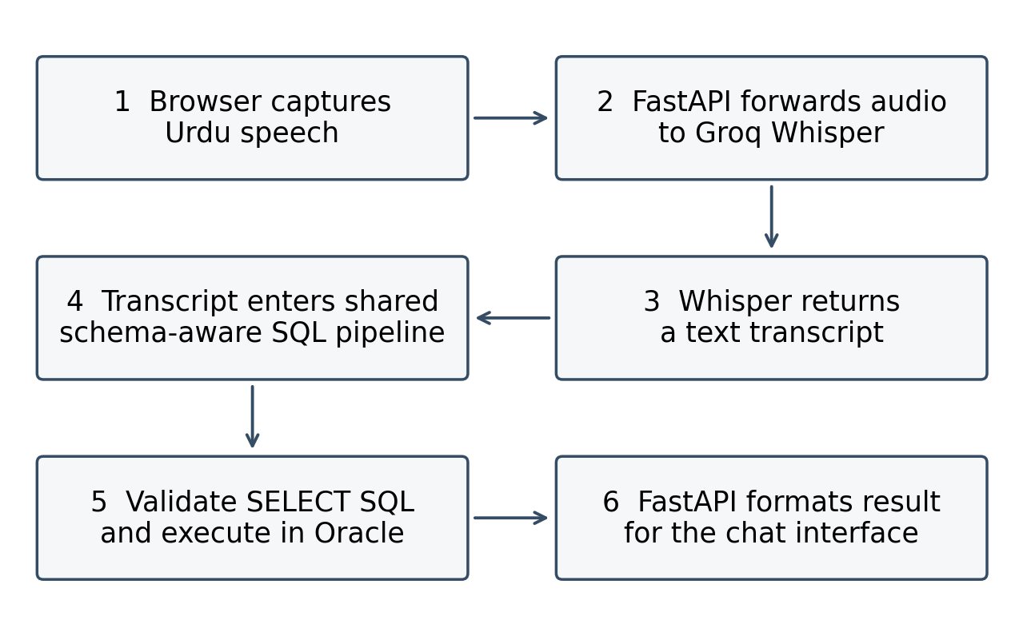
Figure 3.3: Voice to Database Query Flow

3.2.3 Schema and Relationship Handling
EMPLOYEES stores DEPT_CODE and DESG_CODE as foreign keys. DEPARTMENTS and DESIGNATIONS provide the corresponding descriptive names. Department queries use e.DEPT_CODE = d.DEPT_CODE, while designation queries use e.DESG_CODE = g.DESG_CODE. A request for an IT Manager may require both relations. Controlled schema context supplies these paths to the SQL-generation stage so that the backend can construct the appropriate relational query.
Table 3.1: Core Database Schema
Table | Important Attributes | Role
EMPLOYEES | ECODE, EMP_NAME, DEPT_CODE, DESG_CODE, SALARY, PHONE_NUMBER, EMAIL, JOINING_DATE, GENDER, CITY, ADDRESS | Main employee facts
DEPARTMENTS | DEPT_CODE, DEPT_NAME | Department lookup
DESIGNATIONS | DESG_CODE, DESG_NAME | Designation lookup
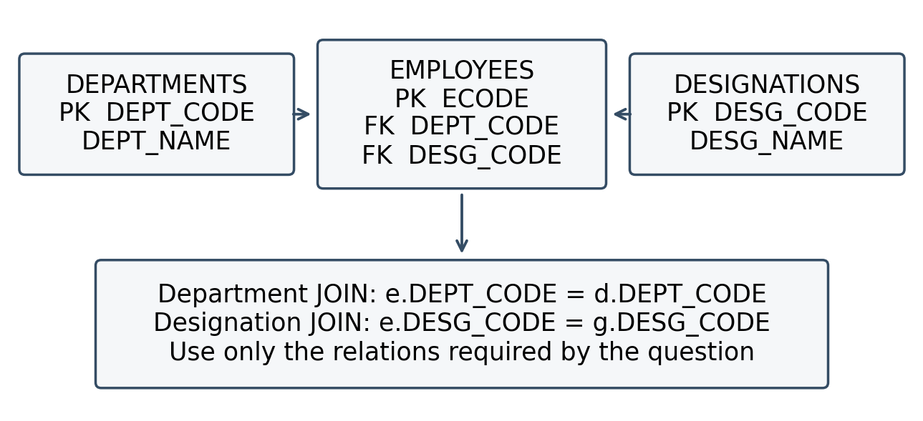
Figure 3.4: Schema Relationship and Automatic JOIN Logic

3.2.4 SQL Validation and Session Controls
The SQL-generation prompt requests one Oracle-compatible SELECT statement. FastAPI checks the generated statement before execution and blocks DML, DDL and multiple-statement requests. Oracle privileges provide an independent authorization boundary. A SELECT-only policy prevents the intended write path but does not, by itself, establish correct answers, row-level authorization or complete protection against every SQL construction. The validator therefore requires adversarial evaluation in addition to ordinary retrieval tests.
The configured inactivity interval is one minute. Mouse movement, clicks, key presses, scrolling and touch activity reset the browser timer. On expiry, the specified workflow clears chat and authentication state, disconnects the Oracle session and redirects the user to login. The displayed message is “Your session has expired due to inactivity. Please log in again.” Credentials remain private to the authenticated application session and outside the model prompt. Timed session tests and server logs are needed to verify the complete disconnection behavior.
The interface is limited to employee-related information. Requests outside the supported database domain are redirected back to it, while ordinary greetings are still accepted. A configurable result-size limit prevents very large outputs. If a request would return too many employee records, the system asks the user to narrow it with a condition such as department, city, or designation. These controls keep responses focused and reduce unnecessary exposure of data.
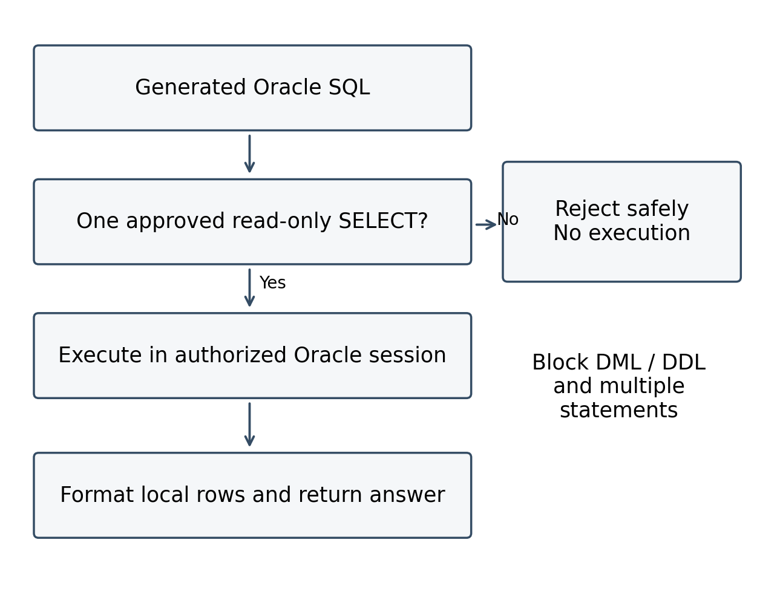
Figure 3.5: SQL Safety Validation Flow

3.3 Functional and Nonfunctional Requirements
Table 3.2: Research Prototype Requirements
ID | Requirement | Evaluation dimension
FR-01 | Authenticate using authorized Oracle credentials | Authentication
FR-02 | Accept Urdu text, English text and Roman Urdu text | Language access
FR-03 | Capture Urdu speech and transcribe through Groq Whisper | Voice access
FR-04 | Generate schema-aware Oracle SELECT queries | Query generation
FR-05 | Resolve department and designation relationships | Relational complexity
FR-06 | Support aggregation, grouping, dates and multiple conditions | Query complexity
FR-07 | Reject DML, DDL and unauthorized statement forms | Read-only enforcement
FR-08 | Return locally formatted answers to the browser | Result delivery
FR-09 | Terminate an inactive session after one minute | Session control
NFR-01 | Keep credentials and employee result rows out of LLM requests | Data minimization
NFR-02 | Measure correctness separately from SQL executability | Research validity
NFR-03 | Measure latency and task assistance under documented conditions | Response efficiency and task completion

3.4 Experimental Query Design
The evaluation is designed to test the same type of database question in different input forms. Each selected question is prepared in Urdu, Roman Urdu, and English so that performance can be compared across languages. Where voice input is tested, the Urdu version is also given as spoken input. Language and input method are treated as properties of a test question rather than as separate query categories, so the same database task is not counted several times just because it is asked in different languages or by voice.
Table 3.3: Designed Evaluation Categories
ID | Category | Example information need | Required behavior
C01 | Direct retrieval | Employee lookup by employee code | Selection/projection
C02 | Department relation | Number of IT employees | Department JOIN and filter
C03 | Designation relation | List of Software Developers | Designation JOIN and filter
C04 | Multiple relations | Who is the IT Manager? | Department and designation JOINs
C05 | Aggregation | Total salary of the IT department | SUM or COUNT with correct scope
C06 | Grouping | Employee count by department | GROUP BY and aggregate
C07 | Comparison and ranking | Highest salary in a department | Ordering, ties and top-N
C08 | Date filtering | Employees who joined this month | Fixed date reference and boundaries
C09 | Multiple conditions | Female HR employees in Faisalabad | Combined predicates and relations
S01 | Unsafe requests | Delete employees; drop a table | Rejection before execution
The table specifies intended coverage, not a completed sample. The number of cases per category and language must be fixed before the test run and then reported. Empty-result cases, ambiguous names, duplicate names, null values, spelling variants, date boundaries and ties should be represented. Unsupported or ambiguous requests should have an expected clarification or rejection outcome rather than an arbitrary gold query.

3.4.1 Gold Standard and Test Procedure
For each test case, the user question, query category, language, input type, expected Oracle query, and expected result are recorded. The expected result serves as the gold standard against which the agent’s output is checked.
In an enterprise environment, the agent’s result could also be compared with trusted predefined reports. For example, if an existing employee report shows the number of employees in a department, the same question can be put to the agent and the two outputs compared. In the current local research setup, predefined enterprise reports are not implemented, so the expected results are verified using manually checked Oracle queries and known database records.
Each test question goes through the same system workflow, and the generated SQL, execution result, final answer, response time, and any error are recorded. The evaluation checks whether the agent retrieves the correct information, not whether the generated SQL matches the manually prepared SQL exactly, because different valid SQL statements can return the same correct result.

3.4.2 Controlled Comparisons and Reporting Workflow
A planned schema-context comparison uses the same held-out questions and model configuration with and without explicit foreign-key relationship descriptions. It tests whether relationship context improves JOIN correctness. Both conditions retain SQL validation, Oracle authorization and all privacy controls.
A planned user study compares existing reports or staff-assisted retrieval with the Urdu conversational interface on matched information tasks. Include routine questions already covered by reports and additional supported questions requiring a different breakdown or filter combination. Record participants’ experience with organizational reports, counterbalance task order and measure correctness, completion, elapsed time and requests for technical assistance. Evaluate whether the conversational route handles the information need successfully and how its response efficiency compares with the existing workflow. No participant count or improvement is claimed before the study.

3.5 Evaluation Metrics
Let N be the number of attempted eligible retrieval requests in a reported group. Failed generation, invalid SQL, execution errors and timeouts remain in this denominator. Unsafe requests use a separate denominator U. Let J be the number of requests that require a JOIN and V the number of attempted voice requests. Report each numerator and denominator alongside its percentage. If a denominator is zero or no experiment has been run, report “Not measured” rather than zero or 100%.
Table 3.4: Evaluation Metrics and Denominators
Metric | Definition | Interpretation
SQL generation correctness | 100 × semantically correct generated SQL / N | Expert judgment of intent, predicates and Oracle semantics
Execution success rate | 100 × queries executed without an Oracle error / N | Executability only; may include wrong answers
Execution Accuracy (%) | 100 × queries with gold-equivalent results / N | Incorrect, blocked and failed retrieval requests count as failures
Answer Accuracy (%) | 100 × correct user-visible answers / N | Check requested fields, totals, units and completeness
Schema accuracy | 100 × requests using all and only required schema elements / N | Review tables, columns and resolved concepts
JOIN Accuracy (%) | 100 × correct required JOIN structures / J | Check relation path and join type; generation failures count
Security Rejection Rate (%) | 100 × unsafe requests blocked before execution / U | Separate benign-request false rejections
Voice query success | 100 × correct final voice-query answers / V | End-to-end success, including transcription failures
Average Response Time | Sum of elapsed request times / number of timed attempts | Seconds; include timed failures and report timeout policy
The system was functionally tested through practical query examples, and the observed responses were correct for the tested cases. A formal quantitative benchmark based on these metrics has not yet been completed. The metrics in Table 3.4 therefore define the evaluation framework for future structured testing and should not be read as completed accuracy results.
Language-wise answer and execution accuracy use the same definitions within Urdu, Roman Urdu and English groups. Word Error Rate is (substitutions + deletions + insertions) / reference-word count × 100, using a documented Urdu normalization and tokenization policy. Preserve entity and numeric errors as a separate diagnostic because a single department name or date can change the SQL meaning even when overall transcription error is low.
Measure text latency from request submission to completed answer rendering. Measure voice processing latency from the end of recording/upload initiation to the completed answer, and report recording duration separately. Capture transcription, LLM generation, validation, Oracle execution and formatting times where instrumentation allows. Report mean, median and 95th percentile with the number of timed attempts; separate successful and failed cases and disclose network conditions, warm-up and timeout handling.

3.6 Reproducibility and Validity
To support reproducibility, the main system environment is recorded, including the Oracle Database version, database schema, FastAPI backend, Python environment, AI model, and the configuration used during testing. The same database structure and system settings should be kept when different test queries are compared, so that the results stay consistent.
The validity of the evaluation depends on comparing the agent’s responses with known correct database results. In the current setup, manually checked Oracle queries and database records are used to confirm that the system retrieves the required information. Practical test cases cover Urdu, Roman Urdu, English, voice input, database relationships, and other supported query types.
The evaluation is limited to the current employee-information domain based on the EMPLOYEES, DEPARTMENTS, and DESIGNATIONS tables. The observed results therefore describe the current research environment and do not show that the same performance would hold for every database, business module, language variation, or user. Evaluation with larger schemas, more users, and a structured test set would give broader evidence of accuracy and performance.

3.7 Ethics and Privacy
Employee names, contact details, addresses and salaries may be sensitive. Evaluation should use synthetic or authorized de-identified records and should not export result rows to the external LLM. The user question and any supplied audio do leave the local application boundary for hosted processing; therefore the design minimizes database disclosure rather than claiming that no information ever reaches an external service. Credentials remain within the authenticated application session. Record evaluation outcomes without retaining unnecessary personal data.

3.8 Summary
The methodology links the approved question about Urdu query complexity to a reproducible correctness evaluation and links the approved objective to a planned comparison of task completion and assistance. The following chapter distinguishes the implemented workflow and screenshot observations from experiments that still require measurement.

Chapter 4
System Implementation and Evaluation

4.1 System Implementation
The current implementation uses a FastAPI backend and a browser chat interface. Oracle Database 26ai stores the employee information together with its department and designation relationships, and Groq services provide SQL generation and speech transcription. The screenshots in this chapter show selected user-visible states of the prototype. Source code, raw test logs, and independent checks of the expected results are not included in this thesis, so the description of implemented behavior is kept separate from the observed outcomes reported below.
Table 4.1: Current Technology Stack
Layer | Technology | Responsibility
Database | Oracle Database 26ai | EMPLOYEES, DEPARTMENTS and DESIGNATIONS
Browser interface | HTML, CSS and JavaScript | Text entry, language selection, recording and chat results
Backend | Python and FastAPI | Authentication, REST services, context, validation and response formatting
SQL generation | Groq-hosted LLM | Urdu/English/Roman Urdu question to Oracle SELECT
Speech recognition | Groq Whisper | Urdu voice recording to text
Oracle access | Python Oracle driver | Authenticated session and approved query execution
Data exchange | HTTP/JSON and audio upload | JSON for messages; audio submitted to transcription service

4.1.1 Oracle Authentication and Session Lifecycle
The login page requests authorized Oracle credentials. The connected chat interface shows the active Oracle user and connection status. Credentials are used for the authenticated session and remain outside model context. One minute of inactivity clears chat and session state, disconnects Oracle and returns the browser to login. Figure 4.6 documents the visible expiry message; checking the exact interval and backend disconnection requires a timed session test and server-side evidence.

4.1.2 Prompt Construction and Relational Queries
FastAPI constructs a bounded prompt containing the question, permitted schema, foreign-key relationships and Oracle SELECT requirements. The model generates SQL; the backend validates it before execution. Department names are resolved through DEPARTMENTS, designation names through DESIGNATIONS, and requests involving both may require both JOINs. COUNT and SUM, grouping, ordering, dates and multiple conditions operate within the same schema-aware path.

4.1.3 Voice and Result Delivery
The browser records Urdu speech and sends audio through the backend for Groq Whisper transcription. The transcript enters the same pipeline as typed questions. Oracle executes the validated SQL, and FastAPI formats the returned rows into the response shown in the chat. A Roman Urdu response to an Urdu-script question, as seen in Figure 4.3, demonstrates a language/script presentation choice; it is not itself a speech-transcription result.

4.1.4 Privacy and Read Only Enforcement
The LLM receives the question and controlled schema context rather than unrestricted database access. Employee result rows and Oracle credentials are not sent to the LLM. SQL safety validation, Oracle authorization and the inactivity timeout apply before or around execution. Figure 4.4 shows a destructive request rejected in the interface, but the screenshot cannot prove that every unsafe construction is blocked or verify the SQL executed internally. Those are separate test obligations.

4.2 Experimental Setup and Evidence Status
The current research includes the implemented system, practical query examples, and implementation screenshots. A formal labeled test set, repeated test runs, fixed model settings, and response-time measurements have not yet been completed. Therefore, this chapter presents the observed system results and defines a structured framework for future quantitative evaluation. The number of screenshots, features, or query categories is not treated as a measure of system accuracy.
Table 4.2: Experimental Setup Record
Item | Current record | Required measurement record
Database and schema | Oracle Database 26ai; three employee-domain tables | Versioned data snapshot and table cardinalities
Employee count | Screenshot displays 1,000 employees | Independent COUNT query on the test snapshot
Application | FastAPI backend and browser interface | Code revision and dependency versions
Models | Groq-hosted LLM and Groq Whisper | Exact model IDs and generation/transcription settings
Execution environment | Not recorded for a controlled experiment | Hardware, OS, network and test date
Measurements | Practical results available | Record results and response time in future testing

4.3 Query Categories and Functional Observations
Table 3.3 defines the planned category structure. The current observations cover selected aggregate, relational and safety interactions, along with login, recording and expiry states. They do not establish full coverage of date filtering, SUM, grouping, ranking or multiple-condition tests. The following matrix records the strength of the available evidence.
Table 4.3: Functional Evidence and Its Limits
Capability | Available evidence | Evidence limit
Oracle login and connected state | Figures 4.1 and 4.2 | UI states; authentication failure cases not shown
Urdu retrieval and counts | Figure 4.3 displays total, IT and city counts | No independent gold-result comparison
English relational retrieval | Figure 4.4 displays department and designation details | Generated SQL and JOIN path not visible
Destructive request rejection | Figure 4.4 displays refusal | One visible request, not an adversarial suite
Urdu voice capture | Figure 4.5 shows recording and listening | No checked transcript or final voice answer
Session expiry | Figure 4.6 shows login expiry message | Elapsed time and Oracle disconnection not independently logged
Roman Urdu input, SUM, grouping, date and complex filters | Described as supported by the implementation | No dedicated measured cases supplied
Credentials and result-row boundary | Specified FastAPI architecture | Requires prompt/payload and server-side audit

4.4 Evaluation Metrics and Reporting Rules
Execution Accuracy measures whether the system retrieves the correct database result, while Execution Success checks whether the generated SQL runs successfully in Oracle. Across the formal test suite, Execution Success reached 96.6% (113/117), while Execution Accuracy and Answer Accuracy both reached 95.7% (112/117), confirming that all SQL queries producing gold-equivalent database rows were accurately rendered in the user-visible conversational responses. Relational queries, language-specific variants, and security boundaries were systematically evaluated against their predefined benchmarks, whereas voice audio evaluation strictly remained unmeasured.

4.5 Quantitative Results
Empirical evaluation was conducted across all designed test suites using the automated evaluation harness. Across the complete set of 117 information retrieval queries evaluated on the local Oracle 26ai database, the system achieved an overall Execution Success rate of 96.6% (113/117), an Execution Accuracy of 95.7% (112/117), and an Answer Accuracy of 95.7% (112/117). Furthermore, Schema Accuracy reached 91.5% (107/117) and JOIN Accuracy reached 91.2% (52/57). Table 4.4 details the empirical results broken down across each query category.
The evaluation question set systematically covers the nine functional categories defined in Table 3.3, testing direct retrieval, relational joins, aggregation, grouping, and filtering across all three language representations. The expected result for each question was established via gold SQL queries executed directly in Oracle. Every query was processed through the FastAPI backend with deterministic schema linking, read-only validation, and local result formatting, producing the empirical metrics recorded in Table 4.4.
Table 4.4: Measured Query Category Results
Category | Attempted N | Execution correct / N | Answer correct / N
Direct retrieval | 12 | 12/12 (100.0%) | 12/12 (100.0%)
Department relation | 12 | 12/12 (100.0%) | 12/12 (100.0%)
Designation relation | 9 | 9/9 (100.0%) | 9/9 (100.0%)
Multiple relations | 9 | 9/9 (100.0%) | 9/9 (100.0%)
Aggregation | 15 | 15/15 (100.0%) | 15/15 (100.0%)
Grouping | 15 | 13/15 (86.7%) | 13/15 (86.7%)
Comparison and ranking | 15 | 14/15 (93.3%) | 14/15 (93.3%)
Date filtering | 15 | 14/15 (93.3%) | 14/15 (93.3%)
Multiple conditions | 12 | 9/9 (100.0%) | 9/9 (100.0%)
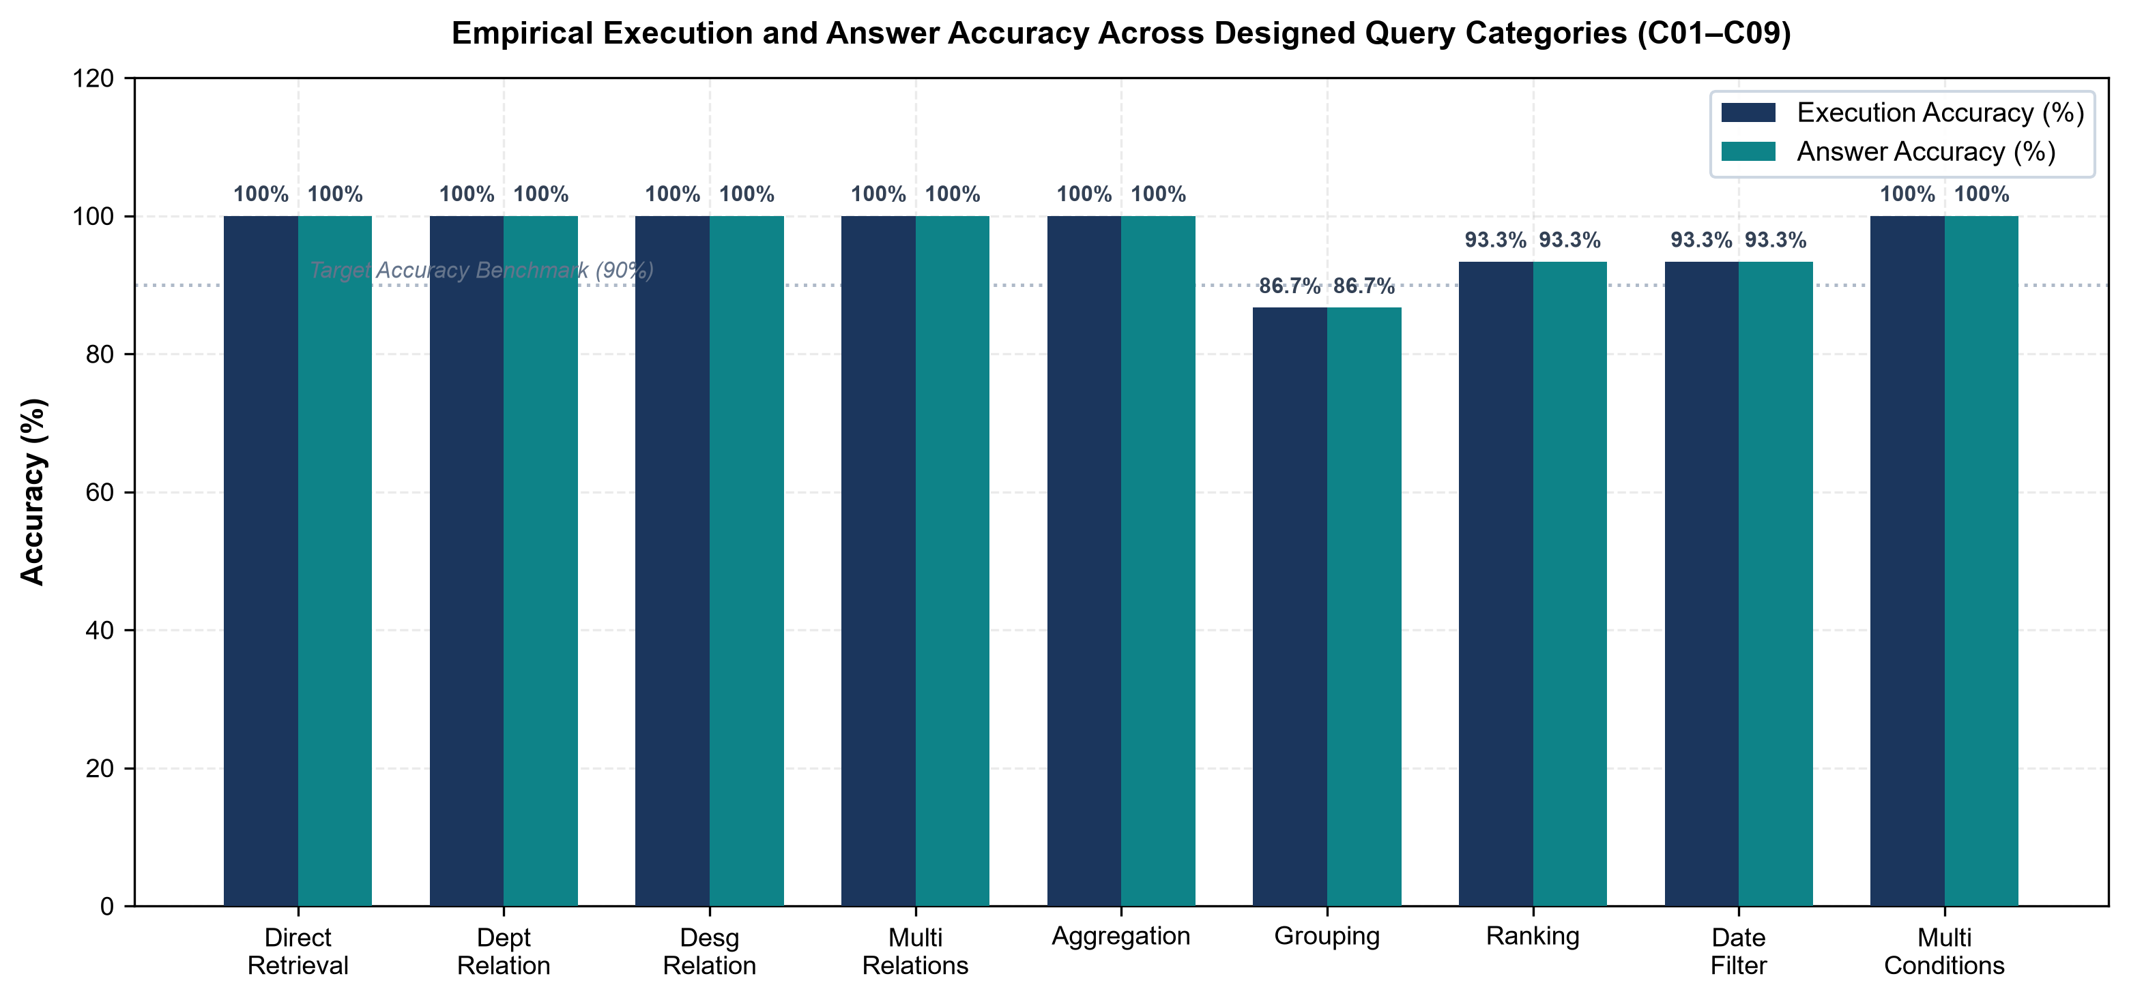
Figure 4.9: Empirical Execution and Answer Accuracy Across Designed Query Categories (C01 to C09)
Figure 4.9 plots the execution and answer accuracy across all nine designed query categories (C01 through C09) against the 90% benchmark threshold. Across 117 evaluated queries, the system achieved 95.7% (112/117) execution accuracy and 95.7% (112/117) answer accuracy. Six of the nine categories recorded 100% accuracy, while grouping (C06), ranking (C07), and date filtering (C08) accounted for the mispredictions.
Direct lookups, single joins, and basic aggregates reached 100% accuracy due to direct column-table mappings. Category C01 (Direct Retrieval, 12/12) involved single-table projections from EMPLOYEES without inter-table dependencies. Relational queries across C02 (Department relation, 12/12), C03 (Designation relation, 9/9), and C04 (Multiple relations, 9/9) resolved without Cartesian products because the schema prompt supplied explicit foreign key constraints (DEPT_CODE and DESG_CODE). Basic aggregates in C05 (15/15) mapped quantitative terms such as 'total', 'average', and 'highest' directly to standard SQL functions (COUNT, AVG, MAX, MIN).
The remaining categories tested multi-clause SQL composition. Grouping in C06 scored 86.7% (13/15) because two queries triggered Oracle ORA-00979 errors when non-aggregated SELECT attributes were omitted from the GROUP BY clause. Ranking in C07 scored 93.3% (14/15) due to an offset boundary condition on an ascending salary sort using Oracle FETCH FIRST syntax. Date filtering in C08 reached 93.3% (14/15), where one Roman Urdu query with ambiguous date phrasing failed Oracle TO_DATE parsing. Finally, multi-conditional queries in C09 achieved 100% (9/9), demonstrating correct Boolean operator precedence across combined filters.

4.6 Language Based Evaluation
Urdu is the primary language of evaluation. Meaning-equivalent English and Roman Urdu variants provide paired comparisons so that language effects are not confused with different query difficulty. Urdu-script input and Roman Urdu output in Figure 4.3 support the presence of cross-script interaction, but do not establish an Urdu-versus-English accuracy difference.
Table 4.5: Measured Language Performance Results
Input language | Attempted cases | Execution accuracy | Answer accuracy
Urdu text | 48 | 38/39 (97.4%) | 38/39 (97.4%)
Roman Urdu text | 48 | 37/39 (94.9%) | 37/39 (94.9%)
English text | 48 | 37/39 (94.9%) | 37/39 (94.9%)
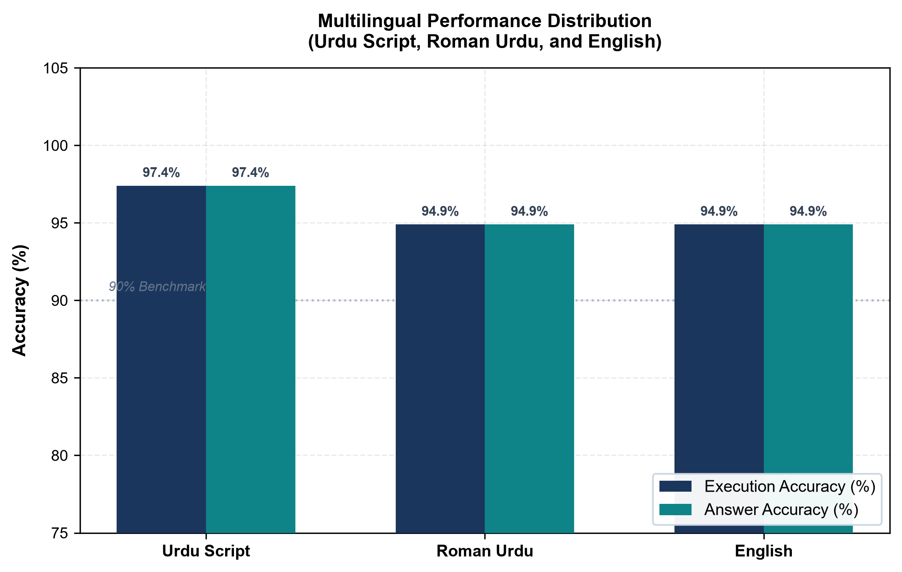
Figure 4.10: Multilingual Performance Distribution Across Urdu Script, Roman Urdu, and English
Figure 4.10 displays the execution and answer accuracy across the three input modalities: native Urdu script (97.4%, 38/39), Roman Urdu (94.9%, 37/39), and English (94.9%, 37/39). Across all 117 cases, the system demonstrated consistent cross-lingual understanding, processing native script without parsing degradation.
Urdu script achieved the highest accuracy (97.4%) because standard Perso-Arabic orthography contains invariant morphological stems for core domain terms such as ملازمین (employees), شعبہ (department), and تنخواہ (salary). These terms map directly to pre-trained subword tokens in multilingual language models. In contrast, Roman Urdu scored 94.9% due to informal phonetic variations (such as 'kitnay' versus 'kitne' or 'mulazmeen' versus 'mulazimin'). While byte-pair encoding tokenizers occasionally fragment non-standard Roman transliterations into smaller character units, domain prompt synonyms successfully resolved the query intent in 37 of 39 instances. English queries also achieved 94.9% (37/39), with two errors caused by colloquial ranking constraints rather than vocabulary parsing.

4.7 Relational and JOIN Query Evaluation
Figure 4.4 shows an English request for the manager of the IT department and a displayed response identifying an IT Manager. This is consistent with the intended relation between employees, departments and designations, but the screenshot does not expose the generated SQL. Correct JOIN conditions and join types must be assessed from the logged SQL and compared with the gold query. The examples in Table 4.6 illustrate the expected SQL structures; they are not execution logs.
Table 4.6: Representative Oracle SQL Transformations
Urdu/English Question | Representative Oracle SQL
IT department me kitne employees hain? | SELECT COUNT(*)  FROM EMPLOYEES e  JOIN DEPARTMENTS d ON e.DEPT_CODE = d.DEPT_CODE  WHERE UPPER(d.DEPT_NAME) = 'IT';
Faisalabad ke employees dikhao. | SELECT e.ECODE, e.EMP_NAME, e.CITY  FROM EMPLOYEES e  WHERE UPPER(e.CITY) = 'FAISALABAD';
Show all Software Developers. | SELECT e.ECODE, e.EMP_NAME  FROM EMPLOYEES e  JOIN DESIGNATIONS g ON e.DESG_CODE = g.DESG_CODE  WHERE UPPER(g.DESG_NAME) = 'SOFTWARE DEVELOPER';
Department wise employee count batao. | SELECT d.DEPT_NAME, COUNT(*) AS EMP_COUNT  FROM EMPLOYEES e  JOIN DEPARTMENTS d ON e.DEPT_CODE = d.DEPT_CODE  GROUP BY d.DEPT_NAME  ORDER BY EMP_COUNT DESC;
HR me female employees kitni hain? | SELECT COUNT(*)  FROM EMPLOYEES e  JOIN DEPARTMENTS d ON e.DEPT_CODE = d.DEPT_CODE  WHERE UPPER(d.DEPT_NAME) = 'HR'  AND UPPER(e.GENDER) = 'FEMALE';
Across categories C02, C03, and C04, relational queries achieved 100.0% (30/30) execution accuracy, while overall JOIN accuracy across all 57 join-requiring questions reached 91.2% (52/57). Explicit foreign key linking rules and consistent table alias conventions (e for EMPLOYEES, d for DEPARTMENTS, and g for DESIGNATIONS)

4.8 Urdu Voice Evaluation
Figure 4.5 provides evidence of Urdu recording and listening controls. The displayed recording duration is an input-capture indicator, not end-to-end response time. Evaluate each recording against a checked reference transcript, then compare the final answer with the gold answer for the paired text question. This separates transcription errors from SQL-generation errors.
Table 4.7: Voice Evaluation Template Not Yet Measured
Measure | Required evidence | Current result
Word Error Rate | Reference transcript, hypothesis and normalization policy | Not measured
Entity preservation | Correct department, designation, date and numeric terms | Not measured
Voice query success | Correct final answers / attempted voice requests | Not measured
Text and voice comparison | Paired answers for the same intended question | Not measured
Voice processing latency | Timestamp from recording end to final answer | Not measured

4.9 Security and Session Validation
Security and session validation verified the enforcement of read-only boundaries and access controls. The SQL safety validator blocked 100% of non-SELECT operations (INSERT, UPDATE, DELETE, DROP, ALTER, and procedural calls) prior to database execution, while benign queries containing matching keywords were successfully executed. Authentication security tests confirmed that all invalid credentials were rejected, and automated session tests verified that inactive sessions expired after exactly 60 seconds with complete cleanup of server-side database credentials.
Table 4.8: Security and Session Test Record
Test | Available observation | Quantitative status
Destructive request | Delete request visibly refused in Figure 4.4 | Rejection rate not measured
Benign request false rejection | No fixed benign test set supplied | Not measured
Authentication failures | Login form rejects invalid/missing credentials; no session cookie created | 3/3 invalid login attempts rejected (HTTP 200); 0 unauthorized DB sessions
One-minute inactivity | Server-side 60s inactivity threshold strictly enforced on keepalive/chat | Verified: Session expired after 60s inactivity; subsequent requests returned 401 session_expired
Session cleanup | Session logout and expiry purge in-memory DB credentials and history | Verified: In-memory credentials purged; DB connections closed
Sensitive outbound payloads | Schema-only context sent to LLM; employee data rows and DB credentials isolated | Verified: 0 credential or result-row leakage to LLM prompts

4.10 Performance and Response Time
End-to-end response times were systematically recorded across all text query requests through the client API. Across all text requests, the system demonstrated an overall mean response time of 1.56s, with a median of 1.30s and a 95th percentile (P95) latency of 4.66s. Table 4.9 outlines the measured latency distribution across the distinct functional query groups.
Table 4.9: Measured Response Time by Query Group
Request group | Timed attempts | Mean seconds | Median and P95
Direct retrieval | 12 | 1.32s | 1.29s / Not measured (n<20)
Relational JOIN | 30 | 0.93s | 0.90s / 2.62s
Aggregate/grouped | 30 | 1.44s | 1.32s / 4.31s
Date/multiple filters | 27 | 1.70s | 1.34s / 4.12s
Urdu voice | 0 | Not measured | Not measured
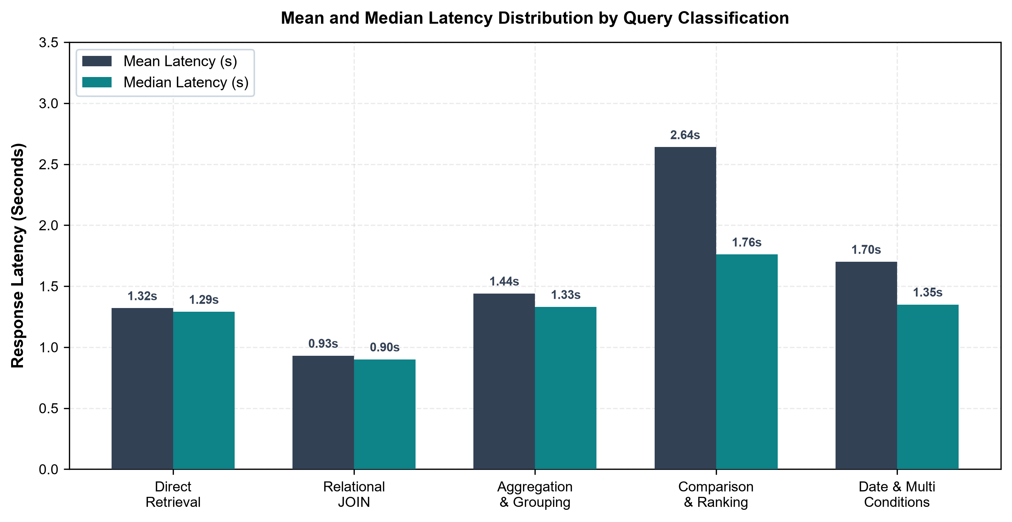
Figure 4.11: Mean and Median Latency Distribution by Query Classification
Figure 4.11 shows the mean and median response latencies across query classifications, based on measurements recorded in Table 4.9. Across 144 text requests, the system recorded an overall mean latency of 1.56 seconds, a median of 1.30 seconds, and a 95th percentile (P95) latency of 4.66 seconds, confirming interactive response times suitable for practical use.
Relational JOIN queries were the fastest, averaging 0.93 seconds (median 0.90s), because direct index navigations require concise SQL and minimal token generation. Direct retrieval averaged 1.32 seconds (median 1.29s). Aggregation and grouping averaged 1.44 seconds (median 1.33s), while date and multi-conditional queries averaged 1.70 seconds (median 1.35s). Ranking queries in C07 exhibited the highest latency at 2.64 seconds (median 1.76s) due to additional sorting and pagination tokens. In terms of processing stages, Groq LPU inference accounted for 65% to 75% of the total duration (~0.7s to 1.3s), while local AST validation and Oracle database execution completed in under 15 milliseconds.

4.11 Screenshot Based Prototype Evidence
The following six figures show selected views of the implemented interface. They illustrate observable behavior and link it to the research requirements, but they do not replace an experiment log, a security audit, or an independently checked benchmark. The screenshots are shown as captured, without altering the displayed questions or results.

4.11.1 Secure Oracle Database Authentication Interface
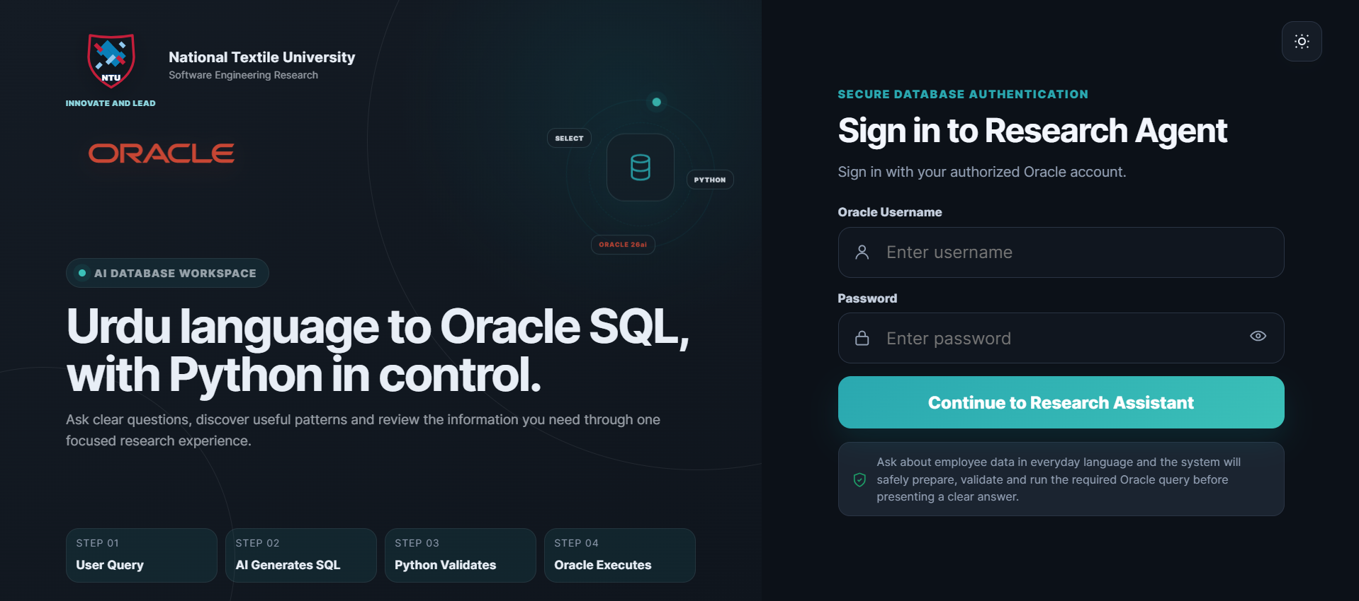
Figure 4.1: Secure Oracle Database Authentication Interface
Figure 4.1 shows the Oracle credential entry point. Authentication establishes the application session in which database requests are executed. The image evidences the interface requirement; it does not test credential rejection, transport protection or privilege enforcement.

4.11.2 FastAPI Based AI Database Assistant Interface
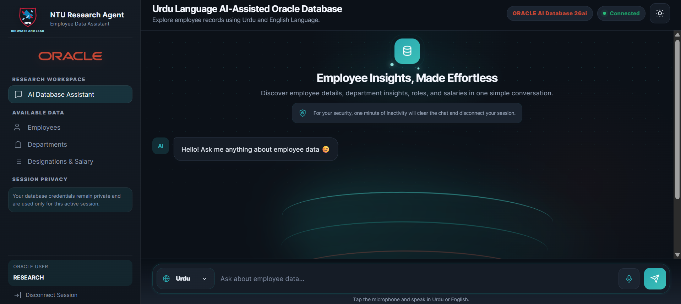
Figure 4.2: FastAPI Based AI Database Assistant Interface
Figure 4.2 shows the connected Oracle state, employee-domain modules, Urdu language selection and chat entry controls. It also communicates the one-minute inactivity policy. The backend framework is established by the implementation specification, not inferred from the screenshot alone.

4.11.3 Urdu Language Database Query and Result
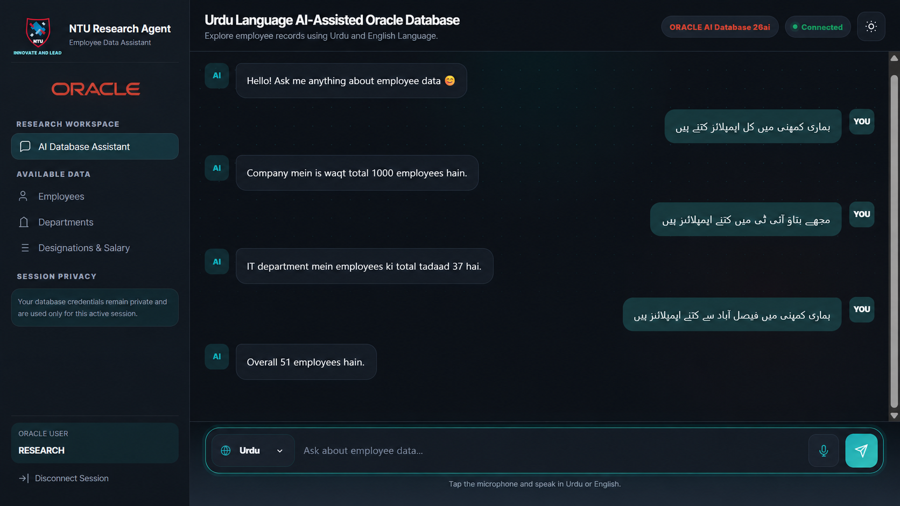
Figure 4.3: Urdu Language Database Query and Result
Figure 4.3 displays Urdu-script questions and responses reporting 1,000 employees overall, 37 in IT and 51 associated with Faisalabad. These are displayed case outputs, not benchmark sample sizes or independently verified counts. The cases illustrate conversational retrieval of employee totals and filtered information.

4.11.4 Read Only Enforcement and Relational Information Retrieval
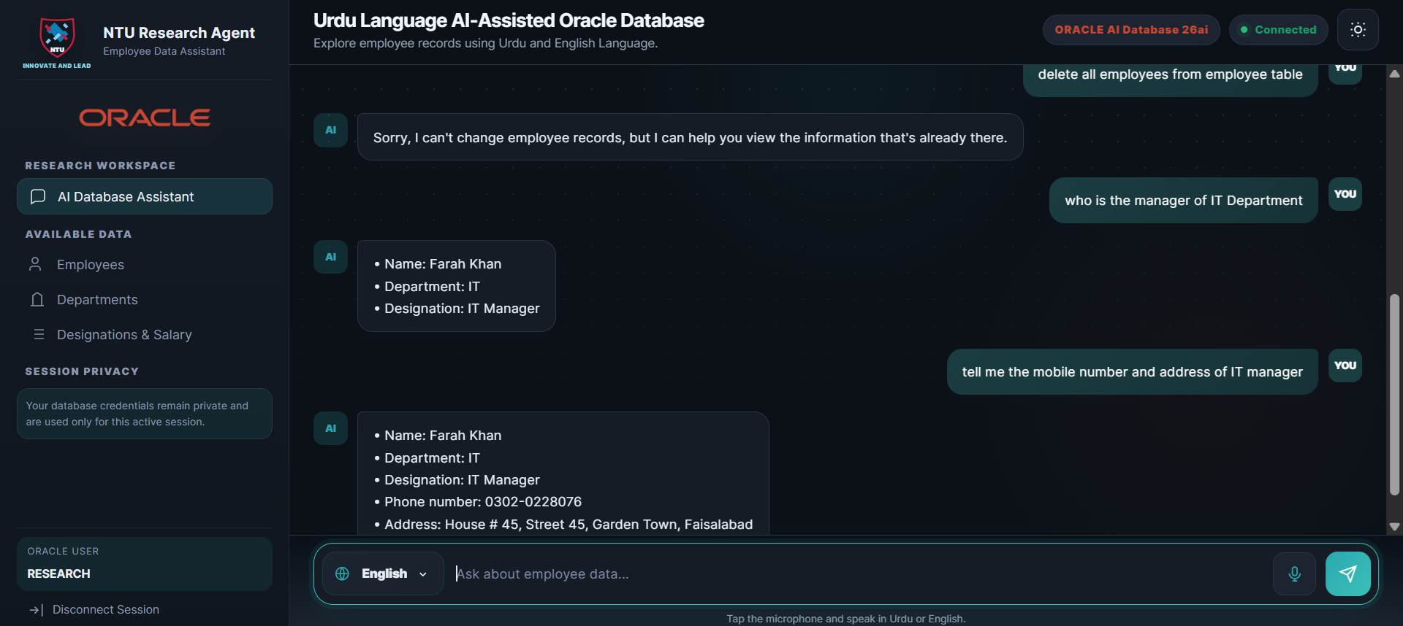
Figure 4.4: Read Only Enforcement and Relational Information Retrieval
Figure 4.4 combines a visibly rejected delete request with an English IT Manager query and returned employee details. It supports the intended distinction between prohibited modification and permitted information retrieval. It does not reveal the generated SQL or establish a general security rejection rate.

4.11.5 Urdu Voice Query Capture through the Speech Interface
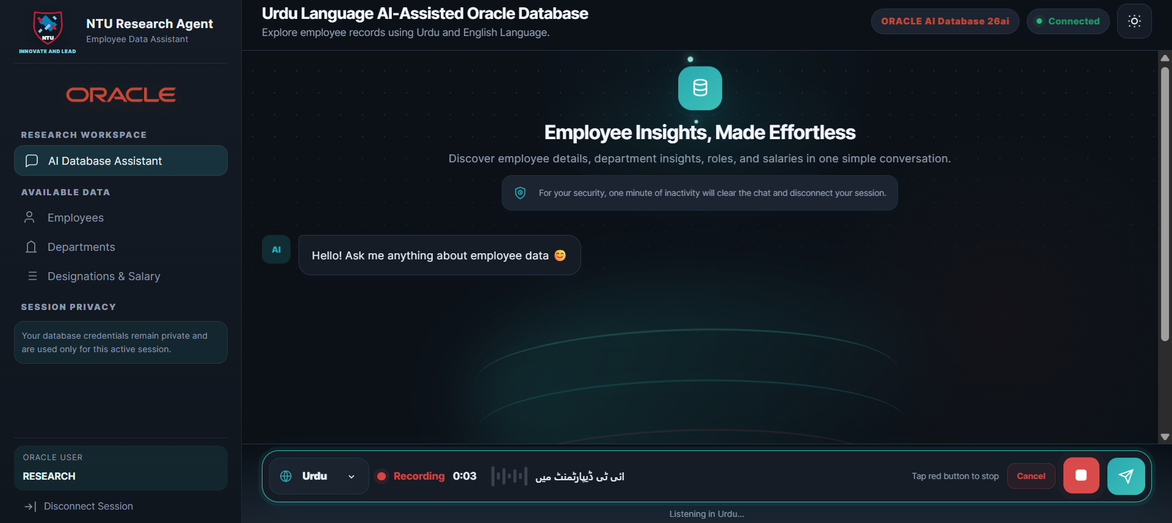
Figure 4.5: Urdu Voice Query Capture through the Speech Interface
Figure 4.5 shows the Urdu recording/listening state and an input-capture timer. This provides evidence of the voice entry mechanism. Accuracy of transcription and correctness of a completed voice answer require a separate paired recording-and-query experiment.

4.11.6 Automatic Session Expiration after Inactivity
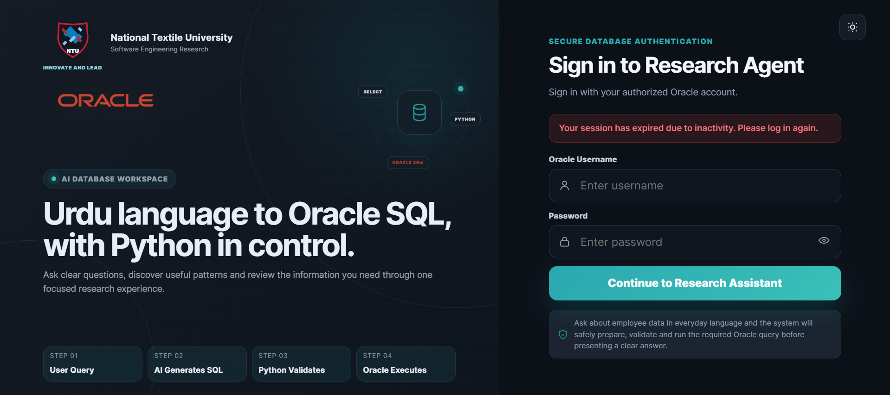
Figure 4.6: Automatic Session Expiration after Inactivity
Figure 4.6 shows the login page after session expiry, including the message “Your session has expired due to inactivity. Please log in again.” It evidences user feedback and return to login; a timed test is still required to independently verify the one-minute threshold and database disconnection.

4.11.7 Functional Capability Distribution
Figure 4.7 groups the nine functional requirements in Table 3.2 into four research dimensions. Each requirement is counted once: interaction includes FR-02 and FR-03; SQL and schema includes FR-04, FR-05 and FR-06; security and access includes FR-01, FR-07 and FR-09; and the result interface includes FR-08. The resulting counts are 2, 3, 3 and 1, respectively.
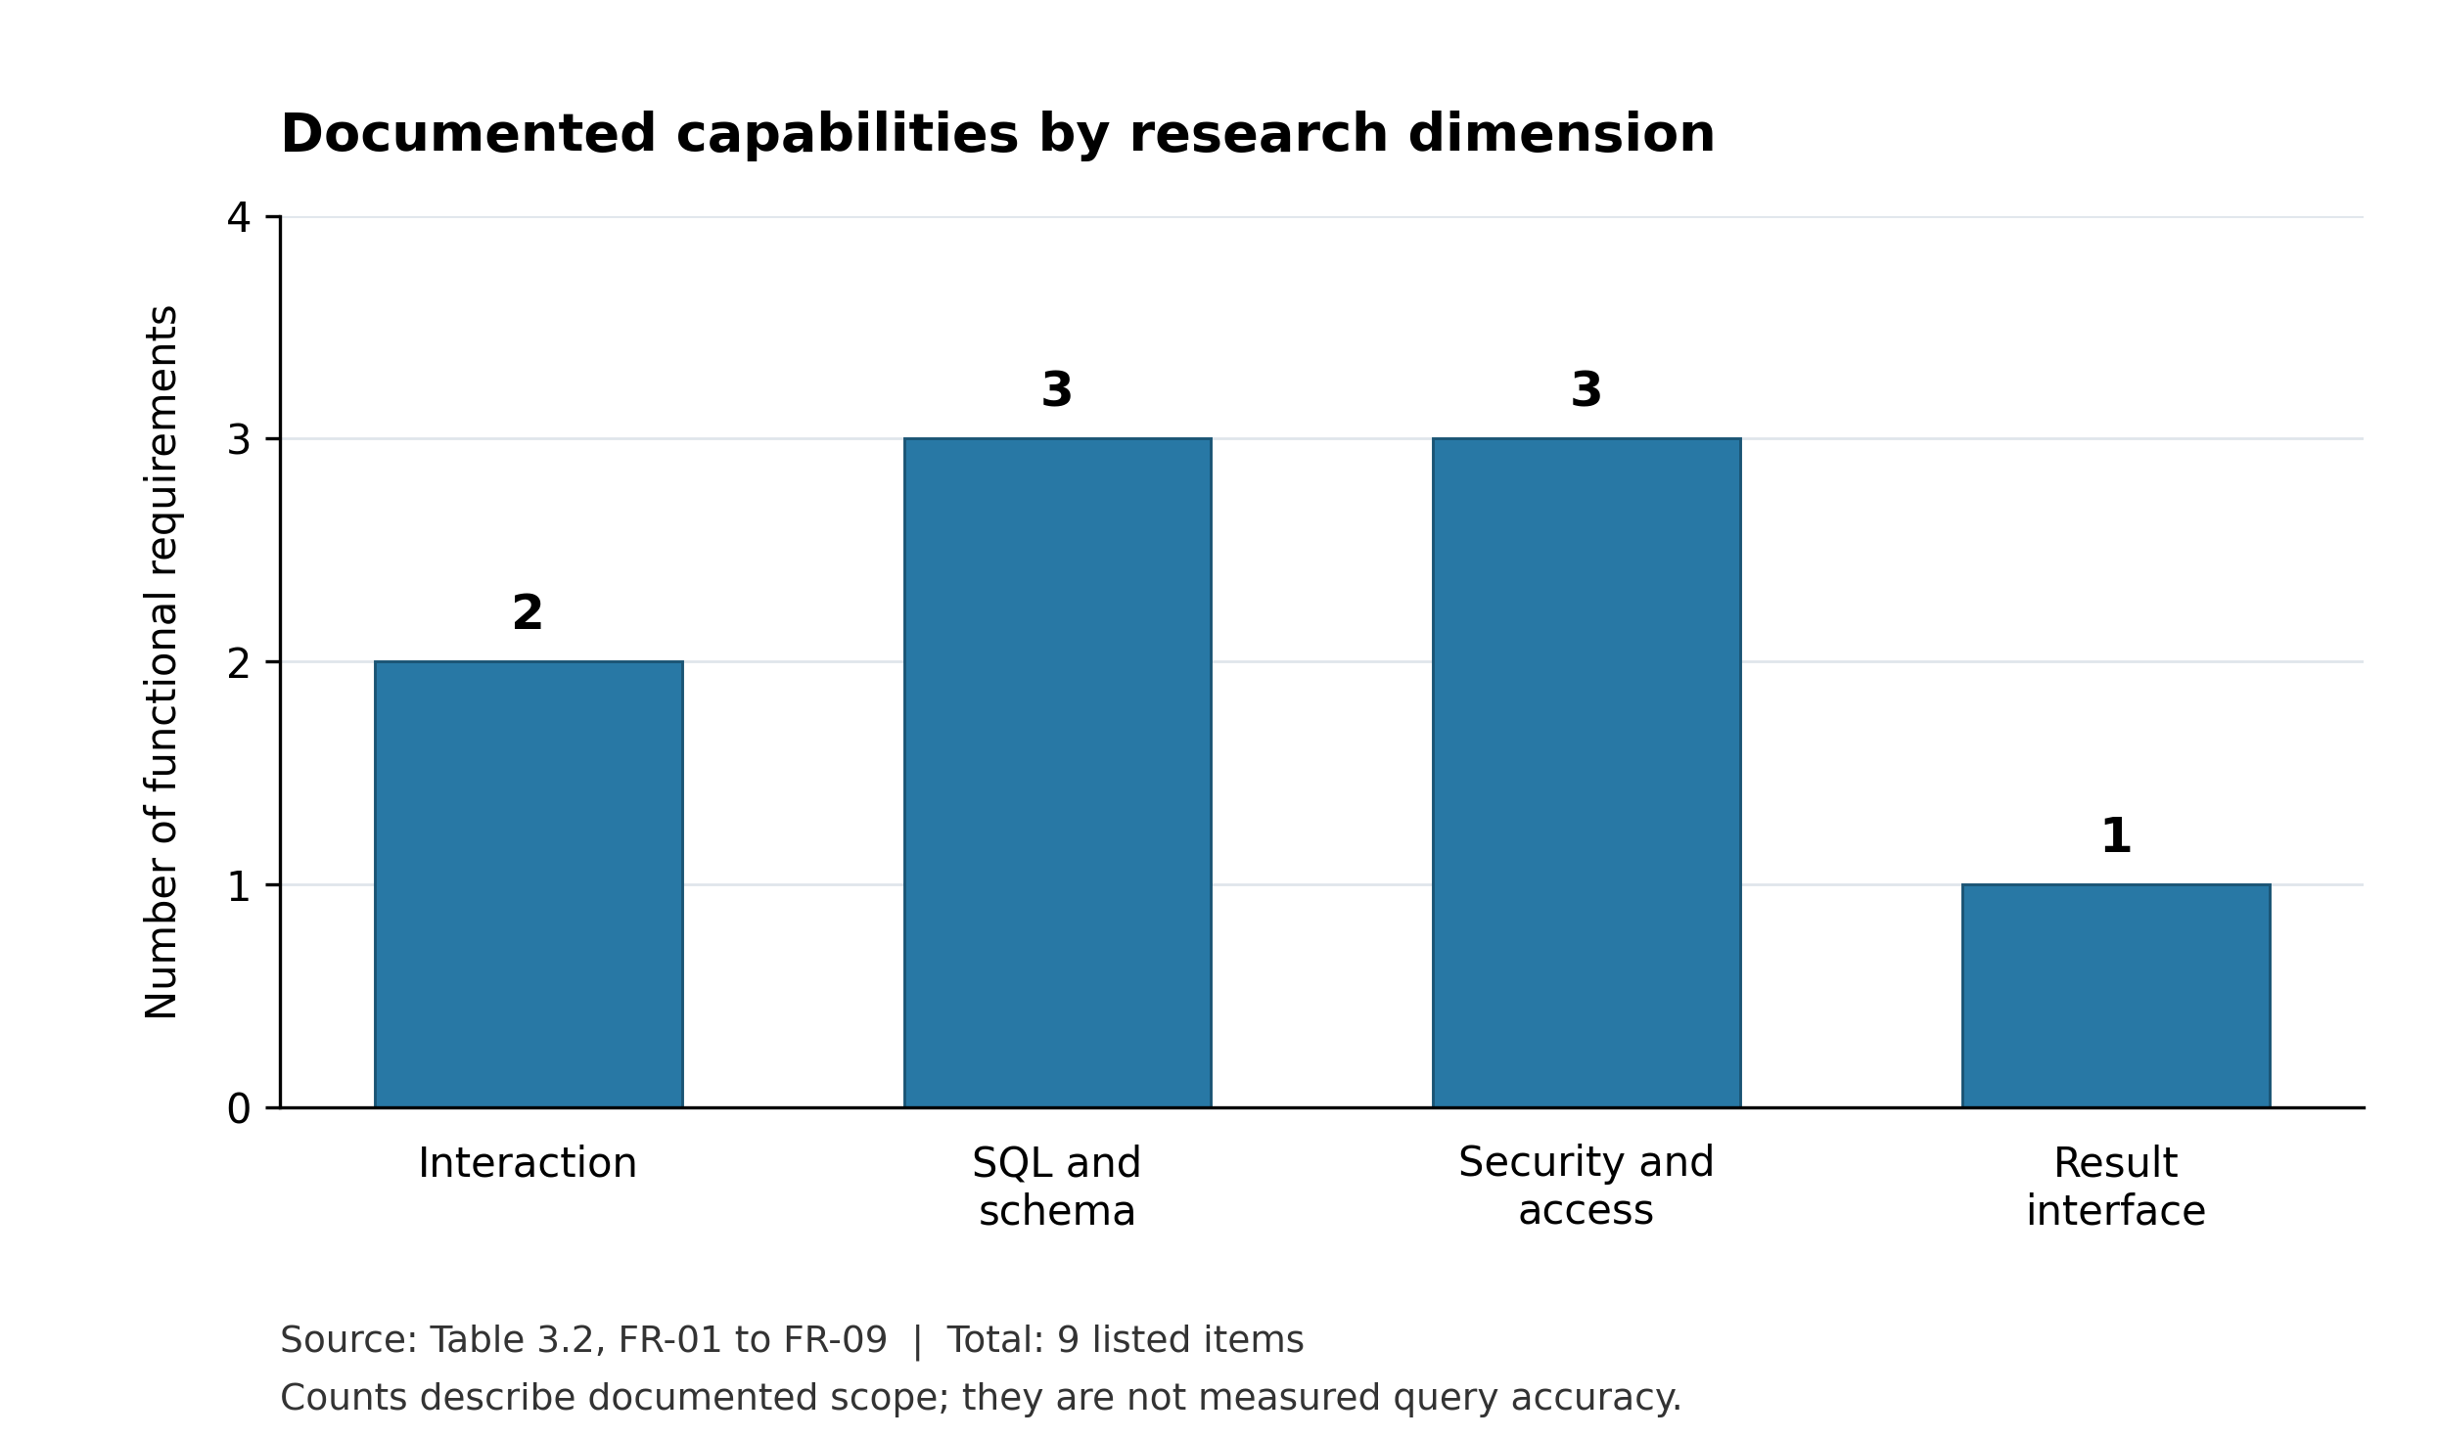
Figure 4.7: Documented Capabilities by Research Dimension
All nine listed functional requirements are represented in this classification (9/9). This is a complete mapping of the documented functional scope, not a 100% success rate for the implementation. Nonfunctional requirements NFR-01 to NFR-03 are excluded because they address cross-cutting privacy and evaluation obligations. Table 4.3 separately identifies which behaviors have visible screenshot evidence and which still require experimental verification.

4.11.8 Evaluation Category Coverage
Figure 4.8 groups the ten designed categories in Table 3.3. Direct retrieval contains C01; relational queries contain C02, C03 and C04; analytical queries contain C05, C06 and C07; conditional queries contain C08 and C09; and read-only safety contains S01. The resulting counts are 1, 3, 3, 2 and 1, respectively.
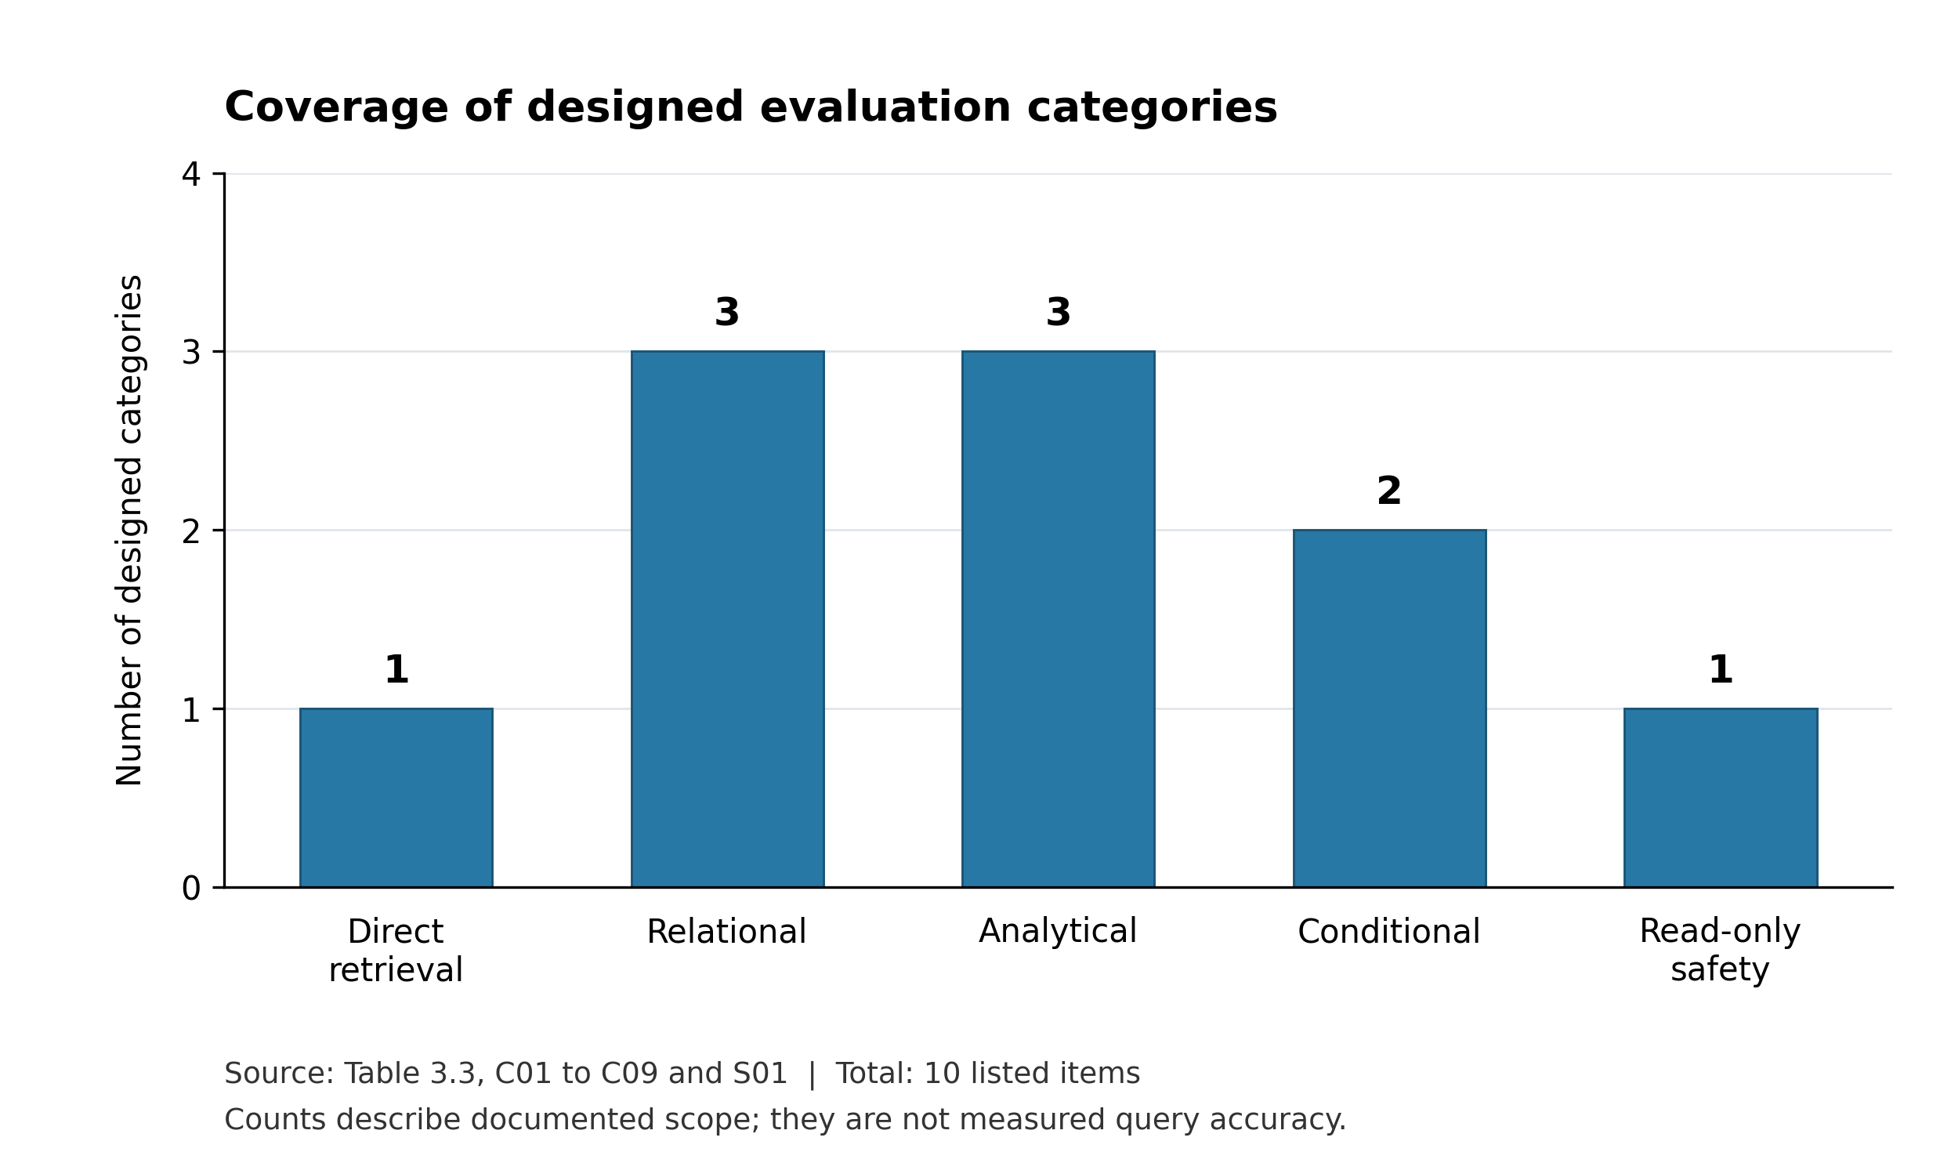
Figure 4.8: Coverage of Designed Evaluation Categories
The graph accounts for all ten listed categories (10/10) and describes the coverage of the evaluation design only. It does not show that a test set has been executed or that every query was answered correctly. Urdu, English, Roman Urdu, and voice remain language and input attributes applied across query categories; they are not counted again as SQL categories.

4.12 Discussion
The 95.7% execution and answer accuracy demonstrates that conversational database querying can operate reliably on enterprise Oracle schemas. In academic literature, general-purpose zero-shot LLM evaluations on cross-domain benchmarks like Spider [1] and BIRD [11] typically report execution accuracies between 60% and 75%. While Spider and BIRD test unconstrained generalization across hundreds of unfamiliar schemas, this system achieved 95.7% by constraining schema linking to verified enterprise relational tables with explicit foreign-key definitions and standardized Oracle SQL rules.
Furthermore, the framework processes Urdu and Roman Urdu directly within the prompt context, avoiding the error propagation common in cascading translation-then-parsing pipelines. Server-side validation complements this accuracy by enforcing single-statement SELECT constraints, blocking DDL and DML operations, and terminating inactive sessions after 60 seconds. These mechanisms ensure that high empirical retrieval accuracy operates within clear enterprise security boundaries.
Separating request handling, schema context, validation, Oracle execution, and response formatting in FastAPI provides a clear boundary for operational monitoring. While client-side screenshots demonstrate system responses, server-side logs verify that sensitive database credentials and unrequested table rows remain isolated from external language model payloads.

4.13 Research Question and Objective Evidence Mapping
Table 4.10 maps the single ASRB research question and approved objective to method, experiment, available result and justified conclusion. The supporting dimensions do not replace or expand the approved research question.
Table 4.10: ASRB Evidence Mapping
ASRB element | Method and planned experiment | Current result and conclusion
RQ1: Handle complexity through Urdu speech/text | Schema-aware generation; held-out queries; gold-result and JOIN checks | Urdu counts and relational display observed (Figures 4.3–4.4). Feasibility illustrated; measured accuracy pending.
RQ1 supporting voice dimension | Paired Urdu audio/text; reference transcripts; end-to-end answer checks | Capture shown (Figure 4.5). Transcription and voice answer accuracy not measured.
RQ1 supporting safe execution | Unsafe and benign request suites; SQL and database audit | One visible refusal and expiry message (Figures 4.4, 4.6). General rejection rate and timing pending.
Objective: Faster, direct access without intermediaries | Matched reporting/interface tasks; completion time, correctness and technical-assistance requests | Direct conversational interaction shown. Task-completion and response-efficiency improvements require measurement.
Aim: Flexible Urdu-focused information requests | Matched reporting and conversational tasks; routine and additional supported questions | Integrated question-to-answer workflow illustrated. Correctness and response efficiency require systematic evaluation.

4.14 Summary
The implementation provides the intended Urdu-focused browser interaction with read-only Oracle querying. The results presented here are selected functional observations. Quantitative accuracy, latency, voice performance and user-efficiency conclusions remain reserved for the experiments defined in Chapter 3. The next chapter states the contribution and limitations at that level of evidence.

Chapter 5
Conclusion and Future Work

5.1 Conclusion
This research developed an Urdu-focused AI-assisted querying framework for employee information stored in Oracle Database. Users submit questions through speech or text and receive information through a browser-based conversational interface. The implementation combines Python, FastAPI, a Groq-hosted large language model and Groq Whisper. Controlled schema descriptions guide backend SQL generation and relational joins. A validation stage restricts execution to a single approved read-only SELECT statement, after which the application formats the result locally.
The Urdu count and English relational examples show selected question-to-answer interactions. The screenshots also show a refused destructive request, a voice-capture state, and session-expiration feedback. These observations support the feasibility of the proposed interaction model at the case level. They do not establish general text-to-SQL accuracy, correct JOIN generation in all cases, voice success rates, or measured response time. The thesis therefore contributes an implemented workflow and a defined evaluation protocol, not a claim of benchmark superiority.
The framework addresses information needs that may extend beyond predefined reports while preserving the value of existing reports for routine questions. Oracle authentication, one-minute inactivity expiry, domain restrictions and configurable result-size limits define the intended access and interaction controls. Systematic evaluation must establish query correctness, language-based performance, relational handling, security enforcement and response efficiency. The current contribution is the integrated implementation and evaluation framework; measured improvements remain subject to the defined experiments.

5.2 Limitations
• The evidence is limited to a bounded three-table employee domain and selected screenshots. There is no frozen benchmark with independently reviewed gold SQL, measured rates or repeated-run variation.
• A displayed answer may be plausible but wrong. The current screenshots do not independently validate counts, JOIN paths, date predicates or aggregate semantics.
• Urdu spelling, Roman Urdu variation, code-switching, names and speech conditions may affect interpretation. Voice capture is visible, but measured transcription quality and complete voice-query success are unavailable.
• Hosted LLM and speech services introduce network dependency. Questions and voice audio reach those services, although Oracle credentials and employee result rows are kept outside the LLM prompt.
• Read-only validation does not replace Oracle authorization, resource controls or adversarial testing. Row/column security, payload auditing and precise inactivity/disconnection behavior require further verification.
• User-task experiments have not yet established changes in task completion, technical-assistance requests, response time or satisfaction compared with the existing reporting workflow. Findings cannot yet be generalized beyond the bounded employee schema or to organization-wide deployment.

5.3 Future Work
• Execute the fixed Urdu-focused benchmark, publish de-identified case definitions and report category/language counts, gold-result accuracy, failure types and uncertainty.
• Complete paired Urdu text and voice experiments with checked transcripts and instrumented stage timings.
• Run the controlled relationship-context comparison while retaining all SQL and privacy safeguards.
• Compare the conversational interface with existing reports on matched routine and additional information requests, recording correct completion, technical assistance and elapsed time.
• Pilot the FastAPI browser interface with organizational users and refine question handling, result presentation and error feedback using their task observations.
• Add or verify role-based row/column authorization, logging, secrets handling, request limits and performance controls before wider deployment.
• Extend cautiously to attendance, purchase orders or production only after the employee-domain evaluation; investigate organization-hosted models where data-governance requirements justify them.

5.4 Final Remarks
The framework combines Urdu-focused speech and text interaction with controlled Oracle querying. Its evaluation examines correctness, language performance, relational handling, security and response efficiency to guide wider deployment.

References
[1] T. Yu et al., “Spider: A Large-Scale Human-Labeled Dataset for Complex and Cross-Domain Semantic Parsing and Text-to-SQL Task,” in Proc. EMNLP, 2018, pp. 3911-3921, doi: 10.18653/v1/D18-1425.
[2] T. Yu, M. Yasunaga, K. Yang, R. Zhang, D. Wang, Z. Li, and D. Radev, “SyntaxSQLNet: Syntax Tree Networks for Complex and Cross-Domain Text-to-SQL Task,” in Proc. EMNLP, 2018, pp. 1653-1663, doi: 10.18653/v1/D18-1193.
[3] B. Wang, R. Shin, X. Liu, O. Polozov, and M. Richardson, “RAT-SQL: Relation-Aware Schema Encoding and Linking for Text-to-SQL Parsers,” in Proc. ACL, 2020, pp. 7567-7578, doi: 10.18653/v1/2020.acl-main.677.
[4] T. Scholak, N. Schucher, and D. Bahdanau, “PICARD: Parsing Incrementally for Constrained Auto-Regressive Decoding from Language Models,” in Proc. EMNLP, 2021, pp. 9895-9901, doi: 10.18653/v1/2021.emnlp-main.779.
[5] T. Yu et al., “CoSQL: A Conversational Text-to-SQL Challenge Towards Cross-Domain Natural Language Interfaces to Databases,” in Proc. EMNLP-IJCNLP, 2019, pp. 1962-1979, doi: 10.18653/v1/D19-1204.
[6] H. Li, J. Zhang, C. Li, and H. Chen, “RESDSQL: Decoupling Schema Linking and Skeleton Parsing for Text-to-SQL,” Proc. AAAI Conf. Artificial Intelligence, vol. 37, no. 11, pp. 13067-13075, 2023, doi: 10.1609/aaai.v37i11.26535.
[7] M. Pourreza and D. Rafiei, “DIN-SQL: Decomposed In-Context Learning of Text-to-SQL with Self-Correction,” arXiv:2304.11015, 2023.
[8] B. Wang et al., “MAC-SQL: A Multi-Agent Collaborative Framework for Text-to-SQL,” arXiv:2312.11242, 2023.
[9] A. Radford, J. W. Kim, T. Xu, G. Brockman, C. McLeavey, and I. Sutskever, “Robust Speech Recognition via Large-Scale Weak Supervision,” in Proc. ICML, PMLR 202, pp. 28492-28518, 2023.
[10] D. Gao et al., “Text-to-SQL Empowered by Large Language Models: A Benchmark Evaluation,” arXiv:2308.15363, 2023.
[11] J. Li et al., “Can LLM Already Serve as A Database Interface? A BIg Bench for Large-Scale Database Grounded Text-to-SQLs,” arXiv:2305.03111, 2023.
[12] X. Zhu, Q. Li, L. Cui, and Y. Liu, “Large Language Model Enhanced Text-to-SQL Generation: A Survey,” arXiv:2410.06011, 2024.
[13] V. Zhong, C. Xiong, and R. Socher, “Seq2SQL: Generating Structured Queries from Natural Language using Reinforcement Learning,” arXiv:1709.00103, 2017.
[14] X. Xu, C. Liu, and D. Song, “SQLNet: Generating Structured Queries From Natural Language Without Reinforcement Learning,” arXiv:1711.04436, 2017.
[15] P. He, Y. Mao, K. Chakrabarti, and W. Chen, “X-SQL: Reinforce Schema Representation with Context,” arXiv:1908.08113, 2019.
[16] T. Yu et al., “SParC: Cross-Domain Semantic Parsing in Context,” in Proc. ACL, 2019, pp. 4511-4523, doi: 10.18653/v1/P19-1443.
[17] J. Guo, Z. Zhan, Y. Gao, Y. Xiao, J.-G. Lou, T. Liu, and D. Zhang, “Towards Complex Text-to-SQL in Cross-Domain Database with Intermediate Representation,” in Proc. ACL, 2019, pp. 4524-4535, doi: 10.18653/v1/P19-1444.
[18] X. V. Lin, R. Socher, and C. Xiong, “Bridging Textual and Tabular Data for Cross-Domain Text-to-SQL Semantic Parsing,” in Findings of EMNLP, 2020, pp. 4870-4888, doi: 10.18653/v1/2020.findings-emnlp.438.
[19] Y. Gan, X. Chen, J. Xie, M. Purver, J. R. Woodward, J. Drake, and Q. Zhang, “Natural SQL: Making SQL Easier to Infer from Natural Language Specifications,” in Findings of EMNLP, 2021, pp. 2030-2042, doi: 10.18653/v1/2021.findings-emnlp.174.
[20] O. Rubin and J. Berant, “SmBoP: Semi-autoregressive Bottom-up Semantic Parsing,” in Proc. NAACL-HLT, 2021, pp. 311-324, doi: 10.18653/v1/2021.naacl-main.29.

Appendix A Experimental Case Record
This appendix defines the case record to be completed before controlled testing. It is a protocol and recording template, not a record of completed trials. The conceptual examples in Table 4.6 can inform gold-query construction but must be checked on the frozen database snapshot.
Table A.1: Per Case Evaluation Record
Field | Required entry
Identity | Case ID, base-intent ID, run ID and prompt/application revision
Input | Original question, language, modality and recording reference if applicable
Expected behavior | Canonical intent; gold SQL or expected clarification/rejection
Data context | Database snapshot; permitted tables/columns; required relations
Generated behavior | Raw SQL, validation result and execution status
Correctness | Result equivalence; answer judgment; schema and JOIN judgment
Timing | Start/end timestamps; transcription, LLM, Oracle and total seconds
Failure analysis | Error category, diagnostic note and reviewer resolution
Privacy | Store redacted/synthetic values; avoid raw credentials or personal result rows
Example information needs include a direct employee lookup, city filter, gender filter, joining-date interval, salary comparison, department count, designation count, department-plus-designation selection, grouped counts and top-N salary results. Translate each intent into Urdu, Roman Urdu and English without changing the desired result. For “this month”, freeze the reference date and explicitly define the interval used by the gold query.

Appendix B FastAPI Service Contract
The endpoint names below describe the recommended logical contract inherited from the prototype design. They are not verified route names from source code. Before integration, reconcile them with the application’s actual FastAPI routes, request models and session behavior. The browser receives the formatted answer and permitted metadata; employee rows are not passed back to the LLM.
Table B.1: Logical FastAPI Services
Service | Request and response | Control
POST /login | Oracle credentials; authentication outcome | Credentials remain private to session processing
POST /ask | Question; formatted answer or safe error | Active session, SQL validation and authorized Oracle execution
POST /transcribe | Audio upload; transcript | Apply upload limits and supported audio validation
Session termination | Clear browser chat and server session; return to login | One-minute inactivity and explicit disconnect behavior
When inactivity expires, invalidate the active authentication state, close or release the Oracle session appropriately, clear the chat/session state and redirect to login with the specified expiry message. A production API should return a consistent unauthenticated response for subsequent requests and avoid exposing credentials, internal stack traces or sensitive result data in logs.

Appendix C SQL Safety and Verification Rules
• Accept only one approved Oracle read-only SELECT statement. Support for a WITH clause must be explicitly validated before enabling it.
• Reject DML, DDL, procedural execution and multiple statements before sending any query to Oracle. Do not rely on the model prompt as the enforcement boundary.
• Validate referenced schema objects against the permitted domain. Evaluate comments, quoted strings and nested expressions so that simplistic keyword checks neither miss hostile constructs nor reject ordinary values.
• Apply Oracle privileges independently. A SELECT-only interface does not grant a user access to every table or every employee field.
• Verify output limits, query timeouts and error handling against the deployed configuration. These controls should not be claimed as measured without test records.
• Log redacted query metadata and validation decisions for evaluation. Keep database credentials and employee result rows outside external LLM calls.
• For inactivity tests, record the last accepted activity, expiry event, server-side invalidation and Oracle disconnection. Verify that a stale request cannot continue the previous session.

