Project1.R

fasya

2025-03-22

library(survival)  
library(survminer)

## Warning: package 'survminer' was built under R version 4.4.3

## Loading required package: ggplot2

## Loading required package: ggpubr

## Warning: package 'ggpubr' was built under R version 4.4.3

##   
## Attaching package: 'survminer'

## The following object is masked from 'package:survival':  
##   
## myeloma

library(dplyr)

##   
## Attaching package: 'dplyr'

## The following objects are masked from 'package:stats':  
##   
## filter, lag

## The following objects are masked from 'package:base':  
##   
## intersect, setdiff, setequal, union

setwd("F:\\Coding\\R\\Model_Survival")  
df <- read.csv("Data_Project_Modsur1.csv")  
  
dfcurve <- survfit(Surv(time, censor)~1, data = df)  
  
ggsurvplot(  
 dfcurve,  
 size = 1,  
 palette = c("#E7B800", "#2E9FDF"),  
 conf.int = FALSE,  
 pval = FALSE,  
 legend.labs = c("Non-Grouped"),  
 ggtheme = theme_classic(),  
 risk.table = TRUE,  
 censor = FALSE  
)

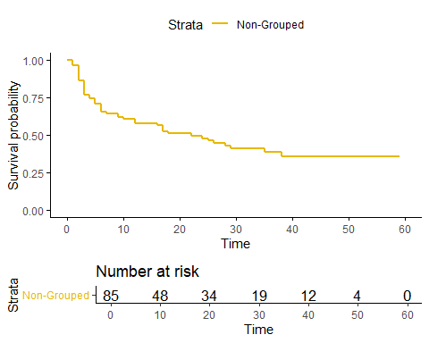

summary(dfcurve)

## Call: survfit(formula = Surv(time, censor) ~ 1, data = df)  
##   
## time n.risk n.event survival std.err lower 95% CI upper 95% CI  
## 1 85 3 0.965 0.0200 0.926 1.000  
## 2 79 8 0.867 0.0374 0.797 0.943  
## 3 71 8 0.769 0.0464 0.683 0.866  
## 4 63 2 0.745 0.0481 0.656 0.845  
## 5 60 3 0.708 0.0503 0.616 0.813  
## 6 57 4 0.658 0.0525 0.563 0.769  
## 7 53 1 0.646 0.0530 0.550 0.758  
## 9 51 2 0.620 0.0538 0.523 0.735  
## 10 48 1 0.607 0.0542 0.510 0.724  
## 12 45 2 0.580 0.0551 0.482 0.699  
## 16 41 1 0.566 0.0555 0.467 0.686  
## 17 40 3 0.524 0.0565 0.424 0.647  
## 18 37 1 0.510 0.0567 0.410 0.634  
## 22 34 1 0.495 0.0570 0.395 0.620  
## 24 31 1 0.479 0.0574 0.378 0.605  
## 25 30 1 0.463 0.0576 0.362 0.591  
## 26 26 1 0.445 0.0581 0.344 0.575  
## 28 24 1 0.426 0.0586 0.326 0.558  
## 29 23 1 0.408 0.0589 0.307 0.541  
## 35 17 1 0.384 0.0601 0.282 0.522  
## 38 14 1 0.356 0.0617 0.254 0.500

#==========================================================  
dfcurve2 <- survfit(Surv(time, censor)~group, data = df)  
  
ggsurvplot(  
 dfcurve2,  
 size = 1,  
 palette = c("#E7B800", "#2E9FDF"),  
 conf.int = FALSE,  
 pval = FALSE,  
 legend.labs = c("Plasebo", "Chemotherapy"),  
 ggtheme = theme_classic(),  
 risk.table = TRUE,  
 censor = FALSE  
)

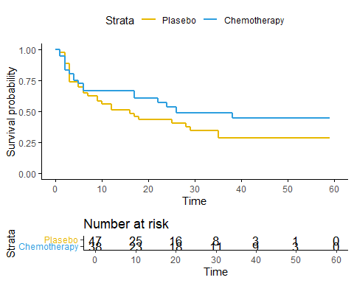

summary(dfcurve2)

## Call: survfit(formula = Surv(time, censor) ~ group, data = df)  
##   
## group=1   
## time n.risk n.event survival std.err lower 95% CI upper 95% CI  
## 1 47 1 0.979 0.0210 0.938 1.000  
## 2 45 4 0.892 0.0457 0.806 0.986  
## 3 41 7 0.739 0.0647 0.623 0.878  
## 5 33 2 0.695 0.0681 0.573 0.842  
## 6 31 2 0.650 0.0707 0.525 0.804  
## 7 29 1 0.627 0.0717 0.502 0.785  
## 9 27 2 0.581 0.0735 0.453 0.745  
## 10 25 1 0.558 0.0742 0.430 0.724  
## 12 23 2 0.509 0.0752 0.381 0.680  
## 16 20 1 0.484 0.0757 0.356 0.657  
## 17 19 1 0.458 0.0758 0.331 0.634  
## 18 18 1 0.433 0.0758 0.307 0.610  
## 25 15 1 0.404 0.0760 0.279 0.584  
## 28 13 1 0.373 0.0763 0.250 0.557  
## 29 12 1 0.342 0.0760 0.221 0.528  
## 35 6 1 0.285 0.0819 0.162 0.501  
##   
## group=2   
## time n.risk n.event survival std.err lower 95% CI upper 95% CI  
## 1 38 2 0.947 0.0362 0.879 1.000  
## 2 34 4 0.836 0.0613 0.724 0.965  
## 3 30 1 0.808 0.0653 0.690 0.947  
## 4 29 2 0.752 0.0717 0.624 0.907  
## 5 27 1 0.724 0.0743 0.593 0.886  
## 6 26 2 0.669 0.0783 0.532 0.841  
## 17 21 2 0.605 0.0828 0.463 0.791  
## 22 18 1 0.571 0.0848 0.427 0.764  
## 24 16 1 0.536 0.0867 0.390 0.736  
## 26 12 1 0.491 0.0902 0.343 0.704  
## 38 11 1 0.446 0.0924 0.298 0.670

#==========================================================  
dfcurve3 <- survfit(Surv(time, censor)~number, data = df)  
  
ggsurvplot(  
 dfcurve3,  
 size = 1,  
 palette = c("#E7B800", "#2E9FDF"),  
 conf.int = FALSE,  
 pval = FALSE,  
 legend.labs = c("1 Tumor", "More than 1 Tumor"),  
 ggtheme = theme_classic(),  
 risk.table = TRUE,  
 censor = FALSE  
)

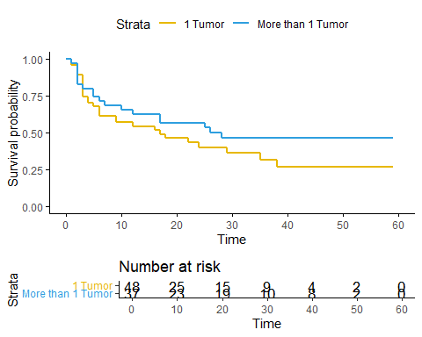

summary(dfcurve3)

## Call: survfit(formula = Surv(time, censor) ~ number, data = df)  
##   
## number=1   
## time n.risk n.event survival std.err lower 95% CI upper 95% CI  
## 1 48 2 0.958 0.0288 0.903 1.000  
## 2 45 3 0.894 0.0447 0.811 0.986  
## 3 42 7 0.745 0.0635 0.631 0.881  
## 4 35 2 0.703 0.0666 0.584 0.846  
## 5 32 1 0.681 0.0681 0.560 0.828  
## 6 31 3 0.615 0.0713 0.490 0.772  
## 9 27 2 0.569 0.0729 0.443 0.732  
## 12 23 1 0.545 0.0739 0.418 0.710  
## 16 20 1 0.517 0.0750 0.389 0.687  
## 17 19 1 0.490 0.0758 0.362 0.664  
## 18 18 1 0.463 0.0764 0.335 0.640  
## 22 15 1 0.432 0.0773 0.304 0.613  
## 24 13 1 0.399 0.0781 0.272 0.586  
## 29 11 1 0.363 0.0790 0.237 0.556  
## 35 8 1 0.317 0.0811 0.192 0.524  
## 38 6 1 0.264 0.0830 0.143 0.489  
##   
## number=2   
## time n.risk n.event survival std.err lower 95% CI upper 95% CI  
## 1 37 1 0.973 0.0267 0.922 1.000  
## 2 34 5 0.830 0.0633 0.715 0.964  
## 3 29 1 0.801 0.0673 0.680 0.945  
## 5 28 2 0.744 0.0737 0.613 0.903  
## 6 26 1 0.715 0.0762 0.581 0.881  
## 7 25 1 0.687 0.0783 0.549 0.859  
## 10 23 1 0.657 0.0804 0.517 0.835  
## 12 22 1 0.627 0.0821 0.485 0.811  
## 17 21 2 0.567 0.0845 0.424 0.760  
## 25 18 1 0.536 0.0854 0.392 0.732  
## 26 15 1 0.500 0.0869 0.356 0.703  
## 28 13 1 0.462 0.0883 0.317 0.672

#==========================================================  
df2 <- df  
  
df2$newgroup <- ifelse(df$number == 1 & df$group == 1, 1,  
 ifelse(df$number == 2 & df$group == 1, 2,  
 ifelse(df$number == 1 & df$group == 2, 3,  
 ifelse(df$number == 2 & df$group == 2, 4, NA))))  
  
View(df2)  
  
dfcurve4 <- survfit(Surv(time, censor)~newgroup, data=df2)  
  
ggsurvplot(  
 dfcurve4,  
 size = 1,  
 palette = c("#E7B800", "#2E9FDF", "#323036", "#de3a3a"),  
 conf.int = FALSE,  
 pval = FALSE,  
 legend.labs = c("Plasebo with 1 Tumor", "Plasebo with 2 or More Tumor",  
 "Chemotherapy with 1 Tumor", "Chemotherapy with 2 or more Tumor"),  
 ggtheme = theme_classic(),  
 risk.table = TRUE,  
 censor = FALSE  
)

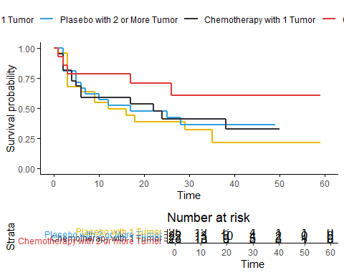

summary(dfcurve4)

## Call: survfit(formula = Surv(time, censor) ~ newgroup, data = df2)  
##   
## newgroup=1   
## time n.risk n.event survival std.err lower 95% CI upper 95% CI  
## 1 25 1 0.960 0.0392 0.8862 1.000  
## 3 24 7 0.680 0.0933 0.5197 0.890  
## 6 16 1 0.638 0.0967 0.4736 0.858  
## 9 14 2 0.546 0.1021 0.3789 0.788  
## 12 11 1 0.497 0.1042 0.3293 0.749  
## 16 9 1 0.442 0.1062 0.2756 0.708  
## 18 8 1 0.386 0.1063 0.2253 0.663  
## 29 6 1 0.322 0.1063 0.1685 0.615  
## 35 3 1 0.215 0.1127 0.0767 0.601  
##   
## newgroup=2   
## time n.risk n.event survival std.err lower 95% CI upper 95% CI  
## 2 21 4 0.810 0.0857 0.658 0.996  
## 5 17 2 0.714 0.0986 0.545 0.936  
## 6 15 1 0.667 0.1029 0.493 0.902  
## 7 14 1 0.619 0.1060 0.443 0.866  
## 10 13 1 0.571 0.1080 0.395 0.828  
## 12 12 1 0.524 0.1090 0.348 0.788  
## 17 11 1 0.476 0.1090 0.304 0.746  
## 25 9 1 0.423 0.1090 0.256 0.701  
## 28 7 1 0.363 0.1089 0.201 0.653  
##   
## newgroup=3   
## time n.risk n.event survival std.err lower 95% CI upper 95% CI  
## 1 23 1 0.957 0.0425 0.877 1.000  
## 2 21 3 0.820 0.0816 0.675 0.997  
## 4 18 2 0.729 0.0946 0.565 0.940  
## 5 16 1 0.683 0.0991 0.514 0.908  
## 6 15 2 0.592 0.1047 0.419 0.837  
## 17 11 1 0.538 0.1082 0.363 0.798  
## 22 9 1 0.478 0.1115 0.303 0.755  
## 24 7 1 0.410 0.1146 0.237 0.709  
## 38 5 1 0.328 0.1174 0.163 0.662  
##   
## newgroup=4   
## time n.risk n.event survival std.err lower 95% CI upper 95% CI  
## 1 15 1 0.933 0.0644 0.815 1.000  
## 2 13 1 0.862 0.0911 0.700 1.000  
## 3 12 1 0.790 0.1081 0.604 1.000  
## 17 10 1 0.711 0.1228 0.507 0.997  
## 26 7 1 0.609 0.1411 0.387 0.959