### Implementation Guide Meta Data

Table 10.1 provides Date Format is YYYYMMDD.

Table .: Implementation Guide Meta Data

| **Attribute** | **Definition** | **Type** | **Use** |
| --- | --- | --- | --- |
| **Name** | The natural language name of the implementation guide. Commonly used as the title of the implementation guide. | String | R |
| **IG Version** | The version of the implementation guide as decided by the author. There is no prescribed format. | String | O |
| **Organization** | The name/identification of the organization or owner of the implementation guide. | String | R |
| **Author** | List of authors that created the implementation guide. | String | O |
| **HL7 Version** | List of HL7 profile versions included in the implementation guide. Generally, most implementation guides include message profiles of the same HL7 version. | String | O |
| **Create Date** | The date the implementation guide was created. | Date Format | O |
| **Last Update Date** | The date the implementation guide was last updated. | Date Format | O |
| **Status** | The status of the implementation guide. Can be draft, published, superseded, or withdrawn. | Enum | R |
| **Publish Date** | If the status is “published”, this is the date the implementation guide was published. Once published, the IG version is static. | Date Format | C |
| **Description** | Provides a short summary and intended use of the implementation guide. | String | O |

Figure 10.9 shows the life cycle of an implementation guide.

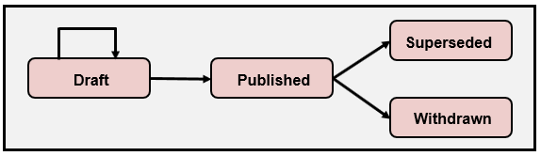

Figure .9: Implementation Guide Life Cycle