**COLLAGE BUSINESS EDUCATION**

**DODOMA COMPAS**

**DEPARTMENT OF INFORMATION AND COMMUNICATION TECHNOLOGY**

**OF BACHELOR DEGREE IN INFORMATION TECHNOLOGY (BIT)**

**LECTURES NAME:ATUPELE CAIRO**

**STUDENT NAME: MFAUME HASHIM MFAUME**

**REGISTRATION NUMBER: 03.8983.02.02.2023**

**COURSE NAME :BIT2**

**NAME OF THE PROJECT: MFAUME MICROFINANCE ONLINE BANK**

**SUBMISSION DATE: JAN/28/2025**

**BANKING ,LOAN IN FINANCIAL MANAGEMENT SYSTEM**

**INTRODUCTION**

Microfinance banks play a crucial role in providing financial services to underserved populations, particularly in developing countries. However, they also face several challenges:

**Challenges:**

* **High Default Rates:** Lending to low-income individuals and businesses inherently carries higher risks. Default rates can be significant, impacting the financial stability of the microfinance institution.
* **Limited Access to Capital:** Microfinance institutions often rely on external funding sources, which can be limited and subject to fluctuations in the global financial markets.
* **Operational Costs:** Reaching and serving rural and remote populations can be expensive, requiring significant investments in infrastructure, transportation, and human resources.
* **Competition:** The microfinance sector is becoming increasingly competitive, with both traditional banks and fintech companies entering the market.
* **Over-indebtedness:** In some cases, aggressive lending practices have led to concerns about over-indebtedness among borrowers, raising ethical and social concerns.
* **Lack of Financial Literacy:** Many borrowers may have limited financial literacy, making it difficult for them to understand loan terms, manage their finances effectively, and make informed decisions.
* **Technological Limitations:** Access to technology and digital infrastructure can be limited in some regions, hindering the adoption of digital financial services.

**Benefits:**

* **Poverty Reduction:** By providing access to credit, savings, and other financial services, microfinance institutions can help alleviate poverty and improve the livelihoods of low-income individuals and communities.
* **Economic Growth:** Microfinance can stimulate economic growth by supporting small businesses and entrepreneurship, creating jobs, and increasing household incomes.
* **Financial Inclusion:** Microfinance institutions play a crucial role in promoting financial inclusion by providing access to financial services for those who are excluded from traditional banking systems.

**Addressing the Challenges:**

* **Developing robust risk management systems.**
* **Diversifying funding sources.**
* **Ensuring responsible lending practices.**
* **Collaborating with governments and other stakeholders to create a supportive regulatory environment.**

I as a programmer came up with an idea to manage the setbacks by making Mfaume online market that allows users to make an account an ask for loans by using the below codes 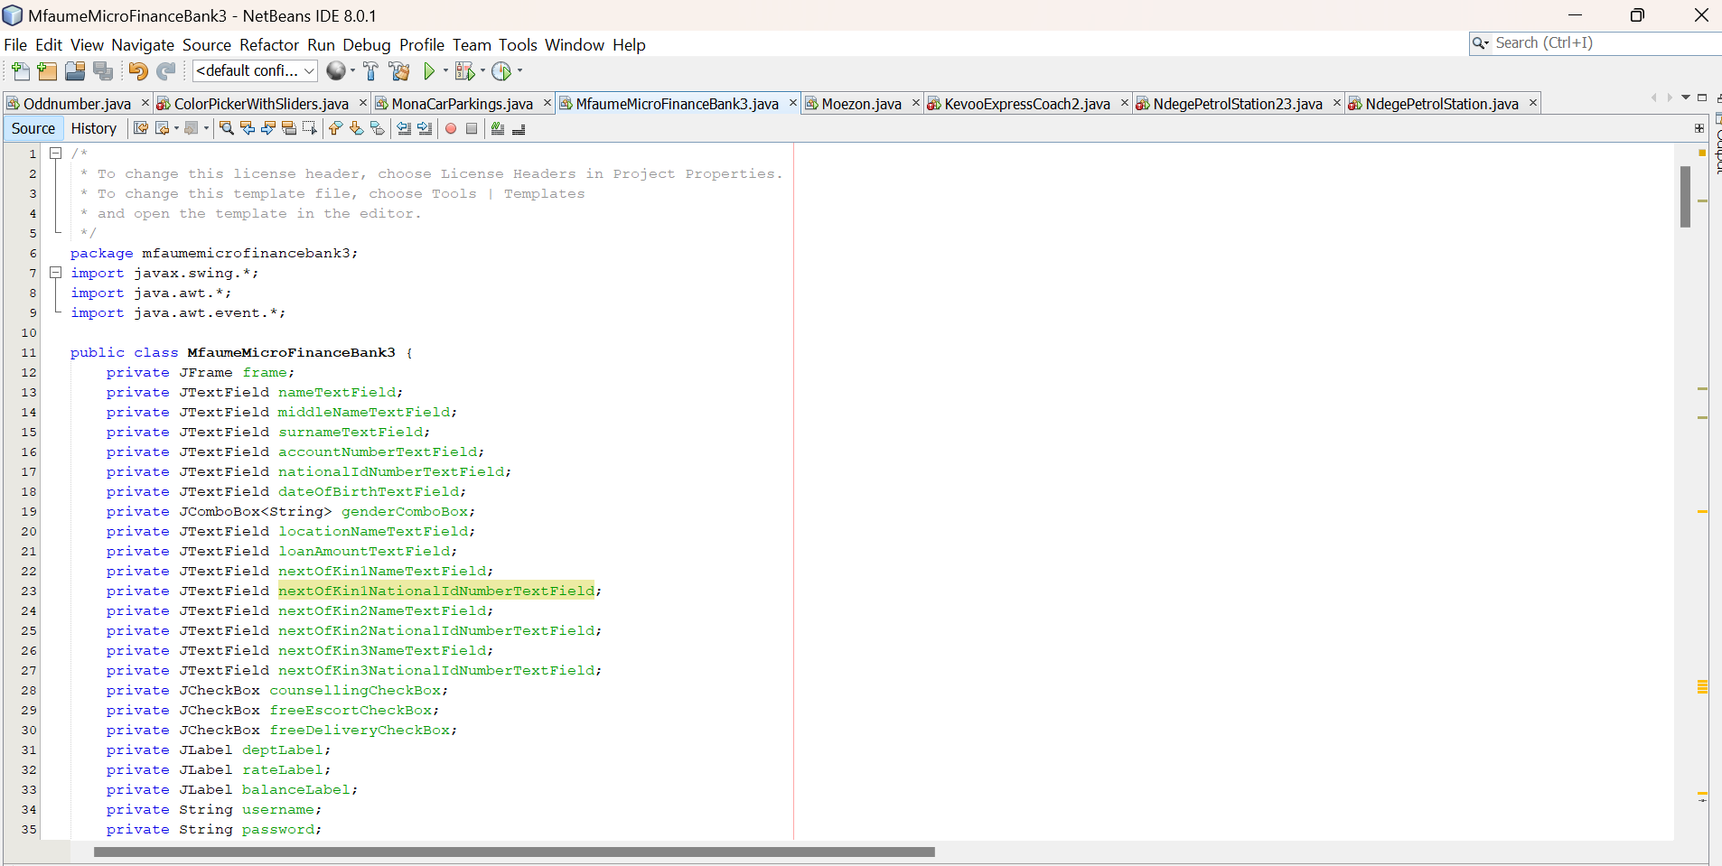 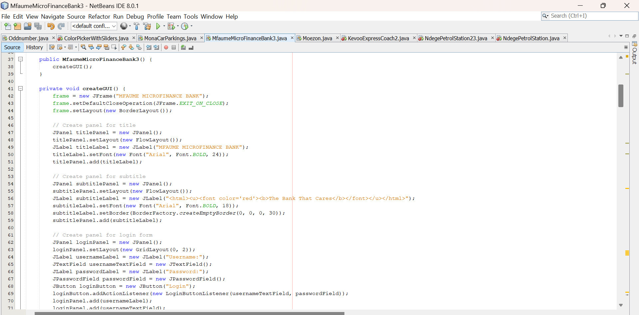 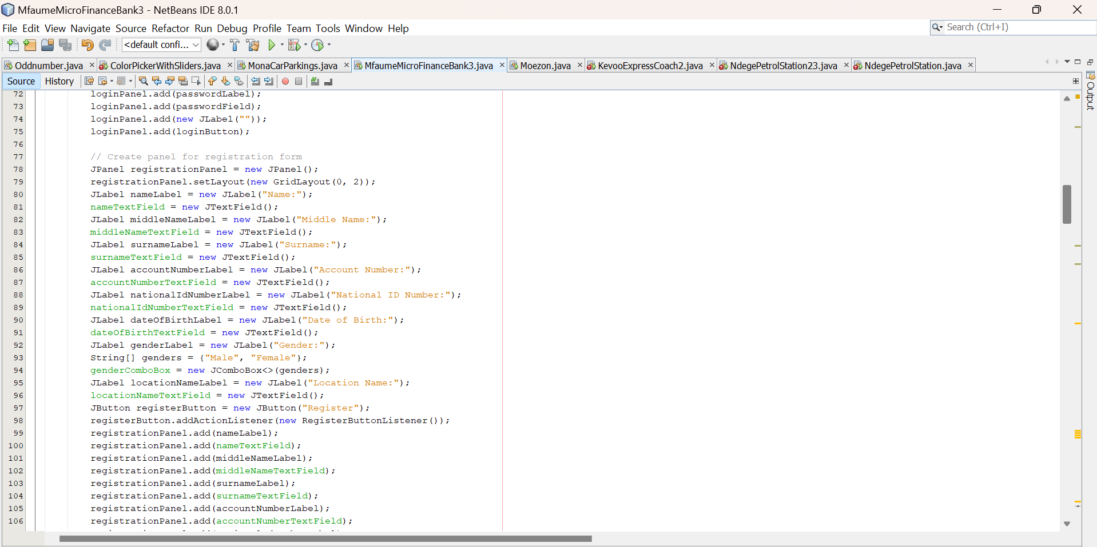 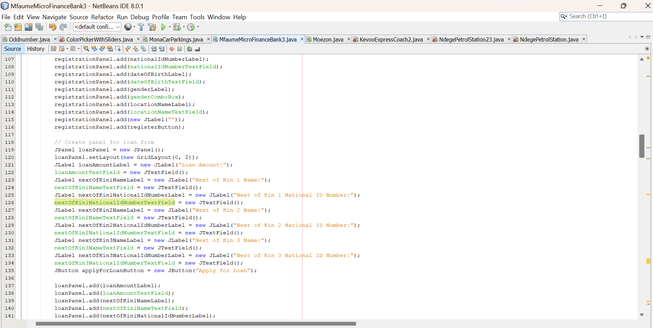 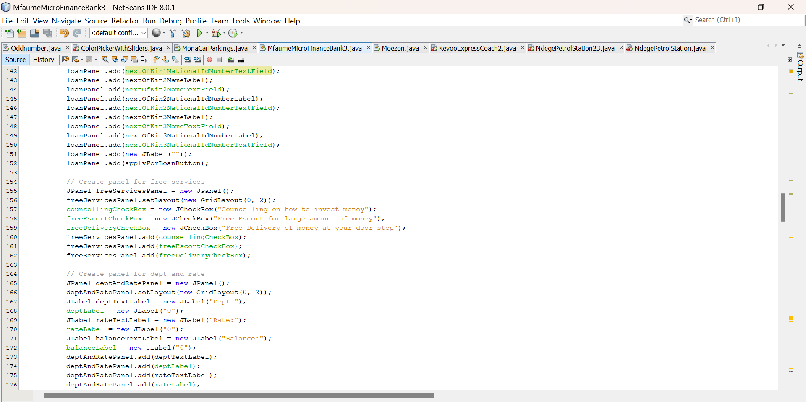 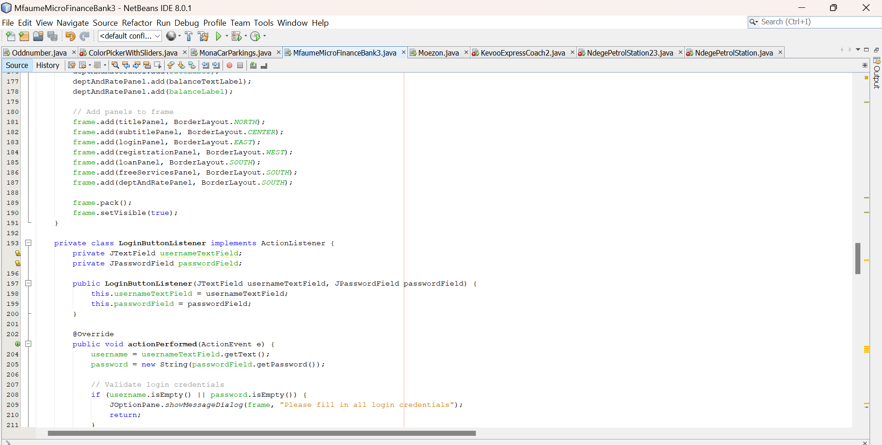 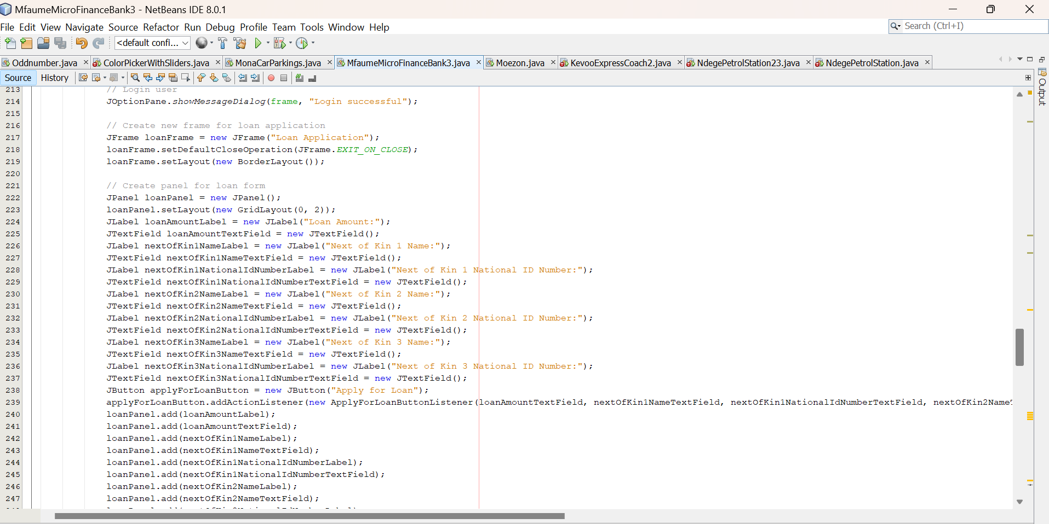  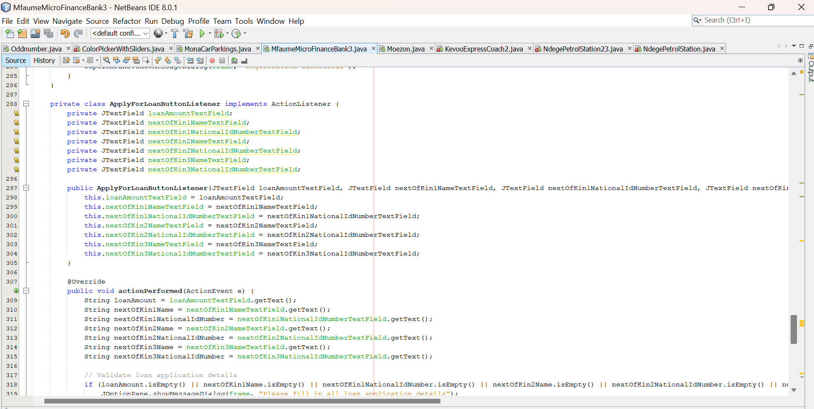  

The images above were the code illustration for the mfaume microfinance bank that allows login and register panel and then loan application there for the out cum of the code were ae following .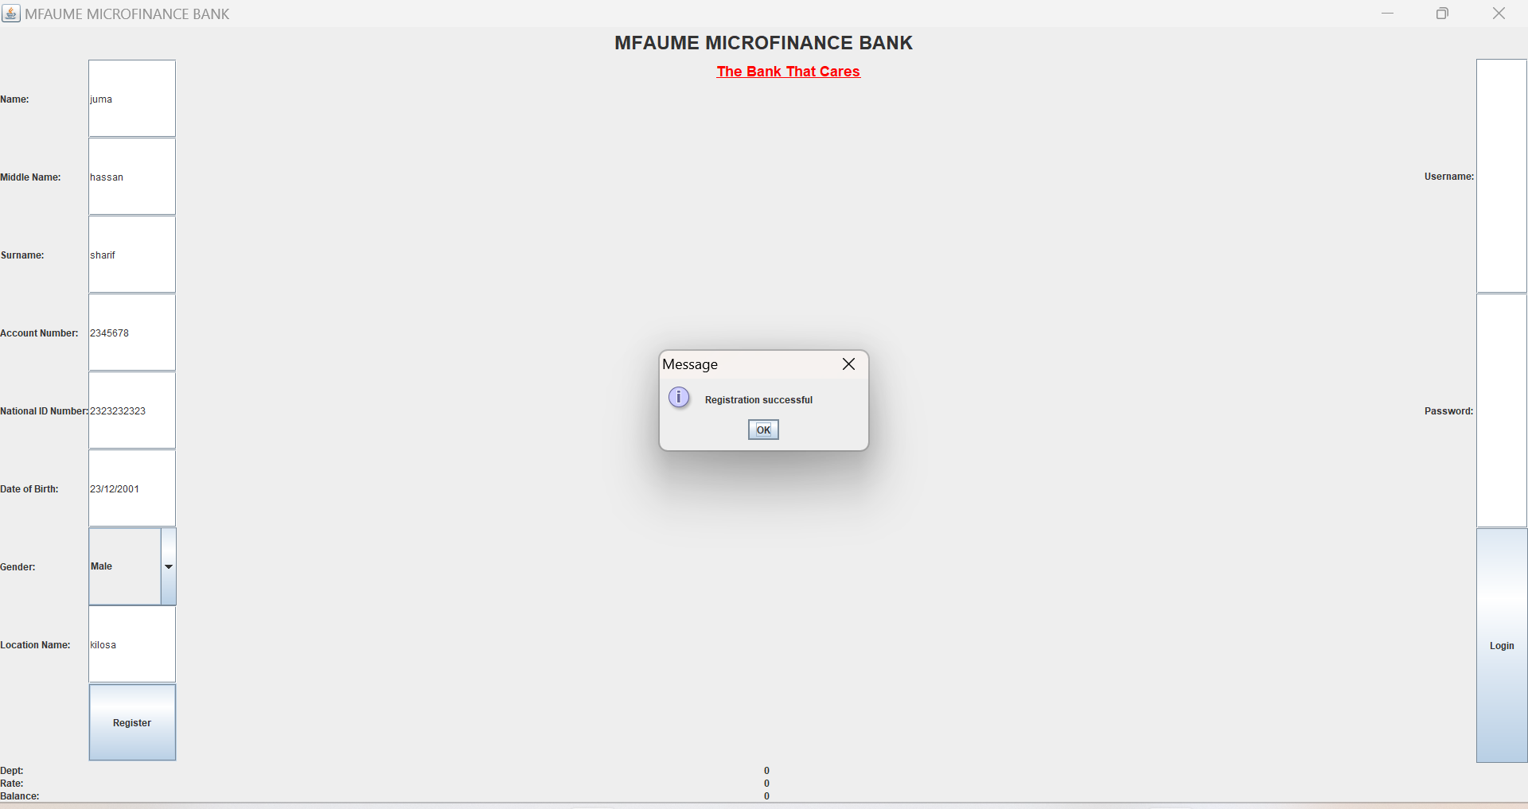

The above diagram shows registration form for loan appliers that are fully registered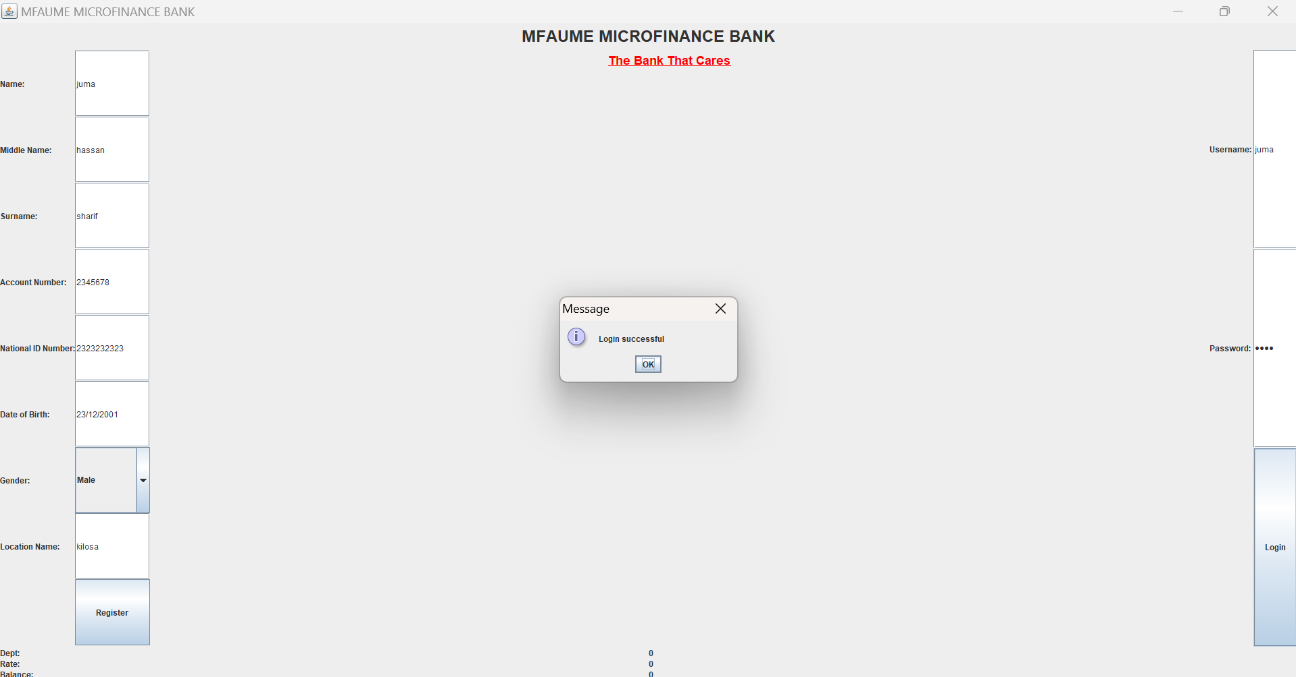 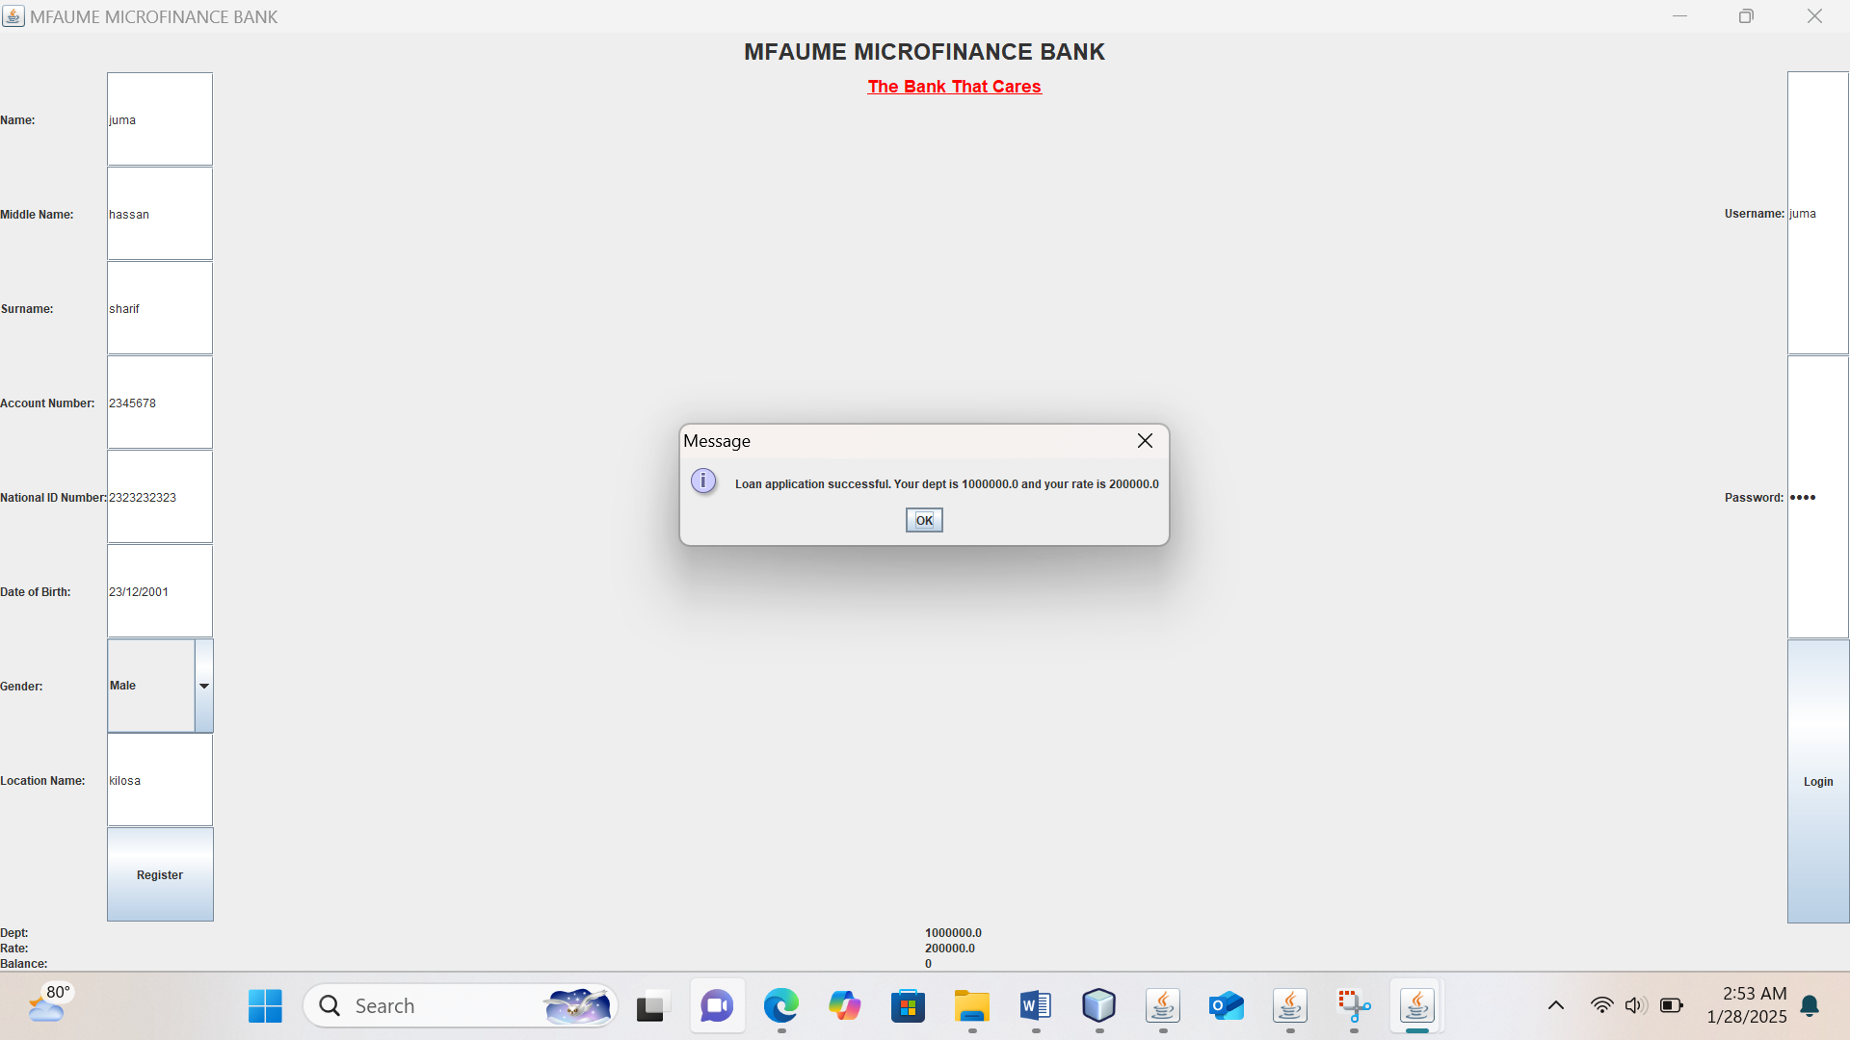 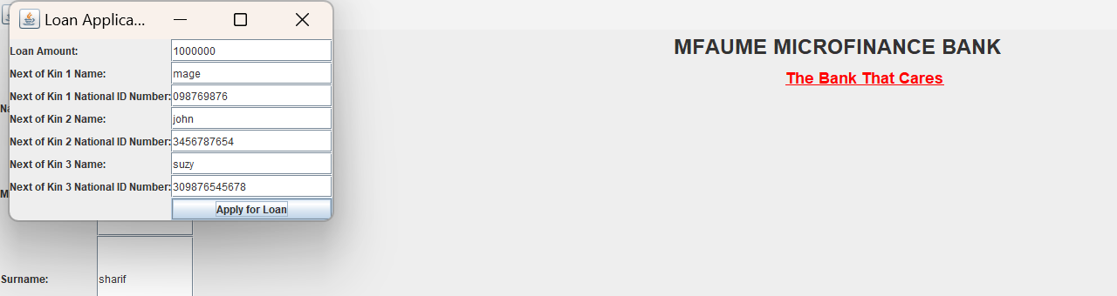

Showing the loan item for juma hasan.so the program was able to give the person the space to login or register and apply for a loan an print its loan receipt that shows rate ,dept amount, balance remained in your account.