**LAPORAN TUGAS 2**

**16TIN5033 Pengolahan Citra Digital**

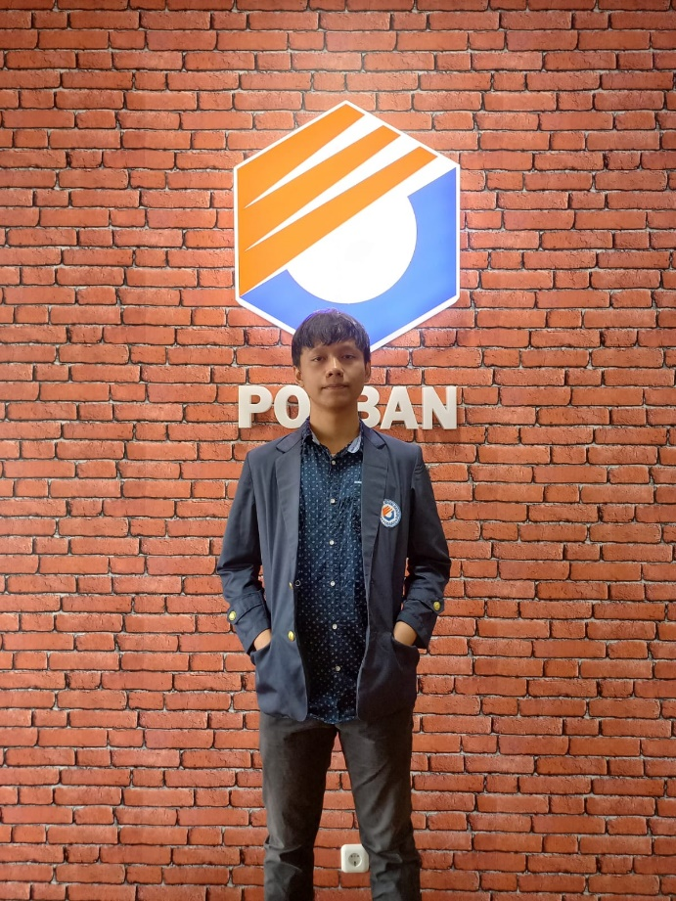

Disusun Oleh:

Muhammad Fauzi Rizki Hamdalah 201524015

**Program Studi D-4 Teknik Informatika**

**Jurusan Teknik Komputer dan Informatika**

**Politeknik Negeri Bandung**

**2022**

**Kode Program**

Kode program saya buat menggunakan …….

1. **Grayscale**

Tuliskan teori singkat tentang grayscale

|  |
| --- |
| Kode dengan opencv |

|  |
| --- |
| Kode tanpa opencv |

1. **Biner**

Tuliskan teori singkat tentang biner

1. **Inverse**

Tuliskan teori singkat tentang inverse

**Tampilan Antarmuka Program**

**Screenshot tampilan antarmuka program anda**

**Hasil Eksekusi Program**

**Grayscale**

|  |  |
| --- | --- |
| **Masukan** | **Keluaran** |
|  |  |
|  |  |
|  |  |

**Arithmetic Operations**

|  |  |  |
| --- | --- | --- |
| **Masukan 1** | **Masukan 2** | **Keluaran** |
|  |  |  |
|  |  |  |

**KENDALA**

**………………………..**

**SOLUSI**

**…………………..**

**LESSON LEARN**

**………**

**Referensi:**

[**https://docs.opencv.org/4.x/d0/d86/tutorial_py_image_arithmetics.html**](https://docs.opencv.org/4.x/d0/d86/tutorial_py_image_arithmetics.html)

[**https://docs.opencv.org/4.x/d7/d4d/tutorial_py_thresholding.html**](https://docs.opencv.org/4.x/d7/d4d/tutorial_py_thresholding.html)

[**https://docs.opencv.org/3.4/de/d25/imgproc_color_conversions.html**](https://docs.opencv.org/3.4/de/d25/imgproc_color_conversions.html)

[**https://www.geeksforgeeks.org/****arithmetic-operations-on-images-using-opencv-set-1-addition-and-subtraction/**](https://www.geeksforgeeks.org/arithmetic-operations-on-images-using-opencv-set-1-addition-and-subtraction/)