Class 05: Data Visualization with GGPLOT

Mia Fava

## Plotting in R

R has lot’s of ways to make plots and figures. This includes so-called **base** graphics and packages like **ggplot2**

plot(cars)

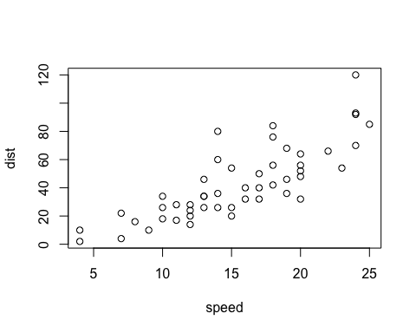

This is a **base** R plot of the in-built cars dataset that has only two columns:

cars

speed dist  
1 4 2  
2 4 10  
3 7 4  
4 7 22  
5 8 16  
6 9 10  
7 10 18  
8 10 26  
9 10 34  
10 11 17  
11 11 28  
12 12 14  
13 12 20  
14 12 24  
15 12 28  
16 13 26  
17 13 34  
18 13 34  
19 13 46  
20 14 26  
21 14 36  
22 14 60  
23 14 80  
24 15 20  
25 15 26  
26 15 54  
27 16 32  
28 16 40  
29 17 32  
30 17 40  
31 17 50  
32 18 42  
33 18 56  
34 18 76  
35 18 84  
36 19 36  
37 19 46  
38 19 68  
39 20 32  
40 20 48  
41 20 52  
42 20 56  
43 20 64  
44 22 66  
45 23 54  
46 24 70  
47 24 92  
48 24 93  
49 24 120  
50 25 85

Q. How would we plot this wee dataset with **ggplot2**?

All ggplot figures have at least 3 layers:

-**data** -**aes** (how data map to the plot) -**geoms** (how we draw the plot, lines, points, etc)

Before I use any new packages I need to download and install it with the install.packages() command.

I never use install.packages() within my quarto document otherwise I will install the package over and over and over again, which is silly!

Once a package is installed I can load it up with the libraary() function

# install.packages("ggplot2")  
library(ggplot2)  
ggplot(cars) +   
 aes(x=speed, y=dist) +  
 geom_point()

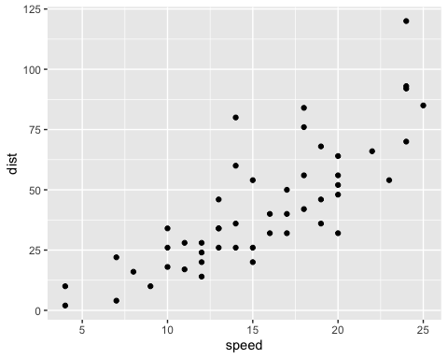

Key point: For simple plots (like the one above) ggplot is more verbose (we need to do more typing) but as plots get more complicated ggplot starts to be more clear and simple than base R plot()

ggplot(cars) +  
 aes(x=speed, y=dist) +  
 geom_point() +   
 geom_smooth(method="lm",se = FALSE ) +  
 labs(title="Stopping distance of old cars", x="Speed (MPH)", y="Stopping distance (ft)", subtitle = "From the in-built cars dataset", caption="Dataset: 'cars'") +  
 theme_bw()

`geom_smooth()` using formula = 'y ~ x'

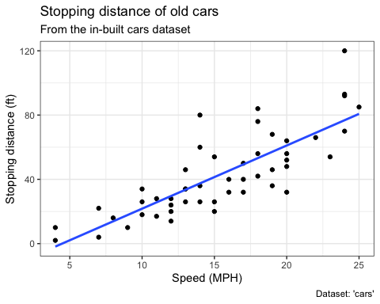

url <- "https://bioboot.github.io/bimm143_S20/class-material/up_down_expression.txt"  
genes <- read.delim(url)  
head(genes)

Gene Condition1 Condition2 State  
1 A4GNT -3.6808610 -3.4401355 unchanging  
2 AAAS 4.5479580 4.3864126 unchanging  
3 AASDH 3.7190695 3.4787276 unchanging  
4 AATF 5.0784720 5.0151916 unchanging  
5 AATK 0.4711421 0.5598642 unchanging  
6 AB015752.4 -3.6808610 -3.5921390 unchanging

nrow(genes)

[1] 5196

colnames(genes)

[1] "Gene" "Condition1" "Condition2" "State"

table(genes$State)

down unchanging up   
 72 4997 127

round( table(genes$State)/nrow(genes) * 100,2)

down unchanging up   
 1.39 96.17 2.44

The key functions here were: nrow() and ncol() table() is very useful for getting counts finally round()

A first plot:

ggplot(genes) +   
 aes(x=Condition1, y=Condition2) +  
 geom_point()

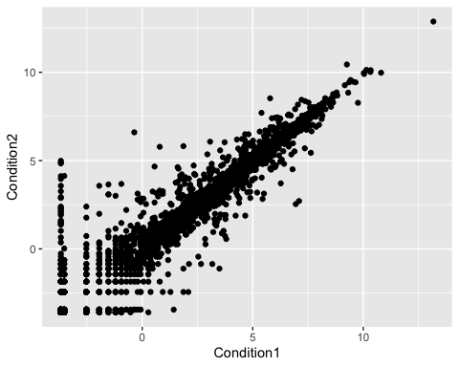

A Second Plot:

ggplot(genes) +   
 aes(x=Condition1, y=Condition2, col=State) +  
 geom_point()

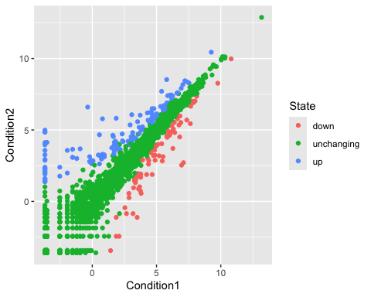

Change the color

A Third Plot:

ggplot(genes) +   
 aes(x=Condition1, y=Condition2, col=State) +  
 geom_point()+  
scale_colour_manual(values=c("blue","gray","red")) +  
 labs(title="Gene Expresion Changes Upon Drug Treatment",  
 x="Control (no drug) ",  
 y="Drug Treatment")

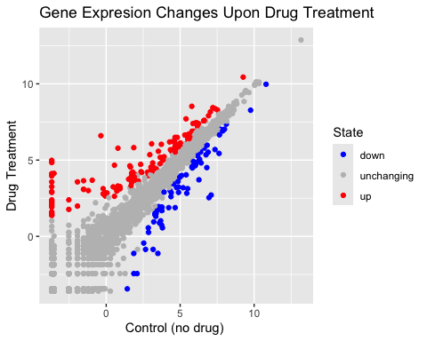

# File location online  
url <- "https://raw.githubusercontent.com/jennybc/gapminder/master/inst/extdata/gapminder.tsv"  
  
gapminder <- read.delim(url)

# install.packages("dplyr")  
library(dplyr)

Attaching package: 'dplyr'

The following objects are masked from 'package:stats':  
  
 filter, lag

The following objects are masked from 'package:base':  
  
 intersect, setdiff, setequal, union

gapminder_2007 <- gapminder %>% filter(year==2007)

library(ggplot2)  
ggplot(gapminder_2007) +  
 aes(x=gdpPercap, y=lifeExp) +  
 geom_point()

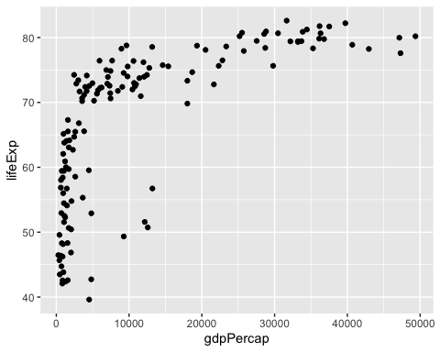

ggplot(gapminder_2007) +  
 aes(x=gdpPercap, y=lifeExp) +  
 geom_point(alpha=0.5)

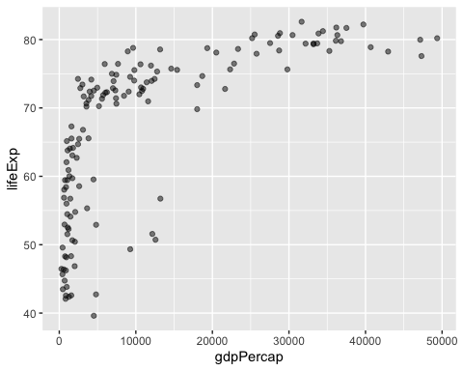

ggplot(gapminder_2007) +  
 aes(x=gdpPercap, y=lifeExp, color=continent, size=pop) +  
 geom_point(alpha=0.5)

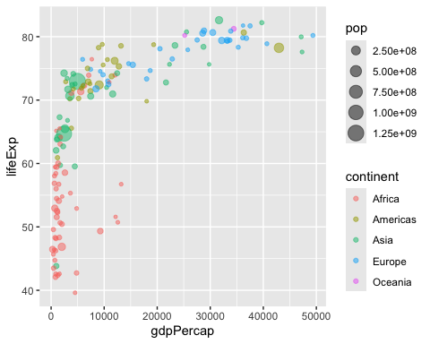

ggplot(gapminder_2007) +   
 geom_point(aes(x = gdpPercap, y = lifeExp,  
 size = pop), alpha=0.5) +   
 scale_size_area(max_size = 10)

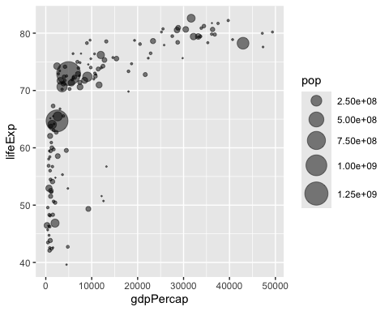

How many years are in this data set?

length(gapminder$year)

[1] 1704

gapminder_1957 <- gapminder %>% filter(year==1957)  
  
ggplot(gapminder_1957) +   
 aes(x = gdpPercap, y = lifeExp, color=continent,  
 size = pop) +  
 geom_point(alpha=0.7) +   
 scale_size_area(max_size = 10)

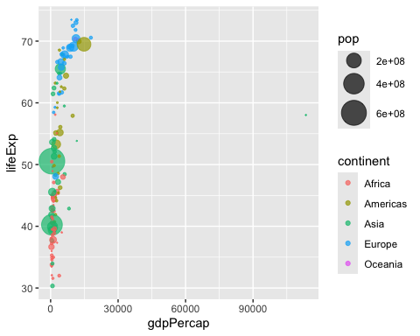

gapminder_1957 <- gapminder %>% filter(year==1957 | year==2007)  
  
ggplot(gapminder_1957) +   
 geom_point(aes(x = gdpPercap, y = lifeExp, color=continent,  
 size = pop), alpha=0.7) +   
 scale_size_area(max_size = 10) +  
 facet_wrap(~year)

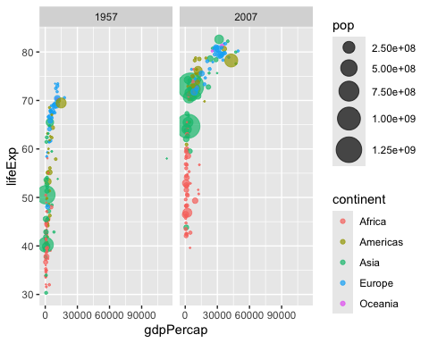

gapminder_top5 <- gapminder %>%   
 filter(year==2007) %>%   
 arrange(desc(pop)) %>%   
 top_n(5, pop)  
  
gapminder_top5

country continent year lifeExp pop gdpPercap  
1 China Asia 2007 72.961 1318683096 4959.115  
2 India Asia 2007 64.698 1110396331 2452.210  
3 United States Americas 2007 78.242 301139947 42951.653  
4 Indonesia Asia 2007 70.650 223547000 3540.652  
5 Brazil Americas 2007 72.390 190010647 9065.801

ggplot(gapminder_top5) +   
 geom_col(aes(x = country, y = pop))

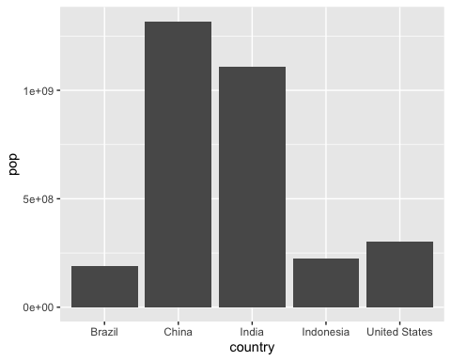

table(gapminder$year)

1952 1957 1962 1967 1972 1977 1982 1987 1992 1997 2002 2007   
 142 142 142 142 142 142 142 142 142 142 142 142

length( unique(gapminder$year))

[1] 12

Q. Extract data for US in 1992

filter(gapminder, country=="United States", year==1992)

country continent year lifeExp pop gdpPercap  
1 United States Americas 1992 76.09 256894189 32003.93

What is the population of Australia in the last year we have data

filter(gapminder, country=="Australia")

country continent year lifeExp pop gdpPercap  
1 Australia Oceania 1952 69.120 8691212 10039.60  
2 Australia Oceania 1957 70.330 9712569 10949.65  
3 Australia Oceania 1962 70.930 10794968 12217.23  
4 Australia Oceania 1967 71.100 11872264 14526.12  
5 Australia Oceania 1972 71.930 13177000 16788.63  
6 Australia Oceania 1977 73.490 14074100 18334.20  
7 Australia Oceania 1982 74.740 15184200 19477.01  
8 Australia Oceania 1987 76.320 16257249 21888.89  
9 Australia Oceania 1992 77.560 17481977 23424.77  
10 Australia Oceania 1997 78.830 18565243 26997.94  
11 Australia Oceania 2002 80.370 19546792 30687.75  
12 Australia Oceania 2007 81.235 20434176 34435.37

filter(gapminder, country=="Australia", year==2007)

country continent year lifeExp pop gdpPercap  
1 Australia Oceania 2007 81.235 20434176 34435.37

Q. What countries in the data set had a population smaller than Australia in 2007?

-First limit/subset the dataset to the year 2007

filter(gapminder, year==2007)

country continent year lifeExp pop gdpPercap  
1 Afghanistan Asia 2007 43.828 31889923 974.5803  
2 Albania Europe 2007 76.423 3600523 5937.0295  
3 Algeria Africa 2007 72.301 33333216 6223.3675  
4 Angola Africa 2007 42.731 12420476 4797.2313  
5 Argentina Americas 2007 75.320 40301927 12779.3796  
6 Australia Oceania 2007 81.235 20434176 34435.3674  
7 Austria Europe 2007 79.829 8199783 36126.4927  
8 Bahrain Asia 2007 75.635 708573 29796.0483  
9 Bangladesh Asia 2007 64.062 150448339 1391.2538  
10 Belgium Europe 2007 79.441 10392226 33692.6051  
11 Benin Africa 2007 56.728 8078314 1441.2849  
12 Bolivia Americas 2007 65.554 9119152 3822.1371  
13 Bosnia and Herzegovina Europe 2007 74.852 4552198 7446.2988  
14 Botswana Africa 2007 50.728 1639131 12569.8518  
15 Brazil Americas 2007 72.390 190010647 9065.8008  
16 Bulgaria Europe 2007 73.005 7322858 10680.7928  
17 Burkina Faso Africa 2007 52.295 14326203 1217.0330  
18 Burundi Africa 2007 49.580 8390505 430.0707  
19 Cambodia Asia 2007 59.723 14131858 1713.7787  
20 Cameroon Africa 2007 50.430 17696293 2042.0952  
21 Canada Americas 2007 80.653 33390141 36319.2350  
22 Central African Republic Africa 2007 44.741 4369038 706.0165  
23 Chad Africa 2007 50.651 10238807 1704.0637  
24 Chile Americas 2007 78.553 16284741 13171.6388  
25 China Asia 2007 72.961 1318683096 4959.1149  
26 Colombia Americas 2007 72.889 44227550 7006.5804  
27 Comoros Africa 2007 65.152 710960 986.1479  
28 Congo, Dem. Rep. Africa 2007 46.462 64606759 277.5519  
29 Congo, Rep. Africa 2007 55.322 3800610 3632.5578  
30 Costa Rica Americas 2007 78.782 4133884 9645.0614  
31 Cote d'Ivoire Africa 2007 48.328 18013409 1544.7501  
32 Croatia Europe 2007 75.748 4493312 14619.2227  
33 Cuba Americas 2007 78.273 11416987 8948.1029  
34 Czech Republic Europe 2007 76.486 10228744 22833.3085  
35 Denmark Europe 2007 78.332 5468120 35278.4187  
36 Djibouti Africa 2007 54.791 496374 2082.4816  
37 Dominican Republic Americas 2007 72.235 9319622 6025.3748  
38 Ecuador Americas 2007 74.994 13755680 6873.2623  
39 Egypt Africa 2007 71.338 80264543 5581.1810  
40 El Salvador Americas 2007 71.878 6939688 5728.3535  
41 Equatorial Guinea Africa 2007 51.579 551201 12154.0897  
42 Eritrea Africa 2007 58.040 4906585 641.3695  
43 Ethiopia Africa 2007 52.947 76511887 690.8056  
44 Finland Europe 2007 79.313 5238460 33207.0844  
45 France Europe 2007 80.657 61083916 30470.0167  
46 Gabon Africa 2007 56.735 1454867 13206.4845  
47 Gambia Africa 2007 59.448 1688359 752.7497  
48 Germany Europe 2007 79.406 82400996 32170.3744  
49 Ghana Africa 2007 60.022 22873338 1327.6089  
50 Greece Europe 2007 79.483 10706290 27538.4119  
51 Guatemala Americas 2007 70.259 12572928 5186.0500  
52 Guinea Africa 2007 56.007 9947814 942.6542  
53 Guinea-Bissau Africa 2007 46.388 1472041 579.2317  
54 Haiti Americas 2007 60.916 8502814 1201.6372  
55 Honduras Americas 2007 70.198 7483763 3548.3308  
56 Hong Kong, China Asia 2007 82.208 6980412 39724.9787  
57 Hungary Europe 2007 73.338 9956108 18008.9444  
58 Iceland Europe 2007 81.757 301931 36180.7892  
59 India Asia 2007 64.698 1110396331 2452.2104  
60 Indonesia Asia 2007 70.650 223547000 3540.6516  
61 Iran Asia 2007 70.964 69453570 11605.7145  
62 Iraq Asia 2007 59.545 27499638 4471.0619  
63 Ireland Europe 2007 78.885 4109086 40675.9964  
64 Israel Asia 2007 80.745 6426679 25523.2771  
65 Italy Europe 2007 80.546 58147733 28569.7197  
66 Jamaica Americas 2007 72.567 2780132 7320.8803  
67 Japan Asia 2007 82.603 127467972 31656.0681  
68 Jordan Asia 2007 72.535 6053193 4519.4612  
69 Kenya Africa 2007 54.110 35610177 1463.2493  
70 Korea, Dem. Rep. Asia 2007 67.297 23301725 1593.0655  
71 Korea, Rep. Asia 2007 78.623 49044790 23348.1397  
72 Kuwait Asia 2007 77.588 2505559 47306.9898  
73 Lebanon Asia 2007 71.993 3921278 10461.0587  
74 Lesotho Africa 2007 42.592 2012649 1569.3314  
75 Liberia Africa 2007 45.678 3193942 414.5073  
76 Libya Africa 2007 73.952 6036914 12057.4993  
77 Madagascar Africa 2007 59.443 19167654 1044.7701  
78 Malawi Africa 2007 48.303 13327079 759.3499  
79 Malaysia Asia 2007 74.241 24821286 12451.6558  
80 Mali Africa 2007 54.467 12031795 1042.5816  
81 Mauritania Africa 2007 64.164 3270065 1803.1515  
82 Mauritius Africa 2007 72.801 1250882 10956.9911  
83 Mexico Americas 2007 76.195 108700891 11977.5750  
84 Mongolia Asia 2007 66.803 2874127 3095.7723  
85 Montenegro Europe 2007 74.543 684736 9253.8961  
86 Morocco Africa 2007 71.164 33757175 3820.1752  
87 Mozambique Africa 2007 42.082 19951656 823.6856  
88 Myanmar Asia 2007 62.069 47761980 944.0000  
89 Namibia Africa 2007 52.906 2055080 4811.0604  
90 Nepal Asia 2007 63.785 28901790 1091.3598  
91 Netherlands Europe 2007 79.762 16570613 36797.9333  
92 New Zealand Oceania 2007 80.204 4115771 25185.0091  
93 Nicaragua Americas 2007 72.899 5675356 2749.3210  
94 Niger Africa 2007 56.867 12894865 619.6769  
95 Nigeria Africa 2007 46.859 135031164 2013.9773  
96 Norway Europe 2007 80.196 4627926 49357.1902  
97 Oman Asia 2007 75.640 3204897 22316.1929  
98 Pakistan Asia 2007 65.483 169270617 2605.9476  
99 Panama Americas 2007 75.537 3242173 9809.1856  
100 Paraguay Americas 2007 71.752 6667147 4172.8385  
101 Peru Americas 2007 71.421 28674757 7408.9056  
102 Philippines Asia 2007 71.688 91077287 3190.4810  
103 Poland Europe 2007 75.563 38518241 15389.9247  
104 Portugal Europe 2007 78.098 10642836 20509.6478  
105 Puerto Rico Americas 2007 78.746 3942491 19328.7090  
106 Reunion Africa 2007 76.442 798094 7670.1226  
107 Romania Europe 2007 72.476 22276056 10808.4756  
108 Rwanda Africa 2007 46.242 8860588 863.0885  
109 Sao Tome and Principe Africa 2007 65.528 199579 1598.4351  
110 Saudi Arabia Asia 2007 72.777 27601038 21654.8319  
111 Senegal Africa 2007 63.062 12267493 1712.4721  
112 Serbia Europe 2007 74.002 10150265 9786.5347  
113 Sierra Leone Africa 2007 42.568 6144562 862.5408  
114 Singapore Asia 2007 79.972 4553009 47143.1796  
115 Slovak Republic Europe 2007 74.663 5447502 18678.3144  
116 Slovenia Europe 2007 77.926 2009245 25768.2576  
117 Somalia Africa 2007 48.159 9118773 926.1411  
118 South Africa Africa 2007 49.339 43997828 9269.6578  
119 Spain Europe 2007 80.941 40448191 28821.0637  
120 Sri Lanka Asia 2007 72.396 20378239 3970.0954  
121 Sudan Africa 2007 58.556 42292929 2602.3950  
122 Swaziland Africa 2007 39.613 1133066 4513.4806  
123 Sweden Europe 2007 80.884 9031088 33859.7484  
124 Switzerland Europe 2007 81.701 7554661 37506.4191  
125 Syria Asia 2007 74.143 19314747 4184.5481  
126 Taiwan Asia 2007 78.400 23174294 28718.2768  
127 Tanzania Africa 2007 52.517 38139640 1107.4822  
128 Thailand Asia 2007 70.616 65068149 7458.3963  
129 Togo Africa 2007 58.420 5701579 882.9699  
130 Trinidad and Tobago Americas 2007 69.819 1056608 18008.5092  
131 Tunisia Africa 2007 73.923 10276158 7092.9230  
132 Turkey Europe 2007 71.777 71158647 8458.2764  
133 Uganda Africa 2007 51.542 29170398 1056.3801  
134 United Kingdom Europe 2007 79.425 60776238 33203.2613  
135 United States Americas 2007 78.242 301139947 42951.6531  
136 Uruguay Americas 2007 76.384 3447496 10611.4630  
137 Venezuela Americas 2007 73.747 26084662 11415.8057  
138 Vietnam Asia 2007 74.249 85262356 2441.5764  
139 West Bank and Gaza Asia 2007 73.422 4018332 3025.3498  
140 Yemen, Rep. Asia 2007 62.698 22211743 2280.7699  
141 Zambia Africa 2007 42.384 11746035 1271.2116  
142 Zimbabwe Africa 2007 43.487 12311143 469.7093

-Then find the pop value of Australia

filter(gapminder, year==2007, country=="Australia")

country continent year lifeExp pop gdpPercap  
1 Australia Oceania 2007 81.235 20434176 34435.37

-Then extract all rows with pop less than Australia’s

filter(gapminder, year==2007, pop<20434176)

country continent year lifeExp pop gdpPercap  
1 Albania Europe 2007 76.423 3600523 5937.0295  
2 Angola Africa 2007 42.731 12420476 4797.2313  
3 Austria Europe 2007 79.829 8199783 36126.4927  
4 Bahrain Asia 2007 75.635 708573 29796.0483  
5 Belgium Europe 2007 79.441 10392226 33692.6051  
6 Benin Africa 2007 56.728 8078314 1441.2849  
7 Bolivia Americas 2007 65.554 9119152 3822.1371  
8 Bosnia and Herzegovina Europe 2007 74.852 4552198 7446.2988  
9 Botswana Africa 2007 50.728 1639131 12569.8518  
10 Bulgaria Europe 2007 73.005 7322858 10680.7928  
11 Burkina Faso Africa 2007 52.295 14326203 1217.0330  
12 Burundi Africa 2007 49.580 8390505 430.0707  
13 Cambodia Asia 2007 59.723 14131858 1713.7787  
14 Cameroon Africa 2007 50.430 17696293 2042.0952  
15 Central African Republic Africa 2007 44.741 4369038 706.0165  
16 Chad Africa 2007 50.651 10238807 1704.0637  
17 Chile Americas 2007 78.553 16284741 13171.6388  
18 Comoros Africa 2007 65.152 710960 986.1479  
19 Congo, Rep. Africa 2007 55.322 3800610 3632.5578  
20 Costa Rica Americas 2007 78.782 4133884 9645.0614  
21 Cote d'Ivoire Africa 2007 48.328 18013409 1544.7501  
22 Croatia Europe 2007 75.748 4493312 14619.2227  
23 Cuba Americas 2007 78.273 11416987 8948.1029  
24 Czech Republic Europe 2007 76.486 10228744 22833.3085  
25 Denmark Europe 2007 78.332 5468120 35278.4187  
26 Djibouti Africa 2007 54.791 496374 2082.4816  
27 Dominican Republic Americas 2007 72.235 9319622 6025.3748  
28 Ecuador Americas 2007 74.994 13755680 6873.2623  
29 El Salvador Americas 2007 71.878 6939688 5728.3535  
30 Equatorial Guinea Africa 2007 51.579 551201 12154.0897  
31 Eritrea Africa 2007 58.040 4906585 641.3695  
32 Finland Europe 2007 79.313 5238460 33207.0844  
33 Gabon Africa 2007 56.735 1454867 13206.4845  
34 Gambia Africa 2007 59.448 1688359 752.7497  
35 Greece Europe 2007 79.483 10706290 27538.4119  
36 Guatemala Americas 2007 70.259 12572928 5186.0500  
37 Guinea Africa 2007 56.007 9947814 942.6542  
38 Guinea-Bissau Africa 2007 46.388 1472041 579.2317  
39 Haiti Americas 2007 60.916 8502814 1201.6372  
40 Honduras Americas 2007 70.198 7483763 3548.3308  
41 Hong Kong, China Asia 2007 82.208 6980412 39724.9787  
42 Hungary Europe 2007 73.338 9956108 18008.9444  
43 Iceland Europe 2007 81.757 301931 36180.7892  
44 Ireland Europe 2007 78.885 4109086 40675.9964  
45 Israel Asia 2007 80.745 6426679 25523.2771  
46 Jamaica Americas 2007 72.567 2780132 7320.8803  
47 Jordan Asia 2007 72.535 6053193 4519.4612  
48 Kuwait Asia 2007 77.588 2505559 47306.9898  
49 Lebanon Asia 2007 71.993 3921278 10461.0587  
50 Lesotho Africa 2007 42.592 2012649 1569.3314  
51 Liberia Africa 2007 45.678 3193942 414.5073  
52 Libya Africa 2007 73.952 6036914 12057.4993  
53 Madagascar Africa 2007 59.443 19167654 1044.7701  
54 Malawi Africa 2007 48.303 13327079 759.3499  
55 Mali Africa 2007 54.467 12031795 1042.5816  
56 Mauritania Africa 2007 64.164 3270065 1803.1515  
57 Mauritius Africa 2007 72.801 1250882 10956.9911  
58 Mongolia Asia 2007 66.803 2874127 3095.7723  
59 Montenegro Europe 2007 74.543 684736 9253.8961  
60 Mozambique Africa 2007 42.082 19951656 823.6856  
61 Namibia Africa 2007 52.906 2055080 4811.0604  
62 Netherlands Europe 2007 79.762 16570613 36797.9333  
63 New Zealand Oceania 2007 80.204 4115771 25185.0091  
64 Nicaragua Americas 2007 72.899 5675356 2749.3210  
65 Niger Africa 2007 56.867 12894865 619.6769  
66 Norway Europe 2007 80.196 4627926 49357.1902  
67 Oman Asia 2007 75.640 3204897 22316.1929  
68 Panama Americas 2007 75.537 3242173 9809.1856  
69 Paraguay Americas 2007 71.752 6667147 4172.8385  
70 Portugal Europe 2007 78.098 10642836 20509.6478  
71 Puerto Rico Americas 2007 78.746 3942491 19328.7090  
72 Reunion Africa 2007 76.442 798094 7670.1226  
73 Rwanda Africa 2007 46.242 8860588 863.0885  
74 Sao Tome and Principe Africa 2007 65.528 199579 1598.4351  
75 Senegal Africa 2007 63.062 12267493 1712.4721  
76 Serbia Europe 2007 74.002 10150265 9786.5347  
77 Sierra Leone Africa 2007 42.568 6144562 862.5408  
78 Singapore Asia 2007 79.972 4553009 47143.1796  
79 Slovak Republic Europe 2007 74.663 5447502 18678.3144  
80 Slovenia Europe 2007 77.926 2009245 25768.2576  
81 Somalia Africa 2007 48.159 9118773 926.1411  
82 Sri Lanka Asia 2007 72.396 20378239 3970.0954  
83 Swaziland Africa 2007 39.613 1133066 4513.4806  
84 Sweden Europe 2007 80.884 9031088 33859.7484  
85 Switzerland Europe 2007 81.701 7554661 37506.4191  
86 Syria Asia 2007 74.143 19314747 4184.5481  
87 Togo Africa 2007 58.420 5701579 882.9699  
88 Trinidad and Tobago Americas 2007 69.819 1056608 18008.5092  
89 Tunisia Africa 2007 73.923 10276158 7092.9230  
90 Uruguay Americas 2007 76.384 3447496 10611.4630  
91 West Bank and Gaza Asia 2007 73.422 4018332 3025.3498  
92 Zambia Africa 2007 42.384 11746035 1271.2116  
93 Zimbabwe Africa 2007 43.487 12311143 469.7093

ggplot(gapminder_top5) +   
 geom_col(aes(x = country, y = lifeExp))

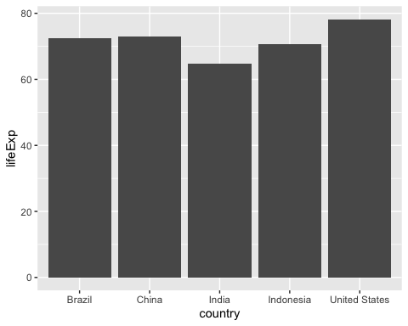

ggplot(gapminder_top5) +   
 geom_col(aes(x = country, y = pop, fill = continent))

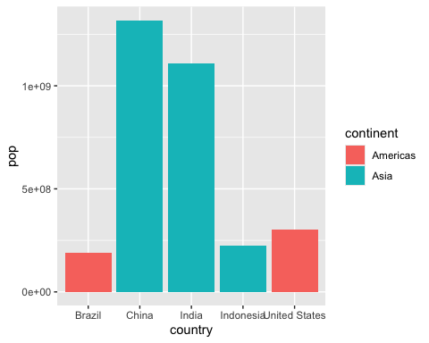

ggplot(gapminder_top5) +   
 geom_col(aes(x = country, y = pop, fill = lifeExp))

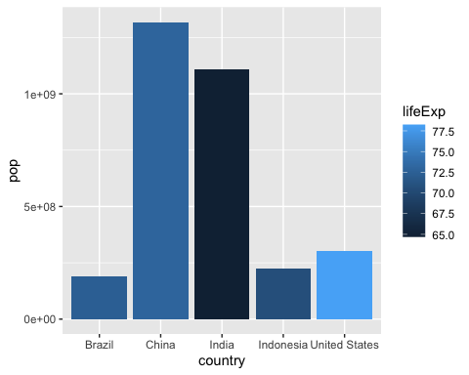

Q. Q. Plot population size by country. Create a bar chart showing the population (in millions) of the five biggest countries by population in 2007

ggplot(gapminder_top5) +  
 aes(x=country, y=pop, fill=gdpPercap) +  
 geom_col()

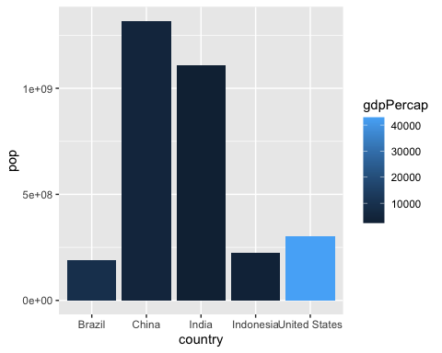

ggplot(gapminder_top5) +  
 aes(x=reorder(country, -pop), y=pop, fill=gdpPercap) +  
 geom_col()

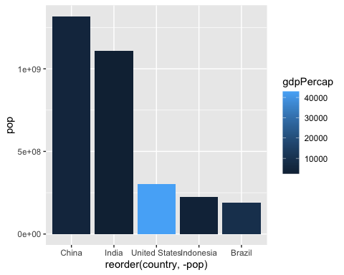

ggplot(gapminder_top5) +  
 aes(x=reorder(country, -pop), y=pop, fill=country) +  
 geom_col(col="gray30") +  
 guides(fill="none")

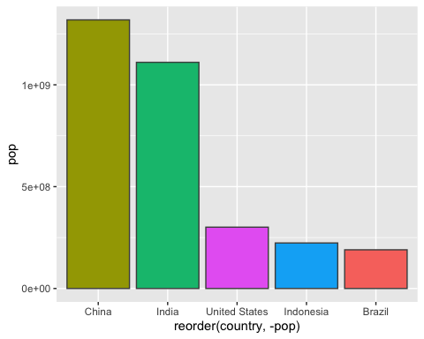

head(USArrests)

Murder Assault UrbanPop Rape  
Alabama 13.2 236 58 21.2  
Alaska 10.0 263 48 44.5  
Arizona 8.1 294 80 31.0  
Arkansas 8.8 190 50 19.5  
California 9.0 276 91 40.6  
Colorado 7.9 204 78 38.7

USArrests$State <- rownames(USArrests)  
ggplot(USArrests) +  
 aes(x=reorder(State,Murder), y=Murder) +  
 geom_col() +  
 coord_flip()

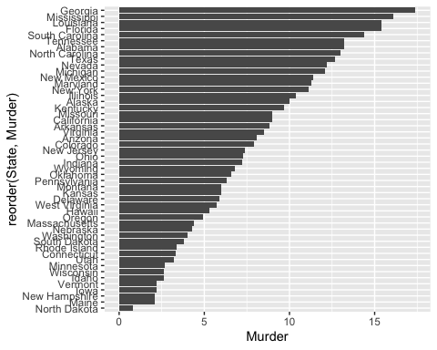

ggplot(USArrests) +  
 aes(x=reorder(State,Murder), y=Murder) +  
 geom_point() +  
 geom_segment(aes(x=State,   
 xend=State,   
 y=0,   
 yend=Murder), color="blue") +  
 coord_flip()

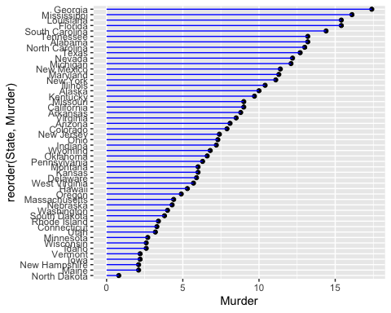

## Running Code

When you click the **Render** button a document will be generated that includes both content and the output of embedded code. You can embed code like this:

1 + 1

[1] 2

You can add options to executable code like this

[1] 4

The echo: false option disables the printing of code (only output is displayed).