class 9 : structural

Mia Fava

library(readr)  
pdbdata <- read_csv("Data Export Summary.csv")

Rows: 6 Columns: 8  
── Column specification ────────────────────────────────────────────────────────  
Delimiter: ","  
chr (1): Molecular Type  
dbl (3): Multiple methods, Neutron, Other  
num (4): X-ray, EM, NMR, Total  
  
ℹ Use `spec()` to retrieve the full column specification for this data.  
ℹ Specify the column types or set `show_col_types = FALSE` to quiet this message.

head(pdbdata)

# A tibble: 6 × 8  
 `Molecular Type` `X-ray` EM NMR `Multiple methods` Neutron Other Total  
 <chr> <dbl> <dbl> <dbl> <dbl> <dbl> <dbl> <dbl>  
1 Protein (only) 167317 15698 12534 208 77 32 195866  
2 Protein/Oligosacc… 9645 2639 34 8 2 0 12328  
3 Protein/NA 8735 4718 286 7 0 0 13746  
4 Nucleic acid (onl… 2869 138 1507 14 3 1 4532  
5 Other 170 10 33 0 0 0 213  
6 Oligosaccharide (… 11 0 6 1 0 4 22

Q1: What percentage of structures in the PDB are solved by X-Ray and Electron Microscopy.

sum(pdbdata$`X-ray`)/sum(pdbdata$Total) *100

[1] 83.25592

Percentage of Xray is 83.3%

sum(pdbdata$EM)/sum(pdbdata$Total) *100

[1] 10.2348

Percentage of EM is 10.2%

Q2: What proportion of structures in the PDB are protein?

pdbdata$Total[1]/sum(pdbdata$Total) *100

[1] 86.3961

Q3: Type HIV in the PDB website search box on the home page and determine how many HIV-1 protease structures are in the current PDB?

According to the search data base, there are 226,707 structures of HIV-1 protease.

##Mol*

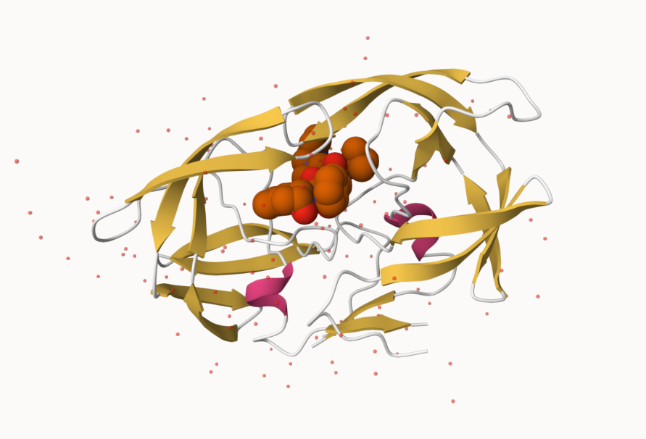

beginning strand

Q4: Water molecules normally have 3 atoms. Why do we see just one atom per water molecule in this structure?

There is only one atom per water molecule in this structure due to how the single atom represents only the oxygen. Oxygen is more electron-dense than hydrogen atoms, resulting in them being easier to detect in comparison to hydrogen atoms.

Q5: There is a critical “conserved” water molecule in the binding site. Can you identify this water molecule? What residue number does this water molecule have

The critical conserved water molecule for 1HSG residue number was seen to be 301.

Q6: Generate and save a figure clearly showing the two distinct chains of HIV-protease along with the ligand. You might also consider showing the catalytic residues ASP 25 in each chain and the critical water (we recommend “Ball & Stick” for these side-chains). Add this figure to your Quarto document. Discussion Topic: Can you think of a way in which indinavir, or even larger ligands and substrates, could enter the binding site?

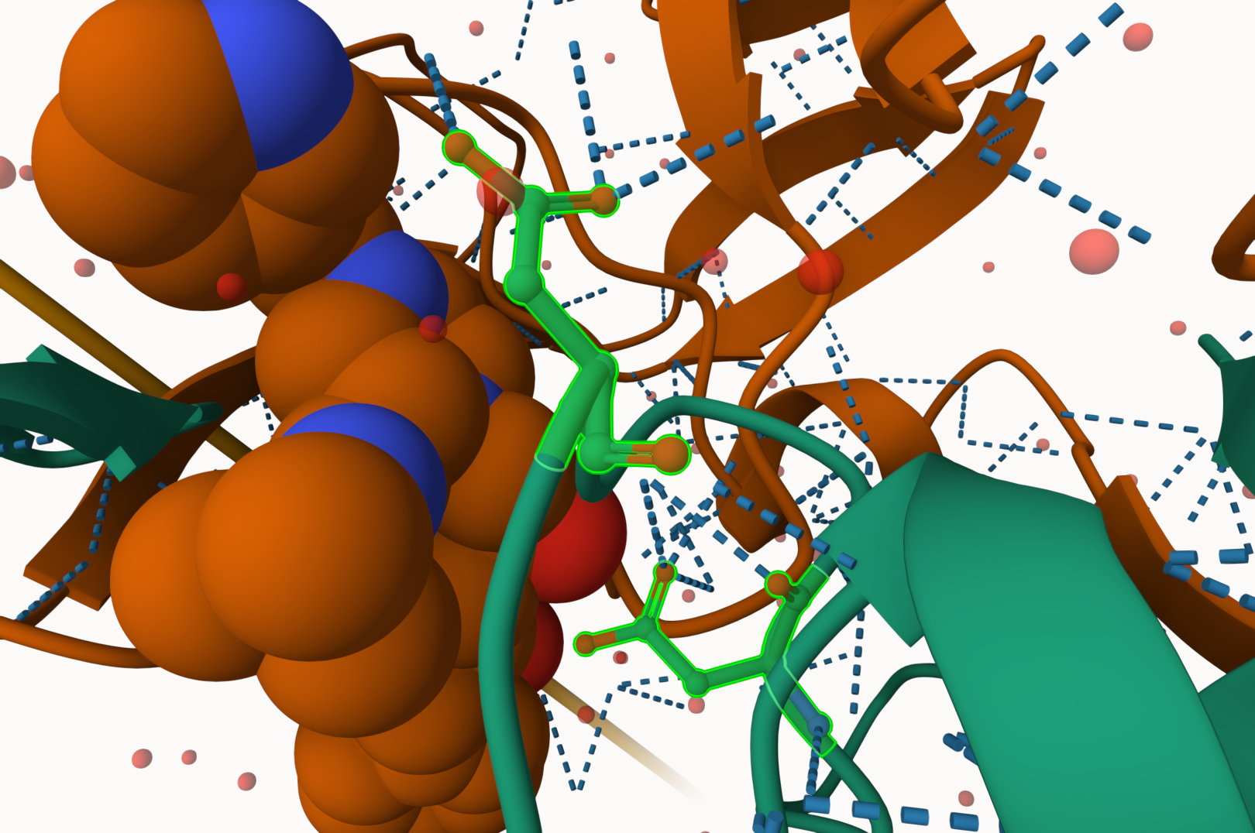

Ligand Strand

Q7: [Optional] As you have hopefully observed HIV protease is a homodimer (i.e. it is composed of two identical chains). With the aid of the graphic display can you identify secondary structure elements that are likely to only form in the dimer rather than the monomer?

The Beta sheets is an example of secondary structures that would form in the dimer rather than the monomer. Another example would be the residue arrangements of Asp25, as they are positioned where dimerization is necessary for them to interact with each other.

##Introduction to BIO3D

library(bio3d)

pdb <- read.pdb("1hsg")

Note: Accessing on-line PDB file

pdb

Call: read.pdb(file = "1hsg")  
  
 Total Models#: 1  
 Total Atoms#: 1686, XYZs#: 5058 Chains#: 2 (values: A B)  
  
 Protein Atoms#: 1514 (residues/Calpha atoms#: 198)  
 Nucleic acid Atoms#: 0 (residues/phosphate atoms#: 0)  
  
 Non-protein/nucleic Atoms#: 172 (residues: 128)  
 Non-protein/nucleic resid values: [ HOH (127), MK1 (1) ]  
  
 Protein sequence:  
 PQITLWQRPLVTIKIGGQLKEALLDTGADDTVLEEMSLPGRWKPKMIGGIGGFIKVRQYD  
 QILIEICGHKAIGTVLVGPTPVNIIGRNLLTQIGCTLNFPQITLWQRPLVTIKIGGQLKE  
 ALLDTGADDTVLEEMSLPGRWKPKMIGGIGGFIKVRQYDQILIEICGHKAIGTVLVGPTP  
 VNIIGRNLLTQIGCTLNF  
  
+ attr: atom, xyz, seqres, helix, sheet,  
 calpha, remark, call

attributes(pdb)

$names  
[1] "atom" "xyz" "seqres" "helix" "sheet" "calpha" "remark" "call"   
  
$class  
[1] "pdb" "sse"

head(pdb$atom)

type eleno elety alt resid chain resno insert x y z o b  
1 ATOM 1 N <NA> PRO A 1 <NA> 29.361 39.686 5.862 1 38.10  
2 ATOM 2 CA <NA> PRO A 1 <NA> 30.307 38.663 5.319 1 40.62  
3 ATOM 3 C <NA> PRO A 1 <NA> 29.760 38.071 4.022 1 42.64  
4 ATOM 4 O <NA> PRO A 1 <NA> 28.600 38.302 3.676 1 43.40  
5 ATOM 5 CB <NA> PRO A 1 <NA> 30.508 37.541 6.342 1 37.87  
6 ATOM 6 CG <NA> PRO A 1 <NA> 29.296 37.591 7.162 1 38.40  
 segid elesy charge  
1 <NA> N <NA>  
2 <NA> C <NA>  
3 <NA> C <NA>  
4 <NA> O <NA>  
5 <NA> C <NA>  
6 <NA> C <NA>

adk <- read.pdb("6s36")

Note: Accessing on-line PDB file  
 PDB has ALT records, taking A only, rm.alt=TRUE

adk

Call: read.pdb(file = "6s36")  
  
 Total Models#: 1  
 Total Atoms#: 1898, XYZs#: 5694 Chains#: 1 (values: A)  
  
 Protein Atoms#: 1654 (residues/Calpha atoms#: 214)  
 Nucleic acid Atoms#: 0 (residues/phosphate atoms#: 0)  
  
 Non-protein/nucleic Atoms#: 244 (residues: 244)  
 Non-protein/nucleic resid values: [ CL (3), HOH (238), MG (2), NA (1) ]  
  
 Protein sequence:  
 MRIILLGAPGAGKGTQAQFIMEKYGIPQISTGDMLRAAVKSGSELGKQAKDIMDAGKLVT  
 DELVIALVKERIAQEDCRNGFLLDGFPRTIPQADAMKEAGINVDYVLEFDVPDELIVDKI  
 VGRRVHAPSGRVYHVKFNPPKVEGKDDVTGEELTTRKDDQEETVRKRLVEYHQMTAPLIG  
 YYSKEAEAGNTKYAKVDGTKPVAEVRADLEKILG  
  
+ attr: atom, xyz, seqres, helix, sheet,  
 calpha, remark, call

# Perform flexiblity prediction  
m <- nma(adk)

Building Hessian... Done in 0.014 seconds.  
 Diagonalizing Hessian... Done in 0.29 seconds.

plot(m)

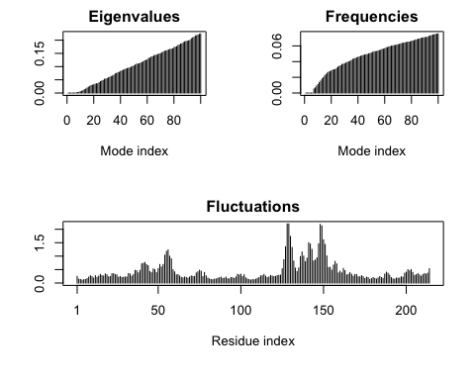

mktrj(m, file="adk_m7.pdb")

library(bio3d)  
aa <- get.seq("1ake_A")

Warning in get.seq("1ake_A"): Removing existing file: seqs.fasta

Fetching... Please wait. Done.

aa

1 . . . . . 60   
pdb|1AKE|A MRIILLGAPGAGKGTQAQFIMEKYGIPQISTGDMLRAAVKSGSELGKQAKDIMDAGKLVT  
 1 . . . . . 60   
  
 61 . . . . . 120   
pdb|1AKE|A DELVIALVKERIAQEDCRNGFLLDGFPRTIPQADAMKEAGINVDYVLEFDVPDELIVDRI  
 61 . . . . . 120   
  
 121 . . . . . 180   
pdb|1AKE|A VGRRVHAPSGRVYHVKFNPPKVEGKDDVTGEELTTRKDDQEETVRKRLVEYHQMTAPLIG  
 121 . . . . . 180   
  
 181 . . . 214   
pdb|1AKE|A YYSKEAEAGNTKYAKVDGTKPVAEVRADLEKILG  
 181 . . . 214   
  
Call:  
 read.fasta(file = outfile)  
  
Class:  
 fasta  
  
Alignment dimensions:  
 1 sequence rows; 214 position columns (214 non-gap, 0 gap)   
  
+ attr: id, ali, call

hits <- NULL  
hits$pdb.id <- c('1AKE_A','6S36_A','6RZE_A','3HPR_A','1E4V_A','5EJE_A','1E4Y_A','3X2S_A','6HAP_A','6HAM_A','4K46_A','3GMT_A','4PZL_A')

files <- get.pdb(hits$pdb.id, path="pdbs", split=TRUE, gzip=TRUE)

Warning in get.pdb(hits$pdb.id, path = "pdbs", split = TRUE, gzip = TRUE):  
pdbs/1AKE.pdb.gz exists. Skipping download

Warning in get.pdb(hits$pdb.id, path = "pdbs", split = TRUE, gzip = TRUE):  
pdbs/6S36.pdb.gz exists. Skipping download

Warning in get.pdb(hits$pdb.id, path = "pdbs", split = TRUE, gzip = TRUE):  
pdbs/6RZE.pdb.gz exists. Skipping download

Warning in get.pdb(hits$pdb.id, path = "pdbs", split = TRUE, gzip = TRUE):  
pdbs/3HPR.pdb.gz exists. Skipping download

Warning in get.pdb(hits$pdb.id, path = "pdbs", split = TRUE, gzip = TRUE):  
pdbs/1E4V.pdb.gz exists. Skipping download

Warning in get.pdb(hits$pdb.id, path = "pdbs", split = TRUE, gzip = TRUE):  
pdbs/5EJE.pdb.gz exists. Skipping download

Warning in get.pdb(hits$pdb.id, path = "pdbs", split = TRUE, gzip = TRUE):  
pdbs/1E4Y.pdb.gz exists. Skipping download

Warning in get.pdb(hits$pdb.id, path = "pdbs", split = TRUE, gzip = TRUE):  
pdbs/3X2S.pdb.gz exists. Skipping download

Warning in get.pdb(hits$pdb.id, path = "pdbs", split = TRUE, gzip = TRUE):  
pdbs/6HAP.pdb.gz exists. Skipping download

Warning in get.pdb(hits$pdb.id, path = "pdbs", split = TRUE, gzip = TRUE):  
pdbs/6HAM.pdb.gz exists. Skipping download

Warning in get.pdb(hits$pdb.id, path = "pdbs", split = TRUE, gzip = TRUE):  
pdbs/4K46.pdb.gz exists. Skipping download

Warning in get.pdb(hits$pdb.id, path = "pdbs", split = TRUE, gzip = TRUE):  
pdbs/3GMT.pdb.gz exists. Skipping download

Warning in get.pdb(hits$pdb.id, path = "pdbs", split = TRUE, gzip = TRUE):  
pdbs/4PZL.pdb.gz exists. Skipping download

|   
 | | 0%  
 |   
 |===== | 8%  
 |   
 |=========== | 15%  
 |   
 |================ | 23%  
 |   
 |====================== | 31%  
 |   
 |=========================== | 38%  
 |   
 |================================ | 46%  
 |   
 |====================================== | 54%  
 |   
 |=========================================== | 62%  
 |   
 |================================================ | 69%  
 |   
 |====================================================== | 77%  
 |   
 |=========================================================== | 85%  
 |   
 |================================================================= | 92%  
 |   
 |======================================================================| 100%

pdbs <- pdbaln(files, fit = TRUE, exefile="msa")

Reading PDB files:  
pdbs/split_chain/1AKE_A.pdb  
pdbs/split_chain/6S36_A.pdb  
pdbs/split_chain/6RZE_A.pdb  
pdbs/split_chain/3HPR_A.pdb  
pdbs/split_chain/1E4V_A.pdb  
pdbs/split_chain/5EJE_A.pdb  
pdbs/split_chain/1E4Y_A.pdb  
pdbs/split_chain/3X2S_A.pdb  
pdbs/split_chain/6HAP_A.pdb  
pdbs/split_chain/6HAM_A.pdb  
pdbs/split_chain/4K46_A.pdb  
pdbs/split_chain/3GMT_A.pdb  
pdbs/split_chain/4PZL_A.pdb  
 PDB has ALT records, taking A only, rm.alt=TRUE  
. PDB has ALT records, taking A only, rm.alt=TRUE  
. PDB has ALT records, taking A only, rm.alt=TRUE  
. PDB has ALT records, taking A only, rm.alt=TRUE  
.. PDB has ALT records, taking A only, rm.alt=TRUE  
.... PDB has ALT records, taking A only, rm.alt=TRUE  
. PDB has ALT records, taking A only, rm.alt=TRUE  
...  
  
Extracting sequences  
  
pdb/seq: 1 name: pdbs/split_chain/1AKE_A.pdb   
 PDB has ALT records, taking A only, rm.alt=TRUE  
pdb/seq: 2 name: pdbs/split_chain/6S36_A.pdb   
 PDB has ALT records, taking A only, rm.alt=TRUE  
pdb/seq: 3 name: pdbs/split_chain/6RZE_A.pdb   
 PDB has ALT records, taking A only, rm.alt=TRUE  
pdb/seq: 4 name: pdbs/split_chain/3HPR_A.pdb   
 PDB has ALT records, taking A only, rm.alt=TRUE  
pdb/seq: 5 name: pdbs/split_chain/1E4V_A.pdb   
pdb/seq: 6 name: pdbs/split_chain/5EJE_A.pdb   
 PDB has ALT records, taking A only, rm.alt=TRUE  
pdb/seq: 7 name: pdbs/split_chain/1E4Y_A.pdb   
pdb/seq: 8 name: pdbs/split_chain/3X2S_A.pdb   
pdb/seq: 9 name: pdbs/split_chain/6HAP_A.pdb   
pdb/seq: 10 name: pdbs/split_chain/6HAM_A.pdb   
 PDB has ALT records, taking A only, rm.alt=TRUE  
pdb/seq: 11 name: pdbs/split_chain/4K46_A.pdb   
 PDB has ALT records, taking A only, rm.alt=TRUE  
pdb/seq: 12 name: pdbs/split_chain/3GMT_A.pdb   
pdb/seq: 13 name: pdbs/split_chain/4PZL_A.pdb

# vector containing PDB codes for figure axis  
ids <- basename.pdb(pdbs$id)  
  
# schematic alignment  
plot(pdbs, labels=ids)

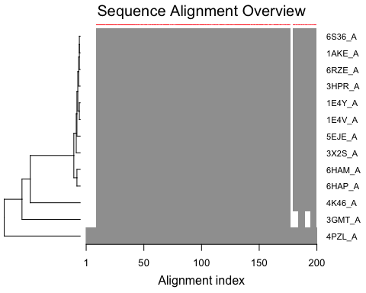

anno <- pdb.annotate(ids)  
unique(anno$source)

[1] "Escherichia coli"   
[2] "Escherichia coli K-12"   
[3] "Escherichia coli O139:H28 str. E24377A"   
[4] "Escherichia coli str. K-12 substr. MDS42"   
[5] "Photobacterium profundum"   
[6] "Burkholderia pseudomallei 1710b"   
[7] "Francisella tularensis subsp. tularensis SCHU S4"

anno

structureId chainId macromoleculeType chainLength experimentalTechnique  
1AKE_A 1AKE A Protein 214 X-ray  
6S36_A 6S36 A Protein 214 X-ray  
6RZE_A 6RZE A Protein 214 X-ray  
3HPR_A 3HPR A Protein 214 X-ray  
1E4V_A 1E4V A Protein 214 X-ray  
5EJE_A 5EJE A Protein 214 X-ray  
1E4Y_A 1E4Y A Protein 214 X-ray  
3X2S_A 3X2S A Protein 214 X-ray  
6HAP_A 6HAP A Protein 214 X-ray  
6HAM_A 6HAM A Protein 214 X-ray  
4K46_A 4K46 A Protein 214 X-ray  
3GMT_A 3GMT A Protein 230 X-ray  
4PZL_A 4PZL A Protein 242 X-ray  
 resolution scopDomain pfam  
1AKE_A 2.00 Adenylate kinase Adenylate kinase, active site lid (ADK_lid)  
6S36_A 1.60 <NA> Adenylate kinase, active site lid (ADK_lid)  
6RZE_A 1.69 <NA> Adenylate kinase (ADK)  
3HPR_A 2.00 <NA> Adenylate kinase, active site lid (ADK_lid)  
1E4V_A 1.85 Adenylate kinase Adenylate kinase (ADK)  
5EJE_A 1.90 <NA> Adenylate kinase, active site lid (ADK_lid)  
1E4Y_A 1.85 Adenylate kinase Adenylate kinase, active site lid (ADK_lid)  
3X2S_A 2.80 <NA> Adenylate kinase (ADK)  
6HAP_A 2.70 <NA> Adenylate kinase (ADK)  
6HAM_A 2.55 <NA> Adenylate kinase, active site lid (ADK_lid)  
4K46_A 2.01 <NA> Adenylate kinase, active site lid (ADK_lid)  
3GMT_A 2.10 <NA> Adenylate kinase, active site lid (ADK_lid)  
4PZL_A 2.10 <NA> Adenylate kinase (ADK)  
 ligandId  
1AKE_A AP5  
6S36_A CL (3),NA,MG (2)  
6RZE_A NA (3),CL (2)  
3HPR_A AP5  
1E4V_A AP5  
5EJE_A AP5,CO  
1E4Y_A AP5  
3X2S_A JPY (2),AP5,MG  
6HAP_A AP5  
6HAM_A AP5  
4K46_A ADP,AMP,PO4  
3GMT_A SO4 (2)  
4PZL_A CA,FMT,GOL  
 ligandName  
1AKE_A BIS(ADENOSINE)-5'-PENTAPHOSPHATE  
6S36_A CHLORIDE ION (3),SODIUM ION,MAGNESIUM ION (2)  
6RZE_A SODIUM ION (3),CHLORIDE ION (2)  
3HPR_A BIS(ADENOSINE)-5'-PENTAPHOSPHATE  
1E4V_A BIS(ADENOSINE)-5'-PENTAPHOSPHATE  
5EJE_A BIS(ADENOSINE)-5'-PENTAPHOSPHATE,COBALT (II) ION  
1E4Y_A BIS(ADENOSINE)-5'-PENTAPHOSPHATE  
3X2S_A N-(pyren-1-ylmethyl)acetamide (2),BIS(ADENOSINE)-5'-PENTAPHOSPHATE,MAGNESIUM ION  
6HAP_A BIS(ADENOSINE)-5'-PENTAPHOSPHATE  
6HAM_A BIS(ADENOSINE)-5'-PENTAPHOSPHATE  
4K46_A ADENOSINE-5'-DIPHOSPHATE,ADENOSINE MONOPHOSPHATE,PHOSPHATE ION  
3GMT_A SULFATE ION (2)  
4PZL_A CALCIUM ION,FORMIC ACID,GLYCEROL  
 source  
1AKE_A Escherichia coli  
6S36_A Escherichia coli  
6RZE_A Escherichia coli  
3HPR_A Escherichia coli K-12  
1E4V_A Escherichia coli  
5EJE_A Escherichia coli O139:H28 str. E24377A  
1E4Y_A Escherichia coli  
3X2S_A Escherichia coli str. K-12 substr. MDS42  
6HAP_A Escherichia coli O139:H28 str. E24377A  
6HAM_A Escherichia coli K-12  
4K46_A Photobacterium profundum  
3GMT_A Burkholderia pseudomallei 1710b  
4PZL_A Francisella tularensis subsp. tularensis SCHU S4  
 structureTitle  
1AKE_A STRUCTURE OF THE COMPLEX BETWEEN ADENYLATE KINASE FROM ESCHERICHIA COLI AND THE INHIBITOR AP5A REFINED AT 1.9 ANGSTROMS RESOLUTION: A MODEL FOR A CATALYTIC TRANSITION STATE  
6S36_A Crystal structure of E. coli Adenylate kinase R119K mutant  
6RZE_A Crystal structure of E. coli Adenylate kinase R119A mutant  
3HPR_A Crystal structure of V148G adenylate kinase from E. coli, in complex with Ap5A  
1E4V_A Mutant G10V of adenylate kinase from E. coli, modified in the Gly-loop  
5EJE_A Crystal structure of E. coli Adenylate kinase G56C/T163C double mutant in complex with Ap5a  
1E4Y_A Mutant P9L of adenylate kinase from E. coli, modified in the Gly-loop  
3X2S_A Crystal structure of pyrene-conjugated adenylate kinase  
6HAP_A Adenylate kinase  
6HAM_A Adenylate kinase  
4K46_A Crystal Structure of Adenylate Kinase from Photobacterium profundum  
3GMT_A Crystal structure of adenylate kinase from burkholderia pseudomallei  
4PZL_A The crystal structure of adenylate kinase from Francisella tularensis subsp. tularensis SCHU S4  
 citation rObserved rFree  
1AKE_A Muller, C.W., et al. J Mol Biol (1992) 0.19600 NA  
6S36_A Rogne, P., et al. Biochemistry (2019) 0.16320 0.23560  
6RZE_A Rogne, P., et al. Biochemistry (2019) 0.18650 0.23500  
3HPR_A Schrank, T.P., et al. Proc Natl Acad Sci U S A (2009) 0.21000 0.24320  
1E4V_A Muller, C.W., et al. Proteins (1993) 0.19600 NA  
5EJE_A Kovermann, M., et al. Proc Natl Acad Sci U S A (2017) 0.18890 0.23580  
1E4Y_A Muller, C.W., et al. Proteins (1993) 0.17800 NA  
3X2S_A Fujii, A., et al. Bioconjug Chem (2015) 0.20700 0.25600  
6HAP_A Kantaev, R., et al. J Phys Chem B (2018) 0.22630 0.27760  
6HAM_A Kantaev, R., et al. J Phys Chem B (2018) 0.20511 0.24325  
4K46_A Cho, Y.-J., et al. To be published 0.17000 0.22290  
3GMT_A Buchko, G.W., et al. Biochem Biophys Res Commun (2010) 0.23800 0.29500  
4PZL_A Tan, K., et al. To be published 0.19360 0.23680  
 rWork spaceGroup  
1AKE_A 0.19600 P 21 2 21  
6S36_A 0.15940 C 1 2 1  
6RZE_A 0.18190 C 1 2 1  
3HPR_A 0.20620 P 21 21 2  
1E4V_A 0.19600 P 21 2 21  
5EJE_A 0.18630 P 21 2 21  
1E4Y_A 0.17800 P 1 21 1  
3X2S_A 0.20700 P 21 21 21  
6HAP_A 0.22370 I 2 2 2  
6HAM_A 0.20311 P 43  
4K46_A 0.16730 P 21 21 21  
3GMT_A 0.23500 P 1 21 1  
4PZL_A 0.19130 P 32

# Perform PCA  
pc.xray <- pca(pdbs)  
plot(pc.xray)

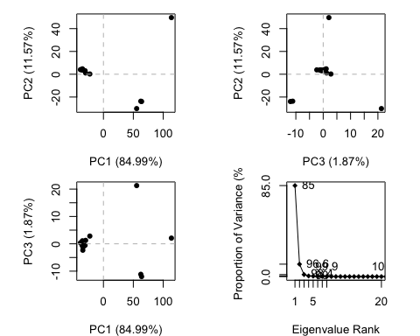

rd <- rmsd(pdbs)

Warning in rmsd(pdbs): No indices provided, using the 204 non NA positions

hc.rd <- hclust(dist(rd))  
grps.rd <- cutree(hc.rd, k=3)  
  
print(plot(pc.xray, 1:2, col="grey50", bg=grps.rd, pch=21, cex=1))

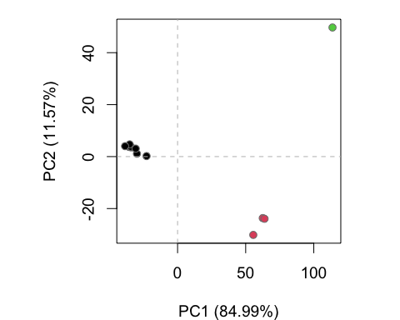

[,1] [,2]  
pdbs/split_chain/1AKE_A.pdb -34.36252 3.8366842  
pdbs/split_chain/6S36_A.pdb 62.52547 -23.6640884  
pdbs/split_chain/6RZE_A.pdb 63.84482 -23.9290507  
pdbs/split_chain/3HPR_A.pdb -35.61549 3.7149408  
pdbs/split_chain/1E4V_A.pdb -34.09106 3.5591318  
pdbs/split_chain/5EJE_A.pdb -34.51491 3.8227770  
pdbs/split_chain/1E4Y_A.pdb -29.84624 1.1101921  
pdbs/split_chain/3X2S_A.pdb -35.18888 4.7081594  
pdbs/split_chain/6HAP_A.pdb -22.78709 0.1990177  
pdbs/split_chain/6HAM_A.pdb -30.73762 3.0699359  
pdbs/split_chain/4K46_A.pdb -38.53786 4.0179543  
pdbs/split_chain/3GMT_A.pdb 113.74018 49.6943861  
pdbs/split_chain/4PZL_A.pdb 55.57121 -30.1400402

##Optional Further Investigation

# Visualize first principal component  
pc1 <- mktrj(pc.xray, pc=1, file="pc_1.pdb")

library(ggplot2)  
library(ggrepel)

df <- data.frame(PC1=pc.xray$z[,1],   
 PC2=pc.xray$z[,2],   
 col=as.factor(grps.rd),  
 ids=ids)  
  
p <- ggplot(df) +   
 aes(PC1, PC2, col=col, label=ids) +  
 geom_point(size=2) +  
 geom_text_repel(max.overlaps = 20) +  
 theme(legend.position = "none")  
p

