1. Slice Acquisition Time Correction (‘Slice Timing’)

Data: FUNC4_vol.xxx.img for xxx = (001,131)

Number of slices: 131

TR: 2 seconds

TA: 2 - (2/21)

Slice Order: 1,3,5,7,9,11,13,15,17,19,21,2,4,6,8,10,12,14,16,18,20

Reference Slice: 1

Output files: aFUNC4_vol.xxx..img

Slice acquisition was corrected for time, under the conditions of TR = 2 seconds for the given TR of 2000 ms. TE was set to ~1.905 as TE was calculated from TR-(TR/#slices). Slice 1 was used for the reference simply because it was first and therefore strongest signal of all the sequential slices. The slice order was defined as an interleaving sample.

2. Correction for bulk head movement ( ‘Realign(Estimate & Reslice)’ )

(*) indicates a default value

Data: aFUNC4_vol.xxx.img

Quality 0.9*

Separation : 3mm

Smoothing: 5*

Number of Passes: Register to mean*

Interpolation: 4th degree b-spline*

Wrapping: None*

Weighting: 0*

Resliced Images: All images and mean image *

Interpolation: 4th degree b-spline*

Wrapping: none *

Masking: applied *

Output files: raFUNC4_vol.xxx.img

Quality of the image was set to 90% to keep the precision of correction higher, rather than speed of alignment. The render time for quality was not lengthy, so 90% was kept, and readability for 90% was adequate. The separation was defined as 3 mm in relation to the points sampled in the reference slide. While smaller sampling distance would generate more accurate results, this value was set to 3mm and would wait for the rendering to see if accuracy was adequate and needed to be reduced. After sampling, 3mm was decided as acceptable. MRI images were registered to the mean to increase the accuracy in comparison to registering to the first image. 4th degree b-spline was used as it was the median of degrees for interpolation options. Higher degrees would produce better interpolation by incorporating a larger window of neighboring voxels, at the compromise of speed. 4th degree was used and would be tested to see if it was adequate. The FUNC4 volume set was tested in HW5 at different interpolation degrees of bulk movement correction. The difference in higher degree interpolation compared to 4th degree was not noticeable. Therefore 4th degree interpolation was kept. No wrapping was used as the data set is being resliced in this step. Weighting was not used as there was no appearance of significant artifacts, so no weighting image was incorporated.

Reslicing was performed on all images and produced a mean image which may provide useful in later steps. Interpolation was kept at 4th degree for similar reasons above. Wrapping was not performed as the images did not need to be wrapped. Masking was performed as a way of improving the image as a result of possible motion artifacts.

3. Functional-Structural coregistration ( ‘Coregister (Estimate & Reslice)’ )

Reference Image: ‘raFUNC4)vol.xxx.img’

Source Image: ‘ANAT4_wholevol.img’

Objective Function: Normalized Mutual Information*

Separation: between 4 and 2 mm

Tolerances: [0.02 0.02 0.02 0.001 0.001 0.01 0.01 0.01 0.001 0.001 0.001]*

Histogram Smoothing [7 x 7]*

Interpolation: 4th degree b-spline

Wrapping: none

Masking: none

Output file: ‘rANAT4_wholevol.img’

The objective function used was normalized mutual information, the default parameter, but was left as NMI is typically a good measure for quality and normalization allows for comparison between coregistration. The separation was defined a range, 4mm to 2mm, as the separation earlier was given as 3mm and added a 1mm buffer on each side. Tolerance was kept as default, which was related to the accuracy for each parameter. The range for values was unknown so it was left as default to see if iterations would terminate as a result of these values. The results produced later on in this test would see if this value may need to be changed. Histogram smoothing was kept as a 7x7 window of smoothing as a 7x7 window should be sufficient. Interpolation was set as a 4th degree b-spline, similarly to previous parameters. No wrapping was incorporated as the file was already re-sliced, and no additional mask was used as already masked in the previous step.

4. Spatial Filtering ( ‘Smooth’ )

Data: ‘raFUNC4_vol.xxx.img’

FWHM: 5 5 5

Data type: same format as input data

Implicit Masking: no

The full width at half maximum was defined as 5 as this was the same parameter used in the smoothing parameter in the realign step.

5. Model specification ( ‘Specify 1st-level’ ’)

Data: ‘sraraFUNC4_vol.xxx.img’

Units: seconds

Interscan interval: 2 seconds

Microtime resolution: 21

Microtime onset: 1

Scans: ‘sraraFUNC4_vol.xxx.img’

Condition Name: ‘finger-tapping’

Condition Onset: 0 1 2 3 4 5 6

Condition Duration: 20 20 20 20 20 20 12

High-pass filter: 128

Output file: SPM.mat

The timing used was in seconds, as the slices were sampled temporally, and since timing for tasks were provided in seconds, this was likely the best way to approach the data. The interscan interval was similar to the TR since all slices were collected in a single TR, the time from one plane to the time acquiring the same plane in the next volume would be the length of TR. The microtime resolution was set to 21 as spm recommended the parameter to be the number of slices used since the data was corrected for slice timing. The microtime onset was set to 1 as this was referencing the first slide as the data was corrected for slice timing. The condition was name ‘finger-tapping’ to reflect the task performed and the onset was defined as 0 through 6 to reflect the seven periods that finger-tapping was performed. The duration was set to match the duration of task performance at each onset, with the last onset being 12 seconds in contrary to 20 seconds for the first 6 intervals. The high-pass filter was set to 128 seconds as spm recommended this value.

6. Model Estimation ( ‘Estimate’)

Data: SPM.mat

Method: Classical

Classical method of model estimation was used.

7. Results ( ‘Results’ )

Data: SPM.mat

Contrast name: trial_003

Contrast type: 1 0

Apply mask: none

P value: 0.05

Extent threshold: 0 voxel

A variety of trials were made, from trial_001 to trial-005. However, realizing that parameters used for generating the results did not save directly to the trial, selecting the trial name did not affect the results of the data. All trials were set to a contrast of 1 0, so they were all similar in this regard. After loading a trial, the parameters then selected varied. No mask was applied to any trial, but p value and extent threshold was varied. It was observed that an extent threshold searching for a minimum value of 3 voxels with low p values did not highlight any areas of the brain, so the extent must be lowered. This was kept to 0 as a value of 1 generated less than 5 points throughout the brain. The p value was first set to 0.001 where only 3 voxels were shown. This was increased to 0.005 and a more regions appeared, but still was too low for analysis. The p value was then changed to 0.05 and displayed an appropriate number of regions in the brain as seen in figure 1.

8. Overlay ( ‘Overlays’ )

Overlay: rANAT4_wholevol.img

Overlay in correlation to glass-model can be seen in Figure 1.

9. Analysis:

[Region, Lowest p-value in region, location]

Left Primary Motor Cortex: 0.002, (-21, -28, 32)

Right Primary Motor Cortex: 0.014, (24, -36, 42)

SMA: 0.013, (13, -13, 42)

Cerebellum: 0.004, (-2, -47, -42)

Additional values can be seen in Figure 2.

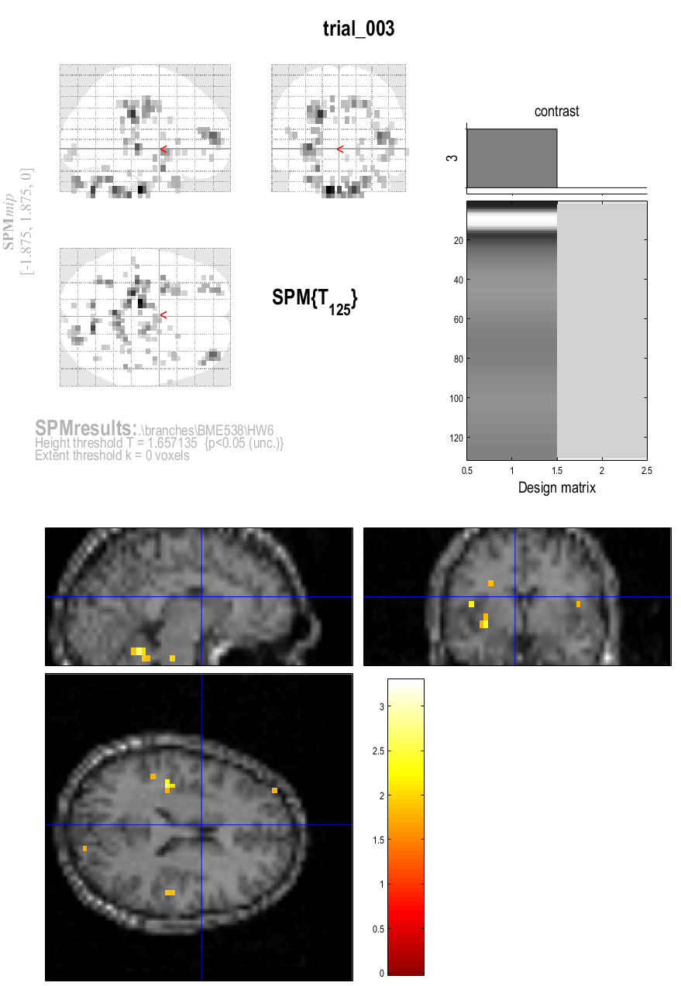

Figure 1. Mapping of brain regions in glass model and anatomical overlay. Figure file name: ‘results_trial_003_favila.fig’

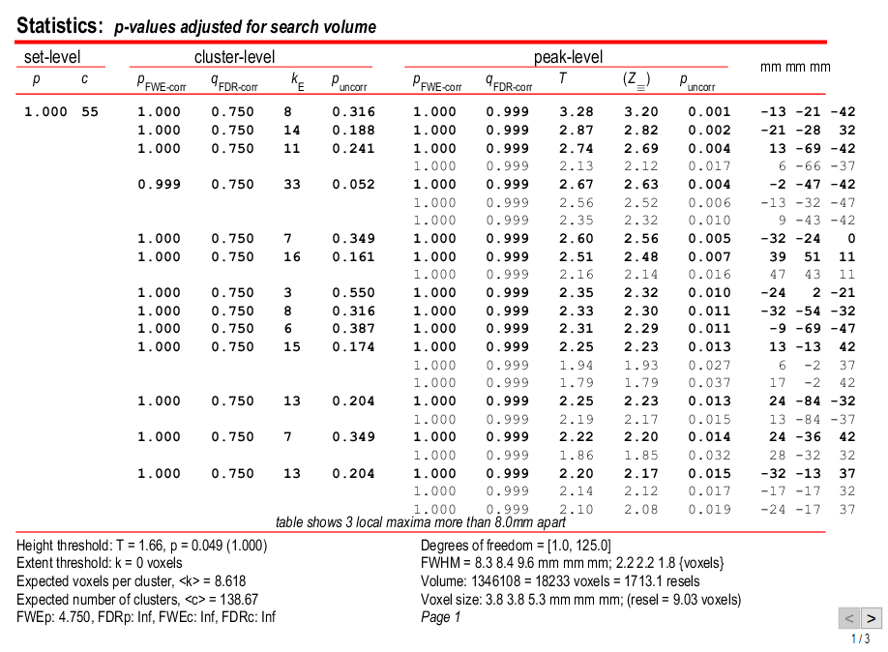

Figure 2. P-value listing, threshold set at p = 0.05 and minimum voxel threshold was 0 voxels. Figure file name: ‘results_trial_003_overlay_favila.fig’

Appendix:

A: list of file names included in this submission

bulkheadmovement_correctoin_favila.fig

results_trial_003_favila.fig

results_trial_003_overlay_favila.fig

model_estimation_favila.fig

func_stru_coreg_favila.fig

B: graphs produced (can also be opened through file listed):

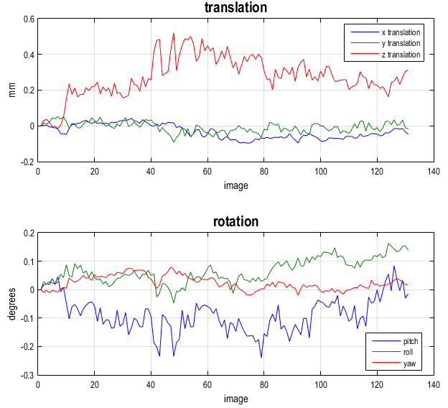

Figure 3: Translation and Rotation for slice timing corrected images (‘aFUNC4….’). Figure file name: ‘bulkheadmovement_correction_favila.fig’

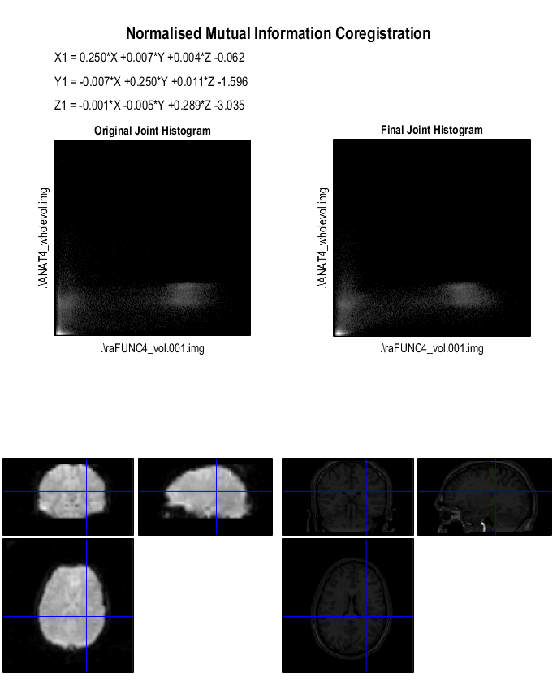

Figure 4. Coregistration on ANAT4_wholevol.img and raFUNC4_vol.001.img. File produced: rANAT4_wholevol.img Figure file name: ‘func_stru_coreg_favila.fig’