Examination of Fig. 1a, through histogram equalization yielded three different images. Fig. 1b and Fig. 1c were derived from manual implementation of local histogram equalization technique. In Fig. 1b., the window size used was a 3x3 neighborhood scope. The technique transformed the test image, Fig. 1., and displayed five different shapes within the five black squares in the test image. A result of the transformation displayed each shape as white or nearly white shapes within the black box. An amount of gray lines appeared to the right of each box. This odd effect was only seen to the right of each shape, or simply, in the location it did appear, the effect was seen from left to right. It is possible that this streak was a result of the implementation of the technique within the MATLAB code. However, the effect is seen only in the horizontal direction, and not in the vertical direction. This would mean that an error in calculation in the horizontal direction would be seen in the vertical direction as well through the algorithm of the MATLAB function.
Increasing the window size to perform the transformation with a 7x7 neighborhood scope produced similar results to using a 3x3 window size. However, the resulting image showed a blurred effect. The shapes were still distinguishable in the black squares; however, edges were not as defined. Additionally, the grey streak effect was seen less prominently. Instead, there were other streaks of a lower intensity value that would appear in the image. Similarly, these effects were only seen in the horizontal direction. It is possible that the prominence of the streaks is inversely related to the window size, and as the blurred effect is related to the window size.
Use of the built-in MATLAB histogram equalization technique as seen in Fig. 1d., resulted in a more prominent grayscale image than Fig. 1b. or 1c. The image showed no streak effects that were visible in Fig.1b or 1c. Additionally, the edges are well defined and showed no signs of blurred effects. However, the image did appear darker in tone. The shapes are not as easily seen as in Fig. 1b. or 1c. They were displayed in a dark gray value similar to the gray space that the rest of the image is seen in. It is likely that a trade-off between increased visibility is the increase of noisy elements.

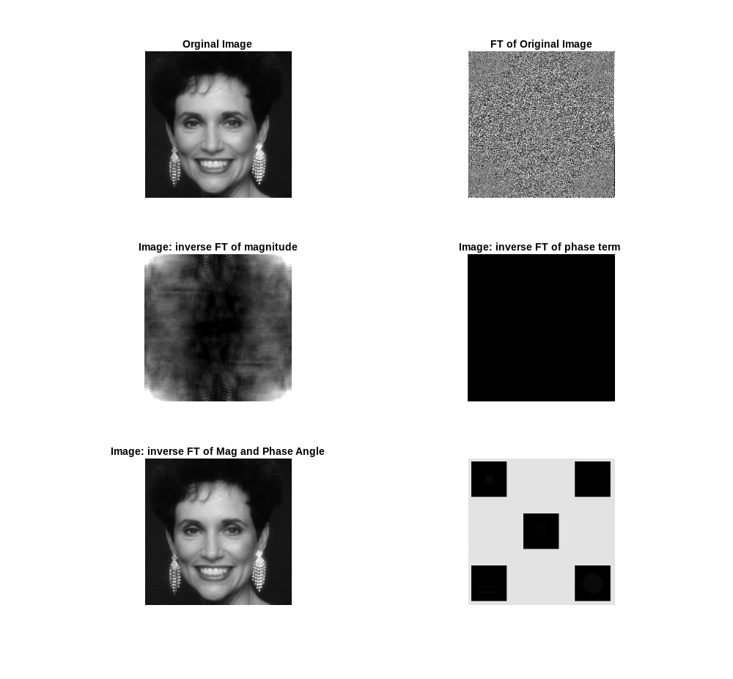
Fig. 1a. Image of test1.tif
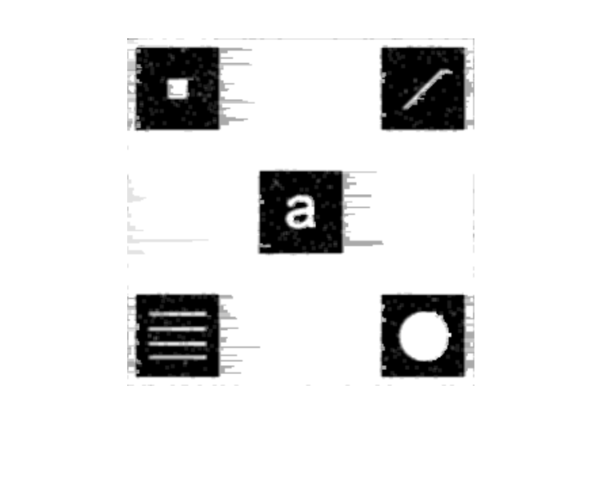
Figure 1b. Image of localhisteq(‘test1.tif’,3,3) : window size of 3x3
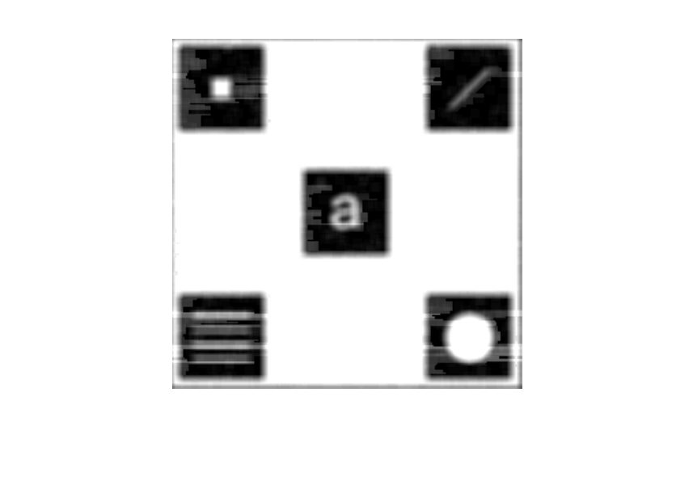
Figure 1c. Image of localhisteq(‘test1.tif’,7,7) : window size of 7x7

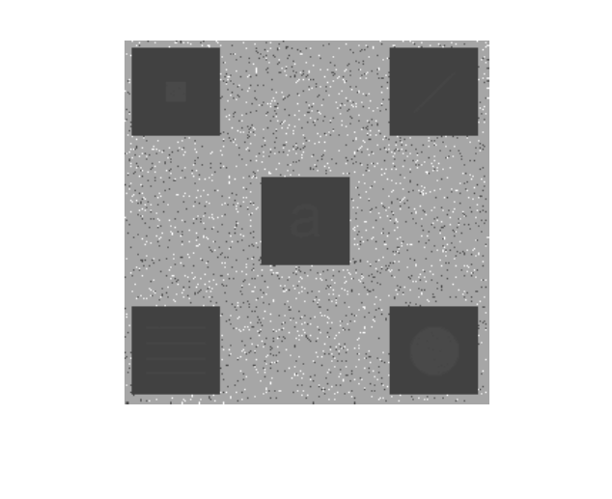
Figure 1d. Image of histeq(‘test.tif’): built in MATLAB function

Examination of the Fourier Transform (FT) of Fig. 2a. demonstrated several properties when computing the FT of an image, and applying the inverse FT on an image. Using the built-in MATLAB function of calculating the 2-D FT of the test image, Fig. 2b. shows the resulting image from the FT. This iamge can be represented as the image in k-space, the space in which the FT can be modeled. The FT of an image has two components, the magnitude spectrum and the phase angle. Each component was separated and its inverse FT was observed. Fig. 2c. shows the inverse FT of the magnitude spectrum, and Fig. 2d. displays the inverse FT of Fig. 2d.
When applying the inverse FT to the phase angle component, the resulting image is a black image. This black image is a result of the method in which MATLAB handles the computed inverse FT of phase angles. It results in attributing a value of 0 to each pixel, which when converted to an image displays a black image. Application of the inverse FT to the magnitude spectrum results in a grayscale image, a result of the magnitude of the FT of the test image. The inverse FT of the FT of an image would result in the original image being displayed. However, when spearating the components of the FT, such as the magnitude spectrum and phase angle component, the original image cannot be recovered with only a single compnent. Thus, signals captured in k-space must have a magnitude component and a phase angle component, otherwise the clairty of the image will be lost, and an image cannot be recovered. This is why there the image of Fig. 2a. does not appear when applying the inverse FT of these individual components.
It is seen in Fig. 2e. that the original image can be recoverd when applying the inverse FT to the product of the magnitude spectrum and the phase angle component. However, computation of the complex conjugate of the phase angle component, can result in a different image when applying the inverse FT to this and the magnitude component. The complex conjugate of the phase angle component in relation to the phase angle component is a 180 degree rotation in the image-space. The mathematical properties of the complex conjugte result in an imaginary component of the value to be 0 when computing the product. This when translated from k-space to image-space, resuls in the 180 degree rotation of the image. As seen in Fig. 2f., the inverse FT of the magnitude spectrum and complex conjugate of the phase component yields ther rotation of the orignal image. Magnitude and phase angle are both necessary to compute the image from k-space because it orients the values in their respective places in image-space. The image cannot be obtain from a single component because the values become arbitrary in image-space without the second component. It is the product of the two that allows the values to be properly attributed so that the inverse FT will produce an image from k-space values.

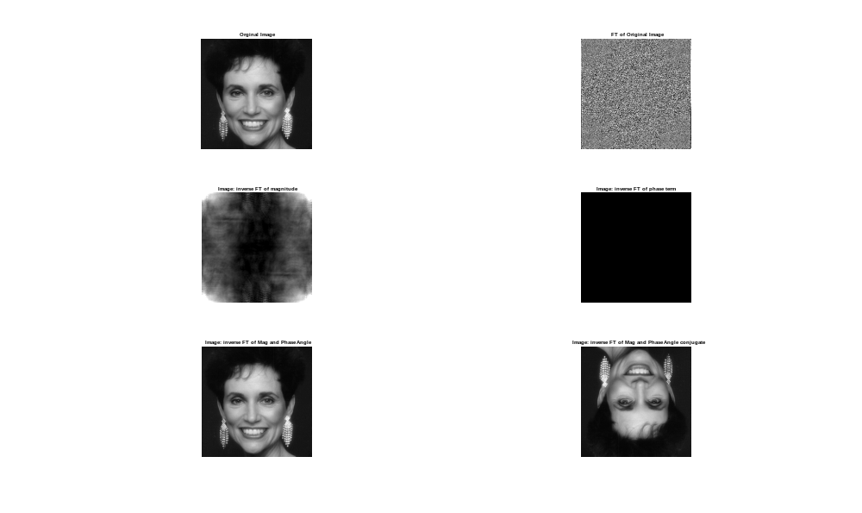
Fig. 2a. test2.tif

Fig 2b. Fourier Transform (FT) of test2.tif

Fig. 2c. Inverse FT of Magnitude Spectrum of FT of test2.tif

Fig. 2d. Inverse FT of Phase component of FT of test2.tif

Fig. 2e. Inverse FT of Magnitude Spectrum multipled by Phase Compoenent

Fig. 2f. Inverse FT of Magnitude Spectrum multipled by complex conjugate of Phase Compoenent

