**Department Of Electronics and Communication Engineering**

**University College of Engineering Osmania University ,Hyderabad**

Major Project Report

On

“**DESIGN AND IMPLEMENTATION OF VOICE CONTROLLED WHEELCHAIR”**

Submitted by :

MANZAR AHMED (1005-18-7350-50)

MOHAMMAD ANAS (1005-18-7350-52)

MOHAMMED FAWWAZ (1005-18-7350-53)

Under the Guidance of:

Mr.G.KISHORE KUMAR

Assistant Professor

ECE Department

# CERTIFICATE

This is to certify that the Project report on "**DESIGN AND IMPLEMENTATION OF VOICE CONTROLLED WHEELCHAIR**” is a bonafide work carried out by MANZAR AHMED (1005-18-7350-50),MOHAMMAD ANAS (1005-18-7350-52),MOHAMMED FAWWAZ (1005-18-7350-53) in the partial fulfillment for the award of B.E. degree in Department of Electronics and Communication Engineering, University College of Engineering (Autonomous), Osmania University, Hyderabad under our guidance and supervision.

PROJECT GUIDE

Mr. G.KISHORE KUMAR

Assistant Professor

Department of Electronics &

Communication Engineering

University College of Engineering(A)

Osmania University

# ACKNOWLEDGEMENT

The satisfaction that accompanies the successful completion of any task would be incomplete without the introduction of the people who made it possible and whose constant guidance and encouragement crowns all efforts with success.

We would like to express our deepest sense of gratitude and thankfulness to our guide

Mr G.KISHORE KUMAR Professor, Department of Electronics and Communication Engineering, University College of Engineering, Osmania University, Hyderabad for giving us this opportunity, providing guidance and encouragement to complete the project(phase 1) within the stipulated time.

We take immense pleasure in thanking PROF. L. NIRMALA DEVI, Head, Dept. of Electronics and Communication Engineering, University College of Engineering, Osmania University, Hyderabad providing excellent computing facilities and the right atmosphere for completing our phase 1 of our project.

We are also thankful to PROF. SRIRAM VENKATESH, Principal, University College of Engineering, Osmania University, for his timely cooperation and providing us all the required facilities to complete the project successfully. Finally, we would like to thank all the faculty and supporting staff that have helped us directly or indirectly in completing the project phase 1.

# DECLARATION

We declare that the work reported in the present thesis titled "**DESIGN AND IMPLEMENTATION OF VOICE CONTROLLED WHEELCHAIR**” is a record of work done by us .

No part of the thesis is copied from books, journals, document or internet and whenever the portion is taken, the same has been duly referred in the text; the reported are based on the project work done currently by us, not copied from any other source.

MANZAR AHMED (1005-18-7350-50)

MOHAMMAD ANAS (1005-18-7350-52)

MOHAMMED FAWWAZ (1005-18-7350-53)

**TABLE OF CONTENTS**

|  |  |  |
| --- | --- | --- |
| **S.NO** | **NAME OF THE CHAPTER** | **P.NO** |
| 1 | ABSTRACT | 8 |
| 2 | INTRODUCTION  2.1 Problem definiton  2.2 Aim and objectives  2.3Motivation  2.4 backround of wheelchairs  2.5 Types of Disabilities  2.6 Methodology  2.7 Report Organization | 9-13 |
| 3 | LITERATURE REVIEW | 14-15 |
| 4 | HARDWARE AND SOFTWARE REQUIREMENTS  4.1 Hardware Requirements  4.2Software requiremnets | 16-22 |
| 5 | METHODOLOGY  5.1 Methodology And Design  5.2software Simulation  5.3preliminary Results | 23-29 |
| 6 | PLAN OF ACTION | 30 |
| 7 | CONCLUSION | 31 |
| 8 | REFRENCES | 32 |

**LIST OF FIGURES**

|  |  |  |
| --- | --- | --- |
| **FIGURE NO** | **FIGURE NAME** | **Page** |
| 1 | STATISTICS OF THE DISABLED POPULATION | 12 |
| 2 | ARDUINO BOARD | 16 |
| 3 | ULTRASONIC SENSOR | 18 |
| 4 | DC MOTOR INTERNAL STRUCTURE | 19 |
| 5 | BLUETOOTH MODULE HC-05 | 20 |
| 6 | METHODOLOGY ROAD MAP | 23 |
| 7 | HARDWARE WORKING | 24 |
| 8 | WHEELCHAIR MOVEMENT PATHS | 26 |
| 9 | SOFTWARE FLOWCHART | 27 |

**LIST OF TABLES**

|  |  |  |
| --- | --- | --- |
| **TABLE NO** | **TABLE NAME** | **Page** |
| 1 | ARDUINO TECHNICAL SPECIFICATIONS | 17 |
| 2 | L293D DRIVER PIN FUNCTIONS | 20 |
| 3 | BLUETOOTH HC MODULE PIN FUNCTIONS | 21 |
| 4 | COMMON WORDS AND THEIR OPERATIONS | 26 |

**Abstract:**

The present day society demands the people to be independent, irrespective of their natural challenges, mentally or physically. Physically impaired people have to rely on someone for fulfilling their even minor needs. The probability of them to go and interact with the outside world is very minimal, unless they are provided with modern moving tools such as a Wheel Chair. There are two possibilities of either using manual driven or electric powered driven wheel chairs. The former solution is only for the people who have disability in lower limbs and also long term usage poses further health problems. Additionally the efficiency of the manual driven wheel chairs are merely 10-20%.

This project aims to control a wheelchair by means of human voice. It enables the disabled people who can’t move their hands and legs to move around independently using the voice recognition application which is interfaced with motors to make the movement easy as much as possible, using a voice recognition application which is interfaced with motors.

The prototype of the wheelchair is built using a computer software, in addition to its versatility and performance in mathematical operations and communication with other electronic devices. The system has been designed and implemented in a cost effective way so that if our project is commercialized the needy users in developing countries will benefit from it. In order to do that we applied a program carried on Arduino circuit which is connected to the voice recognition the signal operates a motor to control the movement of the chair.

In this way we have obtained a wheelchair which can be driven with using voice commands and with the possibility of avoiding obstacles and downstairs or holes detection. The wheelchair has also been developed to allow autonomous driving. The project, in which prototype has been produced, Electronic system configuration, a sensor system, a mechanical model, voice recognition and autonomous control are considered.

**KEYWORDS:** Android Application, Wheel chair, physically Challenged, Ultra sonic Sensor, Voice Command, HC-05 Bluetooth Module, DC Motors, Arduino UNO Micro-controller.

**INTRODUCTION**

“Give me a wheelchair that is light and compact, that fits in a small plane when I need to fly outing the wet season. Make sure it’s comfortable, does not give me pressure sores, to make me look like a cripple straight out of hospital. It has to be easy to push because I want to get out, go crabbing in the boat and go fishing on the beach.” (Hales S 2001) This quotation describes the needs of a wheelchair user in an Aboriginal community.

The number of people who need to move around with the help of some artificial means, whether through an illness or an accident, is continually increasing. These means have to be increasingly sophisticated, taking advantage of technological evolution, in order to increase the quality of life for these people and facilitate their integration into the working world. In this way a contribution may be made to facilitating movement and to making this increasingly simple and vigorous, so that it becomes similar to that of people who do not suffer deficiencies. Systems already exist which respond too many of the needs of people with different degrees of incapacity.

Recently, the old person and the physically handicapped person who use a wheelchair are increasing. However, only two type wheelchairs by the hand-operating and operating the joystick, have come into wide use. The former type needs muscular strength for the operation and the latter type needs the skill. Therefore, there is a problem that it is difficult for the old and the handicapped person to use these interfaces.

Today In biomedical sector, a wheelchair is an important device because of the recent advancements in the industrial populations. The demand of the physically handicapped and the aged are ever rising. As Smart wheelchair will play significant role in the future welfare society.

The use of smart wheelchair inspires the view of the machine as partner rather than as an instrument. The present wheelchairs do not have combination of technologies for their working.

However, only two types of wheelchairs are available in market like hand operated and joystick operated have come into wide use.

We are trying to construct a voice controlled wheelchair; the system will recognize and follows natural language voice instructions such as “Start, Stop etc.” The objective of this project is to make wheelchair moving forward, backward, Left & Right with the help of voice commands. A wheelchair fitted with obstacle sensor to achieve some independent mobility when any obstacle is there in front of wheelchair.

The obstacle sensor will help the rider control the wheelchair by taking over some of the decision for steering and avoiding objects until user is able to handle the job. The voice command is a person dependent, the voice command we provide to the voice recognition model is person dependent. The system comprises of transmitting section and receiving section. Initially, the voice command is stored in the data base with the help of the function keys.

The voice received is processed in the voice recognition system where the feature of the voice command is extracted and matched with the existing sample in the database. The module recognizes the voice and sends control messages to the microcontroller. The proposed Speech Recognition Based Wheelchair Operation allows physically disabled person to control the wheelchair easily without the need to use hands.

The movement of the powered wheelchair depends on the motor control and drive system which consists of microcontroller and motor driving. Once the voice recognition system recognizes the voice commands in comparison to the stored memory, the respective coded digital signals would be sent to the microcontroller which then controls the wheelchair accordingly.

**PROBLEM STATEMENT**

* Many disabled people require wheelchair for mobility.
* They are not always able to control it themselves.
* Caretakers not always able to actively monitor disabled individuals.
* Disabled people need a way to control their wheelchair that meets their

specific need.

**AIM AND OBJECTIVE**

* The objective of this project is to facilitate the movement of people who cannot even use their hands to operate power wheelchair. The result of this project will allow disabled people to live with less dependence of others. Speech recognition will provide a new way of human interaction with machine. This project also includes the Obstacle detection module for automatic detection of obstacles.
* The use of Ultrasonic sensors will help to detect the obstacle and the controller will automatically turn the wheelchair.
* The goal of this smart wheelchair project is to enhance an ordinary powered wheelchair using sensors to perceive the wheelchair's surroundings, a speech interface to interpret commands. Intelligent wheelchair will play an important role in the future welfare society This project contains integration of the voice recognition system and Ultrasonic sensor system. Basic voice commands will be used for the movement of the wheelchair. E.g. Start, Left, Halt. In order to avoid the environmental disturbances, we will provide less number of voice commands. With the help of Ultrasonic sensors, Wheelchair will intelligently detect and avoid obstacles.

**MOTIVATION**

Several studies have shown that both children and adults benefit substantially from access to a means of independent mobility, including power wheelchairs, manual wheelchairs, scooters, etc. Independent mobility increases vocational and educational opportunities, reduces dependence on caregivers and family members, and promotes feelings of selfreliance. For adults, independent mobility is an important aspect of self-esteem and plays a pivotal role in "aging in place." While the needs of many individuals with disabilities can be satisfied with traditional manual or powered wheelchairs, a segment of the disabled community finds it difficult or impossible to use wheelchairs independently. This document describes the project VCOA Wheelchair which will provide mobility to the old as well as physically disabled people with the help of voice commands and Ultrasonic sensors.

**Background of Wheelchairs**

Earlier a wheel chair, used by the disabled people to move around while sitting in it, was propelled manually either by others or by the disabled person itself Now a days they are available by a little automated. Here is the brief explanation of the wheel chair history used by the people with illness, injuries or disabilities. The usage of the wheel chair can be observed in European continent from around the times of German Renaissance. A drawing dated 1595, of the Spain King, King Philips I1, shows him in a wheel chair with foot and armrests. England recorded the usage of wheel chair from 1670’s. However, it was not able to be self-propelled. In 1783, Englishman John Dawson built the first wheelchair that was self-propelled by pushing the wheels. With the invention of Self propulsion push rims, the modern wheel chair have began to take shape since 1881. In 1900 the wooden spiked wheels are replaced by the wire spiked wheels. The first motorized wheelchair was invented in 1918. The wheel chair with voice activation had used by a Norwegian law student where he used it for attending the classes without an attendant help [8-14].

**Types of Disabilities**

A report on disability by World Health Organization (WHO) states that around 15 percent of the world population are living with some kind of disability [6]. Out of which about 2-4 percent had difficulties in functioning . United Nation Development Program (UNDP) estimated that around 80 percent of the disabled people live in developing countries. In India, the census 2011 which collected data for 8 disabilities, states that 20.5 percent of the disabilities lies in the movement [5]. The restriction in movement due to disability lead to the low self-esteem, stress, isolation, fear of abandoning,etc. Arthiritis patients and Multiple sclerosis patients suffer from severe disabilities by which they cannot nmove the joystick mounted on wheel chairs. The purpose of the proposed wheel chair is providing the multi-control operated wheel chair at a lower cost. Fig.1 is depicting the statistics of the disabled population by the type of disability according to census 2011.

***FIGURE 1*:**Statistics of the disabled population by the type of disability according to census 2011

**Methodology**

The system has two parts, namely; hardware and software. The hardware architecture consists of an embedded system that is based on Arduino Uno board, a Bluetooth Module, DC Motor and an Android phone.

The Bluetooth Module provides the communication media between the user through the android phone and the system by means of voice command given to the android phone. The user speaks the desired command to the “Voice Control for Arduino voice (Voice Application)” software application installed in the android phone that is connected through Bluetooth.

The voice command is converted to an array of string and the string is passed to Arduino Uno connected to it. Once the Bluetooth Module receives the message, the command sent will be extracted and executed by the arduino attached to it and depending on the commands fed to the Motor Driver, the motors will function accordingly. The system will interpret the commands and control the Wheelchair accordingly via android application.

**Report Organization**

Chapter one is an introduction ,aim and objective ,theoretical background of wheelchairs, problem statement and motivation.

Chapter two contains literature review of the studies background.

Chapter three which is Hardware and software components.

Chapter four which is explain Methodology,Results and Discussion.

Chapter five contain references, conclusion and Future Scope.

**Literature Review**

2.1 Studies Background Shraddha Uddhav khadilkar and Narendra Wagdarikar [5] stated the wheelchairs are used by the people who cannot walk due to physical illness, injury or other disability. Now a day’s development promises a wide scope in developing smart wheelchair. This paper is to describe an intelligent wheelchair using smart phone is develop to control the rotation of wheel chair based upon voice and gesture movement for the physically challenged persons. In build voice and gesture function are used to control the wheelchair as well as by using smart phone reading SMS, Email, News. The sensor used are 8 in which 2 of them are IR sensors the remaining are for temperature, smoke detection, and light detection sensors. This system that allows the user to robustly interact with the wheelchair at different levels of the control and sensing. The system is divided into 3 main units Voice recognition through Android, Gesture recognition through Android, Motor control through signal conditioning. The system is based on grouping an android phone with an AVR micro-controller and sensors.

Rahul Jiwane, Priyanka Mahamunkar, and Ritu Notani [6] stated the proposed system describes the design of a smart, motorized and voice-controlled wheelchair using an embedded system. The system design depicts the “Smart Wheelchair” that supports voice activation system for physically disabled and old aged people by incorporating voice commands which would control the movement of the wheelchair. The voice command is given through a cellular device such as cell phone having Bluetooth and the command is transferred and converted to the string for Adriano and is transferred to the Bluetooth Module SR-4.0 connected to the Adriano board for the control of the Wheelchair. When the user says “Go” the chair will move in the forward direction, the chair would move in the backward direction for “Back” and similarly “Left”, “Right” for rotating it in left and right directions respectively and “Stop” to stop the wheelchair. This system is designed and developed to save cost, time, energy and dependence on the others for the movements of wheelchairusing physically handicapped person.

Riya Ravi, Berly Paul, Sirin K.L and Varun Kumar4 [7] stated the voice controlled wheel chair is a mobile wheel chair whose motions can be controlled by the user by 5 giving specific voice commands. The speech recognition software running on a PC is capable of identifying the 5 voice commands ‘Run’, ‘Stop’, ‘Left’, ’Right’ and ‘Back’ issued by a particular User. This system controls the wheel chair as well as read the parameters of patient.

M.Prathyusha, K. S. Roy and Mahaboob Ali Shaik [8] stated to describe an intelligent motorized wheel chair for handicapped person using voice and touch screen technology. It enables a disabled person to move around independently using a touch screen and a voice recognition application which is interfaced with motors through microcontroller. When we want to change the direction, the touch screen sensor is modeled to direct the user to required destination using direction keys on the screen and that values are given to microcontroller. Depending on the direction selected on the touch screen, microcontroller controls the wheel chair directions. This can also be controlled through simple voice commands using voice controller. The speech recognition system is easy to use programmable speech recognition circuit that is the system to be trained the words (or vocal utterances) the user wants the circuit to recognize. The speed controller works by varying the average voltage sent to the motor. This is done by switching the motors supply on and off very quickly using PWM technique. The methodology adopted is based on grouping a microcontroller with a speech recognition system and touch screen.

Omair Babri, Saqlain Malik, Talal Ibrahim and Zeeshan Ahmed [9] stated a voice controlled motorized wheelchair with real time obstacle avoidance is designed and implemented. It enables a disabled person to move around independently, using a joystick and a voice recognition application which is interfaced with motors. The prototype of the wheelchair is built using a micro-controller, chosen for its low cost, in addition to its versatility and performance in mathematical operations and communication with other electronic devices. A camera is mounted on the chair for real time obstacle avoidance. The system has been designed and implemented in a cost-effective way so that if our project is commercialized the needy users in developing countries will benefit from it.

M.AL-Rousan and K.Assaleh [10] stated a Power wheelchairs provide unique mobility for the disabled and the elderly with motor impairments. However, it is extremely difficult for people suffering from severe motor impairments, such as tremors, to control standard power wheelchairs. In this paper, we present a design of an automated powered wheelchair system that integrates the latest technologies to assist users with motor disability in moving around and sending help messages to four distinct destinations using SMS messages. A user can move the wheelchair using one of the three techniques integrated in the wheelchair: a joystick, direction 6 buttons, or voice. Moreover, the speed of the wheelchair can be controlled using two buttons (slow and fast). For the recognition of the voice commands, the system uses wavelets and neural networks for feature extraction and classification, respectively.

**Project Requirements**

**Hardware Requirement**

Hardware consists of

1. Microcontroller

2. Motor driver

3. Ultrasonic sensors

4. DC Motors

5. Microphone

Arduino Uno

A micro-controller is a small computer on a single integrated circuit containing a processor core, memory, and programmable input/output peripherals The important part for us is that a micro-controller contains the processor (which all computers have) and memory, and some input/output pins that you can control. (Often called GPIO - General Purpose Input Output Pins). [11] Arduino Uno is a microcontroller board based on the ATmega328P. It has 14 digital input/output pins (of which 6 can be used as PWM outputs), 6 analog inputs, a 16 MHz quartz crystal, a USB connection, a power jack, an ICSP header and a reset button. It contains everything needed to support the microcontroller; simply connect it to a computer with a USB cable or power it with an AC-to-DC adapter or battery to get started. You can tinker with your UNO without worring too much about doing something wrong, worst case scenario you can replace the chip for a few dollars and start over again. “Uno" means one in Italian and was chosen to mark the release of Arduino Software (IDE) 1.0. The Uno board and version 1.0 of Arduino Software (IDE) were the reference versions of Arduino, now evolved to newer releases. The Uno board is the first in a series of USB Arduino boards.

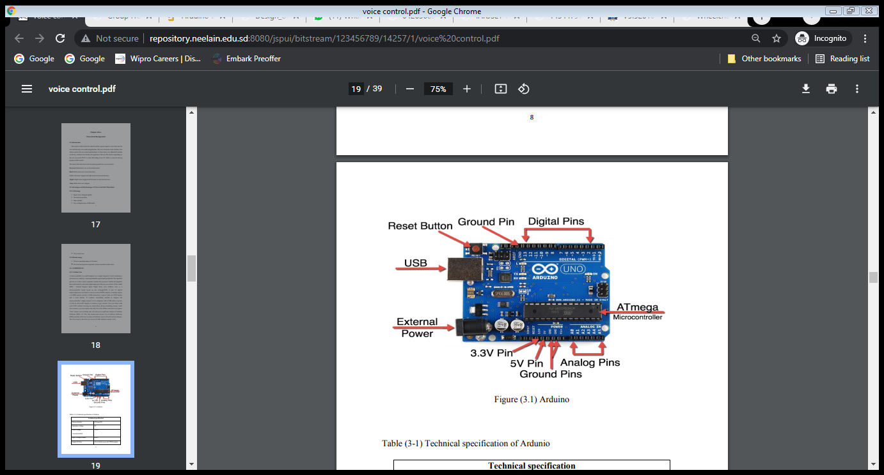

***FIGURE 2***

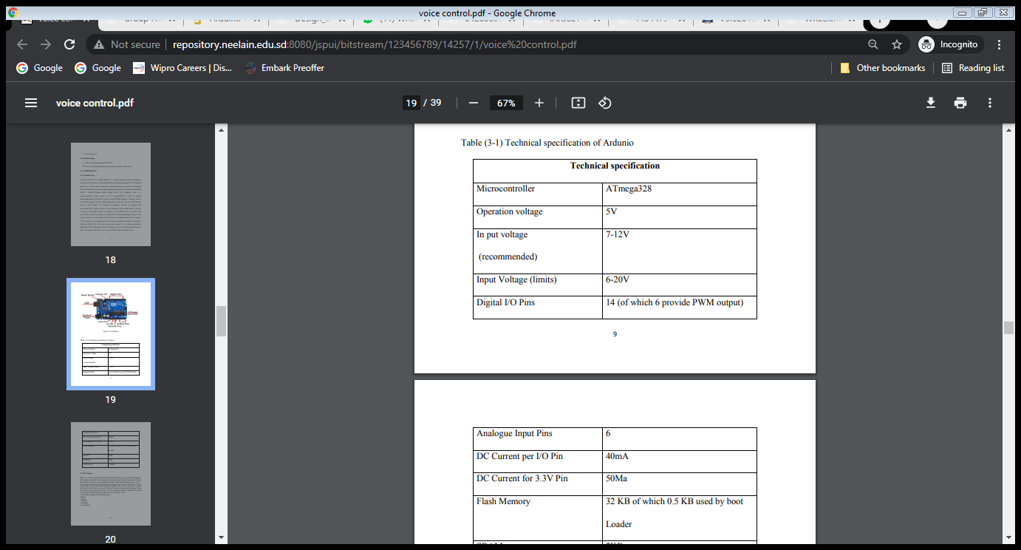

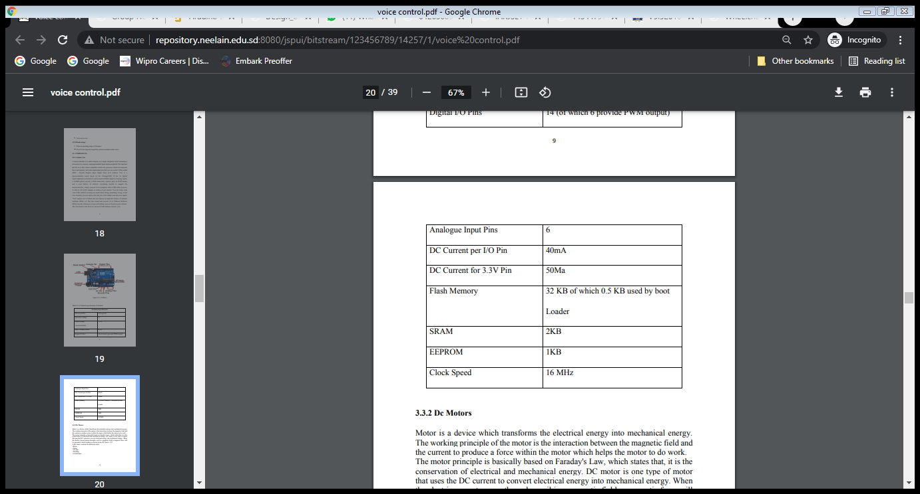

***TABLE 1***

**Ultrasonic Sensor**

Ultrasonic sensor provides an easy method of distance measurement. This sensor is perfect for any number of applications that require you to perform measurements between moving or stationary objects. Interfacing to a microcontroller is a snap. A single I/O pin is used to trigger an ultrasonic burst (well above human hearing) and then "listen" for the echo return pulse. The sensor measures the time required for the echo return, and returns this value to the microcontroller as a variable-width pulse via the same I/O pin.

Ultrasonic sensors are devices that use electrical–mechanical energy transformation to measure distance from the sensor to the target object. Ultrasonic waves are longitudinal mechanical waves which travel as a sequence of compressions and rarefactions along the direction of wave propagation through the medium. Apart from distance measurement, they are also used in ultrasonic material testing (to detect cracks, air bubbles, and other flaws in the products), Object detection, position detection, ultrasonic mouse, etc.

A special sonic transducer is used for the ultrasonic proximity sensors, which allows for alternate transmission and reception of sound waves. The sonic waves emitted by the transducer are reflected by an object and received back in the transducer. After having emitted the sound waves, the ultrasonic sensor will switch to receive mode. The time elapsed between emitting and receiving is proportional to the distance of the object from the sensor

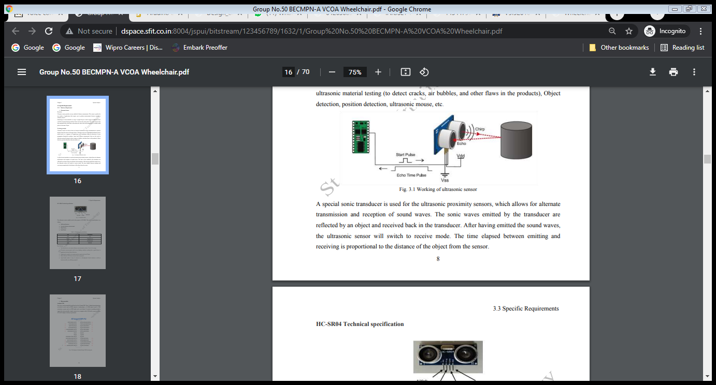

***FIGURE 3***

**Dc Motors**

Dc Motor is a device which transforms the electrical energy into mechanical energy. The working principle of the motor is the interaction between the magnetic field and the current to produce a force within the motor which helps the motor to do work. The motor principle is basically based on Faraday's Law, which states that, it is the conservation of electrical and mechanical energy. DC motor is one type of motor that uses the DC current to convert electrical energy into mechanical energy. When the electric current passes through a coil in a magnetic field, a magnetic force will be generated, which produces a torque in the DC motor.

A DC motor contains the following parts:

• Rotor

• Stator

• Air gap

• Winding

• Commutator

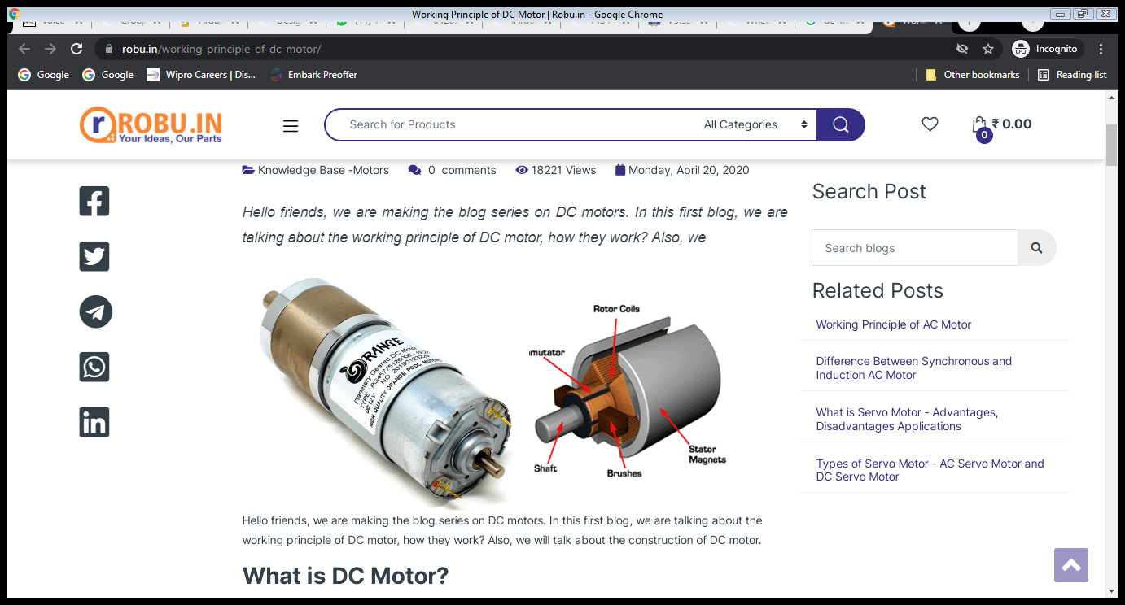

***FIGURE 4***

**Driver (L293D)**

L293D is basically a motor driver or controller. It has two builtin H-bridge circuits which are able to control two DC motors simultaneously in both clockwise and counter clockwise direction. It acts as an current high amplifier because it take low current signal at its input and provides higher current signal at the output in order to drives different load e.g. stepper motor & DC motors. Its features include large input voltage supply range, large output current high noise immunity input signals etc

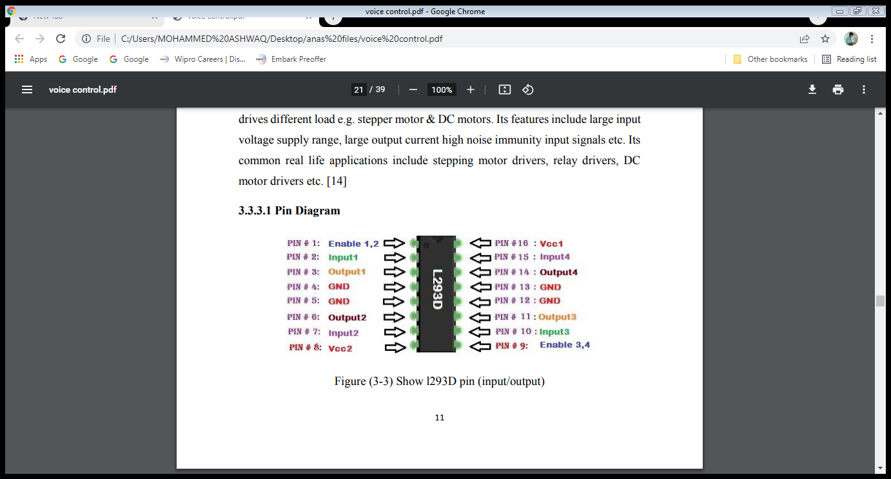

***FIGURE 5***

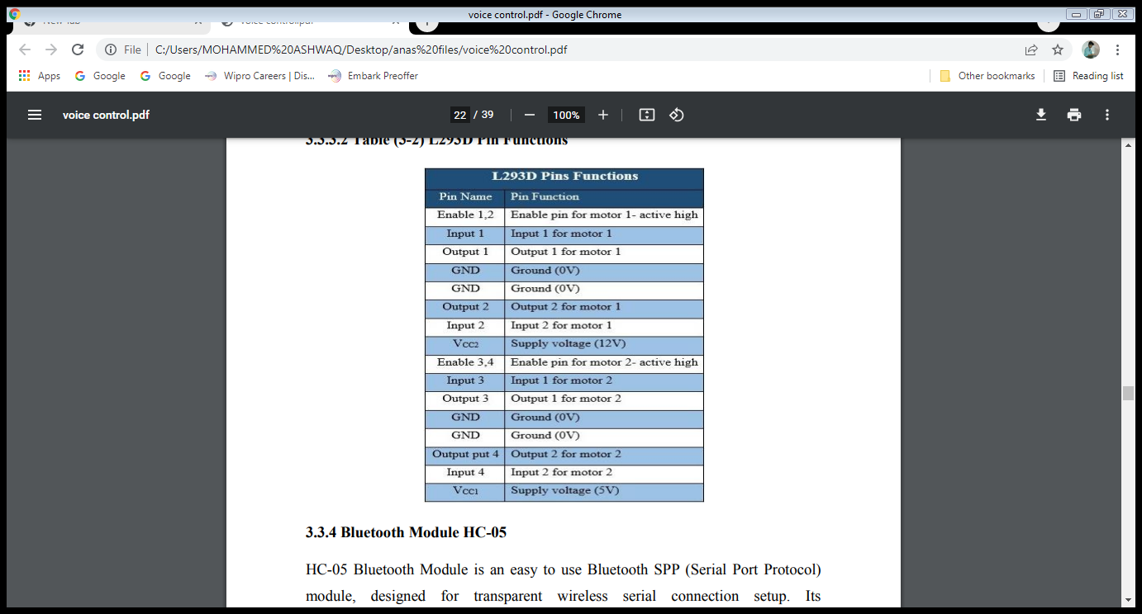

***TABLE 2***

**Bluetooth Module HC-05**

HC-05 Bluetooth Module is an easy to use Bluetooth SPP (Serial Port Protocol) module, designed for transparent wireless serial connection setup. Its communication is via serial communication which makes an easy way to interface with controller or PC. HC-05 Bluetooth module provides switching mode between master and slave mode which means it able to use neither receiving nor transmitting data.

Specification:

• Model: HC-05

• Input Voltage: DC 5V

• Communication Method: Serial Communication

• Master and slave mode can be switched

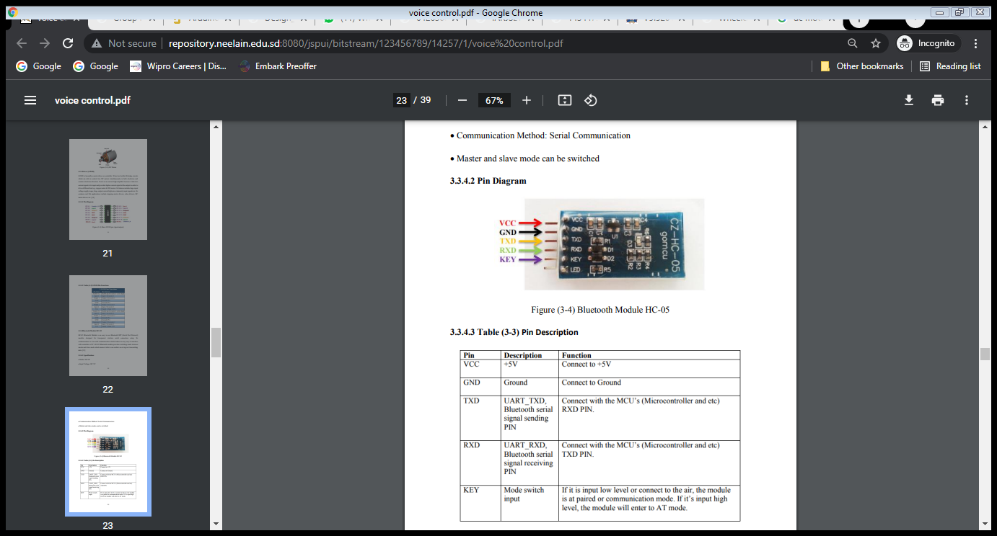

***FIGURE 6***

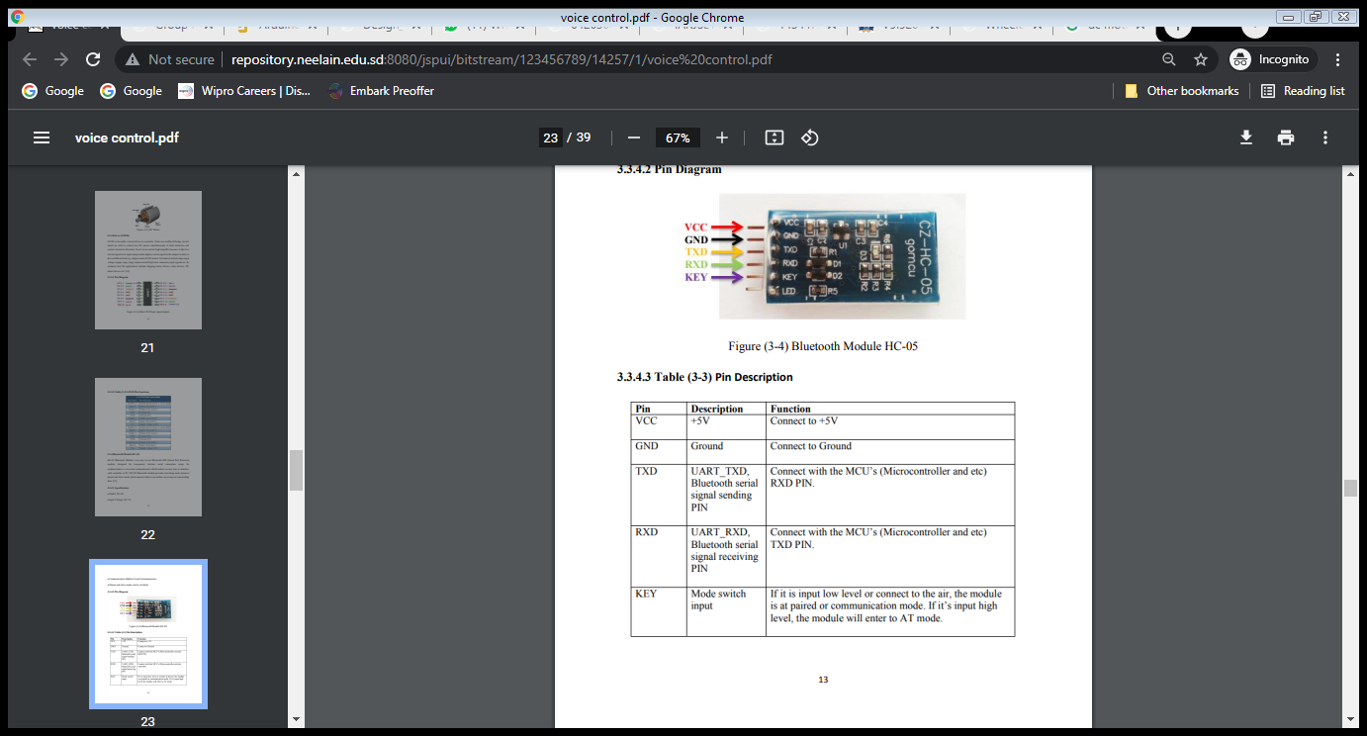

***TABLE 3***

**Software Requirements**

• Arduino compatible Embedded C

1. The C programming language is perhaps the most popular programming language for

programming embedded systems.

2. C remains a very popular language for micro-controller developers due to the code

efficiency and reduced overhead and development time.

3. C is adopted worldwide to program for small microprocessors because it gives a good

trade-off between development effort and program efficiency, and because of its history

there are well-optimized libraries, extensive guides and ways to solve problems.

4. C offers low-level control and is considered more readable than

assembly.

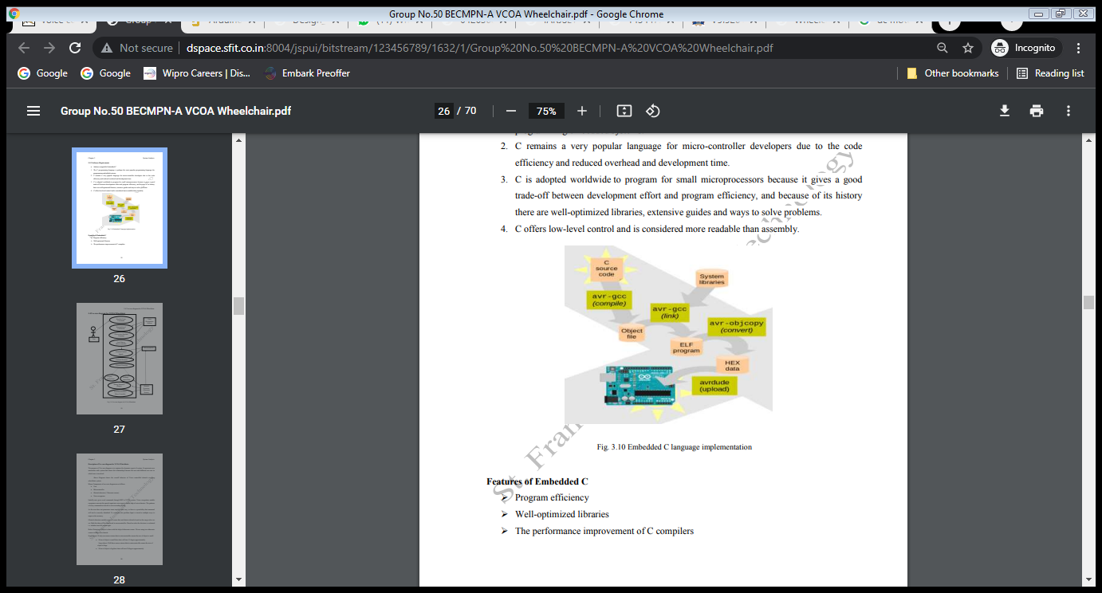

Features of Embedded C

➢ Program efficiency

➢ Well-optimized libraries

➢ The performance improvement of C compilers

**METHODOLOGY**

This system works on voice commands given by the wheelchair user. The system is fully independent as the user do not need any other person to help him to move the wheelchair. There are basically five commands, which command is given by the user, accordingly the wheelchair will move. The voice commands of the user is recognized in the first step. Once it is recognized, the commands are converted into its equivalent instructions which drive the system. This system consists of two major modules namely Voice recognition module and motor driving module. The voice recognition is done through voice recognition module. The output of this module is directed to Arduino which uses a motor driver IC to drive the motors.

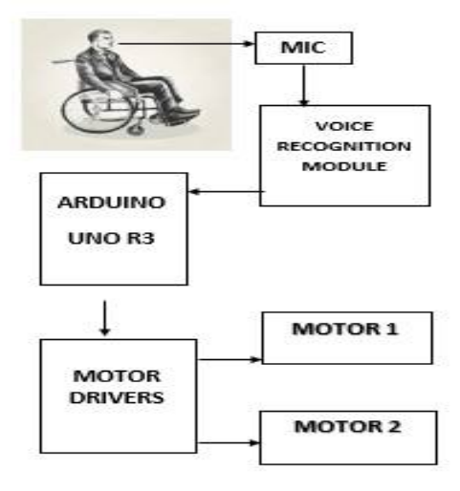The voice controlled wheelchair works using unilateral mic, voice recognition module, Arduino and motors. The input to the system is the unilateral mic. It’s capable to take user’s voice commands and not bother about other noises. The mic will be placed as per the user’s comfort. The output is in the form of voice signals and is transferred to the voice recognition module which acts as an interface between mic and Arduino. The Arduino then receive the output from voice recognition module thus converting it into binary code. The system is unable to understand any language other than binary code. Thus, the generated voice command is converted into machine understandable form. This system uses the Arduino uno R3. It is connected with motors to drive the wheelchair anywhere. Motors are responsible for the movement of wheelchair. Hence, motors receives input from the Arduino and depending upon the instruction type, motors moves accordingly. This system uses two motors connected with motor driver. There are five different instructions that can be given to the motors, they are forward, backward, left, right and stop. The movement of wheelchair depends only upon these five commands The wheelchair responds to the voice command from its user to perform any movement’s functions. The basic movement functions include forward direction, left and right turns and stop. In order to recognize the spoken words, the voice recognition processor must be trained with the word spoken out by the user who is going to operate the wheelchair

***FIGURE 7***

The system would recognize the commands given to it and hence would work or rather respond according to the given command. Below is the flowchart of the acceptance of the commands given to the system. Once the command is given through the mic it hardly takes time for the system to respond accordingly .

In this work, the user controls the wheelchair by the interactive operation. Then, system prevents the wheelchair from taking incorrect movement by false recognition. How- ever, there is a problem of colliding with the wall or obstacle by delaying the voice command. Therefore, collision avoidance function (CAF)is implemented. CAF consists of the stop movement, the avoidance movement, and deceleration movement by using sensor in- formation. The thresholds of the sensor to each movement is set. If any of the sensor’s value becomes less than the threshold, the wheelchair applied assigned movement. The stop movement is set to prevent collision to both the stationary obstacle such as the wall and moving obstacle such as person. This movement works immediately if one of the sensors is less than the threshold.

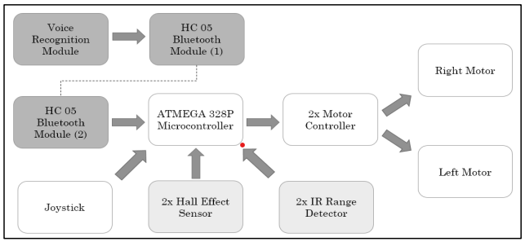***FIGURE 8***

The wheel chair directions and movement possible are as given below.

1. Forward: Motor 1 FW and Motor 2 RW.

2. Reverse: Motor 1 RW and Motor 2 FW.

3. Left: Both motors are in FW.

4. Right: Both motors are in RW.

5. Stop: Both motors are stopped.

When the voice is detected, the wheelchair can be controlled to move in that direction by giving commands to the wheelchair. These commands are transferred to the wheelchair using electrical signals which are used to drive the left or right motor of the wheelchair.

**VOICE RECOGNITION MODULE**

Firstly voice recognition module means a system for computer analysis of the human voice, especially for the purposes of interpreting words and phrases or identifying an individual voice. Here we have to use a voice recognition module to detect and convert detected voice command into binary signal.

**MECHANICAL DESIGN OF THE WHEELCHAIR**

A force is the amount one object tries to push or pull another object. The earth exerts a force on every object, pulling it towards the ground. This is known as the force due to gravity, and the center of gravity of an object is the point where it can be balanced.

Building wheelchair system basically based on mechanical studying. There are two mechanical parts have been studied in this project, the dimensions of all parameters (seat, motors, wheels, gear, batteries and drive kit), the other part was the power calculations.

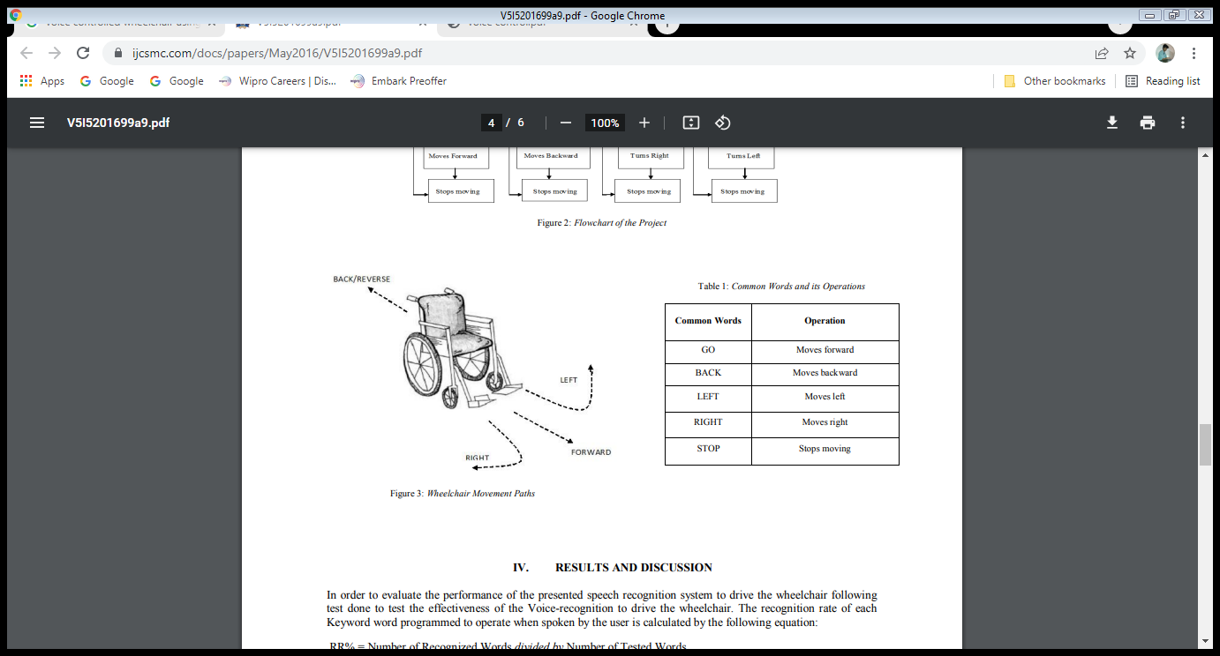

***FIGURE 9***:Wheelchair Movement Paths



***TABLE 4***:Common Words And Their Operations

**SOFTWARE SIMULATION**

In this project, the whole working is controlled mainly by two softwares. 1. Visual basic 2. Arduino compiler Visual basic software is used to compare process and convert the voice signal given through the microphone to certain instruction that is already stored. These instructions are given to the microcontroller. Arduino compiler will process the instruction received by the microcontroller and convert them into certain commands that can be recognized by the motors. Software part can be mainly divided into 3 parts according to the working.

1. Sensor part

2. Serial communication

3. Manual control

First ,initializing the public variable will take place. After that all 3 functions mentioned above will start. All these works are processed at a time, so it is called parallel processing. Once the program starts there is no end or a stop, i.e it will act as a loop until the power

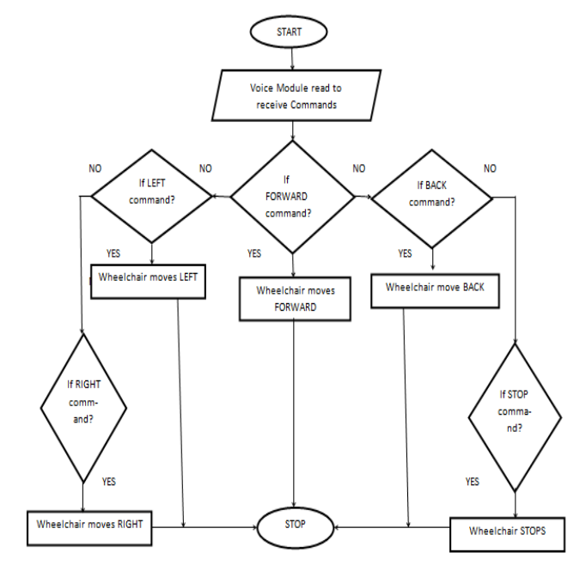

***FIGURE 10***

**PRELIMINARY RESULTS**

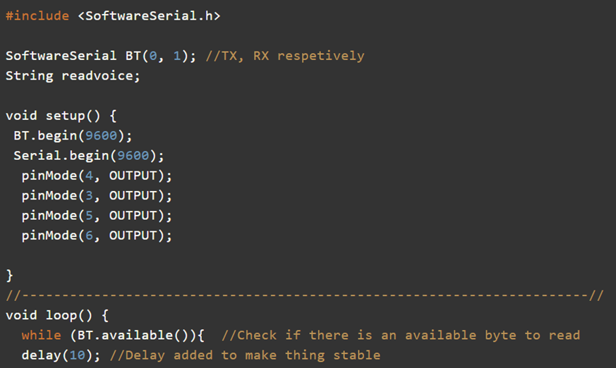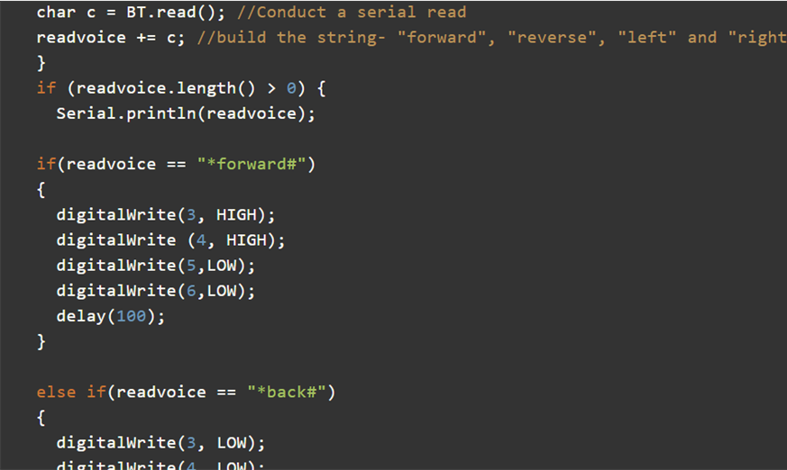

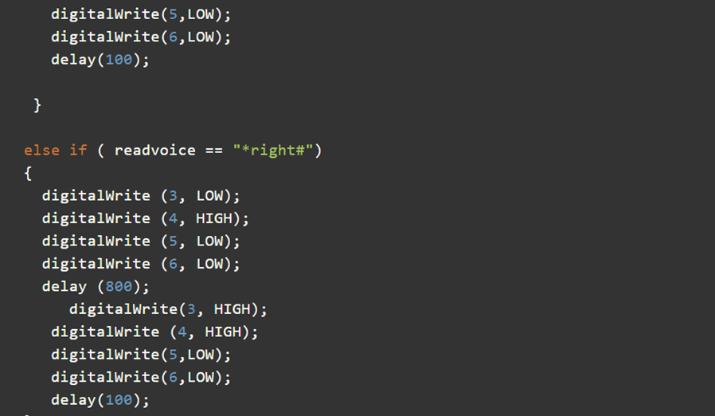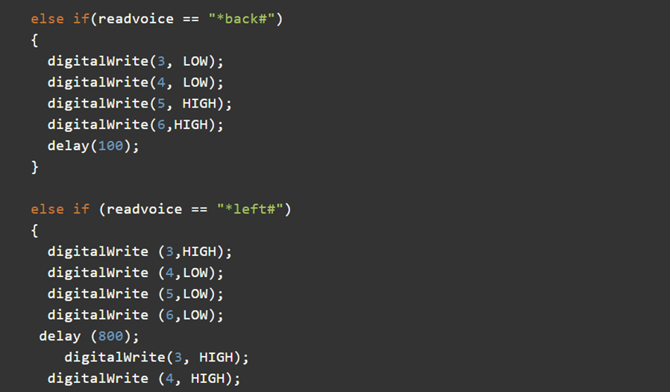

**PLAN OF ACTION**

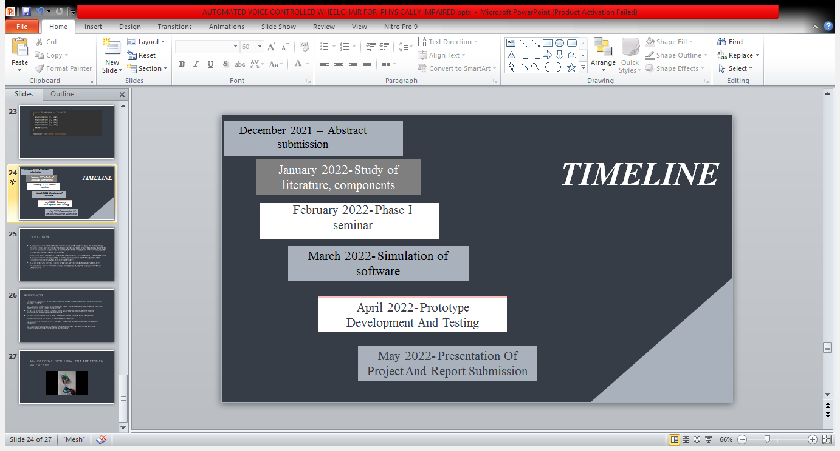

**CONCLUSION AND FUTURE SCOPE**

The social need is the independence of the physically challenged people. The mobility of the physically impaired people is made possible by the use of wheelchairs. Initially manual driven wheelchairs were used by physically handicapped people. However, the electrically driven wheelchairs are gaining popularity in the society.

The aim of the project was to design a voice controlled wheelchair for disabled people usually depend on others in their daily life especially in getting from one place to another. From the above results and discussions following conclusion can be drawn. The voice controlled wheel chair runs successfully with a speed 0.5 m/s for 40kg load.

The wheelchair responds to the voice command from its user to perform any movement functions. The basic movement functions includes forward direction, left and right turns and stop. In order to recognize the spoken words, the voice recognition processor must be trained with the word spoken out by the user who is going to operate the wheelchair. This voice operated wheel chair will assist the handicapped persons to make them selfdependent for the purpose of movement for which these people are dependent on other most of the times. A person with disabled with legs and arms can use this wheel chair efficiently if he is able to speak, the motor drive and control system of the intelligent wheelchair has been presented.

The proposed Arduino based voice operated intelligent wheelchair would bring more convenience for the disabled people. The technology can also enhance safety for users who use ordinary joystick-controlled powered wheelchairs, by preventing collisions with walls, fixed objects, furniture and other people.

A map and GPS system can be added to Arduino and by naming the places, wheelchair can go automatically to required place without commands of directions.

Ultrasonic and infrared sensors can be added to avoid obstacles in the way of the chair, and also joystick can be added to control the wheelchair manually in an emergency situation. A camera can be added to back of the wheelchair and a small LCD screen to let the user see without moving.

**REFERENCES**

1. Smite U. Upases, “Speech recognition based robotic system of wheelchair for disable people”
2. P. Doshi Siddharth, Shripad Deshpande, “Embedded system design for real-time interaction with Smart Wheelchair”
3. Jesse Leaman,Hung Manh La,Luan Nguyen, “Development of a smart wheelchair for people with disabilities
4. Romil Chauhan, Yash Jain, Harsh Agarwal, Abhijit Patil, “Study of implementation of Voice Controlled Wheelchair.
5. A. Joshi, B.Agasthiya,E. Jameela, “Android based automated wheelchair control”
6. Yassine Rabhi,Farhat Fnaiech,Makrem Mrabet,“Intelligent joystick for controlling power wheelchair navigation”
7. [dspace.sfit.co.in:8004/jspui/bitstream/123456789/1632/1/Group%20No.50%20BECMPN-A%20VCOA%20Wheelchair.pdf](http://dspace.sfit.co.in:8004/jspui/bitstream/123456789/1632/1/Group%20No.50%20BECMPN-A%20VCOA%20Wheelchair.pdf)
8. [www.ijert.org/research/arduino-based-voice-operated-wheelchair-with-obstacle-detection-a-survey-IJERTCONV6IS13005.pdf](http://www.ijert.org/research/arduino-based-voice-operated-wheelchair-with-obstacle-detection-a-survey-IJERTCONV6IS13005.pdf)
9. [iarjset.com/upload/2016/si/NCETET-16/IARJSET-NCETET%2064.pdf](https://iarjset.com/upload/2016/si/NCETET-16/IARJSET-NCETET%2064.pdf)
10. [www.ijcsmc.com/docs/papers/May2016/V5I5201699a9.pdf](http://www.ijcsmc.com/docs/papers/May2016/V5I5201699a9.pdf)