**A Tree**

**N-ary Tree**

**Binary Tree**

**Invert Binary Tree**

Given root variable of binary tree. Invert the tree & return it's root.

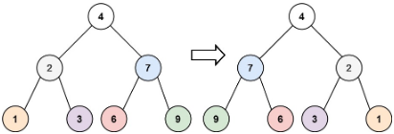

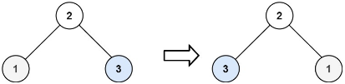

**Example (problem-solving\fajar-leetcode\leetcode1.js)**