Test on 08/17/2023

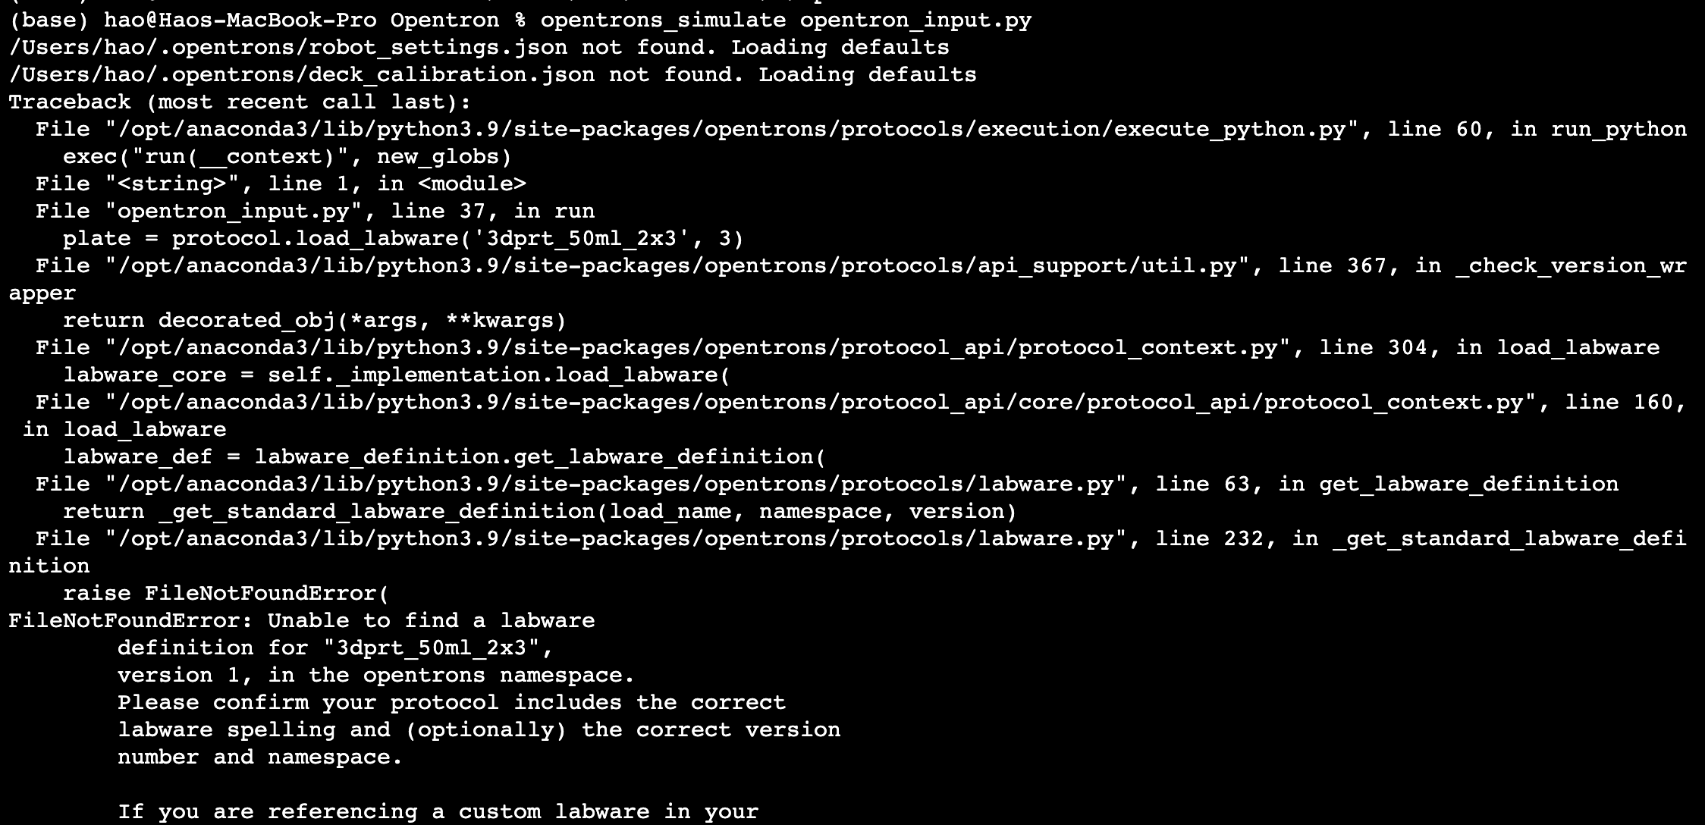

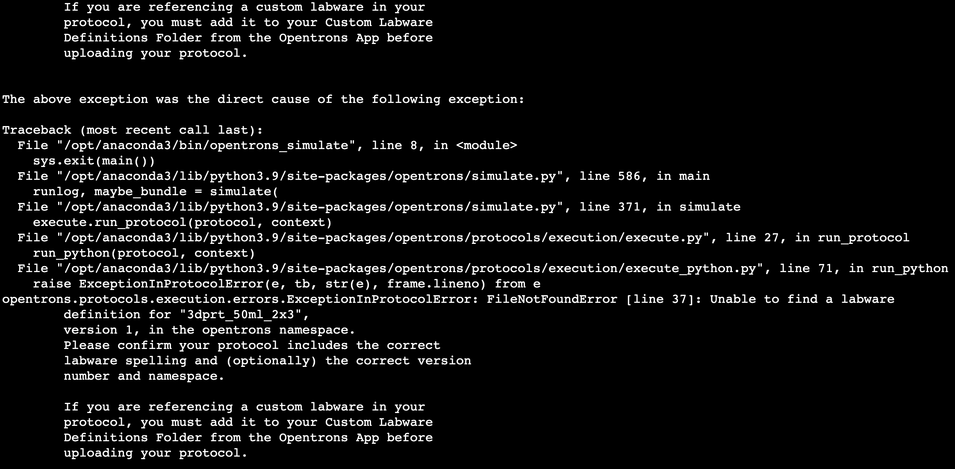

Fixed issues:

1. Import pandas as pd
2. Well-> Well_number
3. The CSV_DATA[STOCK] is a pandas Series object, and in opentron can't directly convert a Series to a single float.

Successful simulation results:

