**Root Cause Analysis**

What is a Root Cause?

A root cause is the core issue — the underlying cause — of a problem.

What’s a Root Cause Analysis?

* A root cause analysis is a systematic process for identifying the underlying causes of a problem or issue.

* It is defined as a collective term that describes a wide range of approaches, tools, and techniques used to uncover causes of problems.

* It involves breaking down the problem into smaller parts, examining each part in detail, and identifying the root causes that are contributing to the problem.

The easiest way to understand root cause analysis is to think about common problems.

**Example -**

* If we’re sick and throwing up at work, we’ll go to a doctor and ask them to find the root cause of our sickness.
* If our car stops working, we’ll ask a mechanic to find the root cause of the problem.
* If our business is underperforming in a certain area, we’ll try to find out why.

Goal of a Root Cause Analysis:

* The **first goal** of root cause analysis is to discover the root cause of a problem or event.
* The **second goal** is to fully understand how to fix, compensate, or learn from any underlying issues within the root cause.
* The **third goal** is to apply what we learn from this analysis to systematically prevent future issues or to repeat successes.

Within an organization, problem solving, incident investigation, and root cause analysis are all fundamentally connected by three basic questions:

* What’s the problem?
  + Define the issue by its impact on overall goals.
* Why did it happen?
  + List Potential Causal Factors
  + Determine the Root Cause of the Problem
* What will be done to prevent it from happening again?
  + Prevent any negative impact by selecting the best solution.

Now that we know what a Root Cause Analysis is, we can now create some general guidelines/steps that you can follow to carry out the analysis.

Life Cycle of the Analysis:

1. Clarify

* Ask questions to get enough clarity on the problem.
* Clarify terms and set up parameters for discussion.
* Create an outline of the approach you’re going to follow.

1. Rule Out

* Explore the possibilities and list some high-level causes.
* Discard issues that seem to be out of the scope.
  1. Check the underlying data to make sure it’s accurate.
  2. Make sure there’s no technical issues / glitch / bugs or outliers.
* List your observations and start diagnosing the root cause.

1. Internal Factors

* Consider any recent features / products that were launched.
* Look for any recent changes made by other teams.
* Slice & dice the data into segments based on user demographics.

1. External Factors

* Look for any kind of bad PR or controversy related to the company.
* Look for any changes in user behavior or customer trends.
* Look for macroeconomic or geographical changes.
* Conduct a competitor analysis.

Based on the analysis you will definitely get a point of issue or error that you can further investigate based on its type. Later, reach a conclusion and suggest a fix to the problem.

Note:

Ensure that all the findings are captured and reported, no matter how small and insignificant they may seem.

**Myntra**

**_____________________________________________________________________**

Problem Statement:

Myntra has observed a decline from 5% to 3% (i.e., **2%**) in the number of confirmed orders over the last 3 days.

You have to perform a **Root** **Cause Analysis** and help us diagnose the issue.

Data:

**Clickstream Data** is the information collected about a user while they browse through a website or use a web browser.

* whether the individual is a unique or repeat visitor to the website.
* the terms an individual plugs into a search engine.
* what page the individual lands on first.
* the amount of time a user spends on a page.
* the features on the page the user clicks on and engages with.
* when and where an item is added or removed from a cart.
* where the user goes next.
* when the back button is used.

Clickstream data collected from a single session of a user interacting with a website may not be very useful. However, an organization can use aggregated data, gathered from many visitors to improve its website or service.

For example, if a lot of visitors leave a site after landing on a page with too little information, the organization may need to enhance the page with more valuable information. Likewise, if visitors often land on a page that isn't the website's [homepage](https://www.techtarget.com/whatis/definition/home-page), then the organization may want to redesign that page to be more inviting and informative to users.

Benefits of clickstream data analysis -

There are a number of benefits organizations can get from clickstream data and clickstream analytics. Among them are the following:

* **User information.** The data collected can include search terms used, pages landed on, webpage features used and the addition or removal of items from a cart, all of which can lead to more actionable insights.
* **User routes.** Organizations can use data analysis to view the different routes their online visitors or customers take to reach a page or to make a purchase.
* **Customer trends and insights.** Collecting and analyzing the clickstreams of a large number of visitors lets an organization identify trends in the following areas:
  + how visitors get to the website.
  + what they do once there.
  + how long they stay on a page.
  + the number of page visits visitors make.
  + the number of unique and repeat visitors.
* **UX.** If a majority of users quickly leave a page or website, it could be a sign that the page is poorly optimized or doesn't contain enough information of value. Clickstream data enables an organization to [recognize UX shortcomings](https://www.techtarget.com/searchcustomerexperience/tip/5-digital-customer-experience-trends-for-businesses-to-consider), enabling them to make necessary changes.
* **Digital marketing.** Clickstream data can be used to determine the amount of traffic coming from ad banners and campaigns. Such data provides insight as to which advertisements are most effective and lead to customer [conversion rate optimization](https://www.techtarget.com/whatis/definition/conversion-rate-optimization). Clickstream analysis can also derive what times of day, month, or year a marketing strategy is most effective.

Establishing basic assumptions:

______________________________________________________________________

Ques.

* How do we define cart additions?

Ans.

* A user can click on a particular item on the product page and add it to their shopping list called the *‘cart’*.
* They can later view the items in their cart and also add/remove items to/from it.
* This is called *cart addition*.

______________________________________________________________________

Ques.

* How are we defining the metric of conversion?

Ans.

* At Myntra, the metric that we look at is the number of orders per session.
* **Orders per session** is defined as

= *No. of orders placed in a day / Total no. of sessions accessed that day*

* One order can have multiple items.

______________________________________________________________________

Ques.

* How do we define a session?

Ans.

* A user session is defined as the browsing period between a *login* and the respective *log out* over the application.
* One session can have multiple orders or cart additions.

**User Journey Funnel**

______________________________________________________________________

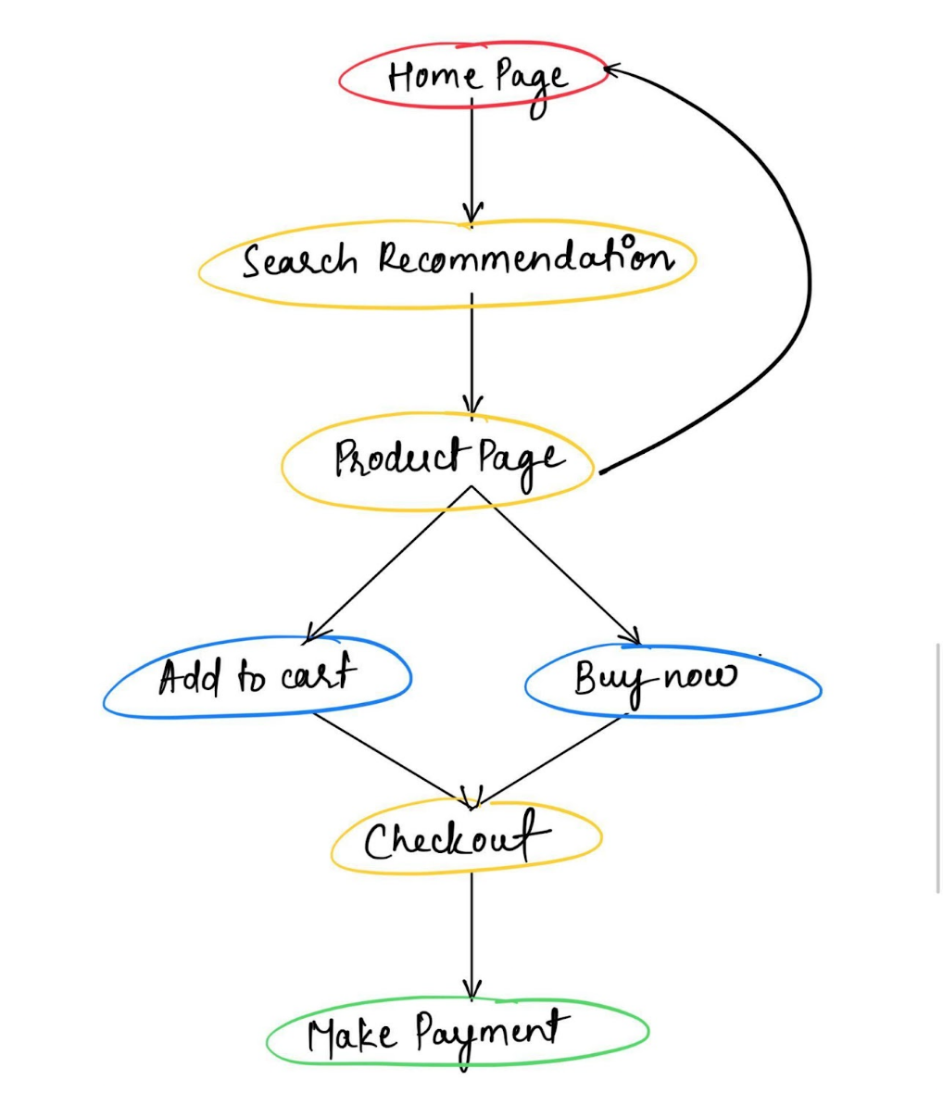

______________________________________________________________________

Ques.

* What is a bounce session?

Ans.

* A user session in which the user landed only on a single page (Homepage) of the application and then is known as a bounce session.
* **Bounce rate** is calculated as

= *No. of bounce sessions in a day / Total no. of sessions accessed that day*

______________________________________________________________________

**Creating a rough estimate -**

* Total no. of Sessions = 100
  + *Assuming that the average no. of sessions per day after the decline was observed were around 100*
* Bounce rate = 10%
  + *Generally, the bounce rate of the app is around 10%*
* Non-bounced Sessions =

=> 100 - 10% of 100 = 90

* Sessions with Product Page view =
  + *Around 1/3rd of the Browsing Sessions ends onto the Product Page*

=> 33% of Non-bounced Sessions = 30 (approx.)

* Sessions with Add to Cart / Buy Now = 15
  + *In 50% of the cases, a user viewing a product adds it to their cart.*
* Sessions with Checkout = 12
* Sessions with Payments = 6
* Sessions with Confirmed Orders = 5
  + *Therefore, conversion rate is 5%*

**\* [Necessary assumptions are made]**

______________________________________________________________________

**Internal factors**

**Backtracking the user journey -**

Since the no. of confirmed orders is down by 2%,

* There could be a drop in total no. of user sessions per day.
* There could be an increase in the bounce rate of the platform.
* Users might not proceed past the product page if they do not like the product.
* Users might not be able to add products to their shopping cart.
* Users might be having some issues during the checkout process or while making payments.

Let us say according to our observations,

* There’s no decline in the overall user activity. The user traffic on the platform is almost the same as usual.
* The bounce rate of the platform is also stagnant at 10%.
* For the product page:
  + The avg product rating for different categories varies between 3.8 to 4.2
  + The expected delivery date of the products is around 5-7 days.
  + The discount offered across multiple categories is from 20-45%
* These numbers are also unchanged since the previous week.

______________________________________________________________________

It means that the issue lies somewhere in the last 3 stages of the user journey i.e.,

1. Add to Cart
2. Checkout
3. Make Payment

Asking clarifying questions:

**External factors** ______________________________________________________________________

Ques.

* Specifically talking about the Indian marketplace, Myntra do have few e-commerce companies as their competitors like Ajio.
* So, have any of them announced an upcoming sale or something?

Ans.

* We have limited knowledge here about what the competitors are doing. Hearing from the customers and looking at their social media handles, we’re not seeing any such thing in particular.
* But it’s not entirely clear. There could be some customer targeting or campaigns that we’re not aware of.

**Demographic details** ______________________________________________________________________

Ques.

* Have we checked if this decline affected customers from a particular region or city?

Ans.

* No, we’re not seeing the impact of location on the decline.
* When we look at the customer location, we’re seeing a spread across many different places.

______________________________________________________________________

Ques.

* Is the decline related to belonging to any specific gender or age group?

Ans.

* No, it is again uniformly distributed for all genders and age groups.
* We’re not seeing any significant deviation for any group.

**Macro-economic changes**

______________________________________________________________________

Ques.

* Has there been any recent partnership change or any merchant just backed out?
* Are the products currently out of stock due to some problem in the supply chain?

Ans.

* No, we haven’t recorded any such event over the past few days.
* We have enough stock of the majority of products listed on the platform.

**Product specific changes** ______________________________________________________________________

Ques.

* Has there been any recent changes/upgrades on the application?

Ans.

* Yes. We have deployed certain upgrades to the application in the last few days.

**Diagnosing the root cause -**

______________________________________________________________________

Ques.

* Is there any change with respect to the “Add to cart” button?
* Are any of these changes done on the Checkout page?

Ans.

* Due to the version upgrade, the complete shopping flow of the application is changed.
* We have improved the checkout process to provide a seamless shopping experience to the customers.
* However, the placement and design of the “Add to cart” button is left untouched.

______________________________________________________________________

Ques.

* Have we received any bug reports for the changes that we’ve made?

Ans.

* We’re not seeing too many bug reports since the new update was launched only a few days ago.

______________________________________________________________________

Ques.

* Are we missing out on any of the leading payment merchants?

Ans.

* Myntra facilitates payments through most of the leading payment merchants like Paytm, PhonePe & GPay so we’re clear on this front.

______________________________________________________________________

Ques.

* Are the payment gateways working properly?

Ans.

* We do have received complaints from a few customers who’ve faced certain issues while trying to make payment during checkout.

______________________________________________________________________

**Let’s explore the payment related issues in detail -**

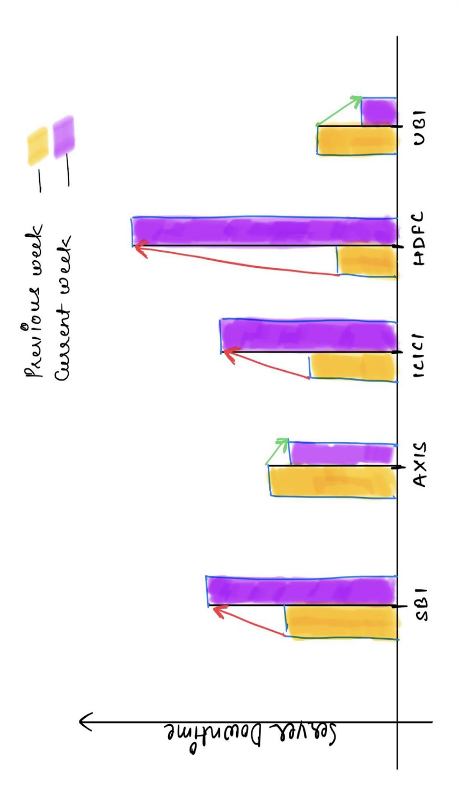

**NOTE:** This data has been fetched from a third-party application that compares the reliability of different payment gateways.

____________________________________________________________

Listing out the conclusion:

* We can see that 3 out of 5 partnering banking services which provide payment options on Myntra are experiencing frequent issues and high server downtime in the current week.
* This validates the complaints that we were getting from some of our customers about incomplete transactions and payment failures.
* It is obvious that if a payment fails multiple times, the customers will not proceed with the transaction due to the risk of losing their money.
* This will result in an automatic decrease in the number of confirmed orders received over the ongoing week.
* However, as we discussed earlier, people are still adding items to their carts. It shows that there’s no critical issue with respect to the application and hopefully everything will go back to normal as soon as the server issues are resolved.